**Reading an Analog Temperature Sensor with an ADC**

* Read an analog temperature sensor and display the value on the LCD
* EELE 465 Project 5
* Jasem Almnaiee and Matt VandeBerg
* 4/3/2025

Introduction:

In this project, we design and implement a real-time temperature monitoring system using the MSP microcontroller. The system samples temperature data from an LM19 analog temperature sensor at a fixed interval of 0.5 seconds and calculates a moving average over a window of three samples to ensure smooth and accurate readings. The measured temperature is displayed on an LCD screen in degrees Celsius by default. However, we also have the option to switch the display to degrees Fahrenheit using a push-button interface. The system ensures that the temperature is not displayed until at least three samples have been collected, after which the display updates dynamically as new readings are obtained.

This project demonstrates the efficient use of MSP430 low-power features, interrupt-driven programming, and analog sensor interfacing, making it a practical application for real-world temperature monitoring systems.

Circuit diagram:

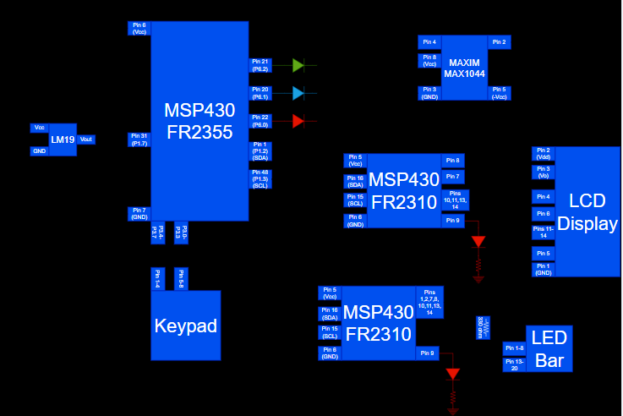

System arch diagram:

The diagram shows how the MSP microcontroller interfacing with various components to achieve real-time temperature monitoring. The temperature sensor provides an analog voltage output, which is sampled by the ADC every 0.5s.A circular buffer stores the last 3 samples to compute a moving average before displaying the temperature on an I2C-based LCD. A push-button interrupt allows the user to switch between Celsius and Fahrenheit modes.

high-level flowchart:

