Spring 2014: Wrapping up

As we wrap up the spring semester, many congratulations must go mentioned! First, congratulations to our lab members that presented at undergraduate conferences this semester:

Toronto Undergraduate Linguistics Conference (TULCON):

* Kyle Latack and Mina Hirzel,  “Taking Baths with Duck-Ducks: Exploring Children’s Understanding of Contrastive Reduplication”

[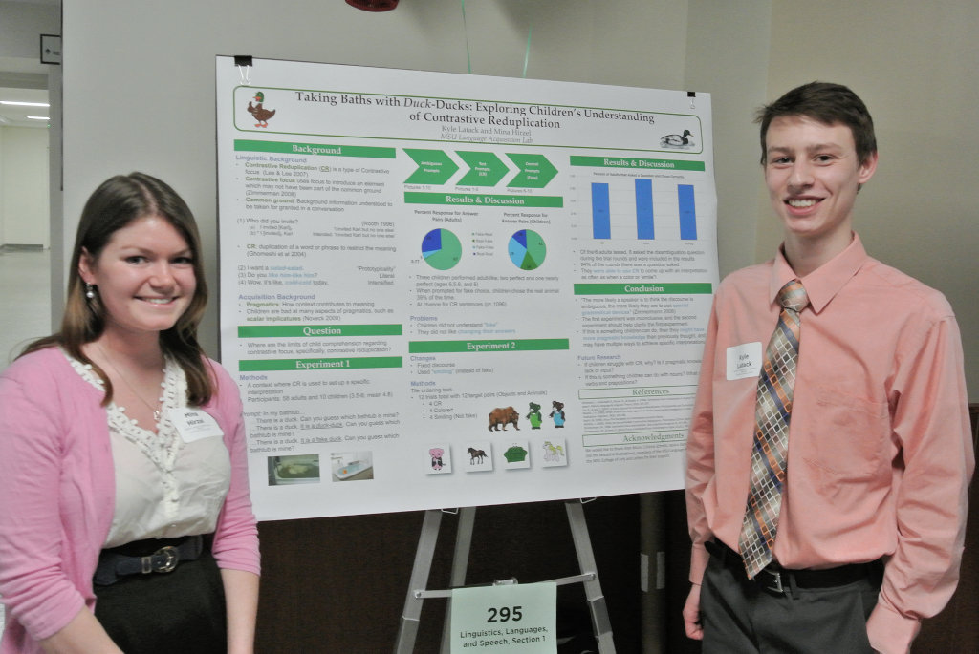] [Above: Mina Hirzel (left) and Kyle Latack (right)]

University Undergraduate Research and Arts Forum (UURAF2014):

* Emily Glaser and Tess Huelskamp, “An Artificial Language Investigation of Number and Number Neutrality”
* Adam Liter, “A unified analysis of passive constructions in English”
* Kyle Latack and Mina Hirzel, “Taking Baths with Duck-Ducks: Exploring Children’s Understanding of Contrastive Reduplication”
* Eric Villanueva, “The Syntax of Japanese Aspect”
* Kenneth Hanson, “The Loss of Bare Singular Noun Phrases in the History of English”
* Kevin Kain and Adam Greene, “Accounting for Comprehension Asymmetries in Children’s Acquisition of the Passive”

[DSC_6621_lzn](http://msuacquisition.files.wordpress.com/2014/04/dsc_6621_lzn.jpg)

[Above: Tess Huelskamp (left) and Emily Glaser (right)]

Michigan State Undergraduate Linguistics Conference (MSULC2014):

* Adam Liter, The Architecture of FL: A View from Appositives”
* Kenneth Hanson, “Methods for Tracking Lexical Classes in Parsed Historical Corpora” (Best Poster)
* Emily Glaser and Tess Huelskamp, “An Artificial Language Investigation of Number and Number Neutrality”
* Kyle Latack and Mina Hirzel, “Taking Baths with Duck-Ducks: Exploring Children’s Understanding of Contrastive Reduplication”
* Eric Villanueva, “The Syntax of Japanese Aspect”
* Kevin Kain and Adam Greene, “Accounting for Comprehension Asymmetries in Children’s Acquisition of the Passive”
* Adam Liter, “A Unified Syntactic Analysis of the Get-passive and the Be-passive” (Best Poster)

[DSC_6658_lzn](http://msuacquisition.files.wordpress.com/2014/04/dsc_6658_lzn.jpg)

[Above: Kenneth Hanson (left) and Adam Liter (right)]

Great Lakes Expo for Experimental and Formal Undergraduate Linguistics (GLEEFUL2014):

* Kenneth Hanson, “The Loss of Bare Singular Noun Phrases in the History of English”
* Kyle Latack and Mina Hirzel, “Taking Baths with Duck-Ducks: Exploring Children’s Understanding of Contrastive Reduplication”
* Eric Villanueva, “The Syntax of Japanese Aspect”

[DSC_6744](http://msuacquisition.files.wordpress.com/2014/04/dsc_6744.jpg)

[Above: GLEEFUL2014 presenters, with keynote speaker Anthony Kroch]

Way to represent! Congratulations on your successful presentations.

Finally, we would like to congratulate graduating undergraduate members of the lab— **Kenneth Hanson** and **Eric Villanueva**. Congratulations on your graduation, and good luck with your journey ahead! Thanks for all of your hard work in the lab.

We have had a very productive year in the lab, and will continue to work throughout the summer. Stay tuned for updates!

The Fall 2014 lab meeting time will be announced in August.

Have a fun and safe summer, everyone!