Tri Peak Solitaire

Software Requirements Specification

Version One

11/16/2015

Marcus Klein
Yubraj Budhathoki

Prepared for
Software Engineering I
Instructor: Mrs. Kussmann
McNeese State University
Fall 2015

Revision History

Date | Description | Author | Comments
11/16/2015 | Version 1 | Marcus Klein  Yubraj Budhathoki | First Draft

Document Approval

The following Software Requirements Specification has been accepted and approved by the following:
Signature | Printed Name | Title | Date
 | Marcus Klein | Software Developer
 | Yubraj Budhathoki | Software Developer
 | Mrs., Kussmann | Instructor

Table of Contents

Revision History ii
Document Approval ii
1. Introduction 1
1.1 Purpose 1
1.2 Scope 1
1.3 Definitions, Acronyms, and Abbreviations 1
1.4 References 1
1.5 Overview 1
2. General Description 2
2.1 Product Perspective 2
2.2 Product Functions 2
2.3 User Characteristics 2
2.4 General Constraints 2
2.5 Assumptions and Dependencies 2
3. Specific Requirements 2
3.1 External Interface Requirements 3
3.1.1 User Interfaces 3
3.1.2 Hardware Interfaces 3
3.1.3 Software Interfaces 3
3.1.4 Communications Interfaces 3
3.2 Functional Requirements 3
3.2.1 <Functional Requirement or Feature #1> 3
3.2.2 <Functional Requirement or Feature #2> 3
3.3 Classes / Objects 3
3.3.1 <Class / Object #1> 3
3.3.2 <Class / Object #2> 3
3.4 Non-Functional Requirements 4
3.4.1 Performance 4
3.4.2 Reliability 4
3.4.3 Availability 4
3.4.4 Security 4
3.4.5 Maintainability 4
3.4.6 Portability 4
3.5 Inverse Requirements 4
3.6 Design Constraints 4
3.7 Logical Database Requirements 4
3.8 Other Requirements 4
4. Change Management Process 5
A. Appendices 5
A.1 Appendix 1 5
A.2 Appendix 2 5

1. Introduction
This is the Requirements Document for Tri Peak Solitaire (see Appendix 1), a web-based card game. This document is part of the Project Documentations for CSCI 410(Software Engineering I) fall, 2015.
This document will provide the requirements specifications for the project Tri Peak Solitaire.

1.1 Purpose
- This document is created for software developers and general users.
  - General users are specified as the instructor and the course students, also referred to as users throughout this document.
  - Students are assumed to have the basic skills required in playing a web-based card game and to be able to understand English.

1.2 Scope
The goal of this project is to produce a fully functional variation of solitaire called Tri-Peaks. Deliverables include:
- HTML and CSS files for the styling of the page, creating a login and registration form,
- Java script files for the classes/objects and logic,
- a database file to store user information like username, password, highest score, current score etc.
- PHP files for interacting the user information to the database.

1.3 Definitions, Acronyms, and Abbreviations
This section contains the definitions of all used terms, acronyms and abbreviations in this document.
Definitions:
Functional Requirement | What the user really wanted
Instructor | In this project, instructor refers to Mrs. Kussmann
Java script | The scripting language used for this project.
Non-functional  requirement | specifies criteria that can be used to judge the operation of a system, rather than specific behaviors.
Product | For this project, the product refers to Tri Peak Solitaire game
Software | For this project, the software refers to the working Tri Peak game.
Software developers | The programmers who wrote the code or the people involved in the software development process.
User | In this project, user refers to anybody who plays the game.
Web-based | Something that is done on website

Abbreviations
CSCI | Computer Science Course
CSS | Cascading Style Sheets
HTML | Hypertext Markup Language
PHP | Pre Processor Hypertext.
SRS | Software Requirement Specification
410 | Software Engineering I course at McNeese State University

1.4 References
- Definition of Tri Peak game from Wikipedia.
- Software Requirement Specification(SRS) template

1.5 Overview
The rest of the document examines the specifications of the Tri peak Solitaire in detail. Section 2 of the SRS presents the general description about the project such as user characteristics and project constraints. Section 3 outlines the detailed, specific functional, performance, system and other related requirements of Tri Peak Solitaire. Supporting information about appendices is provided in Section A.

2. General Description

2.1 Product Perspective
The product is an open to all public users. It is a web based game where anybody who knows English and who has a basic knowledge of computer can play this game.

2.2 Product Functions
The main purpose of this product is to create a card game where user registers or logins to play the game and have a score board displayed at the end of game.

2.3 User Characteristics
The users in this project are open to public. However, for this class we assume that the users are our classmates and the instructor. The user should have a valid email id in order to register for the first time. The user must have a basic knowledge of how to use a computer. The user should register if it is their first time or login if it is not.

2.4 General Constraints
The known constraints on this project are the provision of hardware resources like a computer or a laptop for the user to be able to play the game. The computer must be connected to the internet for the user to be able to play the game because this is a web-based game.

2.5 Assumptions and Dependencies
The requirements stated in this document is dependent on what the instructor stated for this project. The requirements listed in the project are the requirements stated so far as of the date the project was created. Any added requirements or change in requirements will be listed in the updated version of this document.

3. Specific Requirements
This section contains all of the functional and quality requirements of the system. It gives a detailed description of the system and all its features.

3.1 External Interface Requirements
This section provides a detailed description of all inputs and outputs of the system. It also gives a description of the hardware, software and communication interfaces.

3.1.1 User Interfaces
A first-time user of this software should see be directed into the registration page where he/she enters his/her username, password and email address as shown in fig 1 below. If the user has already registered, he/she should be able to login entering required information as shown in fig 2 below.

Fig 1 Fig 2
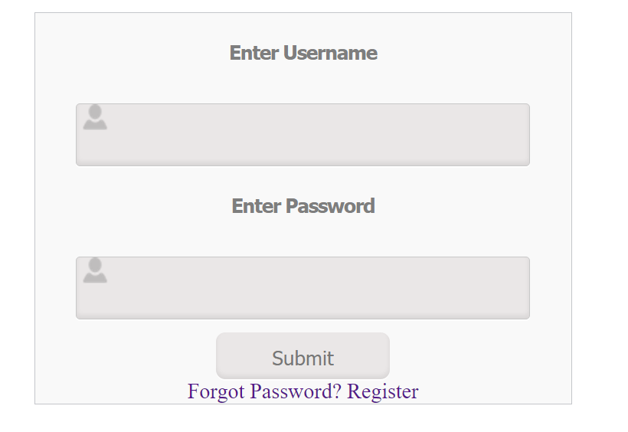
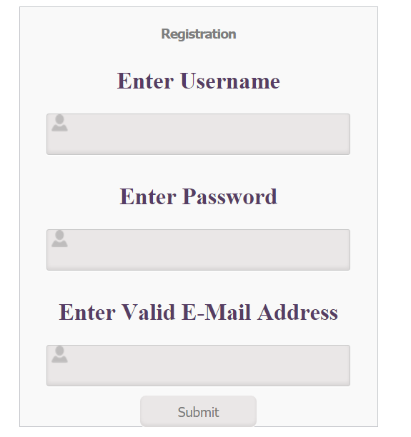

3.1.2 Hardware Interfaces
This project doe not have any hardware interfaces. All the hardware, user need is a computer or a laptop to be able to play the game.

3.1.3 Software Interfaces
The game stores the information about the user like username, password and email address when the user registers into the game. At the end of the game the game retrieves the scoreboard from the database and display it to the user like the fig shown below.
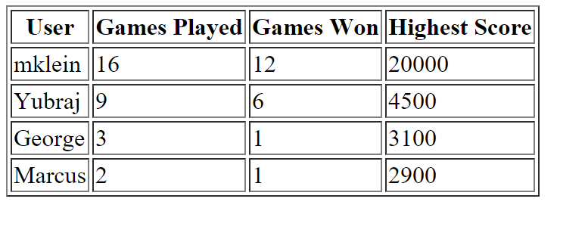

3.1.4 Communications Interfaces
For this project the only communication between two interfaces we are concerned about is how the information about the user and the game scores communicate with the database. PHP files namely login.php, registration.php, scores.php and forgot.php are used to interact to the scores and store them in the database.

3.2 Functional Requirements

Functional Requirement #1
      - Introduction
- There should be a Replay option
      - Inputs
- click replay button
      - Processing
- The replay button should restart the game with same card layout where cards reappear in same location.
3.2.1.4 Outputs
- new game with same card layout

3.2.2 Functional Requirement #2
3.2.1.1 Introduction
- There should be a New Game option
3.2.1.2 Inputs
- click new game button
3.2.1.3 Processing
- The new game button should restart the game with new card layout where cards get shuffled again.
3.2.1.4 Outputs
- new game with a new card layout

3.2.3 Functional Requirement or Feature #3
3.2.1.1 Introduction
- Keep Score:
3.2.1.2 Inputs
- None
3.2.1.3 Processing
- First card matched is worth 100 points and each consecutive card matched is 200 points.
3.2.1.4 Outputs
- Score is displayed at the end of game.

3.2.4 Functional Requirement or Feature #4
3.2.1.1 Introduction
- Keep Time
3.2.1.2 Inputs
- None
3.2.1.3 Processing
- Start time is 2 minutes and 30 seconds.

3.2.1.4 Outputs
- Time is displayed at on the game.

3.2.5 Functional Requirement or Feature #5
3.2.1.1 Introduction
- Add Bonus Time
      - Inputs
- None
3.2.1.3 Processing
- Starts at 20,000 and deduct 200 points for each second of game.
- Any Bonus time is added to score if game is won.

3.2.1.4 Outputs
- Bonus Score is displayed at on the game.

3.2.6 Functional Requirement #6
3.2.1.1 Introduction
- Registration form
3.2.1.2 Inputs
- username ,password, valid email
3.2.1.3 Processing
- Store the information about the user into the database.

3.2.1.4 Outputs
- redirect users to login form

3.2.7 Functional Requirement #7
3.2.1.1 Introduction
- Login form
3.2.1.2 Inputs
- username ,password
3.2.1.3 Processing
- Check to see if the information entered by the user matches with the one in database, if yes redirect the user to play the game if no print the error message

3.2.1.4 Outputs
- redirect users to the game or print error message

3.2.8 Functional Requirement #8
      - Introduction
- Forgot username and or password
      - Inputs
- A valid email address
3.2.1.3 Processing
- Check to see if the email id entered by the user matches with the one in database, if yes return the associated username and password to the email address if not print error message

3.2.1.4 Outputs
- username and password sent to email address or an error message

3.2.9 Functional Requirement #9
3.2.1.1 Introduction
- Score board
3.2.1.2 Inputs
- none
3.2.1.3 Processing
  - Update information about the current user in the database

3.2.1.4 Outputs
- display scoreboard to the user.

3.3 Classes

3.3.1 Class #1

card.js

This JavaScript file designs a card layout. This design is later on used to create a deck of card. By default, the card is faced down.

Card.prototype.flip: flips the card.

Card.prototype.getImagePath: gets the absolute path of the image.

Card.prototype.getValue: returns the face value of the card.

Card.prototype.getNumber: returns the ID number assigned to each card.

Card.prototype.isFaceUp: returns true if the card is face up.

Card.prototype.getWidth: returns the width of the card

Card.prototype.getHeight: returns the height of the card.

Card.prototype.hasBeenPlayed: returns true if the card has been played

Card.prototype.setPlayed: sets the isPlayed value to true or false

3.3.2 Class #2

carddeck.js

Creates an array of Card objects

CardDeck.prototype.getCard: gets the top card of the deck.

CardDeck.prototype.getSize: returns the number of cards in the deck.

CardDeck.prototype.shuffle: shuffles the deck.

CardDeck.prototype.resetDeck: sets all cards’ isPlayed values to false

3.4 Non-Functional Requirements

3.4.1 Performance
- The time required to send an email to the user if he/she forgets the username or password should be no more than few seconds.
- The user should not wait for the time to over if he/she is already done playing the game.
- The messages should be printed promptly.

3.4.2 Reliability
- The game should work on at least the 4 most common Browsers:IE, Safari, Firefox and Chrome.
- The game should work on major operating system(Windows or MacOSX)

3.4.3 Availability
- The game has to be available to be played 24 hours a day .

3.4.4 Security
- No any unauthorized person should be able to access somebody else’s information.
- The user needs to register first in order for him/her to play the game.
- Only the software developers are allowed to enter into the administrative mode.

3.4.5 Maintainability
- The software should be designed in such a way that developers should be able to fix any bugs or upgrade the system in future.

3.4.6 Portability
- Not Applicable

3.5 Inverse Requirements
- Not Applicable

3.6 Design Constraints
- Standard Tri-Peaks Solitaire game

3.7 Logical Database Requirements
- MS Access should be used to store the information about the user.
- The database should have username, password and email address when the user registers.
- When the user plays the game, the current score, highest score, number of games played and number of games won should be updated to each corresponding user.

3.8 Other Requirements
- Not applicable

4.0 Change Management Process
- Instructor species if the requirement specifications are changed or there are any more requirements in the project. A Gantt chart is maintained to keep track of the requirement specifications. Each entry in the chart contains a date started, date completed, the team member responsible for the task and the interrelations between the tasks. Every time a new requirement is received, it is updated in the chart and the task is divided among the team member.

A. Appendices

Appendix 1
Tri-Peak Solitaire is a game played with a deck of card where there are three cards in the first row, 6 in the second, 9 in the third and 10 in the fourth row totaling up to 28 cards in the table. The first, second and third rows are faced down while the fourth row is faced up. There is a stockpile of 23 cards. To begin the game, one card faced up is set aside of stockpile, which is also called a waste pile. The goal of the player is to match a faced up card in the waste pile to those faced up cards in the table. The two cards are matched if one of the faced up card in the table is either one above or one below the face value of the faced up card in waste pile. The player clicks on to the next card in stockpile and checks to see if there is any matching card in the table, and the game continues. If the player matches all cards in the table before the time limit or before the player runs out of the cards in stockpile, then the player wins otherwise the player loses the game.

