Title in Mixed Upper and Lower Case

Marcus Suassuna Santos ¹
¹ Department of Hydrology, Geological Survey of Brasil
Corresponding Author: SBN Quadra 02, Bl. H, Central Brasília, Brasília - DF - Brasil - CEP: 70040-904; marcus.santos@cprm.gov.br

Abstract (up to 300 words)

Keywords: (please provide 3-6 keywords). keyword 1, keyword 2, keyword 3, etc.

INTRODUCTION
NOTE: Please formulate 3-4 clear research questions or objectives, which are clear in terms of how your paper enhances our understanding of hydrological processes.

DATA AND METHODS

Study area and hydrological data
The study focuses on the Paraguay River Basin (PRB), as indicated in Figure 1. We considered the Porto Murtinho stream gauge as the basin outlet (stream gauge 67100000). At this point, the PRB has a drainage area of 575,000 km². Of this, 180,000 km² corresponds to the South American Pantanal, one of the world’s most extensive wetlands, with relevant ecological, cultural and socio-economic interest (Assine et al. 2014; Collischonn, Tucci, and Clarke 2001; Marengo et al. 2021; Santos, Henriques, and Matos 2021; Tomas et al. 2019).
The climate in the region has a well-defined seasonality. The rainy season is observed during the austral summer (from December to February), and reduced rainfall occurs during the austral winter (from June to August). This characteristic is linked to the South America Monsoon System (SAMS) (Cavalcanti et al. 2015; Marengo et al. 2012). It is reflected by annual water level plots, presented in Figure 1. A unique annual peak and a minimum pit are observed in the daily water levels time series in all stream gauges.
Figure 1: The top right image shows the location of the upper Paraguay river in the middle of South America. The larger figure displays the river catchment in detail. The stream gauges are indicated with colours according to the time series length. The sub-catchments and other graphical elements are indicated in the legend. The daily water levels are displayed on the map. The time series plots indicate daily water levels along with annual minimum water levels with darker lines and points.
Figure 1 shows the location of the 24 stream gauges used in this study. Data was collected from the National Water Resources Information System. The National Water and Sanitation Agency (ANA) makes all Brazilian hydrological data freely available from the HidroWeb system (ANA 2017). The data used in this study were accessed in June 2022. The length of the annual minimum water levels in the stream gauges is also indicated in Figure 1.
The data length spans from 24 to 121 years. The most extensive time series in the study area has 121 years of water level data (Ladário, code 66825000). This stream gauge is often used as a reference in the PRB. We evaluated 1.360 annual minimum water levels in the study area.
Rainfall data were collected from two data sources: CHIRPS (Funk et al. 2015) and GPCC (Schneider et al. 2020). CHIRPS data is available from 1981 and is currently one of the official data sources in the analysis of precipitation in the early warning system in the Paraguay river basin, maintained by the Geological Survey of Brazil (Santos, Henriques, and Matos 2021). Additional rainfall information was gathered from GPCC, which produces long-term estimates of global precipitation from 1891. This time window covers some relevant hydrological phenomena in the study area; for instance, a long-term drought observed from 1961 until 1973.
Both products were evaluated to check for relevant biases (Figure 2). The first graphic is a scatter plot of monthly mean precipitation estimated using GPCC and CHIRPS from 1981 until 2020. Although some dispersion exists between both products, on average, the dispersion is randomly distributed along the identity line. More pronounced differences between the two products are estimated in the 1st quarter of the year, during the rainy season. Still, no significant bias is detected between both products.
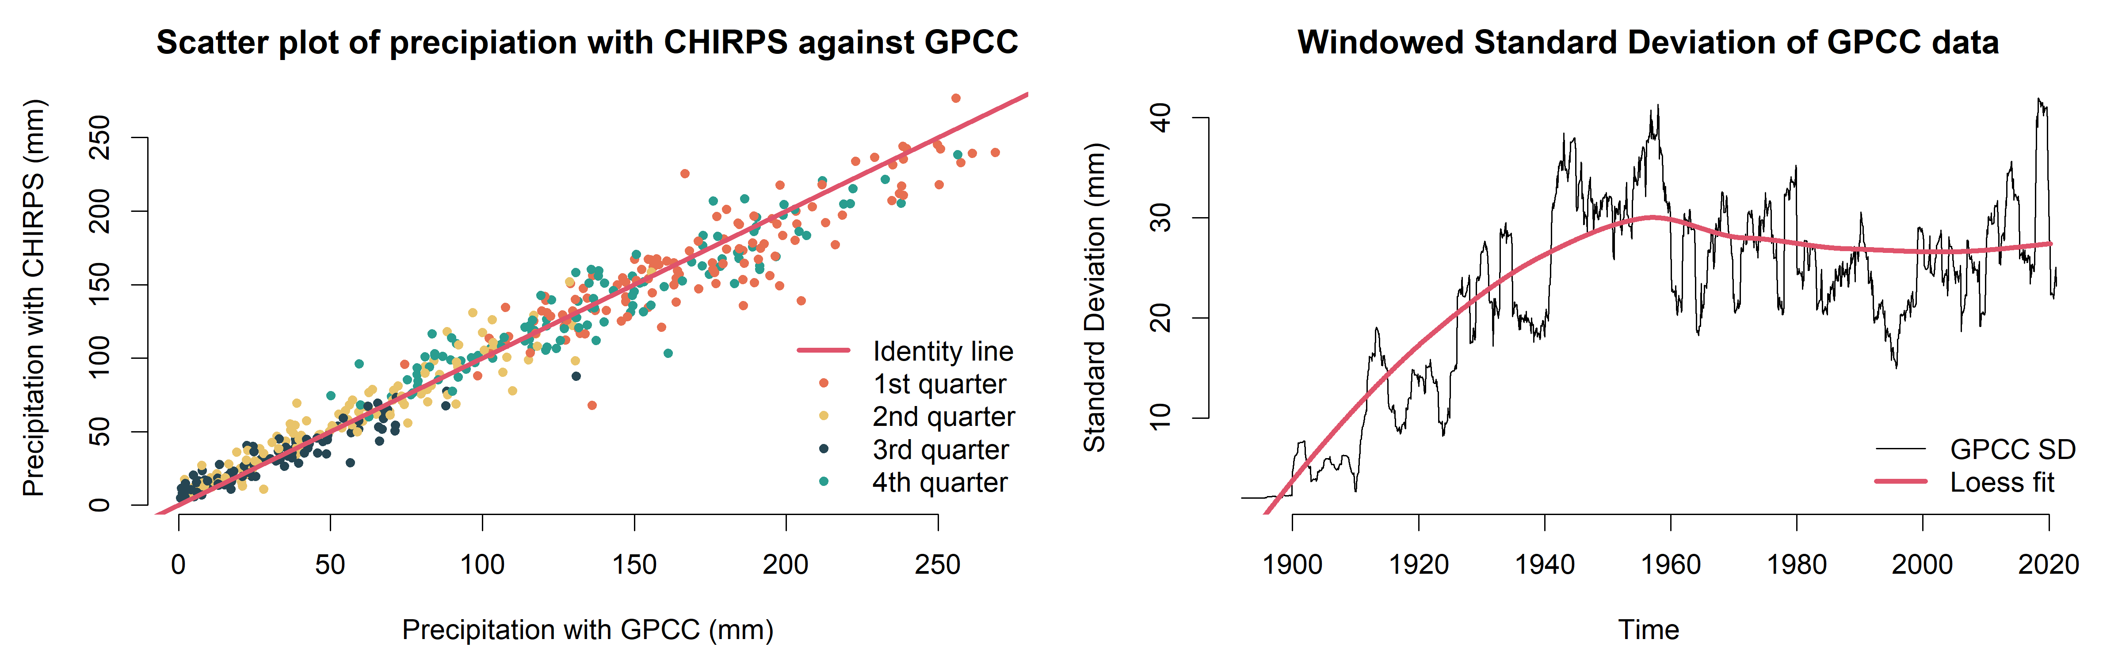
Figure 2: Evaluation of the GPCC precipitation data. GPCC was used to extend CHIRPS precipitation data set. In the first graphic, a scatter plot was built to check for biases. In the second plot, the evolution of the standard deviation was plot with a loess fit.
The period in common of both products is limited from 1981, and an evaluation of older GPCC data is necessary. One main concern is that older GPCC information does not reflect realistic rainfall statistics, mainly the standard deviation of the monthly rainfall. Thus, the second graphic of Figure 2 helps evaluate the windowed standard deviation's evolution of GPCC data in the study area. The same plot displays a local regression line (loess). From this graphic, one can see that the windowed standard deviation stabilizes around 1940. So, since this period, precipitation data has statistical features similar to the observational period. As a result, data from 1940 was used in the study area. In summary, precipitation data used in this study is a composition of GPCC data from 1940 until 1980 and CHIRPS data from 1981 until 2022.

Methodology

Theoretical approach

Multisite HMM approach applied to hydrological data in the PRB
A multisite HMM analysis was performed in the PRB. The depmixS4 package (Visser and Speekenbrink 2010), written in the open software R, was used. We provide reproducible R scripts for all of the results achieved in this study (https://github.com/msuassuna/RegimeSwitchingPantanal).
Some preliminary data preparation is required. The first is to scale the water level data. It was done by subtracting the mean and dividing it by the standard deviation. Missing values are handled as described above. The approach implies that only one stream gauge determines the regional HMM from 1900 until 1932 (Ladário, code 66825000). From 1933 until 1963, data from Porto Murtinho and Cuiabá stream gauges (67100000 and 66260001) is also available. Regional HMM then is determined by those few stream gauges before 1963.
A relevant assumption for the multisite HMM is that the residuals are Gaussian. It is a reasonable assumption to our judgement, as the water level data can assume positive and negative values. The Shapiro-Wilk normality test (Royston 1995) was applied to the residuals of the HMM at the Ladário stream gauge to check if the assumption holds.
The number of drought regimes was defined by evaluating the Bayesian Information Criterion (BIC). We also evaluated the coherence between each stream gauge regime and the regional variation of drought regimes. We performed ANOVA tests (Chambers and Hastie 2017) to check if different drought magnitudes in different sites had the same number of regional drought regimes. We also verified if the magnitudes of drought regimes in each site are consistent with regional drought regimes.
We repeated the analysis using rainfall data. We also evaluated whether different drought regimes could be predicted using precipitation data. The rainfall analysis was limited to the period from 1940 to 2020 due to the limitations of rainfall data, as described above.
Finally, we produced an in-depth analysis of the hidden Markov chains of drought classes using the markovchain package, also written in the open software R (Spedicato and Signorelli 2014). The Markov chains were analysed using “bootstrap”. With this, confidence intervals of drought transition matrices could be estimated.
We compared the transition matrices between the two halves of the time series: 1900-1960 and 1961-2021. This comparison was performed to evaluate if regional transition matrices are homogeneous in time. We also performed simulation studies using the estimates of the transition matrices. We performed so to evaluate the frequency of past extreme drought events in the study area.

RESULTS

Multisite HMM analysis
We fit a multisite HMM model to the scaled water level data in the Paraguay river basin. Stream gauge 66710000 had to be removed from this analysis as it caused convergence issues. Its removal did not affect the regional analysis. The Shapiro-Wilk normality test was performed. When applied to the residuals of the HMM fits in the Ladário stream gauge, it resulted in an estimated value of 0.41 for the p-value. So, the distributional characteristics of the data did not differ significantly from one from a normal distribution. In other words, we can assume normality for the fitted HMM.
The annual minimum water levels time series at the Ladário stream gauge is indicated in Figure 3. The point colours indicate the drought regime of each year, considering three drought classes: severe, intermediate and mild droughts. On the top-right of the figure, the graph shows the BIC evolution with the increase in the number of drought regimes. The BIC graph shows an “elbow” stabilizes with three drought categories. It suggests that considering this number of regimes is a reasonable assumption. The different mean and standard deviation values are indicated in the legend. The estimated standard deviations show no significant variation in different drought regimes. On the contrary, mean values vary significantly.
One relevant aspect that stands out from Figure 3 is the persistency of drought regimes in the second half of the time series. From 1961 to 1973, 12 consecutive years were classified as severe droughts. After that, from 1976 to 1999, 23 consecutive years of mild droughts were observed. From 1974 to 2019, not a single severe drought was observed in the study area in the entire 46-year period. Such long runs were unreported in the first half of the time series. Between 1900 and 1960, a more remarkable alternation between different drought regimes was observed. This aspect will be evaluated in greater depth in the next section.
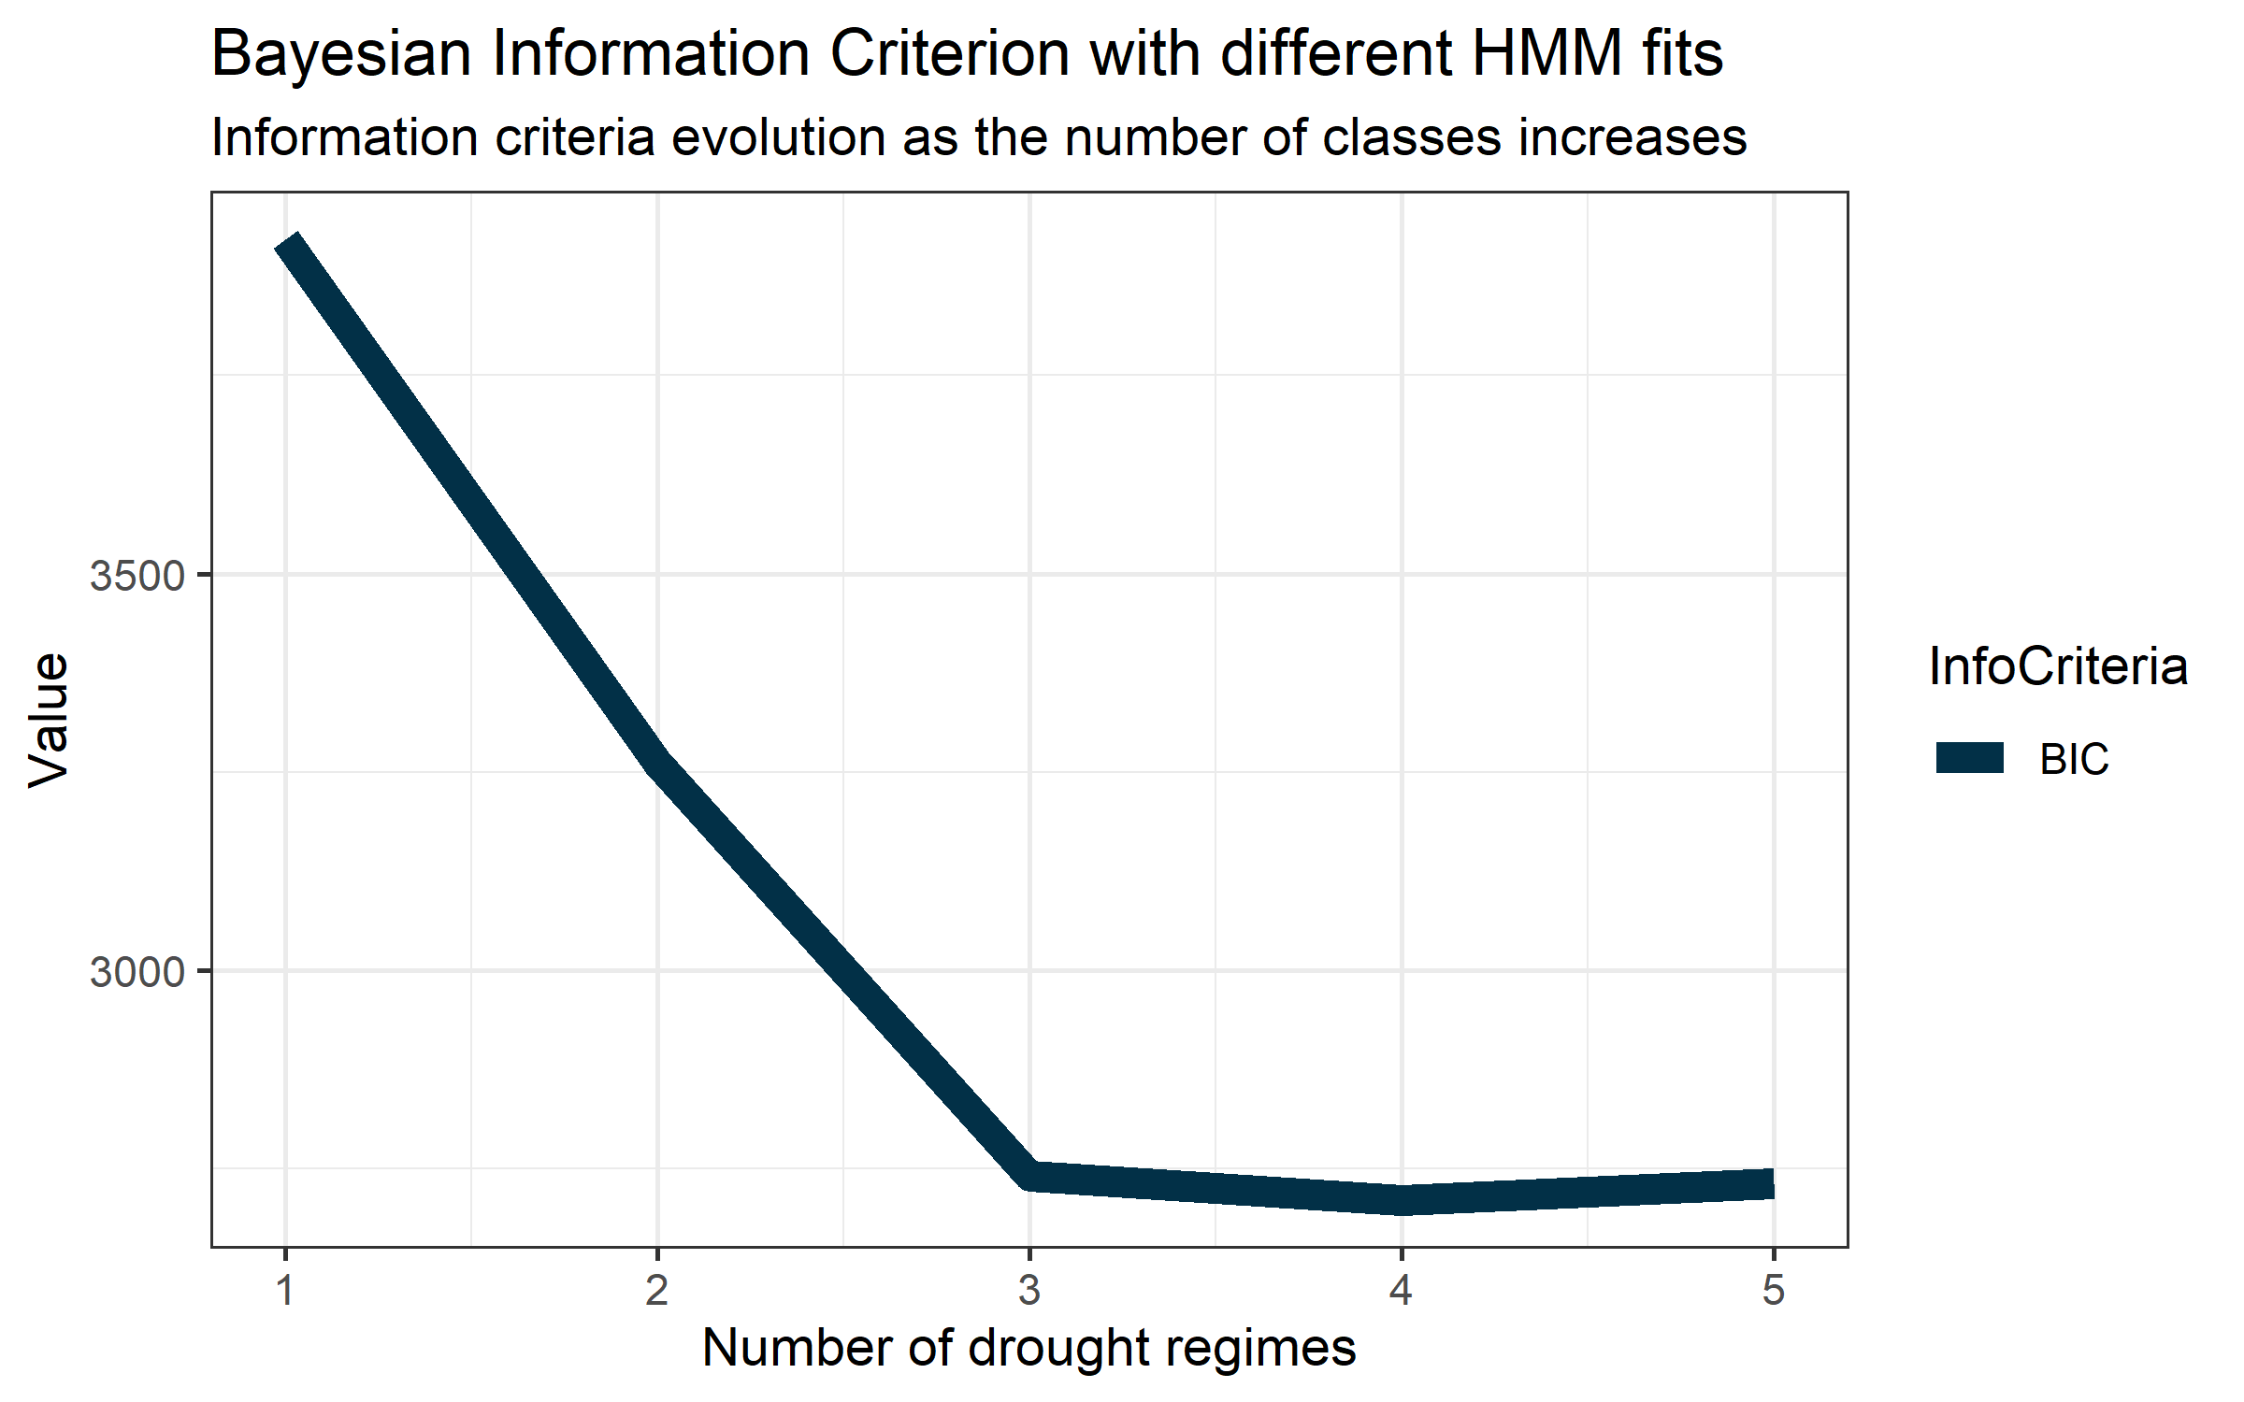
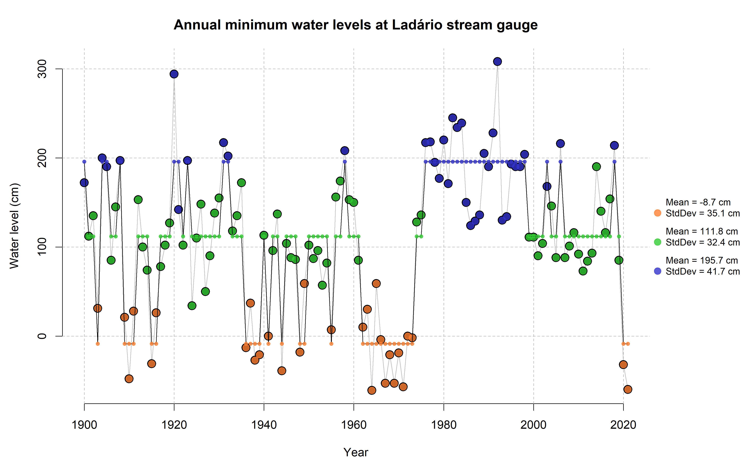
Figure 3: Annual minimum water levels time series at the Ladário stream gauge. The mean and standard deviation of each water level regime are displayed – the plot on the top right side of the figure shows the Bayesian Information Criterion change with the increase of drought regimes. It shows an elbow when 3 drought regimes are considered.
A regional summary of the drought magnitudes in different regimes is displayed on the map in Figure 4. On it, instances of violin plots with three drought regimes are presented on different sites. The main channel of the Paraguay river determines the regional pattern, so the droughts in class 1 are the more severe, class 2 with the intermediate and 3 with the least severe droughts. The Ladário stream gauge, highlighted with a red box, illustrates this regional pattern. This map outlines that the multisite HMM was effective in classifying drought regimes regionally.
The sites marked in orange differ from the regional pattern in two ways. The first are those sites where the three drought regimes do not separate drought classes with different magnitudes. It is the case with most stream gauges in the Cuiabá river basin in the northeastern part of the catchment. For instance, it is evident in the violin plot of the stream gauge 66260001 on the top-right of the map that different drought categories have no relationship with drought magnitudes. The second way is where the differences in drought magnitudes in different regimes are similar to those regional patterns, although not significantly. It is the case of the Miranda river in southern sub-catchments.
Figure 4: Spatial pattern of mean water levels during different regimes: 1 – severe; 2 – intermediate and 3 - mild droughts. Stream gauges marked in blue follow the regional pattern - those in orange, do not. The main channel of the Paraguay river determines the regional pattern, where the Ladário stream gauge is located (highlighted in red).
In each stream gauge marked in blue in Figure 4, a three-component Gaussian mixture distribution is plausible, with different mean values and a fixed standard deviation estimate. For instance, in the Ladário stream gauge, that covers the entire time period from 1900 until 2021, the drought regimes are represented by sub-samples with a frequency of 23.8%, 46.7% and 29.5% in the severe, intermediate and mild droughts, respectively. The mean and standard deviation in each drought regime is displayed in Figure 3.
Thus, the annual minima of -60 cm observed in 2021 in this site result in a probability of occurrence of 7.6% (considering a Gaussian distribution with a mean value of -8.7 cm and a standard deviation of 35.8 cm). The probability of observing the event of -60 cm in this site in a random year is 1.8%. It results from a 23.8% probability of a severe drought, multiplied by a probability of 7.6% of a drought of -60 cm within this drought class. The probability of 1.8% occurrence corresponds to a return period of 55 years.
However, the probability of observing a drought class is conditional to the current drought regime. So, the probability of 23.8% of a severe drought is conditioned to the current drought regime and is not the same along the time series. A more detailed account of that probability is given in the following section.

Evaluation of drought transition matrices
The multisite HMM's hidden states are evaluated in-depth in this topic. The hidden states were evaluated using Markov Chains with bootstrap, so confidence intervals of transition probabilities between drought regimes could be estimated. Figure 4 presents the estimates of drought transition classes using diagrams where the transition probabilities are indicated. The probabilities were estimated in three different time windows: for the entire length of the time series (1900-2021) and its halves, as indicated. A detailed analysis of the transitions is presented in Table 1. It includes lower and upper endpoint matrices representing the 0.95 confidence intervals for the drought transition matrices.
Some aspects of Figure 4 stand out. The matrix from 1961-2021 does not admit the transition between regimes 1 and 3. Although the estimated probability of this transition was low in the first half of the time series (0.24 from class 1 to 3 and 0.14 from class 3 to 1), it was not null. More abrupt transitions between extreme to mild droughts (and vice-versa) were admissible in the first half of the time series. In its second half, the transitions were also gradual.
Another relevant aspect is the persistency of the drought regimes in specific classes. For instance, if one considers the first half of the time series, the probability of a severe drought persisting is 39%. In the second half, this probability is 90%. This aspect was observed previously in Figure 3, but more details are now provided.
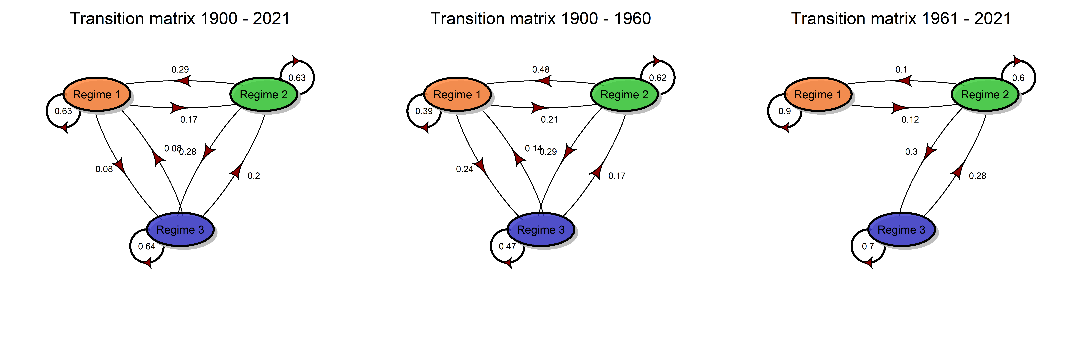
Figure 5: Transition matrices in different periods in the Paraguay river basin. Different transition matrices were estimated for different periods: total length (1900-2021), first (1900-1960) and the second half (1961-2021) of the time series.
In Table 1, it is shown that the lower endpoint probability of this persistency in the second half of the time series (0.88) is significantly higher when compared to the upper endpoint matrix in the first half of the time series (0.45). The same difference holds compared with the entire time series (0.67). It means that the confidence intervals do not intercept; thus, the persistency of the severe drought in the region changed significantly over time in the study area.
For instance, the severe drought observed in 2021 followed another severe drought in 2020. Considering the transition matrix for the entire period, the probability of a severe drought in 2021 would be at most 67%. If the transition matrix for the second half of the time series is considered, the lower endpoint matrix indicates a probability of a severe drought of 88% in 2021. Thus, the probability of observing -60 cm in 2021 in the first case is 67% multiplied by 7.2%. It results in a probability of 4.8%. If the lower endpoint transition matrix of the second half is considered, the probabilities would be 88% multiplied by 7.2%. It results in a probability of 6.3%.
Those conditional probabilities are significantly different from the one estimated in the previous topic when a 1.7% unconditional probability was estimated. Although the unconditional estimates help evaluate the average probabilities and return periods of droughts, conditional probabilities are much more applicable in the operational monitoring of drought conditions in the study area.
Table 1: Transition matrix and 95% confidence level of the lower and upper endpoint matrices, estimated using bootstrap. Different transition matrices were estimated for different periods: total length (1900-2021), first (1900-1960) and the second half (1961-2021) of the time series.
 |  | 1900 - 2021 |  |  | 1900 - 1960 |  |  | 1961 - 2021
 |  | Regime 1 | Regime 2 | Regime 3 | Regime 1 | Regime 2 | Regime 3 | Regime 1 | Regime 2 | Regime 3
Estimate | Regime 1 | 0.63 | 0.27 | 0.09 | 0.39 | 0.44 | 0.17 | 0.90 | 0.10 | 0.00
 | Regime 2 | 0.15 | 0.63 | 0.22 | 0.19 | 0.63 | 0.19 | 0.15 | 0.57 | 0.28
 | Regime 3 | 0.08 | 0.28 | 0.65 | 0.23 | 0.31 | 0.46 | 0.00 | 0.44 | 0.56
Lower Endpoint Matrix | Regime 1 | 0.60 | 0.25 | 0.08 | 0.34 | 0.38 | 0.13 | 0.88 | 0.07 | 0.00
 | Regime 2 | 0.14 | 0.60 | 0.19 | 0.16 | 0.60 | 0.16 | 0.12 | 0.52 | 0.23
 | Regime 3 | 0.06 | 0.25 | 0.62 | 0.19 | 0.26 | 0.42 | 0.00 | 0.32 | 0.45
Upper Endpoint Matrix | Regime 1 | 0.67 | 0.30 | 0.11 | 0.45 | 0.49 | 0.20 | 0.93 | 0.12 | 0.00
 | Regime 2 | 0.17 | 0.66 | 0.24 | 0.21 | 0.65 | 0.21 | 0.19 | 0.63 | 0.32
 | Regime 3 | 0.10 | 0.31 | 0.67 | 0.27 | 0.35 | 0.51 | 0.00 | 0.55 | 0.68

This chapter has provided details on the transition matrices of hidden states of annual minima in the PRB. So far, we saw that the hidden states provide relevant information on changes in the expected values and variability of annual minima and that the transition probabilities are non-homogeneous in the PRB. Therefore, we conclude that the annual minima time series in the study area is non-stationary for two reasons: first, the changing average values and standard deviation violate the stationary assumption; secondly, the way the hidden states vary in time is not homogeneous.
Although it is clear that the transition matrices changed significantly in time, the physical conditions determining which transition matrix is valid are still unknown and are a matter of future research. A preliminary evaluation of whether rainfall plays a role in explaining the minima variability and transitions is provided in the following sections. Before that, we provide a brief simulation study using the estimated transition matrices to evaluate the probabilities of past events in the study area.

Simulation studies
In this topic, we present a synthesis of simulation of hidden states using the estimates of transition matrices indicated in Table 1. We evaluated the frequency of past extreme drought events in the study area. We refer here not to the probabilities of specific annual minima as in the previous section but to the probabilities of long runs of different drought classes observed in the past.
Figure 3 shows that from 1974 to 2019, no severe drought was observed in the PRB for 46 years. So, we simulated 2,000 thousand samples of a 46-year time series using the transition matrices in Table 1. In the simulation, we counted how many severe drought years were observed in the 46 years. Figure 6 shows a summary of the simulations using three histograms of 2,000 counts of severe droughts observed in the 46 years. Each histogram relates to one estimate of the transition matrix from Table 1.
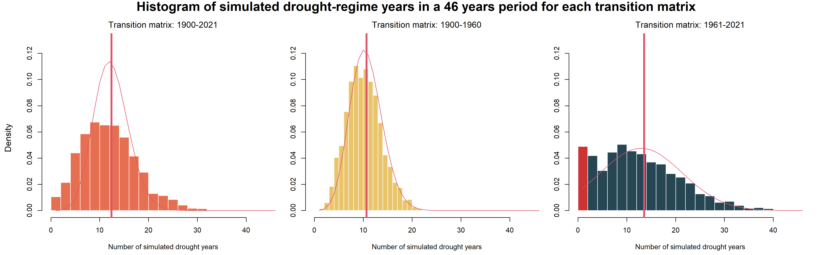
Figure 6: Histograms of the number of years of extreme droughts in a period of 46 years. Time series were simulated using the estimated drought transition matrices. This length is the same of the 1974-2019 period. In the observed regional time series of drought classes, no extreme drought was observed during this period.
Considering the transition matrix from 1900-1960, the number of severe droughts follows a Poisson distribution with an average of 10.6 severe drought events in 46 years. It corresponds to a probability of approximately 23.1% of the years in such a condition. It matches the result of the steady states using the Markov chain model for the hidden states. In this specific case, the probability of observing runs of 46 years without any severe drought results in extremely low probabilities.
Using the transition matrix from 1961-2021, the average number of severe droughts is estimated at 12.9 years. It corresponds to a probability of occurrence of 28.1%. This probability is comparable to the steady state condition of the transition matrix (probability of 29.4% of observing severe droughts). However, the number of occurrences of severe droughts does not follow a Poisson distribution. In this case, the distribution approximates a zero-inflated distribution with a Gaussian-like shape. This zero-inflated distribution that results from this simulation is a statistical phenomenon that deserves better attention in future studies.
In this simulation, the probability of observing zero severe droughts in the 46-year run is 4.45%. It suggests that even if we consider the transition matrix with a long persistency, the 46-year run with no drought observed between 1974 and 2019 has a probability of 4.45%. Given such a low probability, this long run observed in the past is unlikely to be repeated, and severe droughts will likely be more frequent in the future. Such a conclusion holds even if we consider that the transition matrix that will guide the drought occurrences in the future will follow a long-persistency transition matrix, as observed in the second half of the time series. If one considers that future conditions might lead to a transition matrix similar to what was observed during the first half of the time series, the probability of those long runs would be even lower (< 0.1%).

Rainfall analysis
The natural driver of change in extreme hydrological events is precipitation. We used the combination of GPCC and CHIRPS, as indicated in Figure 2, to evaluate if drought transitions were also noticeable with precipitation data. First, we applied the same HMM approach to rainfall data. However, the BIC’s evolution suggested no regime-switching behaviour in precipitation data (figure not shown). We then applied the same drought classes fitted in the multisite HMM to rainfall data and evaluated precipitation in each class differs. The results are summarized in Figure 7.
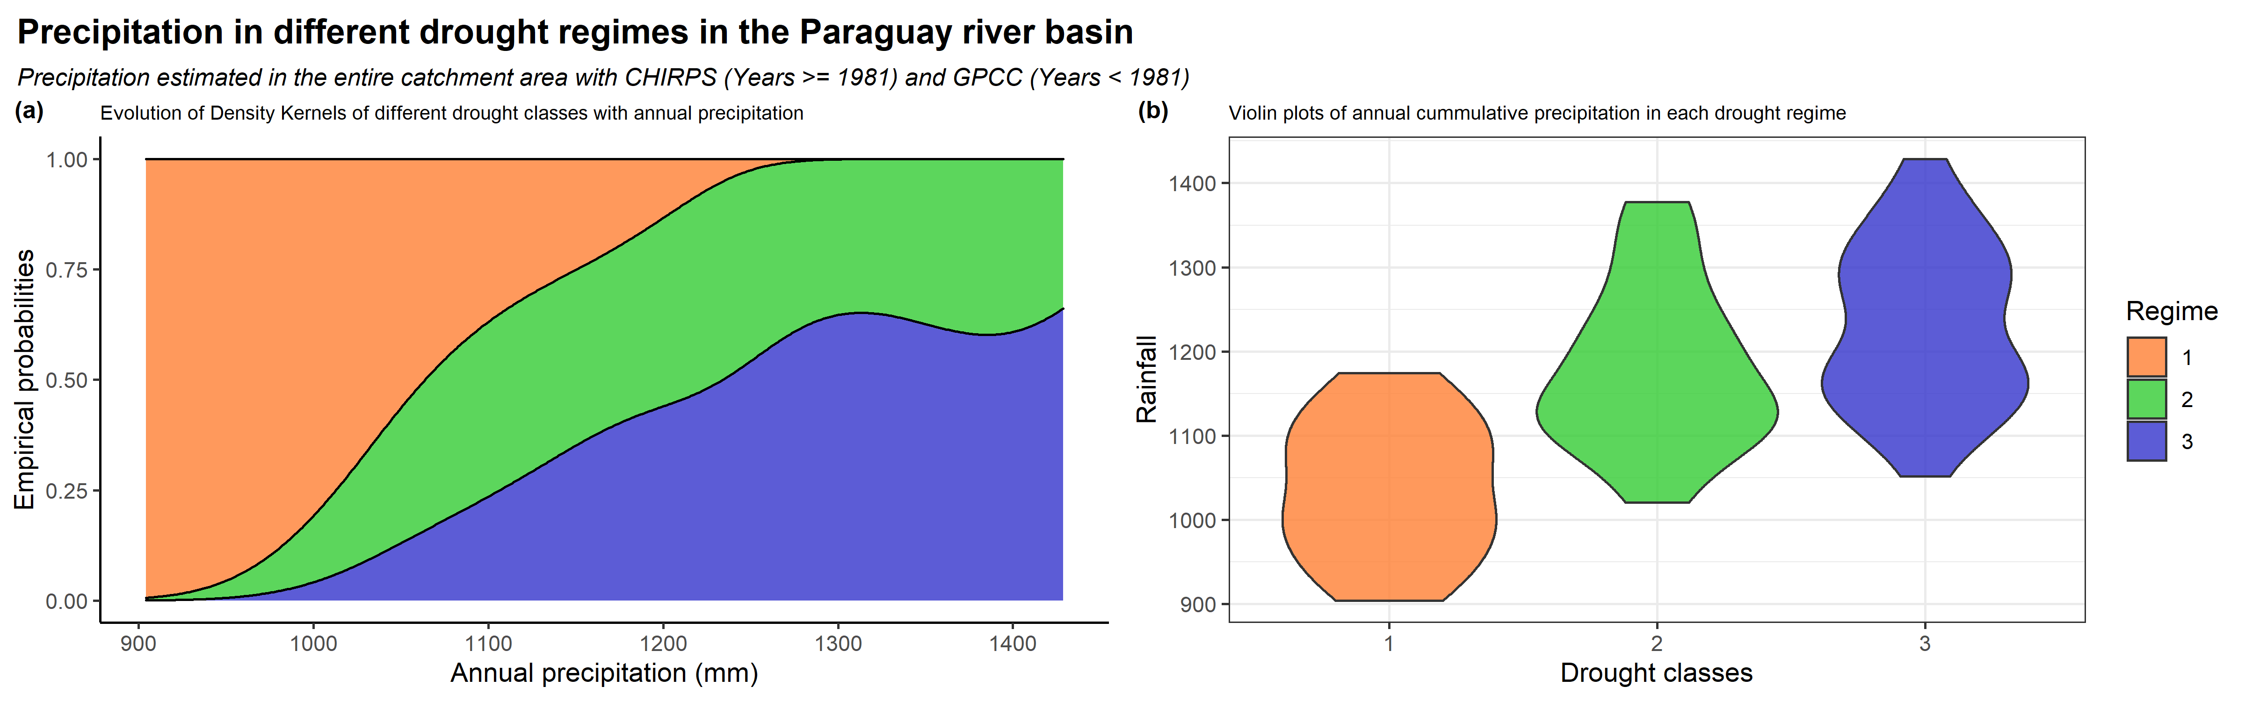
Figure 7: (a) Density kernels of annual cumulative precipitation in different drought classes; (b) violin plots of the annual cumulative average precipitation in different drought classes. Rainfall data from January 1940 to January 1981 were estimated using GPCC. Data from 1981 onwards were estimated using CHIRPS
The first plot shows the evolution of the Kernel's density estimates, a smoothed version of the histograms. Their position on the graphic is set so that the empirical probabilities sum one along the precipitation values. Thus, it can be seen, for instance, that when the precipitation in a given year was lower than 1,050 mm/year, the probability of observing a severe drought in the past (56%) was higher than the sum of intermediate and mild droughts (24% and 20%, respectively). There is a rapid decrease in the probability of severe droughts with the precipitation increase. If the precipitation was 1,150 mm/year in the past, the probability of observing a severe drought is reduced to 25%. With 1,200 mm/year, it reduces to values lower than 13%.
Precipitation during severe droughts is more easily distinguishable from the other two classes. Mean precipitation (± standard deviation) in a severe drought condition is estimated as 1,040 ± 81 mm/year. In the case of intermediate and mild droughts, mean precipitation is 1,204 ± 102 mm/year and 1,208 ± 96 mm/year, respectively. Those differences are shown in the second plot of Figure 7.
Precipitation seems to be a good predictor of drought class transition in the study area, although the changes in precipitation are less noticeable when compared to changes in water levels (and flows in stream gauge 66870000). Collischonn, Tucci, and Clarke (2001) suggested that because the catchment area is so large, small changes in the rainfall could lead to significant changes in the hydrological regimes.
Another relevant aspect in the rainfall analysis is the persistency of the precipitation in a specific drought regime. We evaluated the autocorrelation function of the precipitation time series and found no significant serial correlation, contrary to what happens with the water level data. So the persistence of a drought class is not reproduced in precipitation data.
In summary, it has been seen that precipitation is a good predictor of the drought regimes in the PRB, however the persistency of a specific drought regimes is not explained by the rainfall. So, hydrological features of the study area might be responsible for the drought regime transitions. We would encourage studies that include precipitation as a covariate in the HMM’s transition matrices.

DISCUSSION
NOTE: The discussion should include a critical contextualisation of the main findings with the wider, international literature. If possible, it should also clearly state the wider implications of relevance for a wide, international readership

CONCLUSIONS

ACKNOWLEDGEMENTS
Recognize contributions from people and institutions as appropriate. Authors should acknowledge all funding sources in this section, including the funding body and grant or award number.
CPRM
Artur Matos
Pedro Chaffe

DATA AVAILABILITY
Describe the availability of relevant data, scripts, or other artifacts used to generate the analyses presented. Sharing of results is encouraged (but not required) via a publicly accessible data archive or repository.

REFERENCES

ANA. 2017. “Hidroweb: Sistemas de Informações Hidrológicas.” Agência Nacional de Águas (Brasil). http://www.snirh.gov.br/hidroweb/%5Cnhttp://hidroweb.ana.gov.br/default.asp.
Assine, Mario Luis, Fabrício Anibal Corradini, Fabiano do Nascimento Pupim, and Michael Matthew McGlue. 2014. “Channel Arrangements and Depositional Styles in the São Lourençoo Fluvial Megafan, Brazilian Pantanal Wetland.” Sedimentary Geology 301: 172–84. http://dx.doi.org/10.1016/j.sedgeo.2013.11.007.
Cavalcanti, I. F.A. et al. 2015. “Precipitation Extremes over La Plata Basin - Review and New Results from Observations and Climate Simulations.” Journal of Hydrology 523: 211–30. http://dx.doi.org/10.1016/j.jhydrol.2015.01.028.
Chambers, John M., and Trevor J. Hastie. 2017. Statistical Models in S Statistical Models in S.
Collischonn, W., C. E M Tucci, and Robin T. Clarke. 2001. “Further Evidence of Changes in the Hydrological Regime of the River Paraguay: Part of a Wider Phenomenon of Climate Change?” Journal of Hydrology 245(1–4): 218–38.
Funk, Chris et al. 2015. “The Climate Hazards Infrared Precipitation with Stations - A New Environmental Record for Monitoring Extremes.” Scientific Data 2: 1–21.
Marengo, J. A. et al. 2012. “Recent Developments on the South American Monsoon System.” International Journal of Climatology 32(1): 1–21.
Marengo, Jose A. et al. 2021. “Extreme Drought in the Brazilian Pantanal in 2019–2020: Characterization, Causes, and Impacts.” Frontiers in Water 3(February).
Royston, Patrick. 1995. “Remark AS R94: A Remark on Algorithm AS 181: The W-Test for Normality.” Applied Statistics.
Santos, Marcus Suassuna, Marcelo Parente Henriques, and Artur José Soares Matos. 2021. Relatório de Atividades: Departamento de Hidrologia: Sistema de Alerta Hidrológico Da Bacia Do Rio Paraguai: Relatório Anual de Operação 2021. ed. CPRM. Brasília: CPRM. https://rigeo.cprm.gov.br/handle/doc/22535.
Schneider, Udo et al. 2020. “GPCC Full Data Monthly Product Version 2020 at 0.25°: Monthly Land-Surface Precipitation from Rain-Gauges Built on GTS-Based and Historical Data.” GPCC Full Data Daily Version 2020.
Spedicato, Giorgio Alfredo, and Mirko Signorelli. 2014. “The Markovchain Package: A Package for Easily Handling Discrete Markov Chains in R.” Cran (Spedicato 2017). http://cran.r-project.org/web/packages/markovchain/.
Tomas, Walfrido M. et al. 2019. “Sustainability Agenda for the Pantanal Wetland: Perspectives on a Collaborative Interface for Science, Policy, and Decision-Making.” Tropical Conservation Science 12.
Visser, Ingmar, and Maarten Speekenbrink. 2010. “DepmixS4: An R Package for Hidden Markov Models.” Journal of Statistical Software 36(7): 1–21.

TABLES
Tables should be self-contained and complement, but not duplicate, information contained in the text. They should be fully editable -- and not pasted as images. Each table should be placed on a separate page, be complete with title and footnotes, and understandable without reference to the text. To aid placement, ensure that tables are referenced and located within the text (e.g, [Insert Table 1]).

FIGURE LEGENDS

SUPPORTING INFORMATION

