Muhammad Subhan
20I-0873
DS - N

MLOPS Assignment 2

Overview

Task 1: Extract Links and Metadata
The two sources of news that are extracted for this assignment are 'https://www.dawn.com/latest-news' and 'https://www.bbc.com/news'. The title and description of each article are then extracted by processing it. The article is skipped if the description or title are too brief or absent. To ascertain the sentiment of the description text, a pre-trained model is employed for sentiment analysis. The processed data is gathered and provided back, together with the article ID, sentiment, title, description, and source.

Task 2: CSV data storage
The information gathered in Task 1 is saved in a CSV file by this task. It determines whether the needed directory already exists and, if not, creates it. After that, it gets the information from the XCom that Task 1 passed. It raises an error if no data is received. 'id, sentiment, title, description, and source' are the field names that are sent to a CSV file with the data. Every row represents one article. A success message is printed at the end.

Task 3: Push to Git
The CSV file containing the data that was scraped is pushed to a Git repository by this task. It first verifies the current directory before changing to the proper directory (assuming the directory is part of a project hierarchy). After that, a script is created to add the CSV file to Data Version Control (DVC), push it, add all modifications to Git, commit a message, and push the file to the Git repository. Any errors that arise when the command is being executed are recorded and printed.

The DAG started one day ago and is planned to run every day. Task 1 (extract_links) initiates Task 2 (store_data_in_csv), which in turn initiates Task 3 (push_to_git). This is how the tasks are linked sequentially.

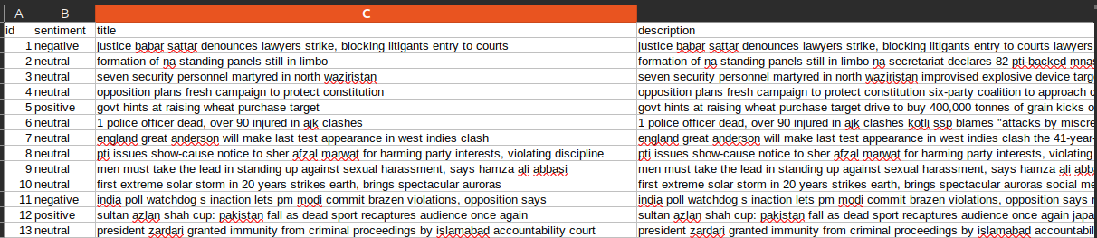
1. CSV file created after DAG run
2. Google Drive Folder:
https://drive.google.com/drive/u/1/folders/11mmC-ZG7wlXiN3VaoiBm2iVyFMeTkydA

3. Airflow History
