Software Requirements and Design Document

for

Railway Management System

**Muhammad Subhan(20I0873) - Jawad Ahmed(20I0945)**



**Nov 27,2022**

**Table of Contents**

**Table of Contents ii**

**1.** **Introduction 1**

1.1 Purpose 1

1.2 Product Scope 1

1.3 Title 1

1.4 Objectives 1

1.5 Problem Statement 1

**2.** **Overall Description 1**

2.1 Product Perspective 1

2.2 Product Functions 2

2.3 List of Use Cases 2

2.4 Extended Use Cases 2

2.5 Use Case Diagram 2

**3.** **Other Nonfunctional Requirements 2**

3.1 Performance Requirements 2

3.2 Safety Requirements 2

3.3 Security Requirements 2

3.4 Software Quality Attributes 2

3.5 Business Rules 3

3.6 Operating Environment 3

3.7 User Interfaces 3

**4.** **Domain Model 3**

**5.** **System Sequence Diagram 3**

**6.** **Sequence Diagram 3**

**7.** **Class Diagram 4**

**8.** **Package Diagram 4**

**9.** **Deployment Diagram 4**

# Introduction

## Purpose

*<Identify the product whose software requirements are specified in this document, including the revision or release number. Describe the scope of the product that is covered by this SRS, particularly if this SRS describes only part of the system or a single subsystem.>*

## Product Scope

*<Provide a short description of the software being specified and its purpose, including relevant benefits, objectives, and goals. Relate the software to corporate goals or business strategies. If a separate vision and scope document is available, refer to it rather than duplicating its contents here.>*

## Title

*Railway Management System*

## Objectives

Some worthiest objectives of Railway Management System are:

To efficiently manage time and resources

To enhance the customer experience

To encourage more people to use Railway Services

To reduce the operational costs

To have greater consistency in the quality of products and services

To have more regulations of regular practices

To have better internal and external communications

## Problem Statement

Pakistan Railway is one of the largest institution of Pakistan which has been providing services and assistance to many people across the country for many years since its inception.

Many problems are faced by the passengers at the Railways Stations including Late arrival of train, Poor behavior of staff members, theft of tickets and inadequate facilities for passengers had urged a need of developing a centralized system for Pakistan Railway System.

The biggest problem that is addressed by this project is providing an extensive architecture for managing the customers, train schedules, Ticket reservation and employee management.

This will facilitate the customers in interacting with the organization. This

project also focuses on productivity by eliminating the time-consuming process. This

integrated system will give the organization the access to Large data and analytics,

enabling them to make accurate decisions.

# Overall Description

## Product Perspective

*<Describe the context and origin of the product being specified in this SRS. For example, state whether this product is a follow-on member of a product family, a replacement for certain existing systems, or a new, self-contained product. If the SRS defines a component of a larger system, relate the requirements of the larger system to the functionality of this software and identify interfaces between the two. A simple diagram that shows the major components of the overall system, subsystem interconnections, and external interfaces can be helpful.>*

## Product Functions

*<Summarize the major functions the product must perform or must let the user perform. Details will be provided in Section 3, so only a high-level summary (such as a bullet list) is needed here. Organize the functions to make them understandable to any reader of the SRS. A picture of the major groups of related requirements and how they relate, such as a top-level data flow diagram or object class diagram, is often effective.>*

## List of Use Cases

|  | **Use Case Name** | **Description** | **User** | **Member** |
| --- | --- | --- | --- | --- |
| 1 | Check Schedule | Customer can check schedule of train and station | Customer | Subhan |
| 2 | Reserve Ticket | Customers can reserve tickets by providing related details | Customer | Jawad |
| 3 | Cancel Ticket | Customer can cancel his already reserved ticket | Customer | Subhan |
| 4 | Calculate Fare | Customers can calculate fare for different journeys | Customer | Jawad |
| 5 | Book Freight | Customer either individual or organization can book freight trains for delivery of goods | Customer | Subhan |
| 6 | Manage Schedule | Admin can manage schedule of trains | Administrator | Jawad |
| 7 | Manage Train | Admin can add/remove and update train information. Admin can also add new trains and remove existing ones. | Administrator | Subhan |
| 8 | Manage Station | Admin can add/remove and update the stations | Administrator | Jawad |
| 9. | Register Account | Customer  can register the account | Customer | Jawad |

## *Extended Use Cases*

|  |  |
| --- | --- |
| **Use Case Name** | **Check Schedule** |
| **Scope** | RMS |
| **User Level** | User goal |
| **Primary Actor** | Customer |
| **Stakeholders and Interests** | Customer wants fast and accurate information about the schedule. |
| **Preconditions** | Customer must be registered and  logged in. |
| **Postconditions** |  |
| **Main Success Scenario** | |  |  | | --- | --- | | Actor Action | System Response | | 1. Customer selects a particular station from the list. 2. Customer clicks show schedule. | 1. System displays the schedule of that particular station. | |
| **Extensions** | 1.Customer is not logged in.   1. System redirects user to login page   2.Customer clicks show schedule without selecting options   1. System does not proceeds and return error statement |

|  |  |
| --- | --- |
| **Use Case Name** | **Cancel Ticket** |
| **Scope** | RMS |
| **User Level** | User goal |
| **Primary Actor** | Customer |
| **Stakeholders and Interests** | * Customer: wants refund as soon as possible without any errors. * Administrator: wants the ticket to be available to others and the amount to be refunded quickly. |
| **Preconditions** | 1. Customer must be registered and logged in. 2. Customer must have a reserved seat. 3. Customer has paid for his seat. 4. The ticket has not expired. |
| **Postconditions** | 1. The ticket is available to others. 2. Amount is refunded to the customer. 3. Event is logged in the database. |
| **Main Success Scenario** | |  |  | | --- | --- | | Actor Action | System Response | | 1. Customer enters his ticket number and other details.            4.  Customer confirms to cancel ticket. | 2.   System checks the ticket number and validates the customer ticket.        3.   System asks for customer confirmation.         5.  System cancels the ticket and refunds the amount.         6.  System records event into database |   . |
| **Extensions** | 1. Customer is not logged in. 2. System redirects user to login page 3. The Entered Ticket was not reserved by the customer. 4. System shows an error and asks the customer to check the ticket number. 5. Ticket is expired 6. System notifies customer |

|  |  |
| --- | --- |
| **Use Case Name** | **Book Freight** |
| **Scope** | RMS |
| **User Level** | User goal |
| **Primary Actor** | Customer |
| **Stakeholders and Interests** | * Customer wants accurate information and confirmation of his booking * Admin wants valid data entry |
| **Preconditions** | 1. Customer must be registered and logged in. 2. Freight services are available 3. Customer has legal papers for his freight |
| **Postconditions** | 1. Freight is booked and reserved 2. Data is maintained in database 3. Customer has a digital receipt |
| **Main Success Scenario** | |  |  | | --- | --- | | Actor Action | System Response | | 1. Customer selects type of freight from supported freight list 2. Customer enter an estimated weight of freight 3. Customer select destination and source 5. Customer selects train according to his schedule 7. Customer enters payment details | 4. System generates list of available freight trains    6.System verifies information and asks for payment  8.   System deducts amount and notifies customer  9.   System generates digital receipt  10. System updates database | |
| **Extensions** | 1. Customer is not logged in. 2. System redirects user to login page 3. Payment errors 4. System inform the customer about any payment issues 5. Entered Weight is out of bound and not supported 6. System informs customer about problem |

|  |  |
| --- | --- |
| **Use Case Name** | **Manage Train** |
| **Scope** | RMS |
| **User Level** | User goal |
| **Primary Actor** | Administrator |
| **Stakeholders and Interests** | * Admin wants accurate and fast entry of data. |
| **Preconditions** | * Administrator must be authenticated and  logged in. |
| **Postconditions** | Train is available to be scheduled   1. Database is updated |
| **Main Success Scenario** | |  |  | | --- | --- | | Actor Action | System Response | | 1. Admin enters details of train | 1. System verifies information 2. System updates database and notifies admin | |
| **Extensions** | 1. Admin is not logged in. 2. System redirects user to login page          2.   Entered details are not valid.                     a.    System notifies admin |

|  |  |
| --- | --- |
| **Use Case Name** | **Reserve Ticket** |
| **Scope** | RMS |
| **User Level** | User goal |
| **Primary Actor** | Customer |
| **Preconditions** | 1. Customer must be Registered and logged in to the system. 2. Customer has a verified payment method linked to his account. 3. Tickets are available |
| **Postconditions** | 1. Tickets are reserved. 2. Amount deducted and transferred. 3. Receipts are generated. |
| **Stakeholders and Interests** | * Admin wants no payment error and database integrity. * Customer wants a ticket receipt and confirmation of his seat  without any effort. |
| **Main Success Scenario** | |  |  | | --- | --- | | Actor Action | System Response | | 1. Customer selects source and destination 2. Customer selects train 3. Customer selects class 4. Customer enters number of seats and berth 5. Customer confirms his choice.             9.  Customer selects payment method | 1. System verifies train and schedule 2. System check availability of seats 3. System asks for payment      1. System deducts amount and generates receipts 2. System notifies the customer. 3. System updates database. | |
| **Extensions** | 1.Customer is not logged in.      a.System redirects user to login page        2.Train does not has particular instance                   a.System notifies the Customer to change that particular instance                   b.System otherwise cancels the ticket        3.Seats are not available      a.System report the Customer regarding unavailability of seats      b.System will provide an alternative solution for this problem.        4.Payment errors                  a.System inform the customer about any payment issues |

|  |  |
| --- | --- |
| **Use Case Name** | **Calculate Fare** |
| **Scope** | RMS |
| **User Level** | User goal |
| **Primary Actor** | Customer |
| **Preconditions** | 1.Customer must be Registered and logged in to the system.       2.Tickets are available |
| **Postconditions** | 1.Customer successfully calculated fare between stations |
| **Stakeholders and Interests** | Customer wants to calculate fare distribution among different stations and cities |
| **Main Success Scenario** | |  |  | | --- | --- | | Actor Action | System Response | | 1.Customer selects the source and       destination among different stations.       2.Customer selects the train type       3.Customer select the No. of seats for reservation | 4.  System provide the calculated fare based on above directions | |
| **Extensions** | 1.Train does not has particular instance                   a.System notifies the Customer to change that particular instance       2.Seats are not available      a.System report the Customer regarding unavailability of seats      b.System will provide an alternative solution for this problem.       3. Customers input the wrong information                   a..Direct the Customer to input correct Information |

|  |  |
| --- | --- |
| **Use Case Name** | **Manage Schedule** |
| **Scope** | RMS |
| **User Level** | User goal |
| **Primary Actor** | Administrator |
| **Stakeholders and Interests** | * Admin wants accurate and fast entry of data. |
| **Preconditions** | * Administrator must be authenticated and  logged in. |
| **Postconditions** | 1. Database is updated 2. Customers are notified about Updated Schedule |
| **Main Success Scenario** | |  |  | | --- | --- | | Actor Action | System Response | | 1. Admin selects source and destination station from list of stations 2. Admin selects train from list of available 3. Admin selects dates and time | 1. System updates database and notifies admin | |
| **Extensions** | 1. Admin is not logged in.                      a .   System redirects user to login page         2.   Entered details are not valid.                     a.    System notifies admin         3. Customers are not notified to updated schedule                     a.Customers are updated through Mail or Contact number. |

|  |  |
| --- | --- |
| **Use Case Name** | **Manage Stations** |
| **Scope** | RMS |
| **User Level** | User goal |
| **Primary Actor** | Administrator |
| **Stakeholders and Interests** | Administrator wants a comprehensive framework coordination among the Station Distribution so that Customers can avoid any inconvenience |
| **Preconditions** | * Administrator must be authenticated and  logged in. |
| **Postconditions** | 1. Station is added to system 2. Database is updated |
| **Main Success Scenario** | |  |  | | --- | --- | | Actor Action | System Response | | 1. Admin enters details of station | 3.    System verifies information        4.    System updates database and notifies admin | |
| **Extensions** | 1.Admin is not logged in.        a.   System redirects user to login page        2. Entered details are not valid.                     a.    System notifies admin        3. Customers aren’t notified on updated stations                     a.Customers are updated through Mail or Contact number |

|  |  |
| --- | --- |
| **Use Case Name** | **Register Account** |
| **Scope** | RMS |
| **User Level** | User goal |
| **Primary Actor** | Customer |
| **Stakeholders and Interests** | Customer wants fast creation of account so that he can access his account with ease.  Admin wants fast access of account so that admin can consolidate or centralize the Customer Account. |
| **Preconditions** | Customer has valid legal documents such as CNIC |
| **Postconditions** | 1.Customer account is created            2. Database updated            3. Customer easily access his/her account. |
| **Main Success Scenario** | |  |  | | --- | --- | | Actor Action | System Response | | 1. Person enters his cnic and contact information | 1. System verifies the credentials 2. Account is created and database is updated 3. Customer is notified about the account creation | |
| **Extensions** | 1. Person does not has valid CNIC or Passport Number 2. Account is not created and person is notified          2.  System doesn’t responding        a.The Admin will restart the System and re-enter the credentials. |

## Use Case Diagram

# Other Nonfunctional Requirements

## Performance Requirements

*<If there are performance requirements for the product under various circumstances, state them here and explain their rationale, to help the developers understand the intent and make suitable design choices. Specify the timing relationships for real time systems. Make such requirements as specific as possible. You may need to state performance requirements for individual functional requirements or features.>*

## Safety Requirements

*<Specify those requirements that are concerned with possible loss, damage, or harm that could result from the use of the product. Define any safeguards or actions that must be taken, as well as actions that must be prevented. Refer to any external policies or regulations that state safety issues that affect the product’s design or use. Define any safety certifications that must be satisfied.>*

## Security Requirements

*<Specify any requirements regarding security or privacy issues surrounding use of the product or protection of the data used or created by the product. Define any user identity authentication requirements. Refer to any external policies or regulations containing security issues that affect the product. Define any security or privacy certifications that must be satisfied.>*

## Software Quality Attributes

*<Specify any additional quality characteristics for the product that will be important to either the customers or the developers. Some to consider are: adaptability, availability, correctness, flexibility, interoperability, maintainability, portability, reliability, reusability, robustness, testability, and usability. Write these to be specific, quantitative, and verifiable when possible. At the least, clarify the relative preferences for various attributes, such as ease of use over ease of learning.>*

## Business Rules

*<List any operating principles about the product, such as which individuals or roles can perform which functions under specific circumstances. These are not functional requirements in themselves, but they may imply certain functional requirements to enforce the rules.>*

## Operating Environment

*<Describe the environment in which the software will operate, including the hardware platform, operating system and versions, and any other software components or applications with which it must peacefully coexist.>*

## User Interfaces

*<Describe the logical characteristics of each interface between the software product and the users. This may include sample screen images, any GUI standards or product family style guides that are to be followed, screen layout constraints, standard buttons and functions (e.g., help) that will appear on every screen, keyboard shortcuts, error message display standards, and so on. Define the software components for which a user interface is needed. Details of the user interface design should be documented in a separate user interface specification.>*

# Domain Model

# System Sequence Diagram

1.Check Schedule

**Cancel Ticket:**

**Book Freight:**

**Manage Trains:**

**Jawad Ahmed**

**20I-0945**

**CALCULATE FARE :**

**MANAGE STATIONS:**

**REGISTER ACCOUNT :**

# Sequence Diagram

1.ShowSchedule()

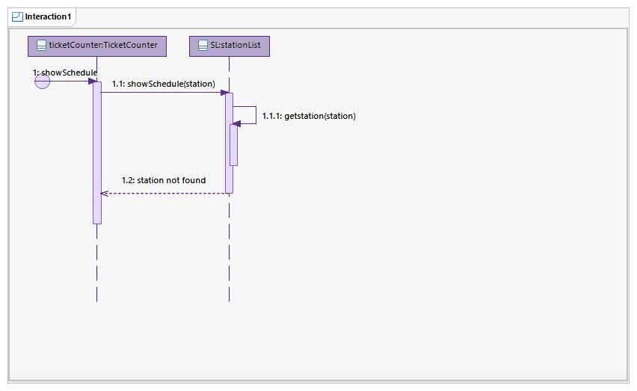

1. 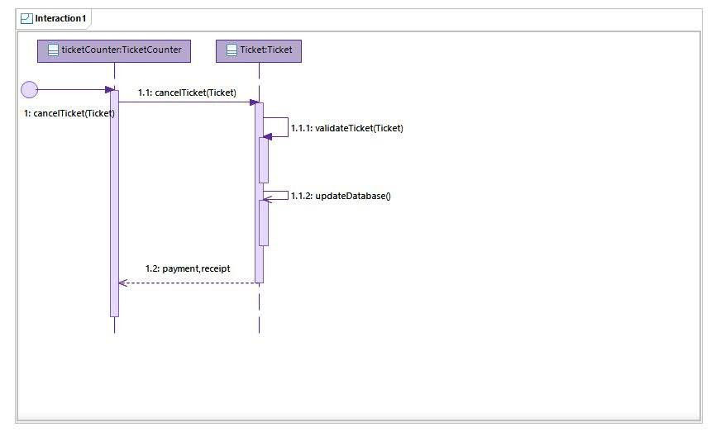**CancelTicket()**

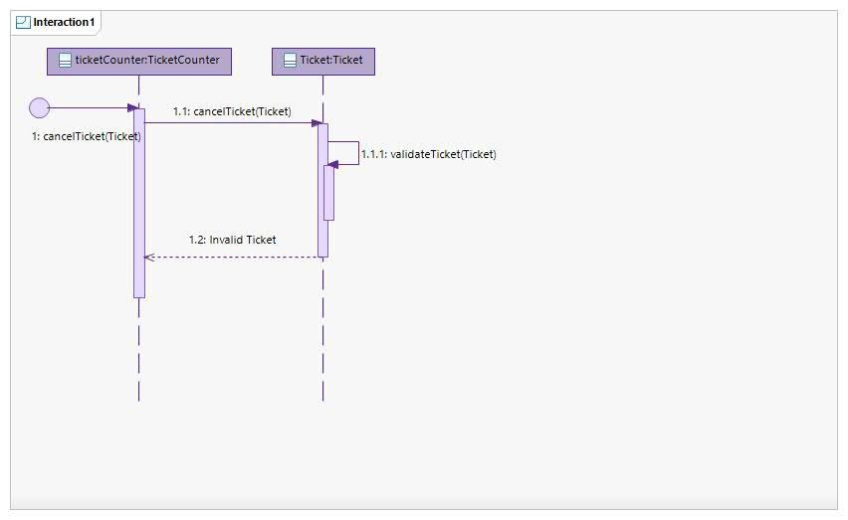

1. 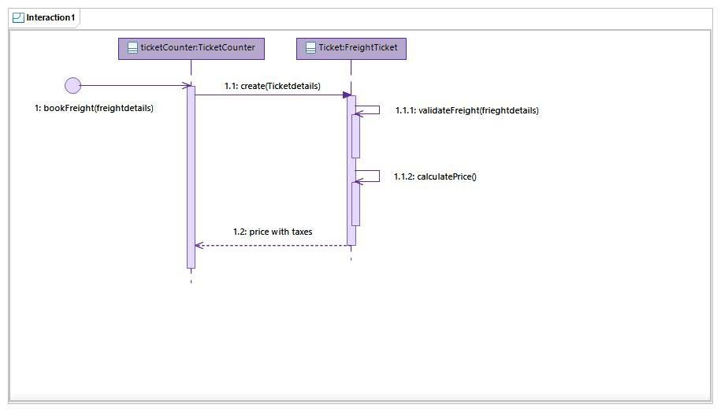**BookFreight()**

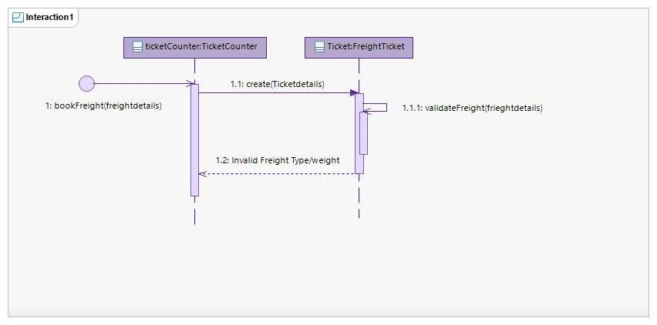

1. 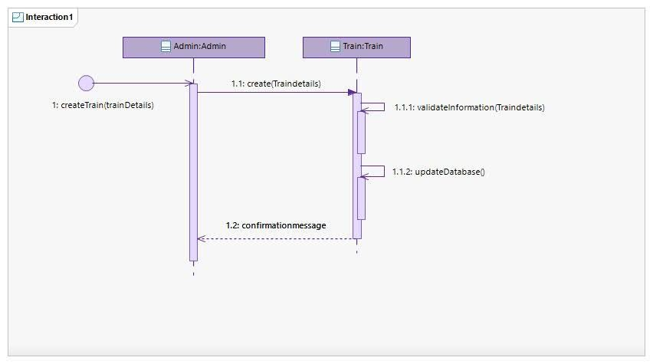**CreateTrain()**
2. **DeleteTrain()**

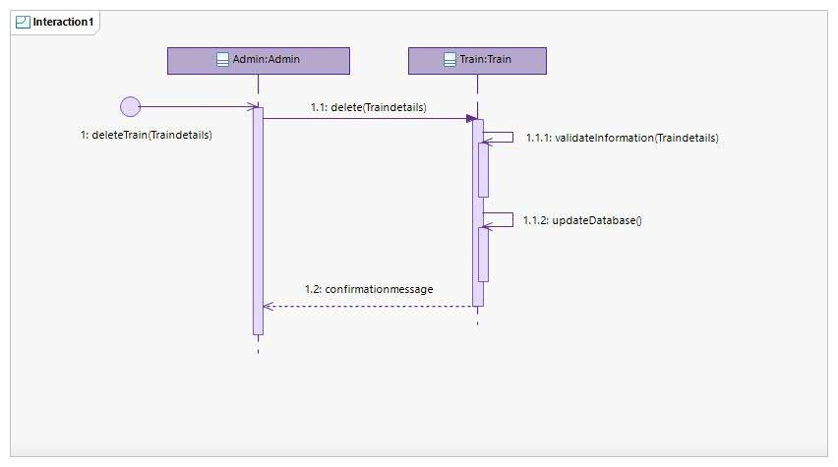

1. 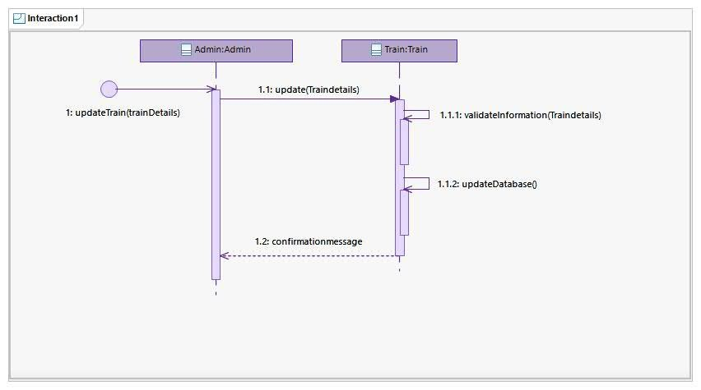**UpdateTrain()**
2. **CalculateFare()**

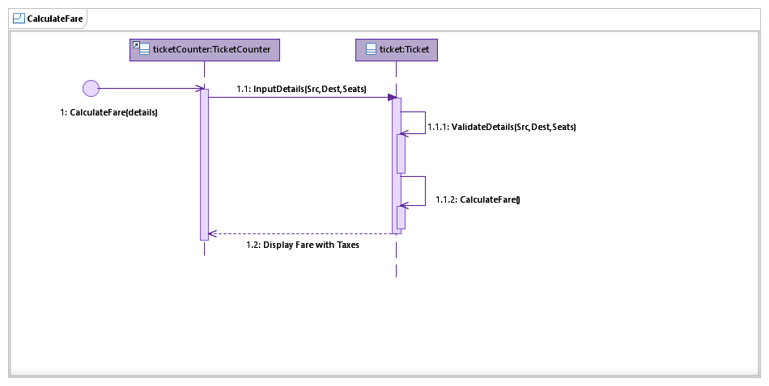

1. **CreateSchedule()**

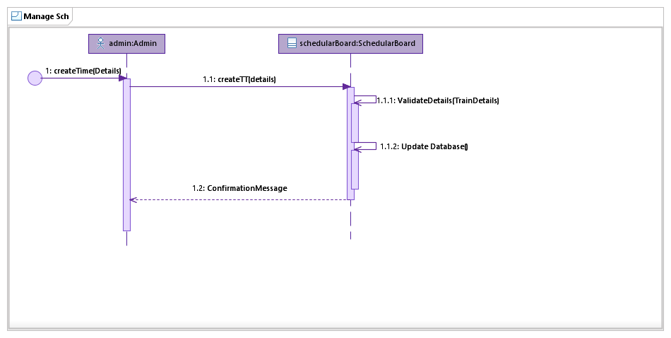

1. **DeleteSchedule()**

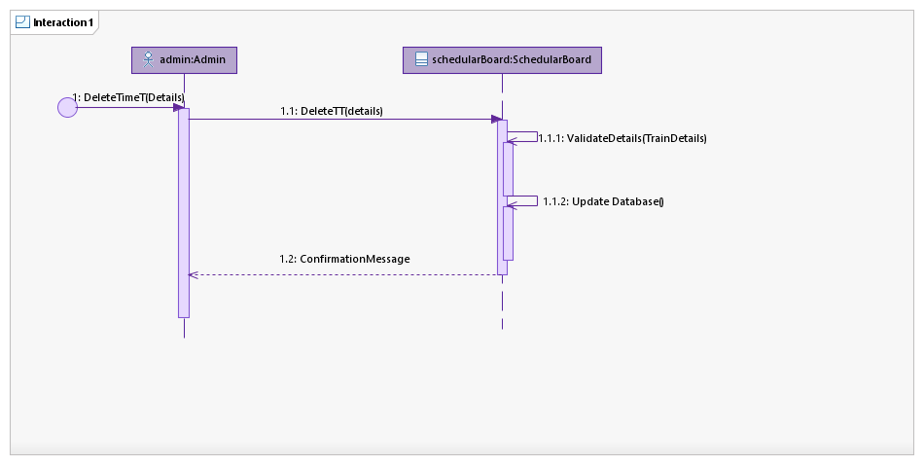

1. **UpdateSchedule()**

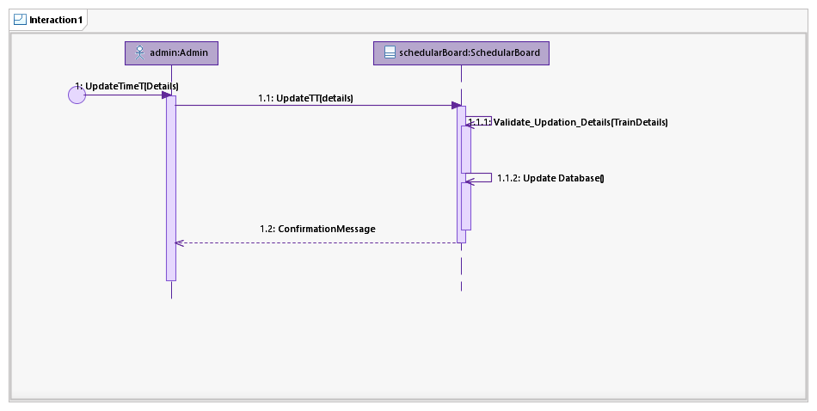

1. **ReserveTicket()**

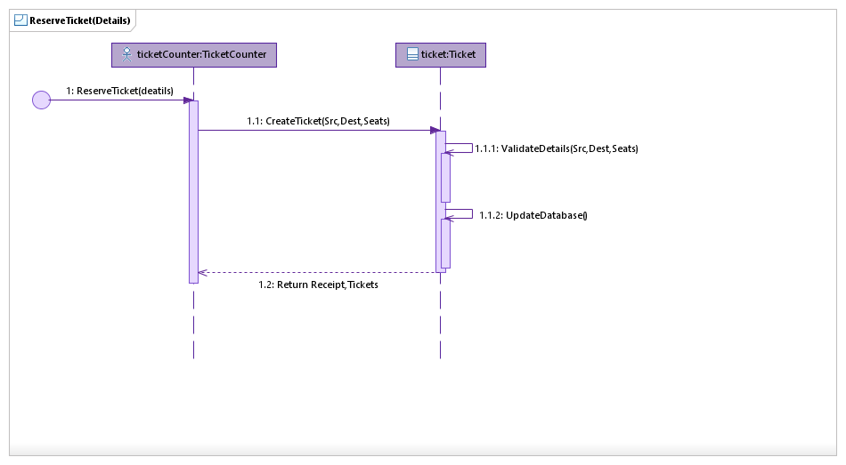

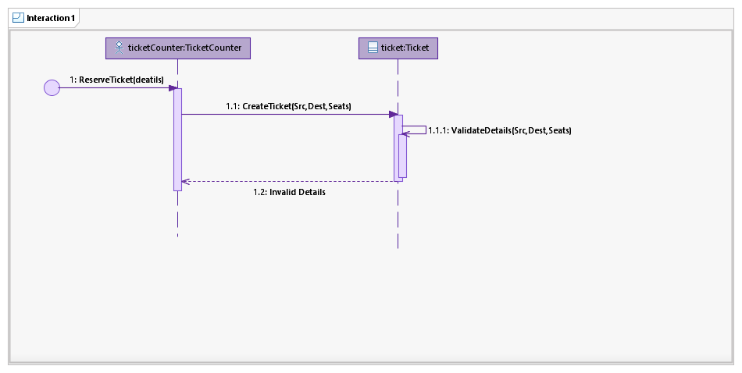

1. **CreateStation()**

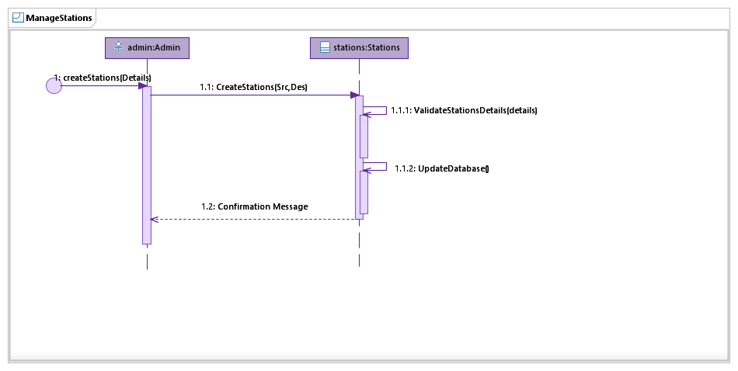

1. **UpdateStation()**

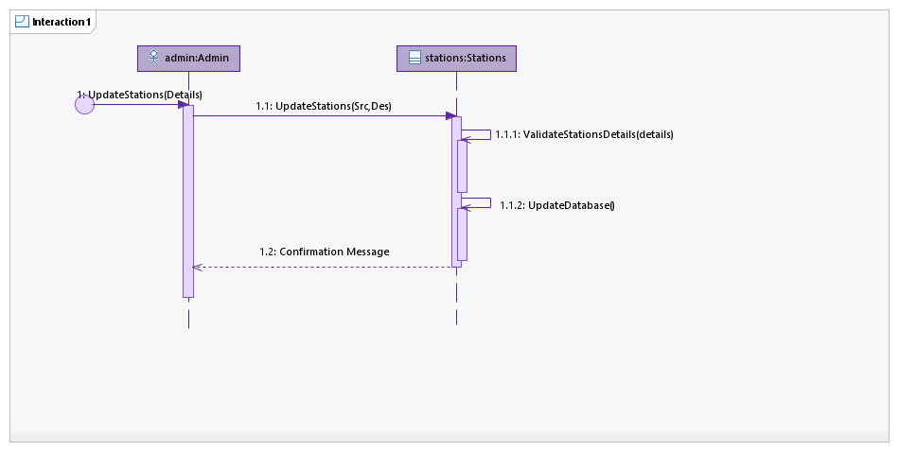

1. **DeleteStation()**

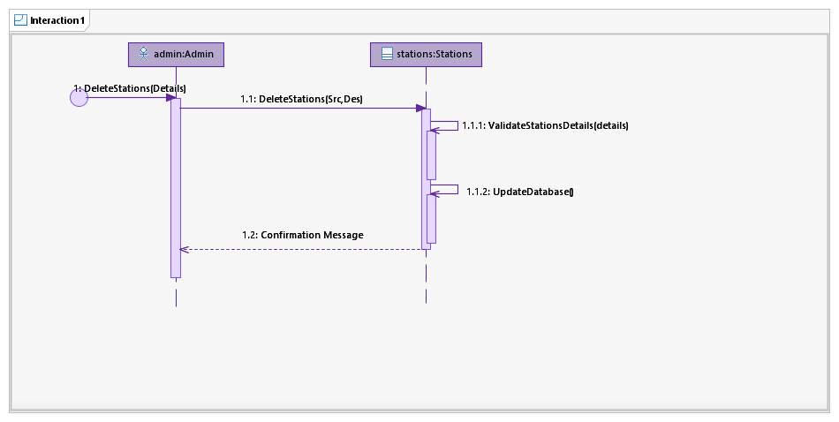

1. **RegisterAccount()**

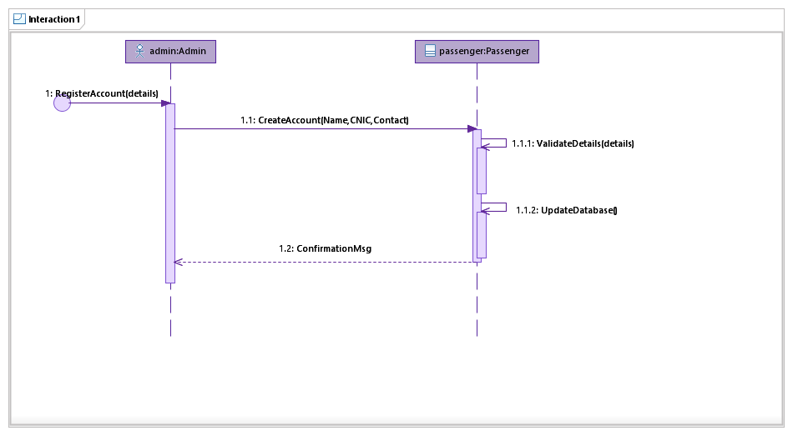

# Diagram Description automatically generatedClass Diagram: