Muhammad Subhan  
Jawad Ahmed  
Rafay Zubair Gill

Sprint 1:  
**Module Developed:** Manage Menu  
**User Stories:** Add Menu, Delete Menu, Update Menu, View Menu

Trello Snapshots:  
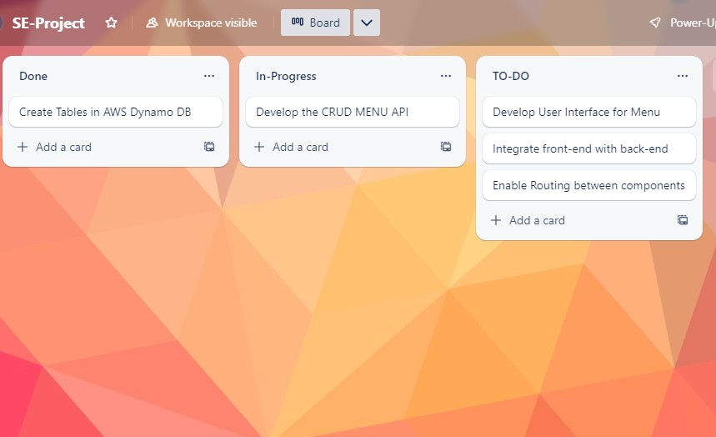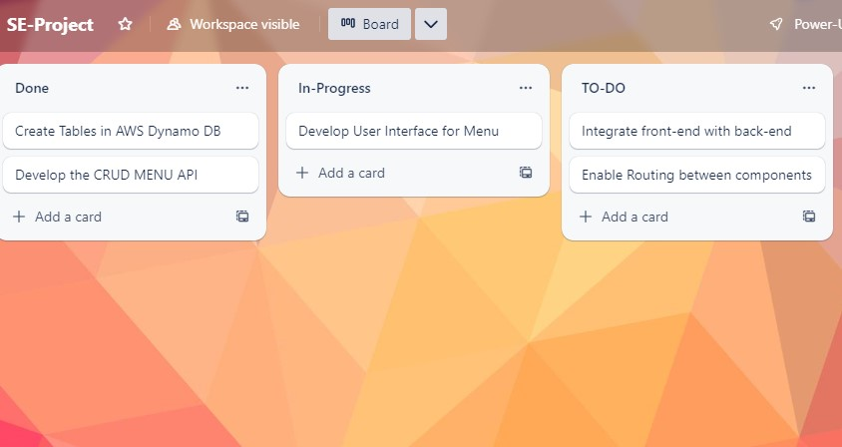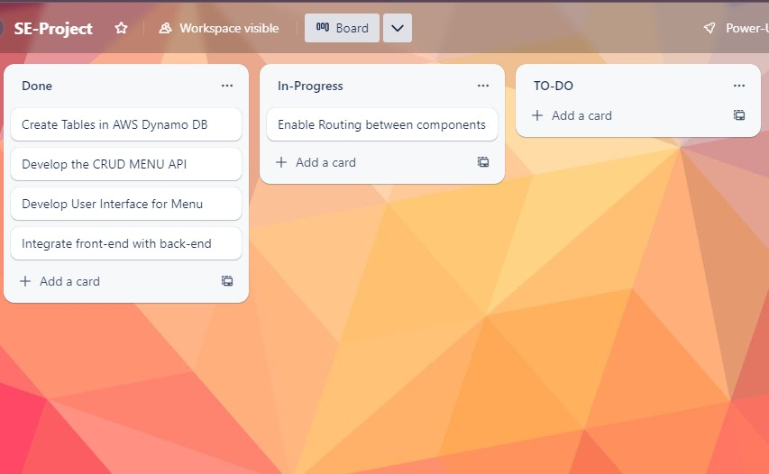

Sprint 2:  
**Module Developed:** Manage Cart  
**User Stories:** Add Item to Cart, Remove Item from Cart

Trello Snapshots:  
