|  |  |
| --- | --- |
|  |  |
| CS3009Software EngineeringDeliverable 3**Spring 2023** |  |
|  |  |
|  | Apr 21,2023Muhammad SubhanRafay Zubair Gill |
|  | Jawad Ahmed |

System Architecture

### Deployment Diagram

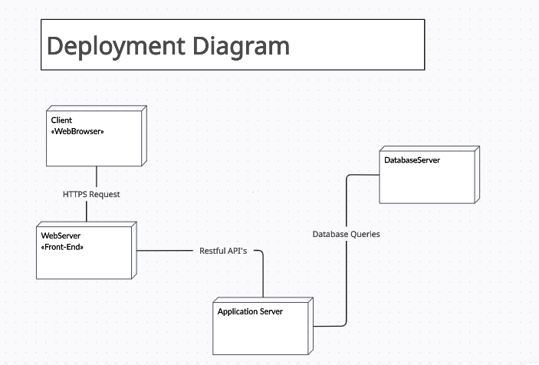

### Component Diagram

