TECD
Tamilnadu Engineering Counselling Database

A mini project report submitted by

Arul.T
Indumathi.R
Jeevitha.S
Maheshwaran.S
Muthunathan.R

In partial fulfillment of the requirements for the award of the
Degree of Bachelor of Engineering in Computer Science and Engineering of Anna University

Under the guidance of

Mrs. P. Sumathi B.E, M.I.S.T.E



DEPARTMENT OF COMPUTER SCIENCE AND ENGINEERING

SONA COLLEGE OF TECHNOLOGY
SALEM – 636 005

OCTOBER 2002

Sona College of Technology, Salem-5

Department of Computer Science and Engineering

PROJECT WORK

Certificate

This is to certify that the contents of the project report entitled as TECD is the bonafide record of work done by Arul.T, Indumathi.R, Jeevitha.S, Maheshwaran.S and Muthunathan.R
Register. No 61801104007, 61801104019, 61801104025, 61801104036, 61801104043 of Department of Computer Science during the academic year 2002-2003.

Head of Department Faculty Guide

Submitted for the university examination held on……………………..

Internal Examiner External Examiner

Successful TECD project is
Dedicated to our parents

Contents
Contents

ACKNOWLEDGEMENT
SYNOPSIS | 1
1.INTRODUCTION
1.1 FEATURES OF THE PROJECT | 4
1.2 CHOICE OF VB AS OUR FRONT END TOOL | 4
2. DATABASE SCHEMA DIAGRAM | 5
3. SYSTEM DESCRIPTION | 7
4. INSIDE OUR PROJECT | 8
5. CONCLUSION | 46
6. BIBILIOGRAPHY | 48

ACKNOWLEDGEMENT

We hereby express our deep sense of gratitude to the Management of Sona College of technology for their kind encouragement bestowed on us to complete this project.

We are grateful to express our sincere thanks to our beloved principal Prof. M. Ramasamy, B.E., M.Sc (Engg.). MISTE, And Vice- Principal Prof. C. Natesan, B.E., Dip. M.Engg., for their cooperation and for providing excellent facilities to do this project.
We also express our sincere thanks to our Head Of the Department
Mrs. Usha M.E., our project coordinator and Guide Mrs. P. Sumathi B.E., MISTE, for their valuable suggestions, encouragement, timely advice and co-operation to do this project in a successful manner.
Also we express our profound and sincere thanks to all the staff members and Lab Technicians of Department of Computer Science and Engineering in our college for their valuable guidance and encouragement given to complete this project. Finally, we thank our beloved parents for their moral and economical support towards our project. We dedicate this work to them.
DATABASE FOR TAMILNADU ENGINEERING COUNSELLING

Abstract

This is the project developed for the perfect database maintenance of the tamilnadu engineering counseling. The project consists of several features which help the user to easily handle the database and the records stored in it in a very easier and in a fast manner.

This project is basically build on Oracle 8i as the database system i.e. as the backend and for the user friendly access Microsoft™ Visual Basic 6.0 is used as the Graphical User Interface i.e. as front end

This database maintains several records such as College list, Course list, Students List etc., these and more records present in the database maintains the corresponding list of the respective record. The College list maintains the list of Colleges affiliated to the university, Course list maintains the list of courses available in those college and so on…

Also some of the important features of this project is Automatic Cut-Off mark processing and Automatic Rank Processing. All these embedded features in this project makes the database to work efficiently and user to interact easily.

Synopsis
Synopsis

This document is a report of the project “Database for Tamilnadu Engineering Counseling”. The project has been developed using
Microsoft® VISUAL BASIC 6.0 as front end tool and Oracle 8 as back-end tool under Microsoft® Windows 2000. The main features behind the project are

- Maintaining large database in an efficient manner
- Maintains student mark list and cut-off mark list
- Maintains the list of colleges available in tamilnadu and courses available in it
- Maintains the eligibility list of candidates to the Engineering counseling sessions.

The whole project is user-friendly and even a novice in computers can handle the database with ease.
The other features are updating of database done very easily, validity of data is maintained throughout the process of counseling and the GUI interface in VB enhances the numerous advantages of the database.

Introduction
Introduction

1.1 FEATURES OF THE PROJECT
This project gives a clear idea of maintaining database for Tamilnadu Engineering Counse This project helps the user to maintain the details of colleges available in Tamilnadu, courses available in each college, no of seats allocated for each college with respect to the courses.
It also maintains the records of students, mark list for each student, Tamilnadu Engineering Entrance mark list, calculates their respective cutoff and their eligibility. Also allocates the rank according to their cutoff with respect to the number of candidates who appeared for the Tamilnadu Engineering Entrance Examination held that year.
This also maintains the joining list of each student in the respective college in the respective course. The project plays a vital role in validating a candidate’s eligibility to the professional courses offered.

  - CHOICE OF VB AS OUR FRONT END TOOL
In VISUAL BASIC application, the user’s actions determine the application’s flow. VB has several hundreds of statements, functions and keywords, many of which relate directly to the Windows GUI. Moreover the properties of the Visual Basic objects can be assigned at design time or at runtime. This is an added advantage of using VB. Thus also VB allows us to create a easy inferface between any of the third party application and to the native application.

Database Schema Diagram
Database Schema Diagram

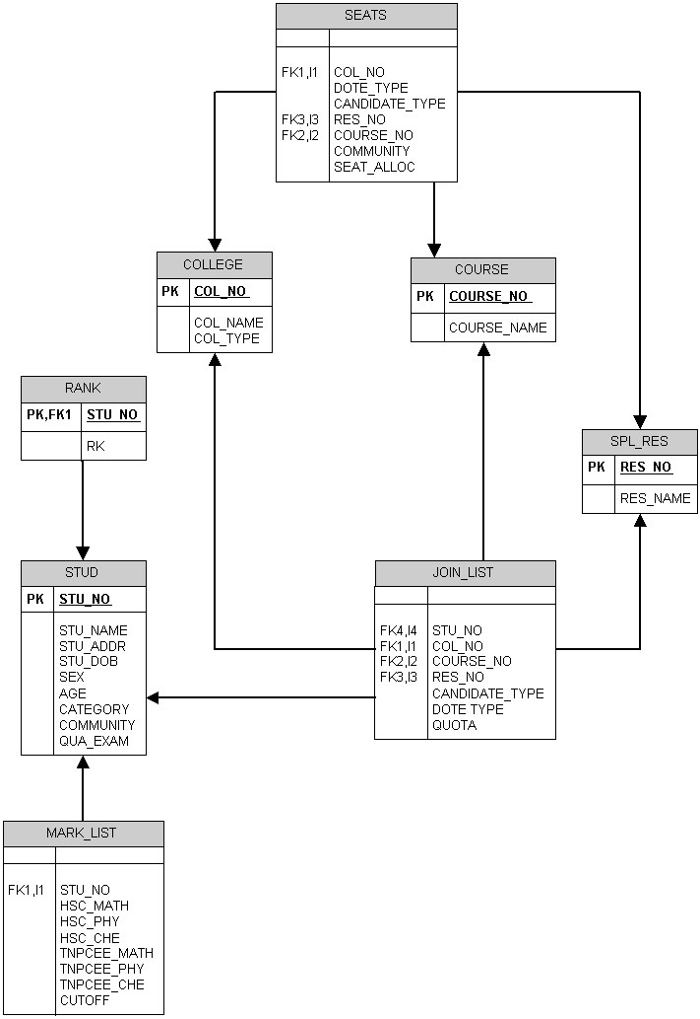
System Description

3.1 Hardware Specifications:

Processor | 650 MHz
SDRAM | 128 MB
Cache | 64 MB
FDD | 1.44”
HD | 30 GB
Monitor | 15” Color Monitor
Keyboard | 108 Keys Wipro Keyboard

3.2 Software Specifications:

Operating System | Microsoft ® Windows 2000
SDK Used | Oracle 8  Microsoft ® Visual Basic 6.0

Inside Our Project Deep Inside Into…
Main Window of the project
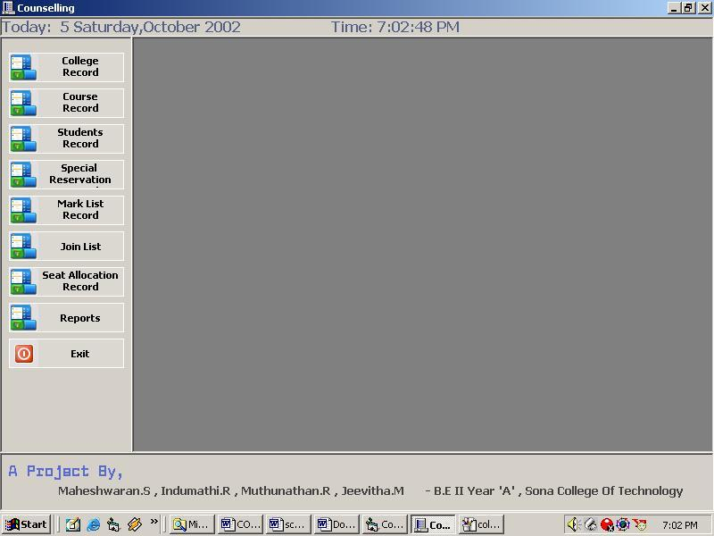

College Register Table

.
College Register Table

College register table has the details of list of colleges that are approved by AICTE and each and every college is registered with a unique id for the easy identification purpose.Those college that are registered in this table are only allowed to allocate seat or used in the student joing list

GUI View:

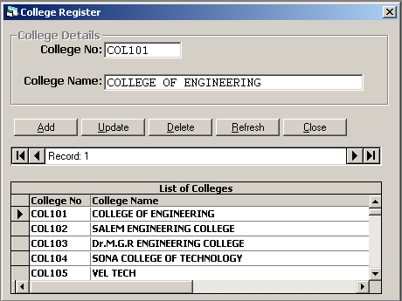

Source Code

Option Explicit

Private Sub Form_Activate()
With DataGrid1
.Columns(0).Width = TextWidth("COL9999999") + 100
.Columns(1).Width = .Width - .Columns(0).Width
End With
Frame1.Enabled = False
End Sub

Private Sub datPrimaryRS_MoveComplete(ByVal adReason As ADODB.EventReasonEnum, ByVal pError As ADODB.Error, adStatus As ADODB.EventStatusEnum, ByVal pRecordset As ADODB.Recordset)
'This will display the current record position for this recordset
datPrimaryRS.Caption = "Record: " & CStr(datPrimaryRS.Recordset.AbsolutePosition)
End Sub

Private Sub cmdAdd_Click()
On Error GoTo AddErr
Frame1.Enabled = True
datPrimaryRS.Recordset.AddNew

Exit Sub
AddErr:
MsgBox Err.Description
End Sub

Private Sub cmdDelete_Click()
On Error GoTo DeleteErr
With datPrimaryRS.Recordset
.Delete
.MoveNext
If .EOF Then .MoveLast
End With
Exit Sub
DeleteErr:
MsgBox Err.Description
End Sub

Private Sub cmdRefresh_Click()
'This is only needed for multi user apps
On Error GoTo RefreshErr
datPrimaryRS.Refresh
Frame1.Enabled = False
Exit Sub
RefreshErr:
MsgBox Err.Description
End Sub

Private Sub cmdUpdate_Click()
On Error GoTo UpdateErr

datPrimaryRS.Recordset.UpdateBatch adAffectAll
Frame1.Enabled = False
Exit Sub
UpdateErr:
MsgBox Err.Description
End Sub

Private Sub cmdClose_Click()
Unload Me
End Sub

Course Register Table

Course Register Table

Course register table has the details of list of courses that are approved by AITCE and each and every courses are registered with the unique course identification number for the fast identification facility. The courses registered here are only used for the future purpose of joining list and seat allocation list.

GUI View:

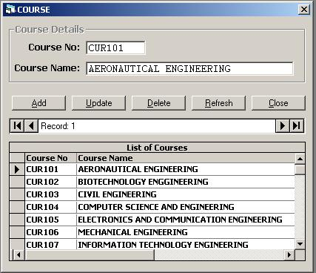

Source Code

Option Explicit

Private Sub cmdAdd_Click()
On Error GoTo AddErr
Frame1.Enabled = True
datPrimaryRS.Recordset.AddNew

Exit Sub
AddErr:
MsgBox Err.Description
End Sub

Private Sub cmdDelete_Click()
On Error GoTo DeleteErr
With datPrimaryRS.Recordset
.Delete
.MoveNext
If .EOF Then .MoveLast
End With
Exit Sub
DeleteErr:
MsgBox Err.Description
End Sub

Private Sub cmdRefresh_Click()
'This is only needed for multi user apps
On Error GoTo RefreshErr
datPrimaryRS.Refresh
Frame1.Enabled = False
Exit Sub
RefreshErr:
MsgBox Err.Description
End Sub

Private Sub cmdUpdate_Click()
On Error GoTo UpdateErr

datPrimaryRS.Recordset.UpdateBatch adAffectAll
Frame1.Enabled = False
Exit Sub
UpdateErr:
MsgBox Err.Description
End Sub

Private Sub cmdClose_Click()
Unload Me
End Sub

Students Record Table

Students Record Table

Students table maintains the details of students who are applied for the engineering counseling. The details of students with their age, address, type of candidate, etc.. Those student who are all have their names entered will have a unique student id or hall ticket number.

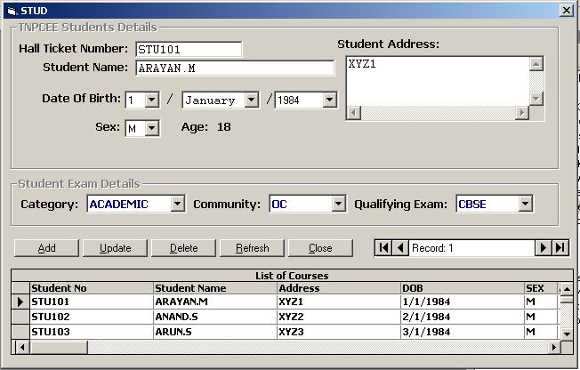
GUI View:

Source Code
Option Explicit
Dim AddNewRec As Boolean

Private Sub Form_Load()
LoadDateList
End Sub

Private Sub datPrimaryRS_MoveComplete(ByVal adReason As ADODB.EventReasonEnum, ByVal pError As ADODB.Error, adStatus As ADODB.EventStatusEnum, ByVal pRecordset As ADODB.Recordset)
Dim d As Integer
'This will display the current record position for this recordset
datPrimaryRS.Caption = "Record: " & CStr(datPrimaryRS.Recordset.AbsolutePosition)
If pRecordset.EOF Then pRecordset.MoveLast
If pRecordset.BOF Then pRecordset.MoveFirst

If Not adReason = adRsnAddNew Then
On Error Resume Next
DTOB.Text = datPrimaryRS.Recordset.Fields("STU_DOB")
'Call Form_Load
LoadDateList
Call setDOB(DatePart("d", DTOB), Month(DTOB), Year(DTOB))
ElseIf adReason = adRsnAddNew Then
DTOB.Text = datPrimaryRS.Recordset.Fields("STU_DOB")
End If

End Sub

Private Sub cmdUpdate_Click()
Dim RecNo As Integer
On Error GoTo UpdateErr
Frame1.Enabled = False
Frame2.Enabled = False
AddNewRec = False
RecNo = 0
RecNo = datPrimaryRS.Recordset.AbsolutePosition
DTOB.Text = day.Text & "/" & Month("1/" & mon.Text & "/" & yr.Text) & "/" & yr.Text
stu_Age.Caption = CalcAge(Date, CDate(DTOB))
datPrimaryRS.Recordset.UpdateBatch adAffectAll
datPrimaryRS.Refresh
datPrimaryRS.Recordset.Move RecNo - 1
Exit Sub
UpdateErr:
MsgBox Err.Description
End Sub

Function getDaysOfMonth(Index As Integer, Y As Integer) As Integer
Select Case Index
Case 2:
If isLeapYear(Y) Then
getDaysOfMonth = 29
Else
getDaysOfMonth = 28
End If
Case 1, 3, 5, 7, 8, 10, 12:
getDaysOfMonth = 31
Case 4, 6, 9, 11:
getDaysOfMonth = 30
End Select

End Function

Function isLeapYear(Y As Integer) As Boolean

isLeapYear = ((Y Mod 4 = 0 Or Y Mod 400 = 0) And Y Mod 100 <> 0)

End Function

Sub MonList()
Dim i As Integer
mon.Clear

For i = 1 To 12
mon.AddItem MonthName(i)
Next i
mon.Text = MonthName(Month(CDate(DTOB)))
End Sub

Sub DayList(Index As Integer, Y As Integer)
Dim i As Integer

day.Clear
For i = 1 To getDaysOfMonth(Index, Y)
day.AddItem i
Next i
day.Text = DatePart("d", DTOB)
End Sub

Sub YearList()
Dim i As Integer, CurYear As Integer, DOB As Variant

DOB = Now
yr.Clear
CurYear = CInt(Year(DTOB))

For i = CurYear - 2 To CurYear + 7
yr.AddItem i
Next i

yr.Text = Year(CDate(DTOB))
End Sub

Private Sub mon_Change()
If Not AddNewRec Then
Call DayList(mon.ListIndex + 1, yr.List(yr.ListIndex))
End If
End Sub

Private Sub mon_Click()
If Not AddNewRec Then
Call DayList(mon.ListIndex + 1, yr.List(yr.ListIndex))
End If
End Sub
Sub setDOB(d As Integer, m As Integer, Y As Integer)
day.Text = d
mon.Text = mon.List(m - 1)
yr.Text = Y
End Sub
Function CalcAge(CurDate As Date, DOB As Date) As Integer
CalcAge = DateDiff("yyyy", DOB, CurDate)
End Function

Sub LoadDateList()
YearList
MonList
Call DayList(mon.ListIndex + 1, yr.List(yr.ListIndex))
End Sub

Special Reservation Table

Special Reservation Table

Special Reservation table has the record entries for the list of special reservation available in whole of tamilnadu and for other state and countries candidate.Special reservation table has entries of the reservation name with an unique reservation number which is being used in the database to identify the records of particular reservation.

GUI View:

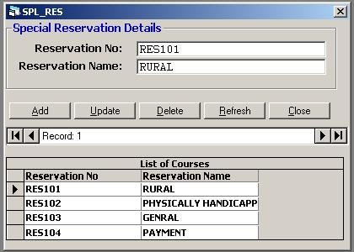
Source Code

Option Explicit

Private Sub cmdAdd_Click()
On Error GoTo AddErr
Frame1.Enabled = True
datPrimaryRS.Recordset.AddNew

Exit Sub
AddErr:
MsgBox Err.Description
End Sub

Private Sub cmdDelete_Click()
On Error GoTo DeleteErr
With datPrimaryRS.Recordset
.Delete
.MoveNext
If .EOF Then .MoveLast
End With
Exit Sub
DeleteErr:
MsgBox Err.Description
End Sub

Private Sub cmdRefresh_Click()
'This is only needed for multi user apps
On Error GoTo RefreshErr
Frame1.Enabled = False
datPrimaryRS.Refresh
Exit Sub
RefreshErr:
MsgBox Err.Description
End Sub

Private Sub cmdUpdate_Click()
On Error GoTo UpdateErr
Frame1.Enabled = False

datPrimaryRS.Recordset.UpdateBatch adAffectAll
Exit Sub
UpdateErr:
MsgBox Err.Description
End Sub

Private Sub cmdClose_Click()
Unload Me
End Sub

Mark List Register Table
Mark List Register Table

Mark List Register is very helpful for maintaing the marks of the students who are already registered their name. This record maintains the students TNPCEE mark and their Higher Secondary or Equivalent Exam Mark.This automatically calculates the student cutoff mark and stores in the register.

GUI View:

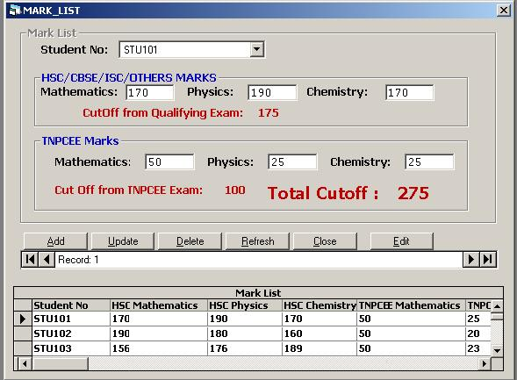

Source Code

Option Explicit

Dim StuNum As String
Dim AddNewRec As Boolean
Dim EditRec As Boolean

Private Sub Command1_Click()
EditRec = Not EditRec

If EditRec Then
Frame1.Enabled = True
Else
Frame1.Enabled = False
End If
End Sub

Private Sub DataCombo1_Click(Area As Integer)
If Not AddNewRec Then
datPrimaryRS.Recordset.Find "stu_no = " & "'" & DataCombo1.Text & "'"
End If
End Sub

Private Sub cmdUpdate_Click()
On Error GoTo ErrList
Dim ErrMsg As String
Dim ErrFound As Boolean

AddNewRec = False

If Not (txtFields(0) >= 0 And txtFields(0) <= 200) Then
ErrMsg = "ACADEMIC Maths Mark is Invalid >=0 and <= 200" & vbCrLf
ErrFound = True
End If

If Not (txtFields(1) >= 0 And txtFields(1) <= 200) Then
ErrMsg = ErrMsg & "ACADEMIC Physics Mark is Invalid >=0 and <= 200" & vbCrLf
ErrFound = True
End If

If Not (txtFields(2) >= 0 And txtFields(2) <= 200) Then
ErrMsg = ErrMsg & "ACADEMIC Chemistry Mark is Invalid >=0 and <= 200" & vbCrLf
ErrFound = True
End If

If Not (txtFields(4) >= 0 And txtFields(4) <= 50) Then
ErrMsg = ErrMsg & "TNPCEE Maths Mark is Invalid >=0 and <= 200" & vbCrLf
ErrFound = True
End If

If Not (txtFields(5) >= 0 And txtFields(5) <= 25) Then
ErrMsg = ErrMsg & "TNPCEE Physics Mark is Invalid >=0 and <= 200" & vbCrLf
ErrFound = True
End If

If Not (txtFields(6) >= 0 And txtFields(6) <= 25) Then
ErrMsg = ErrMsg & "TNPCEE Chemistry is Invalid >=0 and <= 200" & vbCrLf
ErrFound = True
End If
If ErrFound Then Err.Raise 101
datPrimaryRS.Recordset.UpdateBatch adAffectAll
EditRec = False
Frame1.Enabled = False
Exit Sub
ErrList:
MsgBox ErrMsg, , "Mark List"
End Sub

Private Sub cmdClose_Click()
Unload Me
End Sub

Private Sub Timer1_Timer()
On Error Resume Next
CalculateCutOff
End Sub
Sub CalculateCutOff()
mark(3).Caption = CStr(CInt(txtFields(0)) / 2 + CInt(txtFields(1)) / 4 + CInt(txtFields(2)) / 4)
mark(4).Caption = CStr(CInt(txtFields(4)) + CInt(txtFields(5)) + CInt(txtFields(6)))
mark(5).Caption = CStr(CInt(mark(3).Caption) + CInt(mark(4).Caption))
End Sub
Sub CheckMark()
End Sub

Join List Register Table
Joing List Register Table

Join List Register is very helpful for the students to joing in their respective college and course of their wish. This also allows the student to join in their respective dote and in their quota.This table list the students number who are not still joined any college, and this list the courses and details of the college selected by the student.

GUI View:

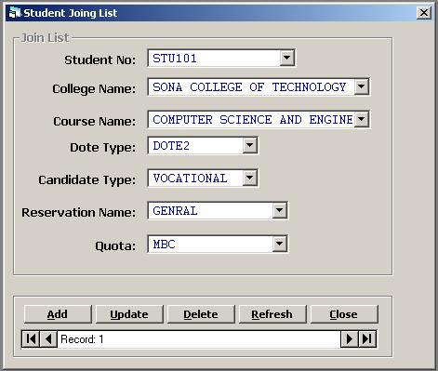

Source Code

Option Explicit
Dim AddRec As Boolean

Private Sub Command1_Click()

End Sub

Private Sub DataCombo1_Click(Area As Integer)
Dim QryStr As String

QryStr = "SELECT COURSE_NAME,COURSE_NO FROM COURSE WHERE COURSE_NO IN " & _
"(SELECT COURSE_NO FROM SEATS WHERE COL_NO LIKE '" & getCollegeNo(DataCombo1.Text) & "')"

ListCourse (QryStr)
End Sub

Private Sub DataCombo2_Click(Area As Integer)

Dim QryStr As String
QryStr = "SELECT DISTINCT DOTE_TYPE FROM SEATS WHERE " & _
"COL_NO = '" & getCollegeNo(DataCombo1.Text) & "' AND " & _
"COURSE_NO = '" & getCourseNo(DataCombo2.Text) & "'"

ListDoteType (QryStr)
End Sub

Private Sub DataCombo3_Click(Area As Integer)
Dim QryStr As String
QryStr = "SELECT DISTINCT COMMUNITY FROM SEATS WHERE " & _
"COL_NO LIKE '" & getCollegeNo(DataCombo1.Text) & "' AND " & _
"COURSE_NO LIKE '" & getCourseNo(DataCombo2.Text) & "' AND " & _
"DOTE_TYPE LIKE '" & DataCombo6.Text & "' AND " & _
"CANDIDATE_TYPE LIKE '" & DataCombo7.Text & "' AND " & _
"RES_NO = '" & getResNo(DataCombo3.Text) & "'"

ListQuota (QryStr)

End Sub

Private Sub DataCombo6_Click(Area As Integer)
Dim QryStr As String

QryStr = "SELECT DISTINCT CANDIDATE_TYPE FROM SEATS WHERE " & _
" COL_NO = '" & getCollegeNo(DataCombo1.Text) & "' AND" & _
" COURSE_NO = '" & getCourseNo(DataCombo2.Text) & "' AND DOTE_TYPE = '" & DataCombo6.Text & "'"
ListCandidateType (QryStr)
End Sub

Private Sub DataCombo7_Click(Area As Integer)
Dim QryStr As String

QryStr = "SELECT RES_NAME,RES_NO FROM SPL_RES WHERE RES_NO IN (SELECT RES_NO FROM SEATS WHERE " & _
"COL_NO LIKE '" & getCollegeNo(DataCombo1.Text) & "' AND " & _
"COURSE_NO LIKE '" & getCourseNo(DataCombo2.Text) & "' AND " & _
"DOTE_TYPE LIKE '" & DataCombo6.Text & "' AND " & _
"CANDIDATE_TYPE LIKE '" & DataCombo7.Text & "')"

ListReservation (QryStr)

End Sub

Private Sub Form_Activate()
Dim QryStr As String

CheckSeats
QryStr = "SELECT COURSE_NAME,COURSE_NO FROM COURSE WHERE COURSE_NO IN " & _
"(select course_no from seats where col_no in " & _
"(select col_no from college where col_name like " & _
"'" & DataCombo1.Text & "'" & "))"

ListCourse (QryStr)

End Sub

Private Sub cmdDelete_Click()
On Error GoTo DeleteErr
Dim LastPos As Integer
With datPrimaryRS.Recordset
.Delete
.MoveNext
If .EOF Then .MoveLast
End With
CollegeName.Refresh
CourseName.Refresh
Adodc1.Refresh
Call cmdRefresh_Click

Exit Sub
DeleteErr:
MsgBox Err.Description
End Sub

Private Sub cmdRefresh_Click()
'This is only needed for multi user apps
On Error GoTo RefreshErr
datPrimaryRS.Refresh
DataCombo4.Visible = True
DataCombo5.Visible = False
Frame2.Enabled = False
Dim Qry As String

Qry = "SELECT COURSE_NAME,COURSE_NO FROM COURSE WHERE COURSE_NO IN " & _
"(select course_no from seats where col_no in " & _
"(select col_no from college where col_name like " & _
"'" & DataCombo1.Text & "'" & "))"

ListCourse (Qry)

Exit Sub
RefreshErr:
MsgBox Err.Description
End Sub

Private Sub cmdUpdate_Click()
On Error GoTo UpdateErr

datPrimaryRS.Recordset.UpdateBatch adAffectAll
UpdateSeats

DataCombo4.Visible = True
DataCombo5.Visible = False

AddRec = False
Adodc1.Refresh
Frame2.Enabled = False
Exit Sub
UpdateErr:
MsgBox Err.Description
End Sub

Sub ListDoteType(Qry)
Dote.RecordSource = Qry
Dote.Recordset.Requery
Dote.Refresh
End Sub
Sub ListCandidateType(Qry)
Candi.RecordSource = Qry
Candi.Recordset.Requery
Candi.Refresh
End Sub
Sub ListReservation(Qry)
On Error Resume Next
With ResName
.RecordSource = Qry
.Recordset.Requery
.Refresh
End With
End Sub
Sub ListQuota(Qry)
On Error Resume Next
With Quota
.RecordSource = Qry
.Recordset.Requery
.Refresh
End With
End Sub

Sub ListCourse(Qry)

CourseName.RecordSource = Qry
CourseName.Refresh
DataCombo2.Refresh

End Sub

Sub UpdateSeats()
Dim findStr As String
Dim Rs As Recordset
findStr = "COL_NO LIKE '" & getCollegeNo(DataCombo1.Text) & "' AND "
findStr = findStr & "COURSE_NO LIKE '" & getCourseNo(DataCombo2.Text) & "' AND "
findStr = findStr & "DOTE_TYPE LIKE '" & DataCombo6.Text & "' AND "
findStr = findStr & "CANDIDATE_TYPE LIKE '" & DataCombo7.Text & "' AND "
findStr = findStr & "RES_NO LIKE '" & getResNo(DataCombo3.Text) & "' AND "
findStr = findStr & "COMMUNITY LIKE'" & DataCombo8.Text & "'"

CheckSeats

With DataEnvironment1.Connection1
.Execute "UPDATE SEATS SET SEAT_ALLOC = SEAT_ALLOC - 1 WHERE " & _
findStr
End With

End Sub

Seat Allocation Table
Seat Allocation Table

Seat allocation table is used to allocate seats for a particular college.The seat allocation is done based on the Courses available, dote type, candidate type, any special reservation and on based on college type.This lists the college and course name that have been already entered or register in the respective table.And same for the special reservation too.

GUI View:

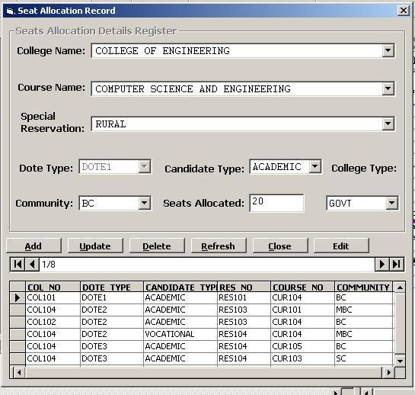

Source Code

Option Explicit

Dim AddNewRec As Boolean
Dim EditRec As Boolean

Private Sub Adodc1_MoveComplete(ByVal adReason As ADODB.EventReasonEnum, ByVal pError As ADODB.Error, adStatus As ADODB.EventStatusEnum, ByVal pRecordset As ADODB.Recordset)
Adodc1.Caption = pRecordset.AbsolutePosition & "/" & pRecordset.RecordCount

If pRecordset.EOF Then pRecordset.MoveLast
If pRecordset.BOF Then pRecordset.MoveFirst
End Sub

Private Sub cmdAdd_Click()
Adodc1.Recordset.AddNew
AddNewRec = True
Frame1.Enabled = True

End Sub

Private Sub cmdClose_Click()
Unload Me
End Sub

Private Sub cmdDelete_Click()
On Error GoTo DeleteErr
With Adodc1.Recordset
.Delete
.MoveNext
If .EOF Then .MoveLast
End With
Exit Sub
DeleteErr:
MsgBox Err.Description

End Sub

Private Sub cmdRefresh_Click()
'This is only needed for multi user apps
On Error GoTo RefreshErr
Adodc1.Refresh
Frame1.Enabled = False
Exit Sub
RefreshErr:
MsgBox Err.Description

End Sub

Private Sub cmdUpdate_Click()
Adodc1.Recordset.UpdateBatch adAffectAllChapters
AddNewRec = False
EditRec = False
Command3.Caption = "Edit"
Frame1.Enabled = False

End Sub

Private Sub Combo4_Change()
Combo1.Clear
If Combo4.Text = "GOVT" Then
Combo1.AddItem "DOTE1"
ElseIf Combo4.Text = "PRIVATE" Then
Combo1.AddItem "DOTE2"
Combo1.AddItem "DOTE3"
End If
End Sub

Private Sub Command1_Click()

End Sub

Private Sub Command2_Click()
End Sub

Private Sub Command3_Click()
EditRec = Not EditRec
If EditRec Then
Frame1.Enabled = True
Command3.Caption = "Cancel Edit"
Else
Frame1.Enabled = False
Command3.Caption = "Edit"
End If

End Sub

Private Sub DataCombo1_Click(Area As Integer)
On Error Resume Next
Combo4.Text = getCollegeType(DataCombo1.Text)
End Sub

Private Sub DataCombo3_Click(Area As Integer)
On Error Resume Next
With DataCombo3
Combo1.Enabled = False
If .Text = "GENRAL" Then
Combo1.Text = "DOTE2"
ElseIf .Text = "PAYMENT" Then
Combo1.Text = "DOTE3"
Else
Combo1.Enabled = True
End If
End With
End Sub

Private Sub Form_Load()
Frame1.Enabled = False
Combo1.Enabled = False
End Sub

Function getCollegeType(ColName As String) As String
Dim Rs As Recordset
On Error Resume Next
ColName = "'" & ColName & "'"

With DataEnvironment1.Connection1
Set Rs = .Execute("select col_type from college " & _
"where col_name = " & ColName)
getCollegeType = Rs(0).Value
Set Rs = Nothing
End With

End Function

Private Sub Timer1_Timer()
If Not AddNewRec Then
Combo4.Text = getCollegeType(DataCombo1.Text)
End If
End Sub

Database Reports Section
Database Reports Section

Report section allows to view three types of reports from the database.These reports are already built in and those reports can be easily published in internet by converting the reports in to the HTML pages.This window allows the user to view the rank of students, list of colleges and courses available in those colleges all over tamilnadu and list of courses in the selected college.

GUI View:
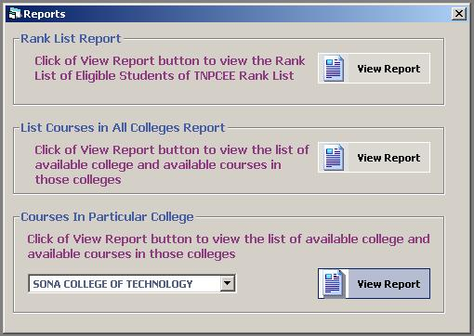

Source Code

Option Explicit

Sub PutRank()
Dim i As Integer, j As Integer

For i = 0 To List1.ListCount

If i > 0 And (List2.List(i) = List2.List(i - 1)) Then
List3.AddItem i
i = i + 1
Else
List3.AddItem i + 1
End If

Next i

End Sub

Sub PrepareRankList()
Dim i As Integer, v As Variant

List1.Clear
List2.Clear
List3.Clear

With DataEnvironment1.rsCMD_MARKLIST

.Open
.Sort = "cutoff desc"

For i = 1 To .RecordCount
List1.AddItem .Fields("stu_no")
List2.AddItem .Fields("cutoff")
.MoveNext
Next i
PutRank
.Close
End With

Adodc1.Refresh
With Adodc1.Recordset

While Not .EOF
.Delete
DoEvents
.MoveNext
Wend

For i = 0 To List1.ListCount - 1
.AddNew
.Fields("stu_no") = List1.List(i)
.Fields("rk") = List3.List(i)
.Update
DoEvents
Next i

End With

End Sub
Private Sub ColCurRpt_Click()
End Sub

Private Sub Command1_Click()
End Sub

Private Sub Form_Load()

End Sub

Private Sub PBXPButton1_Click()
Dim rt As RptTextBox, rl As RptLabel
Dim Rs As Recordset

If DataCombo1.Text <> "" Then

Set Rs = getCourseFromCollege(DataCombo1.Text)
Set SingleColCOurse.DataSource = Rs
Set rt = SingleColCOurse.Sections("section1").Controls("curname")
Set rl = SingleColCOurse.Sections("section2").Controls("colname")

rt.DataMember = Rs.DataMember
rt.DataField = "course_name"
SingleColCOurse.Show
SingleColCOurse.WindowState = vbMaximized
rl.Caption = DataCombo1.Text
Else
MsgBox "Select a college name", , "No College name"
End If
End Sub

Private Sub PBXPButton2_Click()
PrepareRankList
RankList.Show
RankList.WindowState = vbMaximized
End Sub

Private Sub RnkRpt_Click()

End Sub

Private Sub PBXPButton3_Click()
ColCourseRpt.Show
ColCourseRpt.WindowState = vbMaximized
End Sub

Reports View- I

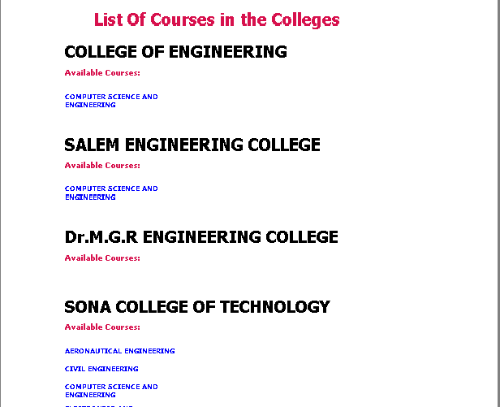

Reports View- II
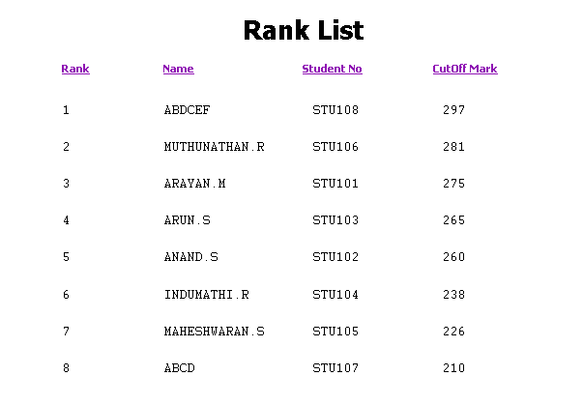

Conclusion
Conclusion

Thus the project provides a robust way of maintaining the database for the tamilnadu engineering counseling. It is efficient in handling all the hoards and hoards of data required for the process of counseling. Moreover, the use of Microsoft Visual Basic 6.0 as the front end tool gives more easy access because of the Graphical User Interface provided by it. This makes the project an easy to handle and each section in this database is available in the form of a separate window and so it gives a clear view for each and every step in the counseling process. Also the use of Oracle 8 as the back end tool has made insertion, updation, retrival to and fro in the databse makes and easy process.

We believe that this project brings into the view of Oracle 8 as a
back – end tool in maintaining large databases and Microsoft Visual Basic 6.0 as a front – end tool for and user friendly environment.

Bibiliography
Bibiliography


Books Refered:
- Mastering Visual Basic 6.0 - Evangelous Petrotous
- Oracle - Visual Basic - SSI Press

