iText
A Rich Text Editor Using C#

User Manual

A Mini Project


By
S.Maheshwaran
III BE (CSE)
Sona College of Technology.
E-Mail: mahesh_monu@yahoo.com

View of the iText:
iText Title Bar

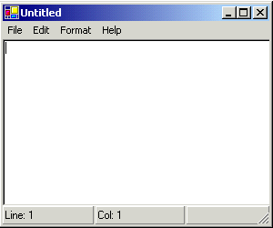
iText Menu Bar
iText Text Area
iText Status Bar

Menus:
iText has four menus namely
- File Menu
- Edit
- Format
- Help

The File Menu:
  - File->New. This is used to open a new text area.
  - File->Open .This is used to open an existing file stored at a location. On clicking this option in the file menu the File Open Dialog Box appears and the user can select the file to be opened. The figure below shows the open dialog box.

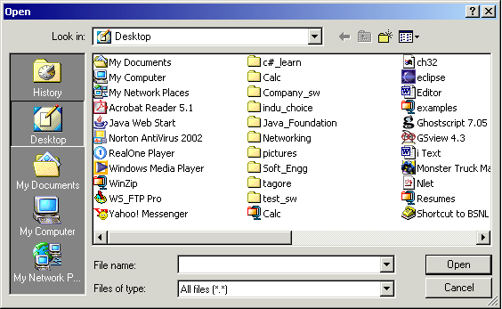

  - File->Save. This is used to save a file in case it is a new file or if an existing file is modified this is used to save the modified file.
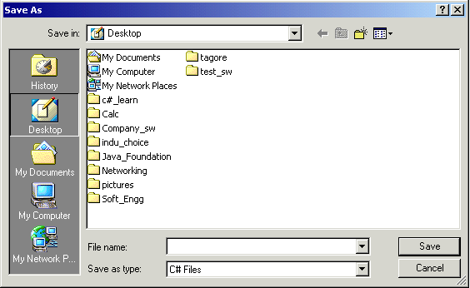

The above figure shows the dialog box that appears while saving.
  - File->Save As. This is used to save the existing file in some other location or type as required by the user. The save as dialog box appears.
  - File->Exit. This is used to exit from the iText editor. If the current text is not saved a dialog box as below appears.
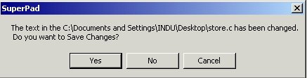

The Edit Menu:
- Edit ->Undo. This option is used to undo a previously performed editing operation.
- Edit->Cut. This option is to cut a selected portion of text.
- Edit->Copy. This option is to copy a selected portion of text.
- Edit->Paste. This option is to paste a selected portion of text after the copy or cut operation.
- Edit->Delete. This option is to delete a selected portion of text.
- Edit->Find. This is used to perform search operation in the currently opened file. Below is the Find dialog box that appears on selecting this option. The radio buttons Up and Down help the user to decide whether the search must be performed from below the current cursor position or from the beginning till the current cursor position.
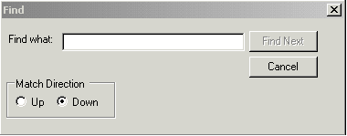
- Edit->Find Next. This option is used to find the next match in a Find operation.
- Edit->Goto. On specifying the line number in the textbox present in the goto dialog box, the cursor is placed in the line specified.
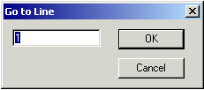
- Edit->Select All. This is used to select the entire contents of the currently opened file.
- Edit->Time/Date. This option is used to display the current date and time.

The Format Menu:
- Format-> Word Wrap. This is used to enable word wrap in the current file.
- Format->Font. This is used to change the font size and color and other formatting features to the selected text. The default font is Courier.

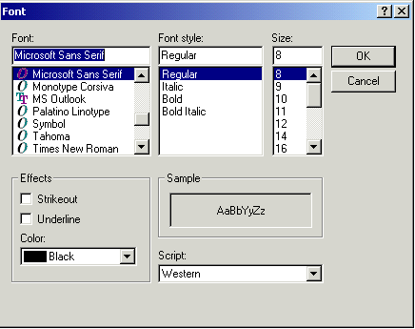
- Format->Image Viewer. This option enables users to see pictures.
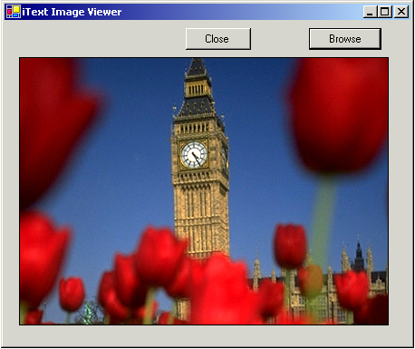
The browse button present in the empty form that appears enables the user to select the picture to view. The close button is used to close the image viewer.

The Help Menu:
- Help->About. This gives us information about the author.
- Help->User Manual. This gives details about the user manual.

Menu Items and Shortcut Keys:
S.No | Menu Item | Shortcut Key
 | New | Ctrl+N
 | Open | Ctrl+O
 | Save | Ctrl+S
 | Save As
 | Exit | Ctrl+X
 | Undo | Ctrl+Z
 | Cut | Ctrl+X
 | Copy | Ctrl+C
 | Paste | Ctrl+V
 | Delete | Del
 | Find | Ctrl+F
 | Find Next | F3
 | Go To | Ctrl+H
 | Select All | Ctrl+G
 | Time/Date | Ctrl+A

