**SECTION-A**

**INTRODUCTION**

**INTRODUCTION**

* Blood Bank is a place where blood bag that is collected from blood donation events as well as from different hospitals etc. is stored in one place.
* Donor is someone who gives a part of their body or some of their body to be used by doctor to help a person who is ill.
* Transfusion is done as a lifesaving maneuver to replace blood cells or blood product lost through severe bleeding.

Online Blood Bank System is an online platform introduced with the main goal to reduce the inconvenience occurred while searching for blood. It is a browser-based system that is designed to store, process, retrieve and analyze information concerned with the administrative and inventory management within a blood bank.

There are many blood banks available in the country but to wander every blood bank in search of blood is tiring. This platform can help alleviate that situation by simply searching the blood required in the database present in our system and find the nearest blood bank with the required blood group.

**STATEMENT OF PROBLEM**

1. **Lack of Unified platform:** Due to the absence of unified platform to search for the required blood, time is consumed searching for blood in different blood banks around the country.
2. **Hassle in finding the nearest blood bank:** In the absence of proper databases of blood banks around the vicinity, it could get hard to find the nearest one,
3. **Lack of information about the blood donation events**
4. **Lack of blood donation awareness**

**PROJECT SCOPES**

This project “Online Blood Bank System” is intended to fulfill the following project scopes:

* Providing the information of blood donation events held
* Keeping well managed databases of the donors and donation receivers
* Well encrypting the data
* In case of any assistance, volunteers are available

**OBJECTIVES**

The objectives of the project “Online Blood Bank System” are:

* To detect the amount of rare bloods in different areas or locality
* To keep the well managed information of donors and receivers
* To ensure convenient process for interaction for getting blood pouches
* To be able to find the specified blood group in record time

**SECTION-B**

**BACKGROUND COVERAGE**

**FRONTEND WEB DEVELOPMENT**

* HTML: HTML stands for Hypertext Markup Language. It is the most basic building block of the Web. It defines the meaning and structure of web content. Other technologies besides HTML are generally used to describe a web page’s appearance/presentation (CSS) or functionality/behavior (JavaScript).
* CSS: CSS Stands Cascading Stylesheet. It is a language that describes the style of an HTML document. It describes how HTML elements should be rendered on screen, on paper, in speech or on other media. It is one of the core languages of the open Web and is standardized across Web browsers according to W3C specification. Developed in levels, CSS1 is now obsolete, CSS2.1 is a recommendation and CSS3, now split into smaller modules, is progressing on the standardization track.
* Bootstrap: Bootstrap is a free and open-source framework for creating websites and web applications. It’s the most popular HTML, CSS and JS framework for developing responsive, mobile first projects on the web. Bootstrap can be used to build websites of any scale, from small blogs to large corporate websites. Organizations that use Bootstrap include NASA, University of Washington, FIFA, Newsweek, VOGUE and many more.
* JavaScript: JavaScript (JS) is a lightweight, interpreted, or just-in-time compiled programming language with first-class functions. While it is most well-known as the scripting language for Web pages, many non-browser environments also use it, such as Node.js, Apache CouchDB and Adobe Acrobat. JavaScript is a prototype-based, multi-paradigm, single-threaded, dynamic language, supporting object-oriented, imperative, and declarative (e.g. functional programming) styles.
* jQuery: jQuery is a lightweight, “write less, do more”, JavaScript library. The purpose of jQuery is to make it much easier to use JavaScript on you website. jQuery takes a lot of common tasks that require many lines of JavaScript code to accomplish, and wraps them into methods that you can call with a single line of code. jQuery also simplifies things from JavaScript, like AJAX calls and DOM manipulation.

**BACKEND WEB DEVELOPMENT**

* PHP: Hypertext Preprocessor (PHP) is a scripting language that allows web developers to create dynamic content that interacts with databases. PHP is basically used for developing web-based software applications. PHP can handle files, save data to a file, through email you can send data, return data to the user. It can also encrypt data.

**SECTION-C**

**PLANNING THE PROJECT**

**OVERVIEW**

The purpose of project planning is to identify the scope of the project, estimate the work involved, and create a project schedule. Project planning begins with requirement that define the desktop app to be developed. The project plan is developed to describe the task that will lead to completion. The purpose of project monitoring and control is to keep the team and management up to date on the project's progress. If the project deviates from the plan, then the project manager can take action to correct the problem. Project monitoring and control involves status meetings to gather status from the team. When changes need to be made then properly the plan is updated.

**UNDERSTANDING THE PROBLEM**

It is very imperative to understand the problem before indulging in the process of finding solution. It might take some time if the problem at hand is somewhat complicated. Even though it consumes time, it is the process of planning the project which should not be omitted for the sake of time.

A good project definition should include:

* A project plan defining the vision, critical success factors and areas of responsibility
* A requirement document which when fulfilled denotes the completion of project

**PLANNING FOR THE DEVELOPMENT PROCESS**

The consideration here is to define a product life cycle model. The software life cycle encompasses all activities required to define, develop, test, deliver, operate and maintain a software project.

**THE PHASE LIFE CYCLE MODEL**

We consider the phase model to consist of the following phases:

* Planning
* Analysis
* Design and Coding
* Testing and Implementation
* Debugging and Maintenance

Fig: The phase life cycle

**PLANNING AN ORGANIZATOIN STRUCTURE**

**PROJECT STRUCTURE**

Use of project format involves assembling a team of programmers who conduct a project from start to finish, project team members do product definition, design the product, implement it, conduct project reviews and prepare the supporting document in the functional approach to organization, a different team of programmer performs each phase of the project, and the work product passes from team to team as they involve. Such a stricter format was not possible such as this with limited resources constraints and resources.

**COST ANALYSIS**

|  |  |  |
| --- | --- | --- |
| S.N. | Particulars | Amount (NRS) |
| 1 | Web Interface |  |
| 2 |  |  |
| 3 |  |  |
| 4 |  |  |
|  |  |  |
|  |  |  |

**TOOLS AND SOFTWARES TO BE USED**

1. Xamp
2. HTML, CSS, JS
3. Bootstrap
4. Apache server

**SECTION-D**

**ANALYSIS AND DESIGN**

**ANALYSIS**

To build an administrator-centered system, the first thing we determined in the analysis phase was who the administrator will be; e.g. blood bank administrator, event administrator, as a whole administrator etc. This is a quite tedious process for an analysis phase. Our team gathered information about the product for development process to give administrator-centered look and feel. They make a list of problems faced by them (administrators) while keeping records and what will make them easier to keep the records.

**APPLICATION ANALYSIS**

After gathering the information about the problems regarding web application development, we compared this problem with our web application. In addition, after critical investigation of the model application, we can determine the proper requirements and develop the overall concept of the new interactive web application.

**DESIGN**

**DESIGN OVERVIEW**

Design for application encompasses technical and non-technical activities that includes: establishing the look and feel of the application, creating the layout of the interface, defining the overall architectural structure, developing the content and functionality and planning the navigation. Design allows to create a model that can be assessed for quality and improved before content and code are generated, and tests are conducted.

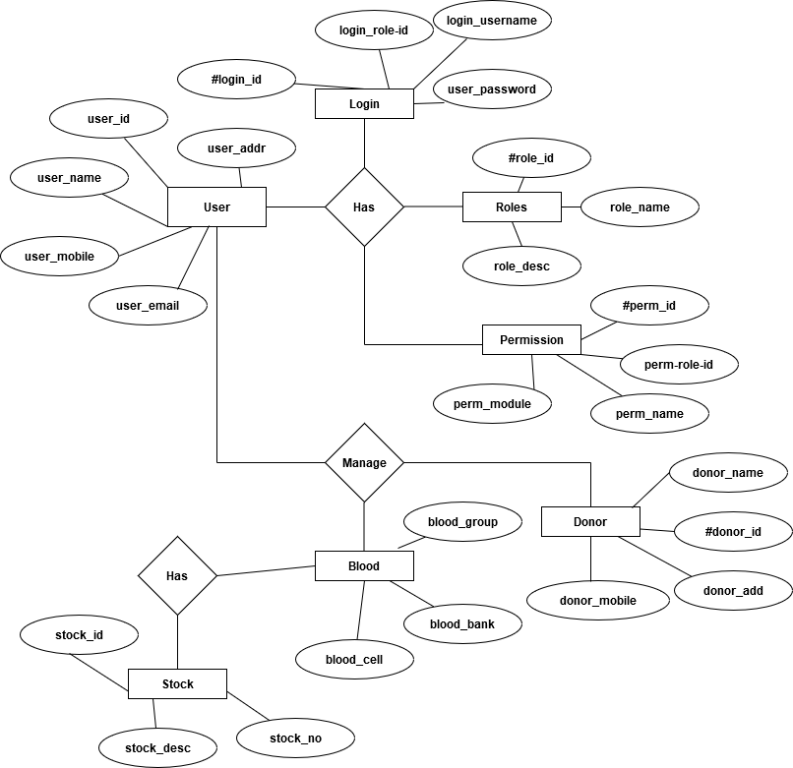**ER-DIAGRAM**

**SCREENSHOTS**

**SECTION-E**

**TESTING AND IMPLEMENTATION**

**TESTING**

Web-application testing is done using various related activities with a single goal of uncovering errors in the application content function, usability, navigation, performance, capacity and security. To accomplish this, a testing strategy that encompasses the review and executable testing is applied.

**IMPLEMENTATION**

After testing of the application, at this phase the application is introduced to respective person for their feedback on the web interface, usage of the web application. Since, it is database collection, news events information provider, etc. this can be obviously used by many other organizations.

**SECTION-F**

**LIMITATIONS AND FUTURE ENHANCEMENTS**

**LIMITATION**

No matter how much better the product be, there could be some limitations? Some of the limitations are listed below:

1. ..
2. …

**CONCLUSION**

Thus, “Online Blood Bank System” is a system for proper maintenance of databases, convenience for acquiring required blood group, convenient communication way to the donor directly and in efficient manner.

**FUTURE ENHANCEMENTS**

**REFERENCES**

1. W3 schools
2. Wikipedia
3. Bootstrap tutorials
4. [www.stackoverflow.com](http://www.stackoverflow.com)
5. [www.tutorialspoint.com](http://www.tutorialspoint.com)
6. [www.startbootstrap.com](http://www.startbootstrap.com)