Agentic AI Travel Itinerary Design Agent - Part 3 Deliverables (Final)

1. System Architecture Diagram & Explanation
The following ASCII diagram represents the end-to-end agentic AI systems, showing all sub-agents, the Orchestrator, the Kafka message bus, data flow, and external APIs integration.
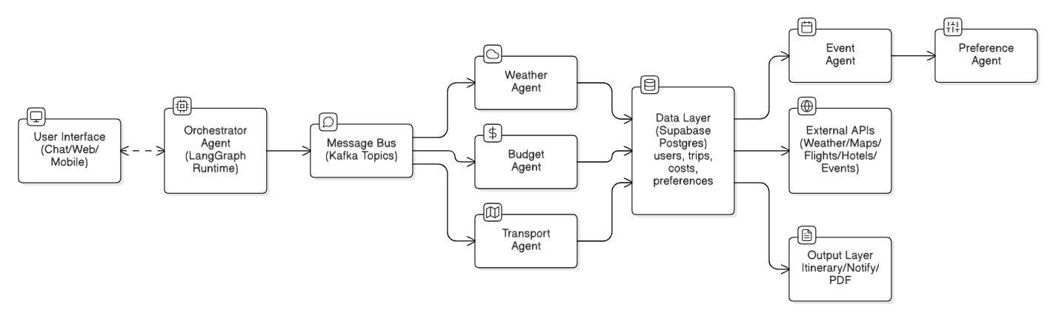
Figure 1: Agentic system architecture showing LangGraph orchestration, sub-agents, Kafka messaging, and external API connectivity.

2. Use Case Flows

2.1 Simple Use Case: Weather-Based Adjustment
Scenario: The user wants to visit Goa in July.
Flow:
1. User inputs Goa and July via the interface.
2. Orchestrator triggers the Weather Agent.
3. Weather Agent retrieves monsoon forecast (rainy).
4. Message sent via Kafka to Itinerary Agent.
5. Itinerary Agent recommends indoor attractions or alternate months (Dec–Feb).
6. Orchestrator aggregates and presents the final recommendation.

2.2 Advanced Use Case: Dynamic Re-planning After Flight Delay
Scenario: User’s flight delayed by 6 hours.
Flow:
1. Transport Agent receives real-time flight delay notification.
2. Event Agent publishes a delay message to Kafka.
3. Orchestrator triggers Itinerary Agent and Budget Agent.
4. Itinerary Agent reprioritizes activities based on arrival time.
5. Budget Agent recalculates costs and hotel adjustments.
6. Orchestrator compiles the updated itinerary and sends notifications.

3. PEAS Framework (Performance, Environment, Actuators, Sensors)
The PEAS framework defines the operational intelligence boundaries and goals of the Agentic AI Travel Itinerary System.
Component | Detailed Description
Performance | • Minimize total cost and travel time.  • Maximize comfort, personalization, and feasibility.  • Adapt to dynamic conditions such as delays or weather changes.
Environment | • APIs: weather, maps, flights, hotels, events.  • Constraints: budget, transport mode, travel dates.  • Infrastructure: LangGraph orchestration, Kafka bus, Supabase DB.
Actuators | • Trigger API calls for bookings and notifications.  • Generate itinerary summaries and updates.  • Modify trip data and retrigger LangGraph workflows.

4. Agent Collaboration Model (Inter-Agent Communication Design)
Agents collaborate asynchronously through Kafka topics, coordinated by the Orchestrator Agent running in LangGraph. Each agent publishes and subscribes to events representing domain-specific updates.
Agents and Responsibilities:
- Itinerary Agent → Synthesizes data from other agents to create plans.
- Weather Agent → Publishes forecasts to /weather.
- Budget Agent → Publishes cost recommendations to /budget.
- Transport Agent → Sends route updates to /transport.
- Event Agent → Publishes holiday alerts to /event.
- Preference Agent → Updates user profiles to /preference.
Message Bus Topics:
/trigger/weather, /weather, /trigger/budget, /budget, /event/flightdelay, /itinerary/update.
Example Message (JSON):
{
"sender": "WeatherAgent",
"receiver": "ItineraryAgent",
"event": "weather.update",
"timestamp": "YYYY-MM-DDTHH:MM:00Z",
"payload": {"destination": "Goa", "forecast": "rainy", "advice": "prefer indoor activities"}
}

LangGraph Coordination:
• Nodes represent agents.
• Edges represent dependencies.
• Parallel nodes execute concurrently (e.g., Weather + Budget).
• Sequential nodes depend on others (e.g., Itinerary waits for both).

5. AI Approach
A hybrid AI model combining:
- Rule-based logic for deterministic constraints.
- Machine Learning for preference and cost optimization.
- Large Language Models for reasoning, summarization, and communication.
This section details a production-oriented HYBRID approach that combines Rule-based logic, Machine Learning, and Large Language Models (LLMs) orchestrated via LangGraph, with Kafka for event-driven collaboration and Supabase (Postgres + pgvector) for persistence and retrieval.

5.1 Why Hybrid?
• Rules ensure reliability for hard constraints (budget caps, date ranges, safety).
• LLMs perform multi-step reasoning, tool selection, and natural language generation.

5.2 Responsibilities by Technique
Rule-based (Deterministic):
• Validate inputs (dates, budget format, destination).
• Enforce constraints (max daily spend, cancellation windows, vendor blacklists).
• Guardrails (PII masking, allowed tools, rate limits).
LLM (Reasoning + NLG + Tool Use):
• Chain-of-Thought (hidden), tool-calling for Weather/Maps/Flights/Hotels APIs.
• Critic/Judge step to sanity-check the plan (self-consistency + constraint re-check via rules).
• Summarization to user-facing itinerary with alternatives and rationale.

5.3 LangGraph Orchestration (Node Roles)
Nodes:
• InputParser → validates/normalizes user request (rules).
• Retrieval → RAG from Supabase pgvector (past trips, templates).
• WeatherNode (tool) → forecast + advisories.
• TransportNode (tool) → routes, flights, delays.
• BudgetNode (ML + rules) → cost envelope, price forecasts.
• RankerNode (ML) → score candidate activities/hotels.
• PlannerNode (LLM + OR-Tools) → construct feasible day-by-day plan.
• CriticNode (LLM) → verify constraints & risks; request fixes if violated.
• GeneratorNode (LLM) → produce final itinerary + alt options.
• NotifierNode → push updates.
Edges enforce: Retrieval → Weather/Transport/Budget → Ranker → Planner → Critic → Generator.

5.4 Retrieval-Augmented Generation (RAG)
• Store prior itineraries, attraction briefs in vecorDB.
• Embed with bge or ada models; use cosine similarity.
• LLM prompts include retrieved snippets; ground responses; cite sources in UI.

5.5 Example Tool Schemas (JSON)
{
"name": "get_weather_forecast",
"input_schema": {"type": "object","properties":{"city":{"type":"string"},"dates":{"type":"array","items":{"type":"string"}}}},
"returns": {"type":"object","properties":{"daily":{"type":"array"},"alerts":{"type":"array"}}}
}
{
"name": "search_flights",
"input_schema": {"type":"object","properties":{"origin":{"type":"string"},"dest":{"type":"string"},"date":{"type":"string"}}},
"returns": {"type":"array","items":{"type":"object","properties":{"carrier":{"type":"string"},"dep":{"type":"string"},"arr":{"type":"string"},"price":{"type":"number"}}}}
}

5.6 Prompt Skeletons
System:
“You are the PlannerNode. Obey hard constraints; call tools when data is missing; if a constraint fails, propose fixes.”
User:
“Plan 3 days in Goa in July, budget ₹25,000, prefers road travel and local cuisine.”
Developer:
“Constraints: max ₹25k, avoid heavy-rain outdoor slots, include 1 cuisine trail, travel time per day ≤ 3h. Tools available: get_weather_forecast, search_hotels, search_flights, get_drive_time_matrix.”

5.7 Safety & Guardrails
• PII masking & consent; redact before logs.
• Allowlist tools; enforce rate limits; block unsafe content.
• Hallucination control: RAG grounding + tool-only for facts; critic step checks claims.

6. Ethical & Responsible Design
- Data Privacy: PII masking, encryption, and consent tracking.
- Explainability: Show reasoning trace for each decision.
- Fairness: Avoid biased vendor selection.
- Safety: Recommend only verified destinations and safe travel routes.

7. Future Enhancements
- GenAI-based itinerary summarization.
- Reinforcement learning for personalization.
- IoT integration for real-time travel updates.

