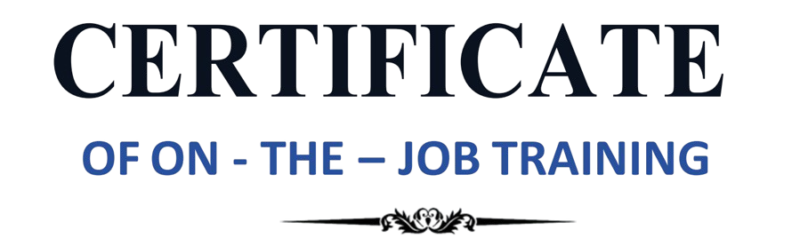

This is to certify that {name} ({reg_no}) from {course}, {university}, as part of the OJT has completed an Academic Internship in Data Analytics at VDart Academy from {start_date} to {end_date}.

During the On-the-Job Training, he had showcased a strong skill set and a unique drive to learn and grow. Through mentorship from the best, collaboration among peers, and guidance provided by the organization, he had exceeded our expectations and successfully completed the training within the expected timeframe.

Congratulations! All the best for future endeavors.

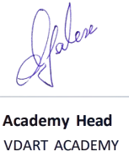

DATE: {issue_date}

PLACE: Mannarpuram, Trichy