*Problem statement:*

“Inaccuracy in emotion detection process, 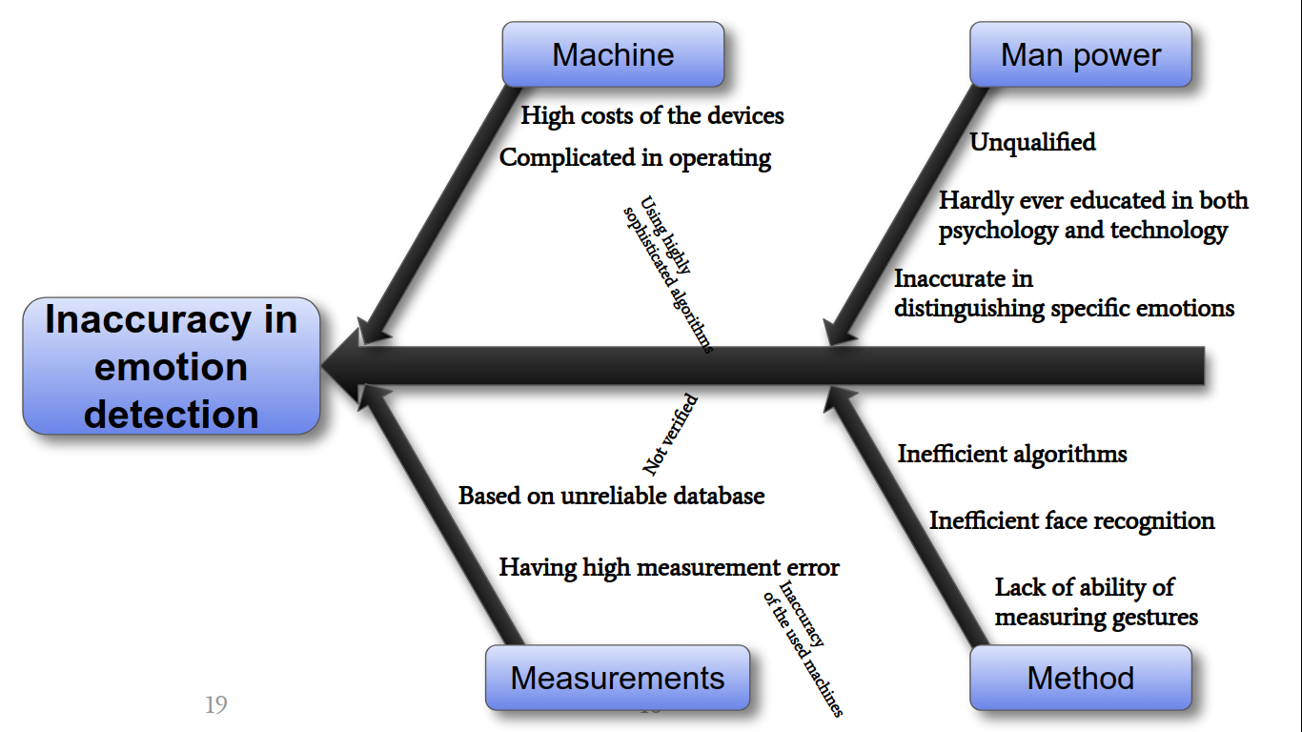

due to lack of verification methods”





Problem:

Accuracy of emotion recognition using not sophisticated device systems.

Do dokładnego wykrywania emocji potrzebny jest drogi sprzęt.

Sophisticated systems are necessary to accurately detect emotion.

Machine:

Expensive machines

Not easy to operate

Heavy, not portable

Static measurement devices.

Method:

Complex and complicated

not easily available

Men

Unqualified

Inpatient

Biased //person

Measurement:

Biofeedback

Temperature measuring

Pressure measuring

Gesture, mimics

Iris recognition

Now it’s finally the time to formulate the problem. After the whole research, we’ve made, we noticed, that all the methods of emotion recognition required ether many different recorders and complicated algorithms or were quite inaccurate. There are not, however, any accurate mobile ways of detecting emotions.

The idea was researched even further. We asked ourselves “why?”. Out of many possible conclusions we noticed a pretty interesting one. The mobile methods are not being proven.

We got to the idea of combining many of methods, which we’ve presented today.

Let’s put a person in front of a simple camera. By using FACS method and deep learning we can categorize their facial expression and stores them. And let’s prove those detected emotions using the bio-feedback machines. As a result we get a mobile device with quite high accuracy.

We’ve spoted a couple of use of such a divice. As an example it might help the people ill on autism in everydays life. They do not recognise emotions. We consulted our thoughts with a specialist, a headmaster of the charity organisation JIM, who showed high interest in the idea.

Our idea of emotion verification consists of using two separate methods. One is **Facial Action Coding System** (FACS) and a deep learning method which might be proven by the bio-feedback machines. That might give even more accurate results.