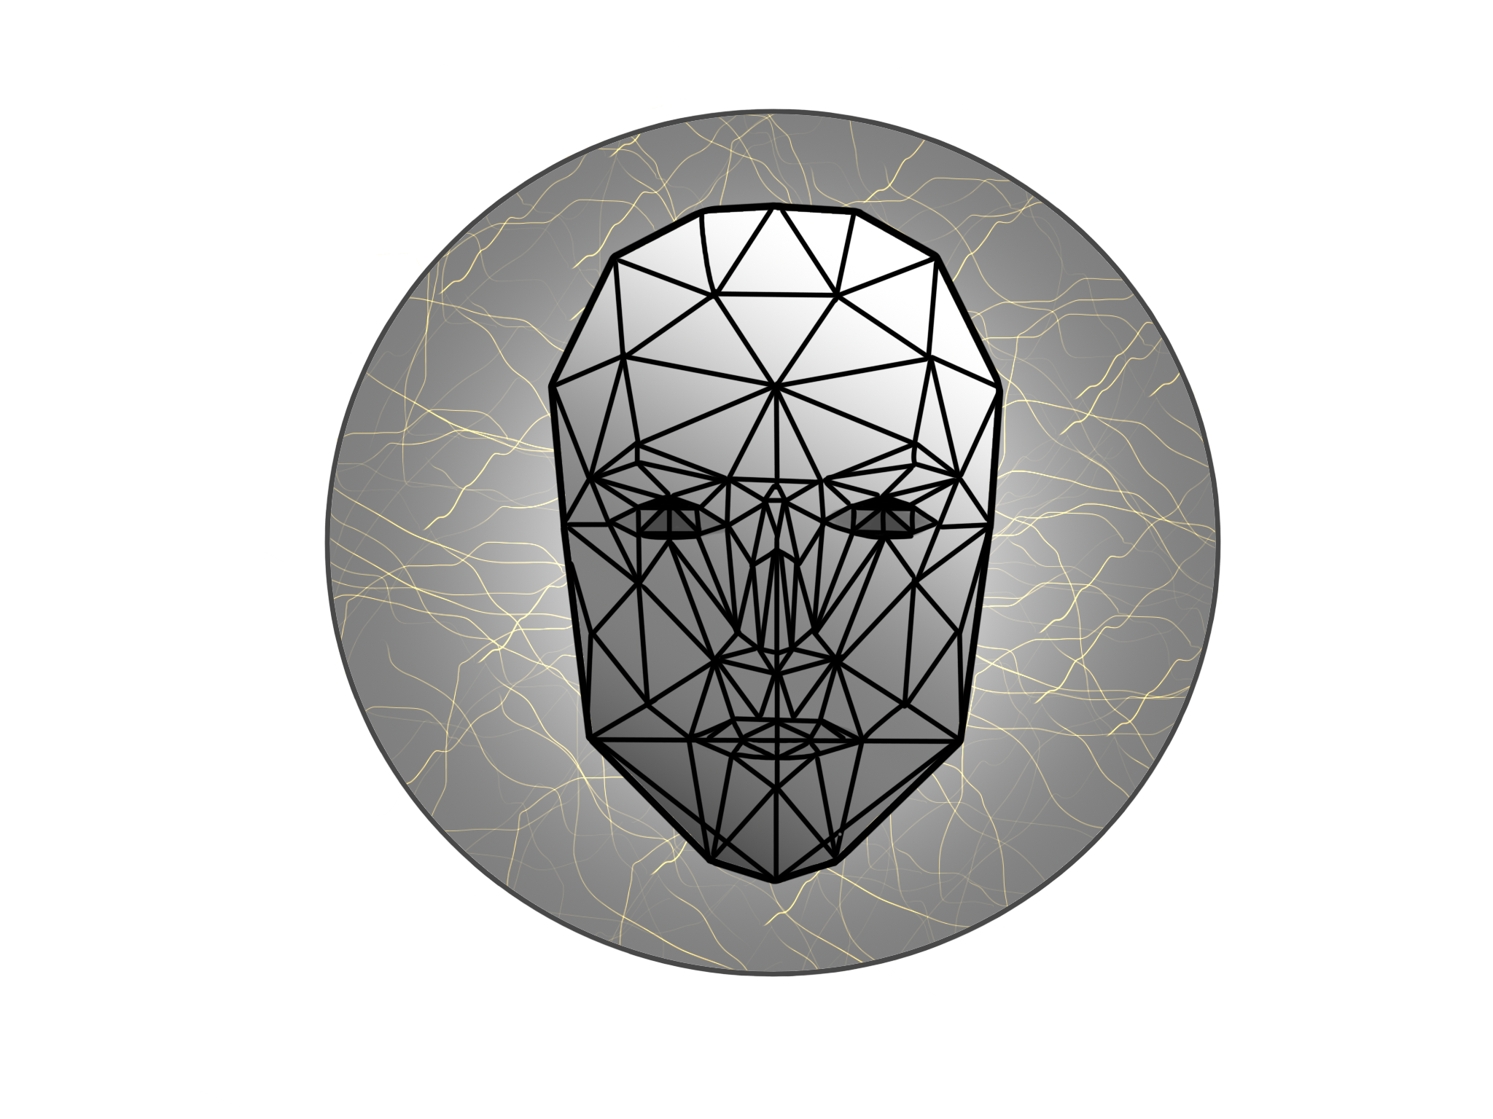

**LOGO:**

**According to our first researches we decided very early that our logo will be based on Candide - the parametrized face, placed in the middle of the logo. It is commonly used to detect face on the picture. During further analysis of the various candide changes, the emotion detection is possible. Although we decided to use a different method to indicate emotions, we came to the conclusion that the parametrized face is strongly associated in the detection of the face or emotions expressed by it and that it is still a suitable element for our logo.**