# DEL-Dock: Enhanced DEL Modeling

The paper introduces a novel approach called DEL-Dock, designed to improve the accuracy of DNA-Encoded Library (DEL) technology by combining ligand-based descriptors with three-dimensional spatial data from docked protein-ligand complexes. DEL-Dock addresses the challenge of noise in DEL data by effectively capturing the nature of protein-ligand interactions beyond traditional two-dimensional molecule-level approaches. The authors demonstrate that DEL-Dock significantly denoises DEL count data, which is crucial for predicting molecule enrichment scores more accurately correlated with experimental binding affinity measurements. The model's ability to utilize 3-D information allows it to implicitly select good docking poses without external supervision, making it more efficient in drug discovery processes. DEL-Dock outperforms previous methods that relied solely on molecular descriptors or docking scores by providing a more holistic view of the binding modality. Its effectiveness is validated on data from panning experiments involving human carbonic anhydrase, showing improved prediction of binding affinities and enhanced interpretability through its attention mechanisms on docking poses.

# DEL-Dock: Enhancing DEL with 3D Docking Data

1. **Integration of 3D Spatial Data in DEL Models**: The study introduces DEL-Dock, a model that enhances DNA-Encoded Libraries (DEL) by integrating traditional ligand-based descriptors with three-dimensional (3D) spatial information from protein-ligand docking data. This integration enables the model to learn actual binding modalities, rather than solely relying on chemical structure information, significantly improving the prediction of molecule enrichment scores aligned with experimental binding affinity measurements.  
  
2. **Modeling and Evaluation Approach**: DEL-Dock employs a probabilistic framework using Morgan fingerprints for molecular representation and pretrained convolutional neural networks (CNNs) for capturing spatial relationships in docked protein-ligand complexes. The model accurately differentiates between target protein binding and non-specific matrix binding, enhancing the denoising process of DEL count data. It was effectively validated against a dataset of molecules screened for human carbonic anhydrase IX (CAIX), showing superior performance over conventional models by leveraging both docking and molecular descriptor data.   
  
3. **Improved Pose Selection and Binding Insights**: DEL-Dock demonstrates the ability to better rank docking poses and identify key binding motifs, especially for the CAIX protein, without requiring supervision from crystal structures. This is achieved through a self-attention mechanism over possible poses, leading to selection strategies that emphasize biologically realistic poses showing effective zinc-sulfonamide coordination, a critical motif for CAIX binding. The model's ability to interpret these signals highlights potential advantages in virtual screening campaigns for drug discovery.

# Figure 1

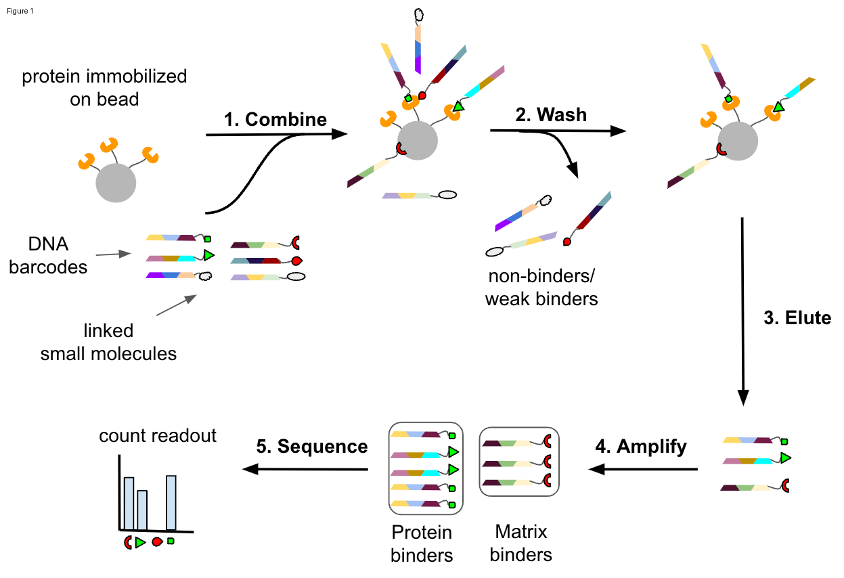

The figure illustrates the key steps involved in a DNA-Encoded Library (DEL) panning experiment to identify protein binders:  
  
1. **Combine**: Proteins are immobilized on beads and combined with a library of small molecules, each tagged with unique DNA barcodes.  
  
2. **Wash**: Non-binders and weak binders are removed through a washing process, leaving strong binders attached to the protein on the beads.  
  
3. **Elute**: The protein-bound small molecules are eluted from the beads, effectively separating them from the immobilization matrix.  
  
4. **Amplify**: The DNA tags (barcodes) of the eluted molecules are amplified. This amplification helps increase the signal for subsequent analysis.  
  
5. **Sequence**: The DNA sequences are read to identify which molecules were enriched, indicating potential strong binders. This results in a count readout, representing the binding affinity of different molecules to the protein target.  
  
This process allows researchers to assess binding affinities by measuring the abundance of specific DNA sequences associated with small molecules. The diagram highlights the flow from initial binding to sequencing, emphasizing the role of DNA barcodes in identifying protein binders.

# Figure 2

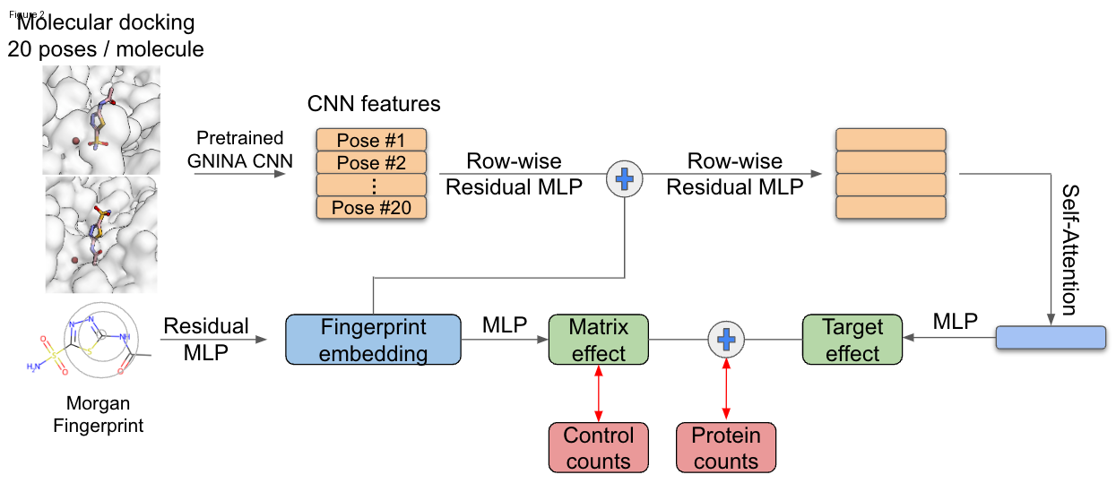

This figure illustrates the workflow of the DEL-Dock model, which incorporates molecular docking and machine learning techniques to predict binding affinities in DNA-Encoded Libraries (DEL).  
  
### Key Components and Workflow:  
  
1. **Molecular Docking:**  
 - Generates 20 possible poses per molecule using a pretrained GNINA CNN. These poses represent potential docking conformations of ligands with a target protein.  
  
2. **CNN Features:**  
 - The generated poses are input into a CNN to extract spatial features crucial for understanding protein-ligand interactions.  
  
3. **Row-wise Residual MLP:**  
 - Processes CNN features through multiple layers of a multilayer perceptron (MLP) with residual connections to refine pose-specific features.  
  
4. **Self-Attention Mechanism:**  
 - Applies self-attention on the pose embeddings to focus on the most relevant poses, enhancing the model's ability to prioritize poses with high binding potential.  
  
5. **Morgan Fingerprint and Residual MLP:**  
 - Converts molecules into Morgan fingerprints, which are then processed with another MLP to embed molecular features.  
  
6. **Integration with Fingerprint Embedding:**  
 - Combines processed molecular characteristics with additional learned effects, such as matrix and target effects, impacting molecular binding.  
  
7. **Matrix and Target Effects:**  
 - Accounts for experimental noise by separating the contributions from matrix binding and target protein binding.  
 - Control and protein counts aid in modeling these effects, influencing the learning of binding affinities.  
  
### Function and Purpose:  
The DEL-Dock model integrates ligand-based descriptors with both 2D and 3D molecular information to improve binding predictions and denoise data from experimental DEL panning. This approach allows the model to implicitly learn docking pose selection, enhancing the discovery of molecules with desirable binding properties.

# Figure 3

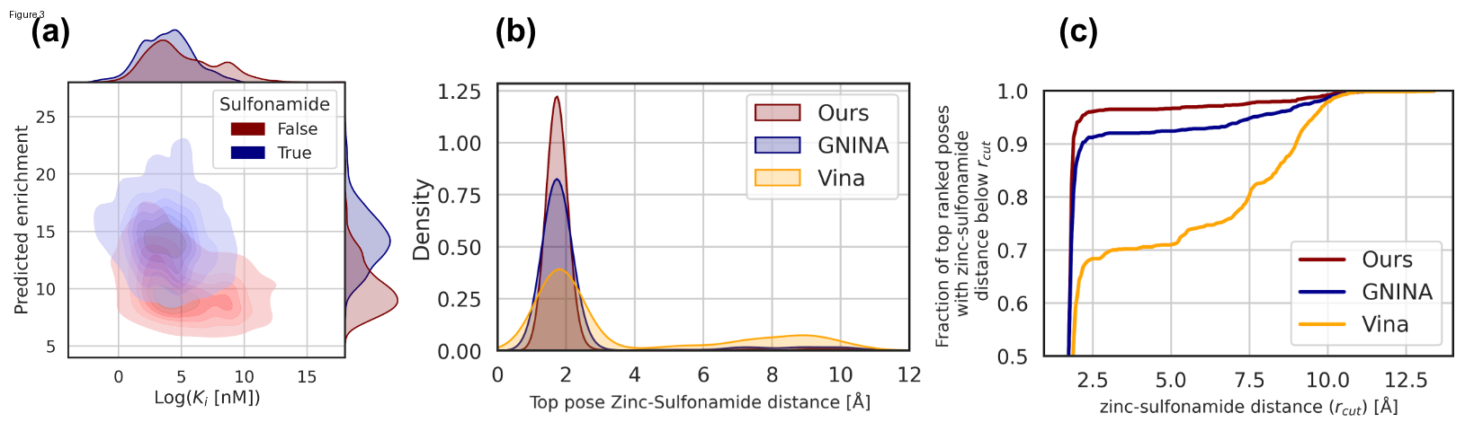

The figure consists of three subplots (a, b, and c), each comparing different models for predicting molecular interactions.  
  
### (a) Predicted Enrichment vs Log(Ki)  
- **Description:** This density plot compares predicted enrichment scores with experimental binding affinities (Log(Ki) values) for molecules, indicating whether they are sulfonamide (True or False).  
- **Insights:** Molecules with higher predicted enrichment tend to have lower Ki values, especially those containing sulfonamide.  
  
### (b) Zinc-Sulfonamide Distance Density  
- **Description:** This plot shows the distribution of zinc-sulfonamide distances for the top docked poses identified by three methods: "Ours," "GNINA," and "Vina."  
- **Insights:** The model labeled "Ours" has a denser distribution around lower distances, suggesting more accurate pose prediction that reflects the anticipated binding mode.  
  
### (c) Cumulative Distribution Function (CDF)  
- **Description:** This CDF plot indicates the fraction of top-ranked poses with zinc-sulfonamide distances below a threshold (r_cut) for the three methods.  
- **Insights:** "Ours" achieves a higher fraction of poses below smaller r_cut values compared to "GNINA" and "Vina," demonstrating superior pose ranking capabilities.  
  
Overall, the figure demonstrates that the "Ours" model performs better in selecting poses and correlating predicted enrichment with molecular binding affinity, especially among sulfonamide-containing molecules.

# Figure 4

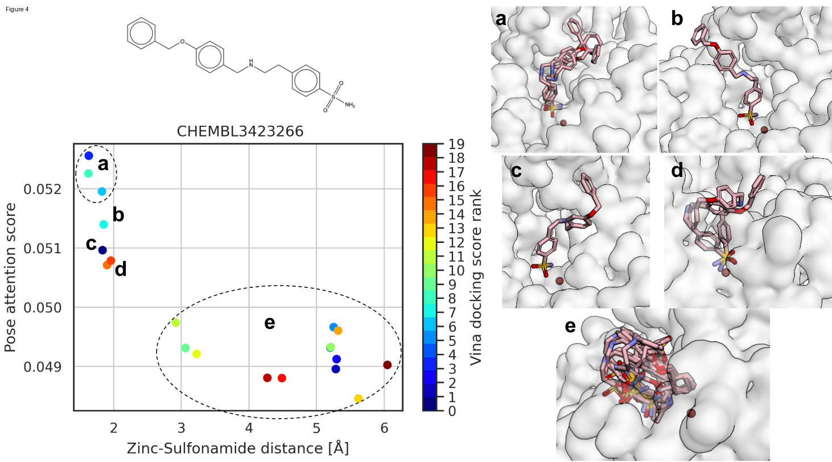

The figure illustrates the performance of a model in molecular docking analysis, focusing on the selection of binding poses for a chemical compound (CHEMBL3423266). Here’s a breakdown:  
  
### Left Panel (Graph)  
- **X-axis (Zinc-Sulfonamide distance (Å))**: Measures the distance between zinc and the sulfonamide group in different docking poses.  
- **Y-axis (Pose attention score)**: Represents the model's confidence in each docked pose.  
- **Color Coding**: Indicates the Vina docking score rank, with colder colors depicting better ranks.  
  
### Graph Observations:  
- **Clusters**:  
 - **a-d**: Indicates high pose attention scores, suggesting these poses are more likely to represent true binding conformations.  
 - **e**: Shows lower attention scores with larger zinc-sulfonamide distances, indicating less favorable binding poses.  
  
### Right Panel (Subfigures a-e):  
- **Docked Poses**:  
 - **a, b, c, d**: These are visual representations of the highly ranked poses. They likely show favorable zinc-sulfonamide interactions, which are critical for binding.  
 - **e**: Illustrates a collection of poses with less desirable configurations.  
  
### Conclusion:  
The figure demonstrates the model's ability to distinguish potential binding poses based on spatial relationships and scoring functions, crucial for protein-ligand interaction prediction.  
  
**Bounding Box Recommendations**:  
- Focus on clusters a-d in the graph to examine highly scored poses and their corresponding docking visualizations (subfigures a-d).

# Limitations of DEL-Dock Study

1. **Noise and Variability in DEL Data**: The study identifies that the DNA-encoded library (DEL) data generation process involves significant noise, including errors from matrix binding and sequencing biases. While the authors acknowledge these issues, the methodology description lacks a detailed explanation of how specific noise factors are quantitatively accounted for, which may affect overall predictive accuracy.  
  
2. **Dependence on Accurate Docking Poses**: The model assumes access to accurate protein-ligand docking poses, which rely heavily on existing docking software capabilities and available crystal structures. However, docking scores are historically unreliable due to a low correlation with actual binding affinities. The paper does not address potential inaccuracies introduced by erroneous docking conformations.  
  
3. **3-D Crystal Structure Requirement**: The methodology requires known 3-D crystal structures of target proteins, significantly limiting the scope of application to proteins where such structures are available and correctly represented. The suitability of using docking data for proteins without high-quality crystal structures is not discussed.  
  
4. **Assumption of Additive Binding**: An additive model is employed for combining matrix and target binding signals, but the choice lacks a detailed empirical basis and may fail to capture complex non-additive interactions, potentially skewing binding affinity predictions.  
  
5. **Zero-Inflated Poisson Model Use**: Although the zero-inflated Poisson model aims to accommodate sequencing noise, this choice is based on the assumption that zero counts primarily result from such noise. The model's dependencies on zero-inflation parameters may not be robust across diverse DEL experiments.  
  
6. **Transferability to Other Targets**: The study primarily focuses on the CAIX protein as the case study. There is limited discussion on the model's transferability and potential generalizability to other protein targets beyond the demonstrated CAIX use case, raising concerns about broader applicability without retraining.  
  
7. **Evaluation Dataset Representativeness**: The evaluation dataset used for benchmarking comprises external affinity measurements. The paper notes its difference from training data, but how these differences may impact the model's predictive validity in real-world scenarios is not fully explored.  
  
8. **Model Complexity and Interpretation**: While the model's performance is linked to internal pose ranking mechanisms using self-attention, there is limited interpretability regarding how attention scores directly correlate with known biophysical interaction determinants.  
  
9. **Bias Toward Known Binding Motifs**: The model successfully identifies some known binding motifs such as benzenesulfonamides, but this may reflect an over-reliance on well-characterized chemical structures, risking biased predictions toward existing knowledge and missing novel binding interactions.  
  
10. **Scalability and Computational Constraints**: The computational efficiency of the docking and prediction processes, especially concerning real-world high-throughput applications, is not sufficiently addressed. Training requirements and resource limitations may impede practical deployment at scale.  
  
11. **Single Protein Focus in Validation**: The validation process is exclusively performed on a single protein target, CAIX, which does not guarantee performance consistency across different classes of protein targets with varied binding site complexities and ligand interactions.  
  
12. **Insufficient Exploration of Model Hyperparameters**: The exploration of different model architecture components and hyperparameters appears limited, potentially leaving room for alternative configurations that might offer enhanced predictive performance or accuracy improvements.  
  
The paper offers several innovative approaches, yet these limitations highlight areas requiring further refinement and comprehensive validation to ensure robust, generalized application of the model in diverse drug discovery scenarios.