First Record :

Input :

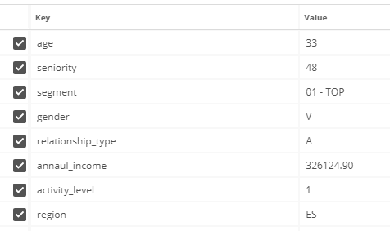

Output :

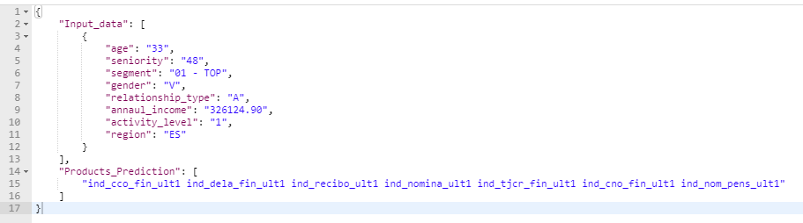

Second Record :

Input :

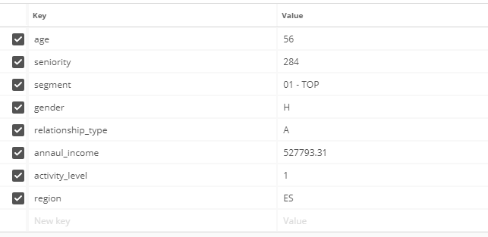

Output :

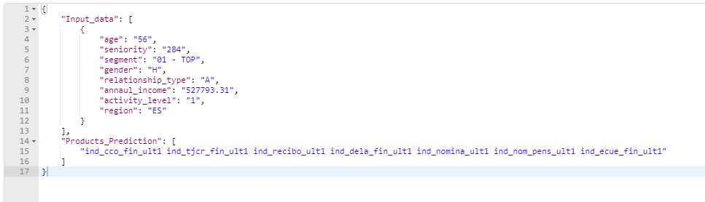

Third Record :

Input :

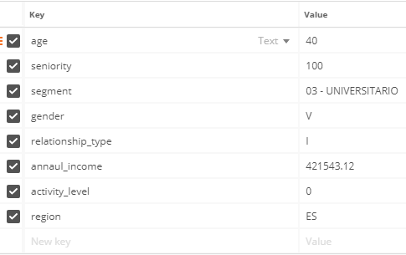

Output:

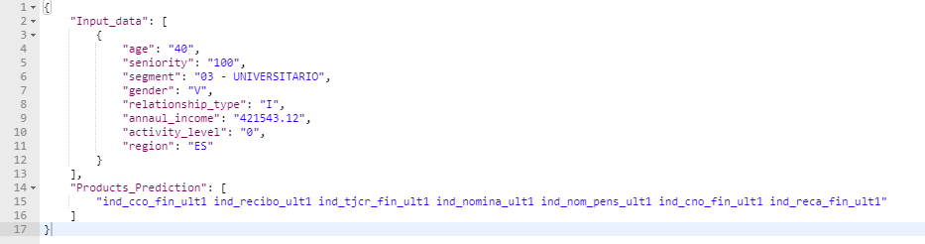

For the Runing and documentation Process please check out the Record in the Link below :

<https://drive.google.com/file/d/1pDA9fG4Ghwd5atTDP_wLtdVx3HDRtN_C/view?usp=sharing>