Bitbucket Installation

|  |  |
| --- | --- |
| Author: | Paul Sehgal |
| Document Name: | VXRW-116-Bitbucket_Installation |
| Document Location: |  |
|  |
| Date Created: | 28/02/2017 |
| Date Last Modified: | 28/02/2017 |
| Status: | Draft |
| Confidentiality: | <Select/enter confidentiality status> |
| Circulation: | <Detail circulation list> |
| Document Version: | 0.1 |

Contents

1. Overview 2

2. Prerequisites 3

1.1. Hardware Requirements 3

1.2. Platform Requirements 3

1.3. Database Requirements 3

3. Process 4

# Overview

This document details step by step instructions on the installation of Bitbucket.

# Prerequisites

* 1. Hardware Requirements

The following list outlines the hardware requirements for Bibucket.

* CPU: 2+ cores
* Memory: 3GB+
  1. Platform Requirements

The following list outlines the requirements for the platform.

* Linux or Windows (only up to 500 users).
* Java 1.8u65+
  1. Database Requirements

The following list outlines the requirements for the compatible databases Bitbucket can use.

* PostgreSQL 9.4 – 9.6
* MySQL 5.7.9+
* Oracle 12c

For further information please refer to the following link <https://confluence.atlassian.com/bitbucketserver/supported-platforms-776640981.html>.

# 3. Process

1. Download the Bitbucket Server installer from the Atlassian download site (<https://www.atlassian.com/software/bitbucket/download>).

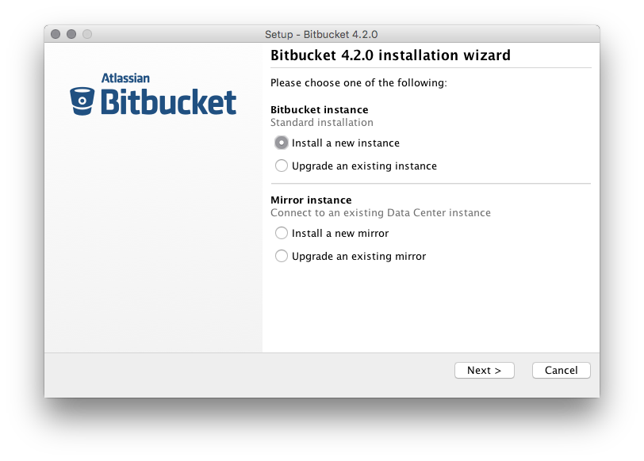2. Run the installer and follow the installation wizard.

3. On Linux and Windows, the installer can install Bitbucket server as a service (although not when upgrading an existing Bitbucket server). A service account named ‘atlbitbucket’ will be created.

1. The Bitbucket Server installer has three modes. However we recommend installing using the GUI mode.

* GUI mode (recommended): the default mode for the installer is to display a GUI installer.
* Console mode: if the installer is invoked with –c argument. The interaction with the user is performed in the terminal which the installer invoked.
* Unattended mode: if the installer is invoked with the –q argument there is no interaction with user and the installation is performed automatically with the default values. You may also supply a response file with a –varfile option, to supply answers for all the questions that are used instead of the defaults.

1. Please find below the suggested values for the questions raised during the installation of Bitbucket.

* Should Bitbucket be installed as Service: Yes
* Bitbucket Ports: (Defaults) http=7990 serverPort=8006
* Path to Bitbucket server home: ~/var/atlassian/application-data/bitbucket
* Target Installation Directory: (Default) /opt/atlassian/bitbucket/<VERSION>