Gitlab Installation

|  |  |
| --- | --- |
| Author: | Paul Sehgal |
| Document Name: | Gitlab Installation |
| Document Location: |  |
|  |
| Date Created: | 07/02/2017 |
| Date Last Modified: | 07/02/2017 |
| Status: | Draft |
| Confidentiality: | <Select/enter confidentiality status> |
| Circulation: | <Detail circulation list> |
| Document Version: | 0.1 |

Contents

1. Overview 2

2. Prerequisites 3

3. Process 4

# Overview

This document details step by step instructions on the installation of Gitlab.

# Prerequisites

* The server must be using Centos 7.
* Ensure you have an SSH client installed such as PUTTY. (<http://www.putty.org/>)

# 3. Process

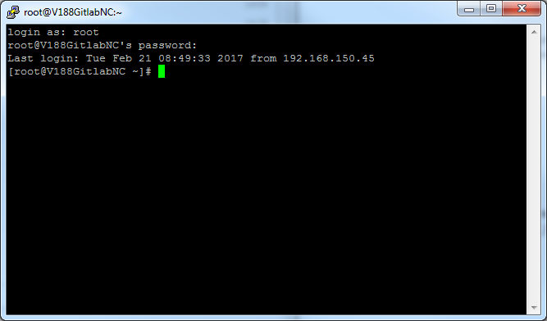1. Using PUTTY login into your Linux server as root:

1. At the prompt please type in the following command:

sudo yum install curl policycoreutils openssh-server openssh-clients

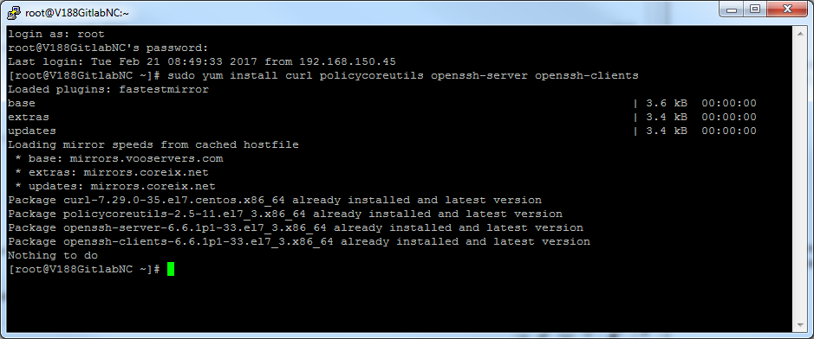The output is shown below.

1. Next type in the following commands to install and configure necessary dependencies:

sudo systemctl enable sshd

sudo systemctl start sshd

sudo yum install postfix

sudo systemctl enable postfix

sudo systemctl start postfix

sudo firewall-cmd --permanent --add-service=http

sudo systemctl reload firewalld

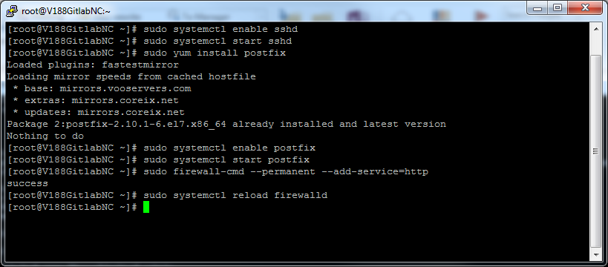The output will be as follows:

1. Next type in the following commands to add the Gtilab package server and install the package:

curl -sS https://packages.gitlab.com/install/repositories/gitlab/gitlab-ce/script.rpm.sh | sudo bash

sudo yum install gitlab-ce

The second command will ask for confirmation concerning the installation size. Please confirm by typing in “y” and then press the “Return”key. The output is shown below:

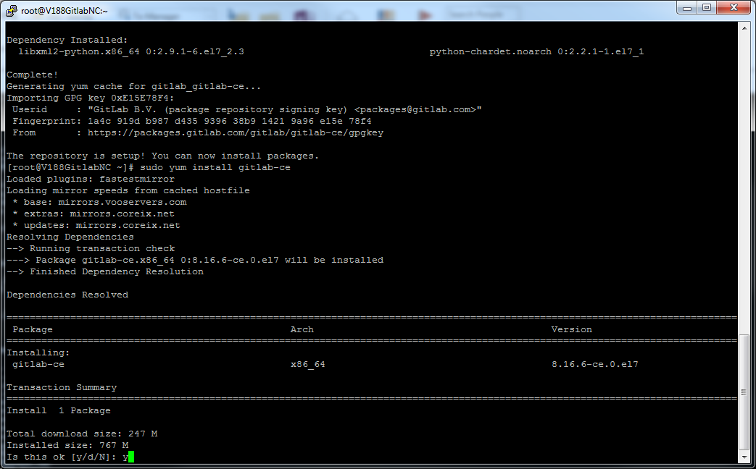

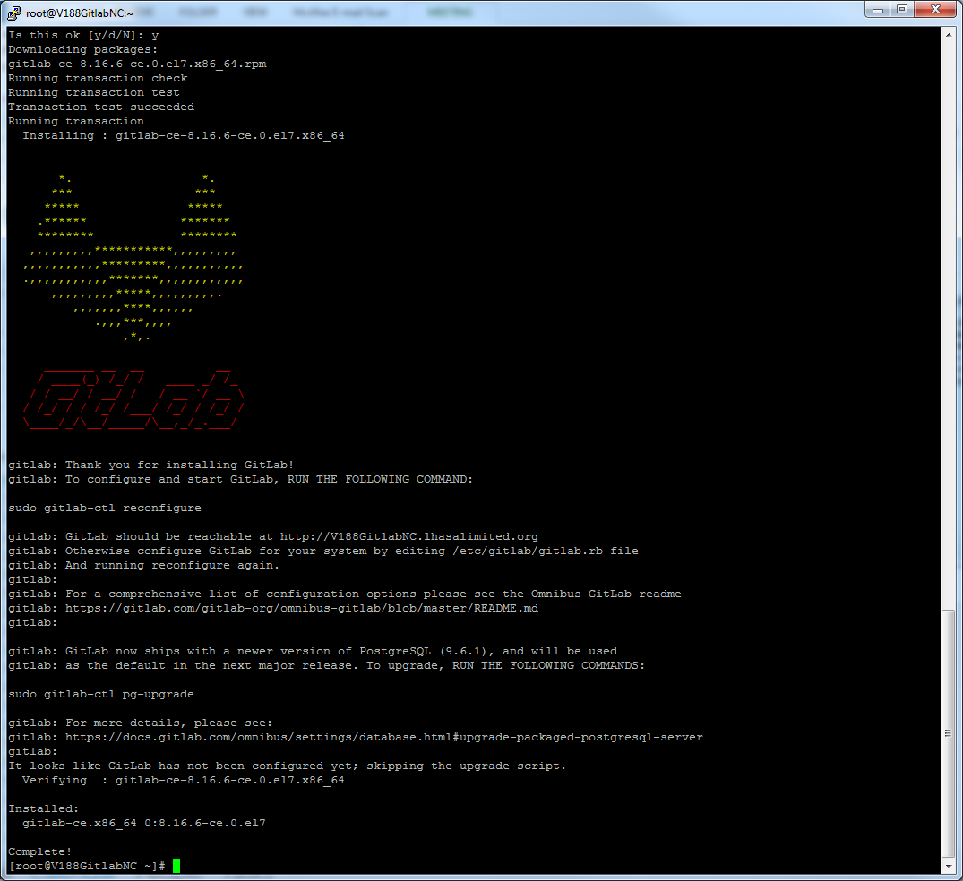

1. Next type in the following command to configure and start GitLab.

sudo gitlab-ctl reconfigure

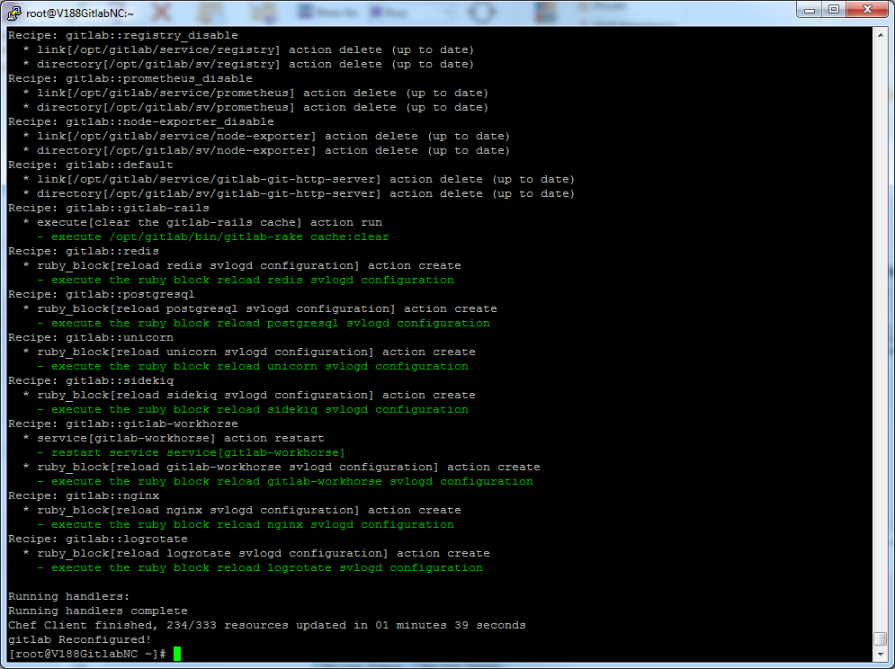The output will be as follows:

1. Browse to the hostname (http://<hostname>) and change your password. The web page should look like the screen below:

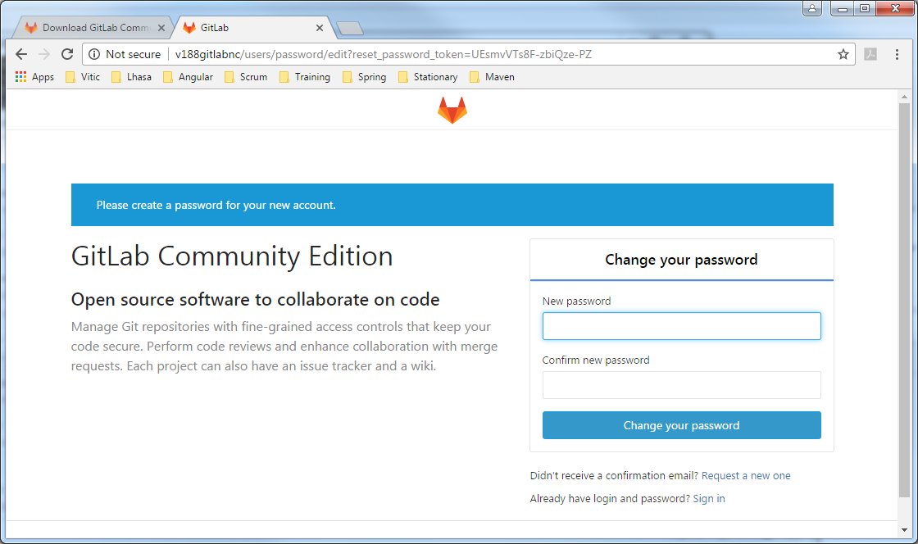

1. 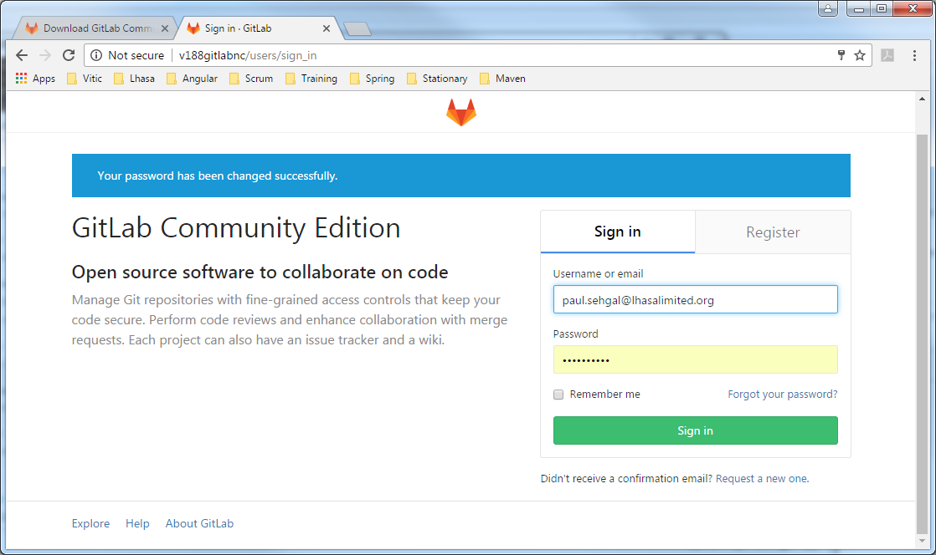The following screen will appear:
2. Click on “Register” and enter your details. Once you have entered your details and registered the following screen will appear. Git lab is now installed.

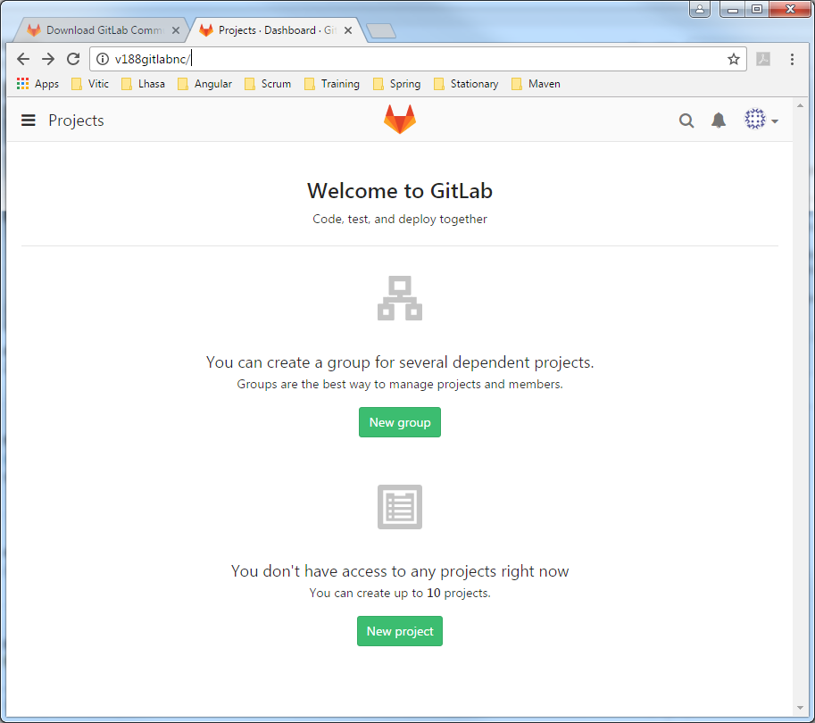

1. To migrate an existing git repository type in the following commands on your local git repository. Ensure you have pulled and fetched the latest version of the orignal remote git repository.

git clone --mirror <url_of_old_repo>

cd <name_of_old_repo>

git remote add new-origin <url_of_new_repo>

git push new-origin --mirror