**Eclipse – Use Git Plugin**

Eclipse uses EGit plugin <http://www.eclipse.org/egit/>

**Clone a repository**

Navigate to the Git Perspective

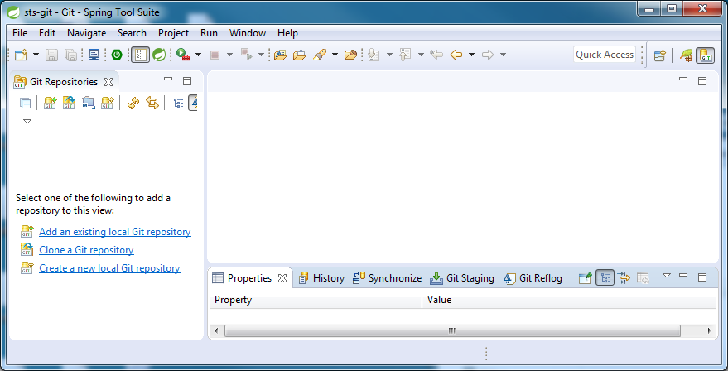

Click on the clone icon:

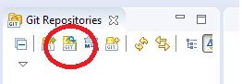

enter the URI in the dialog, finding the clone URI from bitbucket and copying and pasting it into the URI on the dialog will fill in most of the dialog automatically for you, you simply have to provide a password.

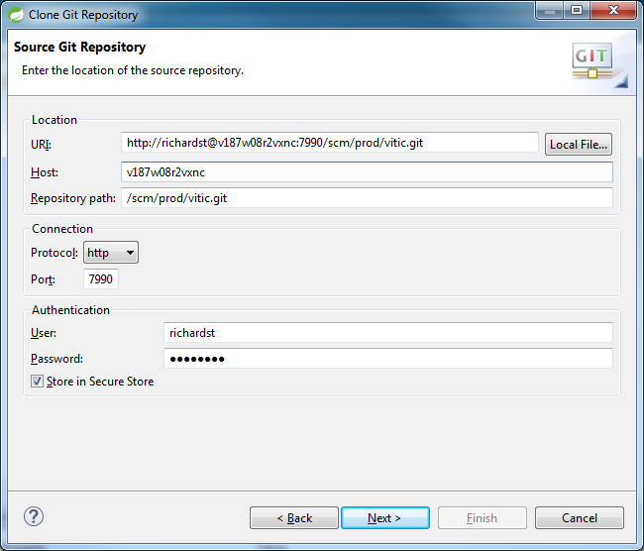

Select master as the branch you are interested in:

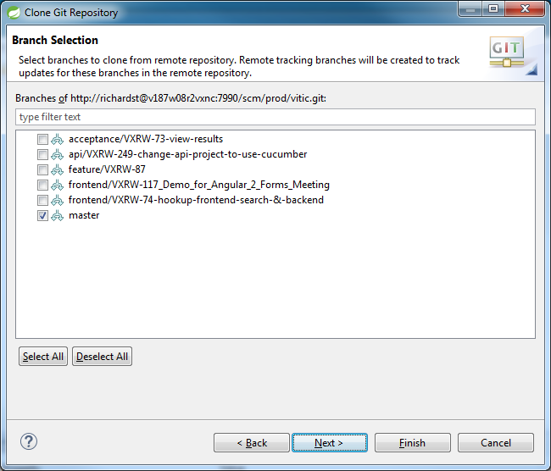

Choose checkout directory and initial branch, leave remote as origin:

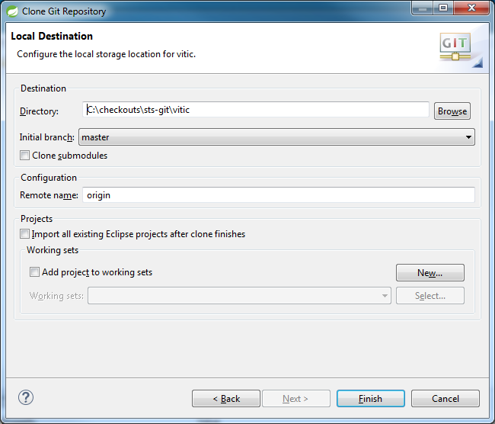

**Create a branch to work on and push the branch to the remote**

Right click on the repository and select “Switch To” -> “New Branch”

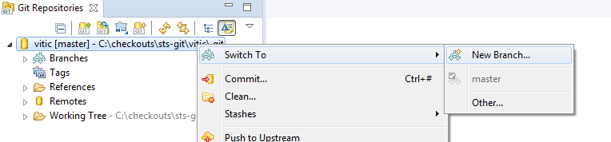

Type in branch name in dialog:

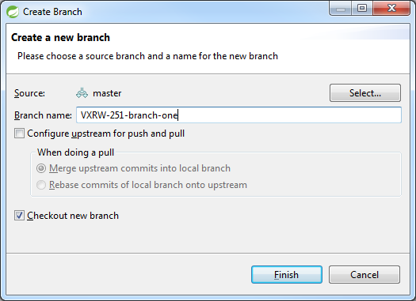

Push this branch to the remote. Now the remote knows about the branch you have made, not just your local machine.

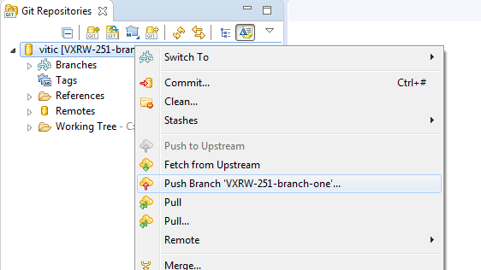

**Make some changes and view them.**

Now make some changes to your codebase. In this case simply alter some Javadoc.

You can see the changes that you have done in the staging view:

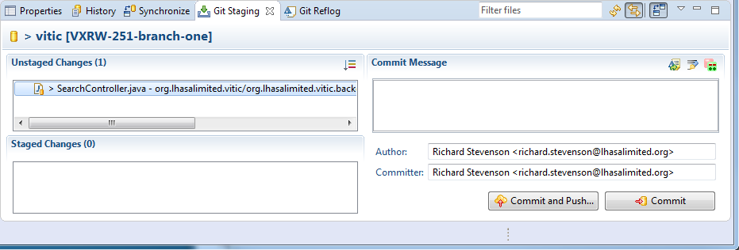

To commit the changes you have to drag your unstaged changes into your staged change area.

Now we can commit, we have a choice of committing locally or committing and pushing our changes to the remote. As we are working on our own branch and we don’t want the changes just to stay on our local machine here we will use the shortcut of committing and pushing. Type in a sensible commit message and hit the button.

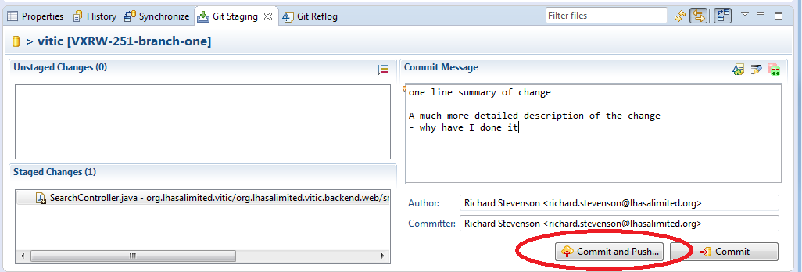

Handle merge conflicts

Now imagine I want to merge and I have conflicts, it might be master or any other branch. Here I have created another branch, VXRW-251-branch-two that I know will have merge conflicts.

Merge by right clicking on repo and selecting merge:

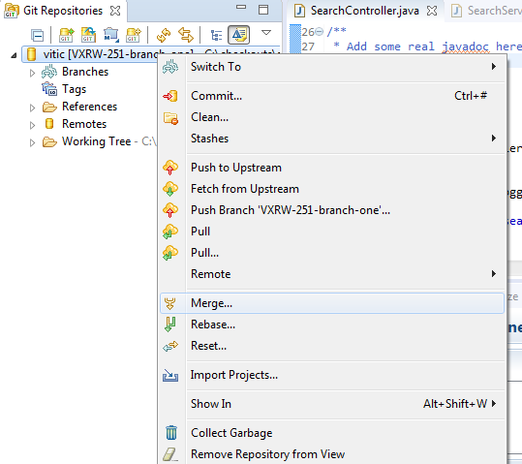

Select the branch you want to merge:

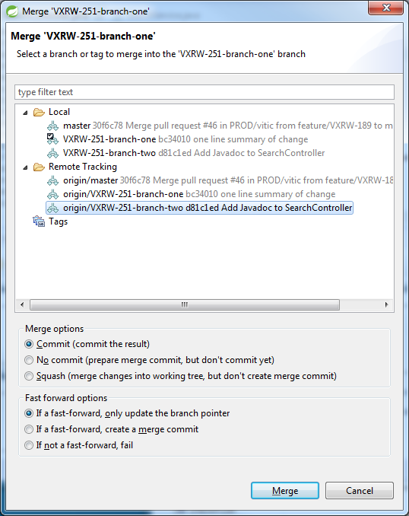

Here we get conflicts:

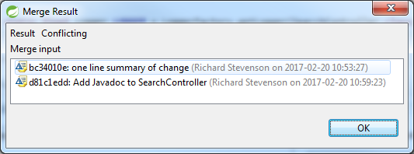

Which we can easily see in our view:

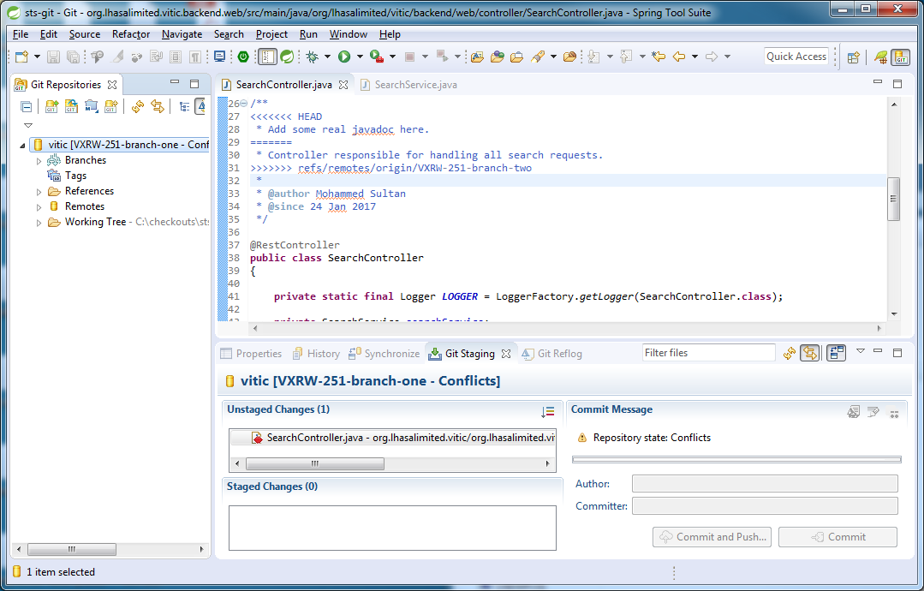

Go to package explorer and either select the resource or a higher level resource that has the conflict and select “Team” -> “Merge Tool”

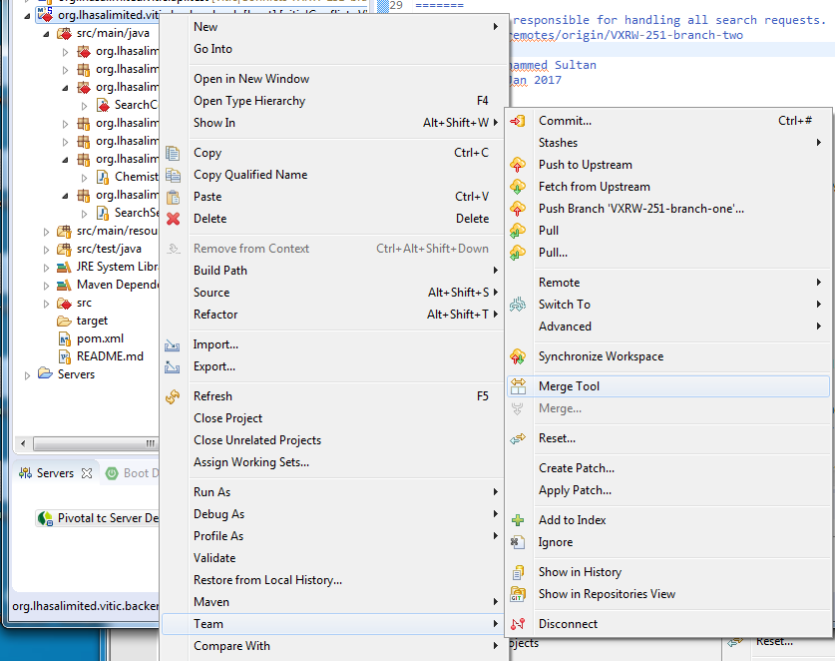

Handle conflicts as you normally would in the merging view:

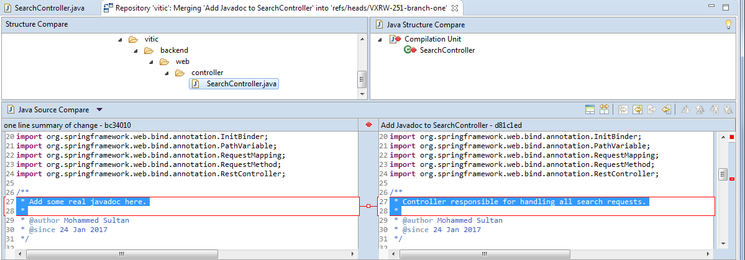

So when you are happy with the changes save them and add the resource to the staged changes. Usually the standard commit message for a merge is good enough so we can now run tests then commit these changes, as before.

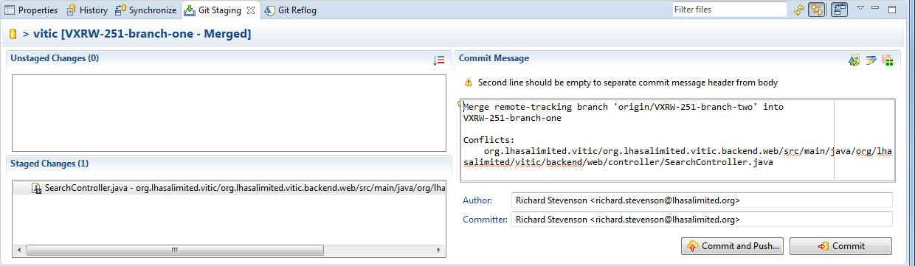

**References**:

http://wiki.eclipse.org/EGit/User_Guide

http://www.vogella.com/tutorials/EclipseGit/article.html