**Node Plugin for Jenkins**

1. Navigate to **Manage Jenkins** > **Manage Plugins** and add NodeJS Plugin

**Install Node JS (Windows Machine Requires manual Installation)**

1. Windows currently requires node to be installed manually
2. Log onto Jenkins machine
3. Install node.js v6.9.4 (<https://nodejs.org/en/download/>
4. Run “node –v” to ensure that node v6.9.4 has been installed
5. Install npm by running command npm install npm@latest –g
6. Check version is higher than 2.1.8 by running “npm -v”
7. as its windows it probably won't work out of the box see http://stackoverflow.com/questions/27327832/nodejs-plugin-for-dalek-on-jenkins-configuration-issues-questions so we have to create a link to a bin folder so that the node plugin for Jenkins will work. Run following command:
   1. mklink /j "C:\Program Files\nodejs\bin" "C:\Program Files\nodejs"

**Jenkins Node JS Plugin Configuration**

1. Go to **Manage Jenkins** > **Global Tool Configuration**
2. Add the node installation as below:

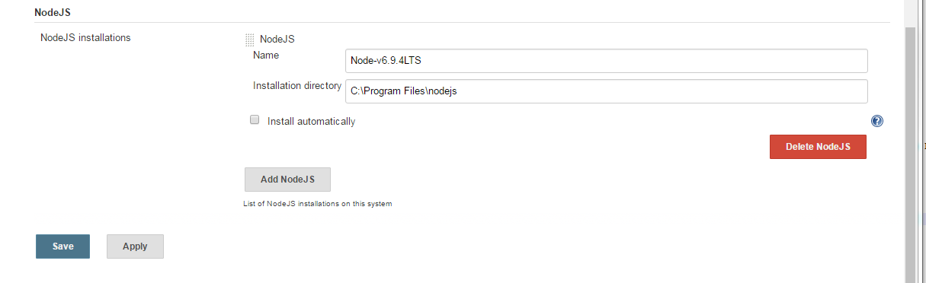

**Jenkins Job Configuration**

1. Add Node and npm to the build environment of your job:

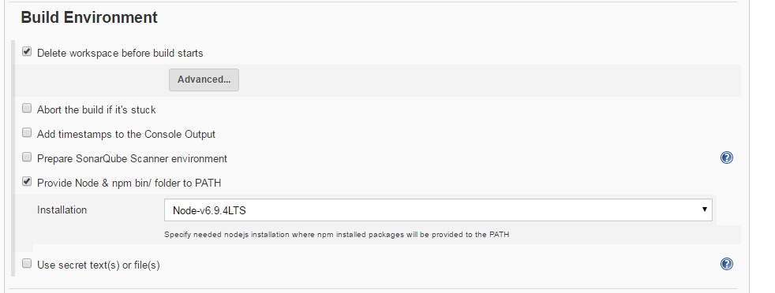

1. In the build you can now call out to npm in a script. Note that for windows the call to npm is a bat file so you need to actually use the “call” command.

Example windows batch command

echo "going to start the npm tests"

echo "version of node is:"

node -v

echo "version of npm is:"

call npm -v

echo "changing directory to the web frontend directory to do the build from there"

cd org.lhasalimited.vitic.frontend.web

echo "installing node modules"

call npm i

echo "running node tests"

call npm run test-jenkins