**Project- II (on Aging data):**  Classification of NH & HL from the scalp surface EEG data

Goals and objective:

1. Find an ERP biomarker that can tell us NH & HL
2. Select the electrodes those cover the auditory associated ROIs
3. Find the ERP as a cluster wise (we made 5 clusters (C-1 to C-5) shown in Fig.1) for each subject
4. Explore the frequency band that associated with hearing loss.

C:\Users\Sultan\OneDrive - The University of Memphis\RESEARCH2017S\Hearing_data\biosemi32_Cluster_marked.tif

Figure-1: Clustering of electrodes.

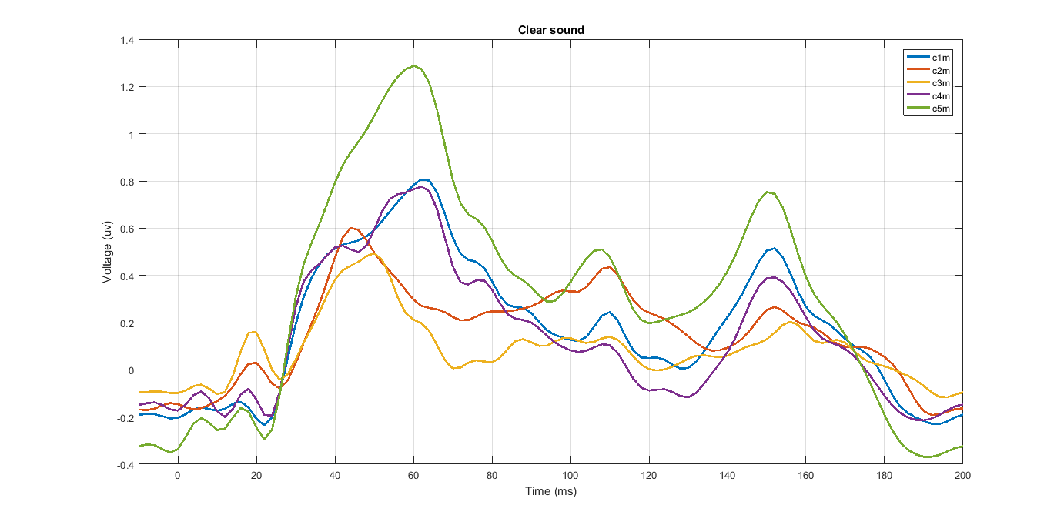

Figure-2: Grand average (cluster wise) of clear sound

**P1 ~ 40-70 ms; N1=90-145 ms and P2=145-175 ms**

Figure-3: Grand average (cluster wise) of noise sound

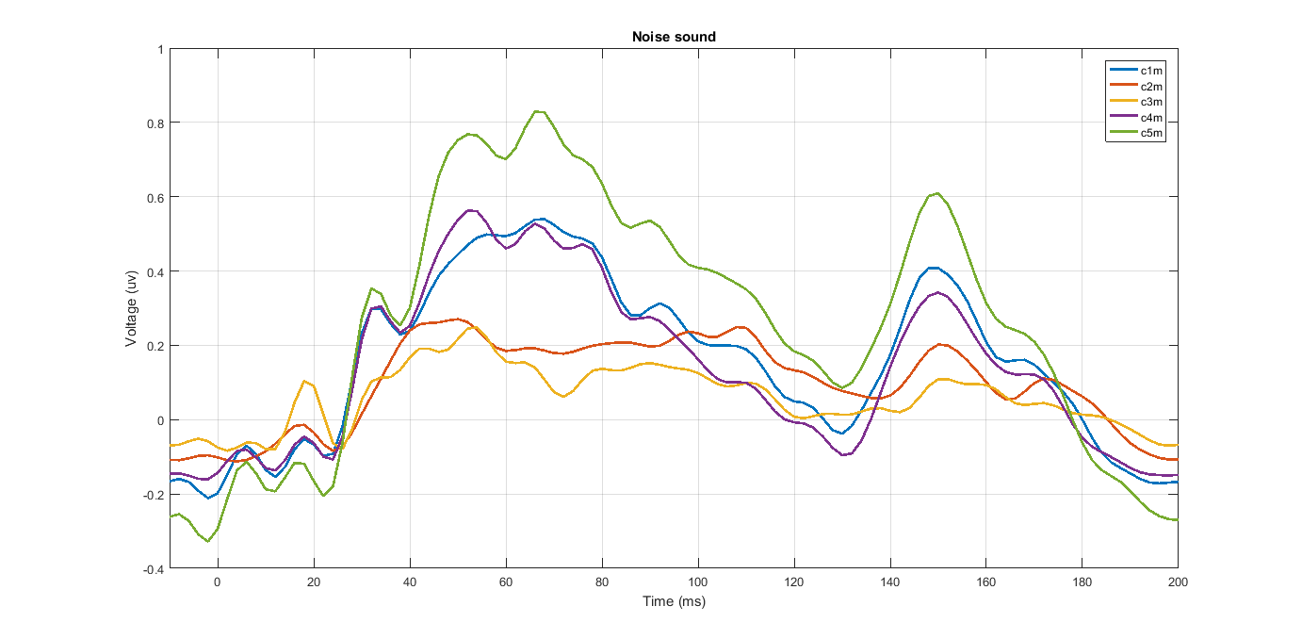

In this dataset, the epoch is 210 ms and sampling rate 500 Hz. So, total data points over 210 ms is: 0.210\*500=105+1=106.

Every cluster data considered as a feature vector. We fed this 5 features to the SVM classifier and observed the accuracy over the whole data

The time versus accuracy over 106 data points is shown in Figure -4.

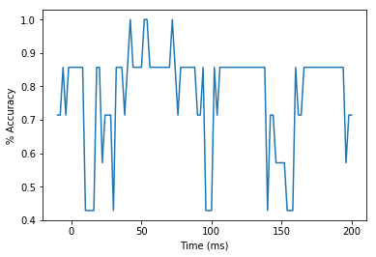

Figure-4: Time versus accuracy for clear speech detection

This is the result over (40-56 ms).

Index Time(ms) Accuracy

25 40.0 0.857143

26 42.0 1.000000

27 44.0 0.857143

28 46.0 0.857143

29 48.0 0.857143

30 50.0 0.857143

31 52.0 1.000000

32 54.0 1.000000

33 56.0 0.857143

The average accuracy over the time (40ms-56ms) is: 90.4761904762 %

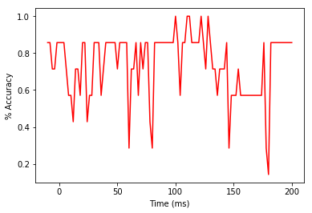

Figure-5: Time versus accuracy for noise-degraded speech detection

This is the result over (96-114 ms).

Index Time(ms) Accuracy

53 96.0 0.857143

54 98.0 0.857143

55 100.0 1.000000

56 102.0 0.857143

57 104.0 0.571429

58 106.0 0.857143

59 108.0 0.857143

60 110.0 1.000000

61 112.0 1.000000

62 114.0 0.857143

The average accuracy over the time is: 87.1428571429

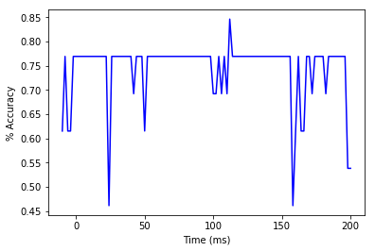

Figure-6: Time versus accuracy for clear and noise-degraded speech detection (together)

0 0

53 96.0 0.769231

54 98.0 0.769231

55 100.0 0.692308

56 102.0 0.692308

57 104.0 0.769231

58 106.0 0.692308

59 108.0 0.769231

60 110.0 0.692308

61 112.0 0.846154

62 114.0 0.769231

63 116.0 0.769231

64 118.0 0.769231

The average accuracy over the time is: 75.0

Frequency band analysis

Frequency band ranges selection [[ref](file:///C:\Users\Sultan\OneDrive%20-%20The%20University%20of%20Memphis\RESEARCH2017S\CLUSTER_channels\Papers\Induced%20neural%20beta%20oscillations%20predict%20categorical%20speech%20perception.pdf)] from Dr. Bidelman paper

Theta=4-8 Hz,

Alpha=9-13 Hz,

Beta= 14-30 Hz

Gamma =31-40 Hz

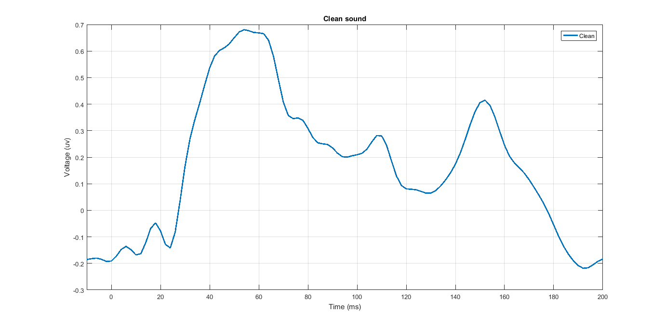

Figure-4: Grand average for clear sound detection (all channels)

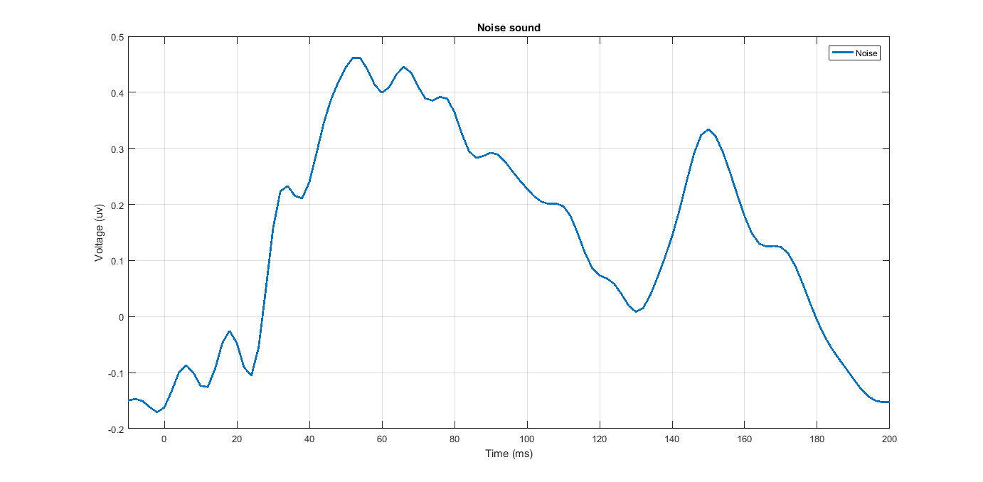

Figure-5: Grand average for noise-degraded sound detection (all channels)