**Project-I (on making sense of sounds (**[**MSOS**](http://cvssp.org/projects/making_sense_of_sounds/site/challenge/)**) data challenge)**

**Goal:** Classify the principle categories of sounds from audio files

**Dataset description:** This data set has 5 principle categories, (each category has different number of sub classes). Each principle category has 300 examples and duration of each audio file is 5 s. Principle class labels are as follows:

1. Nature (sub-classes:18)
2. Human (sub-classes:17)
3. Music (sub-classes: 24)
4. Effects (sub-classes:19)
5. Urban (sub-classes:19)

**So, the total sub-classes are 97**

This is an imbalanced data set. The maximum and minimum frequency of the sub classes are 69 and 1, respectively.

First, I extracted 5 features (e.g., Entropy of energy, spectral spread, spectral entropy, MFCCs and Chroma vector) from the audio file and used this features as an input of the classifier and found the following accuracy:

SVM: 19.66

NB: 22.33

DT: 14.1

**Second**, 50ms and no overlapping, I added a few more features (ZCR, energy, spectral centroid and so on) and classify them in sub-classes label with SVM grid search and tuning the parameters and found 30% accuracy.

Here the feature vectors (34\*100 for each file after concatenate 1\*3400)

Here I did two ways,

In ordinary way, the accuracy was 7 % in sub class label

After up sampling found that 30%

Here I chose the 1460 for training purpose 40 for test purpose

**Features extraction process:**

50ms window and step size 50ms (i.e., there is no overlap), so feature dimension is 5s/50ms=100 each feature

And another way 50ms and 25ms step (i.e., 50% overlapping)

**Project- II (on Aging data):**  Classification of NH & HL from the scalp surface EEG data

Goals and objective:

1. Find a ERP biomarker that can tell us NH & HL
2. Select the electrodes those cover the auditory associated ROIs
3. Find the ERP as a cluster wise (we made 5 clusters (C-1 to C-5) shown in Fig.1) for each subject

C:\Users\Sultan\OneDrive - The University of Memphis\RESEARCH2017S\Hearing_data\biosemi32_Cluster_marked.tif

Figure-1: Clustering of electrodes.

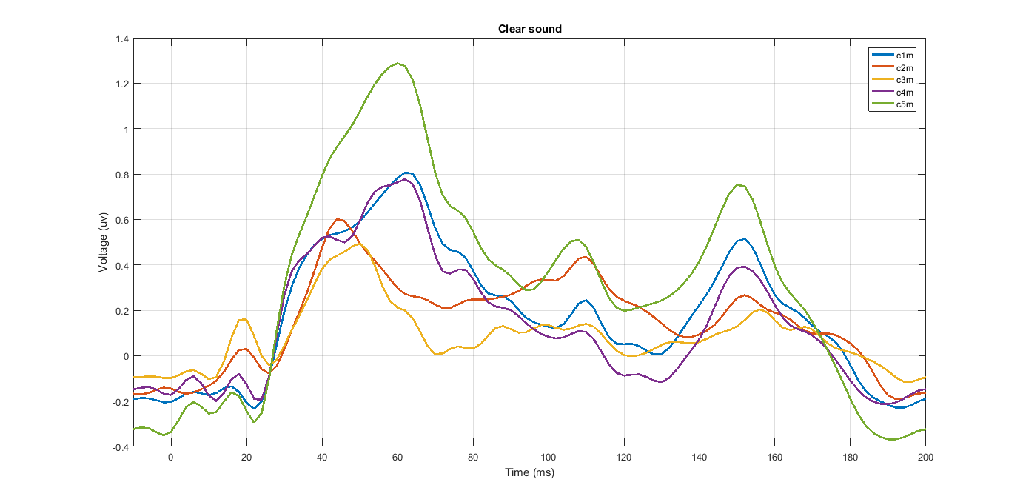

Figure-2: Grand average (cluster wise) of clear sound

P1 ~ 40-70ms; N1=90-145ms and P2=145-175 ms

Figure-3: Grand average (cluster wise) of noise sound

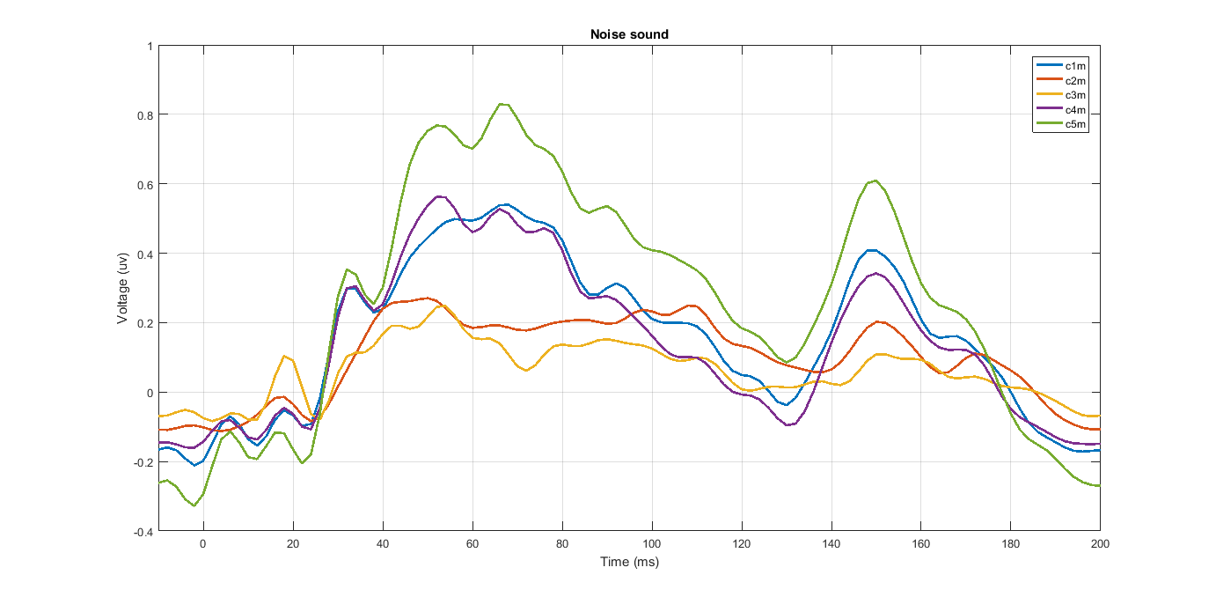

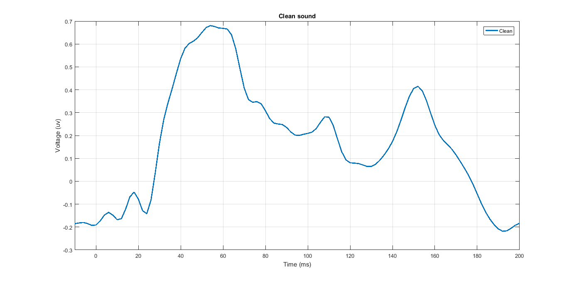

Figure-4: Grand average of clean sound (all channels)

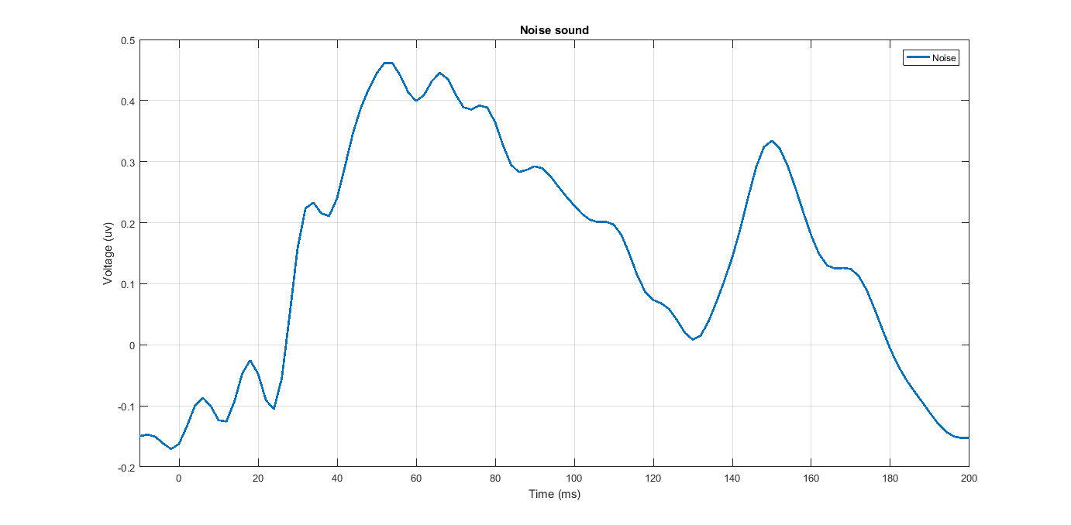

Figure-5: Grand average of noise sound (all channels)