**Project- II (on Aging data):**  Classification of NH & HL from the scalp surface EEG data

Goals and objective:

1. Find an ERP biomarker that can tell us NH & HL
2. Select the electrodes those cover the auditory associated ROIs
3. Find the ERP as a cluster wise (we made 5 clusters (C-1 to C-5) shown in Fig.1) for each subject
4. Explore the frequency band that associated with hearing loss.

C:\Users\Sultan\OneDrive - The University of Memphis\RESEARCH2017S\Hearing_data\biosemi32_Cluster_marked.tif

Figure-1: Clustering of electrodes.

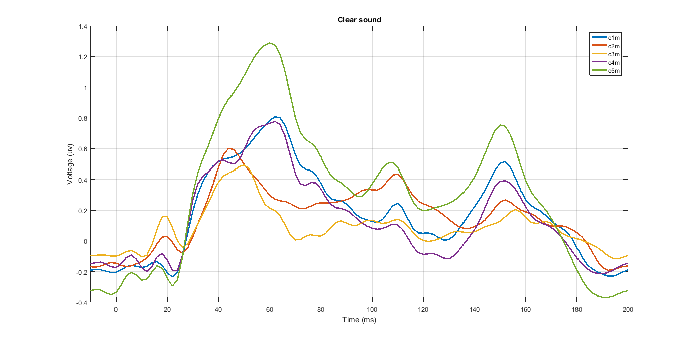

Figure-2: Grand average (cluster wise) of clear sound

**P1 ~ 40-70 ms; N1=90-145 ms and P2=145-175 ms**

Figure-3: Grand average (cluster wise) of noise sound

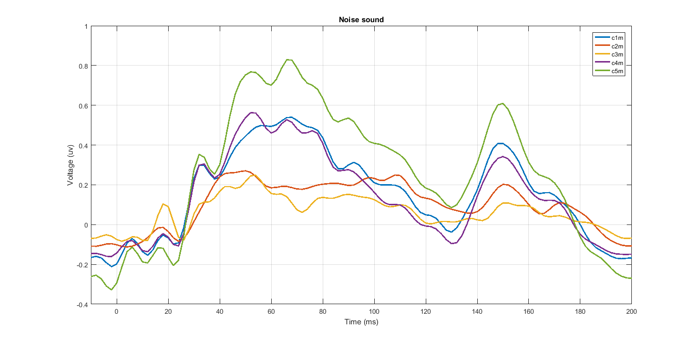

In this dataset, the epoch is 210 ms and sampling rate 500 Hz. So, total data points over 210 ms is: 0.210\*500=105+1=106.

Every cluster data considered as a feature vector. We fed this 5 features to the SVM classifier and observed the accuracy over the whole data

The time versus accuracy over 106 data points is shown in Figure -4.

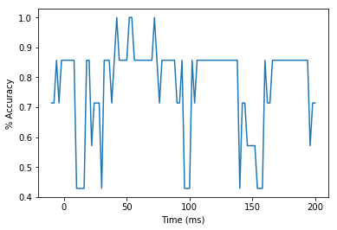

Figure-4: Time versus accuracy for clear speech detection

This is the result over (40-56 ms).

Index Time(ms) Accuracy

25 40.0 0.857143

26 42.0 1.000000

27 44.0 0.857143

28 46.0 0.857143

29 48.0 0.857143

30 50.0 0.857143

31 52.0 1.000000

32 54.0 1.000000

33 56.0 0.857143

The average accuracy over the time (40ms-56ms) is: 90.4761904762 %

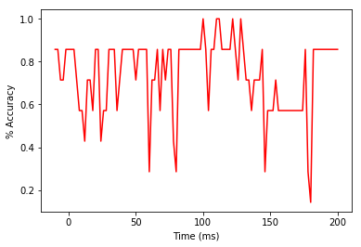

Figure-5: Time versus accuracy for noise-degraded speech detection

This is the result over (96-114 ms).

Index Time(ms) Accuracy

53 96.0 0.857143

54 98.0 0.857143

55 100.0 1.000000

56 102.0 0.857143

57 104.0 0.571429

58 106.0 0.857143

59 108.0 0.857143

60 110.0 1.000000

61 112.0 1.000000

62 114.0 0.857143

The average accuracy over the time is: 87.1428571429

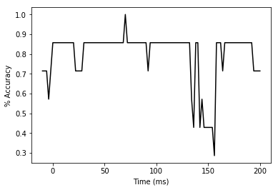

Figure-6: Time versus accuracy for clear speech detection (LH)

0 0

35 60.0 0.857143

36 62.0 0.857143

37 64.0 0.857143

38 66.0 0.857143

39 68.0 0.857143

40 70.0 1.000000

41 72.0 0.857143

42 74.0 0.857143

43 76.0 0.857143

44 78.0 0.857143

The average accuracy over the time is: 87.1428571429

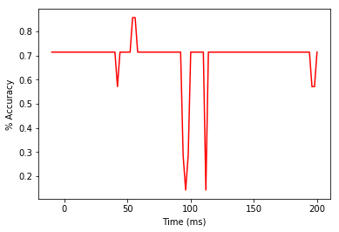

Figure-7: Time versus accuracy for clear speech detection (RH)

0 0

27 44.0 0.714286

28 46.0 0.714286

29 48.0 0.714286

30 50.0 0.714286

31 52.0 0.714286

32 54.0 0.857143

33 56.0 0.857143

34 58.0 0.714286

35 60.0 0.714286

36 62.0 0.714286

The average accuracy over the time is: 74.2857142857

Frequency band analysis

Frequency band ranges selection [[ref](file:///C:\Users\Sultan\OneDrive%20-%20The%20University%20of%20Memphis\RESEARCH2017S\CLUSTER_channels\Papers\Induced%20neural%20beta%20oscillations%20predict%20categorical%20speech%20perception.pdf)] [Induced neural beta, p6] from Dr. Bidelman paper

Theta=4-8 Hz,

Alpha=9-13 Hz,

Beta= 14-30 Hz

Gamma =31-40 Hz

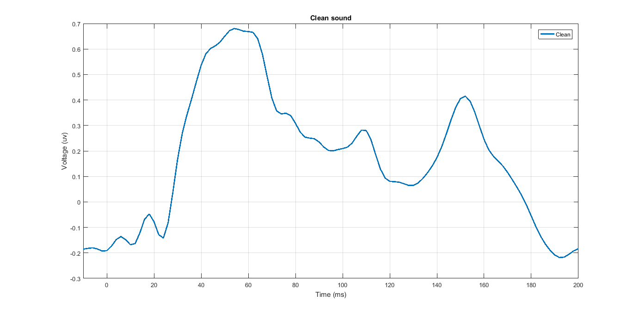

Figure-4: Grand average for clear sound detection (all channels)

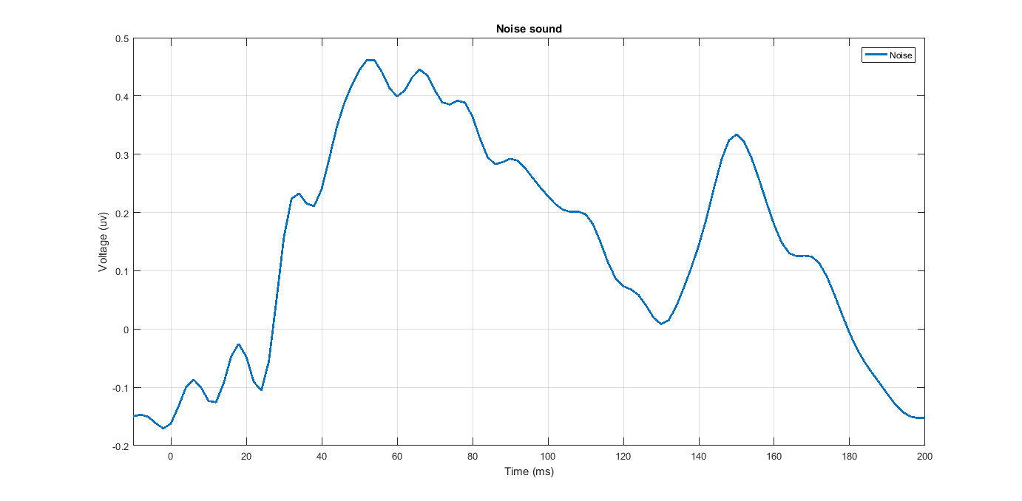

Figure-5: Grand average for noise-degraded sound detection (all channels)