Scandinaviafinal

Sulyok

October 8, 2020

library(readr)  
library(ggplot2)  
#######mobility data  
#gmr <- read_csv("Global_Mobility_Report(3).csv", col_types = cols(date #= col_date(format = "%Y-%m-%d")))  
  
  
#library(data.table)  
#library(ggplot2)  
  
######### Loading country data  
  
#countries <- fread("http://download.geonames.org/export/dump/countryInf#o.txt", skip = "ISO3", na.strings = "")  
#names(countries)[c(1,5, 9)] <- c("geo", "Country.Region", "Continent")  
#countries$lang <- sapply(strsplit(sapply(strsplit(countries$Languages, #","), `[`, 1), "-"), `[`, 1)  
#countries$translated <- "Coronavirus"  
  
############## Obtaining the case numbers  
  
#jhu_url <- paste0("https://raw.githubusercontent.com/CSSEGISandData/COV#ID-19/master/csse_covid_19_data/",  
 # "csse_covid_19_time_series/time_series_covid19_deaths#_global.csv")  
#CaseData <- fread(jhu_url, check.names = TRUE)  
#CaseData$Province.State[ CaseData$Province.State=="" ] <- #CaseData$Country.Region[ CaseData$Province.State=="" ]  
#CaseData <- melt(CaseData, id.vars = 1:4, variable.name = "Date", #variable.factor = FALSE)  
#CaseData$Date <- as.Date( substring(CaseData$Date, 2), format = #"%m.%d.%y" )  
#CaseData <- CaseData[ , .(CumCaseNumber = sum(value)), #.(Country.Region, Date)][order(Country.Region, Date)]  
#CaseData <- CaseData[ ,.(date = Date[-1], CumCaseNumber = #CumCaseNumber[-1], IncCaseNumber = diff(CumCaseNumber)),  
 # .(Country.Region)]  
  
#CaseData[Country.Region=="US"]$Country.Region <- "United States"  
#CaseData <- merge(CaseData,countries[,c("Country.Region", "geo", #"Continent")])  
#CaseData$country_region<-CaseData$Country.Region  
  
#CaseData$IncCaseNumber<-ifelse(CaseData$IncCaseNumber<0, 0, #CaseData$IncCaseNumber )  
#write.csv(CaseData, "CaseNumbersdeaths0610.csv")  
#levels(factor(gmr$country_region))  
#levels(factor(CaseData$country_region))  
  
  
###stringency  
  
#stringency<-fread("https://raw.githubusercontent.com/OxCGRT/covid-polic#y-tracker/master/data/OxCGRT_latest.csv")  
#stringency$Date<-as.Date(as.character(stringency$Date), "%Y%m%d")  
#stringency<-stringency[,c(1,5,35)]  
#stringency$Country.Region<-factor(stringency$CountryName)  
#stringency$date<-stringency$Date  
#write.csv(stringency, "stringency0610.csv")   
  
#allmerged<-merge(gmr, CaseData, by=c("country_region", "date"))  
#all<-allmerged  
#all$NumDate <- as.numeric(all$date)-min(as.numeric(all$date))  
#data<- subset(all, is.na(all$sub_region_1)==TRUE)  
#data$IncCaseNumber<-ifelse(data$IncCaseNumber<0, 0, data$IncCaseNumber #)  
  
  
#data<-data[-c(1,3:8, 18)]  
#summary(data)  
#data<-na.omit(data)  
  
  
###scandinavia  
  
  
  
#data<-subset(data, data$Country.Region=="Sweden" | #data$Country.Region=="Norway"   
 # | data$Country.Region=="Denmark" | #data$Country.Region=="Finland" )   
#  
#data$IncCaseNumber<-ifelse(data$Country.Region=="Norway", #data$IncCaseNumber/5.432295, data$IncCaseNumber)   
#data$IncCaseNumber<-ifelse(data$Country.Region=="Sweden", #data$IncCaseNumber/10.115730, data$IncCaseNumber)   
#data$IncCaseNumber<-ifelse(data$Country.Region=="Denmark", #data$IncCaseNumber/5.797559, data$IncCaseNumber)   
#data$IncCaseNumber<-ifelse(data$Country.Region=="Finland", #data$IncCaseNumber/5.542988, data$IncCaseNumber)  
#data$Country.Region<-factor(data$Country.Region)  
  
  
  
####add stringency  
#stringencysc<-subset(stringency, stringency$Country.Region=="Sweden" | #stringency$Country.Region=="Norway"   
 # | stringency$Country.Region=="Denmark" | #stringency$Country.Region=="Finland" )   
#summary(stringencysc)  
#data<-merge(data, stringencysc, by=c("Country.Region", "date"))  
#write.csv(data, "Scandinaviadata0910.csv")  
data <- read_csv("Scandinaviadata1010.csv", col_types = cols(Date = col_date(format = "%Y-%m-%d"), date = col_date(format = "%Y-%m-%d")))

## Warning: Missing column names filled in: 'X1' [1]

data$Country.Region<-factor(data$Country.Region)  
data<-data[,-1]  
  
  
  
#####visualization  
library(dunn.test)  
dunn.test(data$StringencyIndex, data$Country.Region)

## Kruskal-Wallis rank sum test  
##   
## data: x and group  
## Kruskal-Wallis chi-squared = 153.8512, df = 3, p-value = 0  
##   
##   
## Comparison of x by group   
## (No adjustment)   
## Col Mean-|  
## Row Mean | Denmark Finland Norway  
## ---------+---------------------------------  
## Finland | 9.172419  
## | 0.0000*  
## |  
## Norway | 9.694110 0.530705  
## | 0.0000* 0.2978  
## |  
## Sweden | 11.09787 1.901094 1.367120  
## | 0.0000* 0.0286 0.0858  
##   
## alpha = 0.05  
## Reject Ho if p <= alpha/2

ggplot(data, aes(date, IncCaseNumber, group=Country.Region, color=Country.Region)) +geom_line()

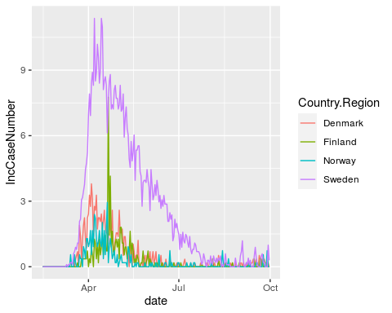

ggplot(data, aes(date, StringencyIndex, group=Country.Region, color=Country.Region)) +geom_line()

## Warning: Removed 2 row(s) containing missing values (geom_path).

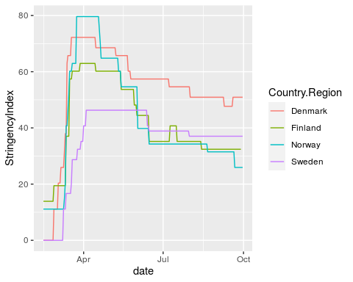

ggplot(data, aes(date, retail_and_recreation_percent_change_from_baseline, group=Country.Region, color=Country.Region)) +geom_line()

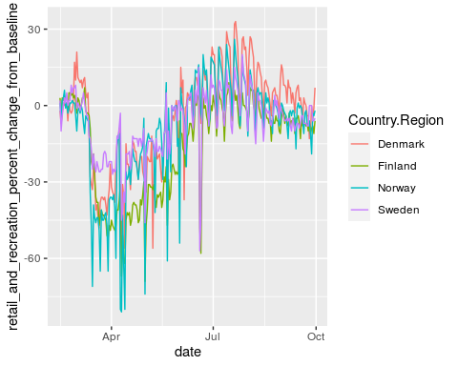

ggplot(data, aes(date, grocery_and_pharmacy_percent_change_from_baseline, group=Country.Region, color=Country.Region)) +geom_line()

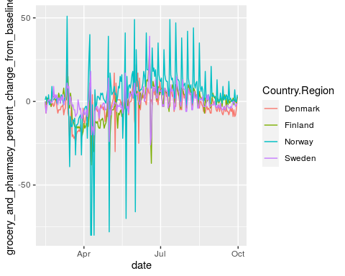

ggplot(data, aes(date, transit_stations_percent_change_from_baseline, group=Country.Region, color=Country.Region)) +geom_line()

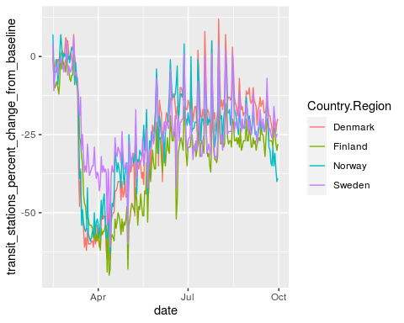

ggplot(data, aes(date, workplaces_percent_change_from_baseline, group=Country.Region, color=Country.Region)) +geom_line()

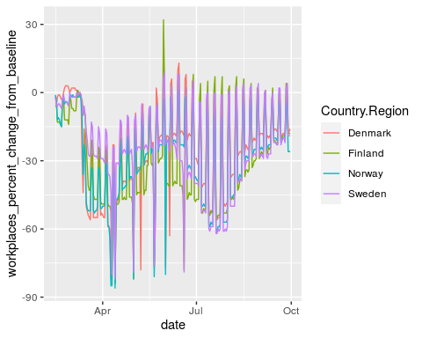

########################################correlations############################  
  
######## contemp deaths correlations ################################  
  
contemp<-function(x) {  
 dat<-subset(data, data$Country.Region==x)  
 corfun<-function(y){cor.test(dat$IncCaseNumber, y, exact = FALSE, method = "spearman")$estimate}  
 cc<-as.data.frame(lapply(dat[c(3:8,15)], corfun))  
cc$Country.Region<-x  
a<-cc  
}  
  
results<-NULL  
d<-NULL  
  
for( Country.Region in unique(data$Country.Region) ) {  
 d<-contemp(Country.Region)  
 results<-rbind(results, data.frame(d))  
 }  
resultscont<-results  
resultscont

## retail_and_recreation_percent_change_from_baseline  
## rho -0.6015667  
## rho1 -0.6424336  
## rho2 -0.3794675  
## rho3 -0.4883875  
## grocery_and_pharmacy_percent_change_from_baseline  
## rho -0.2672288  
## rho1 -0.4212525  
## rho2 -0.1623567  
## rho3 -0.1858322  
## parks_percent_change_from_baseline  
## rho -0.120414895  
## rho1 -0.255202353  
## rho2 -0.119077789  
## rho3 0.004303588  
## transit_stations_percent_change_from_baseline  
## rho -0.7056992  
## rho1 -0.6445364  
## rho2 -0.5567921  
## rho3 -0.6845884  
## workplaces_percent_change_from_baseline  
## rho -0.4332604  
## rho1 -0.2813443  
## rho2 -0.4560485  
## rho3 -0.2889366  
## residential_percent_change_from_baseline StringencyIndex Country.Region  
## rho 0.6212733 0.7027086 Denmark  
## rho1 0.5861261 0.6697014 Finland  
## rho2 0.6014886 0.6276606 Norway  
## rho3 0.5778643 0.8270635 Sweden

summary(resultscont)

## retail_and_recreation_percent_change_from_baseline  
## Min. :-0.6424   
## 1st Qu.:-0.6118   
## Median :-0.5450   
## Mean :-0.5280   
## 3rd Qu.:-0.4612   
## Max. :-0.3795   
## grocery_and_pharmacy_percent_change_from_baseline  
## Min. :-0.4213   
## 1st Qu.:-0.3057   
## Median :-0.2265   
## Mean :-0.2592   
## 3rd Qu.:-0.1800   
## Max. :-0.1624   
## parks_percent_change_from_baseline  
## Min. :-0.255202   
## 1st Qu.:-0.154112   
## Median :-0.119746   
## Mean :-0.122598   
## 3rd Qu.:-0.088232   
## Max. : 0.004304   
## transit_stations_percent_change_from_baseline  
## Min. :-0.7057   
## 1st Qu.:-0.6899   
## Median :-0.6646   
## Mean :-0.6479   
## 3rd Qu.:-0.6226   
## Max. :-0.5568   
## workplaces_percent_change_from_baseline  
## Min. :-0.4560   
## 1st Qu.:-0.4390   
## Median :-0.3611   
## Mean :-0.3649   
## 3rd Qu.:-0.2870   
## Max. :-0.2813   
## residential_percent_change_from_baseline StringencyIndex Country.Region   
## Min. :0.5779 Min. :0.6277 Length:4   
## 1st Qu.:0.5841 1st Qu.:0.6592 Class :character   
## Median :0.5938 Median :0.6862 Mode :character   
## Mean :0.5967 Mean :0.7068   
## 3rd Qu.:0.6064 3rd Qu.:0.7338   
## Max. :0.6213 Max. :0.8271

write.csv(resultscont, "resultscovidcontemcorrtillaugust.csv")  
  
#####contemp pvalues  
  
contemp<-function(x) {  
 dat<-subset(data, data$Country.Region==x)  
 corfun<-function(y){cor.test(dat$IncCaseNumber, y, exact = FALSE, method = "spearman")$p.value}  
 cc<-as.data.frame(lapply(dat[c(3:8,15)], corfun))  
cc$Country.Region<-x  
a<-cc  
}  
  
results<-NULL  
d<-NULL  
  
for( Country.Region in unique(data$Country.Region) ) {  
 d<-contemp(Country.Region)  
 results<-rbind(results, data.frame(d))  
 }  
resultscontp<-results  
resultscontp

## retail_and_recreation_percent_change_from_baseline  
## 1 6.267622e-24  
## 2 4.751302e-28  
## 3 3.747210e-09  
## 4 3.952908e-15  
## grocery_and_pharmacy_percent_change_from_baseline  
## 1 4.194030e-05  
## 2 2.892149e-11  
## 3 1.454736e-02  
## 4 4.781754e-03  
## parks_percent_change_from_baseline  
## 1 6.893277e-02  
## 2 9.397374e-05  
## 3 7.400748e-02  
## 4 9.483579e-01  
## transit_stations_percent_change_from_baseline  
## 1 7.974384e-36  
## 2 2.803859e-28  
## 3 8.439707e-20  
## 4 5.194592e-33  
## workplaces_percent_change_from_baseline  
## 1 6.772961e-12  
## 2 1.547398e-05  
## 3 5.232635e-13  
## 4 8.845752e-06  
## residential_percent_change_from_baseline StringencyIndex Country.Region  
## 1 7.689108e-26 2.067131e-35 Denmark  
## 2 1.602370e-22 6.622692e-31 Finland  
## 3 1.258392e-23 3.681457e-26 Norway  
## 4 8.465111e-22 1.033263e-58 Sweden

summary(resultscontp)

## retail_and_recreation_percent_change_from_baseline  
## Min. :0.000e+00   
## 1st Qu.:0.000e+00   
## Median :2.000e-15   
## Mean :9.368e-10   
## 3rd Qu.:9.368e-10   
## Max. :3.747e-09   
## grocery_and_pharmacy_percent_change_from_baseline  
## Min. :0.000e+00   
## 1st Qu.:3.146e-05   
## Median :2.412e-03   
## Mean :4.843e-03   
## 3rd Qu.:7.223e-03   
## Max. :1.455e-02   
## parks_percent_change_from_baseline  
## Min. :0.000094   
## 1st Qu.:0.051723   
## Median :0.071470   
## Mean :0.272848   
## 3rd Qu.:0.292595   
## Max. :0.948358   
## transit_stations_percent_change_from_baseline  
## Min. :0.00e+00   
## 1st Qu.:0.00e+00   
## Median :0.00e+00   
## Mean :2.11e-20   
## 3rd Qu.:2.11e-20   
## Max. :8.44e-20   
## workplaces_percent_change_from_baseline  
## Min. :1.000e-12   
## 1st Qu.:5.000e-12   
## Median :4.423e-06   
## Mean :6.080e-06   
## 3rd Qu.:1.050e-05   
## Max. :1.547e-05   
## residential_percent_change_from_baseline StringencyIndex   
## Min. :7.690e-26 Min. :0.000e+00   
## 1st Qu.:9.457e-24 1st Qu.:0.000e+00   
## Median :8.641e-23 Median :3.300e-31   
## Mean :2.549e-22 Mean :9.204e-27   
## 3rd Qu.:3.318e-22 3rd Qu.:9.204e-27   
## Max. :8.465e-22 Max. :3.681e-26   
## Country.Region   
## Length:4   
## Class :character   
## Mode :character   
##   
##   
##

pconts<-as.vector(as.matrix(resultscontp[-8]))  
dim(pconts)<-c(4,7)  
adjustedpconts<-p.adjust(pconts, method="holm")  
dim(adjustedpconts)<-c(4,7)  
adjustedpconts

## [,1] [,2] [,3] [,4] [,5]  
## [1,] 1.190848e-22 2.935821e-04 0.2067983002 2.153084e-34 8.127553e-11  
## [2,] 1.045286e-26 3.181364e-10 0.0005638424 6.448876e-27 1.237918e-04  
## [3,] 3.747210e-08 5.818945e-02 0.2067983002 1.265956e-18 6.802426e-12  
## [4,] 5.534071e-14 2.390877e-02 0.9483579019 1.298648e-31 7.961177e-05  
## [,6] [,7]  
## [1,] 1.537822e-24 5.374541e-34  
## [2,] 2.724029e-21 1.589446e-29  
## [3,] 2.265105e-22 7.731060e-25  
## [4,] 1.354418e-20 2.893136e-57

write.csv(adjustedpconts, "adjustedpscontemp.csv")  
################################crosscorrelations##############################  
  
crosscorr<-function(x) {  
 dat<-subset(data, data$Country.Region==x)  
 ccfspear<-function(y){ ccfspearmanx <- sapply( -28:28, function(l) cor.test(y, Hmisc::Lag(dat$IncCaseNumber,l),method = "spearman", use = "complete.obs", exact=FALSE)$estimate)  
 }  
 cc<-as.data.frame(lapply(dat[c(3:8,15)], ccfspear))  
 ccabs<-abs(cc)  
a<-as.data.frame(lapply(ccabs[1:7], which.max))  
b<-as.data.frame(lapply(cc[1:7], max ))  
c<-as.data.frame(lapply(cc[1:7], min))  
e<-ifelse(abs(b)<abs(c), c, b)  
names(e) <-c("V1", "V2", "V3", "V4", "V5", "V7", "Stringrho")  
a$Country.Region<-x  
a<-data.frame(cbind(a,e))  
}  
  
results<-NULL  
d<-NULL  
  
for( Country.Region in unique(data$Country.Region) ) {  
 d<-crosscorr(Country.Region)  
 results<-rbind(results, data.frame(d))  
 }  
  
results$retail_and_recreation_percent_change_from_baseline<-results$retail_and_recreation_percent_change_from_baseline-29  
  
results$grocery_and_pharmacy_percent_change_from_baseline<- results$grocery_and_pharmacy_percent_change_from_baseline-29  
  
results$parks_percent_change_from_baseline<- results$parks_percent_change_from_baseline-29  
  
results$transit_stations_percent_change_from_baseline<-results$transit_stations_percent_change_from_baseline-29  
  
results$workplaces_percent_change_from_baseline<-results$workplaces_percent_change_from_baseline-29  
  
results$residential_percent_change_from_baseline<-results$residential_percent_change_from_baseline-29  
  
results$StringencyIndex<-results$StringencyIndex-29  
  
  
resultscross<-results  
resultscross

## retail_and_recreation_percent_change_from_baseline  
## 1 -3  
## 2 -10  
## 3 -12  
## 4 -18  
## grocery_and_pharmacy_percent_change_from_baseline  
## 1 -22  
## 2 -16  
## 3 -23  
## 4 -26  
## parks_percent_change_from_baseline  
## 1 -27  
## 2 -28  
## 3 -25  
## 4 -28  
## transit_stations_percent_change_from_baseline  
## 1 -7  
## 2 -11  
## 3 -7  
## 4 -7  
## workplaces_percent_change_from_baseline  
## 1 -3  
## 2 -7  
## 3 -7  
## 4 0  
## residential_percent_change_from_baseline StringencyIndex Country.Region  
## 1 -7 -1 Denmark  
## 2 -13 -8 Finland  
## 3 -7 -2 Norway  
## 4 -6 12 Sweden  
## V1 V2 V3 V4 V5 V7 Stringrho  
## 1 -0.6649047 -0.4913891 -0.5246602 -0.7309468 -0.4569666 0.6465610 0.7112945  
## 2 -0.7085436 -0.5840969 -0.5649505 -0.7242699 -0.3227632 0.6883712 0.7252808  
## 3 -0.6100279 -0.4697346 -0.5463638 -0.6024189 -0.4686763 0.6250404 0.6332466  
## 4 -0.6708258 -0.3404934 -0.7054391 -0.7169822 -0.2889366 0.6072917 0.9266042

summary(resultscross)

## retail_and_recreation_percent_change_from_baseline  
## Min. :-18.00   
## 1st Qu.:-13.50   
## Median :-11.00   
## Mean :-10.75   
## 3rd Qu.: -8.25   
## Max. : -3.00   
## grocery_and_pharmacy_percent_change_from_baseline  
## Min. :-26.00   
## 1st Qu.:-23.75   
## Median :-22.50   
## Mean :-21.75   
## 3rd Qu.:-20.50   
## Max. :-16.00   
## parks_percent_change_from_baseline  
## Min. :-28.0   
## 1st Qu.:-28.0   
## Median :-27.5   
## Mean :-27.0   
## 3rd Qu.:-26.5   
## Max. :-25.0   
## transit_stations_percent_change_from_baseline  
## Min. :-11   
## 1st Qu.: -8   
## Median : -7   
## Mean : -8   
## 3rd Qu.: -7   
## Max. : -7   
## workplaces_percent_change_from_baseline  
## Min. :-7.00   
## 1st Qu.:-7.00   
## Median :-5.00   
## Mean :-4.25   
## 3rd Qu.:-2.25   
## Max. : 0.00   
## residential_percent_change_from_baseline StringencyIndex Country.Region   
## Min. :-13.00 Min. :-8.00 Length:4   
## 1st Qu.: -8.50 1st Qu.:-3.50 Class :character   
## Median : -7.00 Median :-1.50 Mode :character   
## Mean : -8.25 Mean : 0.25   
## 3rd Qu.: -6.75 3rd Qu.: 2.25   
## Max. : -6.00 Max. :12.00   
## V1 V2 V3 V4   
## Min. :-0.7085 Min. :-0.5841 Min. :-0.7054 Min. :-0.7309   
## 1st Qu.:-0.6803 1st Qu.:-0.5146 1st Qu.:-0.6001 1st Qu.:-0.7259   
## Median :-0.6679 Median :-0.4806 Median :-0.5557 Median :-0.7206   
## Mean :-0.6636 Mean :-0.4714 Mean :-0.5854 Mean :-0.6937   
## 3rd Qu.:-0.6512 3rd Qu.:-0.4374 3rd Qu.:-0.5409 3rd Qu.:-0.6883   
## Max. :-0.6100 Max. :-0.3405 Max. :-0.5247 Max. :-0.6024   
## V5 V7 Stringrho   
## Min. :-0.4687 Min. :0.6073 Min. :0.6332   
## 1st Qu.:-0.4599 1st Qu.:0.6206 1st Qu.:0.6918   
## Median :-0.3899 Median :0.6358 Median :0.7183   
## Mean :-0.3843 Mean :0.6418 Mean :0.7491   
## 3rd Qu.:-0.3143 3rd Qu.:0.6570 3rd Qu.:0.7756   
## Max. :-0.2889 Max. :0.6884 Max. :0.9266

write.csv(resultscross, "resultscovidcrosscorrtillaugust.csv")  
  
  
crosscorrfun<- function(x) {  
 datx<-subset(data, data$Country.Region==x)  
 ccfspear<-function(y){ ccfspearmanx <- sapply( -28:28, function(l) cor.test(y, Hmisc::Lag(datx$IncCaseNumber,l),method = "spearman", use = "complete.obs", exact=FALSE)$estimate )  
 plot(-28:28,ccfspearmanx,type="h", ylab="Rho", xlab="Lag in Days")  
 abline(h=0)  
 print(ccfspearmanx)  
 print(summary(ccfspearmanx))  
 which.max(abs(ccfspearmanx))-29}  
 lapply(datx[c(3:8,15)], ccfspear)  
}  
  
crosscorrfun("Sweden")

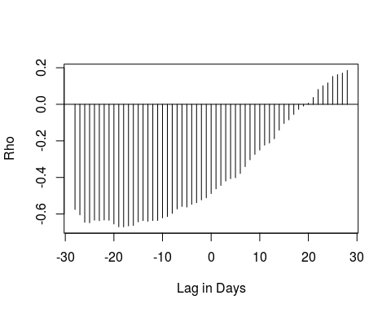

## rho rho rho rho rho rho   
## -0.575384658 -0.604723050 -0.645572795 -0.648228828 -0.633928314 -0.636762733   
## rho rho rho rho rho rho   
## -0.633015165 -0.634490931 -0.654852341 -0.670336761 -0.670825797 -0.665184556   
## rho rho rho rho rho rho   
## -0.662815462 -0.643097558 -0.636359622 -0.639743265 -0.636062340 -0.635315719   
## rho rho rho rho rho rho   
## -0.621309659 -0.614167047 -0.596622298 -0.572370685 -0.558881507 -0.562096174   
## rho rho rho rho rho rho   
## -0.547056277 -0.538280905 -0.523128270 -0.511438227 -0.488387451 -0.462582869   
## rho rho rho rho rho rho   
## -0.444003411 -0.419904814 -0.406968947 -0.401384543 -0.378374872 -0.341099245   
## rho rho rho rho rho rho   
## -0.303783154 -0.274081522 -0.250427483 -0.223415415 -0.211794067 -0.188451724   
## rho rho rho rho rho rho   
## -0.141571400 -0.104701717 -0.085144331 -0.055515968 -0.027572142 -0.009665827   
## rho rho rho rho rho rho   
## 0.006345279 0.037444110 0.081223610 0.101332165 0.117365755 0.152556010   
## rho rho rho   
## 0.162448758 0.170758674 0.185370794   
## Min. 1st Qu. Median Mean 3rd Qu. Max.   
## -0.6708 -0.6339 -0.4884 -0.3750 -0.1416 0.1854

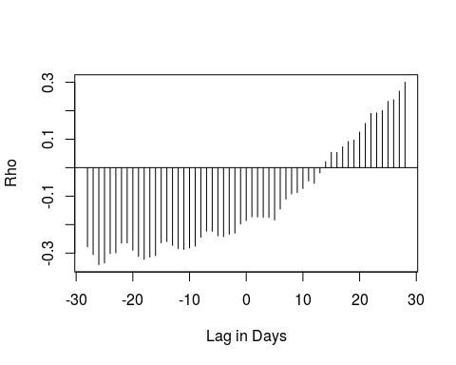

## rho rho rho rho rho rho   
## -0.27830073 -0.30532669 -0.34049342 -0.33457247 -0.30183053 -0.29924078   
## rho rho rho rho rho rho   
## -0.26521514 -0.26414585 -0.28987837 -0.31161760 -0.32170138 -0.31394778   
## rho rho rho rho rho rho   
## -0.30877380 -0.26376245 -0.25955842 -0.27285099 -0.28394740 -0.28700373   
## rho rho rho rho rho rho   
## -0.28146813 -0.27562039 -0.24433579 -0.22293462 -0.22355236 -0.23936860   
## rho rho rho rho rho rho   
## -0.24212942 -0.23367940 -0.22999691 -0.19789016 -0.18583221 -0.17260146   
## rho rho rho rho rho rho   
## -0.17303500 -0.17467883 -0.17489631 -0.18352036 -0.14521021 -0.11049410   
## rho rho rho rho rho rho   
## -0.09230297 -0.08722646 -0.07351386 -0.04681794 -0.05496574 -0.01849012   
## rho rho rho rho rho rho   
## 0.02124257 0.05378923 0.05324538 0.07308634 0.09192524 0.09681708   
## rho rho rho rho rho rho   
## 0.12501261 0.15541585 0.19028554 0.19221026 0.20059638 0.23274557   
## rho rho rho   
## 0.23824509 0.26885512 0.30037020   
## Min. 1st Qu. Median Mean 3rd Qu. Max.   
## -0.34049 -0.27562 -0.18583 -0.12444 0.02124 0.30037

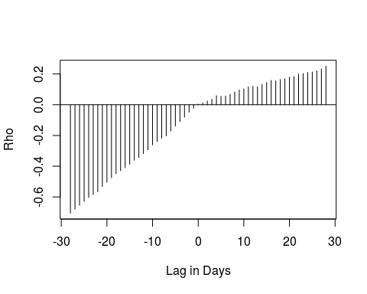

## rho rho rho rho rho rho   
## -0.705439122 -0.679914880 -0.653857511 -0.628276158 -0.603529233 -0.585063950   
## rho rho rho rho rho rho   
## -0.566581955 -0.532962059 -0.504152500 -0.475122687 -0.448514620 -0.429098082   
## rho rho rho rho rho rho   
## -0.409749184 -0.387712598 -0.360931573 -0.343866867 -0.317988976 -0.293247157   
## rho rho rho rho rho rho   
## -0.261222209 -0.239603785 -0.218468134 -0.201860697 -0.170902809 -0.138381943   
## rho rho rho rho rho rho   
## -0.109257268 -0.080581204 -0.048654199 -0.023049377 0.004303588 0.011741318   
## rho rho rho rho rho rho   
## 0.024143524 0.036316098 0.058952788 0.054760757 0.056876845 0.067918892   
## rho rho rho rho rho rho   
## 0.082668368 0.095687562 0.103160507 0.116783387 0.119687317 0.118310148   
## rho rho rho rho rho rho   
## 0.132559526 0.144598598 0.158680169 0.155395463 0.164506867 0.169678412   
## rho rho rho rho rho rho   
## 0.179009341 0.182895831 0.199010160 0.202708103 0.209747435 0.212983608   
## rho rho rho   
## 0.220490582 0.232375099 0.250966121   
## Min. 1st Qu. Median Mean 3rd Qu. Max.   
## -0.705439 -0.360932 0.004304 -0.116685 0.132559 0.250966

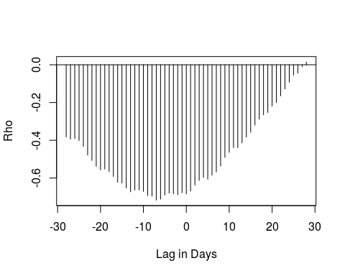

## rho rho rho rho rho rho   
## -0.38208011 -0.39371232 -0.39093951 -0.40155475 -0.43290959 -0.47865921   
## rho rho rho rho rho rho   
## -0.50672948 -0.53798575 -0.55688194 -0.55269929 -0.56561295 -0.59195892   
## rho rho rho rho rho rho   
## -0.62224657 -0.62631433 -0.65252970 -0.67325514 -0.66395998 -0.66323850   
## rho rho rho rho rho rho   
## -0.67115965 -0.69248694 -0.69587002 -0.71698223 -0.71173006 -0.69070355   
## rho rho rho rho rho rho   
## -0.67965430 -0.68319992 -0.68817142 -0.67843835 -0.68458844 -0.66841427   
## rho rho rho rho rho rho   
## -0.63759121 -0.61331340 -0.59688584 -0.60637420 -0.58482881 -0.56748920   
## rho rho rho rho rho rho   
## -0.53639968 -0.49065846 -0.46415400 -0.43900297 -0.43895700 -0.41443064   
## rho rho rho rho rho rho   
## -0.38286665 -0.35793051 -0.31927993 -0.28888821 -0.26488283 -0.25265962   
## rho rho rho rho rho rho   
## -0.21898947 -0.19995652 -0.16485116 -0.12775053 -0.09176554 -0.05460556   
## rho rho rho   
## -0.04397074 -0.01060541 0.01407660   
## Min. 1st Qu. Median Mean 3rd Qu. Max.   
## -0.71698 -0.66324 -0.53799 -0.47561 -0.38208 0.01408

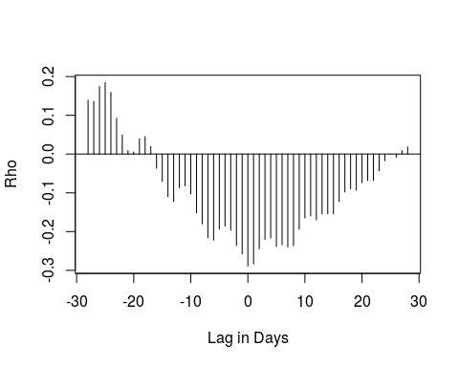

## rho rho rho rho rho   
## 0.1388429681 0.1358645344 0.1741767031 0.1843914610 0.1590047815   
## rho rho rho rho rho   
## 0.0922724217 0.0492595683 0.0089772893 0.0054717117 0.0391938806   
## rho rho rho rho rho   
## 0.0451515314 0.0193660169 -0.0369619882 -0.0704234166 -0.1099410981   
## rho rho rho rho rho   
## -0.1226041078 -0.0869307155 -0.0820545533 -0.1028263047 -0.1519004593   
## rho rho rho rho rho   
## -0.1800127401 -0.2153049192 -0.2221267836 -0.1937956584 -0.1857382378   
## rho rho rho rho rho   
## -0.1965110132 -0.2360746967 -0.2575471075 -0.2889366189 -0.2834321803   
## rho rho rho rho rho   
## -0.2445086048 -0.2201307791 -0.2166062557 -0.2382791949 -0.2344205723   
## rho rho rho rho rho   
## -0.2397322354 -0.2363705206 -0.1938595134 -0.1650715637 -0.1595038937   
## rho rho rho rho rho   
## -0.1698482746 -0.1542789471 -0.1542597218 -0.1543590429 -0.1229590919   
## rho rho rho rho rho   
## -0.0979501795 -0.0891754702 -0.0932146133 -0.0737603965 -0.0684991456   
## rho rho rho rho rho   
## -0.0681471637 -0.0428416797 -0.0172180038 -0.0004284697 -0.0087806413   
## rho rho   
## 0.0090754032 0.0184214002   
## Min. 1st Qu. Median Mean 3rd Qu. Max.   
## -0.2889366 -0.1938595 -0.1028263 -0.0948747 -0.0004285 0.1843915

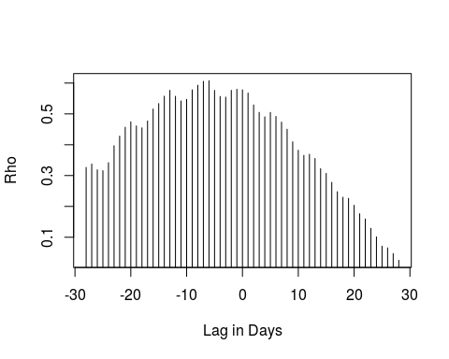

## rho rho rho rho rho rho rho   
## 0.32637137 0.33748091 0.31881229 0.31585909 0.34183747 0.39665595 0.42778686   
## rho rho rho rho rho rho rho   
## 0.45682701 0.47440484 0.46091224 0.45476028 0.47698222 0.51570007 0.53348880   
## rho rho rho rho rho rho rho   
## 0.55744151 0.57627141 0.55695673 0.54172312 0.54697627 0.57795043 0.59281085   
## rho rho rho rho rho rho rho   
## 0.60548442 0.60729166 0.57610255 0.55636516 0.55442502 0.57639158 0.57972859   
## rho rho rho rho rho rho rho   
## 0.57786433 0.56759771 0.52902876 0.50492888 0.49042264 0.50467485 0.49170973   
## rho rho rho rho rho rho rho   
## 0.47326229 0.45021372 0.40941146 0.38214430 0.36557049 0.36908279 0.35538019   
## rho rho rho rho rho rho rho   
## 0.32216729 0.30710565 0.27795677 0.24767715 0.22980462 0.22611094 0.20374278   
## rho rho rho rho rho rho rho   
## 0.17621708 0.15927679 0.12888729 0.10141451 0.07102667 0.06567703 0.04712243   
## rho   
## 0.02541061   
## Min. 1st Qu. Median Mean 3rd Qu. Max.   
## 0.02541 0.31586 0.45476 0.40184 0.54698 0.60729

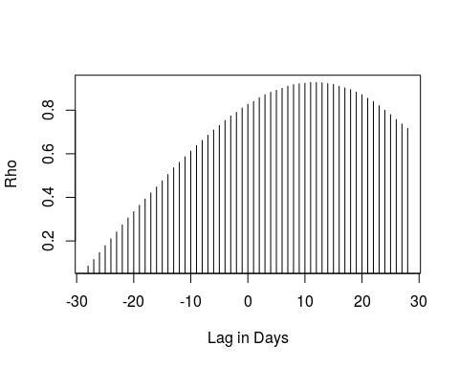

## rho rho rho rho rho rho rho   
## 0.08456484 0.11437657 0.14663771 0.17835334 0.20950852 0.24085135 0.27358548   
## rho rho rho rho rho rho rho   
## 0.30560587 0.33414695 0.36323354 0.39267974 0.42021022 0.44723086 0.47584705   
## rho rho rho rho rho rho rho   
## 0.50478708 0.53537586 0.56094470 0.58623845 0.61213675 0.63765712 0.66144227   
## rho rho rho rho rho rho rho   
## 0.68504974 0.70892959 0.72963607 0.75242193 0.77344534 0.78990790 0.80998242   
## rho rho rho rho rho rho rho   
## 0.82706351 0.83992378 0.85729376 0.87124880 0.88174476 0.89117128 0.90034006   
## rho rho rho rho rho rho rho   
## 0.91008563 0.91652077 0.92109430 0.92352025 0.92644505 0.92660422 0.92553260   
## rho rho rho rho rho rho rho   
## 0.92173644 0.91843634 0.90897902 0.90237671 0.89449299 0.88274554 0.87078039   
## rho rho rho rho rho rho rho   
## 0.85439836 0.83983423 0.82003805 0.79953894 0.77928204 0.75737550 0.73631281   
## rho   
## 0.71603655   
## Min. 1st Qu. Median Mean 3rd Qu. Max.   
## 0.08456 0.50479 0.77345 0.67466 0.88275 0.92660

## $retail_and_recreation_percent_change_from_baseline  
## rho   
## -18   
##   
## $grocery_and_pharmacy_percent_change_from_baseline  
## rho   
## -26   
##   
## $parks_percent_change_from_baseline  
## rho   
## -28   
##   
## $transit_stations_percent_change_from_baseline  
## rho   
## -7   
##   
## $workplaces_percent_change_from_baseline  
## rho   
## 0   
##   
## $residential_percent_change_from_baseline  
## rho   
## -6   
##   
## $StringencyIndex  
## rho   
## 12

crosscorrfun("Norway")

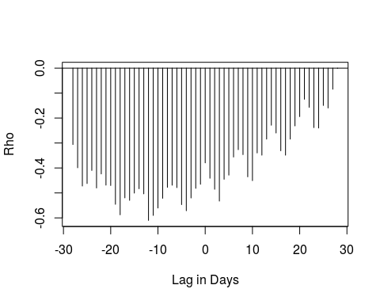

## rho rho rho rho rho rho   
## -0.306043481 -0.399190556 -0.472276086 -0.462321608 -0.409923866 -0.480097722   
## rho rho rho rho rho rho   
## -0.423813707 -0.468749926 -0.470218031 -0.545559820 -0.587671807 -0.519752505   
## rho rho rho rho rho rho   
## -0.529747934 -0.500664008 -0.483204706 -0.503703664 -0.610027890 -0.590055346   
## rho rho rho rho rho rho   
## -0.560451485 -0.521428054 -0.477525536 -0.469037211 -0.478701622 -0.546826076   
## rho rho rho rho rho rho   
## -0.571306702 -0.520194773 -0.481591446 -0.465267978 -0.379467513 -0.441112063   
## rho rho rho rho rho rho   
## -0.485277914 -0.532609274 -0.445222012 -0.428653099 -0.356151200 -0.326631470   
## rho rho rho rho rho rho   
## -0.346536980 -0.435460726 -0.450752221 -0.339782992 -0.348676529 -0.284346515   
## rho rho rho rho rho rho   
## -0.228690763 -0.259869431 -0.331113014 -0.348685819 -0.284397514 -0.231425618   
## rho rho rho rho rho rho   
## -0.194233403 -0.124645476 -0.156952961 -0.238302501 -0.239952113 -0.149533775   
## rho rho rho   
## -0.159686966 -0.084450404 -0.001043853   
## Min. 1st Qu. Median Mean 3rd Qu. Max.   
## -0.610028 -0.485278 -0.441112 -0.394544 -0.306044 -0.001044

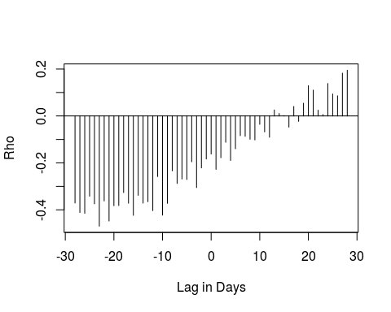

## rho rho rho rho rho rho   
## -0.370942453 -0.411458377 -0.414936894 -0.341877852 -0.374445448 -0.469734559   
## rho rho rho rho rho rho   
## -0.362101940 -0.447808563 -0.382454894 -0.381893891 -0.326510197 -0.371864645   
## rho rho rho rho rho rho   
## -0.423462999 -0.338356032 -0.371477047 -0.365395165 -0.403420657 -0.258294433   
## rho rho rho rho rho rho   
## -0.422588489 -0.372579647 -0.234000864 -0.287855798 -0.268601619 -0.270742972   
## rho rho rho rho rho rho   
## -0.195326853 -0.305357205 -0.221377778 -0.183516561 -0.162356673 -0.227643631   
## rho rho rho rho rho rho   
## -0.178067896 -0.112184738 -0.189724384 -0.139781370 -0.084000728 -0.086841847   
## rho rho rho rho rho rho   
## -0.099295728 -0.102240935 -0.035817939 -0.067984746 -0.090800499 0.025651045   
## rho rho rho rho rho rho   
## 0.010777607 0.001408493 -0.047714133 0.040370857 -0.023037552 0.054458997   
## rho rho rho rho rho rho   
## 0.128874142 0.110263875 0.024493110 0.006245366 0.138460691 0.093693976   
## rho rho rho   
## 0.085922075 0.182524410 0.194970293   
## Min. 1st Qu. Median Mean 3rd Qu. Max.   
## -0.46973 -0.36540 -0.18972 -0.17768 -0.02304 0.19497

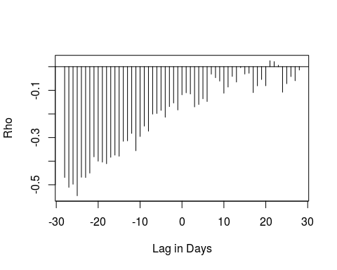

## rho rho rho rho rho rho   
## -0.469031376 -0.510713075 -0.497639368 -0.546363789 -0.468065047 -0.469138470   
## rho rho rho rho rho rho   
## -0.450521121 -0.381559337 -0.400009736 -0.403946546 -0.410764917 -0.383420415   
## rho rho rho rho rho rho   
## -0.374393453 -0.379000264 -0.315737694 -0.313848368 -0.282499914 -0.355727522   
## rho rho rho rho rho rho   
## -0.295470012 -0.251577686 -0.272984530 -0.200768602 -0.198092823 -0.184962018   
## rho rho rho rho rho rho   
## -0.213922298 -0.169011061 -0.153782981 -0.183258834 -0.119077789 -0.110590968   
## rho rho rho rho rho rho   
## -0.115528020 -0.170281087 -0.160064093 -0.135931266 -0.147508020 -0.031585416   
## rho rho rho rho rho rho   
## -0.046639581 -0.061059303 -0.112275763 -0.086246095 -0.041144411 -0.064996925   
## rho rho rho rho rho rho   
## -0.004144308 -0.031229756 -0.027798658 -0.109754758 -0.081176682 -0.054326489   
## rho rho rho rho rho rho   
## -0.080803819 0.025034181 0.021295490 0.005958270 -0.108154236 -0.072010357   
## rho rho rho   
## -0.041923298 -0.059497201 -0.014174903   
## Min. 1st Qu. Median Mean 3rd Qu. Max.   
## -0.54636 -0.35573 -0.16006 -0.20301 -0.06500 0.02503

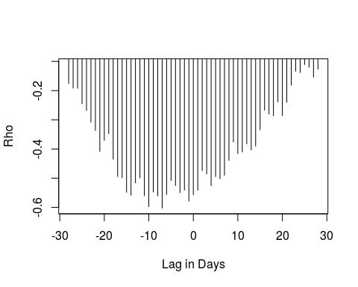

## rho rho rho rho rho rho rho   
## -0.1756947 -0.1918687 -0.1920993 -0.2447484 -0.2678484 -0.3078157 -0.3364651   
## rho rho rho rho rho rho rho   
## -0.4082522 -0.3704205 -0.3472623 -0.4351174 -0.4942603 -0.4984653 -0.5486774   
## rho rho rho rho rho rho rho   
## -0.5586739 -0.5160217 -0.4993377 -0.5598714 -0.5976772 -0.5472268 -0.5606917   
## rho rho rho rho rho rho rho   
## -0.6024189 -0.5560093 -0.5076892 -0.5251486 -0.5499445 -0.5409904 -0.5787343   
## rho rho rho rho rho rho rho   
## -0.5567921 -0.5412607 -0.4745554 -0.4851616 -0.5258917 -0.4948903 -0.5021217   
## rho rho rho rho rho rho rho   
## -0.4900686 -0.4394851 -0.3760467 -0.4159543 -0.4104036 -0.3826132 -0.4034806   
## rho rho rho rho rho rho rho   
## -0.3900190 -0.3336674 -0.2669367 -0.2805361 -0.2861614 -0.2385514 -0.2858117   
## rho rho rho rho rho rho rho   
## -0.2401522 -0.1812589 -0.1334843 -0.1383985 -0.1108152 -0.1201103 -0.1538170   
## rho   
## -0.1266942   
## Min. 1st Qu. Median Mean 3rd Qu. Max.   
## -0.6024 -0.5251 -0.4104 -0.3913 -0.2678 -0.1108

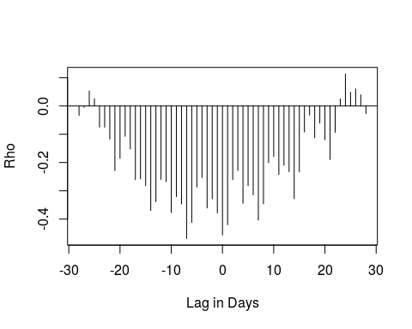

## rho rho rho rho rho rho   
## -0.033229795 -0.004640505 0.053016305 0.026277149 -0.074870612 -0.075019091   
## rho rho rho rho rho rho   
## -0.117156665 -0.228477768 -0.184691873 -0.107295340 -0.152035232 -0.261051810   
## rho rho rho rho rho rho   
## -0.257752759 -0.281866875 -0.369596510 -0.338611981 -0.259513867 -0.267252764   
## rho rho rho rho rho rho   
## -0.376488343 -0.320417599 -0.346651996 -0.468676340 -0.412253968 -0.286595943   
## rho rho rho rho rho rho   
## -0.253029631 -0.360578858 -0.328461623 -0.378446480 -0.456048480 -0.420126704   
## rho rho rho rho rho rho   
## -0.260444708 -0.228370459 -0.344039559 -0.281752917 -0.314129953 -0.403707874   
## rho rho rho rho rho rho   
## -0.346164310 -0.200499757 -0.178684216 -0.242711289 -0.209865297 -0.232581793   
## rho rho rho rho rho rho   
## -0.328178081 -0.233000376 -0.091833365 -0.032363050 -0.112254553 -0.060336662   
## rho rho rho rho rho rho   
## -0.119207780 -0.189481478 -0.093204108 0.024831738 0.112931151 0.048197218   
## rho rho rho   
## 0.060205700 0.039427762 -0.027105502   
## Min. 1st Qu. Median Mean 3rd Qu. Max.   
## -0.46868 -0.32818 -0.23258 -0.20326 -0.09183 0.11293

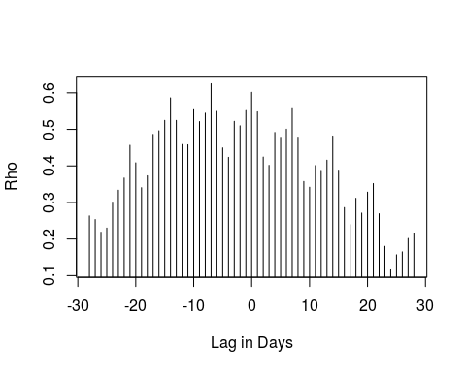

## rho rho rho rho rho rho rho rho   
## 0.2632666 0.2532810 0.2186530 0.2300452 0.2983082 0.3335960 0.3668612 0.4565141   
## rho rho rho rho rho rho rho rho   
## 0.4085442 0.3404115 0.3730790 0.4862431 0.4961463 0.5245704 0.5862940 0.5245288   
## rho rho rho rho rho rho rho rho   
## 0.4586886 0.4579432 0.5565988 0.5212448 0.5443990 0.6250404 0.5493071 0.4492916   
## rho rho rho rho rho rho rho rho   
## 0.4234827 0.5219656 0.5097399 0.5515642 0.6014886 0.5481103 0.4242157 0.4015944   
## rho rho rho rho rho rho rho rho   
## 0.4914972 0.4783943 0.5004600 0.5594213 0.4786963 0.3574456 0.3416829 0.4009561   
## rho rho rho rho rho rho rho rho   
## 0.3876870 0.4157822 0.4817429 0.3884268 0.2860869 0.2397003 0.3114938 0.2710577   
## rho rho rho rho rho rho rho rho   
## 0.3282619 0.3517385 0.2692433 0.1801122 0.1157566 0.1568505 0.1649183 0.2016020   
## rho   
## 0.2155511   
## Min. 1st Qu. Median Mean 3rd Qu. Max.   
## 0.1158 0.2983 0.4085 0.3979 0.5005 0.6250

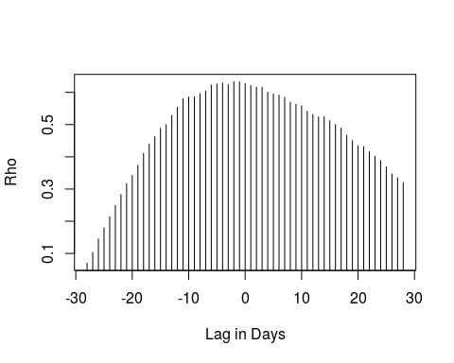

## rho rho rho rho rho rho rho   
## 0.06970493 0.10308498 0.14481653 0.17938177 0.21381803 0.24884483 0.28304745   
## rho rho rho rho rho rho rho   
## 0.31658263 0.34167049 0.37394709 0.41081841 0.43986461 0.46237080 0.48852325   
## rho rho rho rho rho rho rho   
## 0.50020480 0.52805495 0.55415519 0.58026756 0.58540078 0.58629916 0.59627801   
## rho rho rho rho rho rho rho   
## 0.60474091 0.62312567 0.62580559 0.62963304 0.62448793 0.63324663 0.63241691   
## rho rho rho rho rho rho rho   
## 0.62766057 0.62127314 0.61625702 0.61545361 0.60044756 0.59469810 0.59174675   
## rho rho rho rho rho rho rho   
## 0.58434339 0.56966296 0.56304076 0.55855402 0.54171885 0.53112107 0.52379802   
## rho rho rho rho rho rho rho   
## 0.52500439 0.51204955 0.50042169 0.48886414 0.46626808 0.44971853 0.43463955   
## rho rho rho rho rho rho rho   
## 0.43122774 0.41505940 0.40189868 0.38827586 0.36908882 0.34689382 0.33509367   
## rho   
## 0.32012564   
## Min. 1st Qu. Median Mean 3rd Qu. Max.   
## 0.0697 0.3883 0.5120 0.4720 0.5917 0.6332

## $retail_and_recreation_percent_change_from_baseline  
## rho   
## -12   
##   
## $grocery_and_pharmacy_percent_change_from_baseline  
## rho   
## -23   
##   
## $parks_percent_change_from_baseline  
## rho   
## -25   
##   
## $transit_stations_percent_change_from_baseline  
## rho   
## -7   
##   
## $workplaces_percent_change_from_baseline  
## rho   
## -7   
##   
## $residential_percent_change_from_baseline  
## rho   
## -7   
##   
## $StringencyIndex  
## rho   
## -2

crosscorrfun("Denmark")

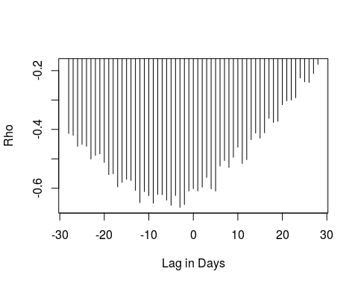

## rho rho rho rho rho rho rho   
## -0.4137574 -0.4198683 -0.4574739 -0.4507603 -0.4571718 -0.5009715 -0.4882802   
## rho rho rho rho rho rho rho   
## -0.4830506 -0.5119681 -0.5538597 -0.5509150 -0.5951958 -0.5800178 -0.5696522   
## rho rho rho rho rho rho rho   
## -0.5734208 -0.6072751 -0.6489796 -0.6113358 -0.6249768 -0.6509471 -0.6209373   
## rho rho rho rho rho rho rho   
## -0.6217965 -0.6403007 -0.6583210 -0.6244283 -0.6649047 -0.6552398 -0.6095117   
## rho rho rho rho rho rho rho   
## -0.6015667 -0.6090559 -0.5960966 -0.5632872 -0.6021825 -0.6093505 -0.5246055   
## rho rho rho rho rho rho rho   
## -0.5056198 -0.5291889 -0.4947765 -0.4602539 -0.5159374 -0.5025894 -0.4346063   
## rho rho rho rho rho rho rho   
## -0.4124783 -0.4297807 -0.4114684 -0.3622572 -0.3763560 -0.3728327 -0.3159061   
## rho rho rho rho rho rho rho   
## -0.3026216 -0.2999672 -0.2922099 -0.2250626 -0.2378298 -0.2401227 -0.2097383   
## rho   
## -0.1787156   
## Min. 1st Qu. Median Mean 3rd Qu. Max.   
## -0.6649 -0.6073 -0.5120 -0.4923 -0.4138 -0.1787

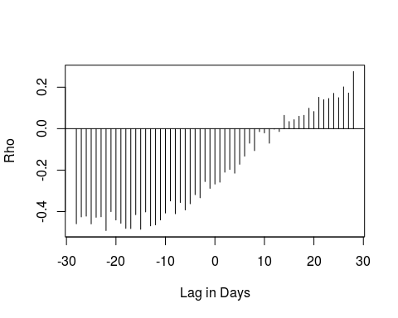

## rho rho rho rho rho rho   
## -0.458769050 -0.425533862 -0.421877446 -0.459358540 -0.427531818 -0.424970555   
## rho rho rho rho rho rho   
## -0.491389138 -0.400030824 -0.440510672 -0.456335207 -0.480890616 -0.482041850   
## rho rho rho rho rho rho   
## -0.414866566 -0.485378814 -0.401540567 -0.468729582 -0.464009896 -0.440276789   
## rho rho rho rho rho rho   
## -0.406826357 -0.348634054 -0.410303669 -0.356112987 -0.391972571 -0.362259591   
## rho rho rho rho rho rho   
## -0.318388273 -0.333397760 -0.255170804 -0.287874362 -0.267228796 -0.258088691   
## rho rho rho rho rho rho   
## -0.209876784 -0.196626539 -0.214719966 -0.171673876 -0.132578335 -0.070123115   
## rho rho rho rho rho rho   
## -0.105966184 -0.014278237 -0.020273199 -0.070174710 -0.002363081 -0.013843771   
## rho rho rho rho rho rho   
## 0.064323995 0.034374387 0.043423294 0.059917698 0.064335338 0.098661624   
## rho rho rho rho rho rho   
## 0.082654249 0.151394220 0.139989224 0.145520230 0.170527791 0.149558144   
## rho rho rho   
## 0.201393634 0.171834333 0.275566455   
## Min. 1st Qu. Median Mean 3rd Qu. Max.   
## -0.49139 -0.42188 -0.25809 -0.20016 0.03437 0.27557

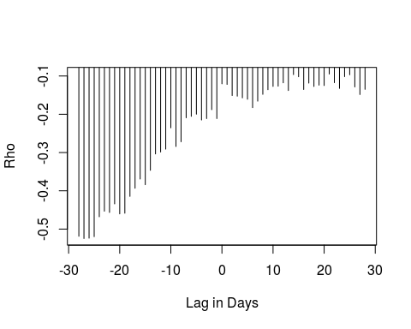

## rho rho rho rho rho rho   
## -0.51878347 -0.52466016 -0.52370124 -0.51979612 -0.46783122 -0.45324702   
## rho rho rho rho rho rho   
## -0.45650255 -0.43413991 -0.46025279 -0.45858011 -0.41455796 -0.39325422   
## rho rho rho rho rho rho   
## -0.36920845 -0.38405058 -0.34647534 -0.30362601 -0.29855963 -0.29108059   
## rho rho rho rho rho rho   
## -0.23537148 -0.28414353 -0.27176049 -0.20914221 -0.20532410 -0.19975459   
## rho rho rho rho rho rho   
## -0.21490925 -0.21123062 -0.18796244 -0.21121071 -0.12041489 -0.12200509   
## rho rho rho rho rho rho   
## -0.15102961 -0.15268903 -0.15706978 -0.16073269 -0.18265188 -0.16569654   
## rho rho rho rho rho rho   
## -0.14791143 -0.13583914 -0.12715496 -0.12653206 -0.11783069 -0.13792604   
## rho rho rho rho rho rho   
## -0.09631778 -0.10201634 -0.13520491 -0.11852562 -0.12733133 -0.12384182   
## rho rho rho rho rho rho   
## -0.12489073 -0.09480244 -0.11742389 -0.13233250 -0.10168618 -0.09670416   
## rho rho rho   
## -0.12851367 -0.14842641 -0.13484342   
## Min. 1st Qu. Median Mean 3rd Qu. Max.   
## -0.5247 -0.3465 -0.1827 -0.2393 -0.1273 -0.0948

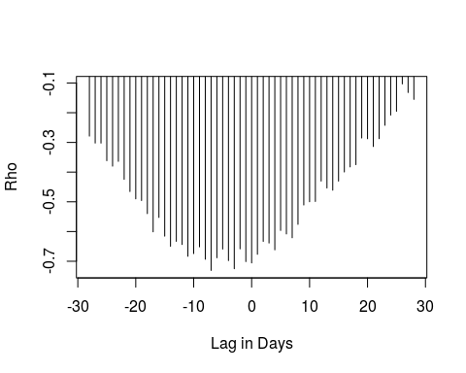

## rho rho rho rho rho rho rho   
## -0.2786972 -0.3022057 -0.3023201 -0.3615505 -0.3798566 -0.3637617 -0.4243251   
## rho rho rho rho rho rho rho   
## -0.4653408 -0.4900347 -0.4956283 -0.5397873 -0.6010220 -0.5526263 -0.6155594   
## rho rho rho rho rho rho rho   
## -0.6496220 -0.6331227 -0.6437397 -0.6834028 -0.6742818 -0.6516734 -0.6933425   
## rho rho rho rho rho rho rho   
## -0.7309468 -0.6883832 -0.6590698 -0.6978810 -0.7252874 -0.6583932 -0.7012632   
## rho rho rho rho rho rho rho   
## -0.7056992 -0.6766757 -0.6332287 -0.6386659 -0.6616143 -0.5963897 -0.6082318   
## rho rho rho rho rho rho rho   
## -0.6210200 -0.5758580 -0.5106306 -0.4997604 -0.4988645 -0.4301752 -0.4535050   
## rho rho rho rho rho rho rho   
## -0.4608751 -0.4302123 -0.3995042 -0.3824683 -0.3749015 -0.2851370 -0.2876418   
## rho rho rho rho rho rho rho   
## -0.3138606 -0.2874798 -0.2424391 -0.2079987 -0.1952577 -0.1031017 -0.1320444   
## rho   
## -0.1551491   
## Min. 1st Qu. Median Mean 3rd Qu. Max.   
## -0.7309 -0.6496 -0.4998 -0.4918 -0.3638 -0.1031

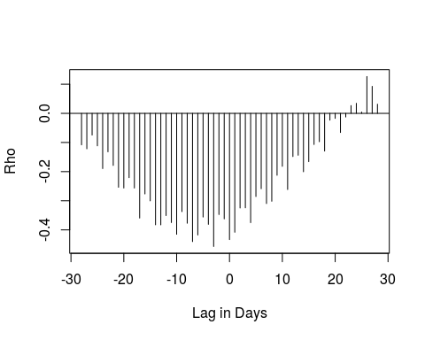

## rho rho rho rho rho rho   
## -0.108163737 -0.121670085 -0.074568829 -0.111561452 -0.189606730 -0.132087693   
## rho rho rho rho rho rho   
## -0.178758220 -0.253722491 -0.256281585 -0.220801104 -0.256301350 -0.359388594   
## rho rho rho rho rho rho   
## -0.276637227 -0.300439843 -0.382580173 -0.382732061 -0.350891010 -0.374806607   
## rho rho rho rho rho rho   
## -0.415071227 -0.337284283 -0.377150413 -0.440143975 -0.417435919 -0.355930186   
## rho rho rho rho rho rho   
## -0.380895581 -0.456966611 -0.347255186 -0.362056590 -0.433260406 -0.408088886   
## rho rho rho rho rho rho   
## -0.324798229 -0.324339665 -0.375075608 -0.285457701 -0.258681213 -0.309595952   
## rho rho rho rho rho rho   
## -0.301683230 -0.212572020 -0.181921686 -0.261418086 -0.148322733 -0.143820678   
## rho rho rho rho rho rho   
## -0.200423753 -0.165763951 -0.106987838 -0.097393809 -0.129375770 -0.023408676   
## rho rho rho rho rho rho   
## -0.017329114 -0.065761949 -0.012538568 0.026595042 0.034408827 0.004398204   
## rho rho rho   
## 0.126429158 0.092566034 0.031393478   
## Min. 1st Qu. Median Mean 3rd Qu. Max.   
## -0.4570 -0.3559 -0.2563 -0.2227 -0.1116 0.1264

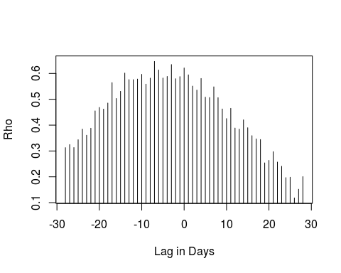

## rho rho rho rho rho rho rho rho   
## 0.3129005 0.3247292 0.3131969 0.3434967 0.3845572 0.3607880 0.3878496 0.4551028   
## rho rho rho rho rho rho rho rho   
## 0.4684614 0.4619838 0.4854145 0.5645033 0.5031312 0.5308624 0.6014993 0.5761255   
## rho rho rho rho rho rho rho rho   
## 0.5760125 0.5782598 0.5965113 0.5586026 0.5818514 0.6465610 0.6134317 0.5822197   
## rho rho rho rho rho rho rho rho   
## 0.5884310 0.6343604 0.5795062 0.5876800 0.6212733 0.5946341 0.5510590 0.5356408   
## rho rho rho rho rho rho rho rho   
## 0.5805522 0.5082988 0.5068255 0.5482230 0.5063532 0.4625588 0.4252266 0.4649372   
## rho rho rho rho rho rho rho rho   
## 0.3885422 0.3845312 0.4204081 0.3898845 0.3591451 0.3467511 0.3441986 0.2539094   
## rho rho rho rho rho rho rho rho   
## 0.2635404 0.2971736 0.2570263 0.2407235 0.1967566 0.1981808 0.1182272 0.1518421   
## rho   
## 0.2007671   
## Min. 1st Qu. Median Mean 3rd Qu. Max.   
## 0.1182 0.3442 0.4649 0.4441 0.5761 0.6466

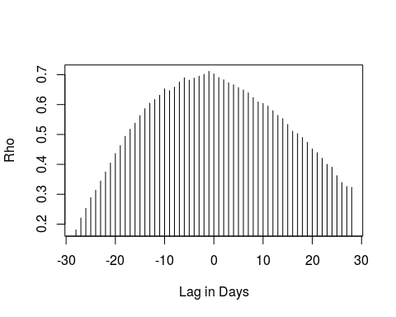

## rho rho rho rho rho rho rho rho   
## 0.1809193 0.2201815 0.2526708 0.2886160 0.3136614 0.3442441 0.3747335 0.4045197   
## rho rho rho rho rho rho rho rho   
## 0.4362274 0.4630530 0.4938546 0.5174632 0.5378302 0.5631815 0.5862566 0.6047097   
## rho rho rho rho rho rho rho rho   
## 0.6169860 0.6311730 0.6526864 0.6469782 0.6584085 0.6754952 0.6899663 0.6818007   
## rho rho rho rho rho rho rho rho   
## 0.6887658 0.6950058 0.7011637 0.7112945 0.7027086 0.6906479 0.6829007 0.6731883   
## rho rho rho rho rho rho rho rho   
## 0.6663663 0.6568474 0.6490093 0.6393205 0.6235092 0.6090874 0.6039657 0.5949448   
## rho rho rho rho rho rho rho rho   
## 0.5796327 0.5638609 0.5531033 0.5333234 0.5108545 0.5030318 0.4897707 0.4738667   
## rho rho rho rho rho rho rho rho   
## 0.4514489 0.4389834 0.4203966 0.3999330 0.3905257 0.3621868 0.3393912 0.3258189   
## rho   
## 0.3228849   
## Min. 1st Qu. Median Mean 3rd Qu. Max.   
## 0.1809 0.4204 0.5632 0.5278 0.6527 0.7113

## $retail_and_recreation_percent_change_from_baseline  
## rho   
## -3   
##   
## $grocery_and_pharmacy_percent_change_from_baseline  
## rho   
## -22   
##   
## $parks_percent_change_from_baseline  
## rho   
## -27   
##   
## $transit_stations_percent_change_from_baseline  
## rho   
## -7   
##   
## $workplaces_percent_change_from_baseline  
## rho   
## -3   
##   
## $residential_percent_change_from_baseline  
## rho   
## -7   
##   
## $StringencyIndex  
## rho   
## -1

crosscorrfun("Finland")

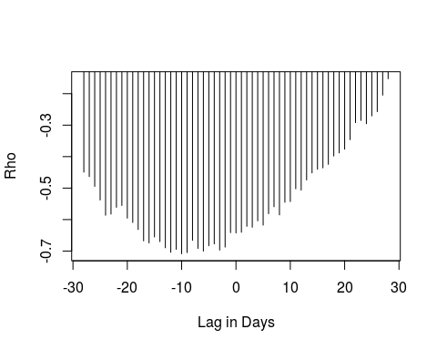

## rho rho rho rho rho rho rho   
## -0.4493036 -0.4635443 -0.4945932 -0.5377762 -0.5862393 -0.5826271 -0.5610407   
## rho rho rho rho rho rho rho   
## -0.5552328 -0.5953987 -0.6090447 -0.6316103 -0.6676566 -0.6741424 -0.6550672   
## rho rho rho rho rho rho rho   
## -0.6698319 -0.6896794 -0.7039337 -0.6943476 -0.7085436 -0.7048952 -0.6659680   
## rho rho rho rho rho rho rho   
## -0.6916377 -0.7001629 -0.6831210 -0.6772465 -0.6968470 -0.6874007 -0.6415470   
## rho rho rho rho rho rho rho   
## -0.6424336 -0.6403372 -0.6214548 -0.6242727 -0.6038826 -0.6176467 -0.5814014   
## rho rho rho rho rho rho rho   
## -0.5592249 -0.5851229 -0.5449753 -0.5427664 -0.5021536 -0.5064298 -0.4741442   
## rho rho rho rho rho rho rho   
## -0.4517081 -0.4400433 -0.4358441 -0.4246304 -0.3981121 -0.3882624 -0.3762583   
## rho rho rho rho rho rho rho   
## -0.3460331 -0.2919855 -0.2851382 -0.2954727 -0.2706919 -0.2571303 -0.2046913   
## rho   
## -0.1525942   
## Min. 1st Qu. Median Mean 3rd Qu. Max.   
## -0.7085 -0.6660 -0.5826 -0.5394 -0.4493 -0.1526

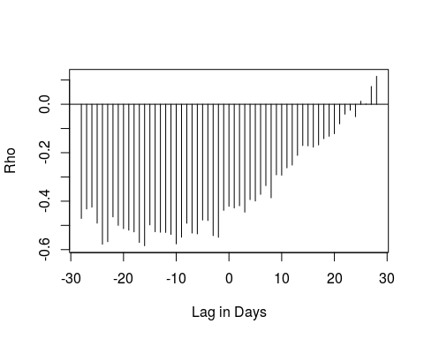

## rho rho rho rho rho rho   
## -0.471411996 -0.432297024 -0.424727602 -0.490808152 -0.577714313 -0.567322067   
## rho rho rho rho rho rho   
## -0.464934725 -0.499998747 -0.513405963 -0.519640539 -0.526830695 -0.570501538   
## rho rho rho rho rho rho   
## -0.584096897 -0.497887839 -0.526305847 -0.528457715 -0.529241697 -0.537108189   
## rho rho rho rho rho rho   
## -0.576356336 -0.548598330 -0.491158727 -0.531693132 -0.534965556 -0.477918122   
## rho rho rho rho rho rho   
## -0.479867024 -0.542037979 -0.549166551 -0.437945558 -0.421252484 -0.428042862   
## rho rho rho rho rho rho   
## -0.419003481 -0.445334375 -0.393614403 -0.399440051 -0.371936715 -0.335886475   
## rho rho rho rho rho rho   
## -0.386117902 -0.291255889 -0.292869456 -0.262345896 -0.251089670 -0.211020480   
## rho rho rho rho rho rho   
## -0.170347384 -0.171819284 -0.176935983 -0.167855459 -0.142079545 -0.132118689   
## rho rho rho rho rho rho   
## -0.121578675 -0.081077874 -0.040928862 -0.024836619 -0.051238398 0.012738295   
## rho rho rho   
## 0.001388016 0.073460548 0.115530820   
## Min. 1st Qu. Median Mean 3rd Qu. Max.   
## -0.5841 -0.5263 -0.4280 -0.3582 -0.1769 0.1155

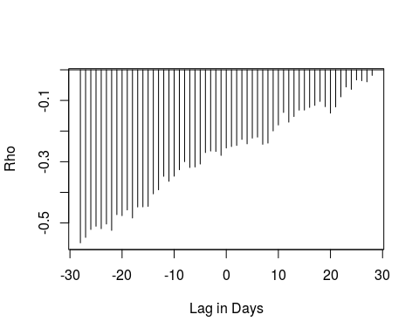

## rho rho rho rho rho rho   
## -0.56495054 -0.54705090 -0.52120087 -0.51066934 -0.51862241 -0.50350099   
## rho rho rho rho rho rho   
## -0.52419026 -0.47278789 -0.47609109 -0.45746132 -0.48373172 -0.44771112   
## rho rho rho rho rho rho   
## -0.44734557 -0.44583826 -0.40498537 -0.39179676 -0.34768717 -0.36399836   
## rho rho rho rho rho rho   
## -0.34728408 -0.32624685 -0.29984613 -0.31897098 -0.31724653 -0.30759756   
## rho rho rho rho rho rho   
## -0.27018911 -0.26511428 -0.26657461 -0.27944347 -0.25520235 -0.25047480   
## rho rho rho rho rho rho   
## -0.24693497 -0.22727867 -0.24171212 -0.22295093 -0.21974053 -0.24322627   
## rho rho rho rho rho rho   
## -0.23926333 -0.19953852 -0.18021072 -0.13931798 -0.17090838 -0.15257092   
## rho rho rho rho rho rho   
## -0.13172094 -0.13150539 -0.12285148 -0.11618984 -0.10326451 -0.12038034   
## rho rho rho rho rho rho   
## -0.14140503 -0.12112218 -0.08822256 -0.05605680 -0.06382928 -0.03307444   
## rho rho rho   
## -0.03565356 -0.03928866 -0.01822001   
## Min. 1st Qu. Median Mean 3rd Qu. Max.   
## -0.56495 -0.40499 -0.25520 -0.27614 -0.13932 -0.01822

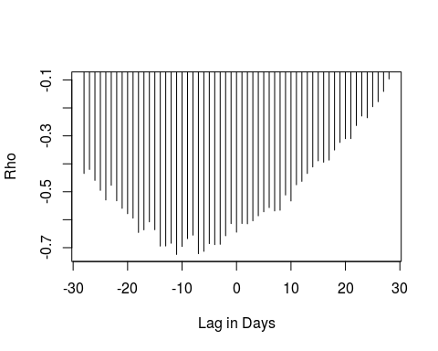

## rho rho rho rho rho rho   
## -0.43467378 -0.42021000 -0.45933712 -0.49487796 -0.52939941 -0.47690076   
## rho rho rho rho rho rho   
## -0.53230649 -0.55934970 -0.57849947 -0.59427601 -0.64552798 -0.63623701   
## rho rho rho rho rho rho   
## -0.60755689 -0.63583924 -0.69433636 -0.69399965 -0.68411767 -0.72426986   
## rho rho rho rho rho rho   
## -0.69571377 -0.66763284 -0.65517401 -0.72146211 -0.71309613 -0.68554359   
## rho rho rho rho rho rho   
## -0.68916364 -0.68789990 -0.65738113 -0.61395638 -0.64453640 -0.61354571   
## rho rho rho rho rho rho   
## -0.61456556 -0.60394123 -0.58593771 -0.57159814 -0.55659259 -0.56857087   
## rho rho rho rho rho rho   
## -0.56604913 -0.51161777 -0.53289366 -0.47498962 -0.46280825 -0.43469043   
## rho rho rho rho rho rho   
## -0.41126073 -0.38935855 -0.39432613 -0.38685708 -0.35070783 -0.32375071   
## rho rho rho rho rho rho   
## -0.31017500 -0.31005981 -0.26315422 -0.22906341 -0.23531982 -0.19578282   
## rho rho rho   
## -0.17800044 -0.14133694 -0.09663969   
## Min. 1st Qu. Median Mean 3rd Qu. Max.   
## -0.72427 -0.64454 -0.55935 -0.51135 -0.41126 -0.09664

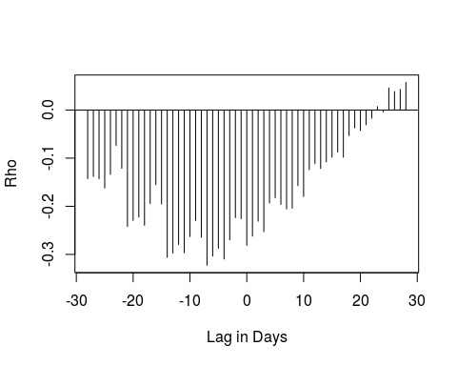

## rho rho rho rho rho rho   
## -0.142628750 -0.138341478 -0.142770262 -0.162124687 -0.133695634 -0.073789581   
## rho rho rho rho rho rho   
## -0.121069961 -0.242193503 -0.229461081 -0.222696104 -0.239406338 -0.194338590   
## rho rho rho rho rho rho   
## -0.155080791 -0.195262095 -0.306363694 -0.297244377 -0.279453663 -0.296755389   
## rho rho rho rho rho rho   
## -0.262981541 -0.229569997 -0.264581057 -0.322763206 -0.303548700 -0.287367712   
## rho rho rho rho rho rho   
## -0.309737655 -0.269558529 -0.223700518 -0.225718990 -0.281344254 -0.262157543   
## rho rho rho rho rho rho   
## -0.231136358 -0.252581835 -0.193186503 -0.182322844 -0.196058253 -0.205816059   
## rho rho rho rho rho rho   
## -0.204184081 -0.157118590 -0.179675796 -0.124001101 -0.111397928 -0.121644860   
## rho rho rho rho rho rho   
## -0.107971328 -0.098083091 -0.087196836 -0.098128648 -0.053292900 -0.037247221   
## rho rho rho rho rho rho   
## -0.042565068 -0.030632776 -0.017099430 0.007124228 -0.004058458 0.045791488   
## rho rho rho   
## 0.038345036 0.042717023 0.057434952   
## Min. 1st Qu. Median Mean 3rd Qu. Max.   
## -0.32276 -0.24219 -0.18232 -0.16421 -0.09813 0.05743

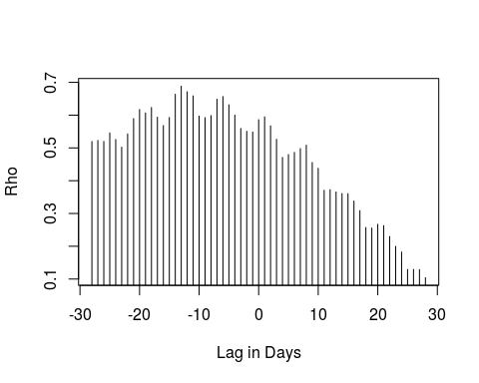

## rho rho rho rho rho rho rho rho   
## 0.5196592 0.5230583 0.5198926 0.5460221 0.5257441 0.5023570 0.5428362 0.5895152   
## rho rho rho rho rho rho rho rho   
## 0.6172589 0.6067463 0.6233432 0.5938831 0.5682763 0.5928001 0.6637050 0.6883712   
## rho rho rho rho rho rho rho rho   
## 0.6714849 0.6588328 0.5971363 0.5924467 0.5987349 0.6488367 0.6568409 0.6315496   
## rho rho rho rho rho rho rho rho   
## 0.6001215 0.5593256 0.5507371 0.5486814 0.5861261 0.5948830 0.5675353 0.5263935   
## rho rho rho rho rho rho rho rho   
## 0.4710237 0.4798387 0.4865085 0.4980567 0.5084406 0.4556116 0.4377876 0.3709314   
## rho rho rho rho rho rho rho rho   
## 0.3727339 0.3658301 0.3608620 0.3605394 0.3381497 0.3086979 0.2574110 0.2556399   
## rho rho rho rho rho rho rho rho   
## 0.2671410 0.2629261 0.2298192 0.1998122 0.1825697 0.1294320 0.1295706 0.1288554   
## rho   
## 0.1042232   
## Min. 1st Qu. Median Mean 3rd Qu. Max.   
## 0.1042 0.3609 0.5231 0.4697 0.5939 0.6884

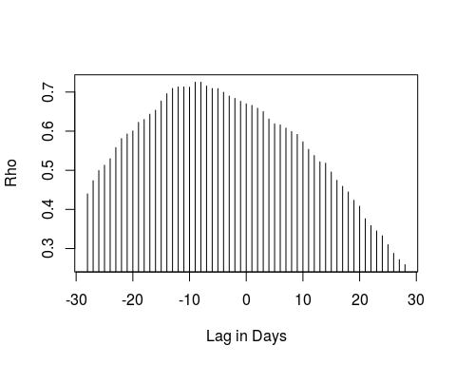

## rho rho rho rho rho rho rho rho   
## 0.4396963 0.4734731 0.4993467 0.5128511 0.5294920 0.5580426 0.5810648 0.5926360   
## rho rho rho rho rho rho rho rho   
## 0.6005305 0.6223731 0.6297526 0.6433346 0.6535142 0.6766261 0.6956238 0.7092764   
## rho rho rho rho rho rho rho rho   
## 0.7129279 0.7130142 0.7123769 0.7251010 0.7252808 0.7152451 0.7090308 0.7086188   
## rho rho rho rho rho rho rho rho   
## 0.6993128 0.6898347 0.6837812 0.6762359 0.6697014 0.6659094 0.6586000 0.6499724   
## rho rho rho rho rho rho rho rho   
## 0.6309549 0.6187151 0.6160182 0.6079437 0.5992035 0.5916053 0.5727884 0.5534307   
## rho rho rho rho rho rho rho rho   
## 0.5376932 0.5216168 0.5180175 0.4956882 0.4743748 0.4590283 0.4446044 0.4233777   
## rho rho rho rho rho rho rho rho   
## 0.4081061 0.3762168 0.3586219 0.3450683 0.3327157 0.3098583 0.2876637 0.2717703   
## rho   
## 0.2589363   
## Min. 1st Qu. Median Mean 3rd Qu. Max.   
## 0.2589 0.4744 0.5992 0.5640 0.6762 0.7253

## $retail_and_recreation_percent_change_from_baseline  
## rho   
## -10   
##   
## $grocery_and_pharmacy_percent_change_from_baseline  
## rho   
## -16   
##   
## $parks_percent_change_from_baseline  
## rho   
## -28   
##   
## $transit_stations_percent_change_from_baseline  
## rho   
## -11   
##   
## $workplaces_percent_change_from_baseline  
## rho   
## -7   
##   
## $residential_percent_change_from_baseline  
## rho   
## -13   
##   
## $StringencyIndex  
## rho   
## -8

#########pvalues crosscorr  
crosscorr<-function(x) {  
 dat<-subset(data, data$Country.Region==x)  
 ccfspear<-function(y){ ccfspearmanx <- sapply( -28:28, function(l) cor.test(y, Hmisc::Lag(dat$IncCaseNumber,l),method = "spearman", use = "complete.obs", exact=FALSE)$p.value)  
 }  
 cc<-lapply(dat[c(3:8,15)], ccfspear)  
}  
  
results<-NULL  
d<-NULL  
  
for( Country.Region in unique(data$Country.Region) ) {  
 d<-crosscorr(Country.Region)  
 results<-rbind(results, data.frame(d))  
}  
results<-as.vector(as.matrix(results))  
resultsadj<-p.adjust(results, method="holm")  
dim(resultsadj)<-c(228, 7)  
a<-as.data.frame(resultsadj)  
colnames(a)<-c("retail and recreation", "grocery and pharmacy", "parks", "transit", "workplace", "residential", "Stringency index")  
a$country<-rep(c("Denmark", "Finland","Norway", "Sweden"),each=57)  
a$day<-rep(c(-28:28), times=4)  
a$country_lag<- with(a, paste0(country, day), collapse="-")  
a<-a[,-c(8:9)]  
write.csv(resultsadj, "crosscorrallpsadj.csv")  
  
  
rownames(a)<-a$country_lag  
a<-a[-8]  
a<-as.matrix(a)  
  
###producing crosscorr heatmap#################  
crosscorr<-function(x) {  
 dat<-subset(data, data$Country.Region==x)  
 ccfspear<-function(y){ ccfspearmanx <- sapply( -28:28, function(l) cor.test(y, Hmisc::Lag(dat$IncCaseNumber,l),method = "spearman", use = "complete.obs", exact=FALSE)$estimate)  
 }  
 cc<-lapply(dat[c(3:8,15)], ccfspear)  
}  
  
results<-NULL  
d<-NULL  
  
for( Country.Region in unique(data$Country.Region) ) {  
 d<-crosscorr(Country.Region)  
 results<-rbind(results, data.frame(d))  
}  
  
  
colnames(results)<-c("retail and recreation", "grocery and pharmacy", "parks", "transit", "workplace", "residential", "Stringency index")  
results$country<-rep(c("D", "F","N", "S"),each=57)  
results$day<-rep(c(-28:28), times=4)  
results$country_lag<- with(results, paste0(country, day), collapse="-")  
results<-results[,-c(8:9)]  
  
rownames(results)<-results$country_lag  
results<-results[-8]  
results<-as.matrix(results)  
library(ggcorrplot)  
ggcorrplot(results)

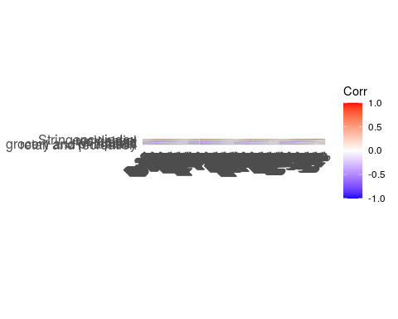

resultsden<-results[1:57, 1:7]  
aden<-a[1:57, 1:7]  
den<-ggcorrplot(resultsden, p.mat = aden, insig = "blank") +  
 ggtitle("Denmark") +  
ggsave("denmarkcross.pdf", width = 20, height = 5)   
  
resultsfin<-results[58:114, 1:7]  
afin<-a[58:114, 1:7]  
fin<-ggcorrplot(resultsfin, p.mat = afin, insig = "blank") +  
 ggtitle("Finland") +  
ggsave("finlandcrossc.pdf", width = 20, height = 5)   
  
  
resultsnor<-results[115:171, 1:7]  
anor<-a[115:171, 1:7]  
nor<-ggcorrplot(resultsnor, p.mat = anor, insig = "blank") +  
 ggtitle("Norway") +  
ggsave("Norwaycrossc.pdf", width = 20, height = 5)   
  
  
resultssweden<-results[172:228, 1:7]  
aswe<-a[172:228, 1:7]  
swe<-ggcorrplot(resultssweden, p.mat = aswe, insig = "blank") +  
 ggtitle("Sweden") +  
ggsave("swedencrossc.pdf", width = 20, height = 5)   
  
  
library(ggpubr)  
ccfplotall<-ggarrange(den, fin, nor, swe, ncol=1, nrow = 4)  
ccfplotall

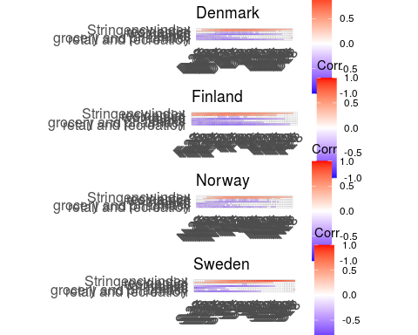

ggsave("crosscorrallheat.pdf", width = 15, height = 10)   
ggsave("crosscorrallheat.png", width = 15, height = 10)   
  
  
  
####modelling###############################################################  
  
data <- read_csv("Scandinaviadata1010.csv", col_types = cols(Date = col_date(format = "%Y-%m-%d"), date = col_date(format = "%Y-%m-%d")))

## Warning: Missing column names filled in: 'X1' [1]

data$Country.Region<-factor(data$Country.Region)  
data<-data[,-1]  
  
library(dplyr)

##   
## Attaching package: 'dplyr'

## The following objects are masked from 'package:stats':  
##   
## filter, lag

## The following objects are masked from 'package:base':  
##   
## intersect, setdiff, setequal, union

datat<-data %>%  
 filter(date<= "2020-08-01")  
datav<-data %>%  
 filter(date> "2020-08-01")  
  
library(dlnm)

## This is dlnm 2.4.2. For details: help(dlnm) and vignette('dlnmOverview').

datat$cb1 <- crossbasis(datat$grocery_and_pharmacy_percent_change_from_baseline , lag=28, argvar=list(fun="bs"),arglag=list(df=5), group=datat$Country.Region)

## Warning in (function (fun = NULL, df = NULL, knots = NULL, ...) : default knots placement along lags has changed since version 2.0.0.  
## See 'file.show(system.file('Changesince200',package='dlnm'))'.  
## See also help(logknots) for setting the knots  
## consistently with the previous versions

datat$cb2 <- crossbasis(datat$retail_and_recreation_percent_change_from_baseline , lag=28, argvar=list(fun="bs"),arglag=list(df=5), group=datat$Country.Region)

## Warning in (function (fun = NULL, df = NULL, knots = NULL, ...) : default knots placement along lags has changed since version 2.0.0.  
## See 'file.show(system.file('Changesince200',package='dlnm'))'.  
## See also help(logknots) for setting the knots  
## consistently with the previous versions

datat$cb4 <- crossbasis(datat$transit_stations_percent_change_from_baseline , lag=28, argvar=list(fun="bs"),arglag=list(df=5), group=datat$Country.Region)

## Warning in (function (fun = NULL, df = NULL, knots = NULL, ...) : default knots placement along lags has changed since version 2.0.0.  
## See 'file.show(system.file('Changesince200',package='dlnm'))'.  
## See also help(logknots) for setting the knots  
## consistently with the previous versions

datat$cb5 <- crossbasis(datat$workplaces_percent_change_from_baseline , lag=28, argvar=list(fun="bs"),arglag=list(df=5), group=datat$Country.Region)

## Warning in (function (fun = NULL, df = NULL, knots = NULL, ...) : default knots placement along lags has changed since version 2.0.0.  
## See 'file.show(system.file('Changesince200',package='dlnm'))'.  
## See also help(logknots) for setting the knots  
## consistently with the previous versions

datat$cb6 <- crossbasis(datat$residential_percent_change_from_baseline , lag=28, argvar=list(fun="bs"),arglag=list(df=5), group=datat$Country.Region)

## Warning in (function (fun = NULL, df = NULL, knots = NULL, ...) : default knots placement along lags has changed since version 2.0.0.  
## See 'file.show(system.file('Changesince200',package='dlnm'))'.  
## See also help(logknots) for setting the knots  
## consistently with the previous versions

datat$cb7 <- crossbasis(datat$StringencyIndex , lag=28, argvar=list(fun="bs"),arglag=list(df=5), group=datat$Country.Region)

## Warning in (function (fun = NULL, df = NULL, knots = NULL, ...) : default knots placement along lags has changed since version 2.0.0.  
## See 'file.show(system.file('Changesince200',package='dlnm'))'.  
## See also help(logknots) for setting the knots  
## consistently with the previous versions

#make data identical to the dataset with crossbasis (deleting the first 28 observations in all countries)  
datam<-datat %>%  
 group_by(Country.Region) %>%  
 slice(-c(1:28))  
  
  
  
  
  
#change ref category?  
library(mgcv)

## Loading required package: nlme

##   
## Attaching package: 'nlme'

## The following object is masked from 'package:dplyr':  
##   
## collapse

## This is mgcv 1.8-31. For overview type 'help("mgcv-package")'.

fitplain<-gam(IncCaseNumber ~s(NumDate, by=Country.Region) + Country.Region, data=datam, family="tw")  
summary(fitplain)

##   
## Family: Tweedie(p=1.011)   
## Link function: log   
##   
## Formula:  
## IncCaseNumber ~ s(NumDate, by = Country.Region) + Country.Region  
##   
## Parametric coefficients:  
## Estimate Std. Error t value Pr(>|t|)   
## (Intercept) -1.09545 0.09251 -11.841 < 2e-16 ***  
## Country.RegionFinland -1.00024 0.21755 -4.598 5.35e-06 ***  
## Country.RegionNorway -0.84249 0.16670 -5.054 5.97e-07 ***  
## Country.RegionSweden 2.07218 0.09720 21.318 < 2e-16 ***  
## ---  
## Signif. codes: 0 '***' 0.001 '**' 0.01 '*' 0.05 '.' 0.1 ' ' 1  
##   
## Approximate significance of smooth terms:  
## edf Ref.df F p-value   
## s(NumDate):Country.RegionDenmark 7.188 8.090 49.60 <2e-16 ***  
## s(NumDate):Country.RegionFinland 5.493 6.526 37.32 <2e-16 ***  
## s(NumDate):Country.RegionNorway 6.225 7.278 33.81 <2e-16 ***  
## s(NumDate):Country.RegionSweden 8.419 8.888 134.56 <2e-16 ***  
## ---  
## Signif. codes: 0 '***' 0.001 '**' 0.01 '*' 0.05 '.' 0.1 ' ' 1  
##   
## R-sq.(adj) = 0.948 Deviance explained = 92.4%  
## -REML = 324.21 Scale est. = 0.18302 n = 561

AIC(fitplain)

## [1] 961.4624

gam.check(fitplain)

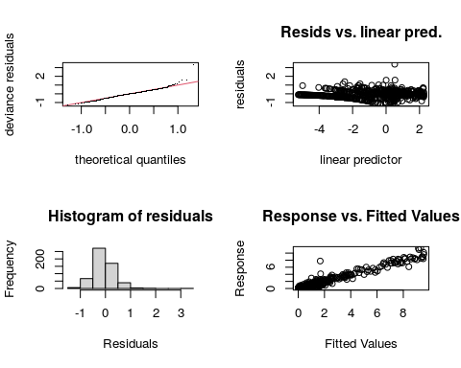

##   
## Method: REML Optimizer: outer newton  
## full convergence after 10 iterations.  
## Gradient range [-5.781186e-07,1.935972e-08]  
## (score 324.2111 & scale 0.1830178).  
## Hessian positive definite, eigenvalue range [0.9541455,39508.9].  
## Model rank = 40 / 40   
##   
## Basis dimension (k) checking results. Low p-value (k-index<1) may  
## indicate that k is too low, especially if edf is close to k'.  
##   
## k' edf k-index p-value  
## s(NumDate):Country.RegionDenmark 9.00 7.19 0.97 0.43  
## s(NumDate):Country.RegionFinland 9.00 5.49 0.97 0.41  
## s(NumDate):Country.RegionNorway 9.00 6.22 0.97 0.47  
## s(NumDate):Country.RegionSweden 9.00 8.42 0.97 0.46

library(sjPlot)

## Registered S3 methods overwritten by 'lme4':  
## method from  
## cooks.distance.influence.merMod car   
## influence.merMod car   
## dfbeta.influence.merMod car   
## dfbetas.influence.merMod car

plot_model(fitplain)

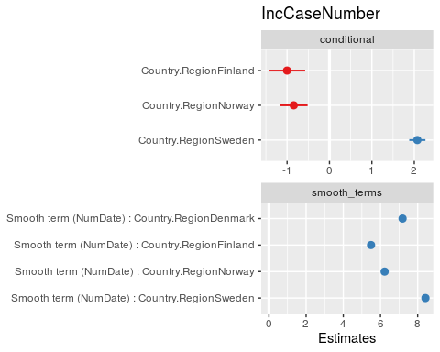

tab_model(fitplain)

IncCaseNumber

Predictors

Estimates

CI

p

(Intercept)

-1.10

-1.28 – -0.91

<0.001

Country.RegionFinland

-1.00

-1.43 – -0.57

<0.001

Country.RegionNorway

-0.84

-1.17 – -0.52

<0.001

Country.RegionSweden

2.07

1.88 – 2.26

<0.001

Smooth term (NumDate) :Country.RegionDenmark

7.19

<0.001

Smooth term (NumDate) :Country.RegionFinland

5.49

<0.001

Smooth term (NumDate) :Country.RegionNorway

6.22

<0.001

Smooth term (NumDate) :Country.RegionSweden

8.42

<0.001

Observations

561

R2

0.948

fitwithout<-gam(IncCaseNumber ~s(NumDate, by=Country.Region) + s(StringencyIndex, by=Country.Region) + Country.Region, data=datam, family=Tweedie(p=1.011))  
summary(fitwithout)

##   
## Family: Tweedie(1.011)   
## Link function: log   
##   
## Formula:  
## IncCaseNumber ~ s(NumDate, by = Country.Region) + s(StringencyIndex,   
## by = Country.Region) + Country.Region  
##   
## Parametric coefficients:  
## Estimate Std. Error t value Pr(>|t|)   
## (Intercept) -2.0862 0.5462 -3.820 0.00015 ***  
## Country.RegionFinland 0.0152 0.5955 0.026 0.97964   
## Country.RegionNorway 0.4688 0.7648 0.613 0.54022   
## Country.RegionSweden 3.2255 0.5736 5.623 3.06e-08 ***  
## ---  
## Signif. codes: 0 '***' 0.001 '**' 0.01 '*' 0.05 '.' 0.1 ' ' 1  
##   
## Approximate significance of smooth terms:  
## edf Ref.df F p-value   
## s(NumDate):Country.RegionDenmark 7.141 8.084 9.178 5.73e-12 ***  
## s(NumDate):Country.RegionFinland 4.416 5.410 17.318 < 2e-16 ***  
## s(NumDate):Country.RegionNorway 6.260 7.454 4.621 6.41e-05 ***  
## s(NumDate):Country.RegionSweden 8.498 8.923 59.084 < 2e-16 ***  
## s(StringencyIndex):Country.RegionDenmark 1.000 1.000 3.438 0.06424 .   
## s(StringencyIndex):Country.RegionFinland 1.000 1.000 0.051 0.82151   
## s(StringencyIndex):Country.RegionNorway 6.804 6.954 3.255 0.00718 **   
## s(StringencyIndex):Country.RegionSweden 1.000 1.001 0.915 0.33951   
## ---  
## Signif. codes: 0 '***' 0.001 '**' 0.01 '*' 0.05 '.' 0.1 ' ' 1  
##   
## R-sq.(adj) = 0.95 Deviance explained = 93%  
## GCV = 0.2219 Scale est. = 0.23516 n = 561

AIC(fitwithout)

## [1] 632.8655

gam.check(fitwithout)

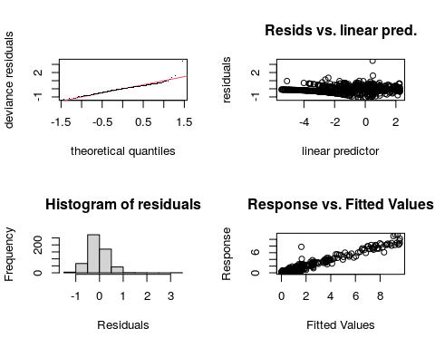

##   
## Method: GCV Optimizer: outer newton  
## full convergence after 11 iterations.  
## Gradient range [-1.690159e-07,2.158844e-08]  
## (score 0.2218963 & scale 0.2351639).  
## Hessian positive definite, eigenvalue range [1.33749e-09,0.001024622].  
## Model rank = 76 / 76   
##   
## Basis dimension (k) checking results. Low p-value (k-index<1) may  
## indicate that k is too low, especially if edf is close to k'.  
##   
## k' edf k-index p-value  
## s(NumDate):Country.RegionDenmark 9.00 7.14 0.94 0.20  
## s(NumDate):Country.RegionFinland 9.00 4.42 0.94 0.22  
## s(NumDate):Country.RegionNorway 9.00 6.26 0.94 0.17  
## s(NumDate):Country.RegionSweden 9.00 8.50 0.94 0.23  
## s(StringencyIndex):Country.RegionDenmark 9.00 1.00 1.05 0.96  
## s(StringencyIndex):Country.RegionFinland 9.00 1.00 1.05 0.97  
## s(StringencyIndex):Country.RegionNorway 9.00 6.80 1.05 0.97  
## s(StringencyIndex):Country.RegionSweden 9.00 1.00 1.05 0.97

plot(fitwithout)

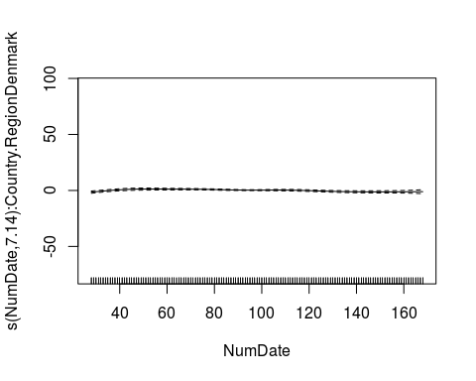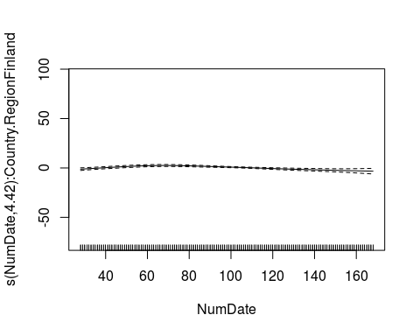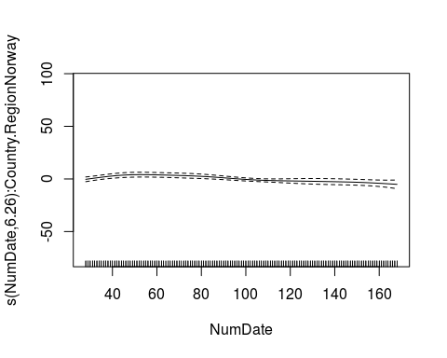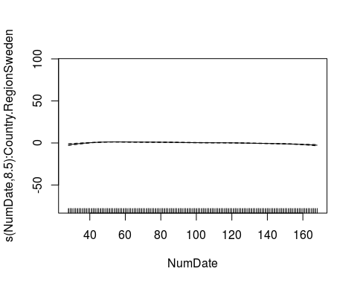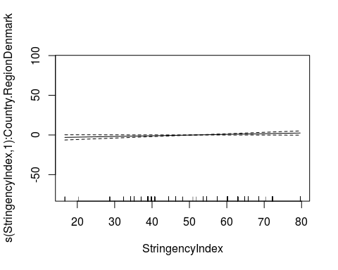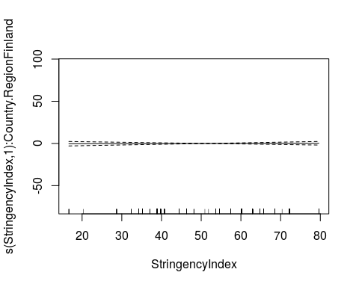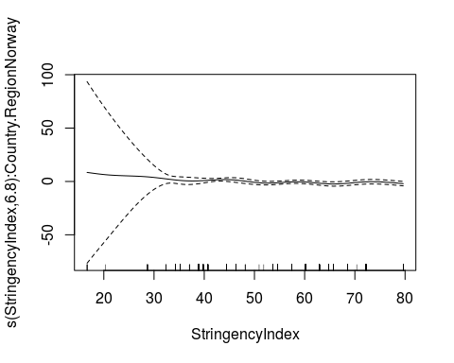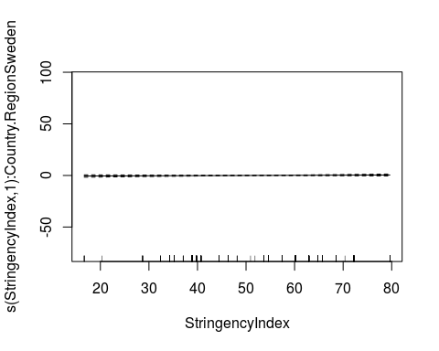

plot_model(fitwithout, title="Daily incident deaths per 1 million")

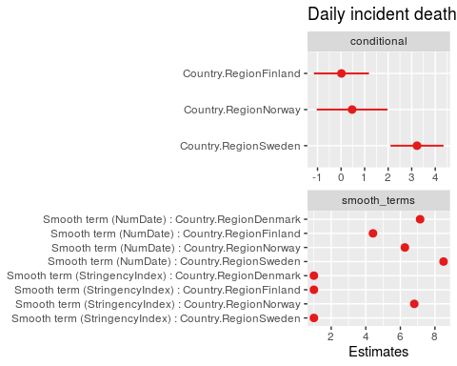

tab_model(fitwithout)

IncCaseNumber

Predictors

Estimates

CI

p

(Intercept)

-2.09

-3.16 – -1.01

<0.001

Country.RegionFinland

0.02

-1.15 – 1.19

0.980

Country.RegionNorway

0.47

-1.03 – 1.97

0.540

Country.RegionSweden

3.23

2.10 – 4.35

<0.001

Smooth term (NumDate) :Country.RegionDenmark

7.14

<0.001

Smooth term (NumDate) :Country.RegionFinland

4.42

<0.001

Smooth term (NumDate) :Country.RegionNorway

6.26

<0.001

Smooth term (NumDate) :Country.RegionSweden

8.50

<0.001

Smooth term(StringencyIndex) :Country.RegionDenmark

1.00

0.064

Smooth term(StringencyIndex) :Country.RegionFinland

1.00

0.822

Smooth term(StringencyIndex) :Country.RegionNorway

6.80

0.007

Smooth term(StringencyIndex) :Country.RegionSweden

1.00

0.340

Observations

561

R2

0.950

fit <- gam(IncCaseNumber~s(NumDate, by=Country.Region) + s(StringencyIndex, by=Country.Region) +s(retail_and_recreation_percent_change_from_baseline, by=Country.Region)  
 + s(grocery_and_pharmacy_percent_change_from_baseline, by=Country.Region)  
 + s(transit_stations_percent_change_from_baseline, by=Country.Region)   
 + s(workplaces_percent_change_from_baseline, by=Country.Region)  
 + s(residential_percent_change_from_baseline, by=Country.Region)  
 + Country.Region, data=datam, family=Tweedie(p=1.011))  
summary(fit)

##   
## Family: Tweedie(1.011)   
## Link function: log   
##   
## Formula:  
## IncCaseNumber ~ s(NumDate, by = Country.Region) + s(StringencyIndex,   
## by = Country.Region) + s(retail_and_recreation_percent_change_from_baseline,   
## by = Country.Region) + s(grocery_and_pharmacy_percent_change_from_baseline,   
## by = Country.Region) + s(transit_stations_percent_change_from_baseline,   
## by = Country.Region) + s(workplaces_percent_change_from_baseline,   
## by = Country.Region) + s(residential_percent_change_from_baseline,   
## by = Country.Region) + Country.Region  
##   
## Parametric coefficients:  
## Estimate Std. Error t value Pr(>|t|)   
## (Intercept) -1.9549 0.5353 -3.652 0.00029 ***  
## Country.RegionFinland -2.4406 2.8995 -0.842 0.40037   
## Country.RegionNorway -0.3245 1.0341 -0.314 0.75380   
## Country.RegionSweden 3.0919 0.5577 5.544 4.92e-08 ***  
## ---  
## Signif. codes: 0 '***' 0.001 '**' 0.01 '*' 0.05 '.' 0.1 ' ' 1  
##   
## Approximate significance of smooth terms:  
## edf  
## s(NumDate):Country.RegionDenmark 7.014  
## s(NumDate):Country.RegionFinland 6.016  
## s(NumDate):Country.RegionNorway 8.266  
## s(NumDate):Country.RegionSweden 8.565  
## s(StringencyIndex):Country.RegionDenmark 1.000  
## s(StringencyIndex):Country.RegionFinland 4.980  
## s(StringencyIndex):Country.RegionNorway 6.847  
## s(StringencyIndex):Country.RegionSweden 1.000  
## s(retail_and_recreation_percent_change_from_baseline):Country.RegionDenmark 2.132  
## s(retail_and_recreation_percent_change_from_baseline):Country.RegionFinland 1.000  
## s(retail_and_recreation_percent_change_from_baseline):Country.RegionNorway 1.000  
## s(retail_and_recreation_percent_change_from_baseline):Country.RegionSweden 1.000  
## s(grocery_and_pharmacy_percent_change_from_baseline):Country.RegionDenmark 2.631  
## s(grocery_and_pharmacy_percent_change_from_baseline):Country.RegionFinland 4.349  
## s(grocery_and_pharmacy_percent_change_from_baseline):Country.RegionNorway 4.063  
## s(grocery_and_pharmacy_percent_change_from_baseline):Country.RegionSweden 1.000  
## s(transit_stations_percent_change_from_baseline):Country.RegionDenmark 2.091  
## s(transit_stations_percent_change_from_baseline):Country.RegionFinland 5.864  
## s(transit_stations_percent_change_from_baseline):Country.RegionNorway 1.000  
## s(transit_stations_percent_change_from_baseline):Country.RegionSweden 1.000  
## s(workplaces_percent_change_from_baseline):Country.RegionDenmark 1.000  
## s(workplaces_percent_change_from_baseline):Country.RegionFinland 1.000  
## s(workplaces_percent_change_from_baseline):Country.RegionNorway 2.509  
## s(workplaces_percent_change_from_baseline):Country.RegionSweden 1.000  
## s(residential_percent_change_from_baseline):Country.RegionDenmark 1.000  
## s(residential_percent_change_from_baseline):Country.RegionFinland 1.000  
## s(residential_percent_change_from_baseline):Country.RegionNorway 6.172  
## s(residential_percent_change_from_baseline):Country.RegionSweden 1.000  
## Ref.df  
## s(NumDate):Country.RegionDenmark 7.977  
## s(NumDate):Country.RegionFinland 7.145  
## s(NumDate):Country.RegionNorway 8.817  
## s(NumDate):Country.RegionSweden 8.942  
## s(StringencyIndex):Country.RegionDenmark 1.000  
## s(StringencyIndex):Country.RegionFinland 5.227  
## s(StringencyIndex):Country.RegionNorway 6.979  
## s(StringencyIndex):Country.RegionSweden 1.000  
## s(retail_and_recreation_percent_change_from_baseline):Country.RegionDenmark 2.724  
## s(retail_and_recreation_percent_change_from_baseline):Country.RegionFinland 1.000  
## s(retail_and_recreation_percent_change_from_baseline):Country.RegionNorway 1.001  
## s(retail_and_recreation_percent_change_from_baseline):Country.RegionSweden 1.000  
## s(grocery_and_pharmacy_percent_change_from_baseline):Country.RegionDenmark 3.246  
## s(grocery_and_pharmacy_percent_change_from_baseline):Country.RegionFinland 5.145  
## s(grocery_and_pharmacy_percent_change_from_baseline):Country.RegionNorway 4.954  
## s(grocery_and_pharmacy_percent_change_from_baseline):Country.RegionSweden 1.000  
## s(transit_stations_percent_change_from_baseline):Country.RegionDenmark 2.696  
## s(transit_stations_percent_change_from_baseline):Country.RegionFinland 6.234  
## s(transit_stations_percent_change_from_baseline):Country.RegionNorway 1.000  
## s(transit_stations_percent_change_from_baseline):Country.RegionSweden 1.000  
## s(workplaces_percent_change_from_baseline):Country.RegionDenmark 1.000  
## s(workplaces_percent_change_from_baseline):Country.RegionFinland 1.000  
## s(workplaces_percent_change_from_baseline):Country.RegionNorway 3.086  
## s(workplaces_percent_change_from_baseline):Country.RegionSweden 1.000  
## s(residential_percent_change_from_baseline):Country.RegionDenmark 1.000  
## s(residential_percent_change_from_baseline):Country.RegionFinland 1.000  
## s(residential_percent_change_from_baseline):Country.RegionNorway 6.680  
## s(residential_percent_change_from_baseline):Country.RegionSweden 1.000  
## F  
## s(NumDate):Country.RegionDenmark 8.838  
## s(NumDate):Country.RegionFinland 10.189  
## s(NumDate):Country.RegionNorway 4.260  
## s(NumDate):Country.RegionSweden 27.581  
## s(StringencyIndex):Country.RegionDenmark 3.781  
## s(StringencyIndex):Country.RegionFinland 1.047  
## s(StringencyIndex):Country.RegionNorway 3.666  
## s(StringencyIndex):Country.RegionSweden 1.117  
## s(retail_and_recreation_percent_change_from_baseline):Country.RegionDenmark 6.366  
## s(retail_and_recreation_percent_change_from_baseline):Country.RegionFinland 2.363  
## s(retail_and_recreation_percent_change_from_baseline):Country.RegionNorway 0.182  
## s(retail_and_recreation_percent_change_from_baseline):Country.RegionSweden 0.367  
## s(grocery_and_pharmacy_percent_change_from_baseline):Country.RegionDenmark 2.906  
## s(grocery_and_pharmacy_percent_change_from_baseline):Country.RegionFinland 3.113  
## s(grocery_and_pharmacy_percent_change_from_baseline):Country.RegionNorway 2.038  
## s(grocery_and_pharmacy_percent_change_from_baseline):Country.RegionSweden 0.150  
## s(transit_stations_percent_change_from_baseline):Country.RegionDenmark 1.077  
## s(transit_stations_percent_change_from_baseline):Country.RegionFinland 6.304  
## s(transit_stations_percent_change_from_baseline):Country.RegionNorway 0.586  
## s(transit_stations_percent_change_from_baseline):Country.RegionSweden 0.328  
## s(workplaces_percent_change_from_baseline):Country.RegionDenmark 0.374  
## s(workplaces_percent_change_from_baseline):Country.RegionFinland 1.118  
## s(workplaces_percent_change_from_baseline):Country.RegionNorway 1.268  
## s(workplaces_percent_change_from_baseline):Country.RegionSweden 0.226  
## s(residential_percent_change_from_baseline):Country.RegionDenmark 0.045  
## s(residential_percent_change_from_baseline):Country.RegionFinland 0.111  
## s(residential_percent_change_from_baseline):Country.RegionNorway 1.081  
## s(residential_percent_change_from_baseline):Country.RegionSweden 0.006  
## p-value  
## s(NumDate):Country.RegionDenmark 3.25e-11  
## s(NumDate):Country.RegionFinland 4.35e-12  
## s(NumDate):Country.RegionNorway 2.55e-05  
## s(NumDate):Country.RegionSweden < 2e-16  
## s(StringencyIndex):Country.RegionDenmark 0.05241  
## s(StringencyIndex):Country.RegionFinland 0.35198  
## s(StringencyIndex):Country.RegionNorway 0.00135  
## s(StringencyIndex):Country.RegionSweden 0.29118  
## s(retail_and_recreation_percent_change_from_baseline):Country.RegionDenmark 0.00282  
## s(retail_and_recreation_percent_change_from_baseline):Country.RegionFinland 0.12487  
## s(retail_and_recreation_percent_change_from_baseline):Country.RegionNorway 0.67032  
## s(retail_and_recreation_percent_change_from_baseline):Country.RegionSweden 0.54490  
## s(grocery_and_pharmacy_percent_change_from_baseline):Country.RegionDenmark 0.03750  
## s(grocery_and_pharmacy_percent_change_from_baseline):Country.RegionFinland 0.00835  
## s(grocery_and_pharmacy_percent_change_from_baseline):Country.RegionNorway 0.07693  
## s(grocery_and_pharmacy_percent_change_from_baseline):Country.RegionSweden 0.69862  
## s(transit_stations_percent_change_from_baseline):Country.RegionDenmark 0.34167  
## s(transit_stations_percent_change_from_baseline):Country.RegionFinland 7.40e-06  
## s(transit_stations_percent_change_from_baseline):Country.RegionNorway 0.44435  
## s(transit_stations_percent_change_from_baseline):Country.RegionSweden 0.56731  
## s(workplaces_percent_change_from_baseline):Country.RegionDenmark 0.54097  
## s(workplaces_percent_change_from_baseline):Country.RegionFinland 0.29098  
## s(workplaces_percent_change_from_baseline):Country.RegionNorway 0.26127  
## s(workplaces_percent_change_from_baseline):Country.RegionSweden 0.63508  
## s(residential_percent_change_from_baseline):Country.RegionDenmark 0.83293  
## s(residential_percent_change_from_baseline):Country.RegionFinland 0.73907  
## s(residential_percent_change_from_baseline):Country.RegionNorway 0.37509  
## s(residential_percent_change_from_baseline):Country.RegionSweden 0.93679  
##   
## s(NumDate):Country.RegionDenmark ***  
## s(NumDate):Country.RegionFinland ***  
## s(NumDate):Country.RegionNorway ***  
## s(NumDate):Country.RegionSweden ***  
## s(StringencyIndex):Country.RegionDenmark .   
## s(StringencyIndex):Country.RegionFinland   
## s(StringencyIndex):Country.RegionNorway **   
## s(StringencyIndex):Country.RegionSweden   
## s(retail_and_recreation_percent_change_from_baseline):Country.RegionDenmark **   
## s(retail_and_recreation_percent_change_from_baseline):Country.RegionFinland   
## s(retail_and_recreation_percent_change_from_baseline):Country.RegionNorway   
## s(retail_and_recreation_percent_change_from_baseline):Country.RegionSweden   
## s(grocery_and_pharmacy_percent_change_from_baseline):Country.RegionDenmark *   
## s(grocery_and_pharmacy_percent_change_from_baseline):Country.RegionFinland **   
## s(grocery_and_pharmacy_percent_change_from_baseline):Country.RegionNorway .   
## s(grocery_and_pharmacy_percent_change_from_baseline):Country.RegionSweden   
## s(transit_stations_percent_change_from_baseline):Country.RegionDenmark   
## s(transit_stations_percent_change_from_baseline):Country.RegionFinland ***  
## s(transit_stations_percent_change_from_baseline):Country.RegionNorway   
## s(transit_stations_percent_change_from_baseline):Country.RegionSweden   
## s(workplaces_percent_change_from_baseline):Country.RegionDenmark   
## s(workplaces_percent_change_from_baseline):Country.RegionFinland   
## s(workplaces_percent_change_from_baseline):Country.RegionNorway   
## s(workplaces_percent_change_from_baseline):Country.RegionSweden   
## s(residential_percent_change_from_baseline):Country.RegionDenmark   
## s(residential_percent_change_from_baseline):Country.RegionFinland   
## s(residential_percent_change_from_baseline):Country.RegionNorway   
## s(residential_percent_change_from_baseline):Country.RegionSweden   
## ---  
## Signif. codes: 0 '***' 0.001 '**' 0.01 '*' 0.05 '.' 0.1 ' ' 1  
##   
## R-sq.(adj) = 0.96 Deviance explained = 94.8%  
## GCV = 0.20111 Scale est. = 0.17759 n = 561

AIC(fit)

## [1] 1193.837

gam.check(fit)

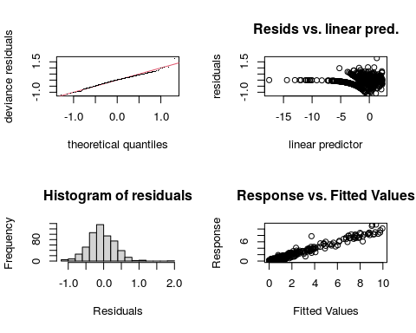

##   
## Method: GCV Optimizer: outer newton  
## full convergence after 22 iterations.  
## Gradient range [-5.655339e-08,1.065777e-08]  
## (score 0.2011125 & scale 0.1775935).  
## Hessian positive definite, eigenvalue range [4.317938e-10,0.0008462312].  
## Model rank = 256 / 256   
##   
## Basis dimension (k) checking results. Low p-value (k-index<1) may  
## indicate that k is too low, especially if edf is close to k'.  
##   
## k'  
## s(NumDate):Country.RegionDenmark 9.00  
## s(NumDate):Country.RegionFinland 9.00  
## s(NumDate):Country.RegionNorway 9.00  
## s(NumDate):Country.RegionSweden 9.00  
## s(StringencyIndex):Country.RegionDenmark 9.00  
## s(StringencyIndex):Country.RegionFinland 9.00  
## s(StringencyIndex):Country.RegionNorway 9.00  
## s(StringencyIndex):Country.RegionSweden 9.00  
## s(retail_and_recreation_percent_change_from_baseline):Country.RegionDenmark 9.00  
## s(retail_and_recreation_percent_change_from_baseline):Country.RegionFinland 9.00  
## s(retail_and_recreation_percent_change_from_baseline):Country.RegionNorway 9.00  
## s(retail_and_recreation_percent_change_from_baseline):Country.RegionSweden 9.00  
## s(grocery_and_pharmacy_percent_change_from_baseline):Country.RegionDenmark 9.00  
## s(grocery_and_pharmacy_percent_change_from_baseline):Country.RegionFinland 9.00  
## s(grocery_and_pharmacy_percent_change_from_baseline):Country.RegionNorway 9.00  
## s(grocery_and_pharmacy_percent_change_from_baseline):Country.RegionSweden 9.00  
## s(transit_stations_percent_change_from_baseline):Country.RegionDenmark 9.00  
## s(transit_stations_percent_change_from_baseline):Country.RegionFinland 9.00  
## s(transit_stations_percent_change_from_baseline):Country.RegionNorway 9.00  
## s(transit_stations_percent_change_from_baseline):Country.RegionSweden 9.00  
## s(workplaces_percent_change_from_baseline):Country.RegionDenmark 9.00  
## s(workplaces_percent_change_from_baseline):Country.RegionFinland 9.00  
## s(workplaces_percent_change_from_baseline):Country.RegionNorway 9.00  
## s(workplaces_percent_change_from_baseline):Country.RegionSweden 9.00  
## s(residential_percent_change_from_baseline):Country.RegionDenmark 9.00  
## s(residential_percent_change_from_baseline):Country.RegionFinland 9.00  
## s(residential_percent_change_from_baseline):Country.RegionNorway 9.00  
## s(residential_percent_change_from_baseline):Country.RegionSweden 9.00  
## edf  
## s(NumDate):Country.RegionDenmark 7.01  
## s(NumDate):Country.RegionFinland 6.02  
## s(NumDate):Country.RegionNorway 8.27  
## s(NumDate):Country.RegionSweden 8.56  
## s(StringencyIndex):Country.RegionDenmark 1.00  
## s(StringencyIndex):Country.RegionFinland 4.98  
## s(StringencyIndex):Country.RegionNorway 6.85  
## s(StringencyIndex):Country.RegionSweden 1.00  
## s(retail_and_recreation_percent_change_from_baseline):Country.RegionDenmark 2.13  
## s(retail_and_recreation_percent_change_from_baseline):Country.RegionFinland 1.00  
## s(retail_and_recreation_percent_change_from_baseline):Country.RegionNorway 1.00  
## s(retail_and_recreation_percent_change_from_baseline):Country.RegionSweden 1.00  
## s(grocery_and_pharmacy_percent_change_from_baseline):Country.RegionDenmark 2.63  
## s(grocery_and_pharmacy_percent_change_from_baseline):Country.RegionFinland 4.35  
## s(grocery_and_pharmacy_percent_change_from_baseline):Country.RegionNorway 4.06  
## s(grocery_and_pharmacy_percent_change_from_baseline):Country.RegionSweden 1.00  
## s(transit_stations_percent_change_from_baseline):Country.RegionDenmark 2.09  
## s(transit_stations_percent_change_from_baseline):Country.RegionFinland 5.86  
## s(transit_stations_percent_change_from_baseline):Country.RegionNorway 1.00  
## s(transit_stations_percent_change_from_baseline):Country.RegionSweden 1.00  
## s(workplaces_percent_change_from_baseline):Country.RegionDenmark 1.00  
## s(workplaces_percent_change_from_baseline):Country.RegionFinland 1.00  
## s(workplaces_percent_change_from_baseline):Country.RegionNorway 2.51  
## s(workplaces_percent_change_from_baseline):Country.RegionSweden 1.00  
## s(residential_percent_change_from_baseline):Country.RegionDenmark 1.00  
## s(residential_percent_change_from_baseline):Country.RegionFinland 1.00  
## s(residential_percent_change_from_baseline):Country.RegionNorway 6.17  
## s(residential_percent_change_from_baseline):Country.RegionSweden 1.00  
## k-index  
## s(NumDate):Country.RegionDenmark 0.93  
## s(NumDate):Country.RegionFinland 0.93  
## s(NumDate):Country.RegionNorway 0.93  
## s(NumDate):Country.RegionSweden 0.93  
## s(StringencyIndex):Country.RegionDenmark 1.11  
## s(StringencyIndex):Country.RegionFinland 1.11  
## s(StringencyIndex):Country.RegionNorway 1.11  
## s(StringencyIndex):Country.RegionSweden 1.11  
## s(retail_and_recreation_percent_change_from_baseline):Country.RegionDenmark 1.03  
## s(retail_and_recreation_percent_change_from_baseline):Country.RegionFinland 1.03  
## s(retail_and_recreation_percent_change_from_baseline):Country.RegionNorway 1.03  
## s(retail_and_recreation_percent_change_from_baseline):Country.RegionSweden 1.03  
## s(grocery_and_pharmacy_percent_change_from_baseline):Country.RegionDenmark 1.04  
## s(grocery_and_pharmacy_percent_change_from_baseline):Country.RegionFinland 1.04  
## s(grocery_and_pharmacy_percent_change_from_baseline):Country.RegionNorway 1.04  
## s(grocery_and_pharmacy_percent_change_from_baseline):Country.RegionSweden 1.04  
## s(transit_stations_percent_change_from_baseline):Country.RegionDenmark 0.99  
## s(transit_stations_percent_change_from_baseline):Country.RegionFinland 0.99  
## s(transit_stations_percent_change_from_baseline):Country.RegionNorway 0.99  
## s(transit_stations_percent_change_from_baseline):Country.RegionSweden 0.99  
## s(workplaces_percent_change_from_baseline):Country.RegionDenmark 0.99  
## s(workplaces_percent_change_from_baseline):Country.RegionFinland 0.99  
## s(workplaces_percent_change_from_baseline):Country.RegionNorway 0.99  
## s(workplaces_percent_change_from_baseline):Country.RegionSweden 0.99  
## s(residential_percent_change_from_baseline):Country.RegionDenmark 1.02  
## s(residential_percent_change_from_baseline):Country.RegionFinland 1.02  
## s(residential_percent_change_from_baseline):Country.RegionNorway 1.02  
## s(residential_percent_change_from_baseline):Country.RegionSweden 1.02  
## p-value  
## s(NumDate):Country.RegionDenmark 0.14  
## s(NumDate):Country.RegionFinland 0.14  
## s(NumDate):Country.RegionNorway 0.11  
## s(NumDate):Country.RegionSweden 0.12  
## s(StringencyIndex):Country.RegionDenmark 1.00  
## s(StringencyIndex):Country.RegionFinland 1.00  
## s(StringencyIndex):Country.RegionNorway 0.99  
## s(StringencyIndex):Country.RegionSweden 0.99  
## s(retail_and_recreation_percent_change_from_baseline):Country.RegionDenmark 0.87  
## s(retail_and_recreation_percent_change_from_baseline):Country.RegionFinland 0.92  
## s(retail_and_recreation_percent_change_from_baseline):Country.RegionNorway 0.93  
## s(retail_and_recreation_percent_change_from_baseline):Country.RegionSweden 0.87  
## s(grocery_and_pharmacy_percent_change_from_baseline):Country.RegionDenmark 0.94  
## s(grocery_and_pharmacy_percent_change_from_baseline):Country.RegionFinland 0.96  
## s(grocery_and_pharmacy_percent_change_from_baseline):Country.RegionNorway 0.95  
## s(grocery_and_pharmacy_percent_change_from_baseline):Country.RegionSweden 0.97  
## s(transit_stations_percent_change_from_baseline):Country.RegionDenmark 0.68  
## s(transit_stations_percent_change_from_baseline):Country.RegionFinland 0.67  
## s(transit_stations_percent_change_from_baseline):Country.RegionNorway 0.57  
## s(transit_stations_percent_change_from_baseline):Country.RegionSweden 0.64  
## s(workplaces_percent_change_from_baseline):Country.RegionDenmark 0.70  
## s(workplaces_percent_change_from_baseline):Country.RegionFinland 0.72  
## s(workplaces_percent_change_from_baseline):Country.RegionNorway 0.67  
## s(workplaces_percent_change_from_baseline):Country.RegionSweden 0.64  
## s(residential_percent_change_from_baseline):Country.RegionDenmark 0.87  
## s(residential_percent_change_from_baseline):Country.RegionFinland 0.84  
## s(residential_percent_change_from_baseline):Country.RegionNorway 0.82  
## s(residential_percent_change_from_baseline):Country.RegionSweden 0.91

plot(fit)

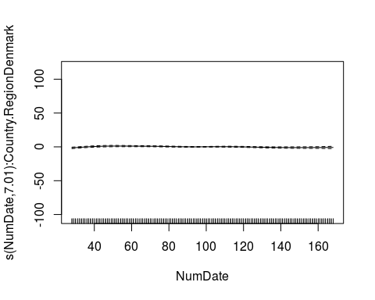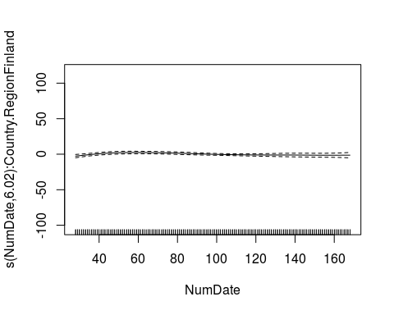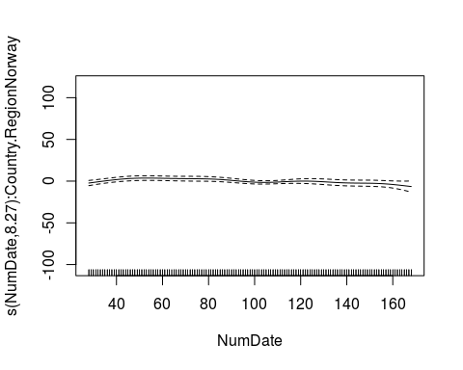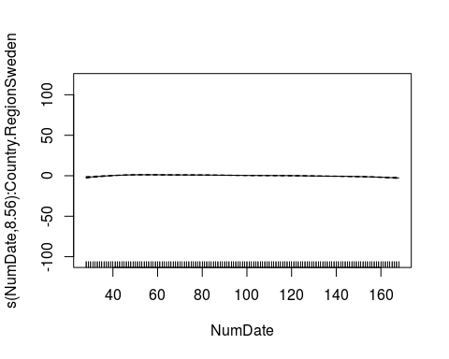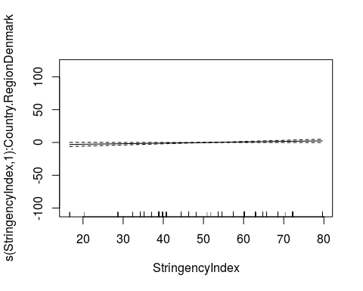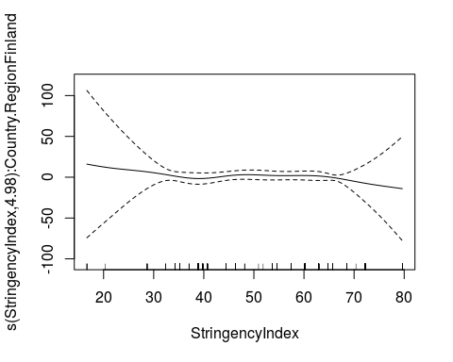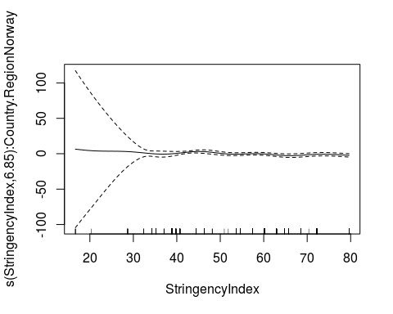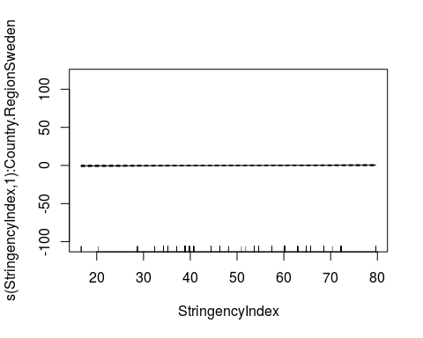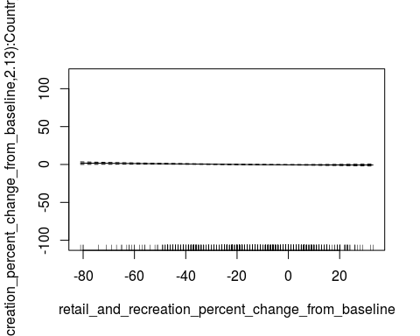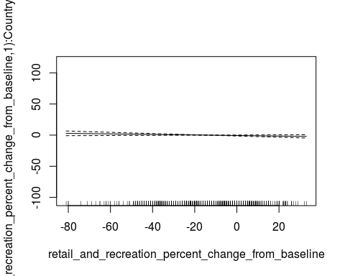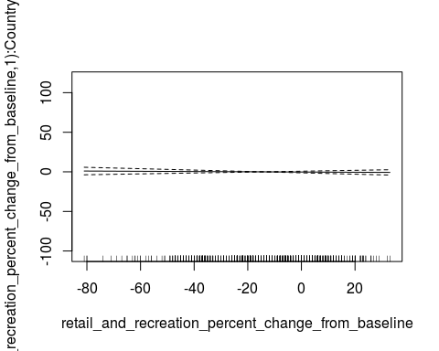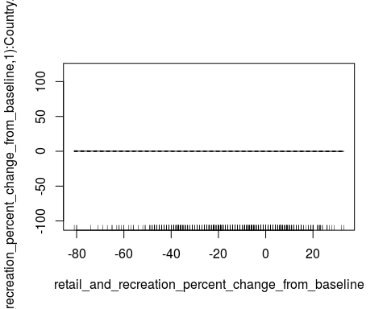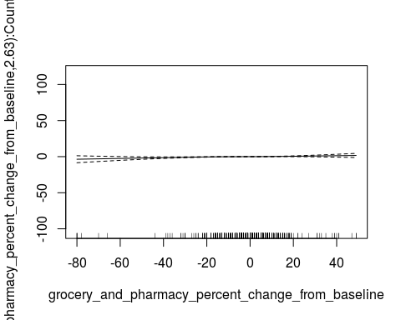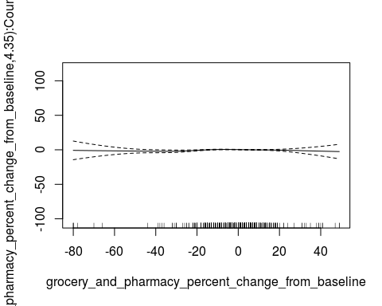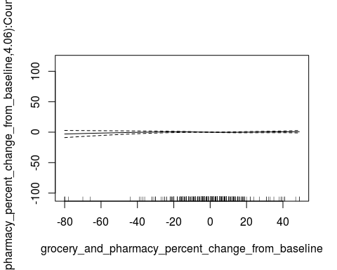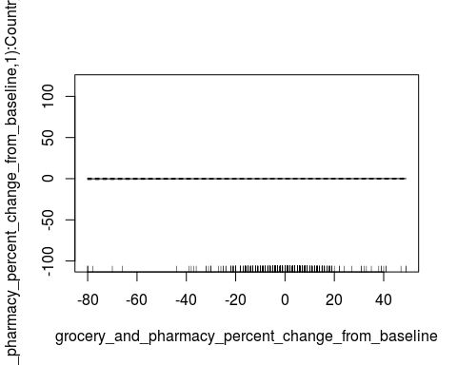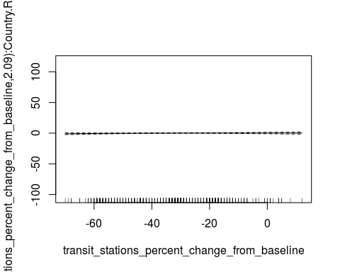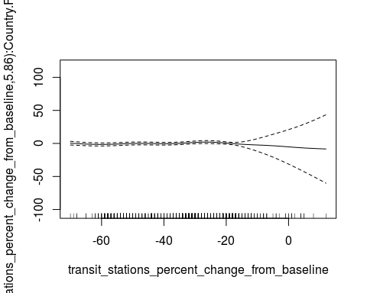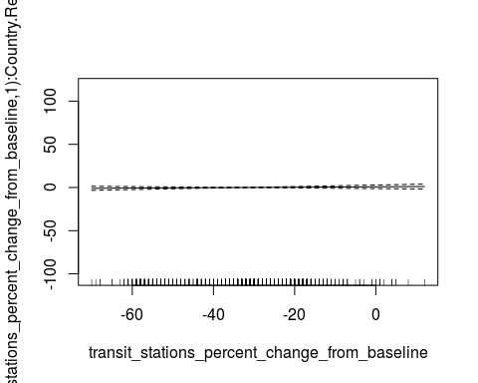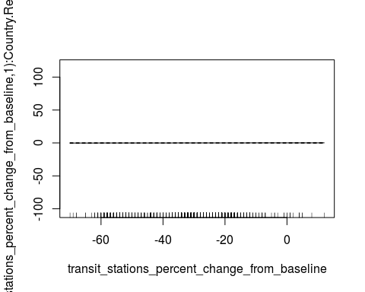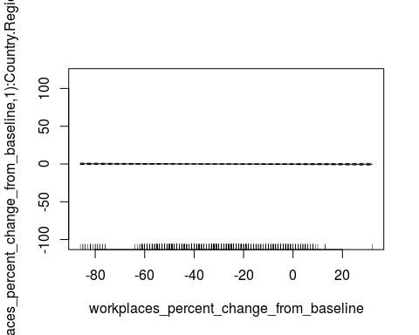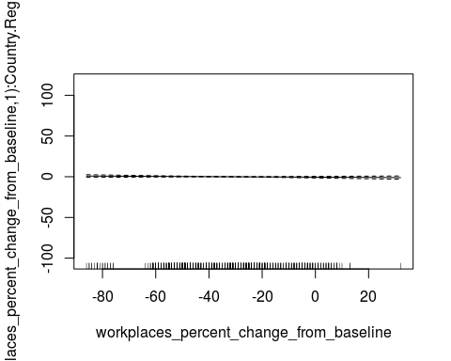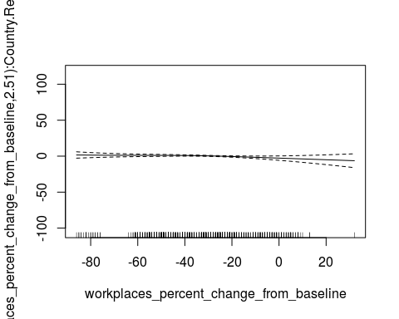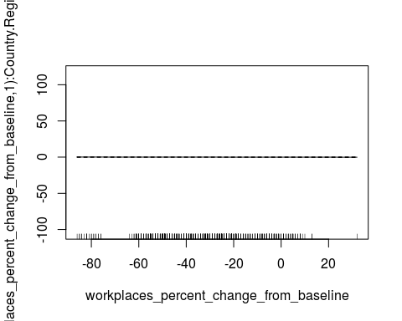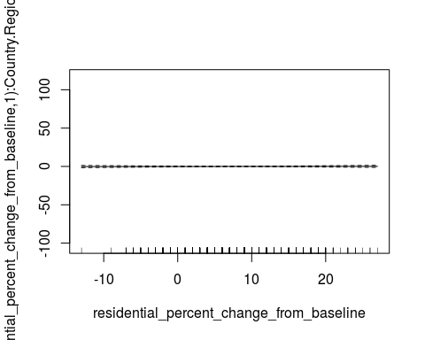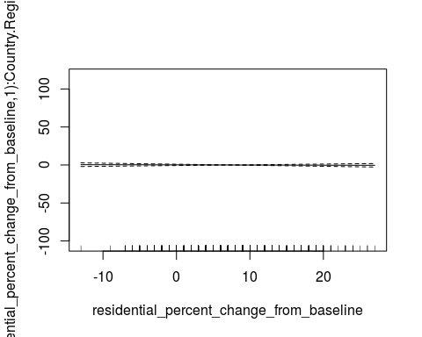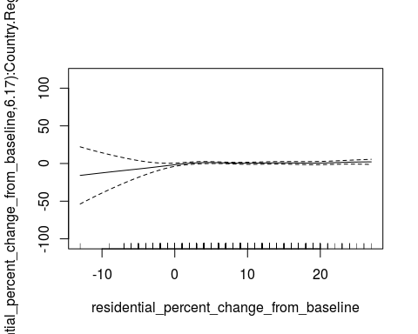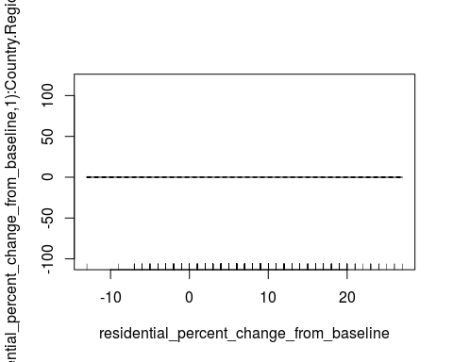

plot_model(fit)

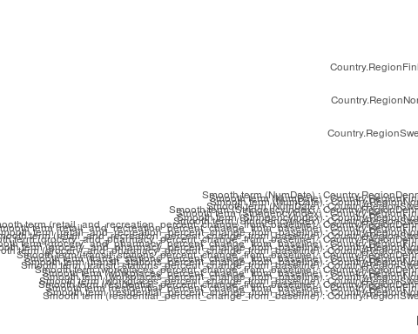

tab_model(fit)

IncCaseNumber

Predictors

Estimates

CI

p

(Intercept)

-1.95

-3.01 – -0.90

<0.001

Country.RegionFinland

-2.44

-8.14 – 3.26

0.400

Country.RegionNorway

-0.32

-2.36 – 1.71

0.754

Country.RegionSweden

3.09

2.00 – 4.19

<0.001

Smooth term (NumDate) :Country.RegionDenmark

7.01

<0.001

Smooth term (NumDate) :Country.RegionFinland

6.02

<0.001

Smooth term (NumDate) :Country.RegionNorway

8.27

<0.001

Smooth term (NumDate) :Country.RegionSweden

8.56

<0.001

Smooth term(StringencyIndex) :Country.RegionDenmark

1.00

0.052

Smooth term(StringencyIndex) :Country.RegionFinland

4.98

0.352

Smooth term(StringencyIndex) :Country.RegionNorway

6.85

0.001

Smooth term(StringencyIndex) :Country.RegionSweden

1.00

0.291

Smooth term(retail_and_recreation_percent_change_from_baseline): Country.RegionDenmark

2.13

0.003

Smooth term(retail_and_recreation_percent_change_from_baseline): Country.RegionFinland

1.00

0.125

Smooth term(retail_and_recreation_percent_change_from_baseline): Country.RegionNorway

1.00

0.670

Smooth term(retail_and_recreation_percent_change_from_baseline): Country.RegionSweden

1.00

0.545

Smooth term(grocery_and_pharmacy_percent_change_from_baseline): Country.RegionDenmark

2.63

0.037

Smooth term(grocery_and_pharmacy_percent_change_from_baseline): Country.RegionFinland

4.35

0.008

Smooth term(grocery_and_pharmacy_percent_change_from_baseline): Country.RegionNorway

4.06

0.077

Smooth term(grocery_and_pharmacy_percent_change_from_baseline): Country.RegionSweden

1.00

0.699

Smooth term(transit_stations_percent_change_from_baseline): Country.RegionDenmark

2.09

0.342

Smooth term(transit_stations_percent_change_from_baseline): Country.RegionFinland

5.86

<0.001

Smooth term(transit_stations_percent_change_from_baseline): Country.RegionNorway

1.00

0.444

Smooth term(transit_stations_percent_change_from_baseline): Country.RegionSweden

1.00

0.567

Smooth term(workplaces_percent_change_from_baseline): Country.RegionDenmark

1.00

0.541

Smooth term(workplaces_percent_change_from_baseline): Country.RegionFinland

1.00

0.291

Smooth term(workplaces_percent_change_from_baseline): Country.RegionNorway

2.51

0.261

Smooth term(workplaces_percent_change_from_baseline): Country.RegionSweden

1.00

0.635

Smooth term(residential_percent_change_from_baseline): Country.RegionDenmark

1.00

0.833

Smooth term(residential_percent_change_from_baseline): Country.RegionFinland

1.00

0.739

Smooth term(residential_percent_change_from_baseline): Country.RegionNorway

6.17

0.375

Smooth term(residential_percent_change_from_baseline): Country.RegionSweden

1.00

0.937

Observations

561

R2

0.960

fitcb<-gam(IncCaseNumber~s(NumDate, by=Country.Region) + cb1 + cb2 + cb4 + cb5 + cb6 + cb7 + Country.Region, data = datat, select=TRUE, family=Tweedie(p=1.011))  
summary(fitcb)

##   
## Family: Tweedie(1.011)   
## Link function: log   
##   
## Formula:  
## IncCaseNumber ~ s(NumDate, by = Country.Region) + cb1 + cb2 +   
## cb4 + cb5 + cb6 + cb7 + Country.Region  
##   
## Parametric coefficients:  
## Estimate Std. Error t value Pr(>|t|)   
## (Intercept) 8.05318 27.50005 0.293 0.7698   
## cb1v1.l1 -1.30591 2.59921 -0.502 0.6156   
## cb1v1.l2 2.85496 4.65313 0.614 0.5398   
## cb1v1.l3 -0.56056 3.40475 -0.165 0.8693   
## cb1v1.l4 0.48205 2.07818 0.232 0.8167   
## cb1v1.l5 -0.61686 1.83559 -0.336 0.7370   
## cb1v2.l1 -0.37922 1.87308 -0.202 0.8396   
## cb1v2.l2 1.84564 1.72817 1.068 0.2861   
## cb1v2.l3 1.10309 1.62660 0.678 0.4980   
## cb1v2.l4 -0.05519 1.63239 -0.034 0.9730   
## cb1v2.l5 1.16550 1.27677 0.913 0.3618   
## cb1v3.l1 -0.38250 2.28006 -0.168 0.8668   
## cb1v3.l2 1.58064 3.31864 0.476 0.6341   
## cb1v3.l3 -1.07597 2.36788 -0.454 0.6498   
## cb1v3.l4 0.05005 1.44819 0.035 0.9724   
## cb1v3.l5 -0.92820 1.32879 -0.699 0.4852   
## cb2v1.l1 0.54021 2.94249 0.184 0.8544   
## cb2v1.l2 -1.88302 2.84706 -0.661 0.5087   
## cb2v1.l3 1.53167 2.31681 0.661 0.5089   
## cb2v1.l4 1.93879 2.08913 0.928 0.3539   
## cb2v1.l5 -1.13119 1.55959 -0.725 0.4686   
## cb2v2.l1 -0.08033 1.18763 -0.068 0.9461   
## cb2v2.l2 -0.10948 1.42581 -0.077 0.9388   
## cb2v2.l3 -0.68043 1.32144 -0.515 0.6069   
## cb2v2.l4 -0.78017 0.83783 -0.931 0.3522   
## cb2v2.l5 0.03741 0.82717 0.045 0.9639   
## cb2v3.l1 0.35919 2.47206 0.145 0.8845   
## cb2v3.l2 -2.04113 2.46886 -0.827 0.4088   
## cb2v3.l3 0.67519 1.88310 0.359 0.7201   
## cb2v3.l4 0.64020 1.58940 0.403 0.6873   
## cb2v3.l5 -0.75236 1.37597 -0.547 0.5848   
## cb4v1.l1 -2.96108 2.00508 -1.477 0.1404   
## cb4v1.l2 0.91248 2.22538 0.410 0.6820   
## cb4v1.l3 -1.03858 1.42046 -0.731 0.4650   
## cb4v1.l4 -0.77342 1.32729 -0.583 0.5604   
## cb4v1.l5 0.57638 1.09059 0.529 0.5974   
## cb4v2.l1 0.38868 1.03766 0.375 0.7081   
## cb4v2.l2 -1.85245 1.34650 -1.376 0.1696   
## cb4v2.l3 0.60072 0.97246 0.618 0.5370   
## cb4v2.l4 1.14557 0.84944 1.349 0.1781   
## cb4v2.l5 -0.45727 0.62576 -0.731 0.4653   
## cb4v3.l1 -2.90433 2.01283 -1.443 0.1497   
## cb4v3.l2 0.88707 2.33411 0.380 0.7041   
## cb4v3.l3 -0.57040 1.50704 -0.378 0.7052   
## cb4v3.l4 0.89613 1.18486 0.756 0.4498   
## cb4v3.l5 -0.03797 0.99905 -0.038 0.9697   
## cb5v1.l1 -0.17573 1.13786 -0.154 0.8773   
## cb5v1.l2 0.45476 1.69105 0.269 0.7881   
## cb5v1.l3 -1.15095 1.62091 -0.710 0.4780   
## cb5v1.l4 0.30526 1.32095 0.231 0.8173   
## cb5v1.l5 -0.77891 0.90455 -0.861 0.3896   
## cb5v2.l1 1.34220 1.19302 1.125 0.2611   
## cb5v2.l2 -0.97138 1.40564 -0.691 0.4899   
## cb5v2.l3 0.61239 1.31128 0.467 0.6407   
## cb5v2.l4 1.11480 0.80526 1.384 0.1669   
## cb5v2.l5 0.35568 0.83064 0.428 0.6687   
## cb5v3.l1 -1.53072 1.28584 -1.190 0.2345   
## cb5v3.l2 1.66570 1.84662 0.902 0.3675   
## cb5v3.l3 -2.70818 1.83818 -1.473 0.1413   
## cb5v3.l4 -0.10580 1.23025 -0.086 0.9315   
## cb5v3.l5 -1.51457 1.13173 -1.338 0.1815   
## cb6v1.l1 -7.77860 3.93990 -1.974 0.0489 *  
## cb6v1.l2 7.47078 4.49358 1.663 0.0971 .  
## cb6v1.l3 -4.46189 4.25865 -1.048 0.2953   
## cb6v1.l4 -2.42551 3.25645 -0.745 0.4567   
## cb6v1.l5 -1.41913 2.78601 -0.509 0.6107   
## cb6v2.l1 -2.57890 1.84961 -1.394 0.1639   
## cb6v2.l2 1.56998 2.28145 0.688 0.4917   
## cb6v2.l3 -2.27140 2.02237 -1.123 0.2620   
## cb6v2.l4 0.90905 1.40097 0.649 0.5167   
## cb6v2.l5 -1.31250 1.52928 -0.858 0.3912   
## cb6v3.l1 -6.28814 3.22950 -1.947 0.0521 .  
## cb6v3.l2 3.54822 3.62629 0.978 0.3283   
## cb6v3.l3 -3.15131 3.08752 -1.021 0.3079   
## cb6v3.l4 -0.29447 2.49247 -0.118 0.9060   
## cb6v3.l5 -1.10240 2.04508 -0.539 0.5901   
## cb7v1.l1 3.39543 2.32685 1.459 0.1452   
## cb7v1.l2 1.14865 0.91269 1.259 0.2088   
## cb7v1.l3 1.30844 1.10493 1.184 0.2369   
## cb7v1.l4 -4.36446 2.90864 -1.501 0.1342   
## cb7v1.l5 3.01479 1.97787 1.524 0.1281   
## cb7v2.l1 1.50447 1.18750 1.267 0.2058   
## cb7v2.l2 1.26163 0.88336 1.428 0.1539   
## cb7v2.l3 0.04555 0.77487 0.059 0.9532   
## cb7v2.l4 -3.15306 1.57084 -2.007 0.0453 *  
## cb7v2.l5 1.44206 1.14910 1.255 0.2101   
## cb7v3.l1 1.94008 1.47603 1.314 0.1894   
## cb7v3.l2 1.52875 0.92091 1.660 0.0976 .  
## cb7v3.l3 0.67277 0.83815 0.803 0.4226   
## cb7v3.l4 -3.19558 1.95445 -1.635 0.1027   
## cb7v3.l5 1.79043 1.37654 1.301 0.1940   
## Country.RegionFinland -1.84650 1.27561 -1.448 0.1484   
## Country.RegionNorway -0.11712 1.47810 -0.079 0.9369   
## Country.RegionSweden 3.39072 1.45489 2.331 0.0202 *  
## ---  
## Signif. codes: 0 '***' 0.001 '**' 0.01 '*' 0.05 '.' 0.1 ' ' 1  
##   
## Approximate significance of smooth terms:  
## edf Ref.df F p-value  
## s(NumDate):Country.RegionDenmark 1.035e-04 9 0 0.538  
## s(NumDate):Country.RegionFinland 1.187e-05 9 0 0.552  
## s(NumDate):Country.RegionNorway 1.229e-04 9 0 0.389  
## s(NumDate):Country.RegionSweden 9.182e-05 9 0 0.794  
##   
## R-sq.(adj) = 0.946 Deviance explained = 93.2%  
## GCV = 0.26636 Scale est. = 0.23812 n = 561

AIC(fitcb)

## [1] 642.3532

gam.check(fitcb)

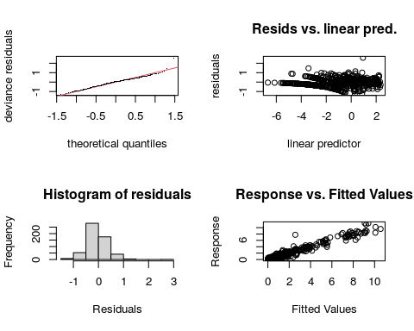

##   
## Method: GCV Optimizer: outer newton  
## full convergence after 7 iterations.  
## Gradient range [-7.045237e-08,-1.316899e-09]  
## (score 0.2663578 & scale 0.2381195).  
## Hessian positive definite, eigenvalue range [1.316904e-09,7.044551e-08].  
## Model rank = 130 / 130   
##   
## Basis dimension (k) checking results. Low p-value (k-index<1) may  
## indicate that k is too low, especially if edf is close to k'.  
##   
## k' edf k-index p-value  
## s(NumDate):Country.RegionDenmark 9.00e+00 1.03e-04 1 0.74  
## s(NumDate):Country.RegionFinland 9.00e+00 1.19e-05 1 0.73  
## s(NumDate):Country.RegionNorway 9.00e+00 1.23e-04 1 0.77  
## s(NumDate):Country.RegionSweden 9.00e+00 9.18e-05 1 0.70

plot(fitcb)

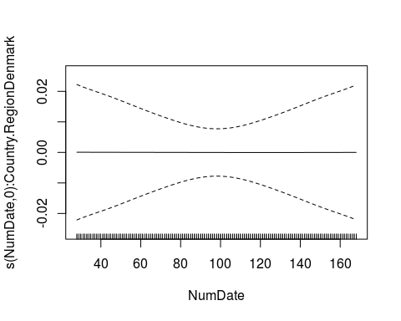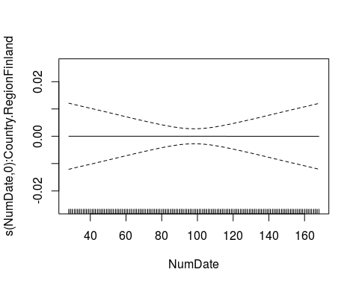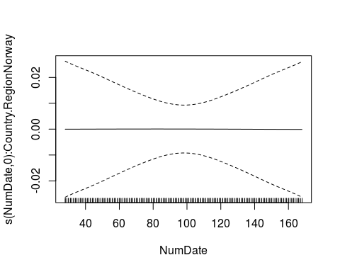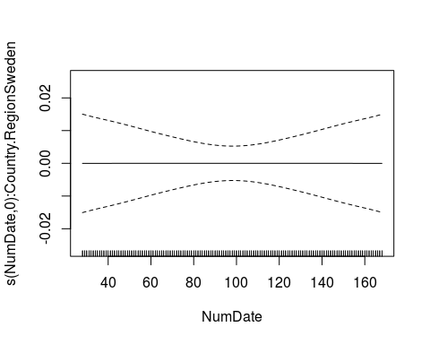

plot_model(fitcb)

## Warning in mapply(function(.d, .l) {: longer argument not a multiple of length  
## of shorter

## Warning: Some model terms could not be found in model data. You probably need to  
## load the data into the environment.

## Warning in mapply(function(.d, .l) {: longer argument not a multiple of length  
## of shorter

## Warning: Some model terms could not be found in model data. You probably need to  
## load the data into the environment.

## Warning in mapply(function(.d, .l) {: longer argument not a multiple of length  
## of shorter

## Warning: Some model terms could not be found in model data. You probably need to  
## load the data into the environment.

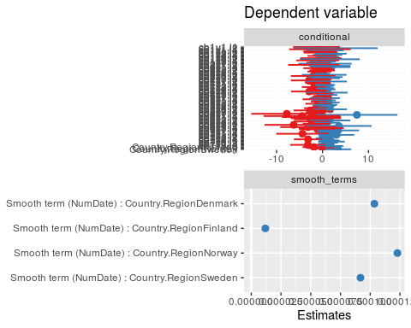

tab_model(fitcb)

## Warning in mapply(function(.d, .l) {: longer argument not a multiple of length  
## of shorter  
  
## Warning in mapply(function(.d, .l) {: Some model terms could not be found in  
## model data. You probably need to load the data into the environment.

## Warning in mapply(function(.d, .l) {: longer argument not a multiple of length  
## of shorter

## Warning: Some model terms could not be found in model data. You probably need to  
## load the data into the environment.

## Warning in mapply(function(.d, .l) {: longer argument not a multiple of length  
## of shorter

## Warning: Some model terms could not be found in model data. You probably need to  
## load the data into the environment.

Dependent variable

Predictors

Estimates

CI

p

(Intercept)

8.05

-45.99 – 62.09

0.770

cb1v1.l1

-1.31

-6.41 – 3.80

0.616

cb1v1.l2

2.85

-6.29 – 12.00

0.540

cb1v1.l3

-0.56

-7.25 – 6.13

0.869

cb1v1.l4

0.48

-3.60 – 4.57

0.817

cb1v1.l5

-0.62

-4.22 – 2.99

0.737

cb1v2.l1

-0.38

-4.06 – 3.30

0.840

cb1v2.l2

1.85

-1.55 – 5.24

0.286

cb1v2.l3

1.10

-2.09 – 4.30

0.498

cb1v2.l4

-0.06

-3.26 – 3.15

0.973

cb1v2.l5

1.17

-1.34 – 3.67

0.362

cb1v3.l1

-0.38

-4.86 – 4.10

0.867

cb1v3.l2

1.58

-4.94 – 8.10

0.634

cb1v3.l3

-1.08

-5.73 – 3.58

0.650

cb1v3.l4

0.05

-2.80 – 2.90

0.972

cb1v3.l5

-0.93

-3.54 – 1.68

0.485

cb2v1.l1

0.54

-5.24 – 6.32

0.854

cb2v1.l2

-1.88

-7.48 – 3.71

0.509

cb2v1.l3

1.53

-3.02 – 6.08

0.509

cb2v1.l4

1.94

-2.17 – 6.04

0.354

cb2v1.l5

-1.13

-4.20 – 1.93

0.469

cb2v2.l1

-0.08

-2.41 – 2.25

0.946

cb2v2.l2

-0.11

-2.91 – 2.69

0.939

cb2v2.l3

-0.68

-3.28 – 1.92

0.607

cb2v2.l4

-0.78

-2.43 – 0.87

0.352

cb2v2.l5

0.04

-1.59 – 1.66

0.964

cb2v3.l1

0.36

-4.50 – 5.22

0.885

cb2v3.l2

-2.04

-6.89 – 2.81

0.409

cb2v3.l3

0.68

-3.03 – 4.38

0.720

cb2v3.l4

0.64

-2.48 – 3.76

0.687

cb2v3.l5

-0.75

-3.46 – 1.95

0.585

cb4v1.l1

-2.96

-6.90 – 0.98

0.140

cb4v1.l2

0.91

-3.46 – 5.29

0.682

cb4v1.l3

-1.04

-3.83 – 1.75

0.465

cb4v1.l4

-0.77

-3.38 – 1.83

0.560

cb4v1.l5

0.58

-1.57 – 2.72

0.597

cb4v2.l1

0.39

-1.65 – 2.43

0.708

cb4v2.l2

-1.85

-4.50 – 0.79

0.170

cb4v2.l3

0.60

-1.31 – 2.51

0.537

cb4v2.l4

1.15

-0.52 – 2.81

0.178

cb4v2.l5

-0.46

-1.69 – 0.77

0.465

cb4v3.l1

-2.90

-6.86 – 1.05

0.150

cb4v3.l2

0.89

-3.70 – 5.47

0.704

cb4v3.l3

-0.57

-3.53 – 2.39

0.705

cb4v3.l4

0.90

-1.43 – 3.22

0.450

cb4v3.l5

-0.04

-2.00 – 1.93

0.970

cb5v1.l1

-0.18

-2.41 – 2.06

0.877

cb5v1.l2

0.45

-2.87 – 3.78

0.788

cb5v1.l3

-1.15

-4.34 – 2.03

0.478

cb5v1.l4

0.31

-2.29 – 2.90

0.817

cb5v1.l5

-0.78

-2.56 – 1.00

0.390

cb5v2.l1

1.34

-1.00 – 3.69

0.261

cb5v2.l2

-0.97

-3.73 – 1.79

0.490

cb5v2.l3

0.61

-1.96 – 3.19

0.641

cb5v2.l4

1.11

-0.47 – 2.70

0.167

cb5v2.l5

0.36

-1.28 – 1.99

0.669

cb5v3.l1

-1.53

-4.06 – 1.00

0.234

cb5v3.l2

1.67

-1.96 – 5.29

0.368

cb5v3.l3

-2.71

-6.32 – 0.90

0.141

cb5v3.l4

-0.11

-2.52 – 2.31

0.932

cb5v3.l5

-1.51

-3.74 – 0.71

0.181

cb6v1.l1

-7.78

-15.52 – -0.04

0.049

cb6v1.l2

7.47

-1.36 – 16.30

0.097

cb6v1.l3

-4.46

-12.83 – 3.91

0.295

cb6v1.l4

-2.43

-8.82 – 3.97

0.457

cb6v1.l5

-1.42

-6.89 – 4.06

0.611

cb6v2.l1

-2.58

-6.21 – 1.06

0.164

cb6v2.l2

1.57

-2.91 – 6.05

0.492

cb6v2.l3

-2.27

-6.25 – 1.70

0.262

cb6v2.l4

0.91

-1.84 – 3.66

0.517

cb6v2.l5

-1.31

-4.32 – 1.69

0.391

cb6v3.l1

-6.29

-12.63 – 0.06

0.052

cb6v3.l2

3.55

-3.58 – 10.67

0.328

cb6v3.l3

-3.15

-9.22 – 2.92

0.308

cb6v3.l4

-0.29

-5.19 – 4.60

0.906

cb6v3.l5

-1.10

-5.12 – 2.92

0.590

cb7v1.l1

3.40

-1.18 – 7.97

0.145

cb7v1.l2

1.15

-0.64 – 2.94

0.209

cb7v1.l3

1.31

-0.86 – 3.48

0.237

cb7v1.l4

-4.36

-10.08 – 1.35

0.134

cb7v1.l5

3.01

-0.87 – 6.90

0.128

cb7v2.l1

1.50

-0.83 – 3.84

0.206

cb7v2.l2

1.26

-0.47 – 3.00

0.154

cb7v2.l3

0.05

-1.48 – 1.57

0.953

cb7v2.l4

-3.15

-6.24 – -0.07

0.045

cb7v2.l5

1.44

-0.82 – 3.70

0.210

cb7v3.l1

1.94

-0.96 – 4.84

0.189

cb7v3.l2

1.53

-0.28 – 3.34

0.098

cb7v3.l3

0.67

-0.97 – 2.32

0.423

cb7v3.l4

-3.20

-7.04 – 0.65

0.103

cb7v3.l5

1.79

-0.91 – 4.50

0.194

Country.RegionFinland

-1.85

-4.35 – 0.66

0.148

Country.RegionNorway

-0.12

-3.02 – 2.79

0.937

Country.RegionSweden

3.39

0.53 – 6.25

0.020

Smooth term (NumDate) :Country.RegionDenmark

0.00

0.538

Smooth term (NumDate) :Country.RegionFinland

0.00

0.552

Smooth term (NumDate) :Country.RegionNorway

0.00

0.389

Smooth term (NumDate) :Country.RegionSweden

0.00

0.794

Observations

561

R2

0.946

##stringency distributed lag  
fitcbstr<-gam(IncCaseNumber~s(NumDate, by=Country.Region) + cb7 + Country.Region, data = datat, select=TRUE, family=Tweedie(p=1.011))  
summary(fitcbstr)

##   
## Family: Tweedie(1.011)   
## Link function: log   
##   
## Formula:  
## IncCaseNumber ~ s(NumDate, by = Country.Region) + cb7 + Country.Region  
##   
## Parametric coefficients:  
## Estimate Std. Error t value Pr(>|t|)   
## (Intercept) -3.2518186 3.4567443 -0.941 0.347281   
## cb7v1.l1 1.3910054 1.6575300 0.839 0.401736   
## cb7v1.l2 -0.0229497 0.5104872 -0.045 0.964159   
## cb7v1.l3 0.3279331 0.7130251 0.460 0.645765   
## cb7v1.l4 -0.0925183 2.0100482 -0.046 0.963305   
## cb7v1.l5 0.8126939 1.3800863 0.589 0.556200   
## cb7v2.l1 0.9349625 0.7430691 1.258 0.208861   
## cb7v2.l2 -0.0005351 0.3549750 -0.002 0.998798   
## cb7v2.l3 0.4988975 0.4273068 1.168 0.243521   
## cb7v2.l4 -1.1383909 1.0102593 -1.127 0.260327   
## cb7v2.l5 0.7162625 0.7764030 0.923 0.356669   
## cb7v3.l1 1.3572165 0.9976003 1.360 0.174259   
## cb7v3.l2 -0.3249160 0.3563350 -0.912 0.362277   
## cb7v3.l3 0.6614440 0.4916829 1.345 0.179118   
## cb7v3.l4 -0.4281769 1.3040191 -0.328 0.742776   
## cb7v3.l5 0.5309457 0.9069206 0.585 0.558504   
## Country.RegionFinland -1.2373211 0.3523923 -3.511 0.000484 ***  
## Country.RegionNorway -1.3284778 0.3053806 -4.350 1.63e-05 ***  
## Country.RegionSweden 2.0283613 0.3456458 5.868 7.79e-09 ***  
## ---  
## Signif. codes: 0 '***' 0.001 '**' 0.01 '*' 0.05 '.' 0.1 ' ' 1  
##   
## Approximate significance of smooth terms:  
## edf Ref.df F p-value   
## s(NumDate):Country.RegionDenmark 2.382 9 6.956 5.79e-16 ***  
## s(NumDate):Country.RegionFinland 4.184 9 9.760 < 2e-16 ***  
## s(NumDate):Country.RegionNorway 1.000 9 1.825 1.52e-05 ***  
## s(NumDate):Country.RegionSweden 7.602 9 24.733 < 2e-16 ***  
## ---  
## Signif. codes: 0 '***' 0.001 '**' 0.01 '*' 0.05 '.' 0.1 ' ' 1  
##   
## R-sq.(adj) = 0.948 Deviance explained = 92.5%  
## GCV = 0.23179 Scale est. = 0.24938 n = 561

AIC(fitcbstr)

## [1] 939.9851

gam.check(fitcbstr)

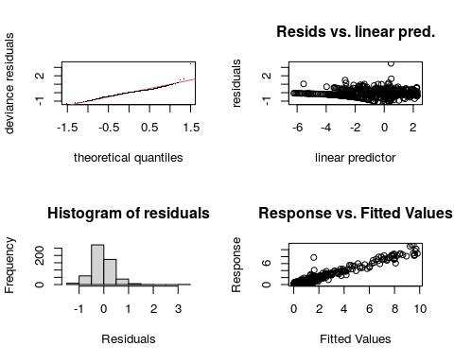

##   
## Method: GCV Optimizer: outer newton  
## full convergence after 14 iterations.  
## Gradient range [-3.044887e-08,3.616392e-08]  
## (score 0.2317901 & scale 0.2493848).  
## eigenvalue range [-2.843228e-09,0.0007378199].  
## Model rank = 55 / 55   
##   
## Basis dimension (k) checking results. Low p-value (k-index<1) may  
## indicate that k is too low, especially if edf is close to k'.  
##   
## k' edf k-index p-value  
## s(NumDate):Country.RegionDenmark 9.00 2.38 0.99 0.65  
## s(NumDate):Country.RegionFinland 9.00 4.18 0.99 0.66  
## s(NumDate):Country.RegionNorway 9.00 1.00 0.99 0.57  
## s(NumDate):Country.RegionSweden 9.00 7.60 0.99 0.62

plot(fitcbstr)

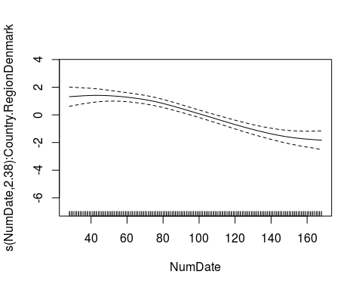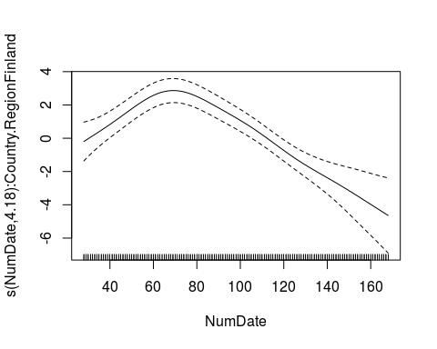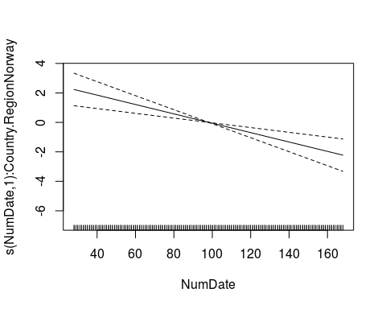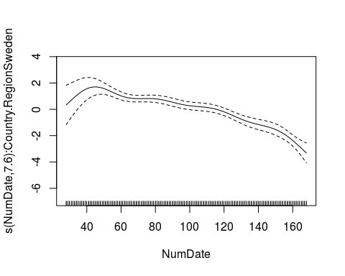

plot_model(fitcbstr)

## Warning in mapply(function(.d, .l) {: longer argument not a multiple of length  
## of shorter  
  
## Warning in mapply(function(.d, .l) {: Some model terms could not be found in  
## model data. You probably need to load the data into the environment.

## Warning in mapply(function(.d, .l) {: longer argument not a multiple of length  
## of shorter

## Warning: Some model terms could not be found in model data. You probably need to  
## load the data into the environment.

## Warning in mapply(function(.d, .l) {: longer argument not a multiple of length  
## of shorter

## Warning: Some model terms could not be found in model data. You probably need to  
## load the data into the environment.

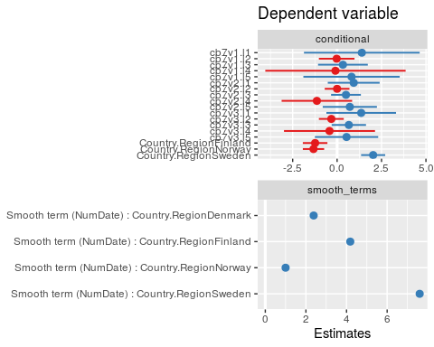

tab_model(fitcbstr)

## Warning in mapply(function(.d, .l) {: longer argument not a multiple of length  
## of shorter  
  
## Warning in mapply(function(.d, .l) {: Some model terms could not be found in  
## model data. You probably need to load the data into the environment.

## Warning in mapply(function(.d, .l) {: longer argument not a multiple of length  
## of shorter

## Warning: Some model terms could not be found in model data. You probably need to  
## load the data into the environment.

## Warning in mapply(function(.d, .l) {: longer argument not a multiple of length  
## of shorter

## Warning: Some model terms could not be found in model data. You probably need to  
## load the data into the environment.

Dependent variable

Predictors

Estimates

CI

p

(Intercept)

-3.25

-10.04 – 3.54

0.347

cb7v1.l1

1.39

-1.87 – 4.65

0.402

cb7v1.l2

-0.02

-1.03 – 0.98

0.964

cb7v1.l3

0.33

-1.07 – 1.73

0.646

cb7v1.l4

-0.09

-4.04 – 3.86

0.963

cb7v1.l5

0.81

-1.90 – 3.52

0.556

cb7v2.l1

0.93

-0.52 – 2.39

0.209

cb7v2.l2

-0.00

-0.70 – 0.70

0.999

cb7v2.l3

0.50

-0.34 – 1.34

0.244

cb7v2.l4

-1.14

-3.12 – 0.85

0.260

cb7v2.l5

0.72

-0.81 – 2.24

0.357

cb7v3.l1

1.36

-0.60 – 3.32

0.174

cb7v3.l2

-0.32

-1.02 – 0.38

0.362

cb7v3.l3

0.66

-0.30 – 1.63

0.179

cb7v3.l4

-0.43

-2.99 – 2.13

0.743

cb7v3.l5

0.53

-1.25 – 2.31

0.559

Country.RegionFinland

-1.24

-1.93 – -0.55

<0.001

Country.RegionNorway

-1.33

-1.93 – -0.73

<0.001

Country.RegionSweden

2.03

1.35 – 2.71

<0.001

Smooth term (NumDate) :Country.RegionDenmark

2.38

<0.001

Smooth term (NumDate) :Country.RegionFinland

4.18

<0.001

Smooth term (NumDate) :Country.RegionNorway

1.00

<0.001

Smooth term (NumDate) :Country.RegionSweden

7.60

<0.001

Observations

561

R2

0.948

AIC(fitplain)

## [1] 961.4624

AIC(fitwithout)

## [1] 632.8655

AIC(fit)

## [1] 1193.837

AIC(fitcb)

## [1] 642.3532

AIC(fitcbstr)

## [1] 939.9851

#preparing data for the validation  
  
datav$cb1 <- crossbasis(datav$grocery_and_pharmacy_percent_change_from_baseline , lag=28, argvar=list(fun="bs"),arglag=list(df=5), group=datav$Country.Region)

## Warning in (function (fun = NULL, df = NULL, knots = NULL, ...) : default knots placement along lags has changed since version 2.0.0.  
## See 'file.show(system.file('Changesince200',package='dlnm'))'.  
## See also help(logknots) for setting the knots  
## consistently with the previous versions

datav$cb2 <- crossbasis(datav$retail_and_recreation_percent_change_from_baseline , lag=28, argvar=list(fun="bs"),arglag=list(df=5), group=datav$Country.Region)

## Warning in (function (fun = NULL, df = NULL, knots = NULL, ...) : default knots placement along lags has changed since version 2.0.0.  
## See 'file.show(system.file('Changesince200',package='dlnm'))'.  
## See also help(logknots) for setting the knots  
## consistently with the previous versions

datav$cb4 <- crossbasis(datav$transit_stations_percent_change_from_baseline , lag=28, argvar=list(fun="bs"),arglag=list(df=5), group=datav$Country.Region)

## Warning in (function (fun = NULL, df = NULL, knots = NULL, ...) : default knots placement along lags has changed since version 2.0.0.  
## See 'file.show(system.file('Changesince200',package='dlnm'))'.  
## See also help(logknots) for setting the knots  
## consistently with the previous versions

datav$cb5 <- crossbasis(datav$workplaces_percent_change_from_baseline , lag=28, argvar=list(fun="bs"),arglag=list(df=5), group=datav$Country.Region)

## Warning in (function (fun = NULL, df = NULL, knots = NULL, ...) : default knots placement along lags has changed since version 2.0.0.  
## See 'file.show(system.file('Changesince200',package='dlnm'))'.  
## See also help(logknots) for setting the knots  
## consistently with the previous versions

datav$cb6 <- crossbasis(datav$residential_percent_change_from_baseline , lag=28, argvar=list(fun="bs"),arglag=list(df=5), group=datav$Country.Region)

## Warning in (function (fun = NULL, df = NULL, knots = NULL, ...) : default knots placement along lags has changed since version 2.0.0.  
## See 'file.show(system.file('Changesince200',package='dlnm'))'.  
## See also help(logknots) for setting the knots  
## consistently with the previous versions

datav$cb7 <- crossbasis(datav$StringencyIndex , lag=28, argvar=list(fun="bs"),arglag=list(df=5), group=datav$Country.Region)

## Warning in (function (fun = NULL, df = NULL, knots = NULL, ...) : default knots placement along lags has changed since version 2.0.0.  
## See 'file.show(system.file('Changesince200',package='dlnm'))'.  
## See also help(logknots) for setting the knots  
## consistently with the previous versions

dataval<-datav %>%  
 group_by(Country.Region) %>%  
 slice(-c(1:28))  
  
  
dataval$pred<-predict.gam(fitplain, dataval, type="response")  
dataval$pred1<-predict.gam(fitwithout, dataval, type="response")  
dataval$pred2<-predict.gam(fit, dataval, type="response")  
dataval$predcb<-predict.gam(fitcb, dataval, type="response")  
dataval$predcbstr<-predict.gam(fitcbstr, dataval, type="response")  
  
  
  
dataval<-na.omit(dataval)  
pred1<-predict.gam(fitplain, dataval, type="response")  
pred<-predict(fitplain, dataval, type="response", interval = "response")  
pred1<-predict.gam(fitwithout, dataval, type="response")  
pred2<-predict.gam(fit, dataval, type="response")  
predcb<-predict.gam(fitcb, dataval, type="response")  
predcbstr<-predict.gam(fitcbstr, dataval, type="response")  
  
  
  
  
  
#predcb<-predcb[!is.na(predcb)]  
  
  
RMSE <- function(pred, obs){  
 sqrt(mean((pred - obs)^2))  
}  
  
  
RMSE(dataval$pred, dataval$IncCaseNumber)

## [1] 0.2503114

RMSE(dataval$pred1, dataval$IncCaseNumber)

## [1] 0.2486492

RMSE(dataval$pred2, dataval$IncCaseNumber)

## [1] 0.5219219

RMSE(dataval$predcb, dataval$IncCaseNumber)

## [1] 104.6195

RMSE(dataval$predcbstr, dataval$IncCaseNumber)

## [1] 0.2520634

library(forecast)

## Registered S3 method overwritten by 'quantmod':  
## method from  
## as.zoo.data.frame zoo

##   
## Attaching package: 'forecast'

## The following object is masked from 'package:nlme':  
##   
## getResponse

## The following object is masked from 'package:ggpubr':  
##   
## gghistogram

dm.test(pred-dataval$IncCaseNumber, pred1-dataval$IncCaseNumber)

##   
## Diebold-Mariano Test  
##   
## data: pred - dataval$IncCaseNumberpred1 - dataval$IncCaseNumber  
## DM = 2.535, Forecast horizon = 1, Loss function power = 2, p-value =  
## 0.01248  
## alternative hypothesis: two.sided

dm.test(pred-dataval$IncCaseNumber, pred2-dataval$IncCaseNumber)

##   
## Diebold-Mariano Test  
##   
## data: pred - dataval$IncCaseNumberpred2 - dataval$IncCaseNumber  
## DM = -4.9851, Forecast horizon = 1, Loss function power = 2, p-value =  
## 2.019e-06  
## alternative hypothesis: two.sided

dm.test(pred-dataval$IncCaseNumber, predcb-dataval$IncCaseNumber)

##   
## Diebold-Mariano Test  
##   
## data: pred - dataval$IncCaseNumberpredcb - dataval$IncCaseNumber  
## DM = -2.1245, Forecast horizon = 1, Loss function power = 2, p-value =  
## 0.0356  
## alternative hypothesis: two.sided

dm.test(pred1-dataval$IncCaseNumber, pred2-dataval$IncCaseNumber)

##   
## Diebold-Mariano Test  
##   
## data: pred1 - dataval$IncCaseNumberpred2 - dataval$IncCaseNumber  
## DM = -5.0094, Forecast horizon = 1, Loss function power = 2, p-value =  
## 1.818e-06  
## alternative hypothesis: two.sided

dm.test(pred1-dataval$IncCaseNumber, predcb-dataval$IncCaseNumber)

##   
## Diebold-Mariano Test  
##   
## data: pred1 - dataval$IncCaseNumberpredcb - dataval$IncCaseNumber  
## DM = -2.1245, Forecast horizon = 1, Loss function power = 2, p-value =  
## 0.0356  
## alternative hypothesis: two.sided

dm.test(pred2-dataval$IncCaseNumber, predcb-dataval$IncCaseNumber)

##   
## Diebold-Mariano Test  
##   
## data: pred2 - dataval$IncCaseNumberpredcb - dataval$IncCaseNumber  
## DM = -2.1244, Forecast horizon = 1, Loss function power = 2, p-value =  
## 0.03561  
## alternative hypothesis: two.sided

dm.test(pred2-dataval$IncCaseNumber, predcbstr-dataval$IncCaseNumber)

##   
## Diebold-Mariano Test  
##   
## data: pred2 - dataval$IncCaseNumberpredcbstr - dataval$IncCaseNumber  
## DM = 4.9585, Forecast horizon = 1, Loss function power = 2, p-value =  
## 2.264e-06  
## alternative hypothesis: two.sided

library(tidyr)  
datavallong<-gather(dataval, reportedornot, number, c(22,10))

## Warning: attributes are not identical across measure variables;  
## they will be dropped

ggplot(datavallong, aes(date, number, group=reportedornot, colour=reportedornot)) +  
 geom_line() + geom_smooth() +  
 ggtitle("Predicted vs. Reported daily deaths per million (19/JUN/2020 to 07/OCT/2020)") +  
 xlab("Date") + ylab("Daily deaths per million") + xlab(" ") + ylab(" ") +   
 theme(legend.title=element_blank()) + xlab(" ") +   
 theme(axis.text.x=element_text(colour="black")) +  
 theme(axis.text.y=element_text(colour="black")) + facet_wrap(.~Country.Region)

## `geom_smooth()` using method = 'loess' and formula 'y ~ x'

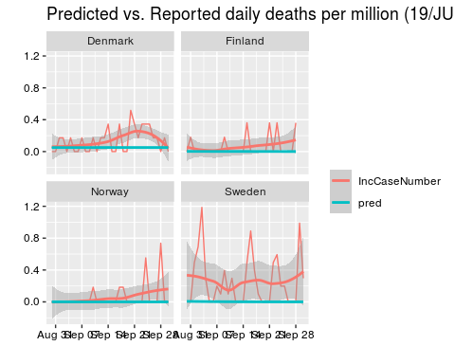

datavallong<-gather(dataval, reportedornot, number, c(23,10))

## Warning: attributes are not identical across measure variables;  
## they will be dropped

ggplot(datavallong, aes(date, number, group=reportedornot, colour=reportedornot)) +  
 geom_line() + geom_smooth() +  
 ggtitle("Predicted vs. Reported daily deaths per million (19/JUN/2020 to 07/OCT/2020)") +  
 xlab("Date") + ylab("Daily deaths per million") + xlab(" ") + ylab(" ") +   
 theme(legend.title=element_blank()) + xlab(" ") +   
 theme(axis.text.x=element_text(colour="black")) +  
 theme(axis.text.y=element_text(colour="black")) + facet_wrap(.~Country.Region)

## `geom_smooth()` using method = 'loess' and formula 'y ~ x'

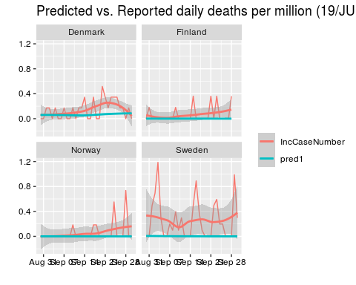

datavallong<-gather(dataval, reportedornot, number, c(24,10))

## Warning: attributes are not identical across measure variables;  
## they will be dropped

ggplot(datavallong, aes(date, number, group=reportedornot, colour=reportedornot)) +  
 geom_line() + geom_smooth() +  
 ggtitle("Predicted vs. Reported daily deaths per million (19/JUN/2020 to 07/OCT/2020)") +  
 xlab("Date") + ylab("Daily deaths per million") + xlab(" ") + ylab(" ") +   
 theme(legend.title=element_blank()) + xlab(" ") +   
 theme(axis.text.x=element_text(colour="black")) +  
 theme(axis.text.y=element_text(colour="black")) + facet_wrap(.~Country.Region)

## `geom_smooth()` using method = 'loess' and formula 'y ~ x'

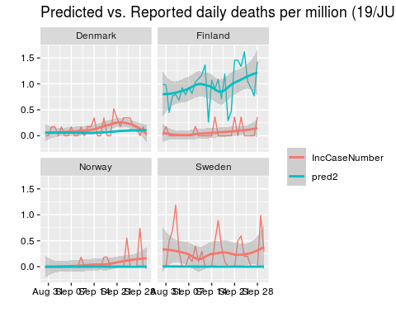

datavallong<-gather(dataval, reportedornot, number, c(25,10))

## Warning: attributes are not identical across measure variables;  
## they will be dropped

ggplot(datavallong, aes(date, number, group=reportedornot, colour=reportedornot)) +  
 geom_line() + geom_smooth() +  
 ggtitle("Predicted vs. Reported daily deaths per million (19/JUN/2020 to 07/OCT/2020)") +  
 xlab("Date") + ylab("Daily deaths per million") + xlab(" ") + ylab(" ") +   
 theme(legend.title=element_blank()) + xlab(" ") +   
 theme(axis.text.x=element_text(colour="black")) +  
 theme(axis.text.y=element_text(colour="black")) + facet_wrap(.~Country.Region)

## `geom_smooth()` using method = 'loess' and formula 'y ~ x'

