GMD Suppl. Plots

Sulyok

September 19, 2020

library(readr)  
library(ggpubr)

## Loading required package: ggplot2

#mobility data  
gmr <- read_csv("Downloads/Global_Mobility_Report(1).csv", col_types = cols(date = col_date(format = "%Y-%m-%d")))  
  
library(data.table)  
library(ggplot2)  
  
### Loading country data  
  
countries <- fread("http://download.geonames.org/export/dump/countryInfo.txt", skip = "ISO3", na.strings = "")  
names(countries)[c(1,5, 9)] <- c("geo", "Country.Region", "Continent")  
countries$lang <- sapply(strsplit(sapply(strsplit(countries$Languages, ","), `[`, 1), "-"), `[`, 1)  
countries$translated <- "Coronavirus"  
  
### Obtaining the case numbers  
  
jhu_url <- paste0("https://raw.githubusercontent.com/CSSEGISandData/COVID-19/master/csse_covid_19_data/",  
 "csse_covid_19_time_series/time_series_covid19_confirmed_global.csv")  
CaseData <- fread(jhu_url, check.names = TRUE)  
CaseData$Province.State[ CaseData$Province.State=="" ] <- CaseData$Country.Region[ CaseData$Province.State=="" ]  
CaseData <- melt(CaseData, id.vars = 1:4, variable.name = "Date", variable.factor = FALSE)  
CaseData$Date <- as.Date( substring(CaseData$Date, 2), format = "%m.%d.%y" )  
CaseData <- CaseData[ , .(CumCaseNumber = sum(value)), .(Country.Region, Date)][order(Country.Region, Date)]  
CaseData <- CaseData[ ,.(date = Date[-1], CumCaseNumber = CumCaseNumber[-1], IncCaseNumber = diff(CumCaseNumber)),  
 .(Country.Region)]  
  
CaseData[Country.Region=="US"]$Country.Region <- "United States"  
CaseData <- merge(CaseData,countries[,c("Country.Region", "geo", "Continent")])  
CaseData$country_region<-CaseData$Country.Region  
  
CaseData$IncCaseNumber<-ifelse(CaseData$IncCaseNumber<0, 0, CaseData$IncCaseNumber )  
  
merged<-merge(gmr, CaseData, by=c("country_region", "date"))  
  
  
super<- function(x,y) {  
 cc<-function(gmdvalue) {crosscorr <- sapply( -28:28, function(l) cor.test(gmdvalue, Hmisc::Lag(x,l),method = "kendall", use = "complete.obs")$estimate )}  
 corr<-cc(gmdvalue = y)  
 plot(-28:28,corr,type="h", ylab="Tau", xlab="Lag in Days")  
 abline(h=0)  
}  
  
set.seed(2020)  
countries<-sample(1:127, 10, replace=TRUE)  
gmdvar<-sample(1:6, 10, replace=TRUE)  
pairs<-cbind(countries, gmdvar)  
  
pairs

## countries gmdvar  
## [1,] 28 1  
## [2,] 108 5  
## [3,] 87 2  
## [4,] 22 2  
## [5,] 88 6  
## [6,] 65 5  
## [7,] 17 2  
## [8,] 36 3  
## [9,] 42 2  
## [10,] 70 5

#1 retail, 2 grocery, 3 park, 4 transit 5 workplace 6 residential  
levels(factor(merged$country_region))

## [1] "Afghanistan" "Angola" "Antigua and Barbuda"   
## [4] "Argentina" "Australia" "Austria"   
## [7] "Bahrain" "Bangladesh" "Barbados"   
## [10] "Belarus" "Belgium" "Belize"   
## [13] "Benin" "Bolivia" "Bosnia and Herzegovina"  
## [16] "Botswana" "Brazil" "Bulgaria"   
## [19] "Burkina Faso" "Cambodia" "Cameroon"   
## [22] "Canada" "Chile" "Colombia"   
## [25] "Costa Rica" "Croatia" "Czechia"   
## [28] "Denmark" "Dominican Republic" "Ecuador"   
## [31] "Egypt" "El Salvador" "Estonia"   
## [34] "Fiji" "Finland" "France"   
## [37] "Gabon" "Georgia" "Germany"   
## [40] "Ghana" "Greece" "Guatemala"   
## [43] "Guinea-Bissau" "Haiti" "Honduras"   
## [46] "Hungary" "India" "Indonesia"   
## [49] "Iraq" "Ireland" "Israel"   
## [52] "Italy" "Jamaica" "Japan"   
## [55] "Jordan" "Kazakhstan" "Kenya"   
## [58] "Kuwait" "Kyrgyzstan" "Laos"   
## [61] "Latvia" "Lebanon" "Libya"   
## [64] "Liechtenstein" "Lithuania" "Luxembourg"   
## [67] "Malaysia" "Mali" "Malta"   
## [70] "Mauritius" "Mexico" "Moldova"   
## [73] "Mongolia" "Morocco" "Mozambique"   
## [76] "Namibia" "Nepal" "Netherlands"   
## [79] "New Zealand" "Nicaragua" "Niger"   
## [82] "Nigeria" "North Macedonia" "Norway"   
## [85] "Oman" "Pakistan" "Panama"   
## [88] "Papua New Guinea" "Paraguay" "Peru"   
## [91] "Philippines" "Poland" "Portugal"   
## [94] "Qatar" "Romania" "Russia"   
## [97] "Rwanda" "Saudi Arabia" "Senegal"   
## [100] "Serbia" "Singapore" "Slovakia"   
## [103] "Slovenia" "South Africa" "Spain"   
## [106] "Sri Lanka" "Sweden" "Switzerland"   
## [109] "Tajikistan" "Tanzania" "Thailand"   
## [112] "Togo" "Trinidad and Tobago" "Turkey"   
## [115] "Uganda" "Ukraine" "United Arab Emirates"   
## [118] "United Kingdom" "United States" "Uruguay"   
## [121] "Venezuela" "Vietnam" "Yemen"   
## [124] "Zambia" "Zimbabwe"

a<-subset(merged, country_region=="Denmark")  
super(a$IncCaseNumber, a$retail_and_recreation_percent_change_from_baseline)

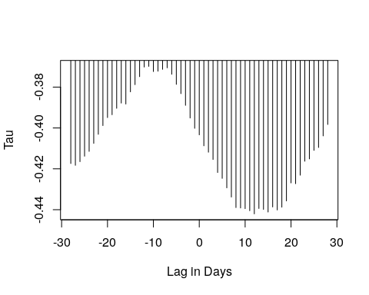

a<-subset(merged, country_region=="Switzerland")  
super(a$IncCaseNumber, a$workplaces_percent_change_from_baseline)

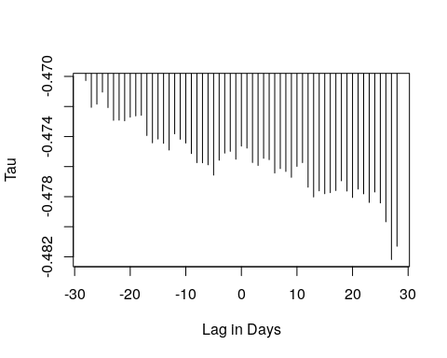

a<-subset(merged, country_region=="Panama")  
super(a$IncCaseNumber, a$grocery_and_pharmacy_percent_change_from_baseline)

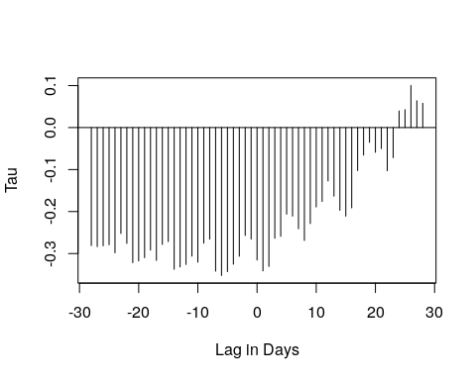

a<-subset(merged, country_region=="Canada")  
super(a$IncCaseNumber, a$grocery_and_pharmacy_percent_change_from_baseline)

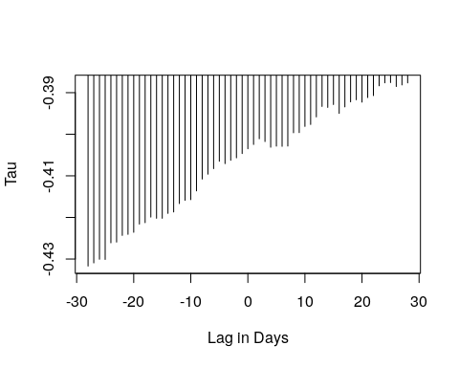

a<-subset(merged, country_region=="Papua New Guinea")  
super(a$IncCaseNumber, a$residential_percent_change_from_baseline)

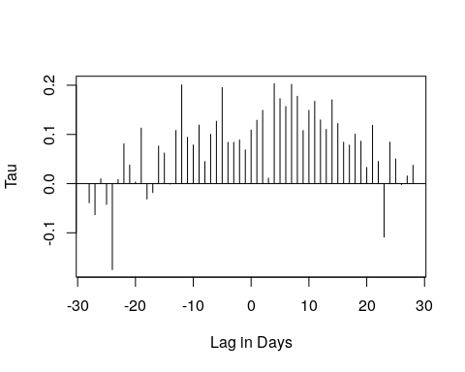

a<-subset(merged, country_region=="Lithuania")  
super(a$IncCaseNumber, a$workplaces_percent_change_from_baseline)

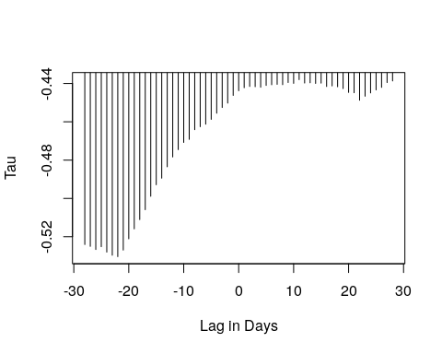

a<-subset(merged, country_region=="Brazil")  
super(a$IncCaseNumber, a$grocery_and_pharmacy_percent_change_from_baseline)

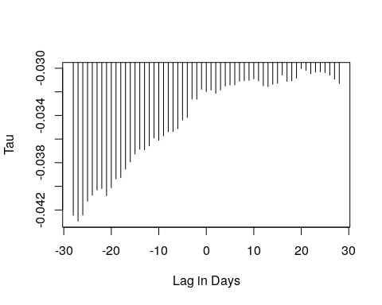

a<-subset(merged, country_region=="France")  
super(a$IncCaseNumber, a$parks_percent_change_from_baseline)

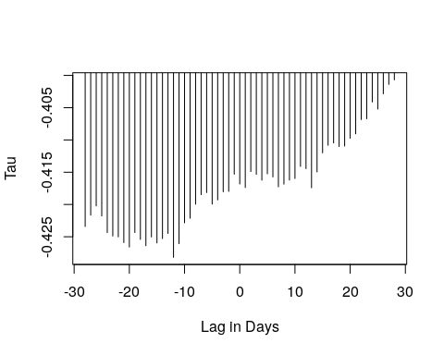

a<-subset(merged, country_region=="Guatemala")  
super(a$IncCaseNumber, a$grocery_and_pharmacy_percent_change_from_baseline)

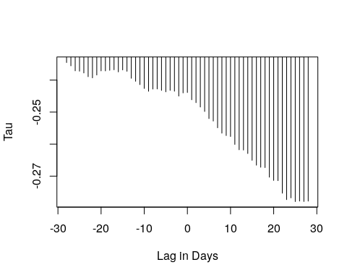

a<-subset(merged, country_region=="Mauritius")  
super(a$IncCaseNumber, a$workplaces_percent_change_from_baseline)

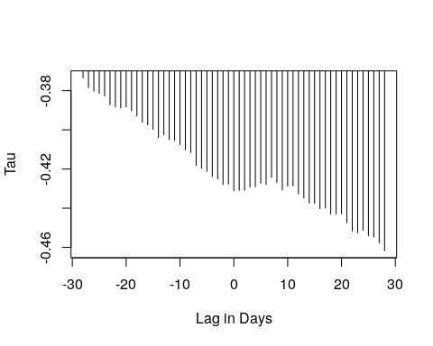 For displaying all plot one should run these lines:

corplotresid<-function(x) {a<-subset(merged, country_region==x) super(a $IncCaseNumber,a$ residential_percent_change_from_baseline) }

for( country_region in unique(gmr$country_region) ) { corplotresid(country_region)}

corplotgroc<-function(x) {a<-subset(merged, country_region==x) super(a $IncCaseNumber,a$ grocery_and_pharmacy_percent_change_from_baseline) }

for( country_region in unique(gmr$country_region) ) { corplotgroc(country_region)}

corplotparks<-function(x) {a<-subset(merged, country_region==x) super(a $IncCaseNumber,a$ parks_percent_change_from_baseline) }

for( country_region in unique(gmr$country_region) ) { corplotparks(country_region)}

corplottransit<-function(x) {a<-subset(merged, country_region==x) super(a $IncCaseNumber,a$ transit_stations_percent_change_from_baseline) }

for( country_region in unique(gmr$country_region) ) { corplottransit(country_region)}

corplotwork<-function(x) {a<-subset(merged, country_region==x) super(a $IncCaseNumber,a$ workplaces_percent_change_from_baseline) }

for( country_region in unique(gmr$country_region) ) { corplotwork(country_region)}

corplotresid<-function(x) {a<-subset(merged, country_region==x) super(a $IncCaseNumber,a$ residential_percent_change_from_baseline) }

for( country_region in unique(gmr$country_region) ) { corplotresid(country_region)}