Open-source ROS interface to Kinect: installation instructions.

System requirements:
Operating System: Linux Ubuntu 14.04, “Trusty” distribution.

1. ROS installation on Linux Ubuntu.

(Detailed ROS installation instructions are at http://wiki.ros.org/indigo/Installation/Ubuntu):
a) Setup your computer to accept software from packages.ros.org. ROS Indigo ONLY supports Saucy and Trusty for debian packages:
sudo sh -c 'echo "deb http://packages.ros.org/ros/ubuntu trusty main" > /etc/apt/sources.list.d/ros-latest.list'

b) Setup keys:
wget https://raw.githubusercontent.com/ros/rosdistro/master/ros.key -O - | sudo apt-key add -

c) make sure Debian package index is up-to-date:
sudo apt-get update

d) “Desktop” (full package) install:
sudo apt-get install ros-indigo-desktop-full

You can select smaller size packages if disk space is a concern. Consult at ROS.org website.

e) Initialize rosdep:
sudo rosdep init
rosdep update

f) Environment setup:

echo "source /opt/ros/indigo/setup.bash" >> ~/.bashrc
source ~/.bashrc
source /opt/ros/indigo/setup.bash

g) Getting (installing) “rosinstall”:
sudo apt-get install python-rosinstall

h) reboot

i) test the installation of ROS by running:
roscore

Further tests for succesfull installation of ROS can be found at http://wiki.ros.org/ROS/Tutorials/UnderstandingNodes if needed.

2. Kinect drivers and interfaces installation: OpenNI

a)
sudo apt-get install ros-indigo-openni-camera
sudo apt-get install ros-indigo-openni-launch

b) reboot computer.

c) Make sure your Kinect sensor is plugged into USB port. To confirm:
lsusb

d) Make sure “roscore” is running in one terminal and Kinect:
roscore

e) In a new terminal window to launch ROS's OpenNI:
roslaunch openni_launch openni.launch

f) To confirm successfull launch:
rostopic list

make sure that you see ROS's “camera” topics:

/camera/debayer/parameter_descriptions
/camera/debayer/parameter_updates
/camera/depth/camera_info
/camera/depth/disparity
/camera/depth/image
/camera/depth/image_raw
/camera/depth/image_rect
/camera/depth/image_rect_raw
/camera/depth/points
/camera/depth_rectify_depth/parameter_descriptions
/camera/depth_rectify_depth/parameter_updates
/camera/depth_registered/camera_info
/camera/depth_registered/disparity
/camera/depth_registered/hw_registered/image_rect_raw
/camera/depth_registered/image_raw
/camera/depth_registered/points
/camera/depth_registered/sw_registered/camera_info
/camera/depth_registered/sw_registered/image_rect_raw
/camera/depth_registered_rectify_depth/parameter_descriptions
/camera/depth_registered_rectify_depth/parameter_updates
/camera/driver/parameter_descriptions
/camera/driver/parameter_updates
/camera/ir/camera_info
/camera/ir/image_raw
/camera/ir/image_rect_ir
/camera/projector/camera_info
/camera/rectify_color/parameter_descriptions
/camera/rectify_color/parameter_updates
/camera/rectify_ir/parameter_descriptions
/camera/rectify_ir/parameter_updates
/camera/rectify_mono/parameter_descriptions
/camera/rectify_mono/parameter_updates
/camera/rgb/camera_info
/camera/rgb/image_color
/camera/rgb/image_mono
/camera/rgb/image_raw
/camera/rgb/image_rect_color
/camera/rgb/image_rect_mono
/rosout
/rosout_agg
/tf
/tf_static

g) Skip this step, step (g), if you see “camera” topics of “rostopic list”.

If you do NOT see “camera” topics, it means that provided by ROS drivers are not working. Solution is to install third party dirvers as described at http://answers.ros.org/question/60562/ubuntu-12042-and-openni_launch-not-detecting-kinect-after-update:

g.1) Download appropriate Avin2 drivers for SensorKinect from https://github.com/avin2/SensorKinect/tree/unstable/Bin

g.2) Execute commands below, but use (substitute) file names with your version name. Exampe here is of x64 version driver:

unzip avin2-SensorKinect-v0.93-5.1.2.1-0-g15f1975.zip
cd avin2-SensorKinect-15f1975/Bin
tar -xjf SensorKinect093-Bin-Linux-x64-v5.1.2.1.tar.bz2
cd Sensor-Bin-Linux-x64-v5.1.2.1
sudo ./install.sh

g.3) reboot

g.4) repeat steps (c) through (f)

h) To view the images, in a new terminal window:
rosrun rviz rviz

i) On the left panel of RVIZ application:
Click “Add”, select “By topic” tab, select /rgb/image_color/image
You should see a live video feed from Kinect sensor.

Click “Add”, select “By topic” tab, select /depth/image/image
Your should see infrared sensor's live image.

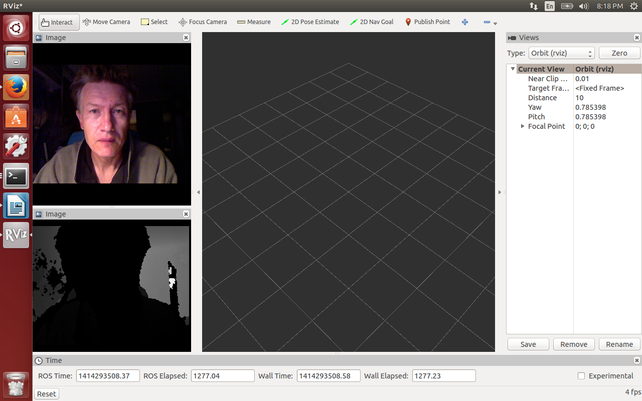

Now, we can use data feeds from ROS topics to further process this data such as position tracking, jesture recognition, PointCloud, etc. Instructions on how to set up these additional displays in RVIZ are at http://wiki.ros.org/rviz/UserGuide

10/25/2014
Peter Depeche

