(Ordinary words that are being used as special terminologies are written with capitalized first letters)

Scenes and Scenarios
We use the term Scene as it was used in the context of a theatrical play (e.g. stage, television, films), which is the units of action or drama of the whole play [ref] – like chapters in a novel. In the context of Robot Theatre in this thesis, we define Scenario as a list of motions in a particular sequence/order for a robot actor. The order of the motions in the list is to be defined by the 'Scene.' So a 'Scene' defines a 'Scenario' of the robot actor. When the Scenes are put together to create the whole Play, one can view the Play as a giant Scenario. Dividing the Play into Scenes allows easier Scenario and motion editing for the user.

To create a Scenario, assuming that the Scene is already well-defined, the user only needs to: 1) select the appropriate motion(s), 2) apply necessary transformations (e.g. mirroring/inversion, repetition), 3) add the motion(s) to the Scenario. We discuss each of these steps below.

Selecting the Appropriate Motion
It is assumed that the motions for the play are created off-line and are stored in a Motion Library. The creation of those motions for the robot can be from a motion capture system, 3-D animation software, a special program for the robot, automated control systems, and other systems. There is direct correlation between 3-D computer animation and robot animation, in terms of both dealing with animation of rigid bodies. However, we noticed that 3-D computer animation (or animation in the traditional sense) is actually a discrete sequence of images, whereas physical robot movement (i.e. animation) is continuous. This difference between animation in the traditional sense and robot animation is discussed Section # (or should this be discussed earlier?).

The motions can be 'atomic' (i.e. a single movement of one DOF), or 'compound' (i.e. consists of one or more simultaneous movements of two or more DOFs) motions. In general, compound motions can be created by combining a set of atomic motions. Creating a compound motion from a set of atomic motions is done with a process separate from the Scenario-building workflow.

What is considered an “appropriate motion” depends on user's interpretation of the action in the Scene that needs to be acted out. To add the motions, the user simply selects the motions from the Motion Library, and add it to the Scenario list. Arranging the order of the motion and applying some transformations to the motions can be done before or after the motions are added to the Scenario List.

Applying Necessary Transformations
We identified five transformations for the motions: Mirroring/Inversion, Repetition, Blending, Noise, and Exaggeration/Subdue. From the five types of transformations, only Blending requires more than one motion – other transformations can be applied to a single motion, including atomic ones.

Mirroring
Mirroring is the transformation function to invert a motion. Mirroring can be done in two ways: directly reverse the order of the joint angles in the motion data (Reflection), or inversion by the action name (Opposition). Reflection is done by using a simple list inversion function. In this sense, we define Reflection as follows:
Suppose a motion M for one DOF which consists of a sequence of joint angle positions p_{i} of length n, such that: M=[p₀, p₁, p₂, … p_{n}]. The Mirror of motion M is motion M' which has the same length of n, and consists of the same elements (joint angle positions) as in motion M, but the sequence is arranged in a reversed order. Therefore M' = [p_{n}, p_{n-1}, p_{n-2}, … p₀]. Executing the motion M' gives the effect of having motion M executed backwards, as if watching a film being re-winded (reverse seek).

Opposition refers to the transformation to execute the opposite action of the selected action. For example: the inverse of “Turn Left” is “Turn Right”, while the inverse of “Walk Forward” is “Walk Backward.” We define Opposition as follows: Suppose we have a motion M for a robot where M=Walk_Forward, and Walk_Forward = [wf₀, wf₁, wf₂, … wf_{n}]. Thus, the inverse of motion M is motion M', where M' = Walk_Backwards, and Walk_Backwards = [wb₀, wb₁, wb₂, … wb_{n}]. Where the elements of the lists Walk_Forward, and Walk_Backwards, wf_{i} and wb_{i}, respectively, are joint angle positions. In contrast to Reflection, with Opposition the length and elements of M' may not necessarily be the same as in M.

In general:
Mirror(M) = M'

Repetition
As the name implies, Repetition refers to the transformation which allows the same motion executed repeatedly. User can specify how many times the motion is to be repeated. However, the transformation itself does not guarantee that the transition between the repeated motion will be smooth. As an illustration, one can imagine repeating a non-periodic signal which the start and end points of the signal are at different tangents (i.e. discontinuous). When the non-periodic signal is repeated, the points where the signal repeats will be discontinuous (even if the signal itself is continuous). To 'smooth' out the transitions between motion, we use the Blending transformation, which is discussed next.

Blending
There are two different types of Blending transformation: transition from one motion to the next, and combining two motions into one motion. We call the former as Transition Blending, while the latter is called Morph Blending. Needless to say, each of them are done using two different processes.

Transition Blending
As mentioned above, Transition Blending is used to ensure a smooth transition from one motion to the next. For example: moving forward followed by turning and moving left 90 degrees. Without Transition Blending, the change from moving forward to turning left will be abrupt, as if creating a corner. With Transition Blending, the turn will be in an arc, which is like how a human does turning.

We implemented Transition Blending by applying a sigmoid function and an inverted sigmoid function to the beginning segment of the second motion, and the ending segment of the first motion, respectively. The result is a smooth transition which the first motion is being 'faded out', and the second motion is 'faded in.'

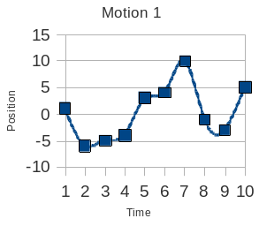
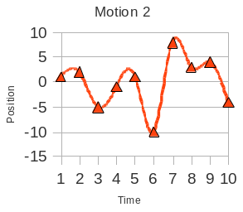
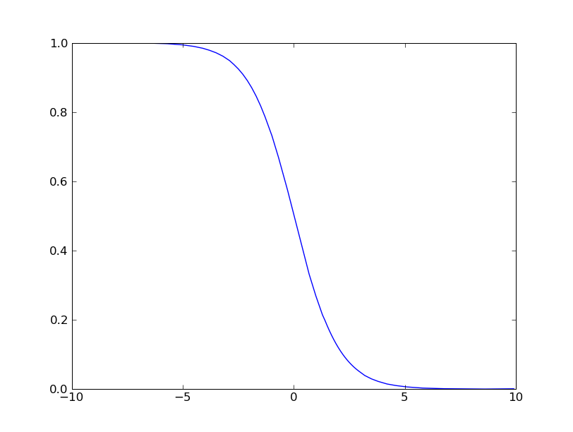
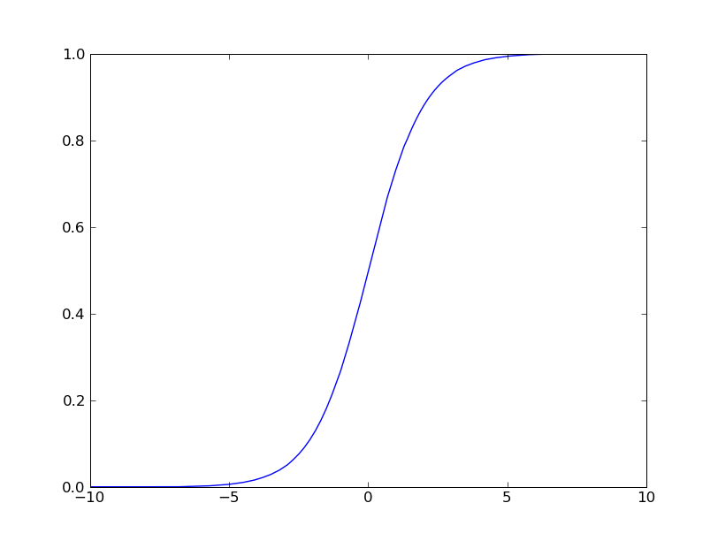
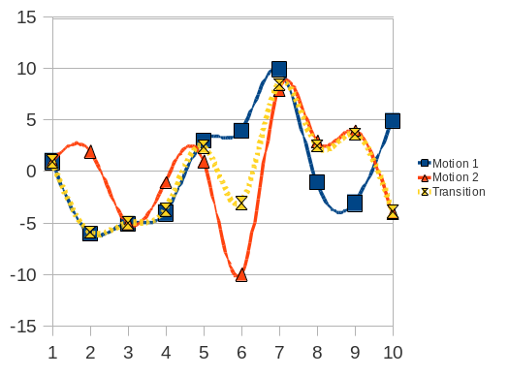
X
X

Morph Blending
Morph Blending can be understood as the interpolation between two motions. Unuma, et. al. [ref] introduced a morphing method using Fourier analysis. Two motions are interpolated by changing the normalized weights [0,1] of the Fourier coefficients of each motion. Weight=0 results in the first motion, weight=1 results in the second motion, and any weight between 0 and 1 results in a motion which is partially look like both the first and second motion. Dynamic Timewarping [ref] is also a method to Morph Blend two motions, but particularly useful for blending two motions with different periods.

Noise
By the recommendation of a professional animator, we included Noise in our system. Noise in this application is not just any randomness in the motion. Instead, Noise is added to create the illusion of 'naturalness' in the motion or in an idle position (e.g. pose). This concept is inspired from the observation that humans never really motionless even when no action is being done.
For example: little movements from breathing, heartbeats, blinking of the eyes, and other ambient motions. Perlin [ref] invented a method to generate pseudo-random noises (now popularly, and aptly known as Perlin Noise). We adapted Perlin Noise to add Noise to any motion, or lack thereof. In our system, users will be able to add Noise to each motion in the Scenario List, or when the robot is idle as needed.

Perlin Noise

Notes/Points to expand on...
(PLEASE NOTE THAT THIS SECTION IS JUST MY 'SKETCHBOOK' WHICH I USE TO BRAINSTORM IDEAS – NOT ALL THAT IS WRITTEN HERE WILL BE INCLUDED IN THE OFFICIAL THESIS)

Building scenario:
- list of motions
- operations on motions:
- reverse/mirror:
- reversing the order/sequence of motions
- also able to figure out the 'opposite' direction/action (e.g. turn left (opposite: turn right), walk forward (opposite: walk backwards), etc.)
- repeats
- problem between animation vs. robot:
- animation is discrete, pose-to-pose: pictures (poses) are being displayed at a rate where the normal human eyes cannot detect the transitions (frame rate: 24 ~ 30fps)
  - robot animation is continuous: pose-to-pose approach doesn't work like in animation - the transition from one pose to the other is continuous. What need to be tested is if we have the hardware that can send position data,the servo controller that can receive position data at 30fps and the servos that are able to execute the position data ... (is that possible?? think think logically)
  - I DO NOT UNDERSTAND WHY YOU ASK IF “IS THAT POSSIBLE?” OF COURSE IT IS, IT DEPENDS ON HARDWARE AND SOFTWARE. DISCUSS ALL CASES
  - Of course, IF the hardware/software supports it. I am asking myself whether or not I can do this for the demo for the thesis. With what we have with KHR-1, however, this is questionable. This is why I question it:
    - Let's say we're sending position data at a frame rate of 30fps (or 30 position or joint angle data per second). That implies each position/joint angle data must be done/ executed in 1/30 seconds in order for the next data to be fully executed. For example: if we have a joint angle sequence for one DOF: [0, 22, 30, 90, 40]. If we are using the exact same principle as traditional animation, we expect each of those joint angle to be executed in 1/30 seconds (in traditional animation, this means each picture is displayed for 1/30 seconds – i.e. for a moving character). That means to execute 0 – 22 (22 degrees), 22 – 30 (8 degrees), 30-90 (60 degrees), 90 – 40 (50 degrees), each of them must be executed in 1/30 seconds... which I don't think is possible with the normal servos we have. I did an experiment; with the fastest speed setting, the KHR-1 servos can turn 90 degrees in about .3 (1/3) seconds average.
    - My experience with KHR-1 so far:
      - it is not possible to do this well by streaming the data from the PC (i.e. the data being sent sequentially through the serial port). The results I had was the motion was executed in short 'bursts' with some pauses in between (you've seen this behavior in the demo in your class this term). The duration of the pauses varies, and sometimes parts of the motion seems to be executed in sequence, most times not. This behavior may be caused by the issue with RCB-1 buffer: if the data in the buffer does not get executed after some time, the data may get flushed. (I still need to confirm this, I got this info from other KHR-1 user in an online forum since I couldn't find any official documentation from Kondo on this issue yet).
      - In another experiment: since streaming the data is problematic, I tried to store the interpolated motion data in RCB-1 memory, and execute it directly from the board (vs. streaming) hoping there will be no bursts/delays/pauses in the execution of the motion (as described above). To 'emulate' the high frame rate, I used the highest speed setting for the servos. The result was definitely better than the streaming approach; I can see that all (if not, most) of the motion data are being executed. The only issue I see of using this highest speed setting is when there is a change of direction. Say that the motion is turning the head to the left 45 degrees and then right 20 degrees. What's going to happen is that the head will turn to the left and before reaching 45 degrees, it will already move to the right. So again, the movement is not complete. But I'm not 100% convinced this is actually a problem (what are the chances/how often we need to have this kind of motion, and at that speed, that behavior is not that unreasonable: if I try to flick my hand quickly for 45 degrees then 20 degrees, chances are my hand won't reach 45 degrees before I move it back to the 20 degrees position. If I need to reach 45 degrees, either I'll have to aim to flick my hand for over 45 (e.g. 60) degree, or I need to slow the flick motion down.)
A more pressing issue about this approach is the repeated storing of motion data to KHR-1's memory. Although the execution of the motions may be ok, we can't have many motions stored (KHR-1 only has 40 motion banks). Let's say we want to have many variants of movements that we created using mirroring, repetition, and from other transformations. Also, if we create these motion variants off-line, and upload it to the ROM on RCB-1 each time, the expense is that we will quickly use up the write-able lifetime of the ROMs.
To ensure each position data was executed completely, I also tried making a routine to check the servo's current position as the servo is moving, and compare it with the current position command. If the servo's current position does not match the commanded position, do not execute the next line. However, there are two issues with this approach. First, obviously this only works if I'm streaming the data from PC (vs. executed from RCB-1 memory – and I've mentioned the issue with streaming above). Second, sending and receiving the checking command adds more delay. By the time my program receives confirmation that the position is complete, the servo already stopped – a pause, before the next line can be sent and executed. So, the movement is not continuous/smooth.
    - Animators have to carefully pay attention to the frame rate to determine how many images to use per second to create the right illusion of speed and acceleration/deceleration.
    - I'm thinking more of an approach to not do as fast as 30fps. We can use the keypoints information (inflection points where the motion change directions), but maybe the speed and acceleration/deceleration can be controlled by the servo controller board (ASC16 has the command to control acceleration/deceleration, RCB-1 on KHR-1 doesn't). I have yet to fully experiment with ASC16.
- experience with the above issue on khr-1:
- not all position data streamed from PC is executed - sometimes it skips.
- correspondence with another khr-1 user on robosavvy.com reveals that there may be a buffer on rcb-1 that gets flushed after a while if the data doesn't get executed (sucky!)
- I'm going to test this issue on ASC-16

- Additionally, there are some more strengths on ASC-16 compared to RCB-1 (admit it, RCB-1 is a sucky SCB):
- acceleration/deceleration control by command! (wahoo!) but I still don't fully understand its behavior need to do more tests on this feature
- absolute and relative position control!
- and some other features...

- robot interact with objects (e.g. with electromagnets)
- morality/ethical issues on humanoid robots:
- one morality point of view: creating an object that potentially induce feelings of attachment/relationship between it and human is immoral. I don't agree with it; it is as if saying that creating humanoid robots is as morally flawed as pornography. Counter-argument: isn't it human's own free will to act and discern what is appropriate and not? I'd say it's the human's own drive/desires that leads to his/her own immorality – not the object itself. Humans have the free will to choose it or avoid it. Bible quote "﻿Not that which goeth into the mouth defileth a man: but what cometh out of the mouth, this defileth a man." (Mat 15:11) Perversion comes from the inside. (Your analysis is not bad but must go deeper. I THINK THAT YOU MISSED HIS POINT. HE DOES NOT SAY THAT ANY OBJECT THAT INDUCES FEELING is bad, as a normal puppet theatre would qualify. He says that children know that puppet is not real. He says that creating an object that would pretend to be human is immoral. So the robot puppet or robot actor looking like robot is moral, only a robot pretending to be truly human is immoral. For instance a robot that would look so human that an old lady whom this robot will be helping will be attached to him as to a son or lover. I think this problem still requires more analysis and we can cut it off in robot theatre telling that it is only theatre and we do not intend to create robots that will be more than actors. The argument with pornography is questionable because the consumer of pornography knows what he is doing and the old lady who is attached to her robot does not see it as wrong. More analysis needed I think) (Perhaps I'm jumping into conclusions – but then, what does it mean to be “truly human”? The reason I give the argument with “object that induces feeling” was because the sample case of “an old lady being attached to the robot as a son or lover.” My assumption is that the lady is aware it is a robot, yet because of the care the robot gives to her, she grows affection towards the robot (hence the comparison to pornography, because she is aware). It would be different if the robot is made to look like her child or spouse, designed to 'fool' the lady into thinking it was her son or spouse (then my argument will be irrelevant). I think you mentioned in our discussion that if “creating an object that would pretend to be human is immoral” then all the works/research to pass the Turing Test would fall under this category. I don't know if we should include this discussion in the thesis, but it is an interesting morality/philosophical question. I agree that our goal is only to create robots merely as actors in the context of robot theatre.)

- Characteristics of robot theatre:
- derive form classical theatre:
- no audience interactions
- full direction - no ability for improv yet...
- synchronization of voice & act
- lights, sounds/music
- treat like watching a movie

- hand puppets:
- experiment: create a robot that operates hand (e.g. sock) puppet - emulate the puppeteers of Muppets/Sesame Streeet

- Chapter on Subjective Evaluation on robots

- in conlusion/epilogue - How the original hypothesis was obliterated after experiments (Mwahahahah!)

OK, i'm done...

