[Control LEDs with your Android-Arduino-Bluetooth module](http://mechstuff.com/control-leds-with-your-android-arduino-bluetooth-module-tutorial/)

## Things you’ll need :-

* Arduino board
* Breadboard
* Bluetooth module/sensor – HC05
* Couple of jumpers/single stranded wires
* LEDs
* An Android Smart Phone(Bluetooth Inbuilt)

## Connections Of Bluetooth module HC05 :-

**VCC** – to VCC of Arduino.  
**GND** – to GND of Arduino.  
**RX** – to digital pin 0(TX pin) of Arduino.  
**TX** – to digital pin 1(RX pin) of Arduino. (connect RX & TX pin after uploading the code)

**Of LED –**  
Positive terminal – to pin 8 of Arduino.  
Negative terminal – GND of Arduino.

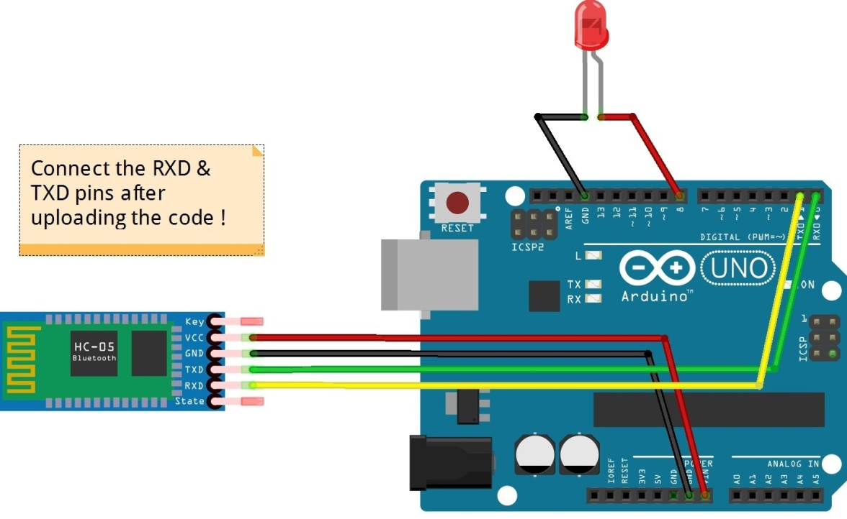

Procedure :-

1. Make the connections as shown in the above image. Don’t connect the RX & TX pins WHILE/BEFORE  uploading the code !
2. Copy the code given below.
3. Download the app called BlueControl (It’s free).
4. Open the app BlueControl (It will automatically turn on the device’s Bluetooth). Go to options. Click on *“Connect to Robot”.*Choose the device – HC 05.
5. When you are connecting to the Bluetooth module for the first time, it will ask you the password. Enter 0000 OR 1234.
6. When the device gets successfully paired with the sensor, the LED lights on sensor will start blinking at a slower rate than usual.
7. DONE. Copy the code given below & test it out !

## Code :-

void setup()

{

Serial.begin(9600);

pinMode(8, OUTPUT); //put your setup code here, to run once

}

void loop()

{

//Put your main code here, to run repeatedly:

If(Serial.available()>0)

{

Char data= Serial.read(); //reading the data receved from the Bluetooth module

switch(data)

{

case ‘a’: digitalWrite(8, HIGH); break; //LED ON

case ‘d’: digitalWrite(8, LOW); break; //LED OFF

default : break;

}

Serial.println(data);

}

delay(50);

}