Microbial community analysis
Workflow has been built with help of “Orchestrating microbiome analysis with R and Bioconductor” (Leo Lahti et. al), various analysis tool guides and own modifications.

Define file locations
Mid-point rooted phylogenetic tree can be created with create_tree python script.

# Path variables
asvfile <- "results/asvs.tsv"
metafile <- "results/meta.tsv"
taxafile <- "results/taxonomy.tsv"
treefile <- "results/rooted_tree.nwk"

Import data
Load tse object from file and phylogenetic tree to it.

tse <- readRDS("results/tse.rds")
# Phylogenetic tree in newick format
phytree <- read.tree(treefile)
rowTree(tse) <- phytree
# Save as a rds file
saveRDS(tse,"results/tse_w_tree.rds")

Community composition
Community composition at different taxonomic ranks can be studied by agglomerating taxa and using getTop function. Easiest way to visualize most common taxonomic features are barplots
Phylum rank

# Reload data
tse <- readRDS("results/tse_w_tree.rds")
n <- 5
# Agglomerate to genus rank
tse <- agglomerateByRank(tse, rank="Phylum", na.rm=T)
# Calculate relative abundance
tse <- transformAssay(tse, method="relabundance")
# Get top 10 features
top_features <- getTop(tse, top=n, method="median",
assay.type="relabundance")
# Get data and filter using top features
df_phylum <- data.frame(assay(tse, "relabundance"))
# Proportion of Others bacteria group is 1 - colsums
df_phylum <- df_phylum %>% rownames_to_column(var="Phylum") %>%
filter(Phylum %in% top_features) %>%
bind_rows(summarise(., Phylum = "Others", across(where(is.numeric),
~ 1 - sum(.))))
# Create long table for ggplot
phylum_long <- pivot_longer(df_phylum, names_to="Sample",
values_to="Abundance", cols = starts_with("Sample"))
# Barplot settings
bar_theme <- list(theme_fivethirtyeight(base_size=8),
scale_fill_stata(), theme(axis.text.x =
element_text(angle = 90,
vjust = 0.5,
hjust = 1)))
# Barplot
barplot1 <- ggplot(phylum_long, aes(x = Sample,
y = Abundance, fill = Phylum)) +
geom_bar(stat = "identity") + xlab("Sample") +
bar_theme
barplot1
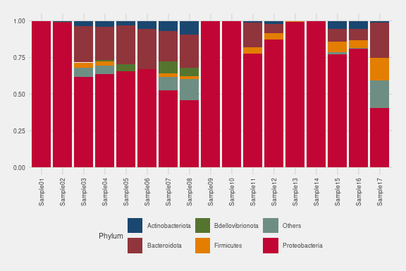

Genus rank

# Reload data
tse <- readRDS("results/tse_w_tree.rds")
n <- 10
# Agglomerate to genus rank
tse <- agglomerateByRank(tse, rank="Genus", na.rm=T)
# Calculate relative abundance
tse <- transformAssay(tse, method="relabundance")
# Get top 10 features
top_features <- getTop(tse, top=n, method="median",
assay.type="relabundance")
# Get data and filter using top features
df_genus <- data.frame(assay(tse, "relabundance"))
# Proportion of Others bacteria group is 1 - colsums
df_genus <- df_genus %>% rownames_to_column(var="Genus") %>%
filter(Genus %in% top_features) %>%
bind_rows(summarise(., Genus = "Others", across(where(is.numeric),
~ 1 - sum(.))))
# Create long table for ggplot
genus_long <- pivot_longer(df_genus, names_to="Sample",
values_to="Abundance", cols = starts_with("Sample"))
# Barplot
barplot2 <- ggplot(genus_long, aes(x = Sample,
y = Abundance, fill = Genus)) +
geom_bar(stat = "identity") + xlab("Sample") +
bar_theme
barplot2
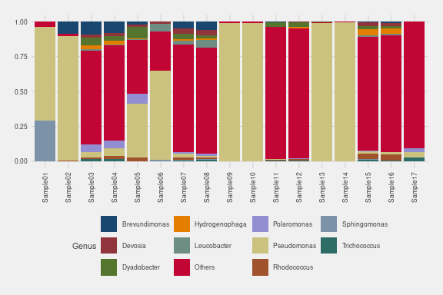

Abundance information can also be arranged to tables. Samples are merged by categorical data, taxonomy is agglomerated and data arranged by abundance.

# Reload tse
tse <- readRDS("results/tse_w_tree.rds")
#Merge filtered values, recount relative abundance and agglomeration to Genus
col4 <- mergeCols(tse,colData(tse)$Filtered)
col4 <- agglomerateByRank(col4, "Genus")
col4 <- relAbundanceCounts(col4)
#Create data frames for merged groups
opt1 <- data.frame(assay(col4,"relabundance")) %>%
rownames_to_column(var = "opt1_asv") %>%
arrange(desc(no)) %>% dplyr::select('Non-filtered' = opt1_asv,
'Rel Abundance'= no)
opt2 <- data.frame(assay(col4,"relabundance")) %>%
rownames_to_column(var = "opt2_asv") %>%
arrange(desc(yes)) %>% dplyr::select(Filtered = opt2_asv,
'Rel Abundance' = yes)
#How many to list in table
n <- 10
col4_table <- cbind(opt1[1:n,], opt2[1:n,])
kable(col4_table, digits = 2, caption = "Common taxa by Filtering") %>%
kable_styling(latex_options = c("HOLD_position","striped"), font_size = 12) %>%
row_spec(0, background = "indigo", color = "ivory")
Common taxa by Filtering
Non-filtered | Rel Abundance | Filtered | Rel Abundance
Silanimonas | 0.10 | Pseudomonas | 0.70
Tabrizicola | 0.08 | Flavobacterium | 0.10
Brevundimonas | 0.04 | Sphingomonas | 0.04
Pedobacter | 0.04 | Brevundimonas | 0.02
Dyadobacter | 0.03 | Dyadobacter | 0.02
Algoriphagus | 0.03 | Polaromonas | 0.02
Aquimonas | 0.03 | Leucobacter | 0.02
Devosia | 0.03 | Chryseobacterium | 0.02
Alishewanella | 0.03 | Paucibacter | 0.01
Kaistia | 0.03 | Peredibacter | 0.01

Algae groups

#Merge filtered values, recount relative abundance and agglomeration to Genus
col5 <- mergeCols(tse, colData(tse)$Algae)
col5 <- agglomerateByRank(col5, "Genus")
col5 <- relAbundanceCounts(col5)
#Create data frames for merged groups
opt1 <- data.frame(assay(col5,"relabundance")) %>%
rownames_to_column(var = "opt1_asv") %>%
arrange(desc(chlorella_s)) %>% dplyr::select(Chlorella = opt1_asv,
'Rel Abundance'= chlorella_s)
opt2 <- data.frame(assay(col5,"relabundance")) %>%
rownames_to_column(var = "opt2_asv") %>%
arrange(desc(selenastrum)) %>% dplyr::select(Selenatrum = opt2_asv,
'Rel Abundance' = selenastrum)
#How many to list in table
n <- 10
col5_table <- cbind(opt1[1:n,], opt2[1:n,])
kable(col5_table, digits = 2, caption = "Common taxa by Algae") %>%
kable_styling(latex_options = c("HOLD_position", "striped"), font_size = 12) %>%
row_spec(0, background = "indigo", color = "ivory")
Common taxa by Algae
Chlorella | Rel Abundance | Selenatrum | Rel Abundance
Pseudomonas | 0.50 | Pseudomonas | 0.34
Silanimonas | 0.09 | Flavobacterium | 0.11
Tabrizicola | 0.06 | Dyadobacter | 0.03
Sphingomonas | 0.05 | Leucobacter | 0.03
Brevundimonas | 0.04 | Chryseobacterium | 0.02
Algoriphagus | 0.03 | Polaromonas | 0.02
Alishewanella | 0.02 | Brevundimonas | 0.02
Dyadobacter | 0.02 | Devosia | 0.02
Polaromonas | 0.01 | Aquimonas | 0.02
Pedobacter | 0.01 | Pedobacter | 0.02

Age groups

#Merge filtered values, recount relative abundance and agglomeration to Genus
col3 <- mergeCols(tse, as.character(colData(tse)$Age))
col3 <- agglomerateByRank(col3, "Genus")
col3 <- relAbundanceCounts(col3)
#Create data frames for merged groups
opt1 <- data.frame(assay(col3, "relabundance")) %>%
rownames_to_column(var = "opt1_asv") %>%
arrange(desc(X5)) %>% dplyr::select(Day5 = opt1_asv, 'Rel Abundance'= X5)
opt2 <- data.frame(assay(col3, "relabundance")) %>%
rownames_to_column(var = "opt2_asv") %>%
arrange(desc(X30)) %>% dplyr::select(Day30 = opt2_asv, 'Rel Abundance' = X30)
#How many to list in table
n <- 10
col3_table <- cbind(opt1[1:n,], opt2[1:n,])
kable(col3_table, digits = 2, caption = "Common taxa by Age") %>%
kable_styling(latex_options = c("HOLD_position","striped"), font_size = 12) %>%
row_spec(0, background="indigo", color="ivory")
Common taxa by Age
Day5 | Rel Abundance | Day30 | Rel Abundance
Pseudomonas | 0.41 | Pseudomonas | 0.40
Flavobacterium | 0.09 | Silanimonas | 0.17
Brevundimonas | 0.04 | Tabrizicola | 0.14
Sphingomonas | 0.03 | Aquimonas | 0.05
Dyadobacter | 0.03 | Algoriphagus | 0.04
Leucobacter | 0.02 | Roseococcus | 0.02
Polaromonas | 0.02 | Clostridium sensu stricto 13 | 0.02
Pedobacter | 0.02 | Rhodobacter | 0.02
Chryseobacterium | 0.02 | Dyadobacter | 0.02
Devosia | 0.02 | Rhodococcus | 0.01

Alpha diversity
Diversity can be studied using diversity indexes. Values can be stored to colData under defined names. We create table with Shannon, Faith and observed features.

# Reload tse
tse <- readRDS("results/tse_w_tree.rds")
#Calculate Shannon index
tse <- addAlpha(tse, assay.type = "counts",
index = "shannon_diversity",
name = "Shannon")
#Calculate phylogenetic Faith index
tse <- addAlpha(tse, assay.type = "counts",
index = "faith_diversity",
name = "Faith", tree_name = "phylo")
#Calculate richness with Chao1 index
tse <- addAlpha(tse, assay.type = "counts",
index = "observed_richness",
name = "Observed")
#Create table
kable(data.frame(Sample = rownames(colData(tse)), Shannon = colData(tse)$Shannon,
Faith = colData(tse)$Faith,
Observed_features = colData(tse)$Observed), digits = 2) %>%
kable_styling(latex_options = c("HOLD_position", "striped"),
font_size = 9) %>%
row_spec(0, background = "indigo", color = "ivory")
Sample | Shannon | Faith | Observed_features
Sample01 | 0.79 | 7.43 | 40
Sample02 | 1.43 | 9.95 | 53
Sample03 | 4.64 | 21.87 | 358
Sample04 | 4.60 | 23.95 | 370
Sample05 | 2.71 | 10.66 | 69
Sample06 | 1.72 | 10.53 | 53
Sample07 | 5.30 | 49.36 | 747
Sample08 | 5.27 | 43.29 | 721
Sample09 | 0.12 | 9.87 | 36
Sample10 | 0.12 | 5.74 | 30
Sample11 | 2.03 | 9.69 | 92
Sample12 | 1.96 | 11.08 | 103
Sample13 | 0.18 | 8.02 | 30
Sample14 | 0.11 | 8.19 | 32
Sample15 | 3.54 | 19.22 | 198
Sample16 | 3.42 | 18.79 | 168
Sample17 | 4.06 | 37.72 | 472

Boxplots can be used to compare diversity between categories

# Boxplot function
plot_shannon <- function(x_var, fill_var, title, x_label, scale_x = FALSE, s_var) {
p <- ggplot(as.data.frame(colData(tse)), aes(x = as.character(.data[[x_var]]), y = Shannon, fill = .data[[fill_var]])) +
geom_boxplot(alpha = 0.7, show.legend = FALSE) +
labs(title = title, y = "Shannon", x = x_label) +
theme_hc(base_size = s_var) + scale_fill_stata()
if (scale_x) p <- p + scale_x_discrete(limits = rev)
return(p)
}
# Generate plots
plot1 <- plot_shannon("Algae", "Algae", "Algae", "Algae",, 8)
plot2 <- plot_shannon("Filtered", "Filtered", "Culture filtering",
"Filtering",, 8)
plot3 <- plot_shannon("Name", "Name", "Samples", "Sample",, 8)
plot4 <- plot_shannon("Age", "Algae", "Algae and age", "Age of culture",
scale_x = TRUE, 8)
plot5 <- plot_shannon("Age", "Filtered", "Filtering and age", "Age of culture",
scale_x = TRUE,8)

Alpha diversity boxplots

# Create the combined plot
combined_plot <- (plot1 | plot2) /
(plot4 | plot5) /
plot3
# Display the combined plot
combined_plot
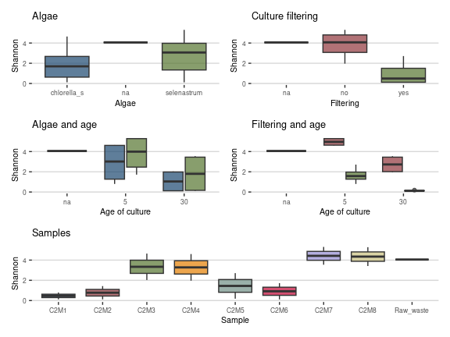

Filtering has clear effect on richness. Both algae species seem also to decrease richness compared to untreated sample. However, there is only one control and decrease is not statistically significant. Culture age also decreases diversity. This is most evident in plots displaying filtering and age categories separately.

Beta diversity
Bray-Curtis dissimilarity analysis using count data and rarefaction to 11 624.

# Reload data
tse <- readRDS("results/tse_w_tree.rds")
# Calculate Bray-Curtis distance and run MDS
tse <- runMDS(tse, FUN = getDissimilarity, method = "bray",
assay.type = "counts", name = "MDS_bray",
sample = 11624)
# Reduce to 2D
pcoa_bray <- plotReducedDim(tse, "MDS_bray")
# Calculate explained variance
e <- attr(reducedDim(tse, "MDS_bray"), "eig")
rel_eig <- e / sum(e[e > 0])
# Create dataframe for each axis and bind sample attributes
bray_attributes <- data.frame(pcoa1 = pcoa_bray$data[, 1],
pcoa2 = pcoa_bray$data[, 2],
Filtering = colData(tse)$Filtered,
Age = as.character(colData(tse)$Age),
Names = colData(tse)$Name,
Algae = colData(tse)$Algae)[1:16,]
# Create series of plots using data frame
plot_pcoa <- function(data, color_var, shape_var, x_label, y_label) {
ggplot(data, aes(x = pcoa1, y = pcoa2, color = !!sym(color_var),
shape = !!sym(shape_var))) + geom_point(size = 2.5) +
theme_pubclean() + scale_color_lancet() + labs(x = x_label, y = y_label)
}
x_label <- paste("PCoA 1 (", round(100 * rel_eig[[1]], 1), "%)", sep = "")
y_label <- paste("PCoA 2 (", round(100 * rel_eig[[2]], 1), "%)", sep = "")
filtering_plot <- plot_pcoa(bray_attributes, "Filtering", "Algae",
x_label, y_label)
age_plot <- plot_pcoa(bray_attributes, "Age", "Algae", x_label, y_label)

Plots

wrap_plots(filtering_plot + ggtitle("Filtering and Algae"),
age_plot + ggtitle("Filtering and Age"), ncol=1)
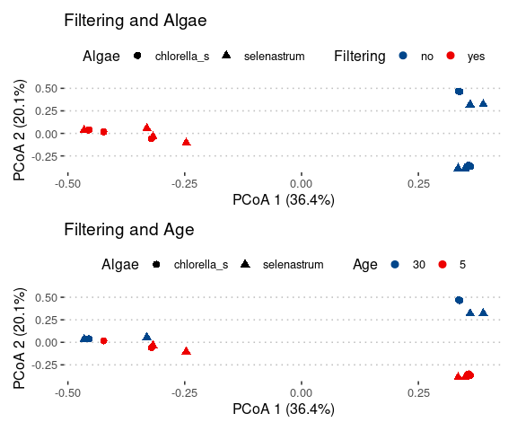

Filtering plays the most significant role in driving sample dissimilarity.
Beta diversity analysis using unifrac method

# Reload data
tse <- readRDS("results/tse_w_tree.rds")
# Method names for both unweighted and weighted UniFrac
methods <- c("unweighted_uni", "weighted_uni")
# Run MDS and create data frames in one loop
results <- lapply(methods, function(method) {
weighted <- method == "weighted_uni"
# Run MDS for each method
tse <- runMDS(tse, FUN = getDissimilarity, method = "unifrac",
name = method, assay.type = "counts", tree = rowTree(tse),
sample = 11624, weighted = weighted)
# Create PCoA data frame and calculate explained variance
pcoa <- reducedDim(tse, method)
pcoa_df <- data.frame(pcoa1 = pcoa[, 1],
pcoa2 = pcoa[, 2],
Filtering = colData(tse)$Filtered,
Age = colData(tse)$Age,
Algae = colData(tse)$Algae)[1:16, ]
# Calculate explained variance
eig <- attr(pcoa, "eig")
rel_eig <- eig / sum(eig[eig > 0])
list(pcoa_df = pcoa_df, rel_eig = rel_eig)
})
# Extract results for each method
unweighted_df <- results[[1]]$pcoa_df
weighted_df <- results[[2]]$pcoa_df
rel_eig_unw <- results[[1]]$rel_eig
rel_eig_w <- results[[2]]$rel_eig

Next ggplot objects

# Define a function to create the plots
create_plot <- function(df, pcoa1, pcoa2, rel_eig, title, color_var, shape_var) {
ggplot(data = df, aes(x = pcoa1, y = pcoa2,
color = !!sym(color_var),
shape = !!sym(shape_var))) + geom_point(size = 2) +
labs(x = paste("PCoA 1 (", round(100 * rel_eig[1], 1), "%)", sep = ""),
y = paste("PCoA 2 (", round(100 * rel_eig[2], 1), "%)", sep = ""),
title = title) + scale_y_continuous(limits = c(-0.5, 0.5)) +
scale_x_continuous(limits = c(-0.5, 0.5)) + theme_hc(base_size = 9) +
scale_color_lancet() + theme(legend.position = "bottom",
legend.box = "vertical",
legend.margin = margin())
}
# List of plot parameters for looping
plots_params <- list(
list(df = unweighted_df, pcoa1 = "pcoa1", pcoa2 = "pcoa2", rel_eig = rel_eig_unw,
title = "Unweighted unifrac (Filtering and Age)",
color_var = "Filtering", shape_var = "Age"),
list(df = weighted_df, pcoa1 = "pcoa1", pcoa2 = "pcoa2", rel_eig = rel_eig_w,
title = "Weighted unifrac (Filtering and Age)",
color_var = "Filtering", shape_var = "Age"),
list(df = unweighted_df, pcoa1 = "pcoa1", pcoa2 = "pcoa2", rel_eig = rel_eig_unw,
title = "Unweighted unifrac (Algae and Age)",
color_var = "Algae", shape_var = "Age"),
list(df = weighted_df, pcoa1 = "pcoa1", pcoa2 = "pcoa2", rel_eig = rel_eig_w,
title = "Weighted unifrac (Algae and Age)",
color_var = "Algae", shape_var = "Age")
)
# Create the plots using the parameters
plots <- lapply(plots_params, function(params) {
create_plot(params$df, params$pcoa1, params$pcoa2, params$rel_eig, params$title,
params$color_var, params$shape_var)
})

Plot unifrac results

wrap_plots(plots[[1]], plots[[2]], plots[[3]],plots[[4]], ncol=2)
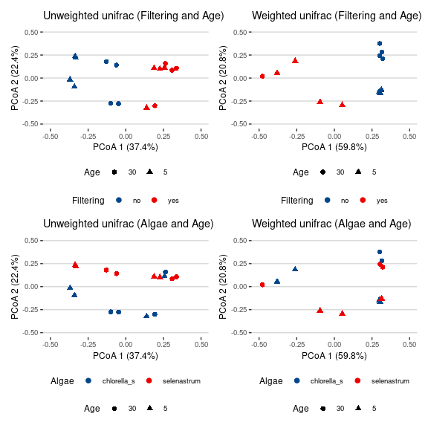

Results are similar to Bray-Curtis, but weighted plots show only small differences with filtering. Explained variance is high, though.

Permanova analysis
Permanova measures importance of each variable to total variance.

# Reload tse
tse <- readRDS("results/tse_w_tree.rds")
# Calculate relabundance
tse <- transformAssay(tse, method = "relabundance")
tse <- addRDA(tse, assay.type = "relabundance", sample=11624,
formula = assay ~ Filtered + Age + Algae,
distance = "bray")
rda_info <- attr(reducedDim(tse, "RDA"), "significance")
kable(rda_info$permanova, digits = 2) %>%
kable_styling(latex_options = c("HOLD_position", "striped"),
font_size = 12) %>%
row_spec(0, background="indigo", color="ivory")
 | Df | SumOfSqs | F | Pr(>F) | Total variance | Explained variance
Model | 4 | 3.98 | 6.02 | 0.00 | 5.96 | 0.67
Filtered | 1 | 2.24 | 13.53 | 0.00 | 5.96 | 0.37
Age | 1 | 0.88 | 5.35 | 0.00 | 5.96 | 0.15
Algae | 1 | 0.29 | 1.75 | 0.13 | 5.96 | 0.05
Residual | 12 | 1.98 | NA | NA | 5.96 | 0.33

Variable groups explain 67 % of total variance. Filtering and Age are statistically significant, algae not.
We also need to check if the homogeneity assumption is fulfilled

kable(rda_info$homogeneity, digits = 2) %>%
kable_styling(latex_options = c("HOLD_position", "striped"),
font_size = 12) %>%
row_spec(0, background="indigo", color="ivory")
 | Df | Sum Sq | Mean Sq | F | N.Perm | Pr(>F) | Total variance | Explained variance
Filtered | 2 | 0.39 | 0.19 | 3.88 | 999 | 0.04 | 1.08 | 0.36
Age | 2 | 0.26 | 0.13 | 1.00 | 999 | 0.60 | 2.05 | 0.12
Algae | 2 | 0.29 | 0.15 | 7.14 | 999 | 0.01 | 0.58 | 0.50

Age does fulfill homogeneity, while filtering does fall slightly below 0.05 level. Algae groups are not homogenous. Results mean that in Filtered groups variance is quite different and can contribute to differences measured.
The plotRDA function can be used to visualize results.

# Generate RDA plot
permanova <- plotRDA(tse, "RDA", colour_by="Filtered", shape="Age", add.ellipse="colour")
permanova$scales$scales <- NULL
#change dot size
permanova$layers[[1]]$aes_params$size <-2.5
#add theme and color palette
permanova + theme_hc(base_size = 10) +
scale_colour_igv() + labs(colour="Filtering")
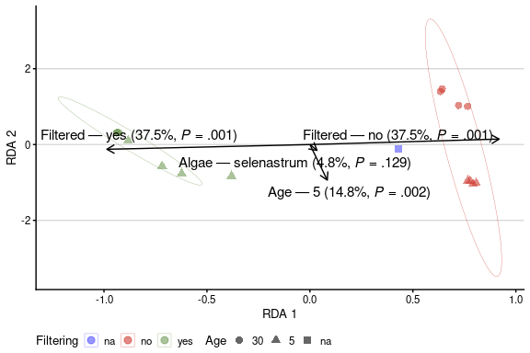

Differential abundance
Differential abundance can be studied with several R packages. Here we use ALDEx2, ANCOM-BC and Maaslin.
First, data is filtered by prevalence. Also taxonomy table is extracted for later use.

# Reload data
tse <- readRDS("results/tse_w_tree.rds")
#Filtering data based on prevalence.We also drop uncategorized raw wastewater
tse_daa <- subsetByPrevalentTaxa(tse[,1:16], detection = 0, prevalence = 0.1)
#We prepare also list of all taxa labels for later use
featureids <- as.data.frame(getTaxonomyLabels(tse_daa, make_unique=FALSE),
rownames(tse_daa))
featureids <- rownames_to_column(featureids, var="asv")
colnames(featureids) <- c("ASV","taxon")

Aldex2 analysis on filtered category.

#ALDEx2 analysis can be performed in modular fashion
#aldex.clr - generates random instances of the centred log-ratio transformed values
filter_aldex <- aldex.clr(assay(tse_daa), tse_daa$Filtered, useMC = T,
mc.samples=256, verbose = F)
#aldex.ttest - perform Welch’s t and Wilcoxon test when there are only two conditions
filter_tt <- aldex.ttest(filter_aldex, paired.test = F, verbose = F)
#aldex.effect - estimate effect size and the within and between condition values
filter_effect <- aldex.effect(filter_aldex, CI = T, verbose = F)
#Merge two outputs
filter_aldex_out <- data.frame(filter_tt, filter_effect)
#Create plots
aldex.plot(filter_aldex_out, type="volcano", test="welch", xlab="Difference",
ylab="-1(log10(q))", Main="Volcano plot")
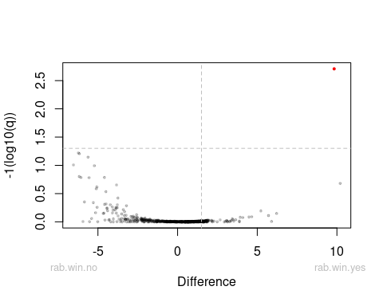

In plot, red dots represent significantly changed taxa, grey dots are abundant taxa and black dots are rare taxa.
Aldex found five variants, where wilcoxon probability test result is p <= 0.05.

#Filter significantly different taxa and create table
aldex_res <- rownames_to_column(filter_aldex_out, "genus")
aldex_res <- aldex_res %>% dplyr::filter(wi.eBH <= 0.05) %>%
dplyr::select(genus, we.eBH, wi.eBH, effect, overlap)
#Merge genus id and taxa names into single table
identity <- merge(aldex_res, featureids, by.x=c("genus"), by.y=c("ASV"))
identity <- identity %>% relocate("genus", "taxon", "we.eBH", "wi.eBH",
"effect", "overlap")
kable(identity, digits=2) %>% kable_styling(latex_options = c("HOLD_position",
"striped"),
font_size = 12) %>%
row_spec(0, background="indigo", color="ivory")
genus | taxon | we.eBH | wi.eBH | effect | overlap
ASV29 | Genus:Trichococcus | 0.07 | 0.01 | -1.76 | 0.00
ASV64 | Genus:Brevundimonas | 0.06 | 0.00 | -2.17 | 0.00
ASV70 | Genus:Dyadobacter | 0.06 | 0.00 | -1.85 | 0.00
ASV78 | Genus:Hydrogenophaga | 0.17 | 0.03 | -1.43 | 0.03
ASV86 | Genus:Devosia | 0.10 | 0.01 | -1.83 | 0.00

Testing algae or culture age did not provide results.
Ancom-BC2 (Analysis of Compositions of Microbiomes with Bias Correction)

#Perform the analysis
ancom_out = ancombc2(data = tse_daa, assay_name = "counts",
fix_formula = "Filtered + Algae + Age",
p_adj_method = "holm", prv_cut = 0, lib_cut = 0,
group = "Filtered", struc_zero = TRUE, global = TRUE)
saveRDS(ancom_out, "rds/ancom_out.rds")

ancom_out <- readRDS("rds/ancom_out.rds")

Results are collected into out$res data frame. We can filter significant variants.
First variable is Filtering (yes/no)

#Create data frame, filter Diff = TRUE and arrange by Lfc
#We also combine taxaid and taxonomic name into first column for our figure
df_filtered <- data.frame(ASV = ancom_out$res$taxon,
Lfc =ancom_out$res$lfc_Filteredyes,
SE = ancom_out$res$se_Filteredyes,
Q = ancom_out$res$q_Filteredyes,
Diff = ancom_out$res$diff_Filteredyes) %>%
dplyr::filter(Diff == "TRUE") %>% arrange(desc(Lfc)) %>%
dplyr::left_join(featureids, by = "ASV")
df_filtered$ASV <- paste(df_filtered$ASV,df_filtered$taxon)
df_filtered <- df_filtered %>% dplyr::select(,-6) %>%
mutate(Change = ifelse(Lfc > 0, "Positive LFC", "Negative LFC"))
kable (df_filtered, caption="Taxa that are changed by filtering",
digits=2,) %>% kable_styling(latex_options = c("HOLD_position",
"striped"),
font_size = 12) %>%
row_spec(0, background="indigo", color="ivory")
Taxa that are changed by filtering
ASV | Lfc | SE | Q | Diff | Change
ASV3 Genus:Pseudomonas | 7.30 | 0.37 | 0.00 | TRUE | Positive LFC
ASV8 Genus:Pseudomonas | 3.81 | 0.60 | 0.03 | TRUE | Positive LFC
ASV29 Genus:Trichococcus | -3.19 | 0.42 | 0.01 | TRUE | Negative LFC
ASV44 Genus:Fluviicola | -3.74 | 0.35 | 0.05 | TRUE | Negative LFC

Testing algae did not provide results.
Culture age variable.

#Create new data frame with Lfc, SE, Diff values
df_age <- data.frame(ASV = ancom_out$res$taxon, Lfc =ancom_out$res$lfc_Age5,
SE = ancom_out$res$se_Age5, Q = ancom_out$res$q_Age5,
Diff = ancom_out$res$diff_Age5) %>%
filter(Diff == "TRUE") %>% arrange(desc(Lfc)) %>%
dplyr::left_join(featureids, by = "ASV")
df_age$ASV <- paste(df_age$ASV,df_age$taxon)
df_age <- df_age %>% dplyr::select(,-6) %>%
mutate(Change = ifelse(Lfc > 0, "Positive LFC", "Negative LFC"))
kable (df_age, caption="Taxa that are changed by culture length",
digits=2,) %>% kable_styling(latex_options = c("HOLD_position",
"striped"),
font_size = 12) %>%
row_spec(0, background="indigo", color="ivory")
Taxa that are changed by culture length
ASV | Lfc | SE | Q | Diff | Change
ASV84 Genus:Porphyrobacter | -4.09 | 0.64 | 0.04 | TRUE | Negative LFC
ASV9 Genus:Tabrizicola | -4.27 | 0.79 | 0.02 | TRUE | Negative LFC
ASV20 Family:Rhodobacteraceae | -4.91 | 0.73 | 0.01 | TRUE | Negative LFC

MaAsLin2

#Maaslin requires data frame as metadata input
meta_data <- data.frame(colData(tse_daa))
#Counts table needs to be transposed
variant_table <- t(assay(tse_daa))
#Maaslin settings
maaslin_filtering <- Maaslin2(
variant_table,
meta_data,
output = "Maaslin2-filtering",
transform = "AST",
fixed_effects = c("Filtered"),
reference = c("Filtered", "no"),
normalization = "TSS",
standardize = FALSE,
min_prevalence = 0
)
saveRDS(maaslin_filtering, "rds/maaslin_filtering.rds")

Note: Maaslin2 will also write results to defined output folder. If you use several fixed effects, it creates also heatmap presentation.

maaslin_filtering <- readRDS("rds/maaslin_filtering.rds")

Filtering significant results to table by qval value (<= 0.05).

maaslin_table <- maaslin_filtering$results %>%
dplyr::select(ASV = feature, Coef = coef, SE = stderr,qval,
N, Nonzero = N.not.zero) %>% filter(qval <= 0.05) %>%
arrange(desc(Coef))
kable(maaslin_table, digits=2) %>% kable_styling(latex_options = c("HOLD_position",
"striped"),
font_size = 10) %>%
row_spec(0, background="indigo", color="ivory")
ASV | Coef | SE | qval | N | Nonzero
ASV3 | 1.03 | 0.14 | 0.00 | 16 | 16
ASV382 | -0.01 | 0.00 | 0.03 | 16 | 6
ASV464 | -0.01 | 0.00 | 0.03 | 16 | 6
ASV378 | -0.02 | 0.00 | 0.03 | 16 | 6
ASV98 | -0.02 | 0.00 | 0.02 | 16 | 7
ASV194 | -0.02 | 0.00 | 0.02 | 16 | 7
ASV245 | -0.02 | 0.00 | 0.00 | 16 | 9
ASV249 | -0.02 | 0.01 | 0.03 | 16 | 6
ASV307 | -0.02 | 0.00 | 0.02 | 16 | 7
ASV242 | -0.02 | 0.01 | 0.03 | 16 | 6
ASV239 | -0.03 | 0.01 | 0.03 | 16 | 6
ASV262 | -0.03 | 0.00 | 0.00 | 16 | 8
ASV184 | -0.03 | 0.01 | 0.03 | 16 | 6
ASV193 | -0.03 | 0.01 | 0.03 | 16 | 6
ASV52 | -0.03 | 0.01 | 0.03 | 16 | 10
ASV183 | -0.03 | 0.01 | 0.03 | 16 | 9
ASV85 | -0.04 | 0.01 | 0.01 | 16 | 7
ASV86 | -0.04 | 0.01 | 0.05 | 16 | 8
ASV101 | -0.04 | 0.01 | 0.03 | 16 | 7
ASV87 | -0.04 | 0.01 | 0.02 | 16 | 11
ASV119 | -0.04 | 0.01 | 0.03 | 16 | 7
ASV106 | -0.05 | 0.01 | 0.03 | 16 | 8
ASV79 | -0.05 | 0.01 | 0.03 | 16 | 7
ASV78 | -0.05 | 0.01 | 0.00 | 16 | 10
ASV70 | -0.06 | 0.01 | 0.03 | 16 | 8
ASV46 | -0.06 | 0.01 | 0.03 | 16 | 10
ASV64 | -0.06 | 0.01 | 0.02 | 16 | 8
ASV29 | -0.09 | 0.01 | 0.00 | 16 | 12
ASV47 | -0.09 | 0.01 | 0.00 | 16 | 10

Testing algae and age did not provide results.

We can summarize results from different DAA methods and look for common features.

#Create daa summaries
aldex_summary <- aldex_res %>% dplyr::select(ASV = genus, Aldex2 = wi.eBH)
ancom_summary <- ancom_out$res %>% dplyr::select(ASV=taxon, Ancombc2 = q_Filteredyes) %>%
filter(Ancombc2 <= 0.05)
maaslin_summary <- maaslin_filtering$results %>% dplyr::select(ASV=feature,Maaslin2=qval) %>%
dplyr::filter(Maaslin2 <= 0.05)
#Join three summaries together
daa_summary <- dplyr::full_join(aldex_summary,ancom_summary, by="ASV")
daa_summary <- dplyr::full_join(daa_summary, maaslin_summary, by="ASV")
#Create TRUE-FALSE data frame and calculate rowsum score
daa_summary <- daa_summary %>% dplyr::mutate(
dplyr::across(c(Aldex2:Maaslin2), ~ .x <= 0.05),
across(-ASV, function(x) ifelse(is.na(x), FALSE, x)),
Score = rowSums(across(c(Aldex2:Maaslin2)))
) %>% filter(Score > 1)
daa_summary <- daa_summary %>% dplyr::left_join(featureids, by = "ASV") %>% arrange(ASV)
daa_summary <- daa_summary[c("ASV","taxon", "Aldex2", "Ancombc2","Maaslin2","Score")]
kable(daa_summary, caption="Differential taxa with minimum score of 2") %>%
kable_styling(latex_options = c("HOLD_position", "striped"),
font_size = 12) %>%
row_spec(0, background="indigo", color="ivory")
Differential taxa with minimum score of 2
ASV | taxon | Aldex2 | Ancombc2 | Maaslin2 | Score
ASV29 | Genus:Trichococcus | TRUE | TRUE | TRUE | 3
ASV3 | Genus:Pseudomonas | FALSE | TRUE | TRUE | 2
ASV64 | Genus:Brevundimonas | TRUE | FALSE | TRUE | 2
ASV70 | Genus:Dyadobacter | TRUE | FALSE | TRUE | 2
ASV78 | Genus:Hydrogenophaga | TRUE | FALSE | TRUE | 2
ASV86 | Genus:Devosia | TRUE | FALSE | TRUE | 2

