Microbial community analysis

Workflow has been built with help of “Orchestrating microbiome analysis with R and Bioconductor” (Leo Lahti et. al), various analysis tool guides and own modifications.

#load required libraries  
library(mia); packageVersion("mia")

[1] '1.12.0'

library(ape); packageVersion("ape")

[1] '5.8'

library(miaViz);packageVersion("miaViz")

[1] '1.12.0'

library(scater);packageVersion("scater")

[1] '1.32.1'

library(vegan);packageVersion("vegan")

[1] '2.6.6.1'

library(tidyverse); packageVersion("tidyverse")

[1] '2.0.0'

library(kableExtra);packageVersion("kableExtra")

[1] '1.4.0'

library(dplyr);packageVersion("dplyr")

[1] '1.1.4'

library(tibble);packageVersion("tibble")

[1] '3.2.1'

library(knitr);packageVersion("knitr")

[1] '1.48'

library(reshape2);packageVersion("reshape2")

[1] '1.4.4'

library(scales);packageVersion("scales")

[1] '1.3.0'

library(ggplot2);packageVersion("ggplot2")

[1] '3.5.1'

library(ggthemes);packageVersion("ggthemes")

[1] '5.1.0'

library(ggsci);packageVersion("ggsci")

[1] '3.2.0'

library(patchwork)  
library(ALDEx2);packageVersion("ALDEx2")

[1] '1.36.0'

library(ANCOMBC);packageVersion("ANCOMBC")

[1] '2.6.0'

library(DT);packageVersion("DT")

[1] '0.33'

library(Maaslin2);packageVersion("Maaslin2")

[1] '1.18.0'

### Set file locations

Set necessary file paths before running code.

# Path variables  
asvfile <- "result_tables/asvs.tsv"  
metafile <- "result_tables/metadata.tsv"  
taxafile <- "result_tables/taxonomy.tsv"  
treefile <- "result_tables/tree.nwk"

### Import data

Data is imported and a TreeSummarizedExperiment object is created.

#Abundance data is imported from tabular txt file, rownames stored and emptied  
counts <- read_tsv(asvfile, show_col_types = FALSE)  
ASV_names <- counts$ASV_names  
counts$ASV_names <- NULL  
#Metadata is imported from tabular txt file, rownames stored and emptied  
samples <- read_tsv(metafile, show_col_types = FALSE)  
sampleid <- samples$sampleid  
samples$sampleid <- NULL  
#Taxonomy table is imported tabular txt file, rownames stored and emptied  
taxonomy <-read_tsv(taxafile, show_col_types = FALSE)  
taxanames <- taxonomy$ASV_names  
taxonomy$ASV_names <- NULL  
#Check if there are discrepancies between data tables  
if( any( colnames(counts) != sampleid ) ){  
 counts <- counts[ , sampleid ]}  
if( any( ASV_names != taxanames ) ){  
 counts <- counts[ taxanames, ]}  
#Abundance values should be in numeric matrix format  
counts <- as.matrix(counts)  
#And should be added to a SimpleList  
assays <- SimpleList(counts = counts)  
#colData and rowData should be in DataFrame format  
colData <- DataFrame(colData)  
rowData <- DataFrame(rowData)  
#Create a TreeSummarized Experiment object  
tse <- TreeSummarizedExperiment(assays = assays,  
 colData = samples,  
 rowData = taxonomy)  
#Add amplicon variant names as rownames  
rownames(tse) <- ASV_names

Add phylogenetic tree

#tree in newick format was created with mafft & fasttree  
phytree <- read.tree(treefile)  
rowTree(tse) <- phytree  
#view tse  
#save as rds object  
saveRDS(tse,"rds/tse.rds")

## Community composition

Community composition can be visualised at different taxonomic ranks by agglomerating information and using getTopFeatures function. Barplots can be created either by arranging assay data to a long data table or straight by using plotAbundance function from miaViz package.

Here we plot top 5 phyla from samples. Rest have been relabeled to Others group.

n <- 5  
p_level <- agglomerateByRank(tse, "Phylum", onRankOnly = TRUE)  
p_level <- relAbundanceCounts(p_level, name="relabundance")  
#Get top orders  
top_phyla <- getTopFeatures(p_level,  
 top = n,  
 method="median",  
 assay_name = "relabundance")  
#Leave only names for top phyla and label the rest to "Others"  
phyla_renamed <- lapply(rowData(p_level)$Phylum,  
 function(x){if (x %in% top_phyla) {x} else {"Others"}})  
rowData(p_level)$Phylum <- as.character(phyla_renamed)  
#Barplot object  
abund1 <- plotAbundance(p_level,  
 assay_name = "relabundance",  
 rank = "Phylum",  
 order_rank_by = "abund",  
 add_x_text = TRUE,  
 one_facet = TRUE) + labs(color = "Phylum", fill = "Phylum")   
abund1$scales$scales <- NULL  
abund1 + theme_hc(base_size = 9) +  
 scale_fill_igv("default") + scale_color_igv("default") +  
 theme(axis.text.x = element_text(angle = 90))

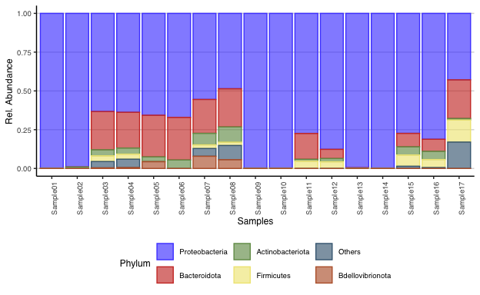

Top 10 genera

n <- 10  
g_level <- agglomerateByRank(tse, "Genus", onRankOnly = TRUE)  
g_level <- relAbundanceCounts(g_level, name="relabundance")  
#Get top orders  
top_genera <- getTopFeatures(g_level,  
 top = n,  
 method = "median",  
 assay_name = "relabundance")  
#Leave only names for top phyla and label the rest to "Others"  
genera_renamed <- lapply(rowData(g_level)$Genus,  
 function(x){if (x %in% top_genera) {x} else {"Others"}})  
rowData(g_level)$Genus <- as.character(genera_renamed)  
#Plot composition as a bar plot  
abund2 <- plotAbundance(g_level,  
 assay_name = "relabundance",  
 rank = "Genus",  
 order_rank_by = "abund",  
 add_x_text = TRUE,  
 one_facet = TRUE) + labs(fill="Genus", color="Genus")  
abund2$scales$scales <- NULL  
abund2 + theme_hc(base_size = 9) + scale_fill_igv("default") +  
 scale_color_igv("default") + theme(axis.text.x = element_text(angle = 90))

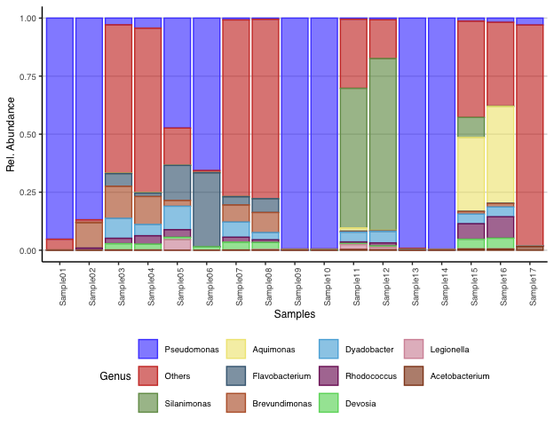

Abundance information can be presented also in tables. Next, samples are merged to groups, taxonomy agglomerated and arranged by abundance.

Top taxa in filtered samples vs non-filtered.

#Merge filtered values, recount relative abundance and agglomeration to Genus  
col4 <- mergeCols(tse,colData(tse)$Filtered)  
col4 <- agglomerateByRank(col4, "Genus")  
col4 <- relAbundanceCounts(col4)  
#Create data frames for merged groups  
opt1 <- data.frame(assay(col4,"relabundance")) %>%  
 rownames_to_column(var = "opt1_asv") %>%  
 arrange(desc(no)) %>% dplyr::select('Non-filtered' = opt1_asv,  
 'Rel Abundance'= no)  
opt2 <- data.frame(assay(col4,"relabundance")) %>%  
 rownames_to_column(var = "opt2_asv") %>%  
 arrange(desc(yes)) %>% dplyr::select(Filtered = opt2_asv,  
 'Rel Abundance' = yes)  
#How many to list in table  
n <- 10  
col4_table <- cbind(opt1[1:n,], opt2[1:n,])  
kable(col4_table, digits = 2, caption = "Common taxa") %>%  
 kable_styling(latex_options = c("HOLD_position","striped"), font_size = 12) %>%  
 row_spec(0, background = "indigo", color = "ivory")

Common taxa

| Non-filtered | Rel Abundance | Filtered | Rel Abundance |
| --- | --- | --- | --- |
| Family:Rhodobacteraceae | 0.15 | Genus:Pseudomonas | 0.63 |
| Genus:Silanimonas | 0.09 | Genus:Flavobacterium | 0.10 |
| Family:Comamonadaceae | 0.08 | Family:Pseudomonadaceae | 0.07 |
| Genus:Brevundimonas | 0.04 | Family:Sphingomonadaceae | 0.04 |
| Genus:Pedobacter | 0.03 | Family:Comamonadaceae | 0.04 |
| Genus:Dyadobacter | 0.03 | Genus:Brevundimonas | 0.02 |
| Family:Rhizobiaceae | 0.03 | Genus:Dyadobacter | 0.02 |
| Genus:Algoriphagus | 0.03 | Family:Microbacteriaceae | 0.02 |
| Genus:Aquimonas | 0.03 | Genus:Chryseobacterium | 0.02 |
| Genus:Alishewanella | 0.02 | Genus:Peredibacter | 0.01 |

Top taxa in microalgae categories.

#Merge filtered values, recount relative abundance and agglomeration to Genus  
col5 <- mergeCols(tse, colData(tse)$Algae)  
col5 <- agglomerateByRank(col5, "Genus")  
col5 <- relAbundanceCounts(col5)  
#Create data frames for merged groups  
opt1 <- data.frame(assay(col5,"relabundance")) %>%  
 rownames_to_column(var = "opt1_asv") %>%  
 arrange(desc(chlorella_s)) %>% dplyr::select(Chlorella = opt1_asv,  
 'Rel Abundance'= chlorella_s)  
opt2 <- data.frame(assay(col5,"relabundance")) %>%  
 rownames_to_column(var = "opt2_asv") %>%  
 arrange(desc(selenastrum)) %>% dplyr::select(Selenatrum = opt2_asv,  
 'Rel Abundance' = selenastrum)  
#How many to list in table  
n <- 10  
col5_table <- cbind(opt1[1:n,], opt2[1:n,])  
kable(col5_table, digits = 2, caption = "Common taxa") %>%  
 kable_styling(latex_options = c("HOLD_position", "striped"), font_size = 12) %>%  
 row_spec(0, background = "indigo", color = "ivory")

Common taxa

| Chlorella | Rel Abundance | Selenatrum | Rel Abundance |
| --- | --- | --- | --- |
| Genus:Pseudomonas | 0.43 | Genus:Pseudomonas | 0.29 |
| Genus:Silanimonas | 0.09 | Genus:Flavobacterium | 0.10 |
| Family:Rhodobacteraceae | 0.08 | Family:Comamonadaceae | 0.07 |
| Family:Pseudomonadaceae | 0.06 | Family:Rhodobacteraceae | 0.06 |
| Family:Sphingomonadaceae | 0.05 | Genus:Dyadobacter | 0.03 |
| Genus:Brevundimonas | 0.04 | Family:Microbacteriaceae | 0.03 |
| Family:Comamonadaceae | 0.03 | Family:Pseudomonadaceae | 0.03 |
| Genus:Algoriphagus | 0.03 | Genus:Chryseobacterium | 0.02 |
| Genus:Alishewanella | 0.02 | Genus:Brevundimonas | 0.02 |
| Genus:Dyadobacter | 0.02 | Family:Rhizobiaceae | 0.02 |

Top taxa in culture age categories (Note that numeric values need to be converted to characters).

#Merge filtered values, recount relative abundance and agglomeration to Genus  
col3 <- mergeCols(tse, as.character(colData(tse)$Age))  
col3 <- agglomerateByRank(col3, "Genus")  
col3 <- relAbundanceCounts(col3)  
#Create data frames for merged groups  
opt1 <- data.frame(assay(col3, "relabundance")) %>%  
 rownames_to_column(var = "opt1_asv") %>%  
 arrange(desc(X5)) %>% dplyr::select(Day5 = opt1_asv, 'Rel Abundance'= X5)  
opt2 <- data.frame(assay(col3, "relabundance")) %>%  
 rownames_to_column(var = "opt2_asv") %>%  
 arrange(desc(X30)) %>% dplyr::select(Day30 = opt2_asv, 'Rel Abundance' = X30)  
#How many to list in table  
n <- 10  
col3_table <- cbind(opt1[1:n,], opt2[1:n,])  
kable(col3_table, digits = 2, caption = "Common taxa") %>%  
 kable_styling(latex_options = c("HOLD_position","striped"), font_size = 12) %>%  
 row_spec(0, background="indigo", color="ivory")

Common taxa

| Day5 | Rel Abundance | Day30 | Rel Abundance |
| --- | --- | --- | --- |
| Genus:Pseudomonas | 0.34 | Genus:Pseudomonas | 0.38 |
| Genus:Flavobacterium | 0.08 | Family:Rhodobacteraceae | 0.21 |
| Family:Comamonadaceae | 0.07 | Genus:Silanimonas | 0.16 |
| Family:Pseudomonadaceae | 0.05 | Genus:Aquimonas | 0.05 |
| Genus:Brevundimonas | 0.04 | Genus:Algoriphagus | 0.03 |
| Family:Sphingomonadaceae | 0.03 | Genus:Roseococcus | 0.02 |
| Genus:Dyadobacter | 0.03 | Family:Clostridiaceae | 0.02 |
| Family:Microbacteriaceae | 0.02 | Genus:Dyadobacter | 0.02 |
| Family:Rhodobacteraceae | 0.02 | Family:Comamonadaceae | 0.01 |
| Genus:Chryseobacterium | 0.02 | Genus:Rhodococcus | 0.01 |

### Alpha diversity

Diversity can be studied using diversity indexes. Values can be added to **colData** under defined names. We create table with Shannon, Faith and observed features diversity indexes.

#Calculate Shannon index  
tse <- mia::estimateDiversity(tse,   
 assay_name = "counts",   
 index = "shannon",   
 name = "Shannon")  
#Calculate phylogenetic Faith index  
tse <- mia::estimateFaith(tse,  
 abund_values = "counts",  
 index = "faith",  
 name = "Faith",  
 tree_name = "phylo")  
#Calculate richness with Chao1 index  
tse <- mia::estimateRichness(tse,  
 abund_values = "counts",  
 index = "observed",  
 name = "Observed")  
#Create table  
kable(data.frame(Shannon = colData(tse)$Shannon, Faith = colData(tse)$Faith,  
 Observed_features = colData(tse)$Observed), digits = 2) %>%  
 kable_styling(latex_options = c("HOLD_position", "striped"),  
 font_size = 12) %>%  
 row_spec(0, background = "indigo", color = "ivory")

|  | Shannon | Faith | Observed_features |
| --- | --- | --- | --- |
| Sample01 | 0.79 | 7.71 | 40 |
| Sample02 | 1.43 | 7.71 | 51 |
| Sample03 | 4.64 | 18.86 | 353 |
| Sample04 | 4.58 | 19.61 | 362 |
| Sample05 | 2.67 | 11.33 | 65 |
| Sample06 | 1.68 | 12.12 | 52 |
| Sample07 | 5.34 | 34.92 | 718 |
| Sample08 | 5.24 | 34.36 | 690 |
| Sample09 | 0.12 | 7.18 | 33 |
| Sample10 | 0.12 | 6.34 | 29 |
| Sample11 | 2.03 | 9.13 | 92 |
| Sample12 | 1.95 | 10.44 | 102 |
| Sample13 | 0.15 | 6.66 | 29 |
| Sample14 | 0.10 | 6.63 | 31 |
| Sample15 | 3.51 | 18.13 | 194 |
| Sample16 | 3.38 | 17.47 | 164 |
| Sample17 | 3.92 | 26.79 | 411 |

Boxplots can be used to compare sample categories

#Shannon boxplot I  
plot1 <- ggplot(as.data.frame(colData(tse)), aes(x = Algae, y = Shannon,  
 fill = Algae)) +  
 geom_boxplot(alpha = 0.7, show.legend = FALSE) +  
 geom_dotplot(binaxis = "y", stackdir = "center", binwidth = 0.3, dotsize = 0.5) +  
 labs (title = "Algae", y = "Shannon", x = "Algae")  
#Shannon boxplot II  
plot2 <- ggplot(as.data.frame(colData(tse)), aes(x = Filtered, y = Shannon,  
 fill = Filtered)) +  
 geom_boxplot(alpha = 0.7, show.legend = FALSE) +  
 geom_dotplot(binaxis = "y", stackdir = "center", binwidth = 0.3, dotsize = 0.5) +  
 labs (title = "Culture filtering", y = "Shannon", x = "Filtering")  
#Shannon boxplot III  
plot3 <- ggplot(as.data.frame(colData(tse)), aes(x = Name, y = Shannon,  
 fill = Name)) +  
 geom_boxplot(alpha = 0.7, show.legend = FALSE) +  
 geom_dotplot(binaxis = "y", stackdir = "center", binwidth = 0.3, dotsize = 0.5) +  
 labs (title = "Samples", y = "Shannon", x = "Sample")  
#Shannon boxplot IV  
plot4 <- ggplot(as.data.frame(colData(tse)), aes(x = as.character(Age), y = Shannon,  
 fill = Algae)) +  
 geom_boxplot(alpha = 0.7, show.legend = FALSE) +  
 geom_dotplot(binaxis = "y", stackdir = "center", binwidth = 0.3, dotsize = 0.5) +  
 labs (title = "Algae and age", y = "Shannon", x = "Age of culture") +  
 scale_x_discrete(limits = rev)  
#Shannon boxplot V  
plot5 <- ggplot(as.data.frame(colData(tse)), aes(x = as.character(Age), y = Shannon,  
 fill= Filtered)) +  
 geom_boxplot(alpha = 0.7, show.legend = FALSE) +  
 geom_dotplot(binaxis = "y", stackdir = "center", binwidth = 0.3, dotsize = 0.5) +  
 labs (title = "Filtering and age", y = "Shannon", x = "Age of culture") +  
 scale_x_discrete(limits = rev)

Algae and culture filtering boxplots (n=8).

plot1 + theme_hc(base_size=9) + scale_fill_igv() + plot2 + theme_hc(base_size=9) + scale_fill_igv()

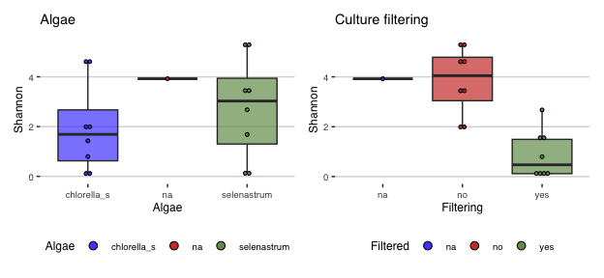

Sample comparison boxplot (n=2)

plot3 + theme_hc(base_size = 9) + scale_fill_igv()

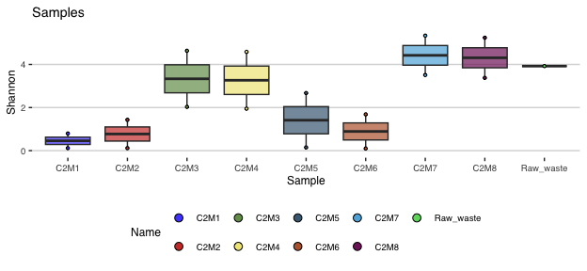

Dual boxplots (n=4)

plot4 + theme_hc(base_size = 9) + scale_fill_igv() + plot5 + theme_hc(base_size = 9) + scale_fill_igv()

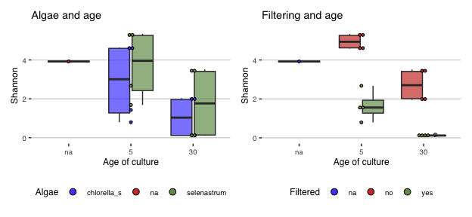

Filtering has an effect on diversity. Both microalgae seem also to decrease diversity compared to untreated. However, there is only one control sample and decrease is not statistically significant. Culture age also decreases diversity. This is most evident in final boxplots.

### Beta diversity

Bray-Curtis dissimilarity analysis

# Convert counts to relabundance  
tse <- transformAssay(tse, method = "relabundance", assay.type = "counts")  
# Perform Bray-Curtis distance calculation  
tse <- runMDS(tse, FUN = vegan::vegdist, method = "bray",  
 name = "Bray", exprs_values = "relabundance")  
#Create 2D ggplot object  
pcoa_bray <- plotReducedDim(tse, "Bray")  
# Calculate explained variance  
e <- attr(reducedDim(tse, "Bray"), "eig");  
rel_eig <- e/sum(e[e>0])  
#Create dataframe for each axis  
bray_curtis_df <- data.frame(pcoa1 = pcoa_bray$data[,1],   
 pcoa2 = pcoa_bray$data[,2])  
#Binding sample attributes to same data frame  
#At same time culture age in Days is converted from numeric to character  
bray_attributes <-cbind(bray_curtis_df,  
 Filtering = colData(tse)$Filtered,  
 Age = as.character(colData(tse)$Age),  
 Names = colData(tse)$Name,  
 Algae = colData(tse)$Algae)  
bray_attributes <- bray_attributes[1:16,]  
#Create series of plots using combined data frame  
filtering <- ggplot(data = bray_attributes, aes(x = pcoa1, y = pcoa2,  
 color = Filtering, shape = Algae)) + geom_point(size = 3) +  
 labs(x = paste("PCoA 1 (", round(100 * rel_eig[[1]],1),  
 "%", ")", sep = ""), y = paste("PCoA 2 (",  
 round(100 * rel_eig[[2]],1), "%", ")", sep = ""),)  
age <- ggplot(data = bray_attributes, aes(x = pcoa1, y = pcoa2, color = Age,  
 shape = Algae)) + geom_point(size = 3) +  
 labs(x = paste("PCoA 1 (", round(100 * rel_eig[[1]],1),  
 "%", ")", sep = ""), y = paste("PCoA 2 (",  
 round(100 * rel_eig[[2]],1), "%", ")", sep = ""),)

Results.

filtering + theme_hc() + ggtitle("Filtering and Algae") +  
 theme(axis.title = element_text()) + scale_color_igv()

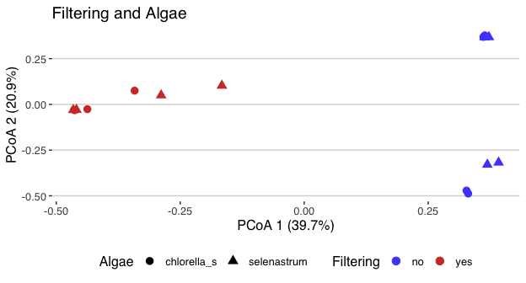

age + theme_hc() + ggtitle("Filtering and Age") +  
 theme(axis.title = element_text()) + scale_color_igv()

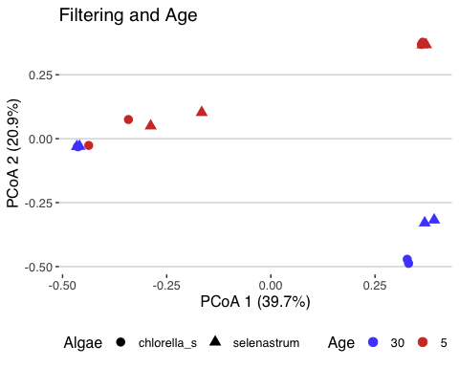

Filtering change community composition.

Beta diversity using unifrac

tse <- runMDS(tse, FUN = mia::calculateUnifrac, name = "unweighted_uni",  
 tree = rowTree(tse),  
 ntop = nrow(tse),  
 exprs_values = "relabundance",  
 weighted = FALSE)  
tse <- runMDS(tse, FUN = mia::calculateUnifrac, name = "weighted_uni",  
 tree = rowTree(tse),  
 ntop = nrow(tse),  
 exprs_values = "relabundance",  
 weighted = TRUE)  
#Create ggplot objects  
unweighted <- plotReducedDim(tse, "unweighted_uni")  
weighted <- plotReducedDim(tse, "weighted_uni")  
#Create data frames  
unweighted_df <- data.frame(pcoa1 = unweighted$data[,1],   
 pcoa2 = unweighted$data[,2])  
weighted_df <- data.frame(pcoa1 = weighted$data[,1],  
 pcoa2 = weighted$data[,2])  
#We want to include sample metadata to the same data frame  
#At same time culture age in Days is converted from numeric data to character  
unweighted_attributes <-cbind(unweighted_df,  
 Filtering = colData(tse)$Filtered,  
 Age = as.character(colData(tse)$Age),  
 Names = colData(tse)$Name,  
 Algae = colData(tse)$Algae,  
 Group = colData(tse)$Group)  
weighted_attributes <-cbind(weighted_df,  
 Filtering = colData(tse)$Filtered,  
 Age = as.character(colData(tse)$Age),  
 Names = colData(tse)$Name,  
 Algae = colData(tse)$Algae,  
 Group = colData(tse)$Group)  
# Calculate explained variances  
eu <- attr(reducedDim(tse, "unweighted_uni"), "eig");  
urel_eig <- eu/sum(eu[eu>0])  
ew <- attr(reducedDim(tse, "weighted_uni"), "eig");  
wrel_eig <- ew/sum(ew[ew>0])  
# Removing wastewater from plots  
unweighted_attributes <- unweighted_attributes[1:16,]  
weighted_attributes <- weighted_attributes[1:16,]

Next create ggplot objects

#Create series of plots using combined data frame  
uni1 <- ggplot(data = unweighted_attributes,  
 aes(x = pcoa1, y = pcoa2, color = Filtering, shape = Age)) +  
 geom_point(size = 2) +  
 labs(x = paste("PCoA 1 (", round(100 * urel_eig[[1]],1), "%", ")", sep = ""),  
 y = paste("PCoA 2 (", round(100 * urel_eig[[2]],1), "%", ")", sep = ""),  
 title = "Unweighted unifrac") +  
 scale_y_continuous(limits = c(-0.5, 0.5)) +   
 scale_x_continuous(limits = c(-0.5, 0.5)) +  
 theme_hc(base_size = 9) + scale_color_igv()  
uni2 <- ggplot(data = weighted_attributes,  
 aes(x = pcoa1, y = pcoa2, color = Filtering, shape = Age)) +  
 geom_point(size = 2) +  
 labs(x = paste("PCoA 1 (", round(100 * wrel_eig[[1]],1), "%", ")", sep = ""),  
 y = paste("PCoA 2 (", round(100 * wrel_eig[[2]],1), "%", ")", sep = ""),  
 title = "Weighted unifrac") +  
 scale_y_continuous(limits = c(-0.5, 0.5)) +   
 scale_x_continuous(limits = c(-0.5, 0.5)) +  
 theme_hc(base_size = 9) + scale_color_igv()  
uni3 <- ggplot(data = unweighted_attributes,  
 aes(x = pcoa1, y = pcoa2, color = Algae, shape = Age)) +  
 geom_point(size = 2) +  
 labs(x = paste("PCoA 1 (", round(100 * urel_eig[[1]],1), "%", ")", sep = ""),  
 y = paste("PCoA 2 (", round(100 * urel_eig[[2]],1), "%", ")", sep = ""),  
 title = "Unweighted unifrac") +  
 scale_y_continuous(limits = c(-0.5, 0.5)) +   
 scale_x_continuous(limits = c(-0.5, 0.5)) +  
 theme_hc(base_size = 9) + scale_color_igv() +  
 theme(legend.position = "bottom", legend.box = "vertical",  
 legend.margin = margin())  
uni4 <- ggplot(data = weighted_attributes,  
 aes(x=pcoa1, y=pcoa2, color = Algae, shape = Age)) +  
 geom_point(size=2) +  
 labs(x = paste("PCoA 1 (", round(100 * wrel_eig[[1]],1), "%", ")", sep = ""),  
 y = paste("PCoA 2 (", round(100 * wrel_eig[[2]],1), "%", ")", sep = ""),  
 title = "Weighted unifrac") +  
 scale_y_continuous(limits = c(-0.5, 0.5)) +   
 scale_x_continuous(limits = c(-0.5, 0.5)) +  
 theme_hc(base_size = 9) + scale_color_igv() +  
 theme(legend.position = "bottom", legend.box = "vertical",  
 legend.margin = margin())

First, comparison of culture filtering and age

uni1 + uni2

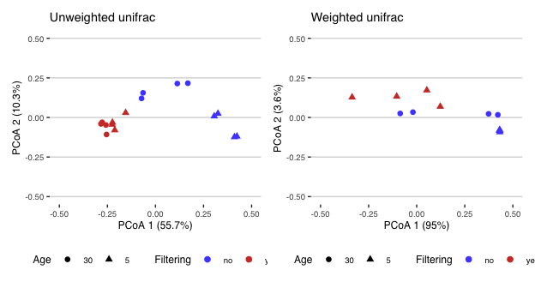

Next algae species along with culture age

uni3 + uni4

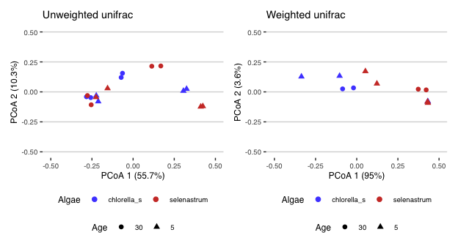

Results are similar to Bray-Curtis. Weighted plots show smaller differences.

### Permanova analysis

Permanova measures importance of each variable to total variance.

#dbRDA assay  
#tse <- transformAssay(tse, method = "relabundance")  
tse <- runRDA(tse, assay.type = "relabundance",  
 formula = assay ~ Filtered + Age + Algae,  
 distance = "bray",  
 na.action = na.exclude)  
rda_info <- attr(reducedDim(tse, "RDA"), "significance")  
kable(rda_info$permanova, digits = 2) %>%  
 kable_styling(latex_options = c("HOLD_position", "striped"),   
 font_size = 12) %>%  
 row_spec(0, background="indigo", color="ivory")

|  | Df | SumOfSqs | F | Pr(>F) | Total variance | Explained variance |
| --- | --- | --- | --- | --- | --- | --- |
| Model | 4 | 3.99 | 6.10 | 0.00 | 5.95 | 0.67 |
| Filtered | 1 | 2.25 | 13.76 | 0.00 | 5.95 | 0.38 |
| Age | 1 | 0.89 | 5.45 | 0.00 | 5.95 | 0.15 |
| Algae | 1 | 0.28 | 1.72 | 0.13 | 5.95 | 0.05 |
| Residual | 12 | 1.96 | NA | NA | 5.95 | 0.33 |

Filtering is most important factor. Culture age is also statistically significant, while Algae is not.

From same df, we can extract information, if homogeneity assumption is fulfilled.

kable(rda_info$homogeneity, digits = 2) %>%  
 kable_styling(latex_options = c("HOLD_position", "striped"),  
 font_size = 12) %>%  
 row_spec(0, background="indigo", color="ivory")

|  | Df | Sum Sq | Mean Sq | F | N.Perm | Pr(>F) | Total variance | Explained variance |
| --- | --- | --- | --- | --- | --- | --- | --- | --- |
| Filtered | 2 | 0.38 | 0.19 | 3.80 | 999 | 0.05 | 1.09 | 0.35 |
| Age | 2 | 0.25 | 0.13 | 0.96 | 999 | 0.58 | 2.09 | 0.12 |
| Algae | 2 | 0.29 | 0.15 | 7.19 | 999 | 0.00 | 0.58 | 0.51 |

Filtering fulfiill homogeneity assumption, Age doesn’t

We can also plot results using plotRDA function from miaViz package.

# Generate RDA plot  
permanova <- plotRDA(tse, "RDA", colour = "Filtered", shape = "Age", add.ellipse = FALSE,  
 parse.labels=TRUE)  
permanova$scales$scales <- NULL  
#change dot size  
permanova$layers[[1]]$aes_params$size <-3  
#add theme and color palette  
permanova + theme_hc(base_size = 10) +  
 scale_colour_igv() + labs(colour="Filtering")

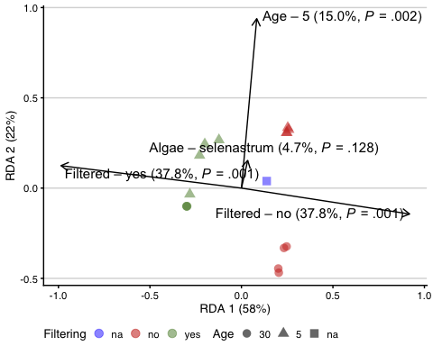

### Differential abundance

Differential abundances of microbial features can be studied with several R packages. ALDEx2 is one of the them.

Data is preprocessed by removing taxa based on low prevalenc. Also, raw wastewater sample is dropped.

#Filtering data based on prevalence.We also drop uncategorized raw wastewater  
tse_daa <- subsetByPrevalentTaxa(tse[,1:16], detection = 0, prevalence = 0.1)  
#We prepare also list of all taxa labels for later use  
featureids <- as.data.frame(getTaxonomyLabels(tse_daa, make_unique=FALSE),  
 rownames(tse_daa))  
featureids <- rownames_to_column(featureids, var="asv")  
colnames(featureids) <- c("ASV","taxon")

Aldex2 analysis on *filtered* category.

#ALDEx2 analysis can be performed in modular fashion  
#aldex.clr - generates random instances of the centred log-ratio transformed values  
filter_aldex <- aldex.clr(assay(tse_daa), tse_daa$Filtered, useMC = TRUE, mc.samples=256, verbose = FALSE)   
#aldex.ttest - perform Welch’s t and Wilcoxon test when there are only two conditions  
filter_tt <- aldex.ttest(filter_aldex, paired.test = FALSE, verbose = FALSE)  
#aldex.effect - estimate effect size and the within and between condition values  
filter_effect <- aldex.effect(filter_aldex, CI = TRUE, verbose = FALSE)  
#Merge two outputs   
filter_aldex_out <- data.frame(filter_tt, filter_effect)  
#Create plots  
par(mfrow = c(1, 2))  
 aldex.plot(filter_aldex_out, type = "MA", test = "welch")  
 aldex.plot(filter_aldex_out, type = "MW", test = "welch")

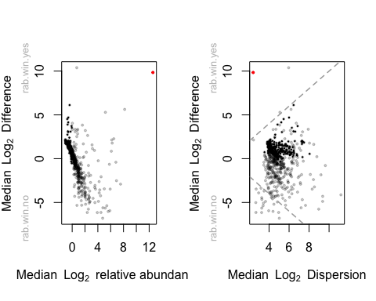

In figure, red dots represent significantly changed taxa, grey dots are abundant taxa and black dots are rare taxa.

We have five variants in which wilcoxon probability test result is p <= 0.05.

#Filter significantly different taxa and create table  
aldex_res <- rownames_to_column(filter_aldex_out, "genus")  
aldex_res <- aldex_res %>% dplyr::filter(wi.eBH <= 0.05) %>% dplyr::select(genus, we.eBH, wi.eBH, effect, overlap)  
#Merge genus id and taxa names into single table  
identity <- merge(aldex_res, featureids, by.x=c("genus"), by.y=c("ASV"))  
identity <- identity %>% relocate("genus","taxon","we.eBH","wi.eBH","effect","overlap")  
kable(identity, digits=2) %>% kable_styling(latex_options = c("HOLD_position",  
 "striped"),  
 font_size = 12) %>%  
 row_spec(0, background="indigo", color="ivory")

| genus | taxon | we.eBH | wi.eBH | effect | overlap |
| --- | --- | --- | --- | --- | --- |
| ASV29 | Family:Carnobacteriaceae | 0.07 | 0.01 | -1.79 | 0.00 |
| ASV64 | Genus:Brevundimonas | 0.05 | 0.00 | -2.14 | 0.00 |
| ASV70 | Genus:Dyadobacter | 0.06 | 0.00 | -1.89 | 0.00 |
| ASV78 | Family:Comamonadaceae | 0.17 | 0.03 | -1.44 | 0.03 |
| ASV86 | Family:Devosiaceae | 0.10 | 0.01 | -1.85 | 0.00 |

Testing algae types or culture age did not provide significantly different features

Ancom-BC2 (Analysis of Compositions of Microbiomes with Bias Correction)

#Perform the analysis   
ancom_out = ancombc2(data = tse_daa, assay_name = "relabundance",  
 fix_formula = "Filtered + Algae + Age",   
 p_adj_method = "holm", prv_cut = 0, lib_cut = 0,   
 group = "Filtered", struc_zero = TRUE, global = TRUE)  
saveRDS(ancom_out, "rds/ancom_out.rds")

ancom_out <- readRDS("rds/ancom_out.rds")

Results are collected into out$res data frame. We can filter statistically significant variants.

First variable is Filtering (yes/no)

#Create data frame, filter Diff = TRUE and arrange by Lfc  
#We also combine taxaid and taxonomic name into first column for our figure  
df_filtered <- data.frame(ASV = ancom_out$res$taxon, Lfc =ancom_out$res$lfc_Filteredyes, SE =  
 ancom_out$res$se_Filteredyes, Q = ancom_out$res$q_Filteredyes,  
 Diff = ancom_out$res$diff_Filteredyes) %>%  
 filter(Diff == "TRUE") %>% arrange(desc(Lfc)) %>% left_join(featureids, by = "ASV")  
df_filtered$ASV <- paste(df_filtered$ASV,df_filtered$taxon)  
df_filtered <- df_filtered %>% dplyr::select(,-6) %>% mutate(Change = ifelse(Lfc > 0, "Positive LFC", "Negative LFC"))  
  
kable (df_filtered, caption="Taxa that are changed by filtering",  
 digits=2,) %>% kable_styling(latex_options = c("HOLD_position",  
 "striped"),  
 font_size = 12) %>%  
 row_spec(0, background="indigo", color="ivory")

Taxa that are changed by filtering

| ASV | Lfc | SE | Q | Diff | Change |
| --- | --- | --- | --- | --- | --- |
| ASV3 Genus:Pseudomonas | 7.06 | 0.33 | 0.00 | TRUE | Positive LFC |
| ASV8 Family:Pseudomonadaceae | 3.54 | 0.51 | 0.01 | TRUE | Positive LFC |
| ASV5 Genus:Pseudomonas | 3.26 | 0.68 | 0.04 | TRUE | Positive LFC |
| ASV46 Genus:Devosia | -2.27 | 0.33 | 0.04 | TRUE | Negative LFC |
| ASV29 Family:Carnobacteriaceae | -3.52 | 0.38 | 0.00 | TRUE | Negative LFC |
| ASV38 Genus:Chryseobacterium | -4.09 | 0.32 | 0.02 | TRUE | Negative LFC |
| ASV149 Genus:Bacteriovorax | -4.10 | 0.35 | 0.03 | TRUE | Negative LFC |
| ASV44 Genus:Fluviicola | -4.28 | 0.27 | 0.01 | TRUE | Negative LFC |
| ASV79 Genus:Bosea | -4.46 | 0.22 | 0.03 | TRUE | Negative LFC |
| ASV119 Family:Pseudomonadaceae | -4.92 | 0.19 | 0.01 | TRUE | Negative LFC |
| ASV54 Family:Oxalobacteraceae | -5.39 | 0.23 | 0.02 | TRUE | Negative LFC |

Bar plot of log fold changes including standard error

#Create ordered taxa list  
p_filter <- ggplot(data = df_filtered,   
 aes(x = factor(ASV, level=df_filtered$ASV), y = Lfc, fill = Change,  
 color = Change)) +   
 geom_bar(stat = "identity", width = 0.7,   
 position = position_dodge(width = 0.4)) +  
 geom_errorbar(aes(ymin = Lfc - SE, ymax = Lfc + SE), width = 0.2,  
 position = position_dodge(0.05), color = "black") +   
 labs(x = "Taxa", y = "Log fold change",   
 title = "Largest changes when samples are filtered") +   
 theme_hc(base_size = 8) + scale_fill_igv() + scale_color_igv() +   
 theme(plot.title = element_text(hjust = 0.5),  
 panel.grid.minor.y = element_blank(),  
 axis.text.x = element_text(angle = 90, hjust=1))  
p_filter

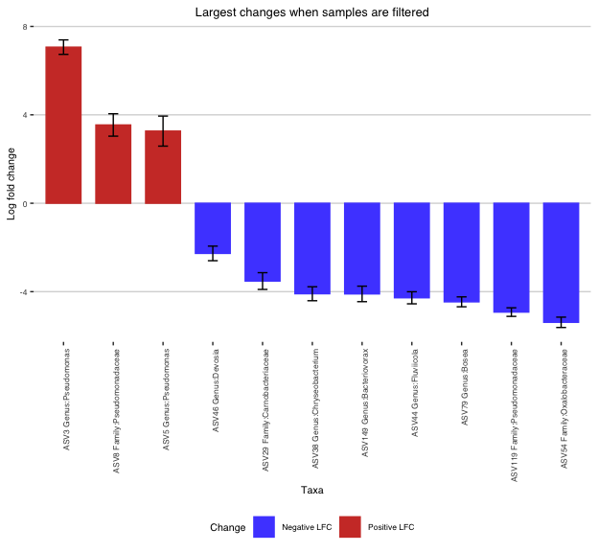

Examination of Algae did not produce significant changes

Culture age variable.

#Create new data frame with Lfc, SE, Diff values  
df_age <- data.frame(ASV = ancom_out$res$taxon, Lfc =ancom_out$res$lfc_Age5, SE =  
 ancom_out$res$se_Age5, Q = ancom_out$res$q_Age5,  
 Diff = ancom_out$res$diff_Age5) %>%  
 filter(Diff == "TRUE") %>% arrange(desc(Lfc)) %>% left_join(featureids, by = "ASV")  
df_age$ASV <- paste(df_age$ASV,df_age$taxon)  
df_age <- df_age %>% dplyr::select(,-6) %>% mutate(Change = ifelse(Lfc > 0, "Positive LFC", "Negative LFC"))  
kable (df_age, caption="Taxa that are changed by culture length",  
 digits=2,) %>% kable_styling(latex_options = c("HOLD_position",  
 "striped"),  
 font_size = 12) %>%  
 row_spec(0, background="indigo", color="ivory")

Taxa that are changed by culture length

| ASV | Lfc | SE | Q | Diff | Change |
| --- | --- | --- | --- | --- | --- |
| ASV54 Family:Oxalobacteraceae | 5.48 | 0.23 | 0.02 | TRUE | Positive LFC |
| ASV44 Genus:Fluviicola | 4.71 | 0.27 | 0.01 | TRUE | Positive LFC |
| ASV38 Genus:Chryseobacterium | 3.50 | 0.32 | 0.03 | TRUE | Positive LFC |
| ASV19 Family:Microbacteriaceae | 3.19 | 0.41 | 0.05 | TRUE | Positive LFC |
| ASV47 Genus:Dyadobacter | -1.72 | 0.23 | 0.03 | TRUE | Negative LFC |
| ASV3 Genus:Pseudomonas | -1.97 | 0.33 | 0.01 | TRUE | Negative LFC |
| ASV13 Family:Comamonadaceae | -2.27 | 0.31 | 0.00 | TRUE | Negative LFC |
| ASV22 Genus:Acetobacteroides | -2.58 | 0.28 | 0.02 | TRUE | Negative LFC |
| ASV94 Family:Rhodobacteraceae | -4.03 | 0.26 | 0.00 | TRUE | Negative LFC |
| ASV14 Genus:Aquimonas | -4.34 | 0.57 | 0.00 | TRUE | Negative LFC |
| ASV7 Genus:Silanimonas | -4.37 | 0.75 | 0.01 | TRUE | Negative LFC |
| ASV84 Family:Sphingomonadaceae | -4.61 | 0.35 | 0.00 | TRUE | Negative LFC |
| ASV9 Family:Rhodobacteraceae | -4.90 | 0.49 | 0.00 | TRUE | Negative LFC |
| ASV36 Family:Clostridiaceae | -5.15 | 0.38 | 0.00 | TRUE | Negative LFC |
| ASV20 Family:Rhodobacteraceae | -5.47 | 0.42 | 0.00 | TRUE | Negative LFC |
| ASV55 Genus:Roseococcus | -5.54 | 0.22 | 0.00 | TRUE | Negative LFC |

Bar plot of LFC including standard error.

p_day <- ggplot(data = df_age,   
 aes(x = factor(ASV, level=df_age$ASV), y = Lfc,  
 fill = Change, color = Change)) +   
 geom_bar(stat = "identity", width = 0.7,   
 position = position_dodge(width = 0.4)) +  
 geom_errorbar(aes(ymin = Lfc - SE, ymax = Lfc + SE), width = 0.2,  
 position = position_dodge(0.05), color = "black") +   
 labs(title = "Largest changes by culture length") +   
 theme_hc(base_size=8) + scale_fill_igv() + scale_color_igv() +  
 theme(plot.title = element_text(hjust = 0.5),  
 panel.grid.minor.y = element_blank(),  
 axis.text.x = element_text(angle = 90, hjust = 1))  
p_day

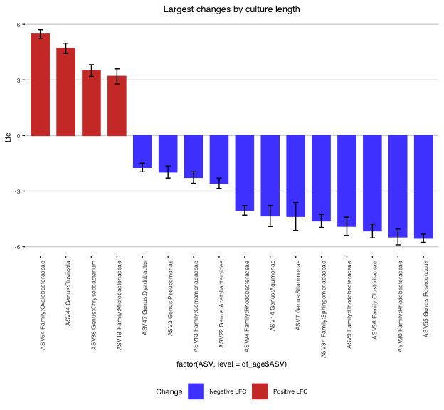

MaAsLin2 package is another DAA analysis package.

#Maaslin requires data frame as metadata input  
meta_data <- data.frame(colData(tse_daa))  
#Counts table needs to be transposed  
variant_table <- t(assay(tse_daa))  
#Maaslin settings  
maaslin_filtering <- Maaslin2(  
 variant_table,  
 meta_data,  
 output = "Maaslin2-filtering",  
 transform = "AST",  
 fixed_effects = c("Filtered"),  
 reference = c("Filtered", "no"),  
 normalization = "TSS",  
 standardize = FALSE,  
 min_prevalence = 0  
)  
saveRDS(maaslin_filtering, "rds/maaslin_filtering.rds")

**Note**: Maaslin2 will also write results to output folder defined. If you use several fixed effects, it will create additional heatmap plot.

maaslin_filtering <- readRDS("rds/maaslin_filtering.rds")

Filtering significant results to table by qval value (<= 0.05).

maaslin_table <- maaslin_filtering$results %>% dplyr::select(ASV = feature,  
 Coef = coef, SE = stderr,qval,  
 N, Nonzero = N.not.zero) %>%  
 filter(qval <= 0.05) %>% arrange(desc(Coef))  
kable(maaslin_table, digits=2) %>% kable_styling(latex_options = c("HOLD_position",  
 "striped"),  
 font_size = 12) %>%  
 row_spec(0, background="indigo", color="ivory")

| ASV | Coef | SE | qval | N | Nonzero |
| --- | --- | --- | --- | --- | --- |
| ASV3 | 1.03 | 0.14 | 0.00 | 16 | 16 |
| ASV382 | -0.01 | 0.00 | 0.03 | 16 | 6 |
| ASV464 | -0.01 | 0.00 | 0.03 | 16 | 6 |
| ASV378 | -0.02 | 0.00 | 0.03 | 16 | 6 |
| ASV98 | -0.02 | 0.00 | 0.02 | 16 | 7 |
| ASV194 | -0.02 | 0.00 | 0.01 | 16 | 7 |
| ASV245 | -0.02 | 0.00 | 0.00 | 16 | 9 |
| ASV249 | -0.02 | 0.01 | 0.03 | 16 | 6 |
| ASV307 | -0.02 | 0.00 | 0.01 | 16 | 7 |
| ASV242 | -0.03 | 0.01 | 0.03 | 16 | 6 |
| ASV239 | -0.03 | 0.01 | 0.03 | 16 | 6 |
| ASV262 | -0.03 | 0.00 | 0.00 | 16 | 8 |
| ASV184 | -0.03 | 0.01 | 0.03 | 16 | 6 |
| ASV193 | -0.03 | 0.01 | 0.03 | 16 | 6 |
| ASV52 | -0.03 | 0.01 | 0.03 | 16 | 10 |
| ASV183 | -0.03 | 0.01 | 0.03 | 16 | 9 |
| ASV85 | -0.04 | 0.01 | 0.01 | 16 | 7 |
| ASV101 | -0.04 | 0.01 | 0.03 | 16 | 7 |
| ASV87 | -0.04 | 0.01 | 0.01 | 16 | 11 |
| ASV119 | -0.04 | 0.01 | 0.03 | 16 | 7 |
| ASV106 | -0.05 | 0.01 | 0.03 | 16 | 8 |
| ASV79 | -0.06 | 0.01 | 0.03 | 16 | 7 |
| ASV78 | -0.06 | 0.01 | 0.01 | 16 | 10 |
| ASV70 | -0.06 | 0.01 | 0.03 | 16 | 8 |
| ASV46 | -0.06 | 0.01 | 0.03 | 16 | 10 |
| ASV64 | -0.06 | 0.01 | 0.02 | 16 | 8 |
| ASV29 | -0.09 | 0.01 | 0.00 | 16 | 12 |
| ASV47 | -0.09 | 0.01 | 0.00 | 16 | 10 |

Testing algae and age did not provide significantly different variants

For filtering, we can summarize results from different DAA functions and look for common features.

#Create daa summaries  
aldex_summary <- aldex_res %>% dplyr::select(ASV = genus, Aldex2 = wi.eBH)  
ancom_summary <- ancom_out$res %>% dplyr::select(ASV=taxon, Ancombc2 = q_Filteredyes) %>%  
 filter(Ancombc2 <= 0.05)  
maaslin_summary <- maaslin_filtering$results %>% dplyr::select(ASV=feature,Maaslin2=qval) %>%  
 dplyr::filter(Maaslin2 <= 0.05)  
#Join three summaries together  
daa_summary <- full_join(aldex_summary,ancom_summary, by="ASV")  
daa_summary <- full_join(daa_summary, maaslin_summary, by="ASV")  
#Create TRUE-FALSE data frame and calculate rowsum score  
daa_summary <- daa_summary %>% dplyr::mutate(  
 dplyr::across(c(Aldex2:Maaslin2), ~ .x <= 0.05),  
 across(-ASV, function(x) ifelse(is.na(x), FALSE, x)),  
 Score = rowSums(across(c(Aldex2:Maaslin2)))   
) %>% filter(Score > 1)  
daa_summary <- daa_summary %>% left_join(featureids, by = "ASV") %>% arrange(ASV)  
daa_summary <- daa_summary[c("ASV","taxon", "Aldex2", "Ancombc2","Maaslin2","Score")]  
kable(daa_summary, caption="Differential taxa with score of 2") %>%  
 kable_styling(latex_options = c("HOLD_position", "striped"),  
 font_size = 12) %>%  
 row_spec(0, background="indigo", color="ivory")

Differential taxa with score of 2

| ASV | taxon | Aldex2 | Ancombc2 | Maaslin2 | Score |
| --- | --- | --- | --- | --- | --- |
| ASV119 | Family:Pseudomonadaceae | FALSE | TRUE | TRUE | 2 |
| ASV29 | Family:Carnobacteriaceae | TRUE | TRUE | TRUE | 3 |
| ASV3 | Genus:Pseudomonas | FALSE | TRUE | TRUE | 2 |
| ASV46 | Genus:Devosia | FALSE | TRUE | TRUE | 2 |
| ASV64 | Genus:Brevundimonas | TRUE | FALSE | TRUE | 2 |
| ASV70 | Genus:Dyadobacter | TRUE | FALSE | TRUE | 2 |
| ASV78 | Family:Comamonadaceae | TRUE | FALSE | TRUE | 2 |
| ASV79 | Genus:Bosea | FALSE | TRUE | TRUE | 2 |