Data-analyysi Raajärvi näytteet ITS1

#### R libraries

library(tidyverse)  
library(knitr)  
library(ggthemes)  
library(ggsci)  
library(ggpubr)  
library(kableExtra)  
library(RColorBrewer)  
library(mia)  
library(miaViz)  
library(scater)  
library(ape)  
library(pheatmap)  
library(bluster)  
library(cluster)  
library(ALDEx2)  
library(ANCOMBC)  
library(Maaslin2)

#### Load data object

# Load data from rds  
tse <- readRDS("results/tse_its1.rds")  
set.seed(123412)

#### Prevalent features on data set

Features that have minimun abundance of 1 % and prevalence of over 50 %

# Agglomerate to genus  
tse <- agglomerateByRank(tse, rank="Genus", na.rm=T)  
tse <- tse[,1:23]  
# Filter abundance  
rowData(tse)$prevalence <- getPrevalence(tse, detection = 1/100,  
 as.relative=T)  
# Filter prevalence  
filtered_prevalence <- tse[rowData(tse)$prevalence >= 0.5,]  
# Plot  
plot <- plotRowData(filtered_prevalence, "prevalence", colour_by="Genus")  
plot$scales$scales <- list()  
plot$layers[[2]]$aes_params$size <- 2.5  
plot + theme_pubclean(base_size=8) + scale_color_lancet() +  
 labs(color="Genus", caption="Prevalence plot")

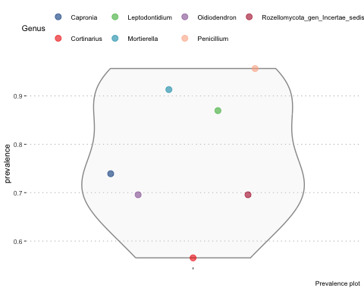

#### Community composition plots

Top ten features calculated by median relative abundance

# Reload data  
tse <- readRDS("results/tse_its1.rds")  
tse <- tse[,1:23]  
# Agglomerate to genus  
tse <- agglomerateByRank(tse, rank="Genus", na.rm=T)  
# Calculate relative abundance  
tse <- transformAssay(tse, method="relabundance")  
# Get top features  
top_features <- getTop(tse, top=10, method="median",  
 assay.type="relabundance")  
# Get data and filter using top features  
df_genus <- data.frame(assay(tse, "relabundance"))  
df_genus <- df_genus %>% rownames_to_column(var="Genus") %>%  
 filter(Genus %in% top_features) %>%  
 bind_rows(summarise(., Genus = "Others", across(where(is.numeric),  
 ~ 1 - sum(.))))  
# Sample names from colData  
coldata_df <- as.data.frame(colData(tse))  
coldata_df <- rownames_to_column(coldata_df, var="Sample")  
# Create a long table  
genus_long <- pivot_longer(df_genus, names_to="Sample",  
 values_to="Abundance",  
 cols = starts_with("Barcode"))  
genus_long <- merge(coldata_df, genus_long, by="Sample")  
#barplot theme settings  
bar_theme <- list(theme_pubclean(base_size=7),scale_fill_igv(), xlab("Sample"),  
 theme(axis.text.x = element_text(angle = 90,  
 vjust = 0.5,  
 hjust = 1)))

Barplot faceted by vegetation

barplot1 <- ggplot(genus_long, aes(x=Labnro, y=Abundance, fill=Genus)) +  
 geom_bar(stat="identity", width=0.8) +  
 facet_wrap(~ Kasvillisuus) + bar_theme  
barplot1

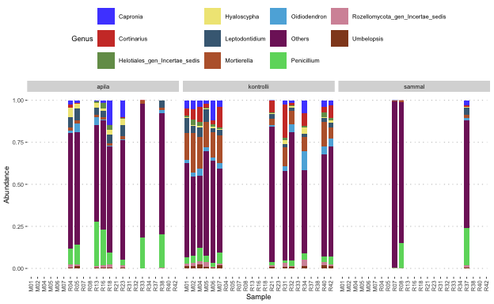

Barplot faceted by soil

barplot2 <- ggplot(genus_long, aes(x=Labnro, y=Abundance, fill=Genus)) +  
 geom_bar(stat="identity", width=0.8) + facet_grid(~ Maanäyte) + bar_theme  
barplot2

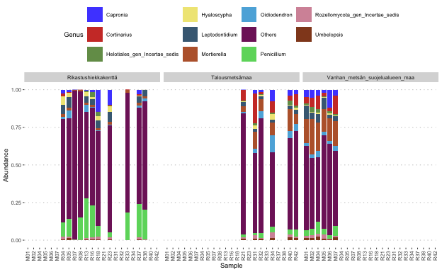

Barplot faceted by pH

barplot3 <- ggplot(genus_long, aes(x=Labnro, y=Abundance, fill=Genus)) +  
 geom_bar(stat="identity", width=0.8) + facet_grid(~ pH) + bar_theme  
barplot3

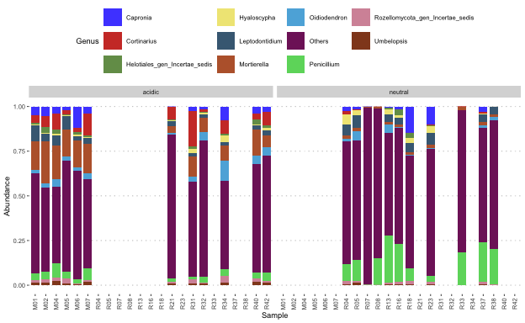

Clustered heatmap with soil pH groups

# Reload object and count relabundance  
tse <- readRDS("results/tse_its1.rds")  
tse <- tse[,1:23]  
tse <- transformAssay(tse, method="relabundance")  
# Get assay data  
assay_data <- assay(tse, "relabundance")  
# Get taxa labels and merge with feature id  
taxa <- data.frame(id = rownames(tse), label = getTaxonomyLabels(tse))  
taxa$cleaned <- sub(".*:", "", taxa$label)  
taxa$merged <- paste(taxa$id, taxa$cleaned, sep = ":")  
# Replace rownames with new label  
rownames(assay_data) <- taxa$merged  
# Calculate rowsums  
abundance <- rowSums(assay_data)  
abundance <- order(abundance, decreasing = TRUE)[1:25]  
# Filter assay data with top25 abundance  
top25 <- assay_data[abundance, ]  
# Extract sample names and material types from colData  
sample_names <- colData(tse)$Labnro  
material_types <- colData(tse)$pH  
# Assign the sample names to the top25 matrix  
colnames(top25) <- sample_names  
# Create a dataframe for annotations  
annotation_data <- data.frame(pH = material_types)  
rownames(annotation_data) <- sample_names  
# Set color for annotations  
annotation_colors <- list(pH = c("neutral" = "navy", "acidic" = "red"))  
# Plot the heatmap with annotations  
pheatmap(  
 top25,  
 cluster_rows = TRUE,  
 cluster_cols = TRUE,  
 clustering_distance_cols = "correlation",  
 main = "Heatmap presentation",  
 scale = "row",  
 color = brewer.pal(11, "RdBu"),  
 fontsize = 8,  
 fontsize_row = 6,  
 fontsize_col = 6,  
 annotation_col = annotation_data,  
 annotation_colors = annotation_colors)

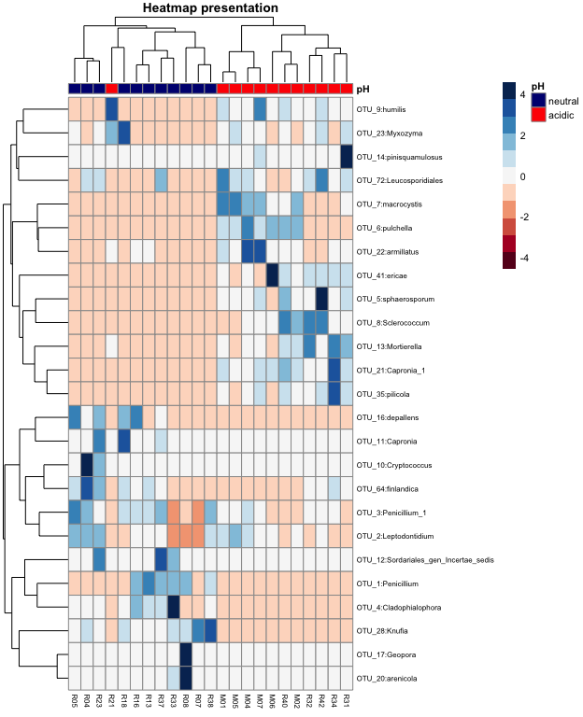

Taxonomy tree plot objects for soil pH groups

# Reload data  
tse <- readRDS("results/tse_its1.rds")  
tse <- tse[,1:23]  
plots <- list()  
materials <- unique(tse$pH)  
# For loop for different groups  
for (i in seq_along(materials)) {  
material <- materials[i]  
# Subset materials  
tse_sub <- tse[, tse$pH == material]  
# Agglomerate omitting empty species column  
tse_sub <- agglomerateByRanks(tse_sub, ranks = taxonomyRanks(tse_sub)[1:6])  
# Calculate prevalence values  
altExps(tse_sub) <- lapply(  
 altExps(tse_sub), function(y){  
 rowData(y)$prevalence <- getPrevalence(y, detection = 1/100,  
 sort = F, as.relative = T,  
 assay.type = "counts")  
return(y)})  
# Define top5 phyla  
top_phyla <- getTop(altExp(tse_sub,"Phylum"),  
 method="mean",  
 top=5,  
 assay.type="counts")  
# Unsplit agglomeration  
taxas <- unsplitByRanks(tse_sub, ranks = taxonomyRanks(tse_sub)[1:6])  
# Add hierarchy  
taxas <- addHierarchyTree(taxas)  
# Plot rowtree  
p <- plotRowTree(  
taxas[rowData(taxas)$Phylum %in% top_phyla,],  
edge.colour.by = "Phylum",  
tip.colour.by = "prevalence",  
node.colour.by = "prevalence")  
plots[[i]] <- p + ggtitle(paste("Soil = ",material)) + scale_color_lancet()  
}

Plot the figure

plots[[1]]/plots[[2]]

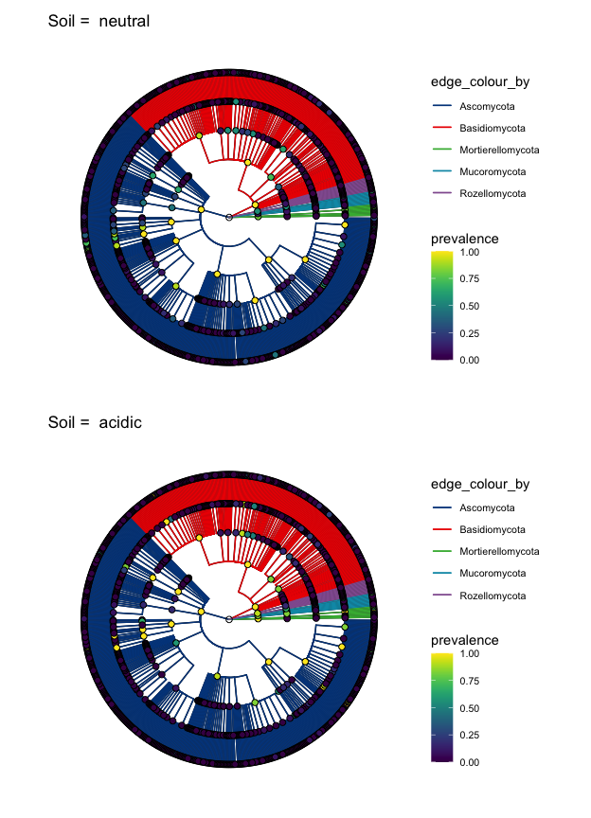

#### Alpha diversity

Calculation of alpha diversity indexes

tse <- readRDS("results/tse_its1.rds")  
tse <- tse[,1:23]  
# Calculate alpha and create df  
tse <- addAlpha(tse, assay.type="counts",  
 index=c("shannon_diversity", "gini_simpson_diversity",  
 "pielou_evenness", "observed_richness"))  
alpha_table <- data.frame(Sample=colData(tse)$Labnro,  
 Shannon = colData(tse)$shannon_diversity,  
 Gini_Simpson = colData(tse)$gini_simpson_diversity,  
 Pielou = colData(tse)$pielou_evenness,  
 Observed_features = colData(tse)$observed_richness)  
common_theme <- list(theme_pubclean(base_size=8), scale_fill_lancet(),  
 theme(legend.position="none"))

Alpha diversity index table

kable(alpha_table, digits = 2, caption = "Diversity indexes") %>%  
kable_styling(latex_options = c("HOLD_position", "striped"),  
font_size = 10) %>% row_spec(0, background = "teal", color = "white")

Diversity indexes

| Sample | Shannon | Gini_Simpson | Pielou | Observed_features |
| --- | --- | --- | --- | --- |
| R08 | 3.44 | 0.89 | 0.48 | 1248 |
| R16 | 4.01 | 0.94 | 0.53 | 2038 |
| R07 | 4.41 | 0.97 | 0.62 | 1195 |
| R37 | 3.90 | 0.95 | 0.53 | 1476 |
| R33 | 3.48 | 0.92 | 0.48 | 1425 |
| R13 | 4.30 | 0.95 | 0.55 | 2316 |
| M06 | 4.57 | 0.97 | 0.60 | 2032 |
| R38 | 4.28 | 0.96 | 0.57 | 1868 |
| R05 | 4.45 | 0.97 | 0.57 | 2489 |
| R34 | 4.72 | 0.98 | 0.62 | 2109 |
| R32 | 4.68 | 0.97 | 0.61 | 2134 |
| R04 | 4.36 | 0.96 | 0.57 | 2169 |
| M04 | 4.72 | 0.98 | 0.60 | 2602 |
| M07 | 4.78 | 0.98 | 0.61 | 2531 |
| M01 | 4.87 | 0.98 | 0.62 | 2525 |
| R21 | 4.79 | 0.98 | 0.63 | 2038 |
| R18 | 4.14 | 0.95 | 0.55 | 1957 |
| R40 | 4.73 | 0.98 | 0.62 | 2056 |
| R42 | 4.32 | 0.95 | 0.56 | 2300 |
| M05 | 4.69 | 0.97 | 0.61 | 2226 |
| M02 | 4.71 | 0.98 | 0.60 | 2434 |
| R31 | 4.42 | 0.96 | 0.58 | 1959 |
| R23 | 4.36 | 0.96 | 0.56 | 2450 |

Group comparison objects

# Data frame for shannon boxplots  
alphadf <- data.frame(colData(tse)) %>%  
 dplyr::select(Labnro, Alue, Kasvillisuus, Maanäyte, pH,  
 Shannon=shannon_diversity)  
# Vegetation  
plot_kasvillisuus <- ggplot(alphadf, aes(x=Kasvillisuus, y=Shannon,  
 fill=Kasvillisuus)) + geom_boxplot() +  
 common_theme + labs(caption="Kasvillisuus")  
# Area  
plot_alue <- ggplot(alphadf, aes(x=Alue, y=Shannon,  
 fill=Alue)) + geom_boxplot() +  
 common_theme + labs(caption="Alue")  
# Soil_type  
plot_Maanäyte <- ggplot(alphadf, aes(x=Maanäyte, y=Shannon,  
 fill=Maanäyte)) +  
 geom_boxplot() + common_theme + labs(caption="Maanäyte")  
# pH  
plot_pH <- ggplot(alphadf, aes(x=pH, y=Shannon,  
 fill=pH)) +  
 geom_boxplot() + common_theme + labs(caption="Soil pH")

Plots

plot_alue + plot_kasvillisuus + plot_Maanäyte + plot_pH

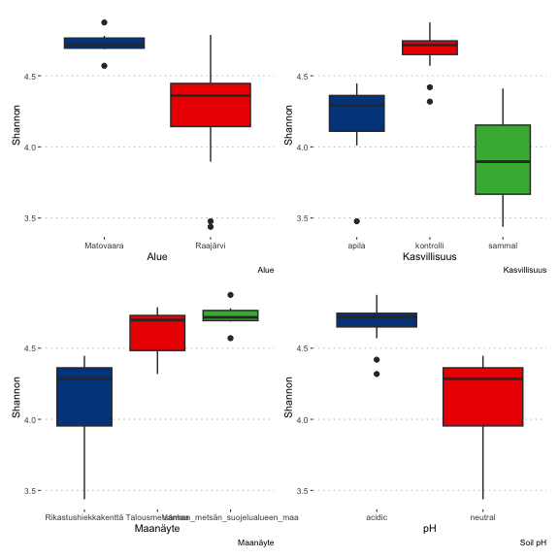

Kruskal-Wallis tests for variables

kruskal.test(Shannon ~ Kasvillisuus, data=alphadf)

Kruskal-Wallis rank sum test  
  
data: Shannon by Kasvillisuus  
Kruskal-Wallis chi-squared = 14.284, df = 2, p-value = 0.000791

kruskal.test(Shannon ~ Alue, data=alphadf)

Kruskal-Wallis rank sum test  
  
data: Shannon by Alue  
Kruskal-Wallis chi-squared = 7.0784, df = 1, p-value = 0.007802

kruskal.test(Shannon ~ Maanäyte, data=alphadf)

Kruskal-Wallis rank sum test  
  
data: Shannon by Maanäyte  
Kruskal-Wallis chi-squared = 14.502, df = 2, p-value = 0.0007094

kruskal.test(Shannon ~ pH, data=alphadf)

Kruskal-Wallis rank sum test  
  
data: Shannon by pH  
Kruskal-Wallis chi-squared = 14.095, df = 1, p-value = 0.0001738

#### Betadiversity

Bray-Curtis distances ja PCoA ordination plots

# Reload object  
tse <- readRDS("results/tse_its1.rds")  
tse <- tse[,1:23]  
tse <- transformAssay(  
 tse, assay.type = "counts", method = "relabundance")  
# Run PCoA on relabundance assay with Bray-Curtis distances  
tse <- runMDS(tse, FUN = getDissimilarity,  
 method = "bray", assay.type = "relabundance",  
 name = "MDS_bray", sample=130000)  
# Create ggplot object  
p1 <- plotReducedDim(tse, "MDS_bray", colour_by = "Kasvillisuus")  
# Calculate explained variance  
e <- attr(reducedDim(tse, "MDS_bray"), "eig")  
rel_eig <- e / sum(e[e > 0])  
p1 <- p1 + labs(  
 x = paste("PCoA 1 (", round(100 * rel_eig[[1]], 1), "%", ")", sep = ""),  
 y = paste("PCoA 2 (", round(100 * rel_eig[[2]], 1), "%", ")", sep = "")  
 ) + theme_pubclean(base_size=8)   
p1$scales$scales <- list()  
p1$layers[[1]]$aes_params$size <- 2.5  
# pH plot  
p2 <- plotReducedDim(tse, "MDS_bray", colour_by = "pH")  
# Calculate explained variance  
e <- attr(reducedDim(tse, "MDS_bray"), "eig")  
rel_eig <- e / sum(e[e > 0])  
p2 <- p2 + labs(  
 x = paste("PCoA 1 (", round(100 * rel_eig[[1]], 1), "%", ")", sep = ""),  
 y = paste("PCoA 2 (", round(100 * rel_eig[[2]], 1), "%", ")", sep = "")  
 ) + theme_pubclean(base_size=8)   
p2$scales$scales <- list()  
p2$layers[[1]]$aes_params$size <- 2.5

Plot vegetation and pH groups

p1 + scale_color_lancet() + p2 + scale_color_lancet()

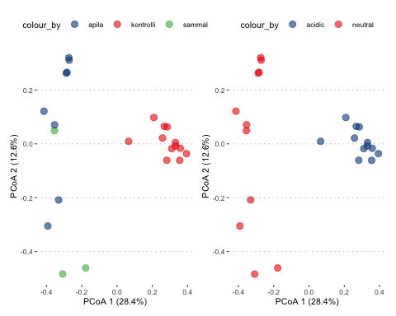

#### Dirichlet-Multinomial Mixture model

Cluster calculation

# Load the tse object  
tse <- readRDS("results/tse_its1.rds")  
tse <- tse[,1:23]  
tse <- transformAssay(tse, method="hellinger")  
# Prevalence is min. 2 samples and rank agglomerated to genus  
tse <- agglomerateByPrevalence(tse, rank="Genus", prevalence=0.05, detection=1/1000)  
# Add DMM clusters  
altExp(tse, "prevalent") <- addCluster(  
 tse,  
 assay.type = "counts",  
 name = "DMM",  
 DmmParam(k = 1:6, type = "laplace"),  
 MARGIN = "samples",  
 full = TRUE,  
 clust.col = "dmmclust")

Laplace approximation tells us optimal number of clusters in data set (2)

# Plot Laplace approximation results  
p <- plotDMNFit(altExp(tse, "prevalent"), type = "laplace", name = "DMM")  
p + theme_pubclean(base_size = 8)

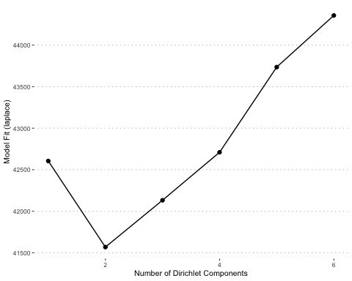

# Extract transformed data for PCA  
data <- assay(altExp(tse, "prevalent"), "hellinger")  
data <- as.matrix(data)  
# Run PCA  
pca_results <- prcomp(t(data)) # Transpose to have samples as rows  
# Extract DMM clusters from metadata  
clusters <- colData(altExp(tse, "prevalent"))$dmmclust  
# Add PCA results to a data frame and include DMM clusters  
pca_df <- as.data.frame(pca_results$x)  
pca_df$Cluster <- as.factor(clusters)  
# Plot PCA  
ggplot(pca_df, aes(x = PC1, y = PC2, color = Cluster)) +  
 geom_point(size = 2) +  
 theme_pubclean(base_size = 8) +   
 scale_color_lancet() +  
 labs(title = "PCA of Samples with DMM Clusters", color = "Cluster")

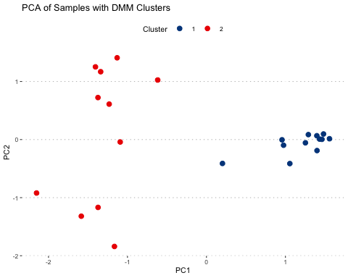

Eigen values for PCA plot

# Calculate eigenvalues and variance explained  
eigenvalues <- pca_results$sdev^2  
variance_explained <- eigenvalues / sum(eigenvalues) * 100  
cumulative_variance <- data.frame(  
 Principal_Component = paste0("PC", 1:length(variance_explained)),  
 Variance_Explained = variance_explained,  
 Cumulative_Variance = cumsum(variance_explained))  
# Display eigenvalues in a table  
kable(cumulative_variance[1:2,], digits = 2,   
 col.names = c("Principal Component", "Variance Explained (%)",  
 "Cumulative Variance (%)")) %>%  
kable_styling(latex_options = c("HOLD_position"),  
font_size = 11) %>% row_spec(0, background = "teal", color = "white")

| Principal Component | Variance Explained (%) | Cumulative Variance (%) |
| --- | --- | --- |
| PC1 | 42.74 | 42.74 |
| PC2 | 15.85 | 58.60 |

Silhoutte plot of clustered samples. Higher the values, tighter the cluster.

# Convert clusters to numeric  
numeric_clusters <- as.numeric(as.character(clusters))  
# Compute silhouette scores  
sil <- silhouette(numeric_clusters, dist(t(data)))  
# Plot silhouette  
plot(sil, main = "Silhouette Plot of DMM Clusters")

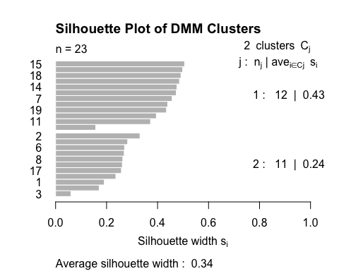

Cluster loadings - ten most important features driving samples into clusters 1 & 2

# Extract best DMM model  
best_model <- metadata(altExp(tse, "prevalent"))$DMM$dmm[2]  
# Extract cluster loadings  
drivers <- as.data.frame(best_model[[1]]@fit$Estimate)  
# Plot cluster loadings  
plotLoadings(as.matrix(drivers), ncomponents = 2) +  
 theme_pubclean(base_size = 7) +  
 scale_fill_manual(values = c("royalblue", "coral"))

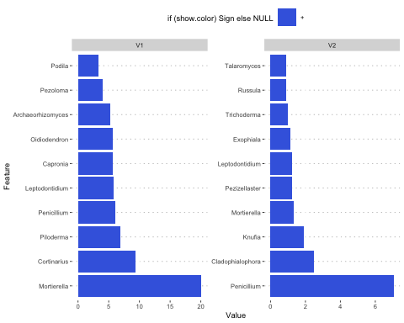

#### DAA analysis - pH variable

Prepare data

# Load tse  
tse <- readRDS("results/tse_its1.rds")  
tse <- tse[,1:23]  
# Agglomerate by genus and subset by prevalence  
tse <- subsetByPrevalent(tse, rank = "Genus", prevalence = 10/100, detection=5/1000)  
# Factor pH category  
tse$pH <- factor(tse$pH, levels = c("neutral", "acidic"))

ALDEx2 analysis

conds <- ifelse(tse$pH == "neutral", 1, 2)  
# Generate Monte Carlo samples of the Dirichlet distribution for each sample.  
x <- aldex.clr(assay(tse), conds, mc.samples = 500)  
x_tt <- aldex.ttest(x, paired.test = FALSE, verbose = FALSE)  
x_effect <- aldex.effect(x, CI = TRUE, verbose = FALSE)  
# combine outputs  
aldex_out <- data.frame(x_tt, x_effect)

Volcano plot

aldex.plot(aldex_out, type="volcano", test="welch", xlab="Difference",  
 ylab="-1(log10(q))", Main ='Volcano plot')

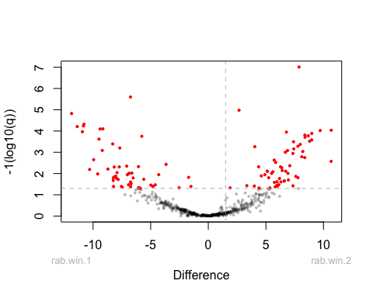

Genera with significantly different abundance

aldex_summary <- aldex_out %>%  
 rownames_to_column(var = "Genus") %>%  
 filter(wi.eBH <= 0.05) %>%  
 dplyr::select(Genus, effect, overlap, we.eBH, wi.eBH) %>%  
 arrange(desc(effect))  
# Summary table  
kable(aldex_summary, digits=2, longtable=T, booktabs=T) %>%  
 kable_styling(latex_options = c("HOLD_position", "striped", "repeat_header"),  
 font_size = 7) %>% row_spec(0, color = "white",  
 background = "teal")

| Genus | effect | overlap | we.eBH | wi.eBH |
| --- | --- | --- | --- | --- |
| Entomortierella | 3.33 | 0.00 | 0.00 | 0.00 |
| Piloderma | 3.16 | 0.00 | 0.00 | 0.00 |
| Rhizidium | 3.11 | 0.00 | 0.00 | 0.00 |
| Podila | 2.87 | 0.00 | 0.00 | 0.00 |
| Archaeorhizomyces | 2.84 | 0.00 | 0.00 | 0.00 |
| Chaetothyriales_gen_Incertae_sedis | 2.79 | 0.00 | 0.00 | 0.00 |
| Meliniomyces | 2.73 | 0.00 | 0.00 | 0.00 |
| Botryobasidium | 2.59 | 0.00 | 0.00 | 0.00 |
| Mortierella | 2.51 | 0.01 | 0.00 | 0.00 |
| Serendipitaceae_gen_Incertae_sedis | 2.51 | 0.00 | 0.00 | 0.00 |
| Hyphodiscus | 2.51 | 0.00 | 0.00 | 0.00 |
| GS21_gen_Incertae_sedis | 2.44 | 0.00 | 0.00 | 0.00 |
| Cephalothecaceae_gen_Incertae_sedis | 2.11 | 0.00 | 0.00 | 0.00 |
| Humicolopsis | 2.05 | 0.00 | 0.00 | 0.00 |
| Lecanicillium | 1.98 | 0.02 | 0.00 | 0.00 |
| Sugiyamaella | 1.87 | 0.02 | 0.00 | 0.00 |
| Pezoloma | 1.85 | 0.03 | 0.00 | 0.00 |
| Blastocladiomycota_gen_Incertae_sedis | 1.83 | 0.02 | 0.00 | 0.00 |
| Hyaloscyphaceae_gen_Incertae_sedis | 1.81 | 0.05 | 0.00 | 0.00 |
| Sclerococcum | 1.79 | 0.08 | 0.00 | 0.00 |
| Cyathicula | 1.76 | 0.00 | 0.00 | 0.00 |
| Acarosporales_gen_Incertae_sedis | 1.70 | 0.06 | 0.01 | 0.00 |
| Gloeopycnis | 1.66 | 0.03 | 0.00 | 0.00 |
| Dermateaceae_gen_Incertae_sedis | 1.65 | 0.06 | 0.01 | 0.00 |
| GS15_gen_Incertae_sedis | 1.64 | 0.05 | 0.00 | 0.00 |
| Cenococcum | 1.62 | 0.05 | 0.00 | 0.00 |
| Cortinarius | 1.61 | 0.02 | 0.00 | 0.00 |
| Leucosporidium | 1.60 | 0.03 | 0.00 | 0.00 |
| Leotiomycetes_gen_Incertae_sedis | 1.50 | 0.10 | 0.02 | 0.01 |
| Leptobacillium | 1.49 | 0.07 | 0.00 | 0.00 |
| Pseudoplectania | 1.35 | 0.09 | 0.01 | 0.00 |
| Epibryon | 1.35 | 0.05 | 0.01 | 0.00 |
| Mycena | 1.32 | 0.04 | 0.01 | 0.00 |
| Syncephalis | 1.31 | 0.06 | 0.01 | 0.00 |
| Trechispora | 1.30 | 0.06 | 0.00 | 0.00 |
| Leccinum | 1.30 | 0.07 | 0.02 | 0.00 |
| GS22_gen_Incertae_sedis | 1.29 | 0.11 | 0.02 | 0.01 |
| Occultifur | 1.29 | 0.11 | 0.01 | 0.01 |
| Phialocephala | 1.28 | 0.07 | 0.01 | 0.00 |
| Galerina | 1.22 | 0.09 | 0.01 | 0.00 |
| Tremella | 1.21 | 0.13 | 0.02 | 0.01 |
| Hymenochaetales_gen_Incertae_sedis | 1.17 | 0.12 | 0.02 | 0.01 |
| Luellia | 1.16 | 0.11 | 0.02 | 0.01 |
| Apiotrichum | 1.14 | 0.13 | 0.01 | 0.01 |
| Cenangiaceae_gen_Incertae_sedis | 1.14 | 0.12 | 0.03 | 0.02 |
| GS04_gen_Incertae_sedis | 1.13 | 0.13 | 0.04 | 0.02 |
| Thaxterogaster | 1.10 | 0.09 | 0.01 | 0.00 |
| Pochonia | 1.06 | 0.11 | 0.06 | 0.01 |
| Chloridium | 1.05 | 0.12 | 0.02 | 0.01 |
| Flagellospora | 1.05 | 0.14 | 0.04 | 0.03 |
| Acarospora | 1.03 | 0.13 | 0.02 | 0.02 |
| Clavaria | 1.03 | 0.11 | 0.03 | 0.01 |
| Myxozyma | 1.02 | 0.18 | 0.04 | 0.05 |
| Filobasidiales_gen_Incertae_sedis | 1.01 | 0.13 | 0.05 | 0.02 |
| Tolypocladium | 1.01 | 0.15 | 0.04 | 0.03 |
| Branch01_gen_Incertae_sedis | 1.00 | 0.16 | 0.04 | 0.04 |
| Scleropezicula | 0.96 | 0.15 | 0.06 | 0.03 |
| Entoloma | 0.94 | 0.13 | 0.13 | 0.01 |
| Chytridiales_gen_Incertae_sedis | 0.94 | 0.15 | 0.08 | 0.03 |
| Cystoderma | 0.93 | 0.13 | 0.05 | 0.03 |
| Genolevuria | 0.93 | 0.17 | 0.08 | 0.05 |
| Tympanidaceae_gen_Incertae_sedis | 0.93 | 0.13 | 0.05 | 0.01 |
| Pseudogymnoascus | 0.92 | 0.14 | 0.04 | 0.02 |
| Sorocybe | 0.91 | 0.14 | 0.04 | 0.03 |
| Pezicula | 0.91 | 0.13 | 0.09 | 0.01 |
| Umbelopsis | 0.90 | 0.12 | 0.05 | 0.01 |
| Fayodia | 0.89 | 0.15 | 0.10 | 0.04 |
| Pseudohyphozyma | 0.88 | 0.15 | 0.11 | 0.04 |
| Sympoventuriaceae_gen_Incertae_sedis | 0.88 | 0.15 | 0.09 | 0.04 |
| Syzygospora | 0.82 | 0.17 | 0.05 | 0.04 |
| Sordariales_gen_Incertae_sedis | -0.91 | 0.14 | 0.04 | 0.03 |
| Cyphellophoraceae_gen_Incertae_sedis | -0.97 | 0.13 | 0.05 | 0.04 |
| Mortierellales_gen_Incertae_sedis | -1.01 | 0.13 | 0.06 | 0.04 |
| Sebacinales_gen_Incertae_sedis | -1.05 | 0.11 | 0.02 | 0.02 |
| Mallocybe | -1.06 | 0.14 | 0.04 | 0.03 |
| Hamatocanthoscypha | -1.07 | 0.12 | 0.04 | 0.03 |
| Schizothecium | -1.08 | 0.14 | 0.05 | 0.04 |
| Laetinaevia | -1.09 | 0.06 | 0.02 | 0.00 |
| Mycosphaerellales_gen_Incertae_sedis | -1.09 | 0.12 | 0.03 | 0.03 |
| Vishniacozyma | -1.10 | 0.10 | 0.04 | 0.01 |
| Nothodactylaria | -1.10 | 0.13 | 0.05 | 0.03 |
| Fungi_gen_Incertae_sedis | -1.10 | 0.13 | 0.02 | 0.02 |
| Verrucoccum | -1.13 | 0.14 | 0.04 | 0.04 |
| Rhizopogon | -1.14 | 0.13 | 0.01 | 0.02 |
| Inocybe | -1.16 | 0.10 | 0.01 | 0.01 |
| Cryptococcus | -1.18 | 0.13 | 0.06 | 0.02 |
| Microdochium | -1.20 | 0.11 | 0.02 | 0.02 |
| Neonectria | -1.20 | 0.12 | 0.02 | 0.02 |
| Penicillium | -1.21 | 0.14 | 0.05 | 0.03 |
| Kurtzmanomyces | -1.22 | 0.11 | 0.02 | 0.02 |
| Oliveonia | -1.23 | 0.10 | 0.01 | 0.01 |
| Triscelophorus | -1.25 | 0.11 | 0.03 | 0.02 |
| Ceratellopsis | -1.28 | 0.09 | 0.02 | 0.01 |
| Herpotrichia | -1.29 | 0.08 | 0.01 | 0.01 |
| Geopora | -1.29 | 0.06 | 0.00 | 0.00 |
| Bionectriaceae_gen_Incertae_sedis | -1.32 | 0.09 | 0.01 | 0.01 |
| Pulvinula | -1.32 | 0.10 | 0.02 | 0.01 |
| Preussia | -1.32 | 0.06 | 0.00 | 0.00 |
| Cladophialophora | -1.35 | 0.06 | 0.00 | 0.00 |
| Psoroglaena | -1.36 | 0.09 | 0.01 | 0.01 |
| Leptodophora | -1.37 | 0.08 | 0.01 | 0.01 |
| Phomatospora | -1.40 | 0.09 | 0.01 | 0.01 |
| Cosmospora | -1.43 | 0.07 | 0.00 | 0.01 |
| Helvella | -1.44 | 0.07 | 0.01 | 0.00 |
| Plectosphaerella | -1.47 | 0.09 | 0.01 | 0.01 |
| Pseudocoleophoma | -1.64 | 0.02 | 0.00 | 0.00 |
| Lobulomycetales_gen_Incertae_sedis | -1.72 | 0.05 | 0.00 | 0.00 |
| Nectriella | -1.82 | 0.02 | 0.00 | 0.00 |
| Pleotrichocladium | -1.84 | 0.06 | 0.00 | 0.00 |
| Cladosporium | -1.87 | 0.02 | 0.00 | 0.00 |
| Talaromyces | -1.90 | 0.04 | 0.00 | 0.00 |
| Tetracladium | -2.04 | 0.01 | 0.00 | 0.00 |
| Sclerostagonospora | -2.07 | 0.03 | 0.00 | 0.00 |
| Kodamaea | -2.23 | 0.00 | 0.00 | 0.00 |
| Truncatella | -2.44 | 0.01 | 0.00 | 0.00 |
| Fusarium | -2.56 | 0.00 | 0.00 | 0.00 |
| Paraphoma | -2.85 | 0.00 | 0.00 | 0.00 |
| Exophiala | -2.98 | 0.00 | 0.00 | 0.00 |
| Pezizellaster | -3.58 | 0.00 | 0.00 | 0.00 |
| Knufia | -3.63 | 0.00 | 0.00 | 0.00 |

Effect positive, genus more abundant in acidic pH (cond2, effect group). Effect negative, genus more abundant in neutral pH (cond1, control). Scale log2.

Ancombc2 analysis

# Run ANCOM-BC at the genus level and only including the prevalent genera  
ancombc2_out <- ancombc2(  
 data = tse,  
 assay.type = "counts",  
 fix_formula = "pH",  
 p_adj_method = "fdr",  
 prv_cut = 0,  
 group = "pH",  
 struc_zero = TRUE,  
 neg_lb = TRUE,  
 global = FALSE,  
 verbose = FALSE  
 )

Genera with significantly different abundance

ancom_summary <- ancombc2_out$res %>%  
 dplyr::select(Genus = taxon, lfc = lfc_pHacidic, se = se_pHacidic, q = q_pHacidic, diff = diff_pHacidic) %>%  
 filter(diff == TRUE) %>% arrange(desc(lfc))  
# Summary table  
kable(ancom_summary, digits=2, longtable=T, booktabs=T) %>%  
 kable_styling(latex_options = c("HOLD_position", "striped", "repeat_header"),  
 font_size = 7) %>% row_spec(0, color = "white",  
 background = "teal")

| Genus | lfc | se | q | diff |
| --- | --- | --- | --- | --- |
| Archaeorhizomyces | 7.43 | 0.61 | 0.00 | TRUE |
| Meliniomyces | 6.54 | 0.55 | 0.00 | TRUE |
| Sclerococcum | 6.48 | 0.60 | 0.00 | TRUE |
| Rhizidium | 6.45 | 0.48 | 0.00 | TRUE |
| Chaetothyriales_gen_Incertae_sedis | 6.32 | 0.53 | 0.00 | TRUE |
| Piloderma | 6.21 | 0.52 | 0.00 | TRUE |
| Serendipitaceae_gen_Incertae_sedis | 5.89 | 0.54 | 0.00 | TRUE |
| Entomortierella | 5.82 | 0.36 | 0.00 | TRUE |
| Podila | 5.78 | 0.52 | 0.00 | TRUE |
| Leotiomycetes_gen_Incertae_sedis | 5.66 | 0.68 | 0.00 | TRUE |
| Cephalothecaceae_gen_Incertae_sedis | 5.60 | 0.63 | 0.00 | TRUE |
| Pezoloma | 5.45 | 0.76 | 0.00 | TRUE |
| Humicolopsis | 4.86 | 0.53 | 0.00 | TRUE |
| Pseudoplectania | 4.76 | 0.60 | 0.00 | TRUE |
| Clavaria | 4.45 | 0.80 | 0.00 | TRUE |
| Cenococcum | 4.38 | 0.72 | 0.00 | TRUE |
| Herpotrichiellaceae_gen_Incertae_sedis | 4.37 | 1.03 | 0.00 | TRUE |
| GS12_gen_Incertae_sedis | 4.30 | 0.74 | 0.00 | TRUE |
| Leucosporidium | 4.29 | 0.64 | 0.00 | TRUE |
| Cyathicula | 4.22 | 0.52 | 0.00 | TRUE |
| Nadsonia | 4.13 | 0.65 | 0.00 | TRUE |
| Tympanidaceae_gen_Incertae_sedis | 4.10 | 0.72 | 0.00 | TRUE |
| Glutinomyces | 3.99 | 0.70 | 0.00 | TRUE |
| Myxozyma | 3.91 | 1.00 | 0.00 | TRUE |
| Blastocladiomycota_gen_Incertae_sedis | 3.85 | 0.53 | 0.00 | TRUE |
| Sugiyamaella | 3.84 | 0.57 | 0.00 | TRUE |
| Tolypocladium | 3.83 | 0.81 | 0.00 | TRUE |
| Ramariopsis | 3.80 | 0.82 | 0.00 | TRUE |
| Phialocephala | 3.77 | 0.64 | 0.00 | TRUE |
| Apiotrichum | 3.73 | 0.81 | 0.00 | TRUE |
| Cortinarius | 3.71 | 0.57 | 0.00 | TRUE |
| Tylospora | 3.70 | 0.92 | 0.00 | TRUE |
| Chytridiales_gen_Incertae_sedis | 3.60 | 0.53 | 0.00 | TRUE |
| Hyaloscyphaceae_gen_Incertae_sedis | 3.52 | 0.59 | 0.00 | TRUE |
| Trechispora | 3.48 | 0.59 | 0.00 | TRUE |
| Hymenochaetales_gen_Incertae_sedis | 3.34 | 0.69 | 0.00 | TRUE |
| Mycena | 3.34 | 0.53 | 0.00 | TRUE |
| Helotiales_gen_Incertae_sedis | 3.12 | 0.91 | 0.01 | TRUE |
| Syncephalis | 3.12 | 0.50 | 0.00 | TRUE |
| Suillus | 3.02 | 0.88 | 0.01 | TRUE |
| Pyronemataceae_gen_Incertae_sedis | 2.92 | 0.94 | 0.02 | TRUE |
| Babjevia | 2.86 | 0.83 | 0.01 | TRUE |
| Mycosymbioces | 2.77 | 0.88 | 0.01 | TRUE |
| Umbelopsis | 2.74 | 0.65 | 0.00 | TRUE |
| Genolevuria | 2.65 | 0.52 | 0.00 | TRUE |
| Occultifur | 2.63 | 0.68 | 0.01 | TRUE |
| Lachnellula | 2.60 | 0.71 | 0.00 | TRUE |
| Mortierella | 2.58 | 0.38 | 0.00 | TRUE |
| Capronia | 2.29 | 0.93 | 0.05 | TRUE |
| Galerina | 2.28 | 0.47 | 0.00 | TRUE |
| Thaxterogaster | 2.27 | 0.76 | 0.02 | TRUE |
| Sistotrema | 2.21 | 0.88 | 0.05 | TRUE |
| Claussenomyces | 2.19 | 0.64 | 0.01 | TRUE |
| Oidiodendron | 2.17 | 0.66 | 0.01 | TRUE |
| Pseudogymnoascus | 2.02 | 0.49 | 0.00 | TRUE |
| Saccharomycetales_gen_Incertae_sedis | 1.97 | 0.72 | 0.03 | TRUE |
| Entoloma | 1.97 | 0.73 | 0.03 | TRUE |
| Glomeromycota_gen_Incertae_sedis | 1.96 | 0.57 | 0.01 | TRUE |
| Tyrannosorus | 1.95 | 0.69 | 0.03 | TRUE |
| Chloridium | 1.92 | 0.49 | 0.01 | TRUE |
| Epibryon | 1.92 | 0.41 | 0.00 | TRUE |
| Syzygospora | 1.73 | 0.60 | 0.03 | TRUE |
| Derxomyces | 1.68 | 0.44 | 0.02 | TRUE |
| Lachnum | 1.65 | 0.53 | 0.02 | TRUE |
| GS05_gen_Incertae_sedis | 1.48 | 0.47 | 0.04 | TRUE |
| Mollisia | 1.43 | 0.55 | 0.04 | TRUE |
| Venturia | 1.41 | 0.55 | 0.04 | TRUE |
| Melanommataceae_gen_Incertae_sedis | 1.15 | 0.35 | 0.04 | TRUE |
| Cystobasidiomycetes_gen_Incertae_sedis | -1.37 | 0.49 | 0.04 | TRUE |
| Camptobasidiaceae_gen_Incertae_sedis | -1.38 | 0.39 | 0.04 | TRUE |
| Podospora | -1.38 | 0.50 | 0.05 | TRUE |
| Drechmeria | -1.55 | 0.50 | 0.03 | TRUE |
| Kurtzmaniella | -1.69 | 0.57 | 0.03 | TRUE |
| Cladophialophora | -1.80 | 0.57 | 0.01 | TRUE |
| Pseudeurotium | -1.89 | 0.77 | 0.05 | TRUE |
| Herpotrichia | -1.92 | 0.67 | 0.03 | TRUE |
| Sporormiella | -1.96 | 0.64 | 0.02 | TRUE |
| Rhizopogon | -2.03 | 0.76 | 0.03 | TRUE |
| Laetinaevia | -2.15 | 0.68 | 0.02 | TRUE |
| Sakaguchia | -2.20 | 0.35 | 0.00 | TRUE |
| Ceratobasidium | -2.21 | 0.52 | 0.00 | TRUE |
| Mrakia | -2.24 | 0.43 | 0.00 | TRUE |
| Hormonema | -2.27 | 0.40 | 0.00 | TRUE |
| Thelephora | -2.37 | 0.91 | 0.04 | TRUE |
| Sordariales_gen_Incertae_sedis | -2.48 | 0.99 | 0.04 | TRUE |
| Phaeothecaceae_gen_Incertae_sedis | -2.49 | 0.41 | 0.01 | TRUE |
| Vishniacozyma | -2.62 | 0.64 | 0.00 | TRUE |
| Taphrina | -2.68 | 0.47 | 0.01 | TRUE |
| Sebacinales_gen_Incertae_sedis | -2.72 | 0.93 | 0.03 | TRUE |
| Preussia | -2.78 | 0.80 | 0.01 | TRUE |
| Ochroconis | -3.10 | 0.67 | 0.00 | TRUE |
| Inocybe | -3.32 | 1.02 | 0.01 | TRUE |
| Calycina | -3.42 | 0.52 | 0.00 | TRUE |
| Sclerostagonospora | -3.45 | 0.63 | 0.00 | TRUE |
| Cladosporium | -3.46 | 0.69 | 0.00 | TRUE |
| Neonectria | -3.58 | 0.53 | 0.00 | TRUE |
| Cryptococcus | -3.72 | 0.83 | 0.00 | TRUE |
| Geopora | -3.88 | 1.02 | 0.00 | TRUE |
| Exophiala | -3.93 | 0.56 | 0.00 | TRUE |
| Lecythophora | -3.96 | 0.67 | 0.00 | TRUE |
| Talaromyces | -4.14 | 0.73 | 0.00 | TRUE |
| Ceratobasidiaceae_gen_Incertae_sedis | -4.36 | 0.45 | 0.00 | TRUE |
| Fusarium | -4.61 | 0.59 | 0.00 | TRUE |
| Tetracladium | -4.62 | 0.82 | 0.00 | TRUE |
| Mallocybe | -4.82 | 0.87 | 0.00 | TRUE |
| Kodamaea | -4.91 | 0.68 | 0.00 | TRUE |
| Pezizellaster | -5.95 | 0.47 | 0.00 | TRUE |
| Knufia | -6.55 | 0.52 | 0.00 | TRUE |

In ancombc analysis control is neutral, effect is acidic. Log fold change is log2 scale.

Maaslin2 analysis

# specifying a ref is especially important if you have more than 2 levels  
maaslin2_out <- Maaslin2(  
 input_data = as.data.frame(t(assay(tse))),  
 input_metadata = as.data.frame(colData(tse)),  
 output = "ITS1",  
 transform = "AST",  
 fixed_effects = "pH",  
 reference = "pH,neutral",  
 normalization = "TSS",  
 analysis_method = "LM",  
 standardize = FALSE,  
 min_prevalence = 0)  
saveRDS(maaslin2_out, "results/its1_maaslin2.rds")

Genera with significantly different abundance

maaslin2_out <- readRDS("results/its1_maaslin2.rds")  
maaslin_summary <- maaslin2_out$results %>% dplyr::select(Genus = feature, coef, stderr, qval, N.not.zero) %>%  
 filter(qval < 0.05) %>% arrange(desc(coef))  
# Summary table  
kable(maaslin_summary, digits=2, longtable=T) %>%  
 kable_styling(latex_options = c("HOLD_position", "striped", "repeat_header"),  
 font_size = 7) %>% row_spec(0, color = "white",  
 background = "teal")

| Genus | coef | stderr | qval | N.not.zero |
| --- | --- | --- | --- | --- |
| Mortierella | 0.25 | 0.03 | 0.00 | 23 |
| Piloderma | 0.21 | 0.04 | 0.00 | 23 |
| Cortinarius | 0.20 | 0.03 | 0.00 | 23 |
| Archaeorhizomyces | 0.19 | 0.03 | 0.00 | 21 |
| Pezoloma | 0.17 | 0.03 | 0.00 | 23 |
| Sclerococcum | 0.16 | 0.03 | 0.00 | 16 |
| Podila | 0.13 | 0.02 | 0.00 | 22 |
| Meliniomyces | 0.13 | 0.02 | 0.00 | 21 |
| Leotiomycetes_gen_Incertae_sedis | 0.09 | 0.02 | 0.00 | 20 |
| Tylospora | 0.09 | 0.03 | 0.04 | 23 |
| Oidiodendron | 0.09 | 0.03 | 0.03 | 23 |
| Rhizidium | 0.08 | 0.01 | 0.00 | 20 |
| Cephalothecaceae_gen_Incertae_sedis | 0.07 | 0.02 | 0.00 | 18 |
| Chaetothyriales_gen_Incertae_sedis | 0.07 | 0.01 | 0.00 | 17 |
| Umbelopsis | 0.07 | 0.01 | 0.00 | 23 |
| Herpotrichiellaceae_gen_Incertae_sedis | 0.06 | 0.02 | 0.04 | 20 |
| Serendipitaceae_gen_Incertae_sedis | 0.06 | 0.01 | 0.00 | 19 |
| Phialocephala | 0.06 | 0.01 | 0.00 | 19 |
| Leucosporidium | 0.05 | 0.01 | 0.00 | 22 |
| Apiotrichum | 0.05 | 0.01 | 0.01 | 20 |
| Lachnellula | 0.05 | 0.01 | 0.02 | 23 |
| Cenococcum | 0.04 | 0.01 | 0.00 | 17 |
| Entomortierella | 0.04 | 0.00 | 0.00 | 17 |
| Pseudoplectania | 0.04 | 0.01 | 0.04 | 17 |
| Mycena | 0.04 | 0.01 | 0.00 | 19 |
| Humicolopsis | 0.04 | 0.01 | 0.00 | 17 |
| Glutinomyces | 0.03 | 0.01 | 0.04 | 17 |
| Sugiyamaella | 0.03 | 0.01 | 0.00 | 15 |
| Babjevia | 0.03 | 0.01 | 0.02 | 23 |
| Hyphodiscus | 0.03 | 0.01 | 0.00 | 14 |
| Syncephalis | 0.03 | 0.00 | 0.00 | 19 |
| Syzygospora | 0.03 | 0.01 | 0.02 | 18 |
| Diademospora | 0.03 | 0.01 | 0.02 | 11 |
| Tolypocladium | 0.03 | 0.01 | 0.02 | 17 |
| Branch01_gen_Incertae_sedis | 0.03 | 0.01 | 0.04 | 12 |
| Hyaloscyphaceae_gen_Incertae_sedis | 0.03 | 0.01 | 0.00 | 15 |
| GS21_gen_Incertae_sedis | 0.03 | 0.00 | 0.00 | 14 |
| Blastocladiomycota_gen_Incertae_sedis | 0.03 | 0.01 | 0.00 | 15 |
| Hymenochaetales_gen_Incertae_sedis | 0.02 | 0.01 | 0.01 | 14 |
| Trechispora | 0.02 | 0.01 | 0.01 | 21 |
| Cyathicula | 0.02 | 0.00 | 0.00 | 15 |
| Lecanicillium | 0.02 | 0.00 | 0.00 | 13 |
| Chytridiales_gen_Incertae_sedis | 0.02 | 0.00 | 0.01 | 16 |
| Botryobasidium | 0.02 | 0.00 | 0.00 | 14 |
| GS15_gen_Incertae_sedis | 0.02 | 0.00 | 0.00 | 11 |
| Luellia | 0.02 | 0.00 | 0.02 | 11 |
| Chaetosphaeria | 0.02 | 0.01 | 0.03 | 11 |
| GS22_gen_Incertae_sedis | 0.01 | 0.00 | 0.01 | 10 |
| Leptobacillium | 0.01 | 0.00 | 0.00 | 14 |
| Galerina | 0.01 | 0.00 | 0.00 | 17 |
| Cenangiaceae_gen_Incertae_sedis | 0.01 | 0.00 | 0.01 | 11 |
| Flagellospora | 0.01 | 0.00 | 0.01 | 10 |
| Acarosporales_gen_Incertae_sedis | 0.01 | 0.00 | 0.00 | 12 |
| Genolevuria | 0.01 | 0.00 | 0.02 | 13 |
| Dermateaceae_gen_Incertae_sedis | 0.01 | 0.00 | 0.00 | 11 |
| Gloeopycnis | 0.01 | 0.00 | 0.00 | 14 |
| GS04_gen_Incertae_sedis | 0.01 | 0.00 | 0.00 | 11 |
| Epibryon | 0.01 | 0.00 | 0.00 | 15 |
| Synnemapestaloides | 0.01 | 0.00 | 0.04 | 11 |
| Tremella | 0.01 | 0.00 | 0.01 | 14 |
| Siepmannia | 0.01 | 0.00 | 0.03 | 8 |
| Crocicreas | 0.01 | 0.00 | 0.04 | 12 |
| Scleropezicula | 0.01 | 0.00 | 0.01 | 11 |
| Pseudogymnoascus | 0.01 | 0.00 | 0.02 | 18 |
| Leccinum | 0.01 | 0.00 | 0.00 | 12 |
| Babjeviella | 0.01 | 0.00 | 0.01 | 12 |
| Rhodotorula | 0.01 | 0.00 | 0.03 | 10 |
| Aspicilia | 0.01 | 0.00 | 0.02 | 9 |
| Endogonomycetes_gen_Incertae_sedis | 0.01 | 0.00 | 0.03 | 7 |
| Cystoderma | 0.01 | 0.00 | 0.01 | 12 |
| Sorocybe | 0.01 | 0.00 | 0.01 | 15 |
| Fayodia | 0.01 | 0.00 | 0.01 | 9 |
| Sympoventuriaceae_gen_Incertae_sedis | 0.01 | 0.00 | 0.02 | 10 |
| Tremellomycetes_gen_Incertae_sedis | 0.01 | 0.00 | 0.04 | 8 |
| Mortierellomycetes_gen_Incertae_sedis | 0.01 | 0.00 | 0.04 | 8 |
| Pochonia | 0.01 | 0.00 | 0.00 | 10 |
| Haplographium | 0.01 | 0.00 | 0.04 | 8 |
| Flammula | 0.01 | 0.00 | 0.01 | 16 |
| Micarea | 0.01 | 0.00 | 0.04 | 7 |
| Dothiorella | 0.01 | 0.00 | 0.03 | 14 |
| Pseudohyphozyma | 0.01 | 0.00 | 0.01 | 10 |
| Microsporomycetaceae_gen_Incertae_sedis | 0.01 | 0.00 | 0.02 | 10 |
| Dermea | 0.01 | 0.00 | 0.02 | 8 |
| Ophiocordycipitaceae_gen_Incertae_sedis | 0.01 | 0.00 | 0.03 | 8 |
| Rhizosphaera | 0.00 | 0.00 | 0.01 | 10 |
| Cladoriellaceae_gen_Incertae_sedis | 0.00 | 0.00 | 0.01 | 9 |
| Endogonales_gen_Incertae_sedis | 0.00 | 0.00 | 0.04 | 8 |
| Hirsutella | 0.00 | 0.00 | 0.03 | 8 |
| Phaeotremella | 0.00 | 0.00 | 0.04 | 11 |
| Gymnopilus | 0.00 | 0.00 | 0.01 | 8 |
| Micropeltidaceae_gen_Incertae_sedis | 0.00 | 0.00 | 0.04 | 8 |
| Krasilnikovozyma | 0.00 | 0.00 | 0.02 | 8 |
| Vestigium | 0.00 | 0.00 | 0.01 | 7 |
| Dothiora | 0.00 | 0.00 | 0.01 | 10 |
| Dictyolus | 0.00 | 0.00 | 0.03 | 7 |
| Yamadamyces | 0.00 | 0.00 | 0.03 | 9 |
| Monoblepharomycota_gen_Incertae_sedis | 0.00 | 0.00 | 0.04 | 6 |
| Aphanocladium | 0.00 | 0.00 | 0.04 | 8 |
| Rhizophagus | -0.01 | 0.00 | 0.04 | 7 |
| Achroceratosphaeria | -0.01 | 0.00 | 0.04 | 5 |
| Lentitheciaceae_gen_Incertae_sedis | -0.01 | 0.00 | 0.05 | 7 |
| Nothodactylaria | -0.01 | 0.00 | 0.01 | 9 |
| Kurtzmaniella | -0.01 | 0.00 | 0.04 | 15 |
| Sporormiaceae_gen_Incertae_sedis | -0.01 | 0.00 | 0.05 | 6 |
| Triscelophorus | -0.01 | 0.00 | 0.00 | 9 |
| Schizothecium | -0.01 | 0.00 | 0.02 | 10 |
| Ceratellopsis | -0.01 | 0.00 | 0.01 | 10 |
| Septoria | -0.01 | 0.00 | 0.05 | 9 |
| Verrucoccum | -0.01 | 0.00 | 0.01 | 8 |
| Lobulomycetales_gen_Incertae_sedis | -0.01 | 0.00 | 0.00 | 11 |
| Herpotrichia | -0.01 | 0.00 | 0.03 | 13 |
| Hamatocanthoscypha | -0.02 | 0.01 | 0.04 | 9 |
| Mycosphaerellales_gen_Incertae_sedis | -0.02 | 0.01 | 0.03 | 9 |
| Cosmospora | -0.02 | 0.00 | 0.00 | 12 |
| Phomatospora | -0.02 | 0.01 | 0.02 | 10 |
| Oliveonia | -0.02 | 0.01 | 0.03 | 12 |
| Entimomentora | -0.02 | 0.01 | 0.03 | 10 |
| Ceratobasidium | -0.02 | 0.01 | 0.02 | 18 |
| Kurtzmanomyces | -0.02 | 0.01 | 0.04 | 10 |
| Pulvinula | -0.02 | 0.01 | 0.01 | 11 |
| Bionectriaceae_gen_Incertae_sedis | -0.02 | 0.01 | 0.02 | 11 |
| Truncatella | -0.03 | 0.01 | 0.00 | 12 |
| Pseudocoleophoma | -0.03 | 0.01 | 0.00 | 12 |
| Helvella | -0.03 | 0.01 | 0.02 | 12 |
| Sclerostagonospora | -0.03 | 0.01 | 0.01 | 16 |
| Neonectria | -0.03 | 0.01 | 0.01 | 14 |
| Pleotrichocladium | -0.03 | 0.01 | 0.00 | 12 |
| Plectosphaerella | -0.04 | 0.01 | 0.02 | 11 |
| Lecythophora | -0.04 | 0.01 | 0.03 | 14 |
| Preussia | -0.04 | 0.01 | 0.03 | 21 |
| Paraphoma | -0.04 | 0.01 | 0.00 | 12 |
| Thelephora | -0.04 | 0.02 | 0.04 | 23 |
| Leptodophora | -0.05 | 0.01 | 0.00 | 12 |
| Rhizopogon | -0.06 | 0.02 | 0.02 | 23 |
| Fusarium | -0.07 | 0.02 | 0.01 | 15 |
| Kodamaea | -0.08 | 0.02 | 0.01 | 19 |
| Tetracladium | -0.08 | 0.02 | 0.01 | 15 |
| Cladosporium | -0.08 | 0.03 | 0.04 | 23 |
| Talaromyces | -0.09 | 0.02 | 0.00 | 21 |
| Cryptococcus | -0.10 | 0.04 | 0.04 | 22 |
| Exophiala | -0.10 | 0.02 | 0.00 | 23 |
| Pezizellaster | -0.11 | 0.01 | 0.00 | 18 |
| Cladophialophora | -0.15 | 0.04 | 0.01 | 23 |
| Knufia | -0.16 | 0.02 | 0.00 | 19 |
| Penicillium | -0.17 | 0.04 | 0.01 | 23 |

In maaslin2 analysis, control is neutral, effect is acidic. Changes are calculated with formula log(q)*sign(coeff)

DAA analysis summary table

summary <- aldex_summary %>% dplyr::select(Genus)  
summary$Aldex2 <- TRUE   
summary <- dplyr::full_join(summary, ancom_summary, by="Genus")  
summary <- summary %>% dplyr::select(Genus, Aldex2, Ancombc = diff)  
summary <- dplyr::full_join(summary, maaslin_summary, by="Genus")  
summary <- summary %>% mutate(Maaslin2=ifelse(is.na(summary$coef) , FALSE, TRUE))  
summary <- summary %>% dplyr::select(Genus, Aldex2, Ancombc, Maaslin2)  
summary[is.na(summary)] <- FALSE

Comparison of DAA analysis results

# Summary table  
kable(summary, digits=2, longtable=T, booktabs=T) %>%  
 kable_styling(latex_options = c("HOLD_position", "striped", "repeat_header"),  
 font_size = 7) %>% row_spec(0, color = "white",  
 background = "teal")

| Genus | Aldex2 | Ancombc | Maaslin2 |
| --- | --- | --- | --- |
| Entomortierella | TRUE | TRUE | TRUE |
| Piloderma | TRUE | TRUE | TRUE |
| Rhizidium | TRUE | TRUE | TRUE |
| Podila | TRUE | TRUE | TRUE |
| Archaeorhizomyces | TRUE | TRUE | TRUE |
| Chaetothyriales_gen_Incertae_sedis | TRUE | TRUE | TRUE |
| Meliniomyces | TRUE | TRUE | TRUE |
| Botryobasidium | TRUE | FALSE | TRUE |
| Mortierella | TRUE | TRUE | TRUE |
| Serendipitaceae_gen_Incertae_sedis | TRUE | TRUE | TRUE |
| Hyphodiscus | TRUE | FALSE | TRUE |
| GS21_gen_Incertae_sedis | TRUE | FALSE | TRUE |
| Cephalothecaceae_gen_Incertae_sedis | TRUE | TRUE | TRUE |
| Humicolopsis | TRUE | TRUE | TRUE |
| Lecanicillium | TRUE | FALSE | TRUE |
| Sugiyamaella | TRUE | TRUE | TRUE |
| Pezoloma | TRUE | TRUE | TRUE |
| Blastocladiomycota_gen_Incertae_sedis | TRUE | TRUE | TRUE |
| Hyaloscyphaceae_gen_Incertae_sedis | TRUE | TRUE | TRUE |
| Sclerococcum | TRUE | TRUE | TRUE |
| Cyathicula | TRUE | TRUE | TRUE |
| Acarosporales_gen_Incertae_sedis | TRUE | FALSE | TRUE |
| Gloeopycnis | TRUE | FALSE | TRUE |
| Dermateaceae_gen_Incertae_sedis | TRUE | FALSE | TRUE |
| GS15_gen_Incertae_sedis | TRUE | FALSE | TRUE |
| Cenococcum | TRUE | TRUE | TRUE |
| Cortinarius | TRUE | TRUE | TRUE |
| Leucosporidium | TRUE | TRUE | TRUE |
| Leotiomycetes_gen_Incertae_sedis | TRUE | TRUE | TRUE |
| Leptobacillium | TRUE | FALSE | TRUE |
| Pseudoplectania | TRUE | TRUE | TRUE |
| Epibryon | TRUE | TRUE | TRUE |
| Mycena | TRUE | TRUE | TRUE |
| Syncephalis | TRUE | TRUE | TRUE |
| Trechispora | TRUE | TRUE | TRUE |
| Leccinum | TRUE | FALSE | TRUE |
| GS22_gen_Incertae_sedis | TRUE | FALSE | TRUE |
| Occultifur | TRUE | TRUE | FALSE |
| Phialocephala | TRUE | TRUE | TRUE |
| Galerina | TRUE | TRUE | TRUE |
| Tremella | TRUE | FALSE | TRUE |
| Hymenochaetales_gen_Incertae_sedis | TRUE | TRUE | TRUE |
| Luellia | TRUE | FALSE | TRUE |
| Apiotrichum | TRUE | TRUE | TRUE |
| Cenangiaceae_gen_Incertae_sedis | TRUE | FALSE | TRUE |
| GS04_gen_Incertae_sedis | TRUE | FALSE | TRUE |
| Thaxterogaster | TRUE | TRUE | FALSE |
| Pochonia | TRUE | FALSE | TRUE |
| Chloridium | TRUE | TRUE | FALSE |
| Flagellospora | TRUE | FALSE | TRUE |
| Acarospora | TRUE | FALSE | FALSE |
| Clavaria | TRUE | TRUE | FALSE |
| Myxozyma | TRUE | TRUE | FALSE |
| Filobasidiales_gen_Incertae_sedis | TRUE | FALSE | FALSE |
| Tolypocladium | TRUE | TRUE | TRUE |
| Branch01_gen_Incertae_sedis | TRUE | FALSE | TRUE |
| Scleropezicula | TRUE | FALSE | TRUE |
| Entoloma | TRUE | TRUE | FALSE |
| Chytridiales_gen_Incertae_sedis | TRUE | TRUE | TRUE |
| Cystoderma | TRUE | FALSE | TRUE |
| Genolevuria | TRUE | TRUE | TRUE |
| Tympanidaceae_gen_Incertae_sedis | TRUE | TRUE | FALSE |
| Pseudogymnoascus | TRUE | TRUE | TRUE |
| Sorocybe | TRUE | FALSE | TRUE |
| Pezicula | TRUE | FALSE | FALSE |
| Umbelopsis | TRUE | TRUE | TRUE |
| Fayodia | TRUE | FALSE | TRUE |
| Pseudohyphozyma | TRUE | FALSE | TRUE |
| Sympoventuriaceae_gen_Incertae_sedis | TRUE | FALSE | TRUE |
| Syzygospora | TRUE | TRUE | TRUE |
| Sordariales_gen_Incertae_sedis | TRUE | TRUE | FALSE |
| Cyphellophoraceae_gen_Incertae_sedis | TRUE | FALSE | FALSE |
| Mortierellales_gen_Incertae_sedis | TRUE | FALSE | FALSE |
| Sebacinales_gen_Incertae_sedis | TRUE | TRUE | FALSE |
| Mallocybe | TRUE | TRUE | FALSE |
| Hamatocanthoscypha | TRUE | FALSE | TRUE |
| Schizothecium | TRUE | FALSE | TRUE |
| Laetinaevia | TRUE | TRUE | FALSE |
| Mycosphaerellales_gen_Incertae_sedis | TRUE | FALSE | TRUE |
| Vishniacozyma | TRUE | TRUE | FALSE |
| Nothodactylaria | TRUE | FALSE | TRUE |
| Fungi_gen_Incertae_sedis | TRUE | FALSE | FALSE |
| Verrucoccum | TRUE | FALSE | TRUE |
| Rhizopogon | TRUE | TRUE | TRUE |
| Inocybe | TRUE | TRUE | FALSE |
| Cryptococcus | TRUE | TRUE | TRUE |
| Microdochium | TRUE | FALSE | FALSE |
| Neonectria | TRUE | TRUE | TRUE |
| Penicillium | TRUE | FALSE | TRUE |
| Kurtzmanomyces | TRUE | FALSE | TRUE |
| Oliveonia | TRUE | FALSE | TRUE |
| Triscelophorus | TRUE | FALSE | TRUE |
| Ceratellopsis | TRUE | FALSE | TRUE |
| Herpotrichia | TRUE | TRUE | TRUE |
| Geopora | TRUE | TRUE | FALSE |
| Bionectriaceae_gen_Incertae_sedis | TRUE | FALSE | TRUE |
| Pulvinula | TRUE | FALSE | TRUE |
| Preussia | TRUE | TRUE | TRUE |
| Cladophialophora | TRUE | TRUE | TRUE |
| Psoroglaena | TRUE | FALSE | FALSE |
| Leptodophora | TRUE | FALSE | TRUE |
| Phomatospora | TRUE | FALSE | TRUE |
| Cosmospora | TRUE | FALSE | TRUE |
| Helvella | TRUE | FALSE | TRUE |
| Plectosphaerella | TRUE | FALSE | TRUE |
| Pseudocoleophoma | TRUE | FALSE | TRUE |
| Lobulomycetales_gen_Incertae_sedis | TRUE | FALSE | TRUE |
| Nectriella | TRUE | FALSE | FALSE |
| Pleotrichocladium | TRUE | FALSE | TRUE |
| Cladosporium | TRUE | TRUE | TRUE |
| Talaromyces | TRUE | TRUE | TRUE |
| Tetracladium | TRUE | TRUE | TRUE |
| Sclerostagonospora | TRUE | TRUE | TRUE |
| Kodamaea | TRUE | TRUE | TRUE |
| Truncatella | TRUE | FALSE | TRUE |
| Fusarium | TRUE | TRUE | TRUE |
| Paraphoma | TRUE | FALSE | TRUE |
| Exophiala | TRUE | TRUE | TRUE |
| Pezizellaster | TRUE | TRUE | TRUE |
| Knufia | TRUE | TRUE | TRUE |
| Herpotrichiellaceae_gen_Incertae_sedis | FALSE | TRUE | TRUE |
| GS12_gen_Incertae_sedis | FALSE | TRUE | FALSE |
| Nadsonia | FALSE | TRUE | FALSE |
| Glutinomyces | FALSE | TRUE | TRUE |
| Ramariopsis | FALSE | TRUE | FALSE |
| Tylospora | FALSE | TRUE | TRUE |
| Helotiales_gen_Incertae_sedis | FALSE | TRUE | FALSE |
| Suillus | FALSE | TRUE | FALSE |
| Pyronemataceae_gen_Incertae_sedis | FALSE | TRUE | FALSE |
| Babjevia | FALSE | TRUE | TRUE |
| Mycosymbioces | FALSE | TRUE | FALSE |
| Lachnellula | FALSE | TRUE | TRUE |
| Capronia | FALSE | TRUE | FALSE |
| Sistotrema | FALSE | TRUE | FALSE |
| Claussenomyces | FALSE | TRUE | FALSE |
| Oidiodendron | FALSE | TRUE | TRUE |
| Saccharomycetales_gen_Incertae_sedis | FALSE | TRUE | FALSE |
| Glomeromycota_gen_Incertae_sedis | FALSE | TRUE | FALSE |
| Tyrannosorus | FALSE | TRUE | FALSE |
| Derxomyces | FALSE | TRUE | FALSE |
| Lachnum | FALSE | TRUE | FALSE |
| GS05_gen_Incertae_sedis | FALSE | TRUE | FALSE |
| Mollisia | FALSE | TRUE | FALSE |
| Venturia | FALSE | TRUE | FALSE |
| Melanommataceae_gen_Incertae_sedis | FALSE | TRUE | FALSE |
| Cystobasidiomycetes_gen_Incertae_sedis | FALSE | TRUE | FALSE |
| Camptobasidiaceae_gen_Incertae_sedis | FALSE | TRUE | FALSE |
| Podospora | FALSE | TRUE | FALSE |
| Drechmeria | FALSE | TRUE | FALSE |
| Kurtzmaniella | FALSE | TRUE | TRUE |
| Pseudeurotium | FALSE | TRUE | FALSE |
| Sporormiella | FALSE | TRUE | FALSE |
| Sakaguchia | FALSE | TRUE | FALSE |
| Ceratobasidium | FALSE | TRUE | TRUE |
| Mrakia | FALSE | TRUE | FALSE |
| Hormonema | FALSE | TRUE | FALSE |
| Thelephora | FALSE | TRUE | TRUE |
| Phaeothecaceae_gen_Incertae_sedis | FALSE | TRUE | FALSE |
| Taphrina | FALSE | TRUE | FALSE |
| Ochroconis | FALSE | TRUE | FALSE |
| Calycina | FALSE | TRUE | FALSE |
| Lecythophora | FALSE | TRUE | TRUE |
| Ceratobasidiaceae_gen_Incertae_sedis | FALSE | TRUE | FALSE |
| Diademospora | FALSE | FALSE | TRUE |
| Chaetosphaeria | FALSE | FALSE | TRUE |
| Synnemapestaloides | FALSE | FALSE | TRUE |
| Siepmannia | FALSE | FALSE | TRUE |
| Crocicreas | FALSE | FALSE | TRUE |
| Babjeviella | FALSE | FALSE | TRUE |
| Rhodotorula | FALSE | FALSE | TRUE |
| Aspicilia | FALSE | FALSE | TRUE |
| Endogonomycetes_gen_Incertae_sedis | FALSE | FALSE | TRUE |
| Tremellomycetes_gen_Incertae_sedis | FALSE | FALSE | TRUE |
| Mortierellomycetes_gen_Incertae_sedis | FALSE | FALSE | TRUE |
| Haplographium | FALSE | FALSE | TRUE |
| Flammula | FALSE | FALSE | TRUE |
| Micarea | FALSE | FALSE | TRUE |
| Dothiorella | FALSE | FALSE | TRUE |
| Microsporomycetaceae_gen_Incertae_sedis | FALSE | FALSE | TRUE |
| Dermea | FALSE | FALSE | TRUE |
| Ophiocordycipitaceae_gen_Incertae_sedis | FALSE | FALSE | TRUE |
| Rhizosphaera | FALSE | FALSE | TRUE |
| Cladoriellaceae_gen_Incertae_sedis | FALSE | FALSE | TRUE |
| Endogonales_gen_Incertae_sedis | FALSE | FALSE | TRUE |
| Hirsutella | FALSE | FALSE | TRUE |
| Phaeotremella | FALSE | FALSE | TRUE |
| Gymnopilus | FALSE | FALSE | TRUE |
| Micropeltidaceae_gen_Incertae_sedis | FALSE | FALSE | TRUE |
| Krasilnikovozyma | FALSE | FALSE | TRUE |
| Vestigium | FALSE | FALSE | TRUE |
| Dothiora | FALSE | FALSE | TRUE |
| Dictyolus | FALSE | FALSE | TRUE |
| Yamadamyces | FALSE | FALSE | TRUE |
| Monoblepharomycota_gen_Incertae_sedis | FALSE | FALSE | TRUE |
| Aphanocladium | FALSE | FALSE | TRUE |
| Rhizophagus | FALSE | FALSE | TRUE |
| Achroceratosphaeria | FALSE | FALSE | TRUE |
| Lentitheciaceae_gen_Incertae_sedis | FALSE | FALSE | TRUE |
| Sporormiaceae_gen_Incertae_sedis | FALSE | FALSE | TRUE |
| Septoria | FALSE | FALSE | TRUE |
| Entimomentora | FALSE | FALSE | TRUE |