De-novo clustering of nanopore reads

Marko Suokas

#### Preprocess reads

Dorado does not support demultiplexing dual indexes located on both the 5’ and 3’ ends. Additionally, in ligated libraries, the reads can appear in either orientation. To address this, we use cutadapt for demultiplexing. Index pairs are identified using the linked adapters approach in both forward and reverse orientations, after which scripts are applied to reverse complement the reverse reads. Finally, the reads are merged.

**Note:** Be aware that autocorrect might change double dashes in command-line examples.

#### Extracting Forward Reads

You can extract forward reads into a FASTQ file using the following command:

cutadapt -e 0 -O 12 -g file:~/scripts/barcodes.fasta --trimmed-only \  
-m 1200 -o "fdemuxed/{name}.fastq.gz" reads.fastq.gz

This command extracts barcodes defined in the barcodes.fasta file and outputs matching reads into individual files within the fdemuxed subdirectory. In this example, the minimum read length is set to 1200 bp.

#### Extracting Reverse Reads

To extract reverse reads, use the reverse-complemented barcode file:

cutadapt -e 0 -O 12 -g file:~/scripts/rev_barcodes.fasta \  
--trimmed-only -m 1200 -o "rdemuxed/{name}.fastq.gz" \  
reads.fastq.gz

The reads are demultiplexed into a separate directory.

**Tip:** Parameters -O, -e, -m, and -M can help reduce the chances of mismatched alignments.

#### Reverse Complementing Reverse Reads

Next, we use a bash script to process each reverse read file and reverse complement them using the following command:

seqkit seq -rp --seq-type DNA -o reverse_comp.fastq.gz \  
reverse_out.fastq.gz

#### Merging Forward and Reverse Reads

Next, forward and reverse reads with the same base name are merged from two directories. Here’s a simple bash command for that:

cat forward_out.fastq.gz reverse_comp.fastq.gz >merged_reads.fastq.gz

#### Trimming Primers

Finally, cutadapt and bash script can be employed to trim forward and reverse PCR primers from the sequence reads.

#### Import sequence data to Qiime 2

#Activate qiime environment  
source /opt/miniconda3/etc/profile.d/conda.sh  
conda activate qiime2-2024.2  
# QIIME 2 command to import sequence data  
qiime tools import \  
 --type 'SampleData[SequencesWithQuality]' \  
 --input-path data/reads/set2/manifest.csv \  
 --output-path data/demux.qza \  
 --input-format SingleEndFastqManifestPhred33

#### Dereplicate sequences

Dereplication removes unnecessary redundancy from sequence files

source /opt/miniconda3/etc/profile.d/conda.sh  
conda activate qiime2-2024.2  
# Dereplicate sequences with vsearch plugin  
qiime vsearch dereplicate-sequences \  
 --p-min-seq-length 1200 \  
 --o-dereplicated-table data/derep_table.qza \  
 --o-dereplicated-sequences data/derep_sequences.qza \  
 --i-sequences data/demux.qza

#### Pick de-novo features

Step executed at CSC.

#!/bin/bash  
#SBATCH --job-name=cluster  
#SBATCH --account=project_2010620  
#SBATCH --time=48:00:00  
#SBATCH --nodes=1  
#SBATCH --ntasks=1  
#SBATCH --cpus-per-task=32  
#SBATCH --mem=48G  
#SBATCH --partition=small  
#SBATCH --gres=nvme:100  
  
#set up qiime  
module load qiime2/2024.2-amplicon  
# run task. Don't use srun in submission as it resets TMPDIR  
qiime vsearch cluster-features-de-novo \  
 --i-sequences data/derep_sequences.qza \  
 --i-table data/derep_table.qza \  
 --p-strand plus --p-threads 32 --p-perc-identity 0.97 \  
 --output-dir data/de_novo

#### Filter rare features

Rare otus are removed from results before chimera detection

#Activate qiime environment  
source /opt/miniconda3/etc/profile.d/conda.sh  
conda activate qiime2-2024.2  
# QIIME 2 command to filter rare features  
qiime feature-table filter-features \  
 --i-table data/de_novo/clustered_table.qza \  
 --p-min-frequency 10 \  
 --o-filtered-table data/de_novo/f1_table.qza  
qiime feature-table filter-seqs \  
 --i-data data/de_novo/clustered_sequences.qza \  
 --i-table data/de_novo/f1_table.qza \  
 --o-filtered-data data/de_novo/f1_sequences.qza

#### Detect chimeric features

#Activate qiime environment  
source /opt/miniconda3/etc/profile.d/conda.sh  
conda activate qiime2-2024.2  
  
qiime vsearch uchime-denovo --i-sequences data/de_novo/f1_sequences.qza \  
 --i-table data/de_novo/f1_table.qza \  
 --o-chimeras data/de_novo/chimeras.qza --o-stats data/de_novo/stats.qza \  
 --o-nonchimeras data/de_novo/nonchimeras.qza

#### Filter chimeras from the table file

#Activate qiime environment  
source /opt/miniconda3/etc/profile.d/conda.sh  
conda activate qiime2-2024.2  
# QIIME 2 command to keep nonchimeric features  
 qiime feature-table filter-features \  
 --i-table data/de_novo/f1_table.qza \  
 --m-metadata-file data/de_novo/nonchimeras.qza \  
 --o-filtered-table data/de_novo/otu_table.qza

#### Filter chimeras from the sequence file

#Activate qiime environment  
source /opt/miniconda3/etc/profile.d/conda.sh  
conda activate qiime2-2024.2  
# QIIME 2 command to keep nonchimeric sequences  
qiime feature-table filter-seqs \  
 --i-data data/de_novo/f1_sequences.qza \  
 --i-table data/de_novo/otu_table.qza \  
 --o-filtered-data data/de_novo/otu_sequences.qza

#### R libraries

library(dada2)  
library(mia)  
library(scater)  
library(vegan)  
library(Biostrings)  
library(tidyverse)  
library(kableExtra)  
library(ggthemes)  
library(ggpubr)

Import qiime otu table and project metadata

#sequence file  
tse <- importQIIME2(featureTableFile = "data/de_novo/otu_table.qza")  
tse <- tse[, sort(colnames(tse))]  
#add metadata  
metadata <- data.frame(read_tsv("data/set2_meta.tsv",  
 show_col_types = F))  
metadata <- column_to_rownames(metadata, "Sampleid")  
colData(tse) <- DataFrame(metadata)  
tse

class: TreeSummarizedExperiment   
dim: 1469 6   
metadata(0):  
assays(1): counts  
rownames(1469): 780015658d5994b3e7649355028cdb0ede4aa40e  
 92901274c2b00cc23f7a06885764bc41e8da85ec ...  
 0ba42ae60d68d1bea239c158de0013e7e169b879  
 586e676bc2eba711e9befb7156796a22819d5f91  
rowData names(0):  
colnames(6): barcode007 barcode008 ... barcode011 barcode012  
colData names(2): Name Media  
reducedDimNames(0):  
mainExpName: NULL  
altExpNames(0):  
rowLinks: NULL  
rowTree: NULL  
colLinks: NULL  
colTree: NULL

Qiime arranges sequence file alphabetically, while TSE expects sequences in same order as rownames. Thus we need to rearrange sequences

ref_sequences <- importQZA("data/de_novo/otu_sequences.qza")  
ref_ids <- names(ref_sequences)  
tse_ids <- rownames(tse)  
# Check if all rownames are present in the reference IDs  
if (!all(tse_ids %in% ref_ids)) {  
 stop("Not all rownames from tse are present in the reference sequences.")  
}  
# Reorder `ref_sequences` to match the order of `tse` rownames  
ref_sequences_ordered <- ref_sequences[match(tse_ids, ref_ids)]  
all(names(ref_sequences_ordered) == rownames(tse))

[1] TRUE

referenceSeq(tse) <- ref_sequences_ordered

#### Assign taxonomy

taxa <- assignTaxonomy(referenceSeq(tse), minBoot=90, multithread=2,  
 refFasta="~/feature_classifiers/silva_nr99_v138.1_train_set.fa.gz")  
saveRDS(taxa, "data/de_novo/taxa.rds" )

Add taxonomy results to rowData and rename identifiers

taxa <- readRDS("data/de_novo/taxa.rds")  
#Add taxonomy  
rownames(taxa) <- NULL  
rowData(tse) <- DataFrame(taxa)  
#Rename rows (alternative to Silva ID)  
rownames(tse) <- paste0("OTU_", seq_len(nrow(tse)))  
tse

class: TreeSummarizedExperiment   
dim: 1469 6   
metadata(0):  
assays(1): counts  
rownames(1469): OTU_1 OTU_2 ... OTU_1468 OTU_1469  
rowData names(6): Kingdom Phylum ... Family Genus  
colnames(6): barcode007 barcode008 ... barcode011 barcode012  
colData names(2): Name Media  
reducedDimNames(0):  
mainExpName: NULL  
altExpNames(0):  
rowLinks: NULL  
rowTree: NULL  
colLinks: NULL  
colTree: NULL  
referenceSeq: a DNAStringSet (1469 sequences)

#### Write object data to files

Write RDS. The object can be easily reloaded in R

saveRDS(tse, "results/denovo/tse.rds")

Write an abundance table

#FeatureID will be rowname  
abd <- data.frame(FeatureID = rownames(tse),assays(tse)$counts)  
#Write  
write_tsv(abd, "results/denovo/feature_table.tsv")

Write a taxonomy table

#FeatureID will be rowname  
taxt <- data.frame(FeatureID = rownames(tse), rowData(tse))  
#Write  
write_tsv(taxt, "results/denovo/taxonomy.tsv")

Write variant sequences to fasta file

writeXStringSet(referenceSeq(tse), "results/denovo/repseq.fasta",  
 append = F, compress = F,  
 format = "fasta")

Write a metadata file

metadf <- data.frame(colData(tse)) %>% rownames_to_column(var="Sampleid")  
#write  
write_tsv(metadf, "results/denovo/metadata.tsv")

#### Microbial data analysis

Agglomerate taxonomy to genus rank and count relative abundance

altExp(tse, "Genus") <- agglomerateByRank(tse, rank="Genus",  
 onRankOnly=T, na.rm=F)  
#relabundance  
altExp(tse, "Genus") <- transformAssay(altExp(tse, "Genus"),  
 assay.type="counts",  
 method="relabundance")

Pick ten most abundant features

#top10 features  
top10 <- getTopFeatures(altExp(tse, "Genus"), top=10,  
 method = "mean",  
 assay.type="relabundance")  
#create and filter table  
table <- data.frame(assays(altExp(tse, "Genus"))$relabundance)  
table <- table %>%  
 rownames_to_column(var = "Genus") %>%   
 filter(Genus %in% top10) %>% bind_rows(  
 summarise(., Genus = "Others", across(where(is.numeric), ~ 1 - sum(.))))

Print abundance table

kable(table, digits=2) %>%   
 kable_styling(latex_options = c("HOLD_position", "striped"),  
 font_size = 10) %>%  
 row_spec(0, background = "teal", color = "white")

| Genus | barcode007 | barcode008 | barcode009 | barcode010 | barcode011 | barcode012 |
| --- | --- | --- | --- | --- | --- | --- |
| Acidocella | 0.12 | 0.00 | 0.00 | 0.53 | 0.00 | 0.00 |
| Microbacter | 0.00 | 0.13 | 0.00 | 0.25 | 0.14 | 0.00 |
| Acidithiobacillus | 0.08 | 0.05 | 0.06 | 0.04 | 0.03 | 0.05 |
| Fonticella | 0.12 | 0.00 | 0.00 | 0.00 | 0.15 | 0.00 |
| Thiomonas | 0.00 | 0.00 | 0.00 | 0.00 | 0.19 | 0.10 |
| Pelosinus | 0.19 | 0.23 | 0.31 | 0.00 | 0.00 | 0.10 |
| Desulfosporosinus | 0.41 | 0.40 | 0.15 | 0.19 | 0.35 | 0.49 |
| Lachnoclostridium | 0.00 | 0.00 | 0.25 | 0.00 | 0.00 | 0.14 |
| Anaerovorax | 0.03 | 0.04 | 0.00 | 0.00 | 0.03 | 0.01 |
| Anaerosinus | 0.00 | 0.11 | 0.00 | 0.00 | 0.00 | 0.00 |
| Others | 0.07 | 0.04 | 0.23 | 0.01 | 0.10 | 0.11 |

#### Composition plot

Transform data to long table format

df_long <- table %>% pivot_longer(cols = starts_with("barcode"),  
names_to = "Sample", values_to = "Abundance")  
#Plot stacked barplot  
ggplot(df_long, aes(x=Sample, y=Abundance, fill=Genus)) +  
geom_bar(stat = "identity") +  
 theme_fivethirtyeight(base_size=8) +  
 scale_fill_brewer(palette = "Spectral") +  
 theme(axis.text.x=element_text(angle=90))

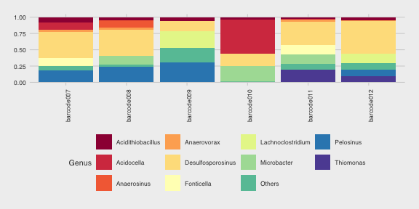

#### Rarefaction

Prior diverisity calculations, we rarefy data to minimize the effect of varying sample sizes.

totalcounts <- colSums(assays(tse)$counts)  
totalcounts

barcode007 barcode008 barcode009 barcode010 barcode011 barcode012   
 345406 212800 361049 367188 320530 273280

set.seed(456)  
tse <- subsampleCounts(tse, name="subsampled", assay.type = "counts",  
 min_size = 210000)

#### Alpha diversity

tse <- estimateDiversity(tse, assay.type="counts", index="shannon")  
shannon <- data.frame(Samples = colnames(tse),  
 Shannon_index = colData(tse)$shannon)  
rownames(shannon) <- NULL  
#colnames(shannon) <- c("Sample", "Shannon index")  
#table  
kable(shannon, digits=2, caption = "Shannon index") %>%  
kable_styling(latex_options = c("HOLD_position", "striped"),  
 font_size = 11) %>% row_spec(0, background = "teal",  
 color = "white")

Shannon index

| Samples | Shannon_index |
| --- | --- |
| barcode007 | 3.46 |
| barcode008 | 3.46 |
| barcode009 | 2.40 |
| barcode010 | 1.71 |
| barcode011 | 2.80 |
| barcode012 | 2.57 |

Shannon boxplot between two media groups

comparisons <- list(c("Media1", "Media2"))  
media <- ggplot(colData(tse), aes(x=Media, y=shannon, fill=Media)) +  
 geom_boxplot(ylim=c(0,4)) + stat_compare_means(comparisons = comparisons,  
 method = "wilcox.test",  
 label = "p.format") +  
 theme_fivethirtyeight( base_size=8) + scale_fill_fivethirtyeight() +   
 ylim(1, 4)  
media

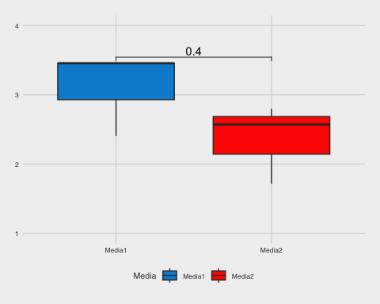

#### Beta diversity measured by Bray-Curtis dissimilarity

PCoA plot illustrating community composition differences using Bray-Curtis dissimilarity distances

tse <- runMDS(tse, FUN = vegan::vegdist, method = "bray",  
 name="PCoA_BC", exprs_values = "subsampled")  
#Explained variance  
e <- attr(reducedDim(tse, "PCoA_BC"), "eig")  
rel_eig <- e / sum(e[e > 0])  
#Plot  
plotReducedDim(tse, "PCoA_BC", colour_by = "Media",  
 text_by = "Name", text_size = 4) +  
 labs(x = paste("PCoA 1 (", round(100 * rel_eig[[1]], 1),  
 "%", ")", sep = ""), y = paste("PCoA 2 (",  
 round(100 * rel_eig[[2]], 1),   
 "%", ")", sep = ""))

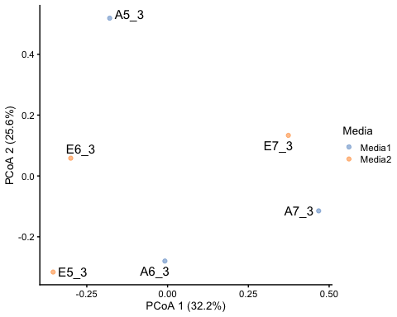

NMDS plot illustrating community composition differences using Bray-Curtis dissimilarity distances

data <- t(assay(tse, "counts"))  
bray_curtis <- vegdist(data, method = "bray")  
nmds <- metaMDS(bray_curtis, k = 2, trymax = 100, trace=0)  
nmds_coords <- as.data.frame(scores(nmds, display = "sites"))  
reducedDim(tse, "NMDS") <- nmds_coords  
plotReducedDim(tse, dimred = "NMDS", colour_by = "Media", text_by="Name")

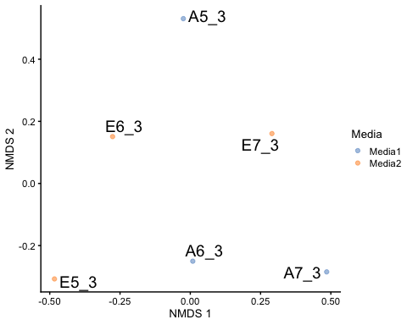

Stress values of NMDS plot

# Stress value  
print(paste0("NMDS stress value ",nmds$stress))

[1] "NMDS stress value 0.0398873869824664"

# Stress plot  
stressplot(nmds)

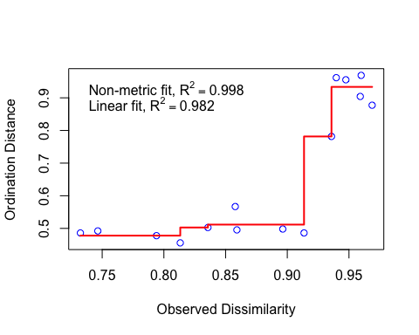

#### Results

The analysis method was switched to de novo clustering at a 97% sequence identity level due to a lack of studies on the performance of new Nanopore sequencing in complex microbial communities. We do have evidence that the sequencer operates accurately when analyzing mock community standards composed of a few microbial species with known quantities.

Each OTU picking strategy introduces minor variations, but the overall patterns remain consistent, as highlighted in the comparison document. De novo clustering appears to be the best compromise among the available methods, followed closely by open-reference clustering, as both methods retain variants that do not match perfectly with the reference database. In contrast, closed-reference OTU picking heavily depends on how well the studied communities are represented in the database.

The Shannon index values suggest that the samples contain enriched microbial communities. While there appears to be some variation between samples grown in different media, this difference is not statistically significant. Although beta diversity analyses did not reveal significant similarities between communities, the plots clearly illustrate the bray-curtis distances between samples.