Processing nanopore reads

Marko Suokas

#### Preprocess reads

Dorado doesn’t support demultiplexing of dual indexes on 5’ and 3’ ends. Additionally, ligated library reads can be either orientation. Most straightforward approach to demultiplex reads, is to utilise cutadapt. You can demultiplex index pairs using liked adapters approach in forward and reverse orientation, then process with scripts to reverse complement reverse read files and merge each of thme with forward reads.

Extracting forward reads to fastq file can be performed with following command

*cutadapt -e 0 -O 12 -g file:~/scripts/barcodes.fasta–trimmed-only -m 1200 -o “fdemuxed/{name}.fastq.gz reads.fastq.gz*

Command will extract barcodes defined in barcodes.fasta file and output matches into individual files in fdemuxed subdirectory. Minimum length is sen in example to 1200 bp.

Extracting reverse reads using reverse complemented barcodes.fasta file

*cutadapt -e 0 -O 12 -g file:~/scripts/rev_barcodes.fasta–trimmed-only -m 1200 -o “rdemuxed/{name}.fastq.gz reads.fastq.gz*

Reads are demultiplexed into separate directory

**Tip!** O, e, m and M parameters can be used to reduce chances of misaligned matches

Next we use bash script that will process each reverse read file and reverse complement them using basic command

*seqkit seq -rp –seq-type DNA -o reverse_comp.fastq.gz reverse_out.fastq.gz*

Final step is merging. You can use also for this simple bash script that merge files with same base name from two separate directories using basic command

*zcat forward_out.fastq.gz reverse_comp.fastq.gz >merged_reads.fastq.gz*

##### Trimming PCR amplification primers

Finally, you can use cutadapt and bash scripts to trim forward and reverse PCR primers from demultiplexed sequence files.

#### Import set2

Load libraries

library(dada2);packageVersion("dada2")

[1] '1.30.0'

library(knitr);packageVersion("knitr")

[1] '1.48'

library(Biostrings);packageVersion("Biostrings")

[1] '2.70.2'

library(DECIPHER);packageVersion("DECIPHER")

[1] '2.30.0'

library(phyloseq);packageVersion("phyloseq")

[1] '1.46.0'

library(tidyverse);packageVersion("tidyverse")

[1] '2.0.0'

library(kableExtra);packageVersion("kableExtra")

[1] '1.4.0'

library(mia);packageVersion("mia")

[1] '1.10.0'

library(qiime2R);packageVersion("qiime2R")

[1] '0.99.6'

Set variables

# Path variables  
path <- "data/processed/set2"  
training <- "~/feature_classifiers/SILVA_SSU_r138_2019.RData"  
meta_file <- "data/set2_meta.tsv"  
exportloc <- "results_set2/"  
# Variables: truncation length, phix (Illumina)  
truncation <- 1400  
#Creates results directory  
dir.create(exportloc)  
#metadata  
metadata <- data.frame(read_tsv(meta_file))

For the project, we take advantage of computing power of CSC puhti server and import already executed data objects from there. R code is unaltered and can can be executed by turning eval to TRUE.

#List files inside directory  
list.files(path)

[1] "barcode07_trimmed_all.fastq.gz" "barcode08_trimmed_all.fastq.gz"  
[3] "barcode09_trimmed_all.fastq.gz" "barcode10_trimmed_all.fastq.gz"  
[5] "barcode11_trimmed_all.fastq.gz" "barcode12_trimmed_all.fastq.gz"  
[7] "filtered"

# Forward fastq filenames have format: SAMPLENAME_R1_001.fastq  
fnFs <- sort(list.files(path, pattern="_trimmed_all.fastq.gz", full.names = TRUE))  
# Extract sample names, assuming filenames have format: SAMPLENAME_XXX.fastq  
sample.names <- sapply(strsplit(basename(fnFs), "_"), `[`, 1)

Plot sequence quality profile for samples

# Base quality plot  
prsetII <- plotQualityProfile(fnFs[1:6])  
prsetII

prsetII <- readRDS("rds/set2_rds/prset2.rds")  
prsetII

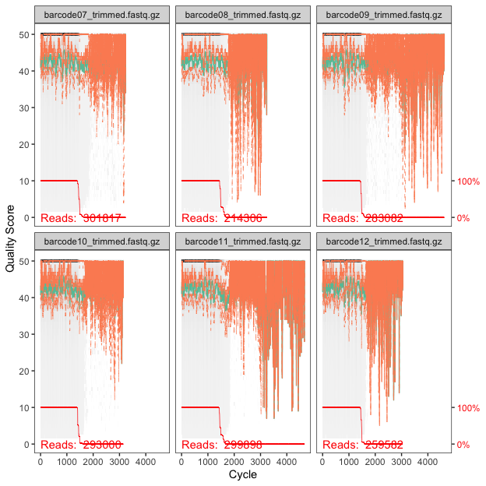

#### Filter sequence data

Filtering reads (maxEE ≈ 1 error/200 bp sequence is good starting point for this amplicon)

# Filtered files are placed in filtered subdirectory  
filtFs <- file.path(path, "filtered", paste0(sample.names,  
 "_F_filt.fastq.gz"))  
# For single end data sets without phix control  
names(filtFs) <- sample.names  
out <- filterAndTrim(fnFs, filtFs, truncLen=truncation,  
 maxN = 0, maxEE = 7 , truncQ = 2,  
 compress = TRUE, multithread = TRUE,  
 rm.phix = FALSE)

out <- readRDS("rds/set2_rds/out2.rds")

#### Learn error rates

# Forward read error rate  
errF <- learnErrors(filtFs, multithread = TRUE)

errF <- readRDS("rds/set2_rds/errF2.rds")

Plott error rates

# Plotting error rate profile for forward reads  
plotErrors(errF, nominalQ = TRUE)

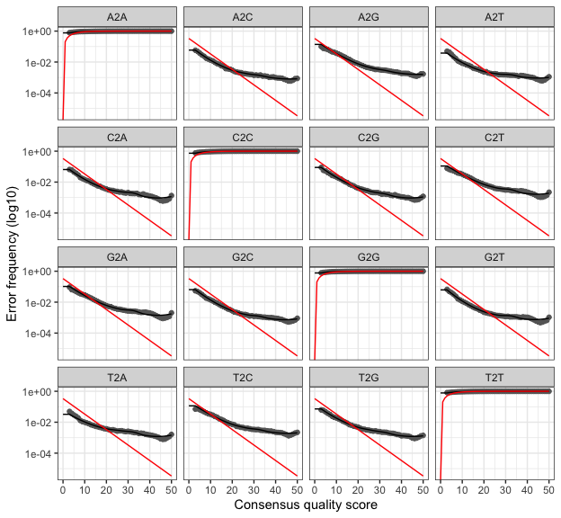

#### Denoise

dadaFs <- dada(filtFs, err = errF, multithread = TRUE)

dadaFs <- readRDS("rds/set2_rds/dadaFs2.rds")

#### Build asv table

seqtab <- makeSequenceTable(dadaFs)  
# Dimensions of ASV table  
dim(seqtab)

[1] 6 1566

#### Chimera removal

seqtab.nochim <- removeBimeraDenovo(seqtab, method = "consensus",  
 multithread = TRUE, verbose = TRUE)  
dim(seqtab.nochim)

[1] 6 933

#### Summary

getN <- function(x) sum(getUniques(x))  
track <- cbind(out, sapply(dadaFs, getN), rowSums(seqtab.nochim),  
 rowSums(seqtab.nochim != 0))  
#If processing a single sample, remove the sapply calls  
colnames(track) <- c("Input", "Filtered", "DenoisedF", "Nonchimeric",  
 "N:o of variants")  
rownames(track) <- metadata$Name  
kable(track, caption="Summary table") %>%  
 kable_styling(latex_options=c("striped", "HOLD_position")) %>%  
 row_spec(0,background = "teal", color = "ivory")

Summary table

|  | Input | Filtered | DenoisedF | Nonchimeric | N:o of variants |
| --- | --- | --- | --- | --- | --- |
| PR07 | 301817 | 229567 | 211982 | 199348 | 190 |
| PR08 | 214306 | 164005 | 144520 | 124792 | 194 |
| PR09 | 283082 | 214821 | 208768 | 202384 | 145 |
| PR10 | 293000 | 224099 | 218197 | 206612 | 129 |
| PR11 | 299898 | 228111 | 209010 | 188314 | 189 |
| PR12 | 259582 | 201157 | 176699 | 151760 | 175 |

#### Taxonomy assignment

IdTaxa from DECIPHER package

#Create a DNAStringSet from the ASV sequences  
repseq <- DNAStringSet(getSequences(seqtab.nochim))  
# CHANGE TO THE PATH OF YOUR TRAINING SET  
load(training)  
ids <- IdTaxa(repseq, trainingSet, strand = "top",  
 processors = 3, verbose = FALSE,  
 threshold = 50)  
ranks <- c("domain", "phylum", "class", "order", "family",  
 "genus", "species")   
# Convert the output to a matrix analogous to the output from assignTaxonomy  
taxid <-t(sapply(ids, function(x) {  
 m <- match(ranks, x$rank)  
 taxa <- x$taxon[m]  
 taxa[startsWith(taxa, "unclassified_")] <- NA  
 taxa  
}))  
colnames(taxid) <- ranks; rownames(taxid) <- getSequences(seqtab.nochim)

taxid <- readRDS("rds/set2_rds/taxid2.rds")

#### Create phyloseq object

pseq <- phyloseq(otu_table(seqtab.nochim, taxa_are_rows = FALSE),  
 tax_table(taxid))  
row.names(metadata) <- sample_names(pseq)  
sample_data(pseq) <- metadata  
pseq

phyloseq-class experiment-level object  
otu_table() OTU Table: [ 933 taxa and 6 samples ]  
sample_data() Sample Data: [ 6 samples by 3 sample variables ]  
tax_table() Taxonomy Table: [ 933 taxa by 7 taxonomic ranks ]

Sequence data is stored as taxa_names. We will store sequences as refseq and create numbered variant names

#create DNA object and store sequences   
seqs <- DNAStringSet(taxa_names(pseq))  
names(seqs) <- taxa_names(pseq)  
pseq <- merge_phyloseq(pseq, seqs)  
#new variant names  
taxa_names(pseq) <- paste0("ASV", seq(ntaxa(pseq)))  
#capitalise taxonomic ranks  
colnames(tax_table(pseq)) <- c("Kingdom", "Phylum", "Class",   
 "Order", "Family", "Genus", "Species")

#### Remove non-bacterial taxa

pseq <- subset_taxa(pseq, Kingdom == c("Bacteria", "Archaea"), na.rm = TRUE)

### Write results to files

Abundance table is transponed and written as tsv file

#variant names in rows  
ASV_names <- taxa_names(pseq)  
#sample names will be columns  
ASV_counts <- t(otu_table(pseq))  
ASVdf <- (data.frame(ASV_names,ASV_counts))  
#write  
write_tsv(ASVdf, paste0(exportloc,"asvs.tsv"))

Likewise taxonomy table is saved as tsv

#variant names in rows  
ASV_names <- taxa_names(pseq)  
#taxonomy ranks in columns  
taxonomy <- (data.frame(ASV_names, tax_table(pseq)))  
#write  
write_tsv(taxonomy,paste0(exportloc,"taxonomy.tsv"))

Variant sequences are saved into fasta file

pseq %>% refseq() %>% writeXStringSet(paste0(exportloc,"repseq.fasta"),  
 append = FALSE, compress = FALSE,  
 format = "fasta")

#### Vsearch@97%

Data has been processed in qiime, except feature classification

#read qiime2 table  
vs97 <- readQZA("data/vsearch2/97/filtered-table.qza")  
#reorder samples  
vs97 <- vs97[, order(colnames(vs97))]  
#read taxonomy  
otu_taxonomy <- readRDS("data/vsearch2/97/taxid.rds")  
pseq_vsearch97 <- phyloseq(otu_table(vs97, taxa_are_rows = TRUE),  
 tax_table(otu_taxonomy))  
#change names  
taxa_names(pseq_vsearch97) <- paste0("ASV", seq(ntaxa(pseq_vsearch97)))  
#capitalise taxonomic ranks  
colnames(tax_table(pseq_vsearch97)) <- c("Kingdom", "Phylum", "Class",   
 "Order", "Family", "Genus", "Species")  
#create DNA object and store sequences   
seqs <- readDNAStringSet("data/vsearch2/97/dna-sequences.fasta")  
names(seqs) <- taxa_names(pseq_vsearch97)  
pseq_vsearch97 <- merge_phyloseq(pseq_vsearch97, seqs)  
#prune non-bacterial taxa  
pseq_vsearch97 <- subset_taxa(pseq_vsearch97, Kingdom == c("Bacteria", "Archaea"),  
 na.rm = TRUE)

Write vsearch97 after data wrangling

#create_directory  
results <- "results_vsearch97/"  
dir.create(results)  
#variant_table  
ASV_names <- taxa_names(pseq_vsearch97)  
ASV_counts <- otu_table(pseq_vsearch97)  
ASVdf <- (data.frame(ASV_names,ASV_counts))  
write_tsv(ASVdf, paste0(results,"asvs_set2.tsv"))  
#taxonomy  
ASV_names <- taxa_names(pseq_vsearch97)  
taxonomy <- (data.frame(ASV_names, tax_table(pseq_vsearch97)))  
write_tsv(taxonomy,paste0(results,"taxonomy_set2.tsv"))  
#sequences  
refseq(pseq_vsearch97) %>% writeXStringSet(paste0(results,"repseq_set2.fasta"),  
 append = FALSE, compress = FALSE,  
 format = "fasta")

#### Vsearch@99%

#read qiime2 table  
vs99 <- readQZA("data/vsearch2/99/filtered-table.qza")  
#reorder samples  
vs99 <- vs99[, order(colnames(vs99))]  
#read taxonomy  
otu_taxonomy <- readRDS("data/vsearch2/99/taxid.rds")  
pseq_vsearch99 <- phyloseq(otu_table(vs99, taxa_are_rows = TRUE),  
 tax_table(otu_taxonomy))  
#change names  
taxa_names(pseq_vsearch99) <- paste0("ASV", seq(ntaxa(pseq_vsearch99)))  
#capitalise taxonomic ranks  
colnames(tax_table(pseq_vsearch99)) <- c("Kingdom", "Phylum", "Class",   
 "Order", "Family", "Genus", "Species")  
#create DNA object and store sequences   
seqs <- readDNAStringSet("data/vsearch2/99/dna-sequences.fasta")  
names(seqs) <- taxa_names(pseq_vsearch99)  
pseq_vsearch99 <- merge_phyloseq(pseq_vsearch99, seqs)  
#prune non-bacterial taxa  
pseq_vsearch99 <- subset_taxa(pseq_vsearch99, Kingdom == c("Bacteria", "Archaea"),  
 na.rm = TRUE)

Write vsearch99 files after data wrangling

#create_directory  
results <- "results_vsearch99/"  
dir.create(results)  
#variant_table  
ASV_names <- taxa_names(pseq_vsearch99)  
ASV_counts <- otu_table(pseq_vsearch99)  
ASVdf <- (data.frame(ASV_names,ASV_counts))  
write_tsv(ASVdf, paste0(results,"asvs_set2.tsv"))  
#taxonomy  
ASV_names <- taxa_names(pseq_vsearch99)  
taxonomy <- (data.frame(ASV_names, tax_table(pseq_vsearch99)))  
write_tsv(taxonomy,paste0(results,"taxonomy_set2.tsv"))  
#sequences  
refseq(pseq_vsearch99) %>% writeXStringSet(paste0(results,"repseq_set2.fasta"),  
 append = FALSE, compress = FALSE,  
 format = "fasta")

#### Observations

With larger number of variant and 1,4 kbp sequence length, error rate profiles start clearly to deviate from expected. Even though, variant numbers seem realistic, denoising might not be best choice.

From same data, vsearch produced >2500 and >18000 variants, respectively. Note that in this set, sequences were truncated to 1400 prior dereplication and clustering.