111ChapterSoftware Design Document
for a Metapopulation Assessment System
Jon Brodziak¹, Matthew Supernaw, and Clay Porch

¹NOAA Inouye Regional Center, Pacific Islands Fisheries Science Center
1845 Wasp Boulevard, Building 176, NMFS/PIFSC/FRMD Mail Room 2247

Jon.Brodziak@NOAA.GOV

1. INTRODUCTION
The scale and connectivity of spatial processes are key to understanding and predicting patterns in resource abundance in population and community ecology. The importance of spatial scale and connectivity is a paradigm for ecology (Levin 1992) and provides a strong rationale to focus on metapopulations, or populations of populations, as the basic unit of population ecology. To understand and predict impacts on populations, population assessments should increasingly focus on the influence of spatial variation on resources and the development of metapopulation assessments will require a shift towards more complex and hierarchical population models.
From a software design perspective, an object-oriented design paradigm where one can provide precise design specifications, have a shorter development phase for new code, and expect easier maintenance with consistency and reusability through time is a natural approach to developing more complex and hierarchical population models. To some extent, features are partially implemented in some existing integrated assessment models, e.g. Stock Synthesis, but there is ample room for improvements in model development, selection, testing, uncertainty quantification, and other assessment components. In this context, rapid prototyping and development of alternative models for a diversity of fishery systems is desirable and could be achieved through the ongoing development of a system library of tested modules and templates. The capacity to build new models from object-oriented templates will foster the ongoing development of structured assessment models and will also help to avoid some of the life cycle issues of maintaining a single omnibus assessment model.

1.1 Purpose
The goal of this design document is to describe the construction and maintenance of an object-oriented stock assessment modeling system that incorporates up-to-date modeling capabilities and ongoing improvements and is readily extensible to adapt to specific stock assessment situations. The paradigm for this modeling system is that the spatial dynamics of fish stocks and fishing fleets are essential for improved understanding and predictive capacity. An inherent capacity to deal with spatial structure and its impacts on population dynamics and the fishery system exploiting the stock is a necessary condition for stock assessment. There has been a clear recognition that spatial structure can have substantial impacts on the pattern of fishery selectivity and on the interpretation of relative abundance indices and structured population information. For this reason, the foundation of any next-generation modeling approach must be able to readily include spatial structure in the population dynamics and the new modeling system is named the metapopulation assessment system, or MAS, to reflect this design element.
In the MAS, each instance of a structured population model consists of one or more structured subpopulations and one or more habitat areas (or locations or patches, depending upon context). In this case, a subpopulation is a group of individual animals with similar demographic characteristics, including life history variation. Each subpopulation has a set of movement probabilities () among areas where each subpopulation can potentially move into any of the areas as well as not move at all and reside within a single habitat area (Figure 1). Information on the structure and character of each habitat area and associated environmental forcing is included in the environment class objects.
Figure 1. A schematic of a subpopulation within a metapopulation inhabiting three areas and with differing environmental characteristics and movement rates among areas.
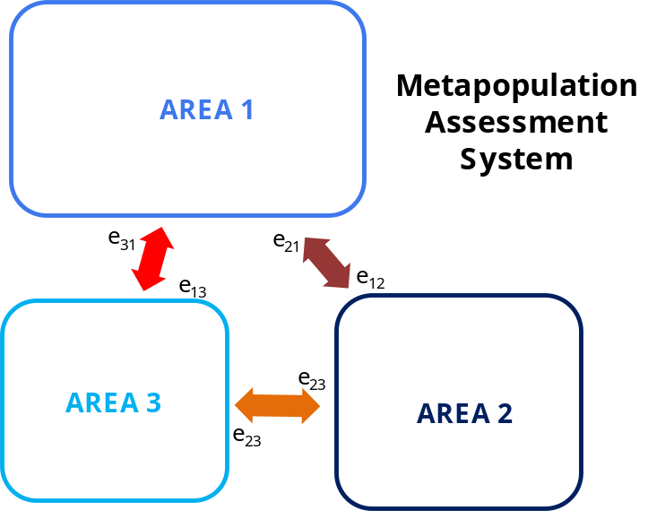

The capacity of MAS to accommodate subpopulations that have a stationary distribution in space as well as subpopulations that can move across the entire spatial domain is a key design element. This design of having a subpopulation with the capacity to transit areas allows for the modeling of highly migratory fish stocks as a metapopulation. Similarly, the design of having subpopulations with spatial distributions that do not change appreciably allows for the modeling of sedentary populations. In between these two extremes of subpopulation movement, a wide variety of movement patterns with interannual and seasonal variability can be accommodated. This flexibility in the modeling of movement is one of the key improvements in MAS and is one of the reasons an object-oriented design is necessary.
1.2 Scope
The scope of the MAS is to provide modeling support for a variety of structures and parameterizations of metapopulation dynamics. In concept, here are some of the features that are envisioned. Movement dynamics among areas can be modeled for highly migratory or relatively sedentary populations with or without exchange of recruitment among areas. The metapopulation size can be a large commercially-important stock with hundreds of millions of individuals or a small bycatch-impacted stock with hundreds of individuals. The spatial resolution of the model areas can be coarse or granular and the size of areas can be uniform or irregular. The parameter estimation process can be based on Bayesian, frequentist, or other approaches, including hierarchical Bayes or random effects for spatial parameters. Metapopulation models can be developed for age-, size-, or stage-based population structures. Fishery systems can be comprised of multiple fleets operating over multiple areas or consist of a single fleet with changing characteristics. The environmental characteristics of areas can be stationary or time-varying and subpopulations can be subject to local area or global multiple-area environmental forcing.
1.3 Overview (of this document)
Under Development

2. SYSTEM OVERVIEW
Assessment systems are typically designed to answer management questions using models that are approximations of nature. Assessment systems produce historic and current estimates of stock abundance, mortality, and productivity and may use a variety of model structures tuned to diverse data availability scenarios. Assessment systems need to provide forecasts of the future stock conditions and yield under alternative harvest scenarios. As a result, there are multiple types of modeling analyses that comprise a stock assessment and these can be categorized into analysis layers.
The MAS consists of three primary analysis layers which correspond to the main applications and work needed to construct and complete a full metapopulation stock assessment. The first analysis layer of MAS produces a single metapopulation assessment model which is created and fitted in the model construction layer (Figure 2). There may be several alternative models, sometimes on the order of dozens, developed in a given stock assessment effort. The process of comparing, contrasting, and selecting a best fitting model, or set of models is the second analysis layer (Figure 2). This layer also includes sensitivity analyses and model uncertainty quantification. The third analysis layer is the model forecasting layer in which the best model or set of models are forecast into the future under alternative states of nature and fishery system harvest control rules, or harvest strategies (Figure 2). Each of the three primary analysis layers includes a flow control algorithm that specifies the individual subprocesses that will occur in the layer.
Figure 2. Analysis layers for MAS including model construction, selection, and forecasting.
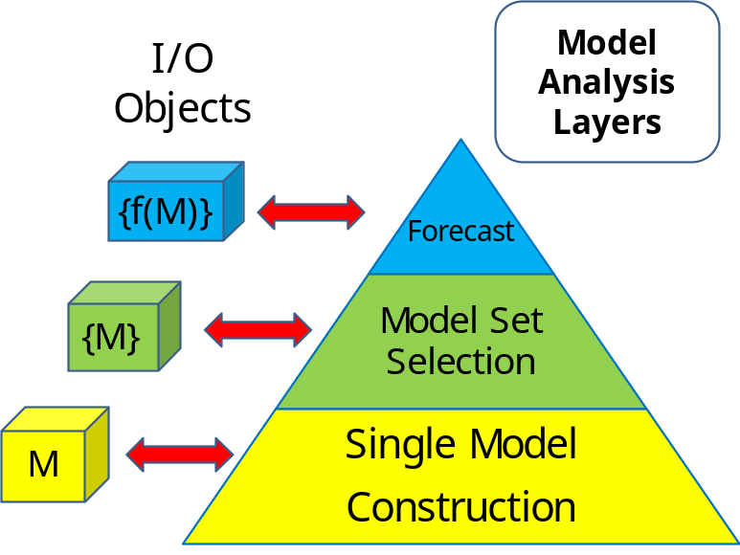

There is a need to be able to specify input/output objects for each layer to provide ease of use and interpretability, flexible capacity for simulation testing and verification, and standard GUI-based model development in MAS. In this case, the model selection layer provides processes for model verification, validation, and uncertainty quantification. Another efficient aspect of MAS is to implement structured model input and output objects and subobjects that can be combined and disaggregated to provide compatibility for diverse types of input or output data and for outputting quantities of interest in specific formats.

3. SYSTEM ARCHITECTURE
The four primary components for an instance of the meta-population model class (Figure 3) are: (1) subpopulation class structure that includes subpopulation characteristics, location, and movement attributes (having only one subpopulation, not moving or completely mixing are common assessment assumptions, for example); (2) observation class with subclass structures that include fisheries data, survey data, results of research studies like estimates of growth, maturity, or fecundity curves or individual observations of tagging or ageing data; (3) an environment class that includes information on habitat in areas and the effects of environmental forcing on subpopulation characteristics and observations with subclasses that include biotic entities or abiotic factors, constant or time-varying predator fields or La Nina/El Nino conditions, for example, and; (4) an information analysis class that has subclasses for parameter input and output, creating simulated input data, likelihood components, model setup and domain parameters, model diagnostics, data weighting and iterative reweighting, model selection and multimodel inference, model averaging, constraints or priors and hyperpriors on model parameters, and uncertainty quantification methods including covariance estimation, bootstrapping, and Markov Chain Monte Carlo simulation approaches.
Figure 3. Schematic diagram of a metapopulation assessment model object showing four primary classes comprising a model.
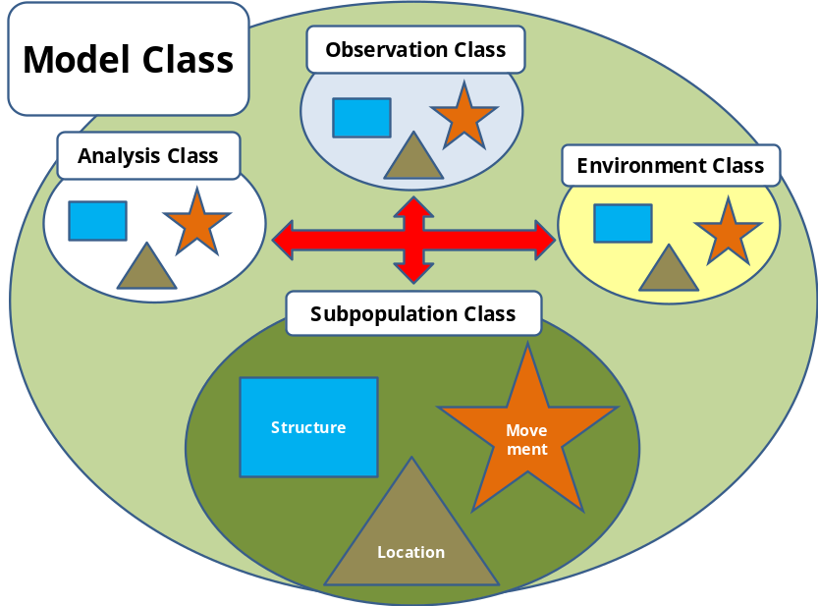

Each of the four primary classes incorporates information about the structure of the subpopulation, the subpopulation’s distribution in space, and the movement of the subpopulation. In this context, the distribution of the subpopulation is the set of areas it inhabits. That is, each subpopulation is associated with a particular set of areas, which could range from one area to all of the areas incorporated in the model. Subpopulations can migrate and move groups, or propagules, across areas. Subpopulations members in specific areas can also go extinct and be recolonized.
3.1 Architectural Design
3.1.1 Subpopulation Class
The subpopulation class follows the well-established premise of conservation of biomass (Russell 1931) within each area of the model. The conceptual model of the time change, indexed by , in the biomass () of the harvested subpopulation in each area depends on biomass increases due to somatic growth (), recruitment (), and immigration () and depends on biomass decreases due to natural deaths (), fishery yields (), and emigration () via
23()
Summing the biomass changes for an individual subpopulation across areas produces the net change in subpopulation biomass. Summing the subpopulation biomass changes across subpopulations produces the net change in metapopulation biomass. To produce total metapopulation biomass in sex-structured population dynamics requires summing over genders. Similarly, computing total biomass for structured population dynamics requires summing over age classes, or length classes, or stage classes, depending on the structuring variable.
The subpopulations are initialized for the first period in the time horizon through the model choices from the subpopulation, observation, analysis, and environment classes. The subpopulation class instances are then projected forward though the assessment time horizon. As the projections sequentially occur, the observation class instances generate observations as fisheries and environmental processes remove fish from subpopulations through harvest and expected natural mortality rates or episodic environmental events.
The structure of the class subpopulation in MAS includes vector, matrix, and higher-dimensional arrays for storing numbers () of fish in particular space, time, age-size, and gender cells. The space dimension consists of categories for area or location. The convention of using areas gives a total of full degrees of freedom for the empirical multinomial distribution in this dimension. Similarly, there are time categories for model fitting in layer 1, age- or size-structured categories for subpopulation structure, and categories for gender structure with associated degrees of freedom of , , and , respectively.
The information on the subpopulations will be stored in multidimensional arrays. The convention for ordering the subscripts for the multidimensional arrays is . This ordering conforms to the focus on the spatial distribution of the population. In what follows, we use a simpler subscript of , noting that the genders can be summed over space and age to produce total subpopulation size at any time. The proportion of the subpopulation in area a during time period t at age s is denoted by and the corresponding number of fish in that area and time is . Similarly, the total number of fish in the subpopulation at time t is . Thus, the information needed to specify the subpopulation at any time includes the 3-dimensional proportion array and the 2-dimensional subpopulation size array which is the subpopulation numbers in each area through the assessment time horizon.
Age composition data can be observed to characterize the age structure of the subpopulation in a given location and time. This sample represents the age structure of a 1-dimensional subarray of the subpopulation array, as for example, the slice (Figure 4).
Figure 4. A three dimensional representation of a subpopulation structured in space and time with age classes.

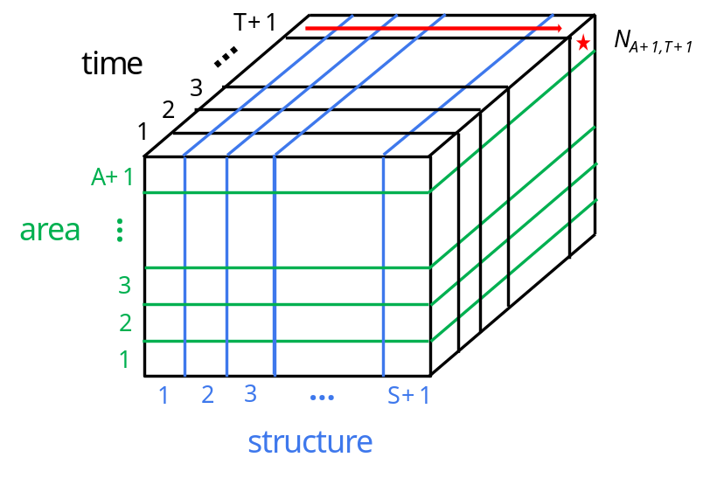

An important element of the subpopulation class is the set of areas the subpopulation can inhabit and move around in. This is the habitat of the subpopulation. The habitat for a subpopulation can be represented as a directed graph in which the connected vertices () are the inhabitable areas and the edges () are the directed movement paths between areas. Here is an example of the directed graph for a subpopulation inhabiting five areas and with one-step movement paths (Figure 5). The information on the nearness of the areas in a subpopulation’s habitat is represented with an adjacency matrix . If the directed habitat graph has vertices or areas, numbered , then the adjacency matrix is with entries if there is an edge with initial vertex and terminal vertex in the directed graph and if there is no edge. The adjacency matrix describes the set of possible one-step movements of the subpopulation within its habitat. Here is the adjacency matrix for the example of a subpopulation with a habitat consisting of five areas (Figure 5).
45()

Figure 5. Directed movement graph of the habitat for a subpopulation inhabiting five areas.
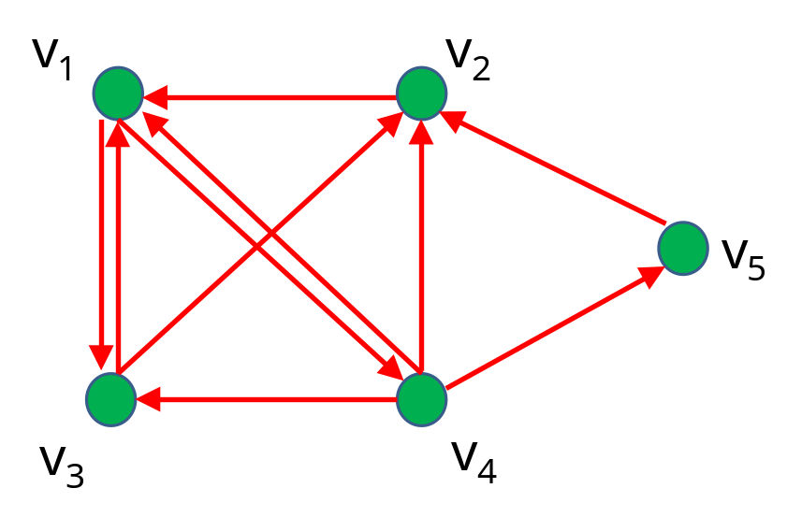

In general, areas that are not part of the subpopulation habitat can be represented as row with zero entries. As a result, the adjacency matrices for each of the subpopulations can be taken to have dimension . This provides a succinct representation of how subpopulations can move through their habitat in one step or on a path of length one.
The adjacency matrix can also be used to determine the number of paths of any length between two areas. This follows from the fact that the entries of raised to the power count the number of distinct paths of length between two vertices. In particular, if denotes the entry in the matrix , then is the number of paths of length between the vertices and .
It is important to note that the number of paths of length zero is given by , where is the identity matrix. This corresponds to no movement between areas noting that a path of length zero connects a vertex or an area to itself. The sum of the adjacency matrix and the identity matrix defines the possible connections between areas for the subpopulation movement probabilities.
The subpopulation movement probabilities define the movement of the subpopulation among areas by structure and correspond to edges in the subpopulation habitat graph. The probability that an individual animal of structure type in area moves to area in time period is denoted by , where these probabilities are all nonnegative and satisfy the constraint that they sum to unity for a given source area (), time period (), and age structure (). That is,
67()
The movement probabilities can be represented as time-specific and age-specific matrices where
and is the movement matrix for time period and subpopulation structure or age class .
Each row of the subpopulation movement matrix that is part of the subpopulation habitat has nonnegative entries that sum to unity as in Eqn (3). Rows of that are not part of the subpopulation habitat have zero entries by convention. The movement probability matrices can also be constant though time or constant across age structure or both, although the most general setting is for the probabilities to vary through time and by age structure.
Here is an example of a movement matrix corresponding to the five area subpopulation habitat along with the associated habitat graph where the movement probabilities are constant in time and by age structure
89()
and satisfy the five probability constraints , , , , and .
Figure 6. Directed movement graph of the habitat for a subpopulation inhabiting five areas along with the associated movement probability matrix .

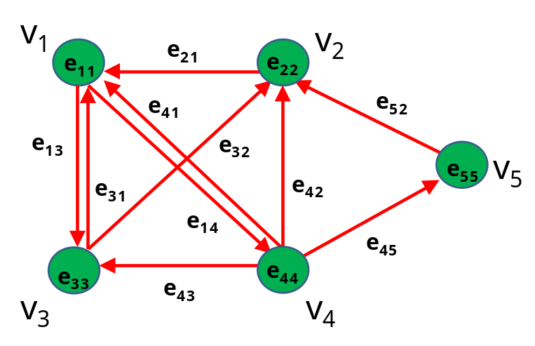
This shows the minimal architectural elements for the subpopulation class, a structured subpopulation distributed in space and time along with the associated movement probabilities. The subpopulation class interfaces with the information class as well as the observation and environment classes to describe the metapopulation dynamics through time.
3.1.2 Observation Class
The observation class is the set of observed data for the metapopulation and fishery system. This includes fisheries data, survey data, results of research studies like estimates of growth, maturity, or fecundity curves or individual observations of tagging or ageing data. Model parameters are fit to the observed data through interface with the subpopulation, environment, and information classes. The observation class is comprised of the basic data and the objects used to store this information and interface with the subpopulation, environment, and information classes.
3.1.3 Environment Class
The environment class characterizes the information on the metapopulation habitat by area. This includes the effects of environmental forcing on subpopulation characteristics and observed data. This class includes biotic entities or abiotic factors, constant or time-varying survival and growth conditions dependent on the existing environmental conditions in each area. The environment class describes the exogenous conditions affecting the metapopulation dynamics by area and interfaces with the subpopulation, observation, and information classes.
3.1.4 Information Class
The information class stores the information needed to fit the parameters of a general discrete-time metapopulation model structure that can include process and observation dynamics (Aoki 1990, Schnute 1994). This includes information needed for parameter input and output, creating simulated input data, likelihood components, model setup and domain parameters, model diagnostics, data weighting and iterative reweighting, model selection and multimodel inference, model averaging, constraints or priors and hyperpriors on model parameters, and uncertainty quantification methods including covariance estimation, bootstrapping, and Markov Chain Monte Carlo simulation approaches. In general, the model structure and information requirements depend on a state space formulation of the metapopulation dynamics, which is described below.
The state space model depends on the relationships between the system state vector (), the observed data vector (), and the parameter vector (). The state vector has dimension p and represents the set of unobserved metapopulation and fishery system characteristics at time t. The data vector has dimension n and represents the set of quantities actually observed at time t. If the set of control variables (e.g., catch or fishing effort) for the system are empirical observations, then these variables will be included in the data vector in contrast to being included in the parameter vector. The parameter vector has dimension z and represents the combined set of all parameters used to describe the process and observation dynamics as well as fitting of the state space model. This includes parameters for population model dynamics (), parameters for prior distributions (), parameters for hyperprior distributions (), parameters for process error distributions (), parameters for observation error distributions (), parameters for system control () if appropriate, and nuisance parameters () if parameter constraints or likelihood penalties are used to improve stability of the numerical computations and as a result, the overall parameter vector is and the estimated parameter subvector () is . This gives a full accounting of the parameters to be estimated versus assumed for the state space model, although we would also add that there may be situations where it is reasonable given the information constrainsts to assume structural dependence of the observation process on the observed data, i.e., an empirical Bayes framework, and that we do not in any way discount the utility of such extensions of the multimodel approach in that manner.
The state space structure ensures that the time dimension is a memory-less process in which the next system state only depends on the current system state and where time-lagged variables are included in the state and parameter vectors as needed. It also implies that the model structure is set up for Markov Chain Monte Carlo simulation which will be used for numerically integrating the posterior distribution for each model (Gilks et al. 1996, Gelman et al. 2005) and also for conducting future forecasts which account for uncertainty in the estimate of system state (Brodziak et al. 1998, Patterson et al. 1999). Last, it is important to note that the state space model structure is completely general and can be applied to single- and multiple-species models with spatial structuring.
The process dynamics of the state space model depend on the previous system state and parameter vector through the function with its range consisting of a smooth region where
(1)
In (1), the function includes the process error distributions, whether process errors are modeled as additive normal distributions, or multiplicative lognormal distributions or other distributional form. Similarly, the system observation dynamics are governed by the function with its range consisting of a smooth region where the observed information depends on the system state and parameter vector at time t
(2)
and the function includes the observation error distributions. Two comments on this minimal representation of the process and observation dynamics of the state space model are warranted. First, the time dynamics are structured to include a discrete Markov time step and given this constraint, if spatial model formulations of the population characteristics variables are included, then these variables need to have informative movement rates among spatial regions within the state space model. Second, while not specifying the form of spatio-temporal constraints for the state space model, we note that this is a rife and open field for investigation given the general nature of the process and observation dynamical framework.
The joint sample likelihood of the model is constructed from the comparison of model predictions to sampled information through time. The objective function consisting of the joint sample likelihood and additional prior information, and constraints is optimized using the best available optimization package, probably ADMB at this point, and parameter uncertainty is characterized using numerical analysis or bootstrap or Markov Chain Monte Carlo simulation based on the best-fitting model(s), the parameter estimates and associated covariance structure.
The capacity to conduct stock projections depends on the estimates of model parameters and their estimated covariance matrix. It is also important to have input/output structures that can efficiently support model verification through simulation testing as well as management strategy evaluation analyses.
In summary, the primary classes for MAS are: (1) subpopulation, this is where the population dynamics information is contained; (2) observation, this is where the observed data are stored; (3) environment, this is where the biotic and abiotic habitat and environmental process information for population dynamics are stored; and (4) information analysis, this is where the model structure and data analysis information is stored.
3.2 Subsystem Description
1022ChapterLists of subsystem objects that may be needed for each of the four primary component classes are described below.
3.2.1 Subpopulation Class
  - Structure
    - Number at age, length, and sex by area. For two-sex models, female and male subpopulation numbers are stored in separate arrays.
    - Biomass at age, length, and sex by area.
    - Growth processes by area. This can be independent or dependent on environment or subpopulation abundance or subpopulation structure, e.g. gender.
    - Recruitment processes by area.
    - Death processes including fishing and environmental effects by area.
    - Maturation and fecundity processes by area.
  - Location
    - Relation to other locations in terms of adjacency and distance, a directed habitat graph by subpopulation.
    - Habitat effects on subpopulation processes for each area.
    - Recruitment distribution among areas.
  - Movement
    - Subpopulation movement probability matrices by age, length, and sex.
    - Subpopulation tagging processes by age, length, and sex.
3.2.2 Observation Class
  - Fisheries Data
    - Catch biomass by area.
    - Catch numbers by area.
    - Catch per unit effort by area.
    - Selectivity by area.
    - Age composition by area.
    - Size composition by area.
    - Sex composition by area.
    - Mean size by area.
    - Tag recovery information by area.
  - Research Survey Data
    - Catch biomass by area.
    - Catch numbers by area.
    - Catch per unit effort by area.
    - Selectivity by area.
    - Age composition by area.
    - Size composition by area.
    - Sex composition by area.
    - Mean size by area.
    - Tag recovery information by area.
    - Life history observations or biological samples by area.
  - Research Data
    - Size-at-age data by area.
    - Maturity-at-age or –size data by area.
    - Fecundity-at-age or –size data by area.
    - Length-weight data by area.
    - Environment Class
  - Subpopulation Effects
    - Structure
    - Location
    - Movement
  - Observation Effects
    - Fisheries by area.
    - Surveys by area.
  - Information Effects
    - Biotic processes by area.
    - Abiotic processes by area.
3.2.4 Information Class
  - Input and Output Objects
    - Model.
    - Subpopulation.
    - Observation.
    - Environment.
    - Results Summary.
    - Projections.
    - Operational model for simulation.
  - Model Predictions
    - Predicted Fisheries Data
      - Catch biomass by area.
      - Catch numbers by area.
      - Catch per unit effort by area.
      - Selectivity by area.
      - Age composition by area.
      - Size composition by area.
      - Sex composition by area.
      - Mean size by area.
      - Tag recovery information by area.
    - Predicted Research Survey Data
      - Catch biomass by area.
      - Catch numbers by area.
      - Catch per unit effort by area.
      - Selectivity by area.
      - Age composition by area.
      - Size composition by area.
      - Sex composition by area.
      - Mean size by area.
      - Tag recovery information by area.
      - Life history observations or biological samples by area.
    - Predicted Research Data
      - Size-at-age data by area.
      - Maturity-at-age or –size data by area.
      - Fecundity-at-age or –size data by area.
      - Length-weight data by area.
  - Model Objective Function
    - Likelihood Components.
    - Priors.
    - Hyperpriors.
    - Numerical Constraints.
    - Other parameter optimization components.
  - Model Diagnostics
    - Residual analyses.
    - Parameter correlations.
    - Goodness-of-fit measures.
    - Leverages.
    - Cross validation.
    - Information theoretic measures.
    - Bayesian P-values.
    - Other model diagnostics.
  - Model Results
    - Biomass time series.
    - Biomass reference points.
    - Harvest rate time series.
    - Harvest rate reference points.
    - Other quantities of interest.
  - Uncertainty Characterization
    - Bootstrapping.
    - Markov Chain Monte Carlo simulation.
    - Covariance matrix.
    - Jackknifing.
    - Probability of having exceeded the OFL as a function of ACL.
    - Model averaging.
    - Other measures of uncertainty characterization.
  - Projections
    - Stochastic or deterministic.
    - Single model or ensemble.
    - Catch-based or effort-based harvest.
    - With or without control rule.
    - With or without implementation error.
    - Probability of exceeding OFL under alternative harvests.
    - Other projected quantities of interest.
  - Management Strategy Evaluation
    - Operational model.
      - True parameter values
      - Simulated subsets of parameters.
        - Covariance.
        - Bias.
    - Performance measures.
    - Harvest control rules.
    - Management procedures.

3.3 Design Rationale
The MAS class structure features were conceived to produce what we now want or imagine we may want in the future. The design paradigm of beginning with the end in mind is an important part of this approach and rather than attempt to list all desirable features in a single bullet list, an attempt was made to group features into related categories may facilitate design and understanding but tempered by the recognition that categorizations may need ongoing refinement. That is, the relationships among some features may have ambiguity in this respect, the suggested categorizations are intended to facilitate, not rigidly define, model capacities for understanding and prediction.
One general feature that we desire from MAS is high quality, reliable, adaptive programming. For this reason, it was chosen to implement MAS in C++ emphasizing an object-oriented programming style. This choice of object orientation will facilitate the maintenance, extensibility, and reusability of code and model structures and most importantly will facilitate rapid model prototyping. Another key structural component for efficient and reliable coding is the use of input/output objects, where these I/O objects can be tailored to specific needs of specific stock assessment projects. An I/O object can be thought of a list of a list of subobjects, which may contain further nesting of subobjects and so on, in an extensible list structure similar to those used for the construction of data frames in the R programming language and its precursors. The programming aspects of MAS are integrated together with a living design document that includes necessary and sufficient information to define and reconstruct MAS and also to extend it with new modules through stepwise QA/QC procedures.
The MAS model structure needs to reflect metapopulation structure. Multiple population habitats and areas need to be part of the system for addressing spatial dynamics and ocean zoning for management. We also need to incorporate the capacity for frequentist and Bayesian population dynamics processes for model fitting to provide adequate generality and flexibility. In general, it is preferable to employ Bayesian approaches to address parameter uncertainty in a direct manner but it is very important to have the option of not making any explicit prior assumptions in a frequentist context. The structural issue of the mode of inference is also linked to the choice of error structure. Error terms can be dichotomized as being additive and normally distributed or as being multiplicative and lognormally distributed. The MAS model needs to provide the capacity to fit both error structures to be a flexible platform for assessment modeling. Following on this point, there needs to be clear and transparent information for model diagnostics and model selection among competing alternative models. This includes options for data weighting, to emphasize or deemphasize information, as well easy to implement data inclusion or exclusion in alternative models. Last, the MAS model also needs to provide standard assessment quantities of interest for fishery management, including biological reference points, status determination information, and also future stock projections.

4. DATA DESIGN
4.1 Data Description
Under Development
4.2 Data Dictionary
Under Development

5. MODEL SELECTION AND INFERENCE
5.1 Model Selection
Under Development
Cross Cutting Modeling Components
- Data Weighting
- Time-Varying Parameters
- Multivariate Priors
- Hierarchical Structure
Robustness and reliability of the understanding and predictability of metapopulation dynamics will be an ongoing process. Quality assurance and quality control for this process can be achieved through an iterative process of model verification, validation, and uncertainty quantification (Figure 7).
Figure 7. Validation, verification, and uncertainty quantification processes for modeling ecosystem impacts on quantities of interest.
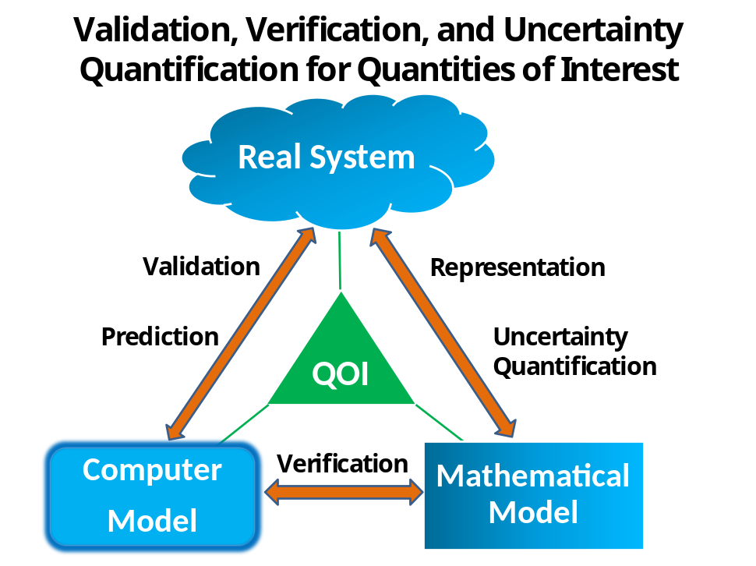
5.2 Multimodel Inference
Structural uncertainty in approximating models used for inference is an important feature of our incomplete knowledge of the complex marine system dynamics. This structural uncertainty, when combined with natural variability and observational error, makes it challenging to provide the understanding and predictive information needed to manage human impacts. We describe a general multimodel inference approach for stock assessment and, using a Bayesian state-space hierarchical state space metapopulation model, provide a means to account for uncertainty in time-varying structure in fishery system models. Information theoretic model selection criteria are applied to weight the probability that alternative candidate model provides the best approximation and predictive information about the system state, given the observed fixed data. Model averaging procedures are described for use when the weight of evidence to support a single operating model is ambiguous. Overall, we advocate the use of multimodel inference for stock assessment to account for the prevalence of structural uncertainty in fishery systems.
In what follows, we describe a general multimodel inference approach (e.g., Burnham and Anderson 2002) for stock assessment and provide specific examples of dealing with uncertainty in time-varying structure in fishery system models. Structural uncertainty in approximating models used for inference is an important feature of our incomplete knowledge of the complex marine system dynamics. This structural uncertainty, when combined with natural variability and observational error, makes it challenging to provide the understanding and predictive information needed to manage human impacts (Peterman 2004, Link et al. 2012). Our multimodel inference approach uses a state space modeling formulation (e.g., Aoki 1990, Schnute 1994) to represent alternative hypotheses with Markov process dynamics. We employ a Bayesian estimation framework (Punt and Hilborn 1997, Ellison 2004) to assess the evidence for alternative models, which are formulated as either simple or hierarchically-structured Bayes models (Clark 2005) with time as a hierarchical dimension. Information theoretic model selection criteria are applied to weight the probability that each alternative candidate model provides the best approximation and predictive information about the system state, given the observed fixed data. Model averaging is applied to the set of credible models when the weight of evidence to support a single operating model is ambiguous (Hoeting et el. 1999, Burnham and Anderson 2002), else the results of a single best operating model are identified and directly applied. Results of this approach can be expected to account for the probable range of uncertainty in model structure while both incorporating relevant prior information in the analyses and providing probabilistic interpretations of results for risk assessment.
We begin by providing a general description of the state space model formulation. Next, the multimodel inference approach and the development of a set of candidate models is discussed, including the calculation of model likelihoods and weights, the multimodel inference process, and model averaging when appropriate. We then show how alternative hypotheses can be formulated as either simple or hierarchical Bayes models and fit the alternative models to the data. We then apply model selection and multimodel inference to judge the adequacy of the models, including formulating model-averaged results. We conclude with a general discussion of the advantages of the multimodel inference approach for stock assessment and also identify some ongoing challenges in its use and application.
The approach we use for model selection and multimodel inference is conceptually based on ideas expressed in Burnham and Anderson (2002) which provides a further discussion of some of the issues raised below. To begin with the multimodel inference approach, one needs to construct a set of candidate models, denoted by , that accurately represent the set of plausible hypotheses about system dynamics. Here it is important to begin with “the method of multiple working hypotheses” and put forward candidate models that have an empirical basis and are grounded in scientific plausibility (e.g., Hilborn and Mangel 1997). In this context, there should be an emphasis on both keeping an open mind about the set of plausible hypotheses and not seeking to derive a dichotomous null versus alternative hypothesis in order to simplify the model selection process. Burnham and Anderson (2002) advocate limiting the set of candidate models for parsimony and we concur that this is an important point to reduce the possibility of chance results due to sampling variability. That is, when more models are included in the set of candidate models with a fixed sample size, then the power to detect important differences between models decreases as the relative sample size per model decreases. Further, it is also useful to avoid including models that are functionally redundant.
The multimodel inference approach is designed to address the important issue of model selection uncertainty. A key feature of the multimodel inference approach is to avoid the risk of making decisions based on overconfidence and overinterpretation of modeling results due to the underestimation of uncertainty and the a priori acceptance of a single best hypothesis without critical examination. Because our understanding of complex fishery systems is and will always be incomplete, there needs to be an ongoing emphasis on confronting our alternative hypotheses about ecosystem dynamics with observed data (Hilborn and Mangel 1997). In this context, we emphasize a tiered approach to the evaluation of each candidate model as being judged to be a credible model that is appropriate for inference in fishery management application. First and foremost, candidate models have to satisfy convergence requirements and statistical optimization criteria, this is a minimal requirement. Second, standard model goodness-of-fit diagnostics need to provide evidence that each candidate model conforms to assumptions. Last, the selected credible models among the set of candidate models should have quantitative support based on information theoretic criteria that provide an estimate of model distance from the unknowable true state of nature (Burnham and Anderson 2002). In the case of one selected, best-fitting credible model, inference and scientific information for management will be based on that single model.
1133ChapterAlternatively, when more than one credible model exists, we apply model averaging to account for model selection uncertainty. In this application, we used the Deviance Information Criterion (, Spieglehalter et al. 2002) as a plug-in measure of the information-theoretic goodness of fit of the alternative candidate models. We also note that alternative information theoretic criteria are available and that some of these criteria may provide better approximations of the relative goodness of fit among alternative models than DIC in some cases. Regardless, we note that the values used in this study were empirically calculated based on the information generated by the convergent Markov Chain Monte Carlo (MCMC) simulations conducted for each model.
To provide some background on the logical basis for as a measure of goodness of fit or conversely the amount of discrepancy between the candidate model and the data (Burnham and Anderson 2002, Gelman et al. 2005), we note that the model deviance is typically defined as -2 times the log-likelihood for the data and the estimated parameters
(3)
The expected deviance, computed by averaging over the true but unknown sampling distribution, is equal to 2 times the Kullback-Leibler information up to a constant that does not depend on the estimated parameters . This relation to the Kullback-Leibler information implies that the parameters that produce the lowest expected deviance will produce the maximum information and have the highest posterior probability. However, we do not know the true sampling distribution and must therefore develop an accurate way to estimate the expected deviance. To this end, note that the discrepancy between the model and the data depends on both data and the set of parameters being estimated in the MCMC simulation process . To get a deviance measure that depends only on the data, one can approximate the model deviance value conditioned on a mean point estimate of , denoted by , as
(4)
where the point estimate was the mean of the posterior MCMC simulations for . That is,
(5)
where is the jth iterate of in a total of J posterior simulations. This is one estimate of the expected deviance for a fixed point estimate of calculated from the posterior simulations.
Another natural approach to estimating the expected deviance would be to use the expected value of , the estimate of model discrepancy, calculated over the posterior distribution as our estimate of the model deviance
(6)
Of course, we do not have complete knowledge or information about the true posterior distribution and so an analytic calculation of the integral for the expected value is not generally possible except for simple problems. However we can use the natural plug-in estimate of the expected deviance by taking the average of over the posterior simulations to be , where
(7)

Given this background, we observe that the difference between the posterior mean of the deviance () minus the deviance evaluated at the posterior mean of the stochastic parameters being estimated () provides a measure of the effect of model fitting and can be used as a measure of the effective degrees of freedom in the model () as argued by Spiegelhalter et al. (2002) under the assumption that the posterior distribution is asymptotically a multivariate normal distribution as
(8)
The value of was then calculated as twice the posterior mean of the deviance minus the deviance evaluated at the posterior mean of the stochastic nodes
(9)
The alternative candidate models, indexed by k (), were ranked by their values (). The best fitting model () with the minimum value of () produced the best fit to the observed data. For each model, the difference in the model’s value of from the minimum was calculated () as
1213()
Models with values of less than 2 were selected as the set of credible candidate models that provided a similar goodness of fit to the observed data as the best fitting production model, while models with greater than 3 were considered to have limited support (Spiegelhalter et al. 2002). In this context, evidence indicated that the credible models also provided adequate fits to the observed data and should be considered as viable alternative states of nature in comparison to the best fitting model. The results from the set of total credible models, denoted by, were model-averaged based on the likelihood of each model . In this context, the model likelihood was proportional to the exponential of the value through the expression
1415()
We applied Bayesian model averaging (BMA) to the set of credible models using the DIC-based approximation of the candidate model likelihood. This produced a model-averaged set of results which were used for probabilistic inference about stock status determination through time and were also available for as a distribution for future population projections under alternative harvest patterns and states of nature.
To apply BMA, prior model probabilities () were developed to express the relative belief that each of the credible models represented the true state of nature. We adopted an objective Bayesian approach for setting the prior model probabilities in the absence of any information for preferring one credible model over another (Berger 2006). Thus, we set the prior model probabilities to be equal based on the principle of indifference, where for all credible models j and k
1617()
Given the integrated likelihoods of the credible models and the prior model probabilities, we calculated the posterior model probabilities () over the set of credible models as
1819()
The posterior model probability quantified the relative support contained in the sample data and the assumed prior model probabilities. Because we did not have any evidence to assume one model was a priori more likely than another, the posterior model probabilities were in effect based on the observed data. In this context, this approach to BMA analyses can be viewed as an objective Bayesian approach (Berger 2006).
The posterior model probabilities provide the essential model weighting information for BMA of the conditional model distributions for any resulting individual state space model parameter or for any derived model output result. The model-averaged estimate of a model result is denoted as and its distribution depends on the expected estimates from each candidate model indexed by k. The expected value of the model-averaged estimate of averaged over the set of credible models is
2021()
(e.g., Buckland et al. 1997, Burnham and Anderson 2002) and the variance of the model-averaged estimate is
2223()
The variance of the model-averaged estimation result includes two components, the first is the variance of the individual model estimates and the second is an expression for the variance contribution of model uncertainty in the point estimate of the result. Given these two fundamental quantities for multimodel inference, one can use the mean and the unconditional variance estimate of the model-averaged result for risk analyses. Alternatively, other measures of model goodness of fit may be applied to subsets of the assessment data when there are differences among the data sets used in alternative models

6. HUMAN INTERFACE DESIGN
6.1 Overview of User Interface
- Lists of Objects
Under Development
- Lists of Actions
Under Development
- Lists of Tools
Under Development
6.2 Screen Images
- Single or Multiple Windows
Under Development
6.3 Screen Objects and Actions
- Model Property Sheet
Under Development
- Action Panel
Under Development
- Information Graphics
- Under Development

7. REQUIREMENTS AND SYSTEM MAINTENANCE
7.1 Requirements
- Optimization Routine Library
- MCMC Simulation Routine Library
- Bootstrap Routine Library
- Probability Distribution Library
- Loglikelihood Function Library
- Growth Function Library
- Recruitment Function Library
- Maturity Function Library
- Fecundity Function Library
- Movement Function Library
- Input Data Function Library
- Output Function Library
- Prior Distribution Library
- Hierarchical Prior Distribution Library
- Operational Model Template Library
7.2 System Maintenance
- Continuous Evaluation
Under Development
- Total Quality Improvement
Under Development

8. REFERENCES
Ando, T. 2007. Bayesian predictive information criterion for the evaluation of hierarchical Bayesian and empirical Bayes models. Biometrika 94:443-458.

Berger, J. 2006. The case for objective Bayesian analysis. Bayesian analysis, 3:385-402.

Brooks, S. P., and Gelman, A. 1998. Alternative methods for monitoring convergence of iterative simulations. Journal of Computational and Graphical Statistics, 7:434-455.
Burnham, K.P., and Anderson, D.R. 2002. Model selection and multimodel inference: A practical information theoretic approach, 2nd ed. Springer, New York, 488 p.

Clark, J.S. 2005. Why environmental scientists are becoming Bayesians. Ecology Letters 8:2-14.

Ellis, A. 2004. Bayesian inference in ecology. Ecology Letters 7:509-520.

Gelman, A., and Rubin, D. 1992. Inference from iterative simulation using multiple sequences. Stat. Sci. 7: 457-511.
Geweke, J. 1992. Evaluating the accuracy of sampling-based approaches to calculating posterior moments. In Bayesian Statistics. Edited by J. Bernardo, J. Berger, A. Dawid, and A. Smith. Vol. 4, Claredon Press, Oxford, U.K. pp. 169-194.
Gilks, W. R., Richardson, S., and Spiegelhalter, D.J. [Eds.] 1996. Markov Chain Monte Carlo in Practice. Chapman and Hall, London. 486 pp.
Heidelberger, P. and Welch, P. 1992. Simulation run length control in the presence of an initial transient. Op. Res. 31: 1109-1144.
Hilborn, R. and Mangel, M. 1997. The ecological detective. Princeton University Press, Princeton, New Jersey, 315 p.
Hill, S., Watters, G., Punt, A., McAllister, M., Le Quere, C., and Turner, J. 2007. Model uncertainty in the ecosystem approach to fisheries. Fish and Fisheries 8: 315-336.
Hoeting, J.A., Madigan, D., Raftery, A., and Volinsky, C.T. 1999. Bayesian model averaging: A tutorial. Statistical Science 14:382-417.
Hollowed, A., Barange, M. Beamish, R., Brander, K., Cochrane, K., Drinkwater, K., Foreman, M., Hare, J., Holt, J., Ito, S., Kim, S., King, J., Loeng, H., MacKenzie, R. Mueter, F., Okey, T., Peck, M., Radchenko, V., Rice, R., Schrippa, M., Yatsu, A., and Yamanaka, Y. 2013. Projected impacts of climate change on marine fish and fisheries. ICES J. Mar. Sci. 70:1023-1037.
Jiao, Y., Cortes, E., Andrews, K., and Guo, F. 2011. Poor-data and data-poor species stock assessment using a Bayesian hierarchical approach. Ecol. Appl. 21:2691-2708.
Kadande, J., and Lazar, N. 2004. Methods and criteria for model selection. Journal of the American Statistical Association 99:279-290.
Levin, S. 1992. The problem of pattern and scale in ecology. Ecology, 73:1943-1967.
Link, J.S., Ihde, T.F., Harvey, C.J., Gaichas, S.K., Field, J.C., Brodziak, J.K.T., Townsend, H.M., and Peterman, R.M. 2012. Dealing with uncertainty in ecosystem models: The paradox of use for living marine resource management. Progress in Oceanography.
McAllister, M. Starr, P., Restrepo, V., and Kirkwood, G. 1999. Formulating quantitative methods to evaluate fishery-management systems: What fishery processes should be modeled and what trade-offs should be made? ICES J. Mar. Sci. 56:900-916.
R Development Core Team. 2008. R: a language and environment for statistical computing. R Foundation for Statistical Computing, Vienna, Austria. ISBN 3-900051-07-0, URL http://www.R-project.org.
Raftery, A., and Zheng, Y. 2003. Discussion: Performance of Bayesian model averaging. Journal of the American Statistical Association 98:931-938.
Patterson, K., Cook, R., Darby, C., Gavaris, S., Kell, L., Lewy, P., Mesnil, B., Punt, A., Restrepo, V., Skagen, D.W., and Stefansson, G. 2001. Estimating uncertainty in fish stock assessment and forecasting. Fish and Fisheries 2:125-157.
Peterman, R.M. 2004. Possible solutions to some challenges facing fisheries scientists and managers. ICES J. Mar. Sci. 61:1331-1343.
Plummer, M., Best, N., Cowles, K., and Vines, K. 2006. CODA: Convergence Diagnosis and Output Analysis for MCMC. R News. 6: 7-11.
Punt, A.E., and Hilborn, R. 1997. Fisheries stock assessment and decision analysis: the Bayesian approach. Reviews in Fish Biology and Fisheries 7:35-63.
Schnute, J.T. 1994. A general framework for developing sequential fisheries models. Can. J. Fish. Aquat. Sci. 51:1676-1688.
Shepherd, J.G. 1999. Extended survivors analysis: An improved method for the analysis of catch-at-age data and abundance indices. ICES J. Mar. Sci. 56:584-591.
Spiegelhalter, D., Best, N., Carlin, B., and van der Linde, A. 2002. Bayesian measures of model complexity and fit. J. R. Statist. Soc. B, 64:583-639.
Spiegelhalter, D., Thomas, A., Best, N., and Lunn, D. 2003. WinBUGS User Manual. Available at: http://www.mrc.bsu.carn.ac.uk/bugs/winbugs/manual14.pdf
Vert-pre, K.A., Amoroso, R.O., Jensen, O.P., and Hilborn, R. 2013. Frequency and intensity of productivity regime shifts in marine fish stocks. Proc. Natl. Acad. Sci. U.S.A. 110(5): 1779-1784.
The Western and Central Pacific Fisheries Commission [WCPFC]. 2011. Scientific Committee. Regular session (7th : 2011 : Pohnpei, Federated States of Micronesia) Seventh regular session, Pohnpei, Federated States of Micronesia, 9-17 August 2011 : summary report, 165 p.
WCPFC. 2012. Scientific Committee. Regular session (8th : 2012 : Busan, Korea) Eighth regular session, Busan, Korea, 7-15 August 2012 : summary report, 163 p.
Zhang, Z., and Perry, R.I. 2005. Use of state-space modeling with a Bayesian approach to estimate target references points for green sea urchin (Strongylocentrotus droebachiensis) stocks in the Queen Charlotte Strait region, British Columbia, Canada. Fish. Res. 74:253-264.

APPENDIX

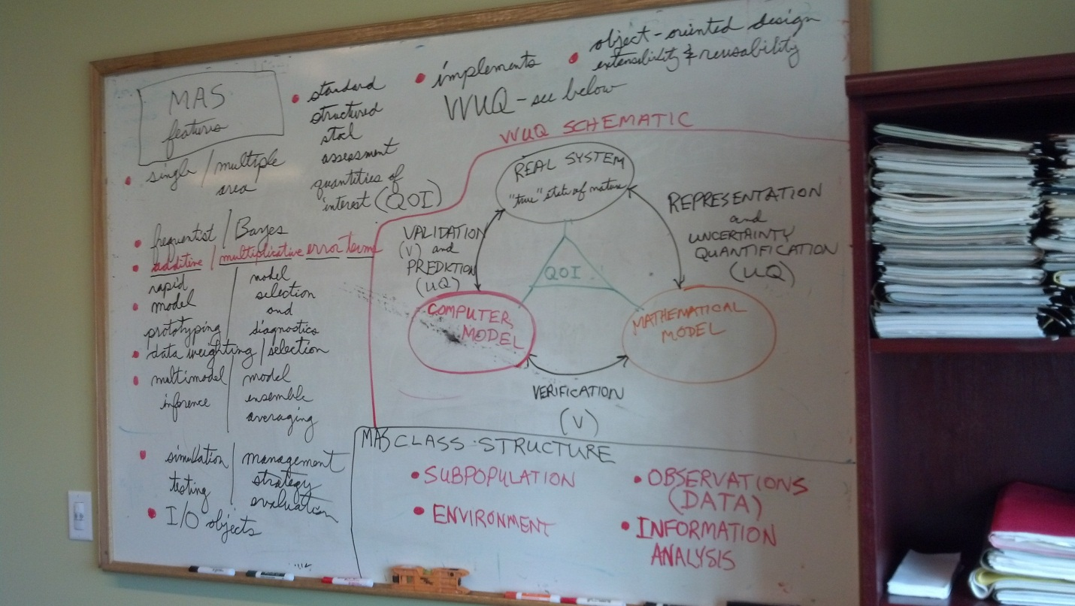
s