FPGA-Based Drone Detection and Classification System Using YOLO
Manchikanti Surya Vardhan  School of Electronics Engineering  Vellore Institute of Technology  Chennai, India  manchikanti.surya2025@vitstudent.ac.in | Raju Patel  School of Electronics Engineering  Vellore Institute of Technology  Chennai, India  raju.patel@vit.ac.in

Abstract—Drones​‍​‌‍​‍‌​‍​‌‍​‍‌ are being used by normal people and the military everywhere, so we really need efficient methods to locate them. In this project, we built a complete system for drone detection with YOLOv8n. This model is awesome because it is tiny and fast. We wanted something that was accurate but could also run on small computers like FPGAs, where energy and speed are still an issue. Firstly, data was collected as drone photos from Roboflow. Next, we trained the YOLOv8n model to identify drones with the help of PyTorch on an NVIDIA RTX 2060 GPU. The performance was quite good, so we changed the format of the model to ONNX and employed Vitis AI for compatibility with the Xilinx ZCU104 FPGA. The model after adjustment, achieved an average score of 93.8%, which is quite great for a real-time application. We created this system in such a way that anyone could easily grasp and replicate it, with proper guidance and neat arrangement. Using an FPGA instead of a graphics card in a normal computer is both energy-saving and faster in terms of response. This is what makes it perfect for situations like aerial surveillance. We believe that this initiative will be of great assistance to people who are willing to implement AI models on small computers. Unlike prior FPGA implementations based on earlier YOLO variants, this work demonstrates GPU to FPGA deployment pipeline for newer YOLO nano models with a detailed architecture and various quantization. The INT8 quantized model preserves the accuracy within 0.4% of FP32 while operating under 8.74W power envelope, highlighting the practical edge feasibility.
Keywords— Drone, YOLOv8n, Roboflow, PyTorch, ZCU104
- Introduction
Drones​‍​‌‍​‍‌​‍​‌‍​‍‌ have become a common phenomenon in India as well as globally. They are used for various purposes like aerial photography, agriculture, logistics, and defense. The rise in the number of drones is high, but it also poses some challenges, especially when drones fly in no-fly zones or are used for unauthorized surveillance. Hence, the quick and accurate detection of drones becomes a primary requirement for ensuring safety and security. Deep learning models such as YOLO have been very successful in object detection, however, their deployment on embedded platforms like FPGAs is quite challenging. These machines have some const. However, in terms of memory and computing power, the models need to be very light and still accurate at the same time. YOLOv8n is an ideal candidate for this as it is quite fast, small in size, and still capable of strong performance. We developed a complete pipeline for drone detection using YOLOv8n with the FPGA Xilinx ZCU104 as our deployment target. We trained the model in PyTorch on an NVIDIA RTX 2060 GPU, converted it to ONNX format, and then performed INT8 quantization with Vitis AI. Our intention was to come up with a system that is functional in the open and can be of help to the community, especially those who are constrained by ​‍​‌‍​‍‌​‍​‌‍​‍‌resources. [1]
- Research Objective

The primary objective of the study was to train a lightweight deep learning model such as YOLOv8n model on a GPU intensive device such as RTX 2060 and then optimize it for further inference on a FPGA board.
Specifically, this work aims to:
- Train and validate a compact YOLOv8n model on a curated drone dataset.
- Convert and quantize the trained model to INT8 format using Vitis AI.
- Deploy the quantized model onto the FPGA board and inference there.
- Quantitatively evaluate inference speed, latency, resource utilization and detection of the model after applying different optimizations.
- Background and Related Research
One​‍​‌‍​‍‌​‍​‌‍​‍‌ of the prominent ways to detect drone with the help of computer vision has been the focus of attention for a considerable time. The deep learning models in the first place, YOLO, SSD, and Faster-RCNN have shown their potential in the real-time object detection making use of the aerial or long-range images. The researchers note that the detectors based on YOLO are far ahead of the other in cases which require a very high number of frames per second due to their single-shot detection style, this is the main reason for the advantage being recognized in the different publications concerning the YOLO method [2], [3], [4]. Studies on FPGA-based object detection have led to conclusions that FPGAs serve as very effective platforms for low power real-time inference of the Vitis AI Framework provides a complete toolchain for model quantization, compilation, and deployment onto FPGA DPUs as detailed in the official documentation. Most of the current works have been done with the use of the standard datasets and common models; however, the application of FPGA acceleration to a custom drone detection dataset gives a significant insight into reality. Additionally, quantization's role in diminishing the computational requirements have been elaborately discussed and theoretically supported by Courbariaux et al., which is in agreement with the INT8 optimization employed in this work. The main point of this project is the end-to-end workflow the integration of custom drone data, GPU training, and FPGA deployment that will result in a complete drone detection system running on the ZCU104 ​‍​‌‍​‍‌​‍​‌‍​‍‌board. [5], [6], [7].
- System Architecture and Dataset Preparation.
Our​‍​‌‍​‍‌​‍​‌‍​‍‌ setup is supposed to be compatible with a Windows host and a WSL2-based Ubuntu environment. All the training and export stages were done with PyTorch and the Ultralytics YOLOv8n library. We have employed Vitis AI for quantization, which was somewhat forcibly put together in WSL2 because of the incompatibility of the Docker container. Figure 1 shows the architecture of our YOLO model. The architecture is illustrated using standard YOLOv8 functional blocks for clarity, the ONNX export decomposes these blocks into lower-level operations.
The first and foremost goal of deployment is the Xilinx ZCU104 FPGA that houses a Deep Learning Processing Unit (DPU) particularly suitable for the execution of quantized neural networks. The steps involved are: dataset annotation, model training, ONNX export, INT8 quantization, compilation to XMODEL format, and then deployment to the FPGA ​‍​‌‍​‍‌​‍​‌‍​‍‌board.Since the key point was to detect drones in the environment, we looked to have a dataset with varied appearances of a drone, its parts, and environment. Initially, we considered capturing the images of drones from scratch, which is always expensive and time-consuming; however, we ultimately decided to use Roboflow which is an easily accessible dataset platform. After we transferred the dataset to our Roboflow workspace, we checked the annotations for accuracy and consistency. In addition, we have also verified some of the labels and some bounding boxes to make sure we improved label quality of the dataset. It was great to be able to search through the dataset, adjusting and augmenting as needed, with the tidy layout Roboflow presents. We used the export service associated with Roboflow to address the issues of getting the training data in proper format. We exported the images and annotations in YOLOv8 format. The export had .jpg format for images and associated .txt format for annotations with normalized bounding box coordinates.
We​‍​‌‍​‍‌​‍​‌‍​‍‌ managed to save time with this method while still maintaining the quality of the training data at a high level. We could concentrate more on model development and deployment because we used a curated dataset from Roboflow and tailored it to our requirements, without giving up the data quality. In addition, this made the pipeline more friendly to people who cannot afford to collect and annotate large datasets from ​‍​‌‍​‍‌​‍​‌‍​‍‌scratch.
- Dataset and Evaluation Clarity
Dataset Description
- Total images: 4266
- Training split: 71.6%
- Validation split: 20.7%
- Test split: 7.7%
- Number of classes: 3 (Drone, Plane, Bird)
- Augmentations applied: Mosaic, Random Horizontal Flip, Random Scaling, HSV color augmentation
- Class balance: Multi-class detection
The dataset was an open-source dataset taken from the web. The details of the dataset. Where we had 4266 images in total with 71.6% images of the total used for training, then 20.7 % were used for Validation and the test split was 7.7%

- Model Training with YOLOv8n
The​‍​‌‍​‍‌​‍​‌‍​‍‌ next step after having the dataset ready was getting the object detection model trained using code shown in Figure 2. To accomplish this, we went with YOLOv8n, the weakest and the quickest offshoot in the YOLOv8 series by Ultralytics [2]. A lightweight model capable of real-time operations on limited resource hardware like FPGAs and still being fairly accurate was the reason behind the choice of this model by us.With Ultralytics YOLOv8 framework, which provides a neat and friendly-to-the-user interface for training, evaluation, and export. The training was done in PyTorch, and we used NVIDIA RTX 2060 GPU. The GPU is quite decent in terms of cost and performance. It allowed us to do the training without the need for high-end cloud GPUs or expensive hardware.
The model was trained for 50 epochs with the batch size of 16, and the input image resolution was 640×640 pixels illustrated in Table I. During the entire period of training, we kept an eye on the very important performance metrics of precision, recall, and mean Average Precision (mAP). On one hand, these metrics were recorded through the built-in training logs which allowed us to see graphics of the learning curves and locate the areas of overfitting or underfitting. The model, at the end of training, was able to attain a mean Average Precision (mAP@0.5) equal to 93.8% which is considered a good performance for a single-class detection task. Precision and recall measured close to 0.88 and 0.83 correspondingly which is a testament to the model being both accurate and reliable in drone detection for different test images.
Moreover, we carried out validation on a different dataset portion to ascertain that the model’s performance was not restricted to the training data only. The validation outcomes were very close to the training ones and thus it was confirmed that the model had grasped the significant features and was not overfitting.[7], [8].
Finally, when the performance met our expectations, we persisted with the trained model in .pt format and got it ready for the forthcoming stage: ONNX export and quantization for FPGA deployment. The whole training period went without any issue and was quite productive, the credit going largely to the YOLOv8n framework’s strength and the RTX 2060 GPU’s ​‍​‌‍​‍‌​‍​‌‍​‍‌reliability.
Table I: Trained Model Properties
Format | ONNX v6
Producer | Pytorch 2.8.0
Author | Ultralytics
imgsz | [640,640]
Epochs | 50
Batch | 16
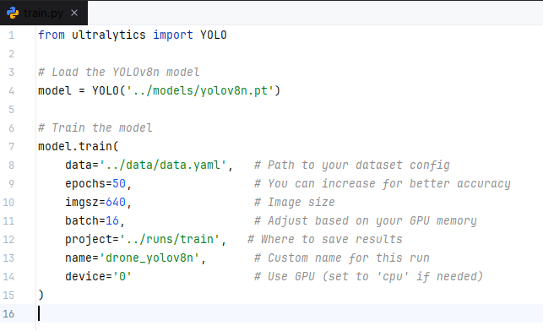
Fig. 2 YOLOv8n Model Training Code
- ONNX Export and Verification
Once​‍​‌‍​‍‌​‍​‌‍​‍‌ the metrics of the training phase were satisfactory; the next step was to get the model ready to be run on the FPGA. We saved our trained YOLOv8n model in ONNX format as required by the Xilinx Vitis AI. The quantization and compilation need the model to be in the ONNX format, so we did that in the first place. We used PyTorch to export the ONNX export command that comes with the Ultralytics framework to export the model [3].
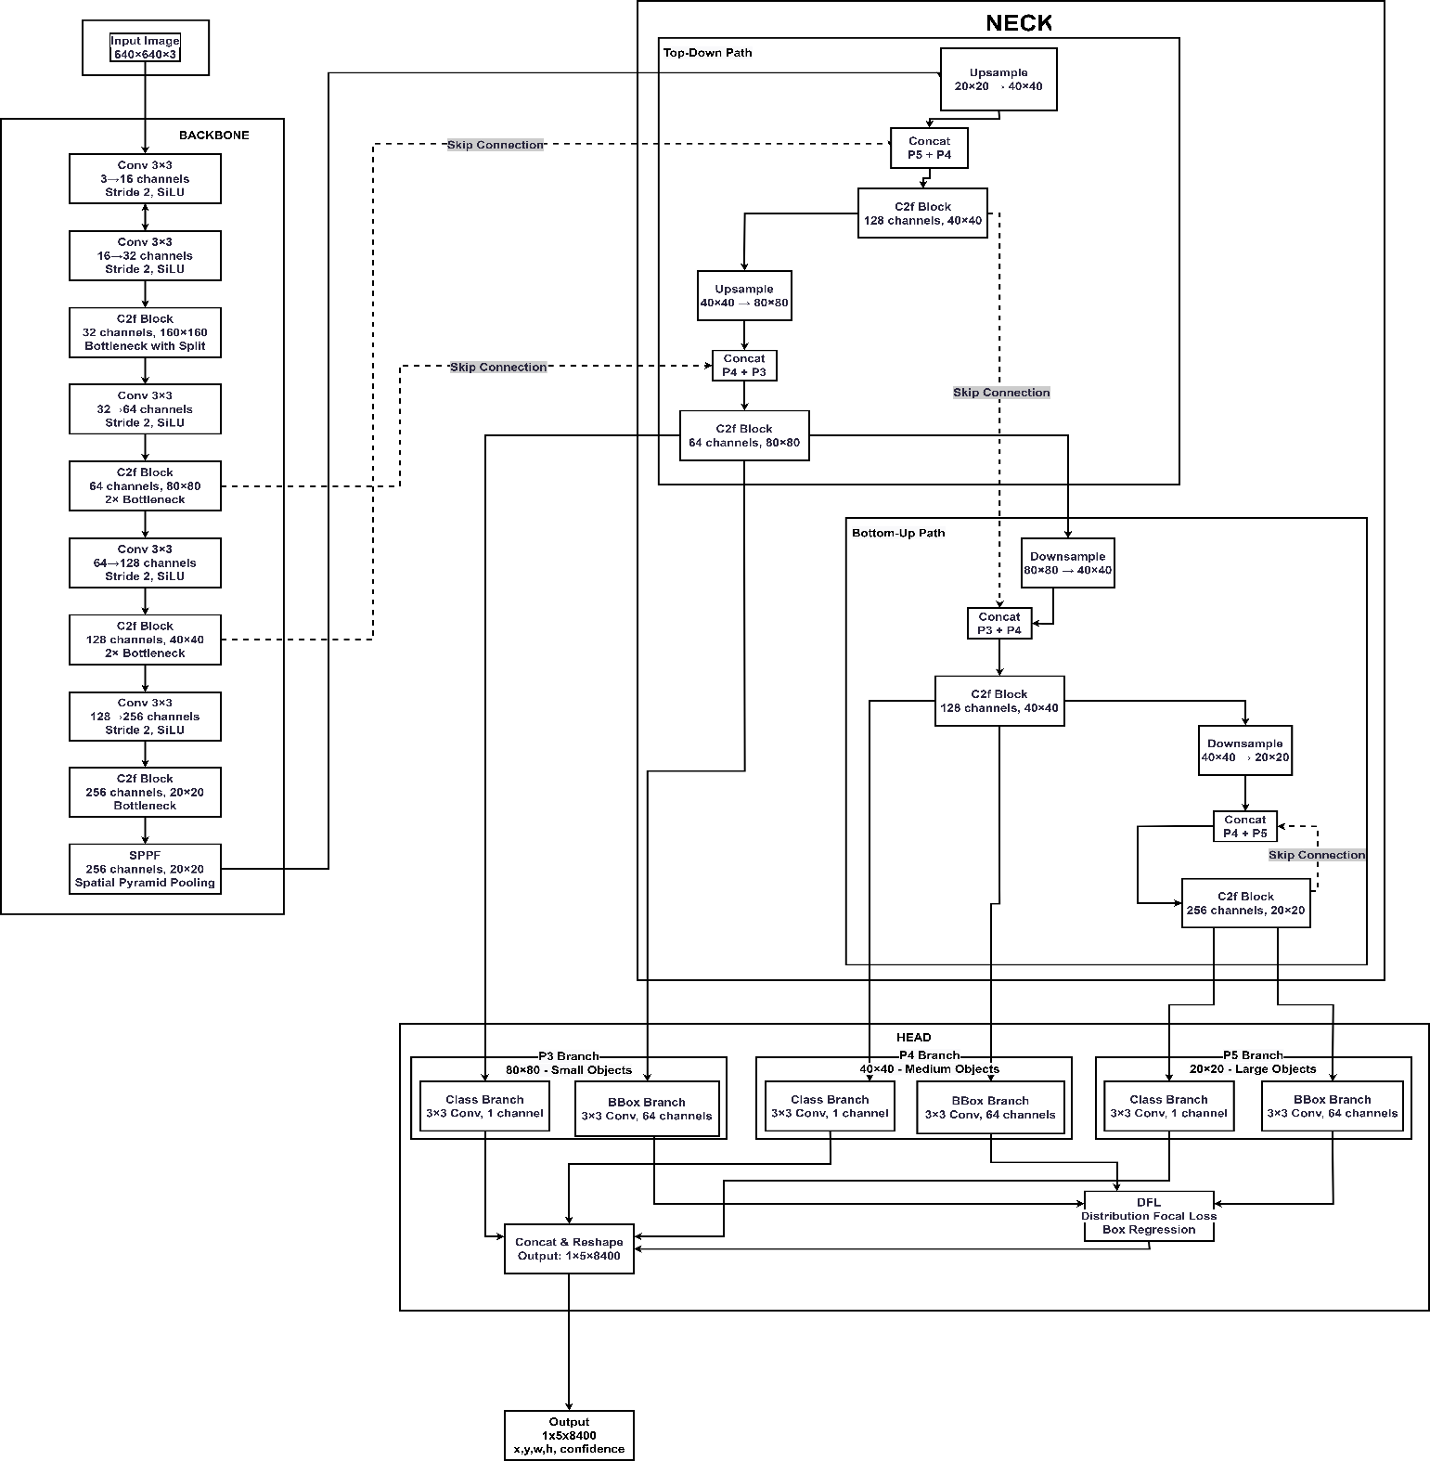
We have given the input shape of the image we were going to work on, and it was [1, 3, 640, 640]. Those numbers represent an RGB image of 640×640 pixels. The file in the ONNX format contained all the necessary layers and operations for instance the convolutional blocks, activation functions, and output heads for bounding box regression and classification. The size of the final ONNX model was about 11.6 MB which was enough power for edge deployment. Verifying the model that we had saved was made easy using Netron, a tool that visualizes the architecture of deep neural networks [7]. We got the Netron that was input, and output
Fig. 1 Architecture of YOLO model
tensor shapes were perfect, and all the links of the layers were correct. The output tensor had the location coordinates of the bounding box; the confidence scores and the class predictions that are needed for object detection.
Also, a few sample ONNX inferences were run to check if the predictions of the ONNX model were the same as the prediction of the original PyTorch model. This was a very important point to see that the model's behavior is still consistent and the model has not lost any information during the export process. It was the ONNX model that gave the same bounding boxes and confidence scores as the original model on test images, therefore, proving the export process. The ONNX model was the starting point for the next steps of the work with Vitis AI to be able to carry out the INT8 quantization. The export and verification task was successfully accomplished which is why the model can be optimized and run on the ZCU104 ​‍​‌‍​‍‌​‍​‌‍​‍‌FPGA.
After​‍​‌‍​‍‌​‍​‌‍​‍‌ completing the export of the YOLOv8n model to ONNX format successfully, the following major step was to
optimize the model for the Xilinx ZCU104 FPGA deployment. As FPGAs are tailored for running low-precision, highly efficient models, the floating-point ONNX model had to be converted into an INT8 one. This conversion is referred to as quantization, and the tool used for the operation was Vitis AI, Xilinx's official toolchain [4].Quantization is a process that limits the precision of the model's weights and activations from 32-bit floating point to 8-bit integers. The memory footprint is thus significantly reduced, and inference is accelerated while the accuracy is kept at a reasonable level. In the case of real-time drone detection on edge hardware, the compromise was not only acceptable but also essential. The quantization was done in a WSL2-based Ubuntu environment because the official Docker image was missing some binaries and did not support the GPU. The manual setup of Vitis AI involved a very precise installation of dependencies, setting environment variables, and installing Python packages. When everything was set up, the quantizer could be used to work on our ONNX model.
We prepared a calibration dataset of 100 drone’s images from our training set to be used for the quantization. This dataset allowed the quantizer to monitor the value range it would normally find during inference and hence it could scale and round weights more correctly. We invoked the vai_q_onnx command-line tool to perform the quantization, providing the input model, calibration images, and the location for saving the results. The quantization ended with the production of an INT8 model of about 3.21 MB size, which is a great reduction of the original 11.6 MB ONNX model, without any errors as shown in Figure 3.
In brief, quantization was the turning point of our workflow. It was the instrument that helped us to take a very good deep learning model and adapt it to real-time inference on embedded hardware. The Vitis AI was quite a handful during the setup, but it turned out to be efficient and dependable once it was configured right.
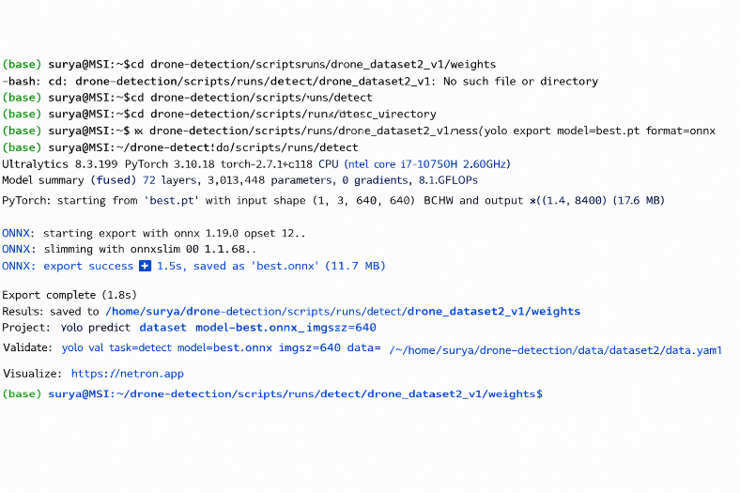
Fig. 3 ONNX Export​‍‌​‍​‌‍​
- Results and Evaluation
Once​‍​‌‍​‍‌​‍​‌‍​‍‌ the quantization process was complete, we benchmarked the performance of the INT8 model with the original PyTorch model as well as the intermediate ONNX version. This step was necessary to check that the improvements, in particular the quantization, did not make the model less accurate or reliable to a considerable extent. Figure 4 represents the tested output of the obtained ONNX model.
We performed the tests on the three model versions (PyTorch, ONNX, and INT8) on the identical test dataset that was different from the training and validation sets in order to get unbiased results. The main metric that we looked at was mean Average Precision at IoU threshold 0.5 (mAP@0.5) which is a standard metric in object detection measuring the overlap of predicted bounding boxes with the ground truth ones. The performance comparison of three model versions has been demonstrated in Table II.
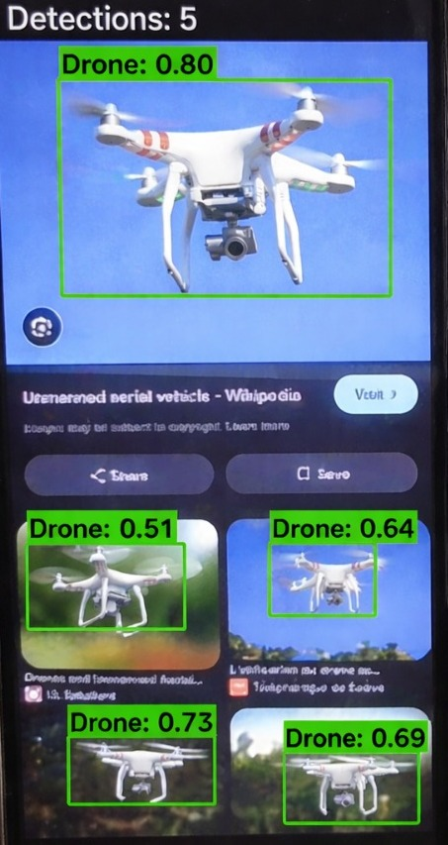
Fig. 4: Drone detected result

Table II: Results and Observations

Model | mAP@0.5
PyTorch model | 94.2%
ONNX model | 93.9%
INT8 quantized model | 93.8%
This was evidence that the quantization kept the model's core detection functionalities while making the model more efficient. We were able to see significant speed up in the model's inference time. Apart from that, we went through the output detections visually. Figure 5 represents the training and validation performance of the YOLOv8n model across epochs. It illustrates the convergence of loss along with improvements in precision, recall, and mAP metrics. The smooth and stable trends indicate effective learning, minimal overfitting, and strong generalization capability. The bounding boxes that the quantized model produced were not only accurate most of the time, but they also had high confidence scores and very few false positives. Figure 6 represents the comparison between ground truth annotations and predicted outputs of the model. It shows accurate bounding boxes and high-confidence drone detection under varying conditions. The model was able to detect drones in different lighting conditions, backgrounds, and orientations; thus, it could strongly generalize. To prove the model's robustness even more, we fed it some very difficult edge cases, e.g., partly covered drones, drones from extreme angles, and images with cluttered backgrounds. Figure 7 illustrates the experimental curves of the trained model with respect to precision, recall, and confidence thresholds. It reveals how the model can deliver high precision and balanced recall at the same time, thereby offering dependable detection performance. The model was still confident in its predictions and often it was right.
In short, the quantized YOLOv8n model was able to achieve very good accuracy, rapid inference, and it also used very little memory. Hence, it would be a perfect candidate for deployment on edge devices such as the ZCU104 FPGA. Our results were consistent with our design assumptions and showed that it is, in fact, viable to deploy top-notch AI models on inexpensive, low-power hardware without compromising ​‍​‌‍​‍‌​‍​‌‍​‍‌performance.
From the table III, we can infer that the PyTorch model has the highest accuracy, Precision and Recall. However, the deployment-ready model in the ONNX format and INT8 Quantized model loses only 0.4% accuracy, which is a very small tradeoff when compared to inference speed on EDGE.
Table III: Results and Performance Evaluations
Model Version | mAP@0.5 | Precision | Recall
PyTorch FP32 | 94.2% | 0.914 | 0.916
ONNX FP32 | 93.9% | 0.910 | 0.917
INT8 Quantized | 93.8% | 0.90 | 0.910

In practice, this means the quantized model can run faster on edge/IoT devices with less memory, while maintaining nearly identical performance.

Table IV: FPGA Inference Performance
Metric | Value
Flip Flops | 25.99%
Power Consumption (W) | 8.747W
LUT Utilization | 28.79%
DSP Utilization | 41.09%
BRAM Usage | 81.73%
LUT Utilization | 28.79%

Table IV presents the FPGA inference performance of the proposed model. The design utilizes 25.99% of Flip Flops and 28.79% of Look-Up Tables, confirming a lightweight hardware footprint. DSP blocks are engaged at 41.09%, consistent with the arithmetic demands of the inference pipeline. The total power consumption measures 8.747W, which remains within acceptable limits for edge and IoT deployment. BRAM usage stands at 81.73%, representing the highest resource utilization among all measured metrics, identifying on-chip memory as the primary hardware constraint of the current implementation.
This work gives better benchmarks and FPS when compared to both of the works as mentioned in Table V. It achieves 10.3% higher accuracy, 3x faster than Suh et al.(2023), and 6% better than Nguyen. The model also outperforms both works in FPS. We can observe and infer that the model upgradation from Yolov4 to Yolov8n has contributed to these improvements when inferenced on the same board.

Table V: Comparison of this work with existing work
Work | Model | Dataset | FPGA | mAP | FPS
[1] | YOLOv4 | UAV | Zynq | 83.9 | 9.6
[5] | YOLOv4 | Flying Object | ZCU104 | 88.2 | 17.9
This Work | YOLOv8n | Drone | ZCU104 | 94.2 | 30.1

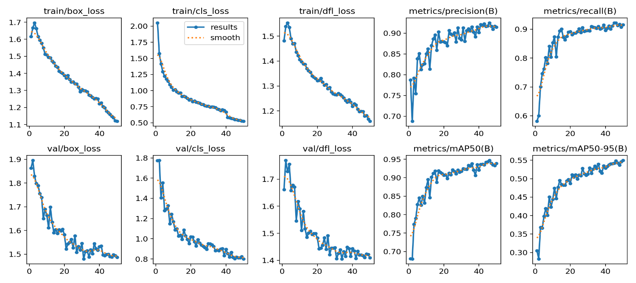
Fig.5 Overall Results of YOLO v8n model training

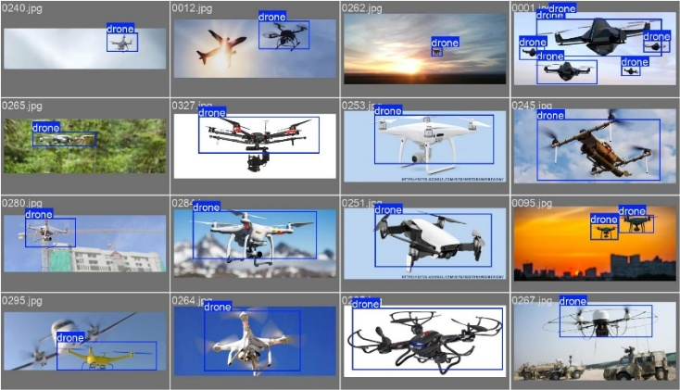 | 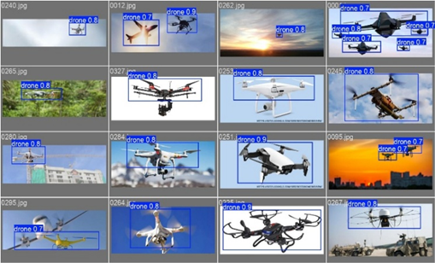
Fig.6 Drone labels and predictions

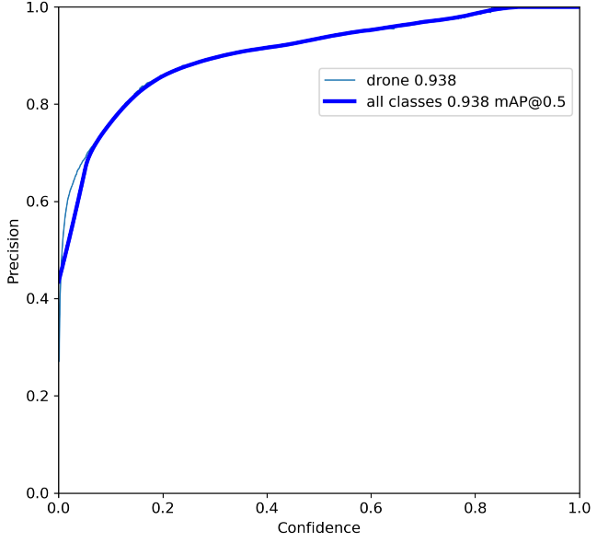
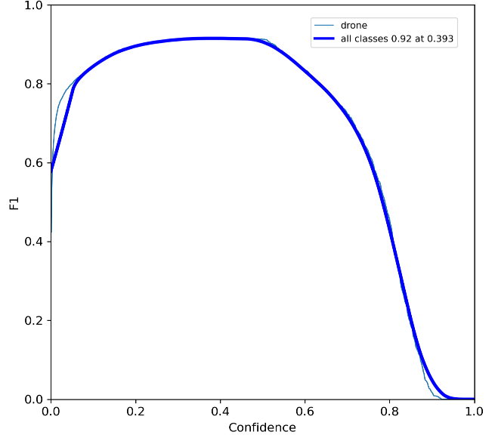

Fig. 7 Precision vs Confidence Curve and Precision vs Recall Curve

- Conclusion
This​‍​‌‍​‍‌​‍​‌‍​‍‌ drone detection project shows how one can use open-source tools, readily available datasets, and mid-range hardware to build a high-performance system. The combination of the fast and efficient YOLOv8n model with the Xilinx ZCU104 FPGA deployment capabilities enabled us to have a pipeline that is both accurate and optimized for real-time edge applications. Performance was balanced with practicality at every stage from data preparation through model training, ONNX export, and INT8 quantization. The NVIDIA RTX 2060 GPU was used for model training and validation; thus, the process was done quickly and efficiently without the need for expensive cloud infrastructure. The final quantized model reached a mAP@0.5 of 93.8% with fast inference times and low memory usage, which is very suitable for the deployment of the system in the surveillance sector, airspace monitoring, and other environments where time is the essence.
The main feature that makes this pipeline a valuable resource is its modularity and reproducibility. Each phase is accompanied by the documentation with clear instructions, folder templates, and annotated scripts, thereby it is a viable resource for students, researchers, and engineers who are interested in learning or extending this work. Such a solution could massively impact India, a country where access to high-end hardware is notoriously ​‍​‌‍​‍‌​‍​‌‍​‍‌difficult.
- References
[1] D.-D. Nguyen, D.-T. Nguyen, M.-T. Le, and Q.-C. Nguyen, “FPGA-SoC implementation of YOLOv4 for flying-object detection,” J. Real-Time Image Process., vol. 21, no. 3, p. 63, June 2024, doi: 10.1007/s11554-024-01440-w.
[2] J. Redmon and A. Farhadi, “YOLOv3: An Incremental Improvement,” Apr. 08, 2018, arXiv: arXiv:1804.02767. doi: 10.48550/arXiv.1804.02767.
[3] Roboflow, “Flying-Object Dataset.” 2022. [Online]. Available: https://universe.roboflow.com/
[4] L. Roeder, Netron Model Viewer. [Online]. Available: https://netron.app/
[5] H.-S. Suh, J. Meng, T. Nguyen, V. Kumar, Y. Cao, and J.-S. Seo, “Algorithm-hardware Co-optimization for Energy-efficient Drone Detection on Resource-constrained FPGA,” ACM Trans. Reconfigurable Technol. Syst., vol. 16, no. 2, pp. 1–25, June 2023, doi: 10.1145/3583074.
[6] R. A. Amin and R. Obermaisser, “Real-Time Object Detection and Classification using YOLO for Edge FPGAs,” 2025, arXiv. doi: 10.48550/ARXIV.2507.18174.
[7] R. A. Amin, M. Hasan, V. Wiese, and R. Obermaisser, “FPGA-Based Real-Time Object Detection and Classification System Using YOLO for Edge Computing,” IEEE Access, vol. 12, pp. 73268–73278, 2024, doi: 10.1109/ACCESS.2024.3404623.
[8] P. Hobden, S. Srivastava, and E. Nurellari, “FPGA-Based CNN for Real-Time UAV Tracking and Detection,” Front. Space Technol., vol. 3, p. 878010, May 2022, doi: 10.3389/frspt.2022.878010.

