SCHEMA/ERD SKETCH
Raw data (Original CSV data loaded into PostgreSQL with python script)
games, players, earn_events, redeem_events, fx_rates
Staging layer (Type casting, deduplication, and redemption history reconstruction)
stg_games, stg_players, stg_earn_events, stg_redeem_events, stg_redemption_history, stg_fx_rates
Analytics layer (Monthly reporting models used in Excel report)
monthly_earned, monthly_redeemed, monthly_redeemed_by_game, monthly_outstanding_float

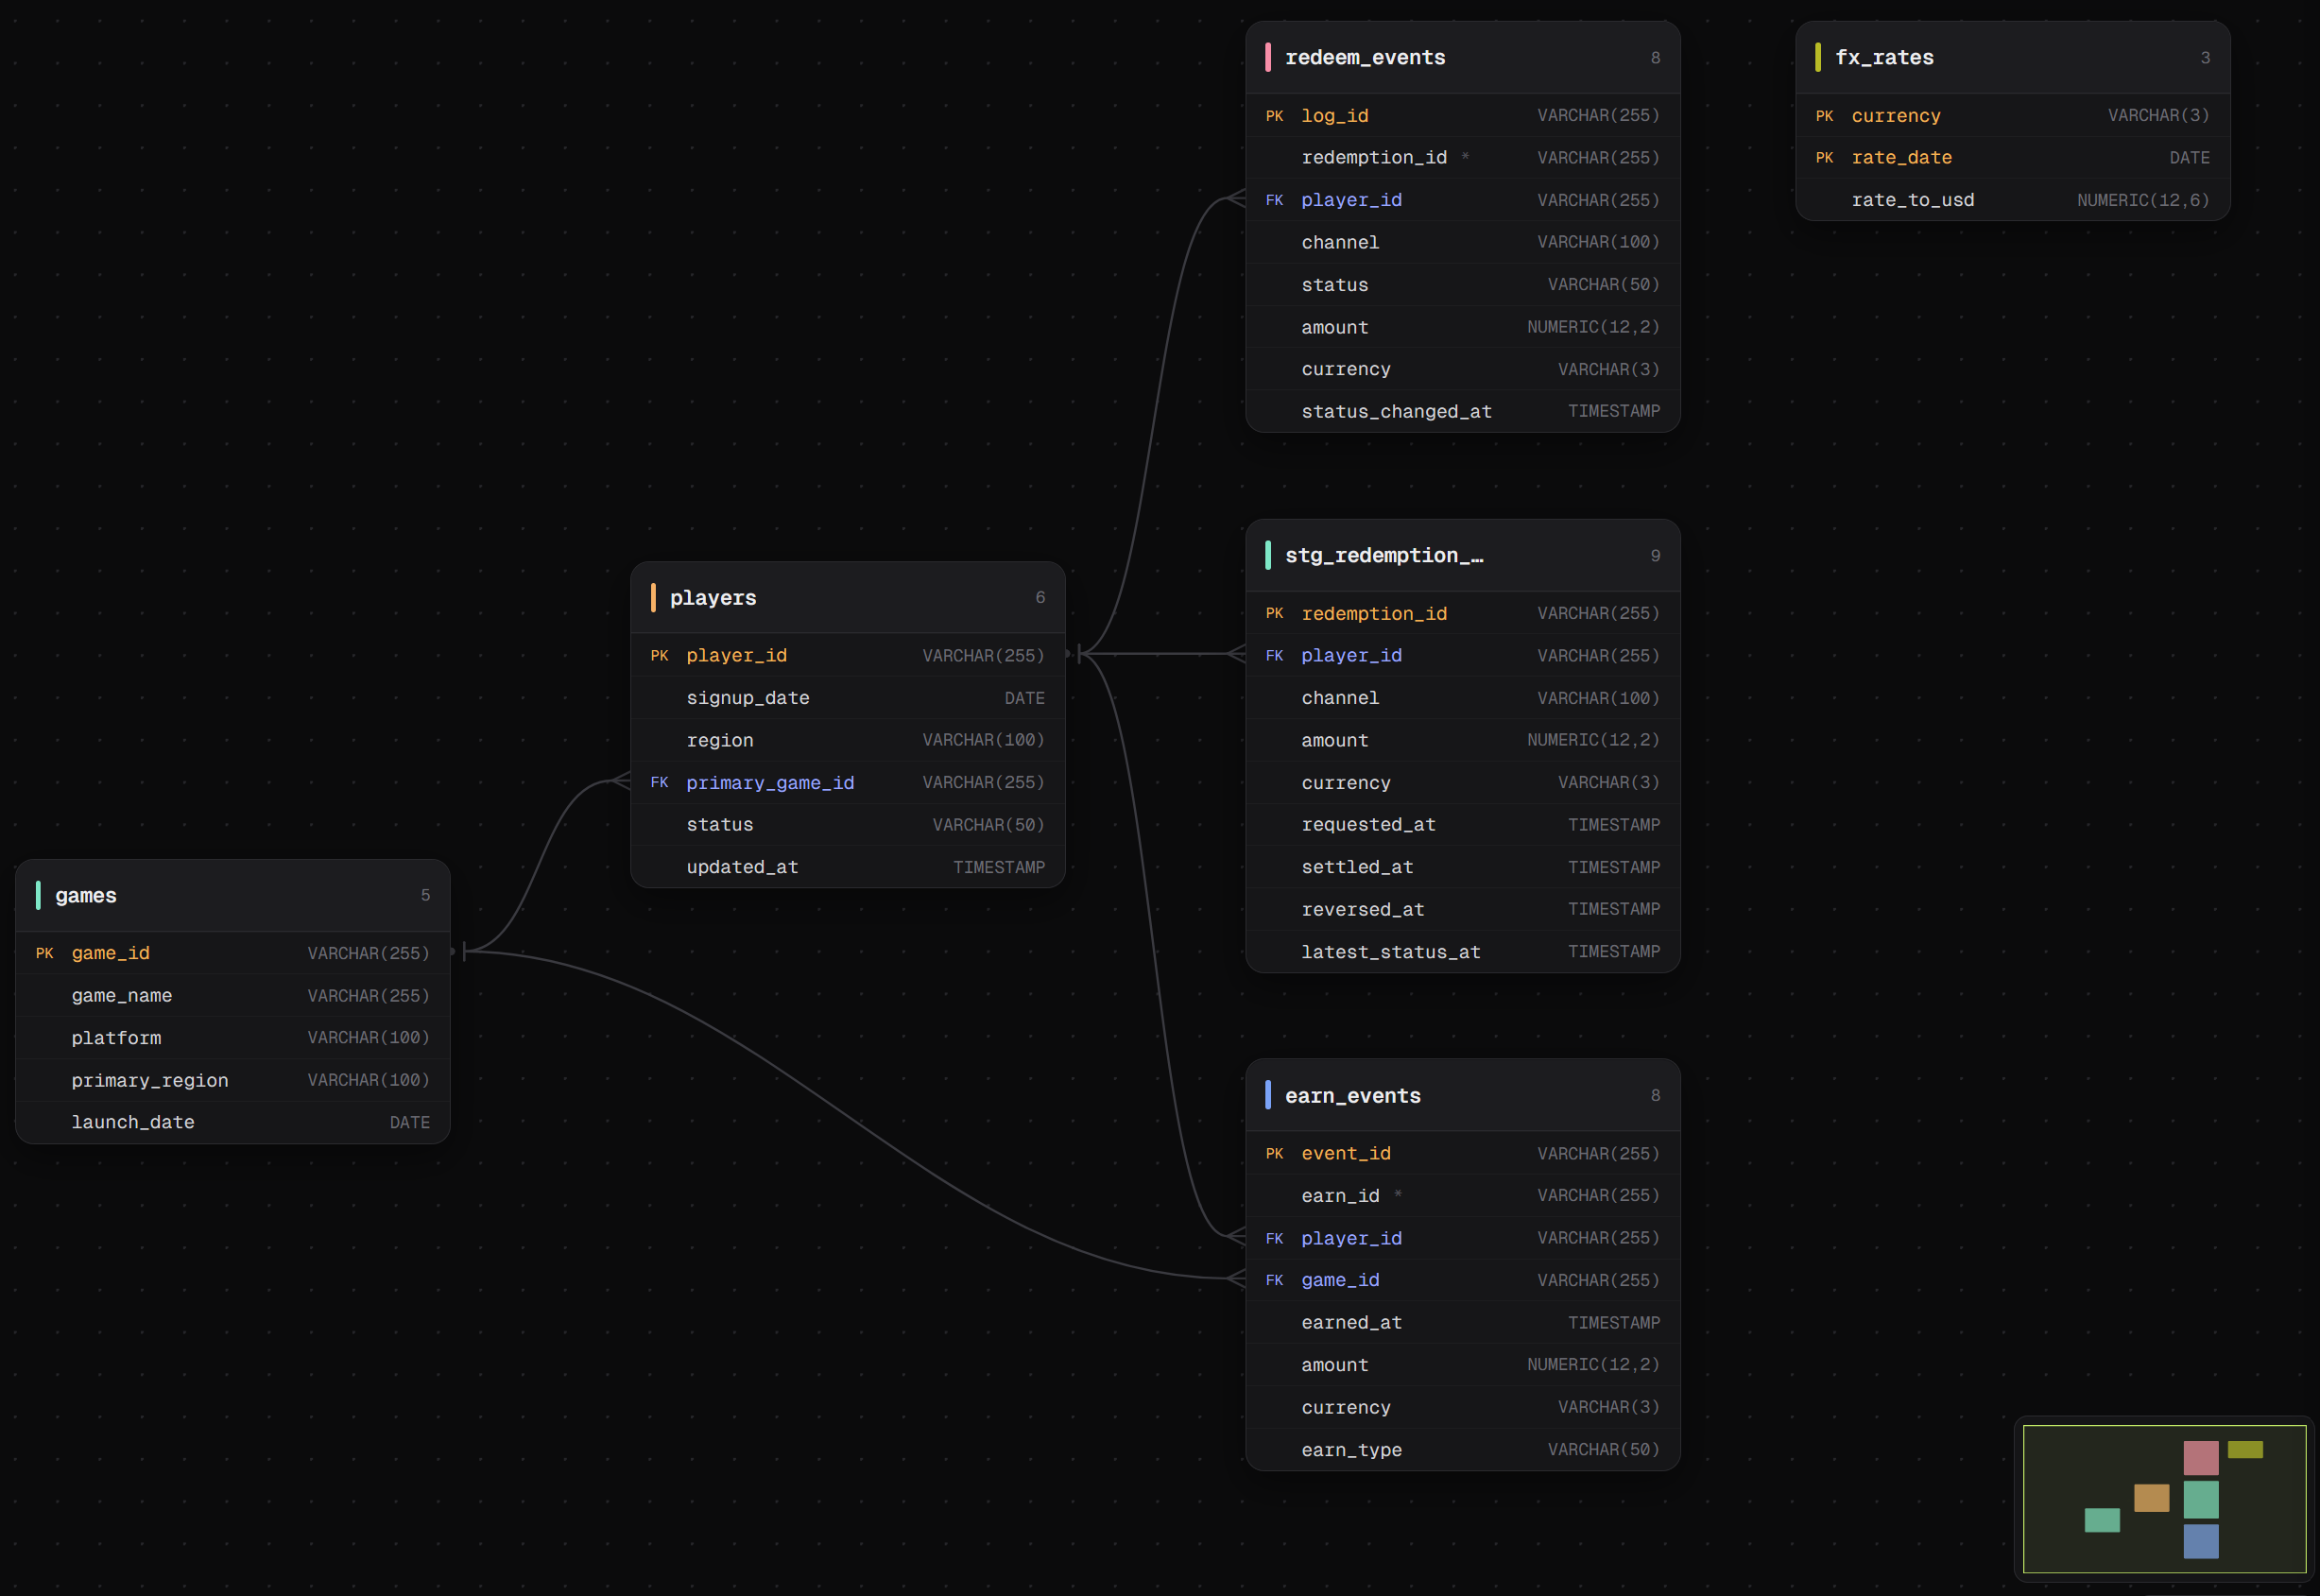

ASSUMPTIONS/STAKEHOLDER QUESTIONS
All dates are in the same timezone.
There is no earned or redemption history before January 2024 (starting at $0).
Duplicate earn records that share the same earn_id are treated as duplicate records and counted once (earliest record).
Redeem events table does not include a game_id so using primary_game_id (see “if I had more time” below).
Outstanding float is calculated as cumulative of earned value minus net redeemed value (settlements = positive, reversals = negative). Assumed these are the only statuses and there are no expirations, etc.

AI USAGE
AI was used to help generate the raw ingestion python script, help generate SQL code for staging tables, generate code for ERD image, explain what outstanding float meant, help me remember cumulative total syntax, and create a lot of the tests included in the file. I also used it to validate totals after creating pivots on the excel files. Also helped with creating a git repo (have not created one before).

WHAT I’D DO DIFFERENTLY WITH MORE TIME
Take a breath.
Manage and track time better.
Spend more time thinking about the project before diving in and wasting time on things that don’t matter.
Have more time to look into and validate results.
Spend more time digging into earned events vs redeemed events vs game_id to see if I can correctly identify the actual game_id for each redemption.
Make the Excel report prettier – add slicers and organize it better. Add additional things that might be interesting/important to stakeholders and group by different fields, etc.

APPROXIMATE TIME TAKEN FROM START TO GIT UPLOAD
4 hours 50 minutes

