1. Write a program to count
2026-27
Python Programming
a. vowels, consonants, digits, and special characters in a string given as input.

PROGRAM:
s = input("Enter a string: ")
vowels = 0
consonants = 0
digits = 0
special = 0
for ch in s:
if ch.isalpha():
if ch.lower() in "aeiou":
vowels += 1
else:
consonants += 1
elif ch.isdigit():
digits += 1
else:
special += 1
print("Vowels:", vowels)
print("Consonants:", consonants)
print("Digits:", digits)
print("Special characters:",special)

OUTPUT:

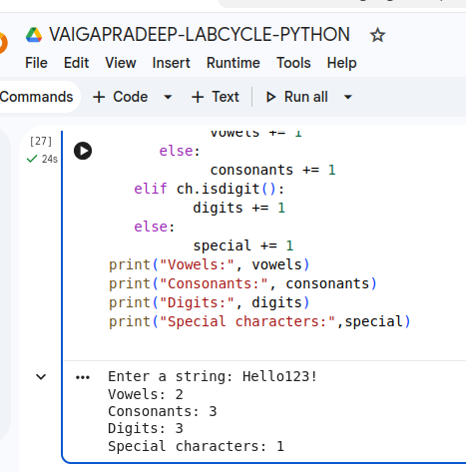

Chinmaya Arts & Science College For Women
1
2. Write a program to find the largest and second largest element in a list.
Python Programming
2026-27

PROGRAM:

numbers = [10, 25, 8, 45, 32]
largest = second = float('-inf')
for num in numbers:
if num > largest:
second = largest
largest = num
elif num > second and num != largest: second = num
print("Largest element:", largest)
print("Second largest element:", second)

OUTPUT:
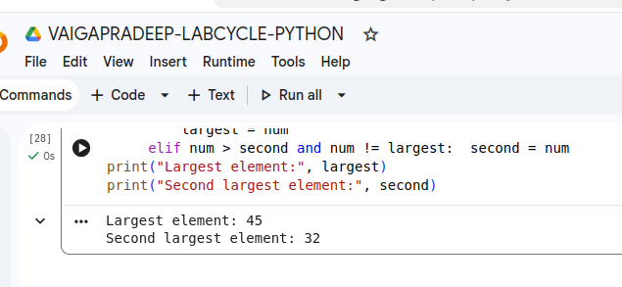

Chinmaya Arts & Science College For Women
2
3. Write a program to count word frequency using a dictionary
Python Programming
2026-27

PROGRAM:

text = input("Enter a sentence: ")
words = text.split()
frequency = {}
for word in words:
if word in frequency:
frequency[word] += 1
else:
frequency[word] = 1
print("Word frequency:")
for word, count in frequency.items():
print(word, ":", count)

OUTPUT:

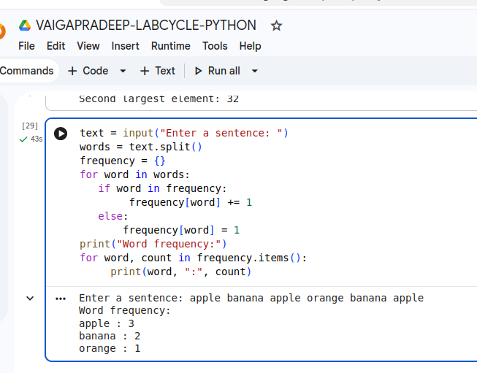

Chinmaya Arts & Science College For Women
3
4. Write a program to sort dictionary by keys and the by values
Python Programming
2026-27

PROGRAM:

#Sort dictionary by keys
d = {'b': 2, 'a': 1, 'c': 3}
sorted_d = dict(sorted(d.items()))
print("Dictionary sorted by keys:")
print(sorted_d)
#Sort dictionary by values
d = {'a': 3, 'b': 1, 'c': 2}
sorted_d = dict(sorted(d.items(), key=lambda x: x[1]))
print("Dictionary sorted by values:")
print(sorted_d)

OUTPUT:

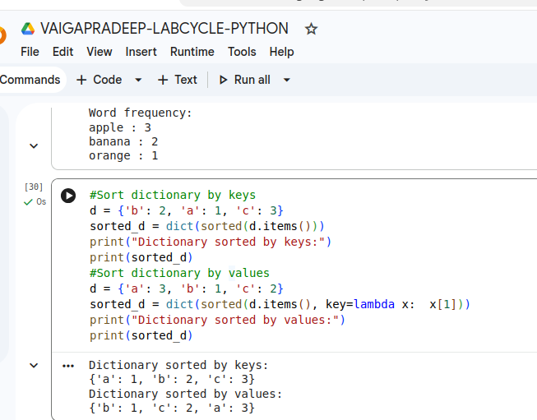

Chinmaya Arts & Science College For Women
4
5. Write a program using list comprehension to generate prime numbers.
2026-27
Python Programming

PROGRAM:

#USING LIST
def chk_prime(n):
if n<=1:
return True
for i in range(2,(n//2)+1):
if(n%i==0):
return False
else:
return True
l1=[]
n=int(input("enter how many elements:"))
for i in range(n):
x=int(input("enter the values:"))
l1.append(x)
prime_of_l1=[]
for x in l1:
if chk_prime(x):
prime_of_l1.append(x)
print("the given list:",l1)
print("the list of prime number:",prime_of_l1)
print("---"*10)
#using list comprehension
def chk_prime(n):
if n<=1:
return True
for i in range(2,(n//2)+1):
if(n%i==0):
return False

return True
l1=[]
n=int(input("enter how many elements:"))
for i in range(n):
x=int(input("enter the values:"))
l1.append(x)
prime_of_l1=[x for x in l1 if chk_prime(x)]
print("the list given is:",l1)
print("the list of prime numberis:",prime_of_l1)

Chinmaya Arts & Science College For Women
5
OUTPUT:
2026-27
Python Programming

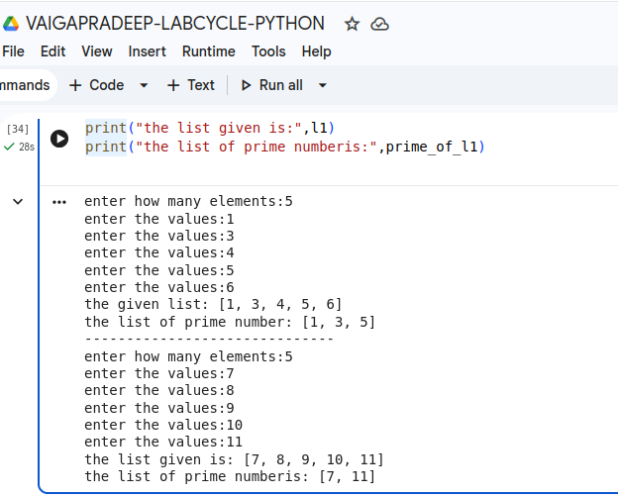

Chinmaya Arts & Science College For Women
6
6. Write a program to generate Fibonacci series using loops.
2026-27
Python Programming

PROGRAM:

n = int(input("Enter the number of terms: "))
a = 0
b = 1
print("Fibonacci series:")
for i in range(n):
print(a, end=" ")
c = a + b
a = b
b = c

OUTPUT:

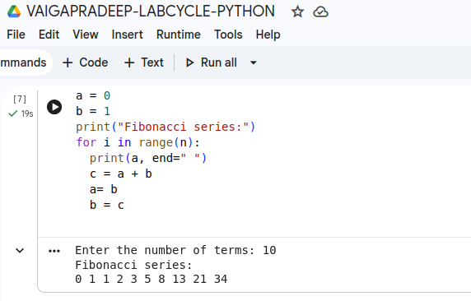

Chinmaya Arts & Science College For Women
7
7. Sort strings by length using lambda function
Python Programming
2026-27

PROGRAM:

#Sort strings by length using lambda function.

strings = ["apple", "cat", "banana", "dog"]

sorted_strings = sorted(strings, key=lambda x: len(x))

print("Strings sorted by length:")
print(sorted_strings)

OUTPUT:

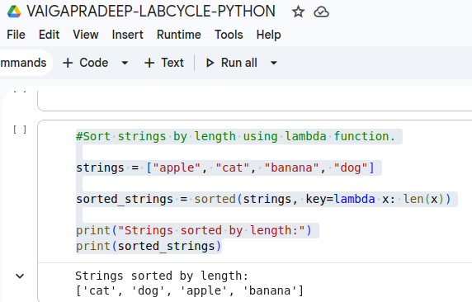

Chinmaya Arts & Science College For Women
8
8. Sort dictionary using multiple values and lambda function
2026-27
Python Programming

PROGRAM:
students = {
"Asha": (85, 90),
"Binu": (75, 95),
"Cathy": (85, 80),
"Deepa": (75, 85)
}

sorted_students = dict(sorted(students.items(), key=lambda x: (x[1][0], x[1][1])))

print(sorted_students)

OUTPUT:

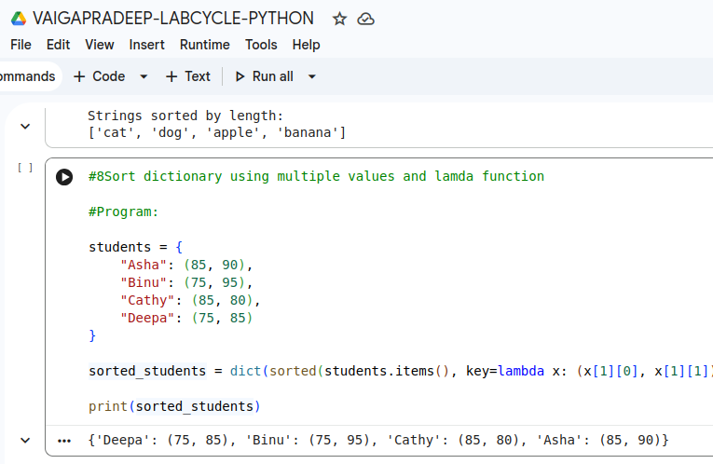

Chinmaya Arts & Science College For Women
9
9.a.Write a program to demonstrate polymorphism using function overloading and operator overloading
Python Programming
2026-27
b.write a program to demonstrate inheritence

PROGRAM:
(Polymorphism):
class ComplexNumber:
real = 0
img = 0
def __init__(self, rel, ig):
self.real = rel
self.img = ig
def display(self):
print(f"The complex number = {self.real}+{self.img}i")
def __add__(self, other):
real = self.real + other.real
img = self.img + other.img
return ComplexNumber(real, img)
def __mul__(self, other):
real = self.real * other.real - self.img * other.img
img = self.real * other.img + self.img * other.real
return ComplexNumber(real, img)
# Main program
print("Sum of these =")
c1 = ComplexNumber(5,4)
c2 = ComplexNumber(5,3)
c1.display()
c2.display()
c3 = c1 + c2
c3.display()
print("Product of these =")
c4 = c1 * c2
c4.display()

OUTPUT:
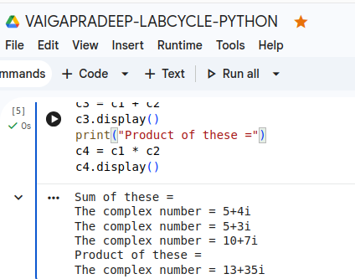

Chinmaya Arts & Science College For Women
10
(Inheritence)
2026-27
Python Programming
class Person:
def __init__(self, name, department):
self.name = name
self.department=department
def display(self):
print("NAME:", self.name)
print("DEPARTMENT:", self.department)
class Student(Person):
def __init__(self,name,department,perc):
super().__init__(name,department)
self.perc=perc
def findgrade(self):
if self.perc>=90:
print("Grade: A")
elif self.perc>=80:
print("Grade: B")
elif self.perc>=70:
print("Grade: C")
else:
print("Grade: D")
def display(self):
print("NAME:",self.name)
print("DEPARTMENT:",self.department)
print("PERCENTAGE:",self.perc)
class Teacher(Person):
def __init__(self,name,department,salary):
super().__init__(name,department)
self.salary=salary
def teach(self):
print(self.name,"has salary")
print(self.salary)
s1=Student("ANU","BCA",98)
s2=Student("MANU","BBA",55)
t1=Teacher("SREE","Bcom",150000)
t2=Teacher("TOM","BSC",100000)
s1.findgrade()
s1.display()
s2.findgrade()
s2.display()
print("*"*25)
t1.display()
t1.teach()
t2.display()
t2.teach()

Chinmaya Arts & Science College For Women
11
OUTPUT:
2026-27
Python Programming

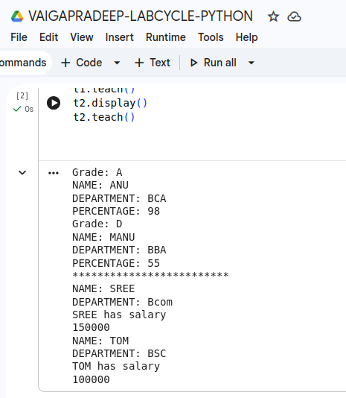

Chinmaya Arts & Science College For Women
12
10. Write a program to read and write text files .Use exceptions
2026-27
Python Programming

PROGRAM:

try:
# Writing to a file
file = open("students.txt", "w")
file.write("Vaiga- BCA - 85\n")
file.write("Prathya- BCA - 90\n")
file.close()

# Reading from the file
file = open("students.txt", "r")
data = file.read()
print("File Content:")
print(data)
file.close()

except FileNotFoundError:
print("File not found.")

except Exception as e:
print("An error occurred:", e)

OUTPUT:
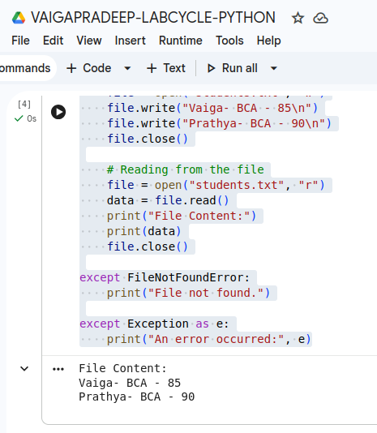

Chinmaya Arts & Science College For Women
13
11. Write a Python program using Pandas
2026-27
Python Programming
a. to create and analyze a student dataset containing student name, marks and grade.
b. Use the following data:
data = { "Name": ["Aman", "Diya", "Rahul", "Sneha", "Arjun"], "Marks": [78, 92, 85, 67, 74], "Grade": ["B", "A", "A", "C", "B"]}
c. Perform the following operations:
i. Create a Pandas DataFrame using the given dataset.
ii. Display the complete dataset.
iii. Display the first 3 rows of the dataset.
iv. Check whether the dataset contains missing values.
v. Create a histogram showing mark distribution.
vi. Find median and standard deviation of marks.

PROGRAM:

import pandas as pd
import matplotlib.pyplot as plt
# Given data
data = {
"Name": ["Aman", "Diya", "Rahul", "Sneha", "Arjun"],
"Marks": [78, 92, 85, 67, 74],
"Grade": ["B", "A", "A", "C", "B"]
}
# i. Create DataFrame
df = pd.DataFrame(data)
# ii. Display complete dataset
print("Complete Dataset:")
print(df)
# iii. Display first 3 rows
print("\nFirst 3 Rows:")
print(df.head(3))
# iv. Check for missing values
print("\nMissing Values:")
print(df.isnull().sum())
# v. Create histogram
plt.hist(df["Marks"], bins=5,
edgecolor="black")
plt.xlabel("Marks")
plt.ylabel("Number of Students")
plt.title("Mark Distribution")
plt.show()
# vi. Find median and standard deviation
print("\nMedian of Marks:",
df["Marks"].median())
print("Standard Deviation of Marks:", df["Marks"].std())

Chinmaya Arts & Science College For Women
14
OUTPUT:
2026-27
Python Programming
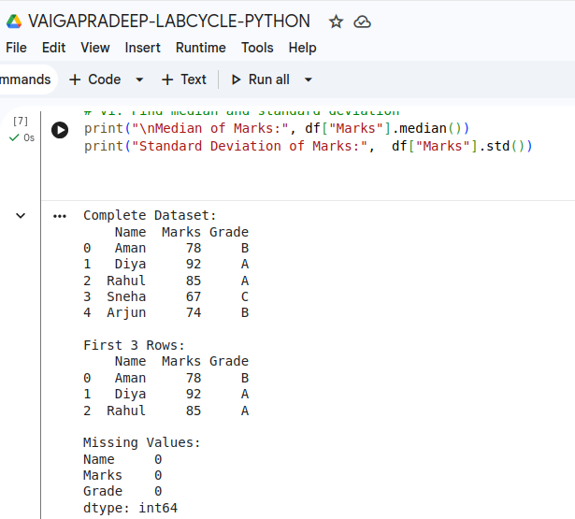

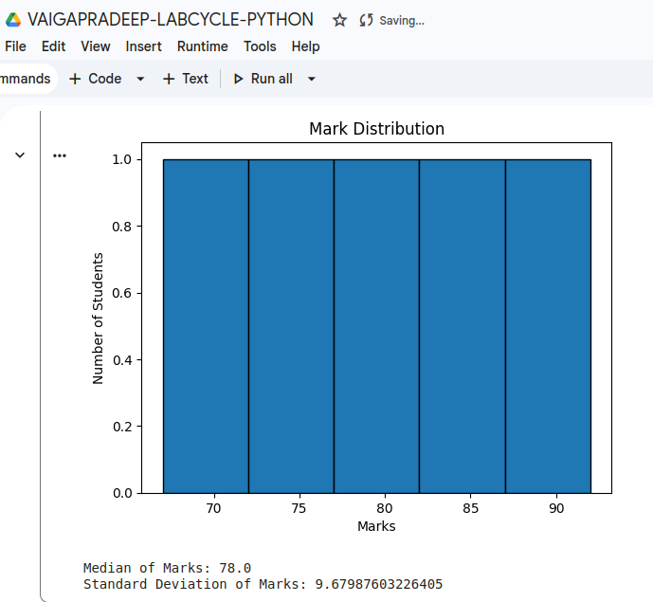

Chinmaya Arts & Science College For Women
15
12. Create dataframe from the given
2026-27
Python Programming
a. data = {"Name": ["Aman", "Diya", "Rahul", "Sneha", Arjun"], "Department": ["CS", "IT", "CS", "ECE", "IT"], "Marks": [78, 92, 85, 67, 74], "Attendance": [85, 90, 88, 75, 80], "Grade": ["B", "A", "A", "C", "B"]}.
b. Display Dataset Information
c. Display Statistical Summary
d. Display only student names and marks
e. Display students scoring more than 80 marks.
f. Sort students based on marks in descending order.
g. Add a new column named “Bonus” containing: 5 marks bonus for every student.

PROGRAM:

import pandas as pd
# a. Create DataFrame
data = {
"Name": ["Aman", "Diya", "Rahul", "Sneha", "Arjun"],
"Department": ["CS", "IT", "CS", "ECE", "IT"],
"Marks": [78, 92, 85, 67, 74],
"Attendance": [85, 90, 88, 75, 80],
"Grade": ["B", "A", "A", "C", "B"]
}
df = pd.DataFrame(data)
# b. Display Dataset Information
print("Dataset Information:")
print(df.info())
# c. Display Statistical Summary
print("\nStatistical Summary:")
print(df.describe())
# d. Display only student names and marks
print("\nStudent Names and Marks:")
print(df[["Name", "Marks"]])
# e. Display students scoring more than 80 marks
print("\nStudents scoring more than 80:")
print(df[df["Marks"] > 80])
# f. Sort students based on marks in descending order
print("\nStudents sorted by marks:")
print(df.sort_values("Marks", ascending=False))
# g. Add Bonus column
df["Bonus"] = 5
print("\nDataset after adding Bonus:")
print(df)

Chinmaya Arts & Science College For Women
16
OUTPUT:
Python Programming
2026-27
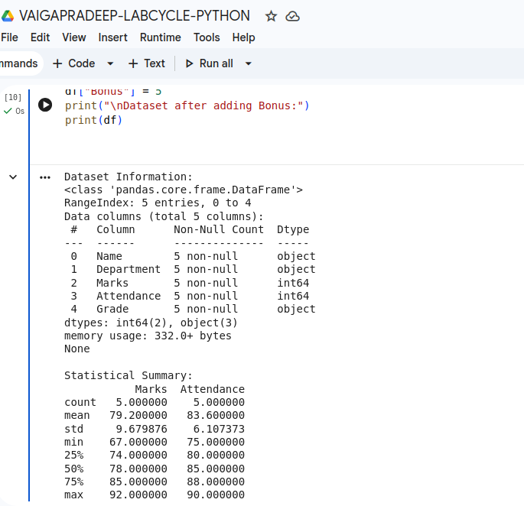

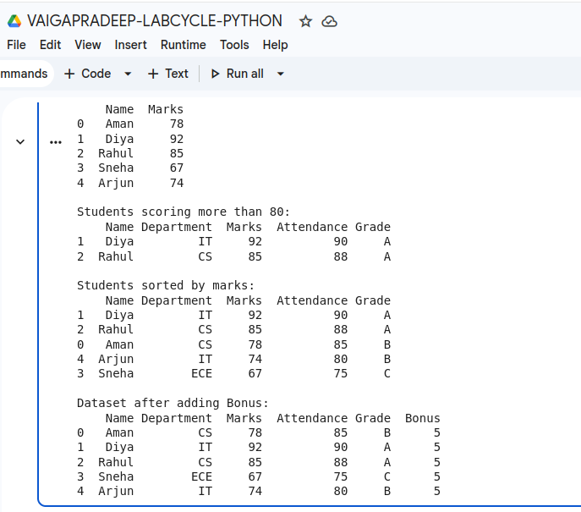

Chinmaya Arts & Science College For Women
17
13. Using the above dataframe answer the following questions.
2026-27
Python Programming
a. Create a new column named “Total” by adding marks and bonus.
b. Find average marks department-wise.
c. Count the number of students in each grade category.
d. Calculate: mean, median,standard deviation of student marks.
e. Display students having maximum attendance. f. Increase marks of all students by 5.

PROGRAM:

import pandas as pd
# a. Create a total column
df["Total"] = df["Marks"] + df["Bonus"]
# b. average marks department-wise
print("Average marks department-wise:")
print(df.groupby("Department")["Marks"].mean())
# c. Count the number of students in each grade
print("\nStudents in each grade:")
print(df["Grade"].value_counts())
# d. mean, median,standard deviation
print("\nMean:", df["Marks"].mean())
print("Median:", df["Marks"].median())
print("Standard Deviation:", df["Marks"].std())
# e. students having maximum attendance
max_attendance = df["Attendance"].max()
print("\nStudents having maximum attendance:")
print(df[df["Attendance"] == max_attendance])
# f. increase marks of all students by 5
df["Marks"] = df["Marks"] + 5
print("\nMarks after increasing by 5:")
print(df)

Chinmaya Arts & Science College For Women
18
OUTPUT:
Python Programming
2026-27

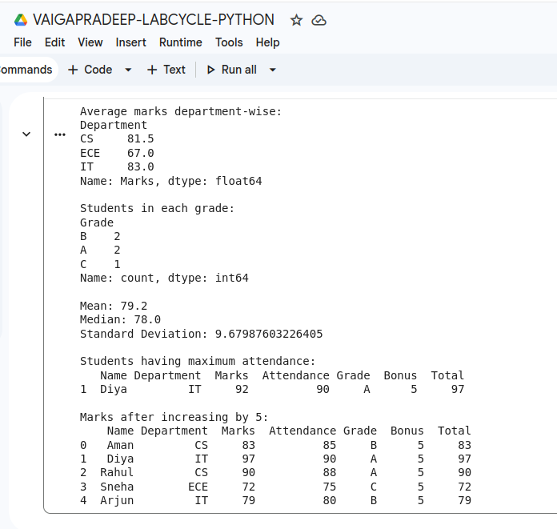

Chinmaya Arts & Science College For Women
19
14. Write a Python program using Pandas to clean and preprocess the following student dataset.
2026-27
Python Programming
a. Perform the following operations:
i. Create a DataFrame containing student details.
ii. Identify missing values in the dataset.
iii. Replace missing values in the Marks column using the mean value.
iv. Remove duplicate rows from the dataset.
v. Convert student names into uppercase.
vi. Rename the column Marks to Score.
vii. Display the cleaned dataset.

PROGRAM:

# Data Cleaning and Preprocessing using Pandas

import pandas as pd
import numpy as np

# Create a DataFrame containing student details
data = {
"Name": ["Aman", "Diya", "Rahul", "Sneha", "Arjun", "Rahul", "Meera"],
"Department": ["CS", "IT", "CS", "ECE", "IT", "CS", "ECE"],
"Marks": [78, 92, 85, np.nan, 74, 85, np.nan],
"Grade": ["B", "A", "A", "C", "B", "A", "B"]}

df = pd.DataFrame(data)

print("\nGiven Dataset")
print(df)
print("--"*25)

# Find missing values in the dataset
print("\nMissing Values per Column")
print(df.isnull().sum())
print("--"*25)

# Replace missing values in the Marks column using the mean
mean_marks = df["Marks"].mean()
df["Marks"] = df["Marks"].fillna(mean_marks)

print(f"\nAfter Filling Missing Marks with Mean ({mean_marks:.2f})")
print(df)
print("--"*25)

# Remove duplicate rows
print("\nNumber of duplicate rows found:", df.duplicated().sum())
df = df.drop_duplicates().reset_index(drop=True)
Chinmaya Arts & Science College For Women
20
print("\nAfter Removing Duplicate Rows")
Python Programming
2026-27
print(df)
print("--"*25)

# Convert student names to uppercase
df["Name"] = df["Name"].str.upper()
print("\nAfter coverting to upper case")
print(df)
print("--"*25)

# Rename the column Marks to Score
df = df.rename(columns={"Marks": "Score"})
print(df)
print("--"*25)

# Display the cleaned dataset
print("\nCleaned Dataset")
print(df)
print("--"*25)

OUTPUT:

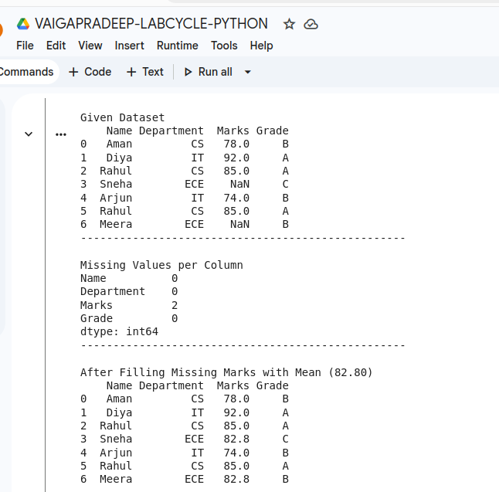
Chinmaya Arts & Science College For Women
21
Python Programming
2026-27
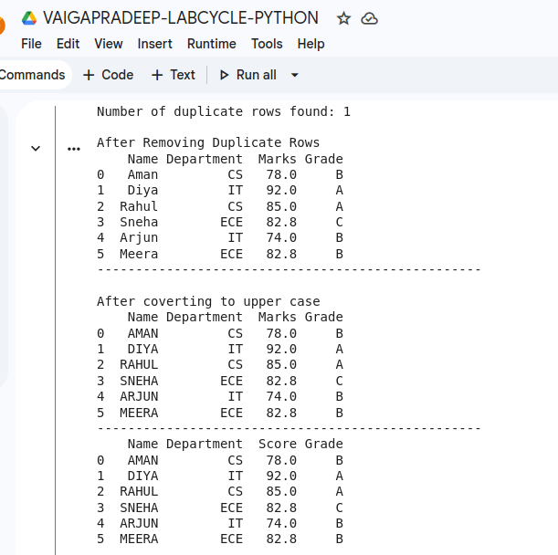

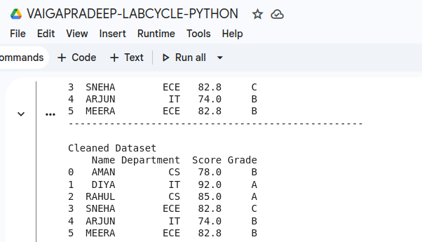

Chinmaya Arts & Science College For Women
22
15.Plot simple mathematical functions.[y=3x^2+4x]
2026-27
Python Programming

PROGRAM:

import matplotlib.pyplot as plt
x = range(-10, 11)
y = [3*i**2 + 4*i for i in x]
plt.plot(x, y)
plt.xlabel("x")
plt.ylabel("y")
plt.title("y = 3x^2 + 4x")
plt.show()

OUTPUT:
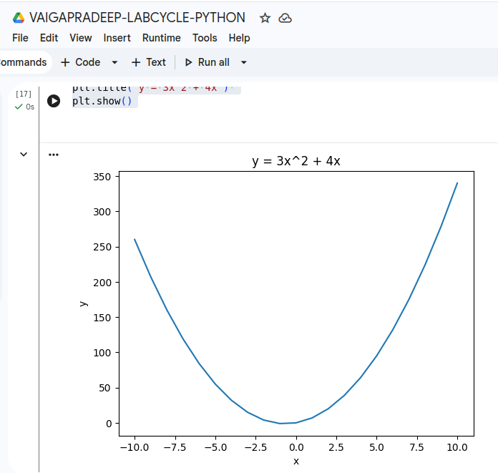

Chinmaya Arts & Science College For Women
23
16. Create simple login form using streamlit
Python Programming
2026-27

PROGRAM:

%%writefile login-gui.py
import streamlit as st

st.title("Login Form")

username = st.text_input("Username")
password = st.text_input("Password", type="password")

if st.button("Login"):
if username == "admin" and password == "1234":
st.success("Login Successful")
else:
st.error("Invalid Username or Password")

OUTPUT:

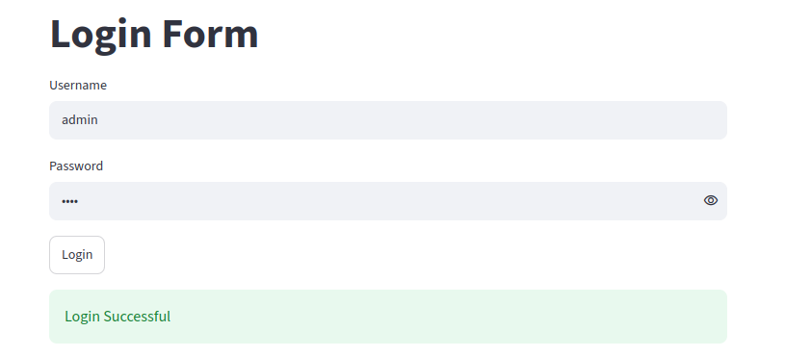

Chinmaya Arts & Science College For Women
24
17. Create student registration form using streamlit
2026-27
Python Programming

PROGRAM:

%%writefile register-gui.py
import streamlit as st

st.title("Student Registration Form")

name = st.text_input("Enter Name")
age = st.number_input("Enter Age", min_value=1, max_value=100)
course = st.selectbox("Select Course", ["BCA", "BBA", "BCom"])
gender = st.radio("Select Gender", ["Male", "Female", "Other"])
email = st.text_input("Enter Email")

if st.button("Register"):
st.success("Registration Successful")
st.write("Name:", name)
st.write("Age:", age)
st.write("Course:", course)
st.write("Gender:", gender)
st.write("Email:", email)

OUTPUT:
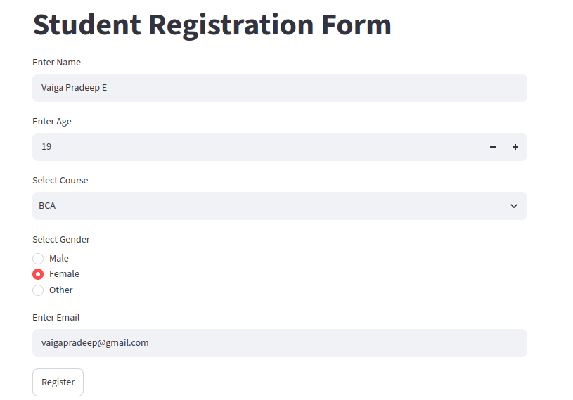
Chinmaya Arts & Science College For Women
25
2026-27
Python Programming

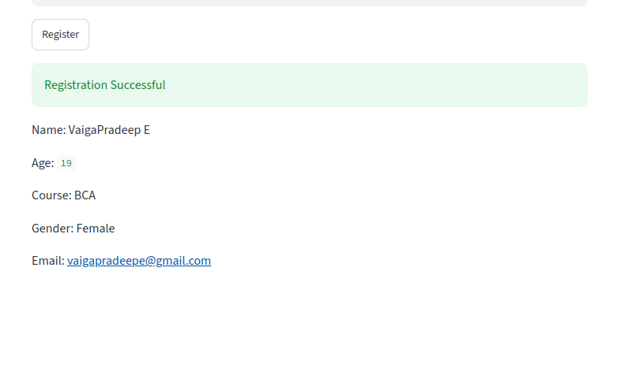

Chinmaya Arts & Science College For Women
26
18. Sample program to use Git and Github
Python Programming
2026-27

Chinmaya Arts & Science College For Women

