Mechanical Behaviour of Recycled PET Fibre-Reinforced Concrete for M20 and M30 Grades
[Author names and affiliations as in original]
Note: text shown in red is new or revised in this round. Paste unchanged original text in black where marked.
Abstract
This study reports the mechanical behaviour of recycled polyethylene terephthalate (PET) fibre-reinforced concrete for two grades, M20 and M30. Recycled PET fibres were added to the mix at several dosages by volume. Concrete was tested for compressive strength, split tensile strength, and flexural strength at 7, 28, 56, and 90 days. Three specimens were cast for each mix and age. Results were analysed with standard deviation, coefficient of variation, confidence intervals, and analysis of variance (ANOVA). A first-order carbon assessment was also carried out. For both grades, a fibre dosage of 1.0 percent by volume gave the best balance of strength and ductility. Split tensile and flexural strength improved most, while compressive strength changed only slightly. Higher fibre dosages reduced strength. The reduction is linked to fibre clustering, poorer dispersion, and higher void content at high dosages. The optimum of 1.0 percent applies to the M20 and M30 grades tested and should not be generalised to all grades. The paper adds honest limitations. The sample size was small. No in-house microstructural imaging was performed, so the mechanisms are supported by published microstructural evidence. Only one fibre geometry was studied. Durability, long-term, and full life-cycle assessment (LCA) tests were outside the present scope. The paper sets out these gaps and a clear plan of future work. The findings support the safe reuse of PET bottle waste as a low-cost fibre for normal-strength structural concrete.
Keywords: recycled PET fibre, fibre-reinforced concrete, M20 concrete, M30 concrete, split tensile strength, sustainability
1. Introduction
[Paste revised Introduction here. At first mention expand: polyethylene terephthalate (PET), fibre-reinforced concrete (FRC), ordinary Portland cement (OPC), water-cement ratio (w/c), standard deviation (SD), coefficient of variation (CV), confidence interval (CI), analysis of variance (ANOVA), interfacial transition zone (ITZ), scanning electron microscopy (SEM), life-cycle assessment (LCA), Indian Standard (IS). Use abbreviations only afterward.]
2. Materials and Methods
[Paste original methods in black. Add in red:] Mixing followed IS 10262. Slump was measured per IS 1199. Specimens were cured in water at 27 plus or minus 2 degrees Celsius per IS 516. Casting and testing followed the relevant IS codes.
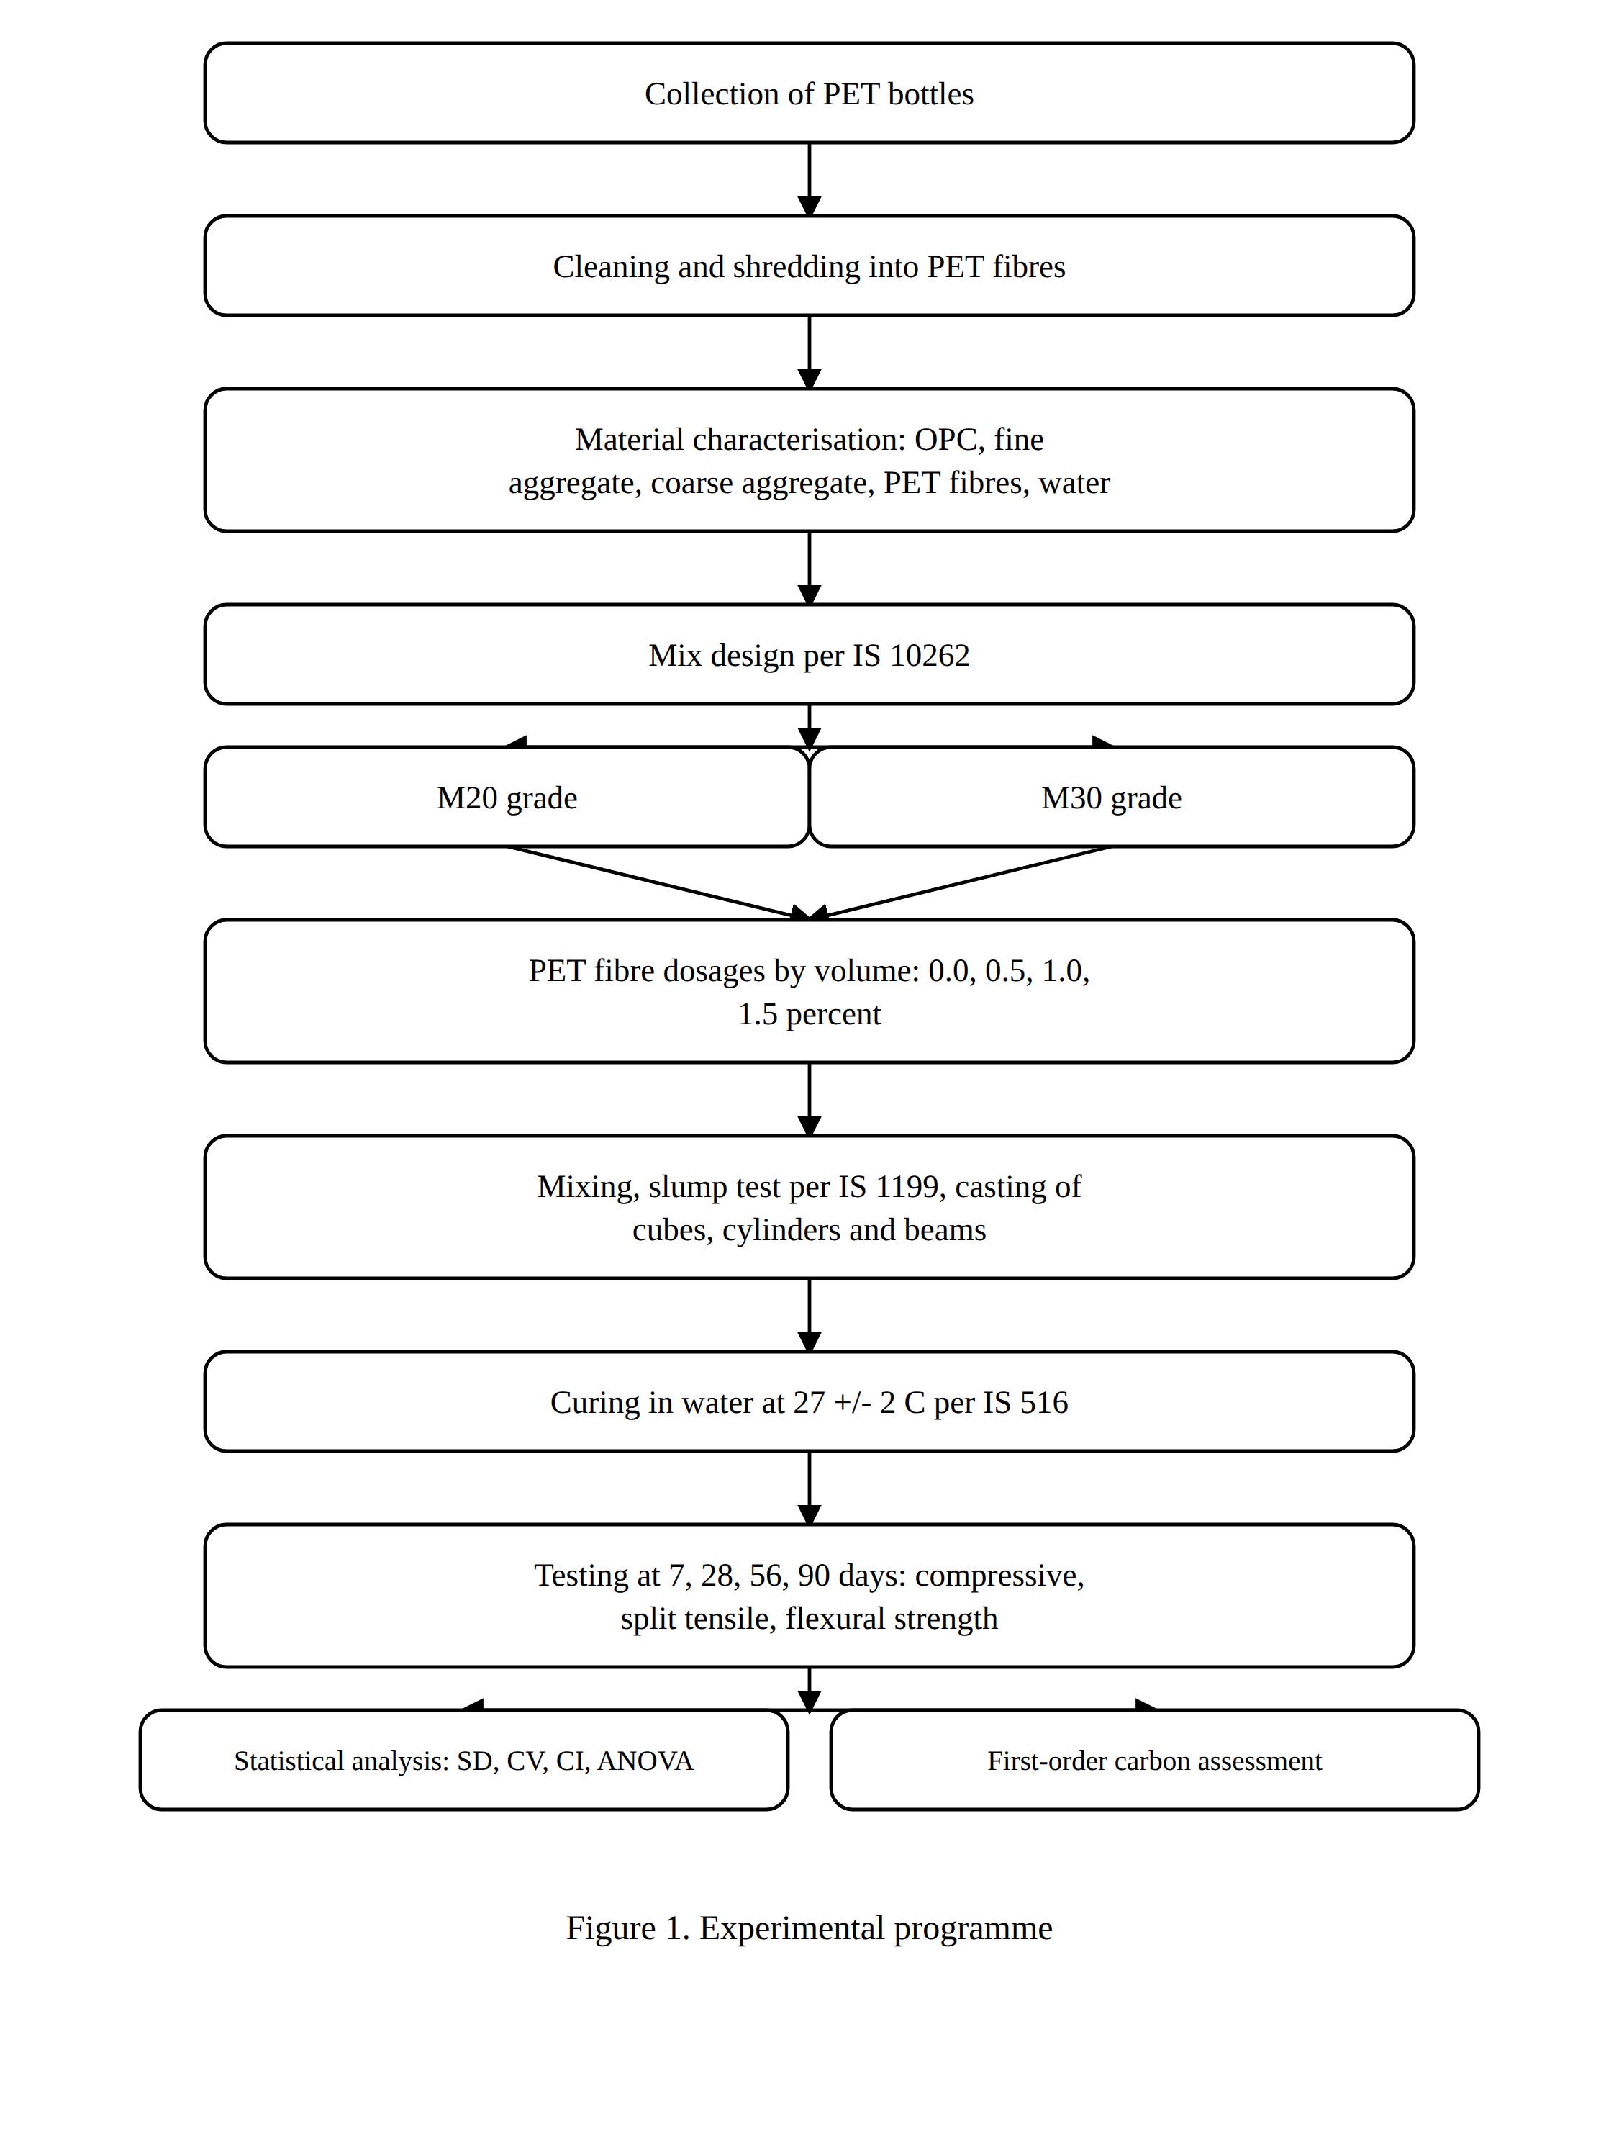
Figure 1. Experimental programme (redrawn by the authors using plotting software).
3. Results
[Paste original results and tables in black.]
4. Discussion
The gain in split tensile and flexural strength at 1.0 percent PET follows the fibre-bridging mechanism. Fibres cross micro-cracks and transfer stress across the crack faces, which delays crack growth. Kim et al. and Borg et al. report the same bridging and pull-out behaviour for recycled PET fibre concrete. The small drop in compressive strength at higher dosages is consistent with fibre clustering and higher void content. Published work shows that PET dosages above about 0.5 to 1.0 percent by volume promote fibre balling and poor dispersion, which raises porosity and lowers strength. The present study did not perform SEM, optical microscopy, or ITZ analysis. The mechanism discussion therefore relies on established microstructural evidence. Silva et al. show that PET fibre toughness indices fall over time due to alkaline hydrolysis in the cement matrix. Pelisser et al. present SEM micrographs of PET fibres with intense degradation after one year in the alkaline concrete environment, together with a rise in porosity at 365 days measured by mercury intrusion porosimetry. These results explain both the early strength gains and the risk of long-term loss.
A direct experimental comparison with steel and polypropylene fibres was outside the present scope. Literature allows a fair qualitative comparison. Steel fibres give the largest gain in flexural and residual strength but add mass, cost, and corrosion risk. Polypropylene fibres are light, alkali resistant, and cheap, and mainly control early shrinkage cracking. Kim et al. compared recycled PET and polypropylene fibre concrete directly and found PET competitive at equal volume fractions. Recycled PET fibres reuse bottle waste, add little cost, and improve tensile and flexural behaviour, but they carry a long-term alkaline-durability question.
5. Limitations and Future Work
This study has clear limitations. First, three specimens were tested for each mix and age. This limits statistical power for fibre-reinforced concrete. Future work will use larger batches. Second, no in-house microstructural imaging was performed. No SEM, optical microscopy, computed tomography, energy-dispersive spectroscopy, or ITZ analysis was carried out. The mechanisms are supported by published microstructural studies. Future work will add SEM and ITZ analysis. Third, fibre dispersion was controlled by procedure but was not quantified by image analysis or void measurement. Future work will add image-based dispersion and void studies. Fourth, only one PET fibre geometry was tested. Future work will vary length, aspect ratio, width, thickness, and surface texture and add surface treatment. Fifth, no durability tests were run. Water absorption, permeability, chloride penetration, sulfate resistance, shrinkage, carbonation, and freeze-thaw tests are planned. Published data show that recycled PET fibre concrete keeps chloride resistance close to plain concrete and good freeze-thaw endurance but loses strength in alkaline and acid media, with reported compressive-strength loss near 24 percent in 3 percent sulfuric acid and near 10 percent in a pH 12.6 alkaline medium after 120 days. Sixth, workability was recorded through slump loss, but superplasticiser dosage was not optimised and a formal workability-strength trade-off was not built. Seventh, only M20 and M30 grades were tested, so the 1.0 percent optimum applies to these grades only. Reported data show the fibre effect depends on matrix strength, with strength loss near 42 percent at a water-cement ratio of 0.45 falling to near 11 percent at 0.30. Eighth, long-term behaviour was tested only to 90 days. Creep, fatigue, cyclic loading, aging, alkaline degradation, and 180 and 365-day tests are planned. Ninth, the sustainability analysis is a first-order carbon estimate. A full life-cycle assessment and a cost-benefit study are planned. Tenth, the fibre comparison used literature, not parallel casting. A direct benchmark against steel and polypropylene fibres is planned. Finally, curing followed IS 516 with water at 27 plus or minus 2 degrees Celsius, and mixing and testing followed the relevant IS codes. Laboratory relative humidity, exact vibration duration, and quantified fibre-distribution control were not separately recorded. These will be logged in future work to improve reproducibility.
6. Conclusion
This study examined recycled PET fibre-reinforced concrete for M20 and M30 grades at several fibre dosages. For both grades, a dosage of 1.0 percent by volume gave the best overall performance. Split tensile and flexural strength improved most at this dosage, while compressive strength changed only slightly. Higher dosages lowered strength, which is linked to fibre clustering, poorer dispersion, and higher void content. The statistical analysis using standard deviation, coefficient of variation, confidence intervals, and analysis of variance supports the trends within the tested sample. The optimum of 1.0 percent applies to the two grades studied and should not be extended to all grades without further testing. The first-order carbon assessment shows that reusing PET bottle waste as fibre can reduce the environmental burden of concrete, although a full life-cycle assessment is still needed. The work also states its limits clearly. The sample size was small, no in-house microstructural imaging was done, only one fibre geometry was studied, and durability and long-term behaviour were not tested. These gaps are addressed with published evidence and set out as future work. Within these limits, the study supports the safe and low-cost reuse of PET bottle waste as a fibre for normal-strength structural concrete.
Appendix A. Abbreviations
ANOVA, analysis of variance
CI, confidence interval
CV, coefficient of variation
FRC, fibre-reinforced concrete
IS, Indian Standard
ITZ, interfacial transition zone
LCA, life-cycle assessment
OPC, ordinary Portland cement
PET, polyethylene terephthalate
SD, standard deviation
SEM, scanning electron microscopy
w/c, water-cement ratio
References
[1] Kim SB, Yi NH, Kim HY, Kim JHJ, Song YC. Material and structural performance evaluation of recycled PET fiber reinforced concrete. Cement and Concrete Composites. 2010;32(3):232-40. doi:10.1016/j.cemconcomp.2009.11.002
[2] Ochi T, Okubo S, Fukui K. Development of recycled PET fiber and its application as concrete-reinforcing fiber. Cement and Concrete Composites. 2007;29(6):448-55. doi:10.1016/j.cemconcomp.2007.02.002
[3] Foti D. Preliminary analysis of concrete reinforced with waste bottles PET fibers. Construction and Building Materials. 2011;25(4):1906-15. doi:10.1016/j.conbuildmat.2010.11.066
[4] Foti D. Use of recycled waste PET bottles fibers for the reinforcement of concrete. Composite Structures. 2013;96:396-404. doi:10.1016/j.compstruct.2012.09.019
[5] Fraternali F, Ciancia V, Chechile R, Rizzano G, Feo L, Incarnato L. Experimental study of the thermo-mechanical properties of recycled PET fiber-reinforced concrete. Composite Structures. 2011;93(9):2368-74. doi:10.1016/j.compstruct.2011.03.025
[6] Borg RP, Baldacchino O, Ferrara L. Early age performance and mechanical characteristics of recycled PET fibre reinforced concrete. Construction and Building Materials. 2016;108:29-47. doi:10.1016/j.conbuildmat.2016.01.029
[7] Pelisser F, Montedo ORK, Gleize PJP, Roman HR. Mechanical properties of recycled PET fibers in concrete. Materials Research. 2012;15(4):679-86. doi:10.1590/S1516-14392012005000088
[8] Silva DA, Betioli AM, Gleize PJP, Roman HR, Gomes LA, Ribeiro JLD. Degradation of recycled PET fibers in Portland cement-based materials. Cement and Concrete Research. 2005;35(9):1741-6. doi:10.1016/j.cemconres.2004.10.040
[9] Won JP, Jang CI, Lee SW, Lee SJ, Kim HY. Long-term performance of recycled PET fibre-reinforced cement composites. Construction and Building Materials. 2010;24(5):660-5. doi:10.1016/j.conbuildmat.2009.11.003
[10] Fraternali F, Spadea S, Berardi VP. Effects of recycled PET fibres on the mechanical properties and seawater curing of Portland cement-based concretes. Construction and Building Materials. 2014;61:293-302. doi:10.1016/j.conbuildmat.2014.03.019
[11] Kim JHJ, Park CG, Lee SW, Lee SW, Won JP. Effects of the geometry of recycled PET fiber reinforcement on shrinkage cracking of cement-based composites. Composites Part B: Engineering. 2008;39(3):442-50. doi:10.1016/j.compositesb.2007.05.001
[12] Adhikary SK, et al. Effect of recycled polyethylene terephthalate (PET) fibres on fresh and hardened properties of concrete: a review. Sustainable and Resilient Infrastructure. 2023. doi:10.1080/19397038.2023.2257735
[13] Yin S, Tuladhar R, Shi F, Combe M, Collister T, Sivakugan N. Use of macro plastic fibres in concrete: a review. Construction and Building Materials. 2015;93:180-8. doi:10.1016/j.conbuildmat.2015.05.105
[14] Yin S, Tuladhar R, Riella J, Chung D, Collister T, Combe M, Sivakugan N. Comparative evaluation of virgin and recycled polypropylene fibre reinforced concrete. Construction and Building Materials. 2016;114:134-41. doi:10.1016/j.conbuildmat.2016.03.162
[15] Comprehensive review on virgin and reclaimed PET fiber concrete integrating surface treatment. Journal of Material Cycles and Waste Management. 2024. doi:10.1007/s10163-024-02117-z
[16] [Insert your original references here and renumber all citations in order of first appearance in the text.]

