Docker

Dia 1 – 16/08/2026

1. Apresentação

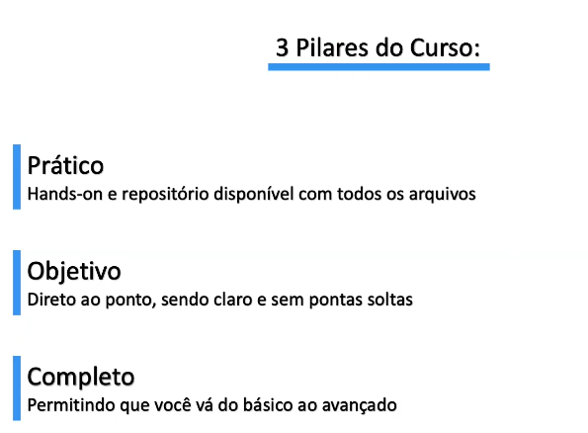

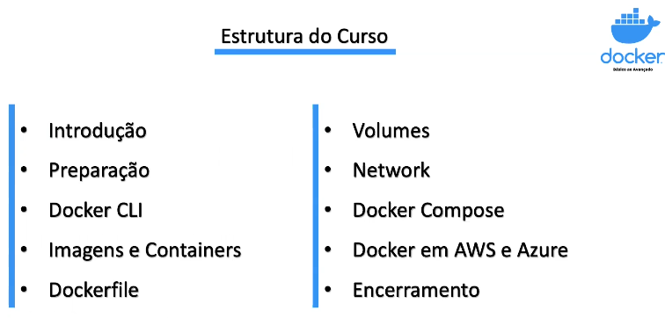

2. Introdução ao Docker

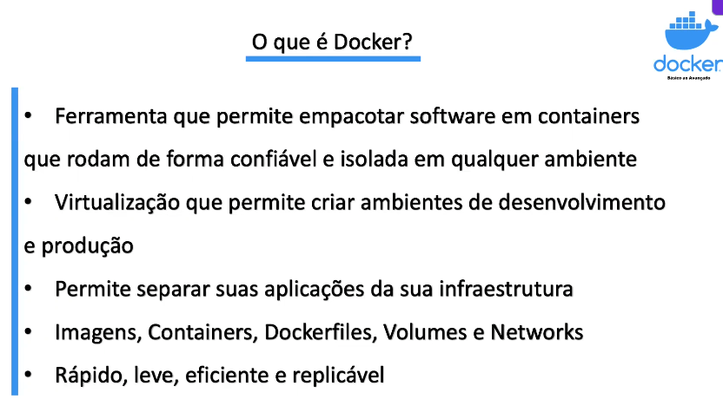

Vantagens Docker

Containers
Definição:
- Pacote de software leve e autossuficiente que inclui código, bibliotecas, dependências e configurações.
- Executa o aplicativo de forma idêntica em qualquer ambiente.
- Compartilha o kernel do SO do host (não precisa de SO completo), sendo mais leve e rápido que VMs.
Vantagens:
- Portabilidade: Funciona em qualquer ambiente sem alterações.
- Eficiência e Velocidade: Consome menos recursos e inicia em segundos.
- Consistência: Ambiente padronizado do desenvolvimento à produção.
- Isolamento: Falhas em um container não afetam outros.
- Escalabilidade: Criação rápida de instâncias; fácil integração com Kubernetes.
Desvantagens:
- Menor isolamento: Compartilhamento do kernel pode gerar riscos de segurança.
- Dependência de SO: Containers devem ser compatíveis com o SO do host.

Máquinas Virtuais (VMs)
Definição:
- Computador completo dentro de outro, com seu próprio SO “convidado” e recursos dedicados (CPU, memória, armazenamento).
- Gerenciadas por hypervisors.
Vantagens:
- Isolamento total: Alta segurança entre VMs.
- Flexibilidade: Permite diferentes sistemas operacionais na mesma máquina.
Desvantagens:
- Pesadas: Consomem mais recursos e demoram mais para iniciar devido ao SO completo.

Quando usar cada um?
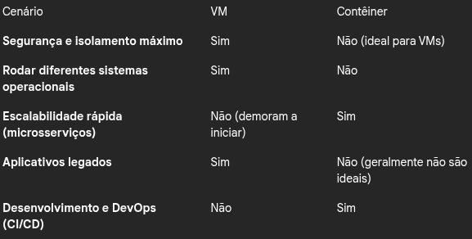

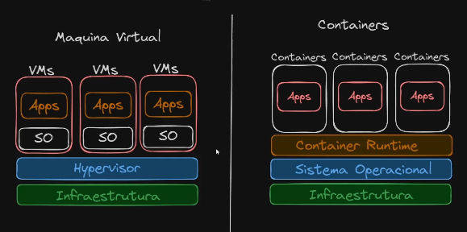

3. Link Repositorio

https://gitlab.com/docker-basico-ao-avancado

4. Docker Engine e Docker Desktop

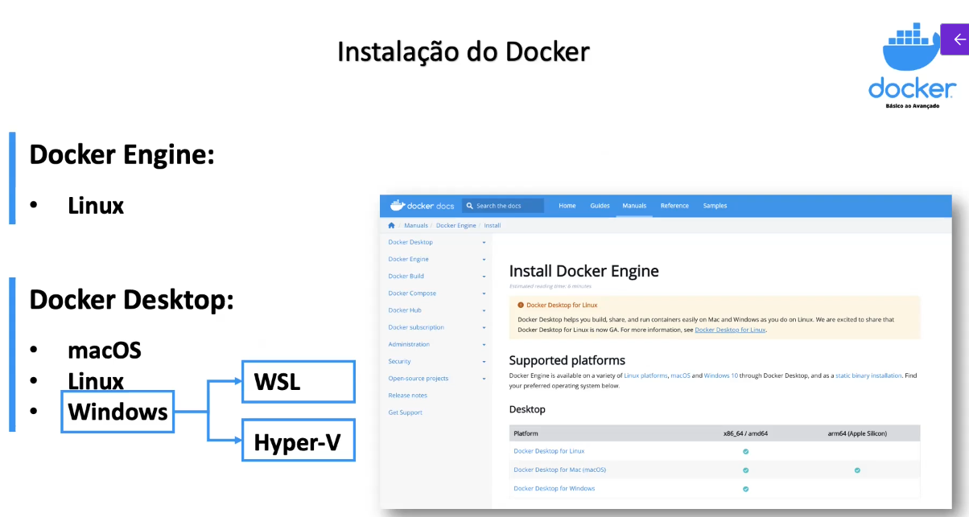

5. Instalação do Docker no Linux

https://docs.docker.com/engine/install/debian/

# Add Docker's official GPG key:
sudo apt-get update
sudo apt-get install ca-certificates curl
sudo install -m 0755 -d /etc/apt/keyrings
sudo curl -fsSL https://download.docker.com/linux/debian/gpg -o /etc/apt/keyrings/docker.asc
sudo chmod a+r /etc/apt/keyrings/docker.asc

# Add the repository to Apt sources:
echo \
"deb [arch=$(dpkg --print-architecture) signed-by=/etc/apt/keyrings/docker.asc] https://download.docker.com/linux/debian \
$(. /etc/os-release && echo "$VERSION_CODENAME") stable" | \
sudo tee /etc/apt/sources.list.d/docker.list > /dev/null
sudo apt-get update

6. Instalação do Docker no macOS

https://docs.docker.com/engine/install/

7. ATUALIZADA: Instalação do Docker no Windows
https://learn.microsoft.com/pt-br/windows/wsl/install
https://docs.docker.com/desktop/setup/install/windows-install/

8. Instalação VS Code no macOS
https://code.visualstudio.com/docs/setup/mac

9. Instalação VS Code no Windows
https://code.visualstudio.com/docs/setup/windows

10. Familiarizando com a Documentação
https://docs.docker.com/reference/

Dia 2 – 17/08/2026

11. Reestruturação da CLI do Docker

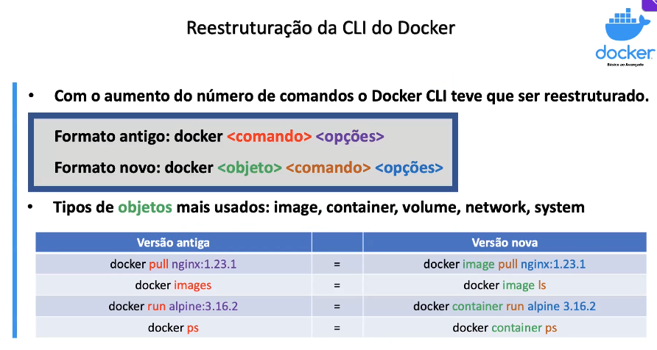

12. Ocultando Comandos da CLI Antiga no Help

export DOCKER_HIDE_LEGACY_COMMANDS=true
docker --help
unset DOCKER_HIDE_LEGACY_COMMANDS

13. Comando docker system

docker system df | Show docker disk usage
docker system events | Get real time events from the server
docker system info | Display system-wide information
docker system prune | Remove unused data

14. docker system info

Pegar informações do sistema

host:
arch: amd64
buildahVersion: 1.43.1
cgroupControllers:
- memory
- pids
cgroupManager: systemd
cgroupVersion: v2
conmon:
package: conmon-2.2.1-2.el10.x86_64
path: /usr/bin/conmon
version: 'conmon version 2.2.1, commit: '
cpuUtilization:
idlePercent: 95.41
systemPercent: 0.5
userPercent: 4.09
cpus: 28
databaseBackend: sqlite
distribution:
distribution: rocky
version: "10.2"
eventLogger: journald
freeLocks: 2048
hostname: marcos
idMappings:
gidmap:
- container_id: 0
host_id: 1000
size: 1
- container_id: 1
host_id: 524288
size: 65536
uidmap:
- container_id: 0
host_id: 1000
size: 1
- container_id: 1
host_id: 524288
size: 65536
kernel: 6.12.0-211.40.1.el10_2.x86_64
linkmode: dynamic
logDriver: journald
memFree: 34244833280
memTotal: 66978717696
networkBackend: netavark
networkBackendInfo:
backend: netavark
defaultNetwork: podman
dns:
package: aardvark-dns-1.17.1-1.el10_2.x86_64
path: /usr/libexec/podman/aardvark-dns
version: aardvark-dns 1.17.1
package: netavark-1.17.2-1.el10.x86_64
path: /usr/libexec/podman/netavark
version: netavark 1.17.2
ociRuntime:
name: crun
package: crun-1.27-2.el10_2.x86_64
path: /usr/bin/crun
version: |-
crun version 1.27
commit: a718a92cc9a94955a5a550b6fdec1378c247ec50
rundir: /run/user/1000/crun
spec: 1.0.0
+SYSTEMD +SELINUX +APPARMOR +CAP +SECCOMP +EBPF +CRIU +LIBKRUN +YAJL
os: linux
pasta:
executable: /usr/bin/pasta
package: passt-0^20251210.gd04c480-5.el10_2.x86_64
version: |
pasta 0^20251210.gd04c480-5.el10_2.x86_64
Copyright Red Hat
GNU General Public License, version 2 or later
<https://www.gnu.org/licenses/old-licenses/gpl-2.0.html>
This is free software: you are free to change and redistribute it.
There is NO WARRANTY, to the extent permitted by law.
remoteSocket:
exists: true
path: /run/user/1000/podman/podman.sock
rootlessNetworkCmd: pasta
security:
apparmorEnabled: false
capabilities: CAP_CHOWN,CAP_DAC_OVERRIDE,CAP_FOWNER,CAP_FSETID,CAP_KILL,CAP_NET_BIND_SERVICE,CAP_SETFCAP,CAP_SETGID,CAP_SETPCAP,CAP_SETUID,CAP_SYS_CHROOT
rootless: true
seccompEnabled: true
seccompProfilePath: /usr/share/containers/seccomp.json
selinuxEnabled: true
serviceIsRemote: false
slirp4netns:
executable: ""
package: ""
version: ""
swapFree: 0
swapTotal: 0
uptime: 0h 38m 39.00s
variant: ""
plugins:
authorization: null
log:
- k8s-file
- none
- passthrough
- journald
network:
- bridge
- macvlan
- ipvlan
volume:
- local
registries:
search:
- registry.access.redhat.com
- registry.redhat.io
- docker.io
store:
configFile: /home/marcos/.config/containers/storage.conf
containerStore:
number: 0
paused: 0
running: 0
stopped: 0
graphDriverName: overlay
graphOptions: {}
graphRoot: /home/marcos/.local/share/containers/storage
graphRootAllocated: 153453498368
graphRootUsed: 106238439424
graphStatus:
Backing Filesystem: xfs
Native Overlay Diff: "true"
Supports d_type: "true"
Supports shifting: "false"
Supports volatile: "true"
Using metacopy: "false"
imageCopyTmpDir: /var/tmp
imageStore:
number: 1
runRoot: /run/user/1000/containers
transientStore: false
volumePath: /home/marcos/.local/share/containers/storage/volumes
version:
APIVersion: 5.8.2
BuildOrigin: Rocky Linux Build System <releng@rockylinux.org>
Built: 1783641600
BuiltTime: Thu Jul 9 21:00:00 2026
GitCommit: a476c2b2c35443a3db1a1668ac7b402eb1eb0619
GoVersion: go1.26.5 (Red Hat 1.26.5-1.el10_2)
Os: linux
OsArch: linux/amd64
Version: 5.8.2

15. Docker Hub

https://hub.docker.com/

16. Conceito de Tags em Imagens

É a versão da imagem, sendo que latest a ultima versão, em um projeto real nunca deixamos em latest

17. Comando docker image

Command | Description
docker image build | Build an image from a Dockerfile
docker image history | Show the history of an image
docker image import | Import the contents from a tarball to create a filesystem image
docker image inspect | Display detailed information on one or more images
docker image load | Load an image from a tar archive or STDIN
docker image ls | List images
docker image prune | Remove unused images
docker image pull | Download an image from a registry
docker image push | Upload an image to a registry
docker image rm | Remove one or more images
docker image save | Save one or more images to a tar archive (streamed to STDOUT by default)

18. docker image pull

Baixa uma imagem do Docker Hub ou de outro registry para a máquina.

Ex: docker image pull nginx:1.22.0

marcos@marcos:~$ podman image pull nginx:1.22.0
Resolved "nginx" as an alias (/etc/containers/registries.conf.d/000-shortnames.conf)
Trying to pull docker.io/library/nginx:1.22.0...
Getting image source signatures
Copying blob 1cb127bd9321 done |
Copying blob 9f5a323076dc done |
Copying blob e0c68760750a done |
Copying blob 265da2307f4a done |
Copying blob bd159e379b3b done |
Copying blob 20d83d630f2b done |
Copying config 08a1cbf9c6 done |
Writing manifest to image destination
08a1cbf9c69edd2ab8e5250ae97703f60b9393fc5a4827cedda4b7387a5cfc6a

marcos@marcos:~$ podman image pull nginx:latest
Resolved "nginx" as an alias (/etc/containers/registries.conf.d/000-shortnames.conf)
Trying to pull docker.io/library/nginx:latest...
Getting image source signatures
Copying blob 3c55dc422a81 done |
Copying blob f5de6e85ac74 done |
Copying blob c0df8d325117 done |
Copying blob b8b80b9bc028 done |
Copying blob d84ae7b21412 done |
Copying blob 26c307b5e35a done |
Copying blob 5a4222b844e8 done |
Copying config 5253dc86cc done |
Writing manifest to image destination
5253dc86cc93ac6249902934655c6f7c959d8caa45a8c2ecc0b95953834d8ee8

19. docker image ls

Lista as imagens Docker que já estão disponíveis localmente.

marcos@marcos:~$ podman image ls
REPOSITORY TAG IMAGE ID CREATED SIZE
docker.io/library/nginx latest 5253dc86cc93 8 days ago 165 MB
docker.io/rockylinux/rockylinux 10.1-minimal 33c4b20bff19 9 months ago 131 MB
docker.io/library/nginx 1.22.0 08a1cbf9c69e 3 years ago 146 MB

marcos@marcos:~$ podman image ls --help
List images in local storage

Description:
Lists images previously pulled to the system or created on the system.

Usage:
podman image list [options] [IMAGE]

Aliases:
list, ls

Examples:
podman image list --format json
podman image list --sort repository --format "table {{.ID}} {{.Repository}} {{.Tag}}"
podman image list --filter dangling=true

Options:
-a, --all Show all images (default hides intermediate images)
--digests Show digests
-f, --filter stringArray Filter output based on conditions provided (default [])
--format string Change the output format to JSON or a Go template
--history Display the image name history
--no-trunc Do not truncate output
-n, --noheading Do not print column headings
-q, --quiet Display only image IDs
--sort choice Sort by created, id, repository, size, tag (default created)

marcos@marcos:~$ podman image ls -q
5253dc86cc93
33c4b20bff19
08a1cbf9c69e

20. docker image inspect

Mostra informações detalhadas de uma imagem, como configuração, tamanho, arquitetura e camadas

marcos@marcos:~$ podman image inspect 08a1cbf9c69e
[
{
"Id": "08a1cbf9c69edd2ab8e5250ae97703f60b9393fc5a4827cedda4b7387a5cfc6a",
"Digest": "sha256:f0d28f2047853cbc10732d6eaa1b57f1f4db9b017679b9fd7966b6a2f9ccc2d1",
"RepoTags": [
"docker.io/library/nginx:1.22.0"
],
"RepoDigests": [
"docker.io/library/nginx@sha256:b3a676a9145dc005062d5e79b92d90574fb3bf2396f4913dc1732f9065f55c4b",
"docker.io/library/nginx@sha256:f0d28f2047853cbc10732d6eaa1b57f1f4db9b017679b9fd7966b6a2f9ccc2d1"
],
"Parent": "",
"Comment": "",
"Created": "2022-10-05T12:45:11.834223042Z",
"Config": {
"ExposedPorts": {
"80/tcp": {}
},
"Env": [
"PATH=/usr/local/sbin:/usr/local/bin:/usr/sbin:/usr/bin:/sbin:/bin",
"NGINX_VERSION=1.22.0",
"NJS_VERSION=0.7.6",
"PKG_RELEASE=1~bullseye"
],
"Entrypoint": [
"/docker-entrypoint.sh"
],
"Cmd": [
"nginx",
"-g",
"daemon off;"
],
"Labels": {
"maintainer": "NGINX Docker Maintainers <docker-maint@nginx.com>"
},
"StopSignal": "SIGQUIT"
},
"Version": "20.10.12",
"Author": "",
"Architecture": "amd64",
"Os": "linux",
"Size": 146079071,
"VirtualSize": 146079071,
"GraphDriver": {
"Name": "overlay",
"Data": {
"LowerDir": "/home/marcos/.local/share/containers/storage/overlay/be1632f103a25b7b112497bec5ac80a89982f4108f053cdd6ba4c45dfa84b64b/diff:/home/marcos/.local/share/containers/storage/overlay/d433c09ca33effd782480ccb38e9e95444a35befa6cac760f53d2d33fe5a7562/diff:/home/marcos/.local/share/containers/storage/overlay/b5a325a14c089f6e55a4d9f92a0770feb5bb1dd47ff515e0ee3a979790c2b3ae/diff:/home/marcos/.local/share/containers/storage/overlay/25bfa1559e808b8c0b928d0295df4a287896932c75b7fb105e0fefae0d292b74/diff:/home/marcos/.local/share/containers/storage/overlay/fe7b1e9bf7922fbc22281bcc6b4f5ac8f1a7b4278929880940978c42fc9d0229/diff",
"UpperDir": "/home/marcos/.local/share/containers/storage/overlay/0448893f2a10868105e7ba45cd908304e696cef56257d3d61335308e9b509672/diff",
"WorkDir": "/home/marcos/.local/share/containers/storage/overlay/0448893f2a10868105e7ba45cd908304e696cef56257d3d61335308e9b509672/work"
}
},
"RootFS": {
"Type": "layers",
"Layers": [
"sha256:fe7b1e9bf7922fbc22281bcc6b4f5ac8f1a7b4278929880940978c42fc9d0229",
"sha256:b9361c275c5d9b3d5a8c6cff59733193fec1be8cb57374d880e8dd8fd503ed8b",
"sha256:89dade9c1793e410569e09590ef37bbad0a66f55106880547a5bf79fc045be11",
"sha256:eabe89adceee656a54376951753f0721007fcc311429d8f8be78c50e06b3b624",
"sha256:a6edfce9a309ca578ed40204ad3332ad5a098cedac483bf8187698891835c1d4",
"sha256:0810d1ac3f2f042aaa11f5dc95b5d2bad0a2be99fb6563672b47738acb6b011b"
]
},
"Labels": {
"maintainer": "NGINX Docker Maintainers <docker-maint@nginx.com>"
},
"Annotations": {},
"ManifestType": "application/vnd.docker.distribution.manifest.v2+json",
"User": "",
"History": [
{
"created": "2022-10-04T23:26:39.460307991Z",
"created_by": "/bin/sh -c #(nop) ADD file:b78b777208be08edd8f297035cdfbacddb45170ad778fd643c792ee045187e39 in / "
},
{
"created": "2022-10-04T23:26:39.844454325Z",
"created_by": "/bin/sh -c #(nop) CMD [\"bash\"]",
"empty_layer": true
},
{
"created": "2022-10-05T12:44:01.003148077Z",
"created_by": "/bin/sh -c #(nop) LABEL maintainer=NGINX Docker Maintainers <docker-maint@nginx.com>",
"empty_layer": true
},
{
"created": "2022-10-05T12:44:52.978922451Z",
"created_by": "/bin/sh -c #(nop) ENV NGINX_VERSION=1.22.0",
"empty_layer": true
},
{
"created": "2022-10-05T12:44:53.088747324Z",
"created_by": "/bin/sh -c #(nop) ENV NJS_VERSION=0.7.6",
"empty_layer": true
},
{
"created": "2022-10-05T12:44:53.185083509Z",
"created_by": "/bin/sh -c #(nop) ENV PKG_RELEASE=1~bullseye",
"empty_layer": true
},
{
"created": "2022-10-05T12:45:10.869226141Z",
"created_by": "/bin/sh -c set -x && addgroup --system --gid 101 nginx && adduser --system --disabled-login --ingroup nginx --no-create-home --home /nonexistent --gecos \"nginx user\" --shell /bin/false --uid 101 nginx && apt-get update && apt-get install --no-install-recommends --no-install-suggests -y gnupg1 ca-certificates && NGINX_GPGKEY=573BFD6B3D8FBC641079A6ABABF5BD827BD9BF62; found=''; for server in hkp://keyserver.ubuntu.com:80 pgp.mit.edu ; do echo \"Fetching GPG key $NGINX_GPGKEY from $server\"; apt-key adv --keyserver \"$server\" --keyserver-options timeout=10 --recv-keys \"$NGINX_GPGKEY\" && found=yes && break; done; test -z \"$found\" && echo >&2 \"error: failed to fetch GPG key $NGINX_GPGKEY\" && exit 1; apt-get remove --purge --auto-remove -y gnupg1 && rm -rf /var/lib/apt/lists/* && dpkgArch=\"$(dpkg --print-architecture)\" && nginxPackages=\" nginx=${NGINX_VERSION}-${PKG_RELEASE} nginx-module-xslt=${NGINX_VERSION}-${PKG_RELEASE} nginx-module-geoip=${NGINX_VERSION}-${PKG_RELEASE} nginx-module-image-filter=${NGINX_VERSION}-${PKG_RELEASE} nginx-module-njs=${NGINX_VERSION}+${NJS_VERSION}-${PKG_RELEASE} \" && case \"$dpkgArch\" in amd64|arm64) echo \"deb https://nginx.org/packages/debian/ bullseye nginx\" >> /etc/apt/sources.list.d/nginx.list && apt-get update ;; *) echo \"deb-src https://nginx.org/packages/debian/ bullseye nginx\" >> /etc/apt/sources.list.d/nginx.list && tempDir=\"$(mktemp -d)\" && chmod 777 \"$tempDir\" && savedAptMark=\"$(apt-mark showmanual)\" && apt-get update && apt-get build-dep -y $nginxPackages && ( cd \"$tempDir\" && DEB_BUILD_OPTIONS=\"nocheck parallel=$(nproc)\" apt-get source --compile $nginxPackages ) && apt-mark showmanual | xargs apt-mark auto > /dev/null && { [ -z \"$savedAptMark\" ] || apt-mark manual $savedAptMark; } && ls -lAFh \"$tempDir\" && ( cd \"$tempDir\" && dpkg-scanpackages . > Packages ) && grep '^Package: ' \"$tempDir/Packages\" && echo \"deb [ trusted=yes ] file://$tempDir ./\" > /etc/apt/sources.list.d/temp.list && apt-get -o Acquire::GzipIndexes=false update ;; esac && apt-get install --no-install-recommends --no-install-suggests -y $nginxPackages gettext-base curl && apt-get remove --purge --auto-remove -y && rm -rf /var/lib/apt/lists/* /etc/apt/sources.list.d/nginx.list && if [ -n \"$tempDir\" ]; then apt-get purge -y --auto-remove && rm -rf \"$tempDir\" /etc/apt/sources.list.d/temp.list; fi && ln -sf /dev/stdout /var/log/nginx/access.log && ln -sf /dev/stderr /var/log/nginx/error.log && mkdir /docker-entrypoint.d"
},
{
"created": "2022-10-05T12:45:11.13687773Z",
"created_by": "/bin/sh -c #(nop) COPY file:65504f71f5855ca017fb64d502ce873a31b2e0decd75297a8fb0a287f97acf92 in / "
},
{
"created": "2022-10-05T12:45:11.245118049Z",
"created_by": "/bin/sh -c #(nop) COPY file:0b866ff3fc1ef5b03c4e6c8c513ae014f691fb05d530257dfffd07035c1b75da in /docker-entrypoint.d "
},
{
"created": "2022-10-05T12:45:11.352981253Z",
"created_by": "/bin/sh -c #(nop) COPY file:0fd5fca330dcd6a7de297435e32af634f29f7132ed0550d342cad9fd20158258 in /docker-entrypoint.d "
},
{
"created": "2022-10-05T12:45:11.45630321Z",
"created_by": "/bin/sh -c #(nop) COPY file:09a214a3e07c919af2fb2d7c749ccbc446b8c10eb217366e5a65640ee9edcc25 in /docker-entrypoint.d "
},
{
"created": "2022-10-05T12:45:11.547888048Z",
"created_by": "/bin/sh -c #(nop) ENTRYPOINT [\"/docker-entrypoint.sh\"]",
"empty_layer": true
},
{
"created": "2022-10-05T12:45:11.641445236Z",
"created_by": "/bin/sh -c #(nop) EXPOSE 80",
"empty_layer": true
},
{
"created": "2022-10-05T12:45:11.73646032Z",
"created_by": "/bin/sh -c #(nop) STOPSIGNAL SIGQUIT",
"empty_layer": true
},
{
"created": "2022-10-05T12:45:11.834223042Z",
"created_by": "/bin/sh -c #(nop) CMD [\"nginx\" \"-g\" \"daemon off;\"]",
"empty_layer": true
}
],
"NamesHistory": [
"docker.io/library/nginx:1.22.0"
]
}
]

Dia 3 – 18/08/2026

21. docker image save

Salvar uma imagem em uma imagem compactada.

docker image save alpine:3.16.2 -o alpine.tar
docker image save nginx -o nginx.tar

22. docker image rm

Serve para remover a imagem do nosso host

docker image rm alpine:3.16.2
docker image rm nginx:latest
docker image rm <id-da-imagem>

23. docker image load

docker image load -i alpine.tar
docker image rm nginx:1.22.0
docker image load -i nginx.tar

24. Comando docker container

[root@lab-podman ~]# podman container --help
Manage containers

Description:
Manage containers

Usage:
podman container [command]

Available Commands:
attach Attach to a running container
checkpoint Checkpoint one or more containers
cleanup Clean up network and mountpoints of one or more containers
clone Clone an existing container
commit Create new image based on the changed container
cp Copy files/folders between a container and the local filesystem
create Create but do not start a container
diff Inspect changes to the container's file systems
exec Run a process in a running container
exists Check if a container exists in local storage
export Export container's filesystem contents as a tar archive
init Initialize one or more containers
inspect Display the configuration of a container
kill Kill one or more running containers with a specific signal
list List containers
logs Fetch the logs of one or more containers
mount Mount a working container's root filesystem
pause Pause all the processes in one or more containers
port List port mappings or a specific mapping for the container
prune Remove all non running containers
ps List containers
rename Rename an existing container
restart Restart one or more containers
restore Restore one or more containers from a checkpoint
rm Remove one or more containers
run Run a command in a new container
runlabel Execute the command described by an image label
start Start one or more containers
stats Display a live stream of container resource usage statistics
stop Stop one or more containers
top Display the running processes of a container
unmount Unmount working container's root filesystem
unpause Unpause the processes in one or more containers
update Update an existing container
wait Block on one or more containers

25. docker container ls

docker container ls
docker container run -d nginx:1.23.1
docker container stop <id-do-container>
docker container ls -a
docker container rm <id-do-container>

26. docker container run - Rodando Primeiro Container

docker container run nginx:1.23.1
docker container run nginx:1.23.1 ls
docker container run --entrypoint /bin/bash nginx:1.23.1

27. docker container run - Rodando em Segundo Plano e de Forma Interativa

docker container run -d nginx:1.23.1
docker container run -i --entrypoint /bin/sh nginx:1.23.1
docker container run -it --entrypoint /bin/sh nginx:1.23.1

28. docker container run - Removendo Container Automaticamente e Nomeando Container

docker container run --rm nginx:1.23.1
docker container run -d --name nginx nginx:1.23.1

29. docker container create/start/stop/kill/pause/unpause/rm

docker container create --name nginx-2 nginx:1.23.1 (cria mais nao inicia o container)
docker container start nginx-2
docker container stop nginx-2
docker container start nginx-2
docker container kill nginx-2
docker container start nginx-2
docker container pause nginx-2
docker container unpause nginx-2
docker container rm <nome-do-container>
docker container rm <id-do-container>
docker container rm nginx-2 --force

30. docker container restart/rename/wait

docker container run --name nginx-restart nginx:1.23.1
docker container restart nginx-restart
docker container rename <nome-original-do-container> nginx-renamed
docker container run --name nginx-wait nginx:1.23.1
docker container wait nginx-wait

Dia 4 – 19/08/2026

31. docker container run - Associando Porta do Host à uma Porta do Container

docker container run --name nginx-port -p 8080:80 nginx:1.23.1
docker container start nginx-port
docker container stop nginx-port
docker container run -dt --name mysql --entrypoint /bin/sh -P mysql:8.0.30

32. docker container inspect/port/diff/logs

docker container inspect nginx-renamed
docker container port mysql
docker container run -it --name alpine-diff alpine:3.16.2
docker container diff alpine-diff
docker container run -d --name nginx-logs -p 8000:80 nginx:1.23.1
docker container logs nginx-logs
docker container logs nginx-logs -f

33. docker container exec/cp

docker container exec -it nginx-logs bash
docker container exec nginx-logs ls
docker container exec nginx-logs touch file-test
echo "Arquivo criado no container" > container-file
docker container cp nginx-logs:/container-file .
mkdir cp-example
docker container cp nginx-logs:/container-file <path-completo-para-destino-do-arquivo>
echo "Arquivo criado no host" > host-file
docker container cp <path-completo-do-arquivo-de-origem> nginx:logs/host-file

34. docker container run - Variáveis de Ambiente, Hostname e Read Only

docker container run -it --name alpine-environment -e VAR1=abc123 -e VAR2=def456 alpine:3.16.2
docker container inspect alpine-environment
docker container run -it --name alpine-read-only --read-only alpine:3.16.2
docker container run -it --name ubuntu ubuntu:18.04
docker container run -it --name ubuntu-hostname --hostname curso-docker ubuntu:18.04

35. docker container run - Health Check

docker container run -d --name nginx-healthcheck --rm --health-cmd "cat /usr/share/nginx/html/index.html" nginx:1.23.1
docker container stop nginx-healthcheck
docker container run -d --name nginx-healthcheck --rm --health-cmd "cat /usr/share/nginx/html/home.html" nginx:1.23.1
docker container run -d --name nginx-healthcheck --rm --health-cmd "cat /usr/share/nginx/html/home.html" --health-interval 500ms --health-retries 3 --health-start-period 5s nginx:1.23.1
docker container inspect nginx-healthcheck

36. docker container commit

docker container run -dt --name alpine-commit alpine:3.16.2
docker container exec -it alpine-commit sh
echo "Arquivo criado no container" > container-file
docker container commit alpine-commit alpine:custom
docker container commit -p alpine-commit alpine:custom
docker container run -it --name alpine-custom-commit alpine:custom

37. docker container export

docker container run -dt --name alpine-export alpine:3.16.2
docker container exec -it alpine-export sh
apk add curl
echo "Arquivo criado no container" > container-file
docker container export alpine-export -o alpine-export.tar

38. docker image import

docker image import alpine-export.tar alpine:export
docker container run -it --name alpine-import --entrypoint /bin/sh alpine:export
docker container run -it --name alpine-test-curl alpine:3.16.2

39. docker container run - Limitando Recursos

docker container run -dt --name ubuntu-resource --cpus 0.1 -m 100m ubuntu:18.04
docker system info
docker container run -dt --name ubuntu-oom-killed --cpus 0.1 -m 10m ubuntu:18.04 /bin/sh -c "dd if=/dev/zero of=/dev/null bs=100M"
docker container inspect ubuntu-oom-killed

40. docker container stats/top/update

docker container stats
docker container exec -it ubuntu-resource bash
apt-get update && apt-get install -y stress bash
stress -c 4 -t 20
dd if=/dev/zero of=/dev/null bs=1G
dd if=/dev/zero of=/dev/null bs=50M
docker container top ubuntu-resource
docker container top nginx-healthcheck
docker container run -dt --name ubuntu-no-limits ubuntu:18.04
docker container exec -it ubuntu-no-limits bash
docker container update --cpus 0.8 -m 120M --memory-swap 150M ubuntu-no-limits

