**Project Proposal**

Sadiq Warsi, 001232055

**Title of Degree:** BSc in Computer Science (Data Science)

**Provisional Title:**  
**Machine Learning and Sentiment Analysis based Optimized Portfolio Management**

1. **Introduction**

In recent years, the financial sector has increasingly embraced machine learning and sentiment analysis as transformative tools for portfolio management and improving stock prediction accuracy. Researchers have investigated a variety of methods, from analyzing financial news and investor sentiment (Schumaker & Chen, 2009) to deploying large language models for extracting nuanced sentiment data from market communications (Zhang et al., 2023). Such advancements reflect a shift in finance toward leveraging unstructured data to capture investor sentiment and market trends.

Pioneering studies by Lopez de Prado (2018, 2020) highlight the potential of machine learning in asset management, revealing ways to predict market trends and identify patterns that were previously difficult to quantify. These studies illustrate machine learning's application in addressing complex finance problems, including high-frequency trading (HFT), risk assessment, and adaptive investment strategies. What machine learning algorithms are most effective in financial sentiment analysis? As financial markets become increasingly interconnected and data-rich, the ability to synthesize diverse data types, particularly investor sentiment, has become essential for informed decision-making. Can sentiment data improve risk-adjusted returns?

This project aims to bridge machine learning techniques with sentiment analysis and risk management to develop an innovative portfolio management approach. By assessing the effects of investor sentiment on market volatility and incorporating these insights into machine learning-driven optimization models, this project seeks to create a decision-support system that enhances asset management strategies and adapts dynamically to market shifts.

|  |  |  |
| --- | --- | --- |
| **Aspect** | **Traditional Models** | **Machine Learning/Deep Learning Models** |
| **Data Dependency** | Relies on historical data | Can incorporate historical, real-time, and alternative data |
| **Adaptability** | Static, assumes fixed parameters | Dynamic, can adapt to changing market conditions |
| **Complexity** | Simpler, easier to interpret | More complex, harder to interpret |
| **Risk Management** | Based on variance and covariance | Can incorporate more sophisticated risk measures like CVaR and multi-factor models |
| **Prediction Accuracy** | Limited by linear assumptions | Can capture non-linear relationships |
| **Investment Horizon** | Typically, single period | Can handle multi-period investment horizons |

1. **Problem Domain**

Optimizing financial portfolios has traditionally relied on models like the Markowitz portfolio theory, which focuses on balancing returns and risk using historical data (Trichilli et al., 2020). However, these models are often constrained by assumptions that may not hold under dynamic market conditions, particularly as they lack the flexibility to incorporate real-time and unstructured data such as investor sentiment or evolving risk factors (Fisher & Statman, 2000). Recent advances in machine learning and quantitative finance offer new opportunities to address these limitations.

Current studies suggest that integrating machine learning algorithms into portfolio optimization can improve predictive accuracy and responsiveness to market trends. Machine learning models, such as neural networks and gradient boosting methods, have shown potential in capturing complex relationships within financial data, enabling more nuanced risk assessments and dynamic portfolio adjustments. Additionally, improvements in quantitative finance, such as Bayesian methods and factor analysis, have introduced refined techniques for identifying and weighting risk factors that can complement machine learning approaches (IEEE Transactions, 2023).

This project proposes an innovative framework that combines machine learning-driven predictions with enhanced risk assessment methods and quantitative finance techniques to optimize portfolios in a more robust manner. By integrating multi-dimensional sentiment scores alongside traditional financial metrics, this model aims to deliver a comprehensive, adaptive portfolio management solution. The goal is to create an intelligent system capable of analyzing a broader range of risk factors and delivering portfolio recommendations that are resilient to both structured financial risks and the nuanced, often unpredictable shifts in market sentiment.

1. **Methodology**

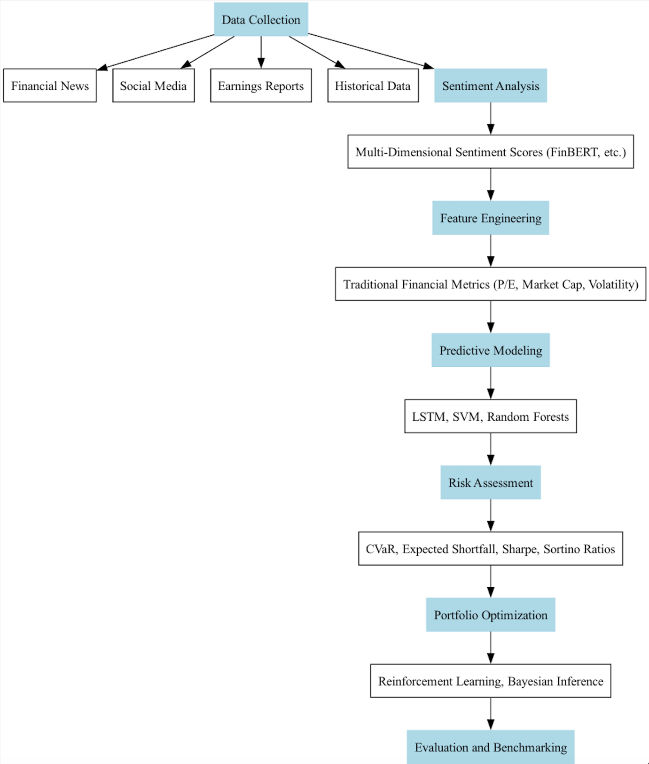

This project will employ a comprehensive methodology for data collection, processing, and model deployment. Key steps include:

**Data Collection and Multi-Dimensional Sentiment Scoring**  
Data will be collected from financial news, social media, earnings reports, and historical stock market data via APIs from sources like Bloomberg, Twitter, and Yahoo Finance. Multi-dimensional sentiment scores, capturing aspects like optimism, fear, and uncertainty, will be generated using finance-specific NLP models such as FinBERT, along with complementary machine learning models to capture sentiment shifts and intensities across data sources.

**Financial Metric Integration and Feature Engineering**  
Traditional financial metrics, including price-to-earnings (P/E) ratios, market capitalization, and historical volatility, will be combined with sentiment scores. Feature engineering will be applied to derive interactions between sentiment factors and financial metrics, thus allowing the model to capture complex dependencies that influence stock performance. Quantitative finance techniques will also be used to derive additional factors, such as momentum and volatility clustering.

**Machine Learning-Driven Predictive Modeling**  
Predictive models will be developed using algorithms such as LSTM networks, Support Vector Machines (SVM), and ensemble learning methods (e.g., Random Forests). These models will be trained to forecast asset returns and risk metrics by incorporating sentiment data as a dynamic feature, allowing predictions to adapt based on real-time market sentiment.

**Enhanced Risk Assessment and Quantitative Finance Integration**  
Advanced risk assessment methods, such as Conditional Value at Risk (CVaR) and Expected Shortfall, will be used alongside traditional metrics like the Sharpe and Sortino ratios. By quantifying both tail risk and the model’s ability to adjust for volatility shifts, this step ensures that portfolio allocations account for extreme market movements. Quantitative finance techniques, including the Black-Litterman model and stochastic volatility models, will be used to refine portfolio allocations further based on identified risk factors.

**Adaptive Portfolio Management and Reinforcement Learning**  
To create a responsive and resilient portfolio, reinforcement learning will be applied to adjust allocations dynamically as market conditions and sentiment factors change. Bayesian inference will be used to update the model’s understanding of risk in response to new data, and a reward function based on risk-adjusted return metrics will guide the reinforcement learning agent toward optimal portfolio adjustments.

**Evaluation and Benchmarking**  
Portfolio performance will be assessed using traditional financial metrics such as Alpha, Beta, and the Sharpe Ratio, as well as sentiment-integrated metrics. Comparative evaluations against benchmark indices (e.g., S&P 500) and standard models without sentiment integration will highlight the value added by this multi-dimensional approach. The model’s adaptability will also be tested in varying market conditions, such as bull, bear, and volatile markets, to assess resilience and consistency.

1. **Evaluation**

The evaluation of this portfolio optimization framework will involve a multi-layered approach to assess predictive accuracy, risk management effectiveness, adaptability, and overall performance relative to industry benchmarks. Key components of the evaluation process include:

1. **Model Performance Metrics**  
   The predictive power of the machine learning models will be evaluated using:
   * **Mean Absolute Error (MAE)** and **Root Mean Square Error (RMSE)** for forecasting returns.
   * **Classification accuracy** for directional movement predictions (up/down) based on sentiment shifts.
   * **Confusion Matrix** and **F1-Score** for assessing accuracy in identifying sentiment-driven market reactions.
2. **Financial Performance Metrics**  
   To measure the effectiveness of the optimized portfolio, the following financial performance metrics will be applied:
   * **Sharpe Ratio**: This will indicate the risk-adjusted return of the portfolio relative to its volatility.
   * **Sortino Ratio**: Focusing on downside risk, this ratio will provide a more comprehensive measure of performance under varying market conditions.
   * **Alpha and Beta**: These will evaluate the portfolio’s excess return and sensitivity to the market, assessing how well the model outperforms market benchmarks.
3. **Risk Assessment and Robustness**  
   The portfolio’s resilience to extreme market conditions will be tested by assessing:
   * **Conditional Value at Risk (CVaR)** and **Expected Shortfall**: These will quantify potential losses in extreme scenarios and provide insight into tail risk.
   * **Stress Testing**: This will evaluate the portfolio's performance under hypothetical market events, such as sudden drops or surges in sentiment, to verify the robustness of the model in various market conditions.
4. **Comparative Analysis and Benchmarking**  
   The portfolio’s performance will be benchmarked against traditional models and major indices:
   * **Baseline Models**: Comparisons with a Markowitz-based portfolio and other conventional models (e.g., Equal-Weighted Portfolio) will measure the added value of the sentiment-integrated approach.
   * **Market Benchmarks**: Comparative analysis with indices like the S&P 500 will highlight the framework’s relative performance, focusing on periods of high volatility to gauge adaptability.
5. **Adaptability and Dynamic Adjustment Metrics**  
   The reinforcement learning component’s adaptability will be tested through:
   * **Cumulative Reward Analysis**: Tracking the cumulative rewards over time will help assess the efficiency and accuracy of the reinforcement learning agent in dynamically adjusting allocations based on sentiment shifts and market trends.
   * **Portfolio Turnover Ratio**: This will measure the frequency of adjustments, balancing between responsiveness and transaction costs, to ensure that the model remains cost-effective while responsive to sentiment-driven market changes.
6. **User-Defined Metrics for Practical Applicability**  
   Finally, to ensure the model’s practical applicability for real-world portfolio managers:
   * **Transaction Cost Analysis**: Simulated transaction costs will be factored in to evaluate real-world viability and the model’s net profitability.
   * **Sentiment-Driven Performance Attribution**: This will help quantify the specific impact of sentiment analysis on overall returns, providing insights into how much the inclusion of sentiment data contributes to risk management and return optimization.

Through this comprehensive evaluation framework, the model’s success will be measured not only in terms of performance but also in its adaptability, robustness, and practical applicability for real-world portfolio management. This ensures that the final product is both innovative and grounded in industry-relevant metrics.

**References**

1. Lopez de Prado, M. (2018). *Advances in Financial Machine Learning*. Wiley.
2. Lopez de Prado, M. (2020). *Machine Learning for Asset Managers*. Cambridge University Press.
3. Fisher, K.L., & Statman, M. (2000). Investor sentiment and stock returns. *Financial Analysts Journal*, 56(2), pp.16-23.
4. Trichilli, Y., et al. (2020). Islamic and conventional portfolios optimization under investor sentiment states. *Journal of Economic Behavior & Organization*, 177, pp.1-20.
5. Schumaker, R.P., & Chen, H. (2009). Textual analysis of stock market prediction using breaking financial news. *ACM Transactions on Information Systems (TOIS)*, 27(2), pp.1-19.
6. Zhang, B., et al. (2023). Enhancing financial sentiment analysis via retrieval-augmented language models. *Proceedings of the 2023 EMNLP*.
7. Li, Y., et al. (2023). Large language models in finance: A survey. *Journal of Financial Data Science*, 5(1), pp.1-20.
8. Zhao, Y., et al. (2023). DocMath-Eval: Evaluating Math Reasoning Capabilities of LLMs in Understanding Financial Documents. *Proceedings of the 2023 EMNLP*.
9. Sirignano, J., & Cont, R. (2019). Universal features of price formation in financial markets. *Quantitative Finance*, 19(1), pp.1-20.
10. Cheng, D., et al. (2023). Financial time series forecasting with multi-modality graph neural network. *IEEE Transactions on Neural Networks and Learning Systems*, 34(1), pp.1-12.