Installation of qto
qto.0.8.3.dev.sveta@sveta-Lenovo-G50-30

By running this command

Provision the application locally

# go to the product instance dir
source $(find . -name '.env') && cd qto/qto.$VERSION.$ENV_TYPE.$USER

# ensure application layer consistency, run db ddl's and load data from s3
./src/bash/qto/qto.sh -a check-perl-syntax -a scramble-confs -a provision-db-admin -a run-qto-db-ddl -a load-db-data-from-s3

by running the second command these are the errors I am getting

got postgresql error telling create dbsql..
so I installed postgresql using commands

sudo apt update
sudo apt install postgresql postgresql-contrib
then created a new role
sudo -u postgres createuser --interactive
and created a new database
sudo -u postgres createdb

then again runned the same command and I got carp error then I installed
how to install the Carp::Always module ubuntu linux

sudo apt update
sudo apt install libcarp-always-perl

then got bash error telling no file or such directory found.

installed bash
sudo apt install bash

runned the command got local lib error and telling to install local lib

installed local lib
sudo apt-get install liblocal-lib-perl

again runned the command and got psql could not connected to the server...for this error to fix i followed these steps

Certify that postgresql service is running, using sudo service postgresql start
Run pg_lsclusters
from your terminal

Check what is the cluster you are running, the output should be something like:

Version - Cluster Port Status Owner Data directory

9.6 ------- main -- 5432 online postgres /var/lib/postgresql/9.6/main

Disregard the '---' signs, as they are being used there only for alignment. The important information are the version and the cluster. You can also check whether the server is running or not in the status column.

Copy the info from the version and the cluster, and use like so: pg_ctlcluster <version> <cluster> start, so in my case, using version 9.6 and cluster 'main', it would be pg_ctlcluster 9.6 main start
If something is wrong, then postgresql will generate a log, that can be accessed on /var/log/postgresql/postgresql-<version>-main.log, so in my case, the full command would be sudo nano /var/log/postgresql/postgresql-9.6-main.log.

020-05-07 19:05:05.798 EEST [39644] LOG: starting PostgreSQL 12.2 (Ubuntu 12.2-4) on x86_64-pc-linux-gnu, compiled by gcc (Ubuntu 9.3.0-8ub>
2020-05-07 19:05:05.802 EEST [39644] LOG: listening on IPv4 address "127.0.0.1", port 5432
2020-05-07 19:05:05.837 EEST [39644] LOG: listening on Unix socket "/var/run/postgresql/.s.PGSQL.5432"
2020-05-07 19:05:05.974 EEST [39645] LOG: database system was shut down at 2020-05-07 19:05:00 EEST
2020-05-07 19:05:06.024 EEST [39644] LOG: database system is ready to accept connections
2020-05-07 21:45:55.744 EEST [39644] LOG: received fast shutdown request
2020-05-07 21:45:56.632 EEST [39644] LOG: aborting any active transactions
2020-05-07 21:45:56.648 EEST [39644] LOG: background worker "logical replication launcher" (PID 39651) exited with exit code 1
2020-05-07 21:45:56.649 EEST [39646] LOG: shutting down
2020-05-07 21:45:57.514 EEST [39644] LOG: database system is shut down
2020-05-08 13:45:26.588 EEST [971] LOG: starting PostgreSQL 12.2 (Ubuntu 12.2-4) on x86_64-pc-linux-gnu, compiled by gcc (Ubuntu 9.3.0-8ubun>
2020-05-08 13:45:26.639 EEST [971] LOG: listening on IPv4 address "127.0.0.1", port 5432
2020-05-08 13:45:26.753 EEST [971] LOG: listening on Unix socket "/var/run/postgresql/.s.PGSQL.5432"
2020-05-08 13:45:28.231 EEST [1009] LOG: database system was shut down at 2020-05-07 21:45:57 EEST
2020-05-08 13:45:29.162 EEST [971] LOG: database system is ready to accept connections
2020-05-08 23:59:39.715 EEST [971] LOG: received fast shutdown request
2020-05-08 23:59:39.969 EEST [971] LOG: aborting any active transactions
2020-05-08 23:59:39.985 EEST [971] LOG: background worker "logical replication launcher" (PID 1025) exited with exit code 1
2020-05-08 23:59:39.988 EEST [1020] LOG: shutting down
2020-05-08 23:59:41.152 EEST [971] LOG: database system is shut down
2020-05-10 16:12:40.054 EEST [915] LOG: starting PostgreSQL 12.2 (Ubuntu 12.2-4) on x86_64-pc-linux-gnu, compiled by gcc (Ubuntu 9.3.0-8ubun>
2020-05-10 16:12:40.094 EEST [915] LOG: listening on IPv4 address "127.0.0.1", port 5432
2020-05-10 16:12:40.216 EEST [915] LOG: listening on Unix socket "/var/run/postgresql/.s.PGSQL.5432"
2020-05-10 16:12:41.021 EEST [963] LOG: database system was shut down at 2020-05-08 23:59:41 EEST
2020-05-10 16:12:41.937 EEST [915] LOG: database system is ready to accept connections
2020-05-10 17:03:03.651 EEST [23311] sveta@postgres FATAL: role "sveta" does not exist
2020-05-10 17:03:03.659 EEST [23312] sveta@template1 FATAL: role "sveta" does not exist
2020-05-10 17:25:23.338 EEST [31749] postgres@postgres ERROR: syntax error at or near "sudo" at character 1
2020-05-10 17:25:23.338 EEST [31749] postgres@postgres STATEMENT: sudo -u postgres createuser sveta
sudo -u postgres createdb ball
sudo -u postgres psql
psql=# alter user sveta with encrypted password 'vytahavya';
2020-05-10 17:26:22.093 EEST [31749] postgres@postgres ERROR: role "sveta" does not exist
2020-05-10 17:26:22.093 EEST [31749] postgres@postgres STATEMENT: alter user sveta with encrypted password 'vytahavya';

I am able to see the logs but I dont knoww how to resolve those…..

/home/sveta/opt/qto/qto.0.8.3.dev.sveta@sveta-Lenovo-G50-30/src/bash/qto/funcs/mojo-hypnotoad-start.func.sh: line 11: kill: (113584) - No such process
sveta 112194 102619 1 21:41 pts/0 00:00:00 bash src/bash/qto/qto.sh -a mojo-hypnotoad-start
sveta 113608 112194 0 21:42 pts/0 00:00:00 /usr/bin/perl /home/sveta/perl5/bin/hypnotoad qto
[INFO ] 2020.05.12-21:42:01 EEST [qto][@sveta-Lenovo-G50-30] [112194] STOP ::: running function :: doMojoHypnotoadStart
[INFO ] 2020.05.12-21:42:01 EEST [qto][@sveta-Lenovo-G50-30] [112194] STOP FOR qto RUN with:
[INFO ] 2020.05.12-21:42:01 EEST [qto][@sveta-Lenovo-G50-30] [112194] STOP FOR qto RUN: 0 # ::: STOP MAIN ::: qto
sveta@sveta-Lenovo-G50-30 [ti touko 12 21:42:01] [~/opt/qto/qto.0.8.3.dev.sveta@sveta-Lenovo-G50-30] $

sveta@sveta-Lenovo-G50-30 [ti touko 12 21:42:01] [~/opt/qto/qto.0.8.3.dev.sveta@sveta-Lenovo-G50-30] $

[INFO ] 2020-05-12 21:42:05 [113608] Qto:111 ::: START MAIN
DBI connect('dbname=dev_qto;host=127.0.0.1;port=15432','usrdevqtoapp',...) failed: FATAL: password authentication failed for user "usrdevqtoapp"
FATAL: password authentication failed for user "usrdevqtoapp" at /home/sveta/opt/qto/qto.0.8.3.dev.sveta@sveta-Lenovo-G50-30/src/perl/qto/script/../lib/Qto/App/Db/In/Postgres/RdrPostgresDb.pm line 939.
[ERROR] 2020-05-12 21:42:05 [113608] RdrPostgresDb:953 ::: cannot connect to the "dev_qto" database: FATAL: password authentication failed for user "usrdevqtoapp"
FATAL: password authentication failed for user "usrdevqtoapp"

Uncaught exception from user code:
Can't load application from file "/home/sveta/opt/qto/qto.0.8.3.dev.sveta@sveta-Lenovo-G50-30/src/perl/qto/script/qto": not a reference at /home/sveta/opt/qto/qto.0.8.3.dev.sveta@sveta-Lenovo-G50-30/src/perl/qto/script/../lib/Qto/App/Db/Out/WtrRedis.pm line 25.
Compilation failed in require at (eval 88) line 1.
Mojo::Server::load_app(Mojo::Server::Prefork=HASH(0x55ed6b59cbe8), "/home/sveta/opt/qto/qto.0.8.3.dev.sveta\@sveta-Lenovo-G50-30/s"...) called at /home/sveta/perl5/lib/perl5/Mojo/Server/Hypnotoad.pm line 53
Mojo::Server::Hypnotoad::run(Mojo::Server::Hypnotoad=HASH(0x55ed6b59c918), "/home/sveta/opt/qto/qto.0.8.3.dev.sveta\@sveta-Lenovo-G50-30/s"...) called at /home/sveta/perl5/bin/hypnotoad line 14

while running the Provision the application locally
2.9///# ensure application layer consistency, run db ddl's and load data from s3
./src/bash/qto/qto.sh -a check-perl-syntax -a scramble-confs -a provision-db-admin -a run-qto-db-ddl -a load-db-data-from-s3

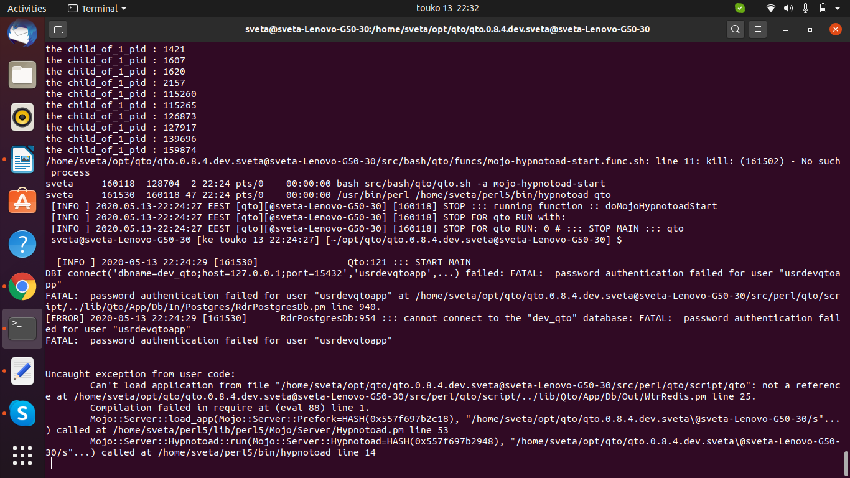

while running the Start the application layer on the dev instance command

2.10//# start the web server
bash src/bash/qto/qto.sh -a mojo-hypnotoad-start

