# **Query 1**

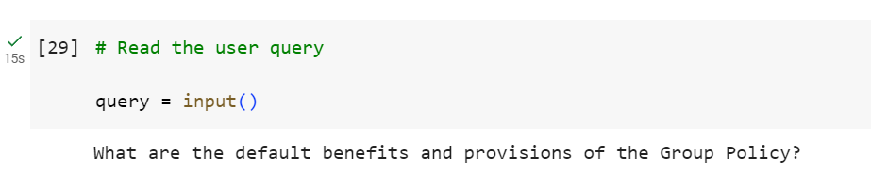

## **Top 3 Results from the Search Layer**

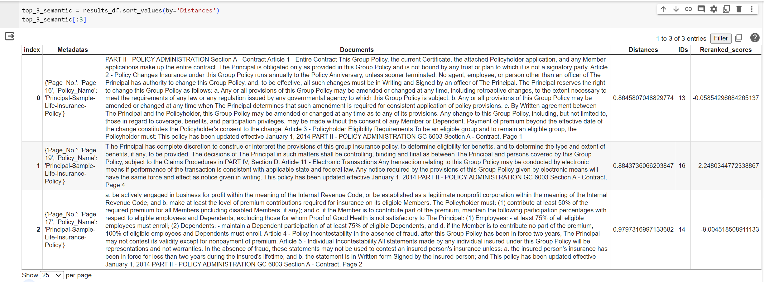

## **Final Generated Answer from the Generation Layer**

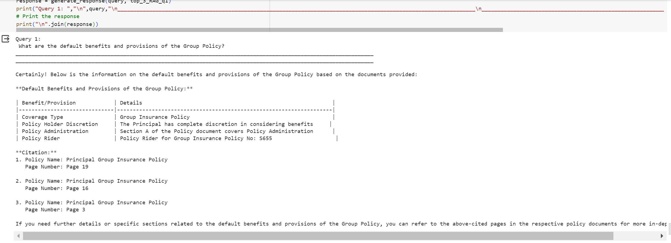

# **Query 2**

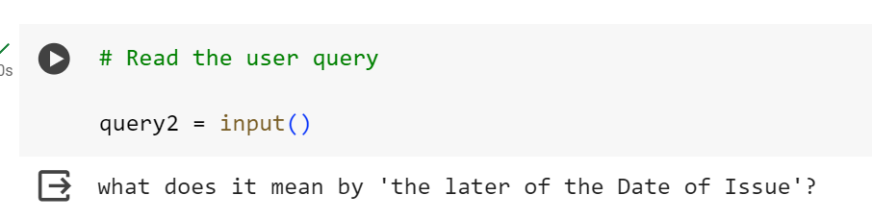

## **Top 3 Results from the Search Layer**

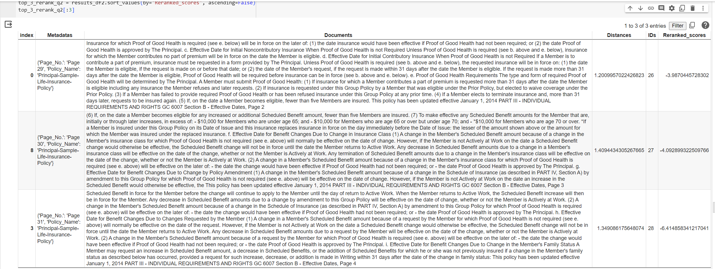

## **Final Generated Answer from the Generation Layer**

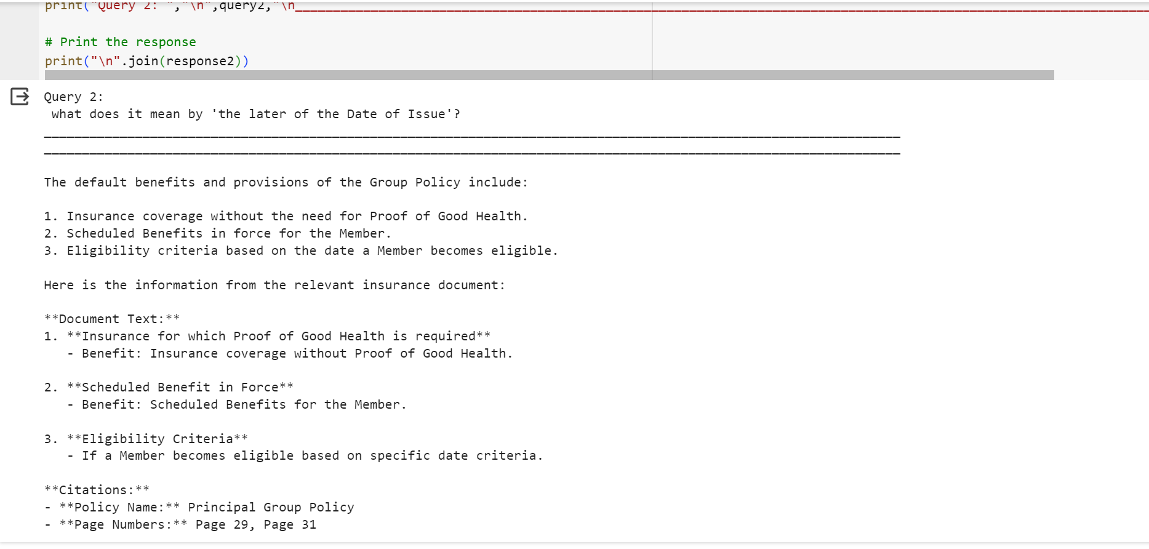

# **Query 3**

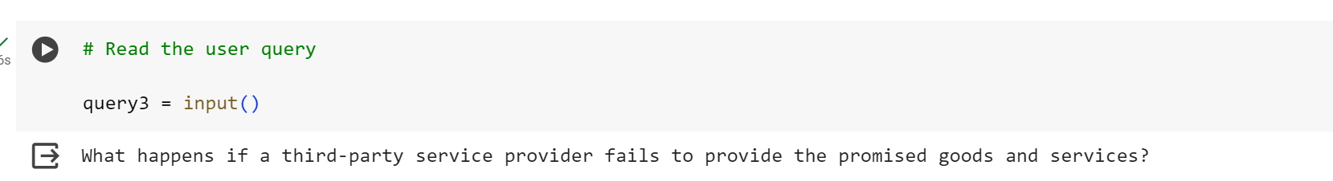

## **Top 3 Results from the Search Layer**

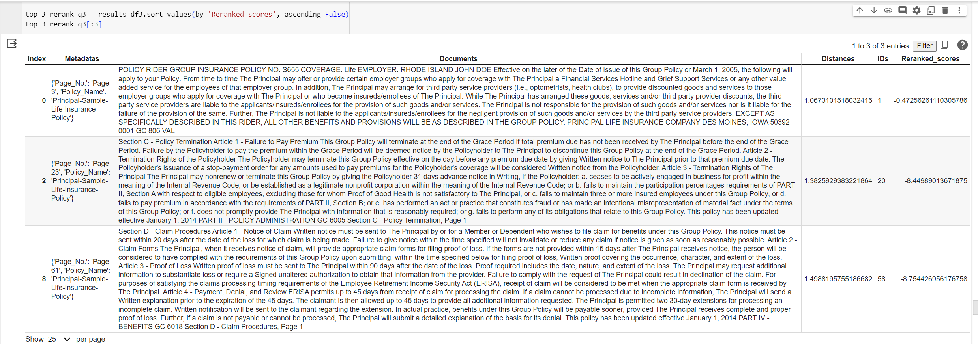

## **Final Generated Answer from the Generation Layer**

