路由
- 本课内容
理解路由的作用
掌握一级路由的配置方法，重点
掌握二级路由的配置方法，重点
掌握路由传参的使用方法，难点，重点
- 路由的概述
  - 了解路由的作用
根据url锚点路径，在容器中加载不同的模块
完成spa（single page application）的开发
使用场景，点击首页显示首页，点击书影音，显示不同的内容,但是内容并没有变化，切换的不是整个页面，只是页面的一部分
  - 实现的本质原理
利用锚点完成切换，页面不会刷新
  - 路由的引入：vue-router.js库来引入路由功能模块
小结：作用，原理
- 一级路由配置方法1
- 引入vue-router.js库
- 创建路由所需模块
使用Vue.extend()方法创建模块
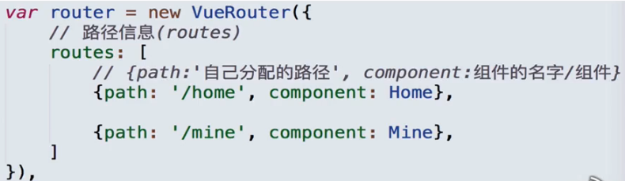
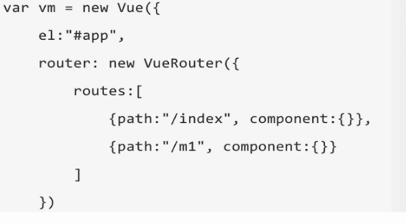
Demo1
<script src="../vue.js"></script>
<script src="../vue-router.js"></script>
<style>
li{ list-style: none; display: inline-block; margin:20px 10px; }
a{ text-decoration: none}
#show{ width: 300px; height: 200px; background-color: grey; }
</style>
</head>
<body>
<div id="box">
<ul>
<!--<li><a href="#">home</a></li>-->
<!--<li><a href="#">news</a></li>-->
<!--<li><a href="#">hot</a></li>-->
<li>
<router-link to="/home">home</router-link>
</li>
<li>
<router-link to="/news">news</router-link>
</li>
<li>
<router-link to="/hot">hot</router-link>
</li>
</ul>
<div id="show">
<router-view></router-view>
</div>
<!--使用路由完成跳转，不再使用a标签
<router-link></router-link>
router-link:在两对尖括号中添加文本，
to属性用来设置跳转url地址 to = 路由配置时，routes数组中的path信息需要填写在此处
router-view:
<router-view></router-view>用来占位
-->
</div>
<script>
var vm = new Vue({
el:"#box",
data:{
},
//添加路由配置项
//router:路由实例对象
//router:new VueRouter()
//设置路由对象的配置项
router:new VueRouter({
routes:[
//路径命名‘/+小写单词’
{path:'/home',component:{
template:'<h2>首页</h2>'
}},
{path:'/news',component:{
template:'<h2>新闻</h2>'
}},
{path:'/hot',component:{
template:'<h2>热点</h2>'
}}
]
})
})
</script>
- 二级路由配置方法2
<script src="../vue.js"></script>
<script src="../vue-router.js"></script>
<style>
li{ list-style: none; display: inline-block; margin:20px 10px; }
a{ text-decoration: none}
.show{ width: 300px; height: 200px; background-color: grey; }
</style>
</head>
<body>
<div id="box">
<ul>
<li>
<router-link to="/home">home</router-link>
</li>
<li>
<router-link to="/news">news</router-link>
</li>
<li>
<router-link to="/hot">hot</router-link>
</li>
</ul>
<div class="show">
<!--router-view占位-->
<router-view></router-view>
</div>
</div>
<template id="home">
<div>
<h2>首页</h2>
<ul>
<li>今日热点</li>
<li>体育新闻</li>
<li>关爱八卦成长协会</li>
</ul>
</div>
</template>
<template id="news">
<div>news</div>
</template>
<template id="hot">
<div>hot</div>
</template>
<script>
/*
1.准备路由所需的模块（组件）
全局Vue下，有extend（），用来注册路由所需的模块（组件）
组件名称，首字母大写
2.配置路径信息
3.创建路由对象
4.添加路由配置项 router:路由对象
*/
var Home = Vue.extend({
template:'#home'
});
var News = Vue.extend({
template:'#news'
});
var Hot = Vue.extend({
template:'#hot'
});
var arr = [
{path:'/home',component:Home},
{path:'/news',component:News},
{path:'/hot',component:Hot}
];
var router = new VueRouter({
//配置项
//routes：存储路径信息的数组
//es6:如果配置项名称与后方配置项名称相同，可以简写
routes:arr
});
var vm = new Vue({
el:"#box",
router:router
})
</script>
- 路由重定向,如刷新时回到首页
路由对象:$router
路由跳转方法：push()
语法：$router.push(“url地址”)
分写方式：
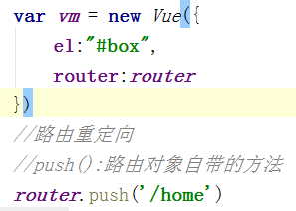
也可以在生命周期中写
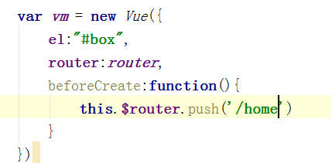
合写方式中只能用钩子函数实现
小结：配置方式
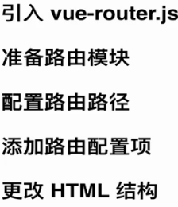
- 二级路由配置
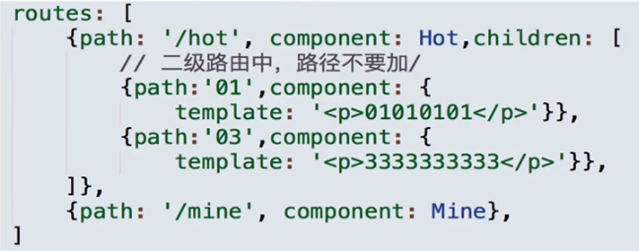
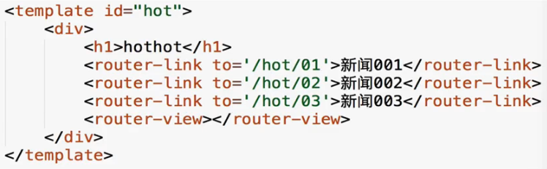
效果：如豆瓣中书影音页面
Demo3
<script src="../vue.js"></script>
<script src="../vue-router.js"></script>
<style>
li{ list-style: none; display: inline-block; margin:20px 10px; }
a{ text-decoration: none}
.show{ width: 300px; height: 200px; background-color: grey; }
</style>
</head>
<body>
<div id="box">
<div class="show">
<router-view></router-view>
</div>
<ul>
<li>
<router-link to="/home">home</router-link>
</li>
<li>
<router-link to="/news">news</router-link>
</li>
<li>
<router-link to="/hot">hot</router-link>
</li>
</ul>
</div>
<template id="home">
<div>
<h2>首页</h2>
<ul>
<li>今日热点</li>
<li>体育新闻</li>
<li>关爱八卦成长协会</li>
</ul>
</div>
</template>
<template id="news">
<div>
<div>news</div>
<router-link to="/news/gym">体育</router-link>
<router-link to="/news/amu">娱乐</router-link>
<router-view></router-view>
</div>
</template>
<template id="hot">
<div>hot</div>
</template>
<template id="c1">
<div>体育新闻</div>
</template>
<template id="c2">
<div>娱乐新闻</div>
</template>
<script>
var Home = Vue.extend({
template:'#home'
});
var News = Vue.extend({
template:'#news'
});
var Hot = Vue.extend({
template:'#hot'
});
var Child1 = Vue.extend({
template:'#c1'
});
var Child2 = Vue.extend({
template:'#c2'
});
var arr = [
{path:'/home',component:Home},
{path:'/news',component:News,children:[
//二级路由配置时前面不要有/
{path:'gym',component:Child1},
{path:'amu',component:Child2},
{path:'',component:Child1}
]},
{path:'/hot',component:Hot}
];
var router = new VueRouter({
routes:arr
});
var vm = new Vue({
el:"#box",
router:router,
beforeCreate:function(){
this.$router.push('/home')
}
})
</script>
- 路由传参
  - 传递参数 <router-link to=”/news/001”>
  - 接收参数$router.params.id
<script src="../vue.js"></script>
<script src="../vue-router.js"></script>
<style>
.show{ background-color: gray; width: 300px; height: 300px}
</style>
</head>
<body>
<div id="box">
<ul>
<li><router-link to="/home">首页</router-link></li>
<li><router-link to="/news">新闻</router-link></li>
</ul>
<div class="show">
<router-view></router-view>
</div>
</div>
<template id="home">
<div>
<h1>home</h1>
<router-link to="/home">home1</router-link>
<router-link to="/home">home2</router-link>
</div>
</template>
<template id="news">
<div>
<h1>news</h1>
<router-link to="/news/1">新闻1</router-link>
<router-link to="/news/2">新闻2</router-link>
<!--变量传递-->
<h1>变量传递</h1>
<ul>
<li v-for="(i,index) in item"><a href="#/news1/detailNews1" @click="fn(i.id)">{{i.name}}</a></li>
</ul>
</div>
</template>
<template id="detailNews">
<div>
<h2>新闻详情</h2>
<span>这是传递过来的数据{{$route.params.id}}</span>
<span>这是传递过来的数据{{arr[$route.params.id]}}</span>
<button><router-link to="/news">返回</router-link></button>
</div>
</template>
<template id="detailNews1">
<div>
<h2>新闻详情1</h2><br />
<!--<p @click="fn()">获取</p>-->
<span>这是传递过来的数据:{{msg}}</span>
<button><router-link to="/news">返回</router-link></button>
</div>
</template>
<script>
var Home = Vue.extend({
template:"#home"
})
var News = Vue.extend({
template:"#news",
data:function(){
return {
item:[
{id:111,name:'aaa'},
{id:222,name:'bbb'},
{id:333,name:'ccc'}
]
}
},
methods:{
fn:function(key){
localStorage.setItem("id", key);
}
}
});
var DetailNews = Vue.extend({
template:"#detailNews",
data:function(){
return {
arr:["aa","bb","cc"]
}
}
})
var DetailNews1 = Vue.extend({
template:"#detailNews1",
data:function(){
return {
msg:""
}
},
created:function(){
this.msg = localStorage.getItem("id")
console.log(this.msg)
}
})
var arr = [
{path:'/home',component:Home},
{path:'/news',component:News},
{path:'/news/:id',component:DetailNews},
{path:'/news1/detailNews1',component:DetailNews1}
]
var router = new VueRouter({
routes:arr
});
var vm = new Vue({
el:"#box",
router:router,
beforeCreate:function(){
this.$router.push('/home')
}
})
</script>

