# Report of Equation Style Lunar Crescent Visibility Criterion

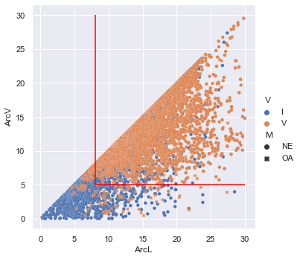

Figure 1: Tested Criterion Over Data of Lunar Crescent Sighting

-----------------------------------------------

## Contradiction Rate of the Criterion

-----------------------------------------------

### Contradiction Rate Of Whole Data

Total Data Above Criteria = 6284

Total Positive Contradiction = 1522

Total Data Below Criteria = 1682

Total Negative Contradiction = 188

-----------------------------------------------

### Contradiction Rate Of Naked Eye (NE) Data

Total Data Above Criteria (NE) = 5340

Total Positive Contradiction (NE) = 1512

Total Data Below Criteria (NE) = 1504

Total Negative Contradiction (NE) = 10

### Contradiction Rate Of Optical Aided (OA) Data

Total Data Above Criteria (OA) = 944

Total Positive Contradiction (OA) = 10

Total Data Below Criteria (OA) = 178

Total Negative Contradiction (OA) = 178

-----------------------------------------------

### Contradiction Rate Summary in Percentage

|  |  |  |
| --- | --- | --- |
| Parameter | Positive | Negative |
| Whole (%) | 24.22 | 11.18 |
| Naked Eye (%) | 28.31 | 0.66 |
| Optical Aided (%) | 1.06 | 100.0 |

-----------------------------------------------

## Comparison of the Tested Criterion Against other Criterion

Ranking for general contradiction is based on the mean percentage value of both positive and negative contradiction of a criterion

### Whole Contradiction Percentage

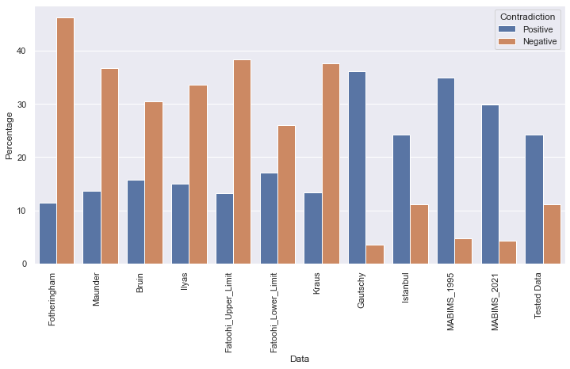

Figure 2: Comparison of Whole Contradiction Rate for Tested Criterion against other Criterion

|  |  |  |  |  |
| --- | --- | --- | --- | --- |
| Ranking | Data | Mean Percentage | Negative Contradiction | Positive Contradiction |
| 1 | MABIMS_2021 | 17.04 | 4.23 | 29.85 |
| 2 | Istanbul | 17.69 | 11.18 | 24.2 |
| 3 | Tested Data | 17.7 | 11.18 | 24.22 |
| 4 | Gautschy | 19.86 | 3.57 | 36.14 |
| 5 | MABIMS_1995 | 19.88 | 4.77 | 34.98 |
| 6 | Fatoohi_Lower_Limit | 21.59 | 26.03 | 17.15 |
| 7 | Bruin | 23.1 | 30.42 | 15.77 |
| 8 | Ilyas | 24.34 | 33.62 | 15.06 |
| 9 | Maunder | 25.22 | 36.72 | 13.71 |
| 10 | Kraus | 25.53 | 37.62 | 13.44 |
| 11 | Fatoohi_Upper_Limit | 25.8 | 38.39 | 13.2 |
| 12 | Fotheringham | 28.84 | 46.21 | 11.46 |

### Naked Eye General Contradiction Percentage

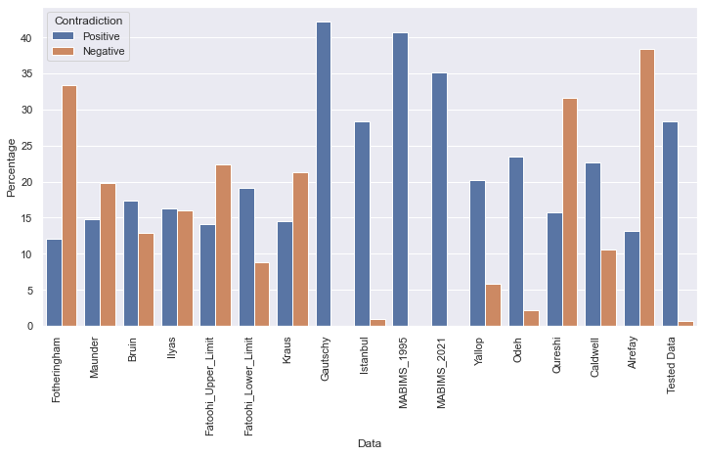

Figure 3: Comparison of Naked Eye Contradiction Rate for Tested Criterion against other Criterion

|  |  |  |  |  |
| --- | --- | --- | --- | --- |
| Ranking | Data | Mean Percentage | Negative Contradiction | Positive Contradiction |
| 1 | Odeh | 12.84 | 2.2 | 23.49 |
| 2 | Yallop | 13.02 | 5.83 | 20.2 |
| 3 | Fatoohi_Lower_Limit | 13.98 | 8.82 | 19.15 |
| 4 | Tested Data | 14.48 | 0.66 | 28.31 |
| 5 | Istanbul | 14.61 | 0.93 | 28.29 |
| 6 | Bruin | 15.12 | 12.87 | 17.37 |
| 7 | Ilyas | 16.13 | 15.95 | 16.32 |
| 8 | Caldwell | 16.6 | 10.51 | 22.69 |
| 9 | Maunder | 17.3 | 19.84 | 14.77 |
| 10 | MABIMS_2021 | 17.56 | 0.0 | 35.11 |
| 11 | Kraus | 17.84 | 21.24 | 14.45 |
| 12 | Fatoohi_Upper_Limit | 18.24 | 22.33 | 14.16 |
| 13 | MABIMS_1995 | 20.38 | 0.0 | 40.75 |
| 14 | Gautschy | 21.08 | 0.0 | 42.15 |
| 15 | Fotheringham | 22.68 | 33.34 | 12.03 |
| 16 | Qureshi | 23.67 | 31.65 | 15.69 |
| 17 | Alrefay | 25.8 | 38.39 | 13.2 |

### Optical Aided General Contradiction Percentage

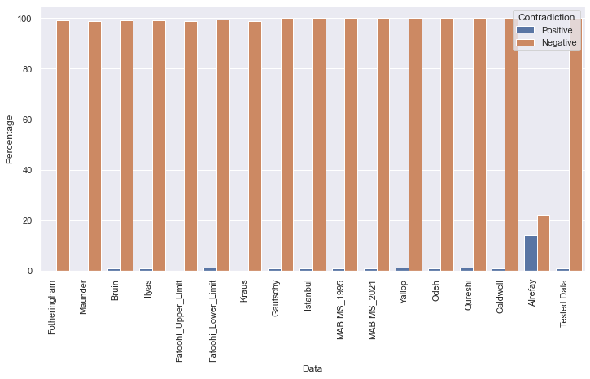

Figure 4: Comparison of Optical Aided Contradiction Rate for Tested Criterion against other Criterion

|  |  |  |  |  |
| --- | --- | --- | --- | --- |
| Ranking | Data | Mean Percentage | Negative Contradiction | Positive Contradiction |
| 1 | Alrefay | 18.24 | 22.33 | 14.16 |
| 2 | Maunder | 49.4 | 98.79 | 0.0 |
| 3 | Kraus | 49.4 | 98.81 | 0.0 |
| 4 | Fatoohi_Upper_Limit | 49.41 | 98.82 | 0.0 |
| 5 | Fotheringham | 49.49 | 98.98 | 0.0 |
| 6 | Bruin | 50.0 | 99.1 | 0.9 |
| 7 | Ilyas | 50.14 | 99.2 | 1.08 |
| 8 | Fatoohi_Lower_Limit | 50.34 | 99.45 | 1.23 |
| 9 | Gautschy | 50.45 | 100.0 | 0.9 |
| 10 | MABIMS_1995 | 50.46 | 100.0 | 0.91 |
| 11 | MABIMS_2021 | 50.46 | 100.0 | 0.93 |
| 12 | Caldwell | 50.48 | 100.0 | 0.95 |
| 13 | Odeh | 50.48 | 100.0 | 0.95 |
| 14 | Istanbul | 50.53 | 100.0 | 1.06 |
| 15 | Tested Data | 50.53 | 100.0 | 1.06 |
| 16 | Yallop | 50.6 | 100.0 | 1.2 |
| 17 | Qureshi | 50.62 | 100.0 | 1.25 |

## Comparison of the Tested Criterion Against other Criterion (For Calendrical Purposes)

Ranking for calendrical based criterion is based on percentage of negative contradiction. The lower is better.

### Calendrical Purposed for Naked Eye

|  |  |  |
| --- | --- | --- |
| Ranking | Percentage | Data |
| 1 | 0.0 | MABIMS_2021 |
| 2 | 0.0 | MABIMS_1995 |
| 3 | 0.0 | Gautschy |
| 4 | 0.66 | Tested Data |
| 5 | 0.93 | Istanbul |
| 6 | 2.2 | Odeh |
| 7 | 5.83 | Yallop |
| 8 | 8.82 | Fatoohi_Lower_Limit |
| 9 | 10.51 | Caldwell |
| 10 | 12.87 | Bruin |
| 11 | 15.95 | Ilyas |
| 12 | 19.84 | Maunder |
| 13 | 21.24 | Kraus |
| 14 | 22.33 | Fatoohi_Upper_Limit |
| 15 | 31.65 | Qureshi |
| 16 | 33.34 | Fotheringham |
| 17 | 38.39 | Alrefay |

-----------------------------------------------

### Calendrical Purposed for Optical Aided

|  |  |  |
| --- | --- | --- |
| Ranking | Percentage | Data |
| 1 | 22.33 | Alrefay |
| 2 | 98.79 | Maunder |
| 3 | 98.81 | Kraus |
| 4 | 98.82 | Fatoohi_Upper_Limit |
| 5 | 98.98 | Fotheringham |
| 6 | 99.1 | Bruin |
| 7 | 99.2 | Ilyas |
| 8 | 99.45 | Fatoohi_Lower_Limit |
| 9 | 100.0 | Caldwell |
| 10 | 100.0 | Qureshi |
| 11 | 100.0 | Odeh |
| 12 | 100.0 | Istanbul |
| 13 | 100.0 | MABIMS_2021 |
| 14 | 100.0 | MABIMS_1995 |
| 15 | 100.0 | Gautschy |
| 16 | 100.0 | Yallop |
| 17 | 100.0 | Tested Data |

-----------------------------------------------

## Comparison of the Tested Criterion Against other Criterion (Observation Purposes)

Ranking for criterion is based on percentage of positive contradiction. The lower is better.

### Observation Purposed for Naked Eye

|  |  |  |
| --- | --- | --- |
| Ranking | Percentage | Data |
| 1 | 12.03 | Fotheringham |
| 2 | 13.2 | Alrefay |
| 3 | 14.16 | Fatoohi_Upper_Limit |
| 4 | 14.45 | Kraus |
| 5 | 14.77 | Maunder |
| 6 | 15.69 | Qureshi |
| 7 | 16.32 | Ilyas |
| 8 | 17.37 | Bruin |
| 9 | 19.15 | Fatoohi_Lower_Limit |
| 10 | 20.2 | Yallop |
| 11 | 22.69 | Caldwell |
| 12 | 23.49 | Odeh |
| 13 | 28.29 | Istanbul |
| 14 | 28.31 | Tested Data |
| 15 | 35.11 | MABIMS_2021 |
| 16 | 40.75 | MABIMS_1995 |
| 17 | 42.15 | Gautschy |

### Observation Purposed for Optical Aided

|  |  |  |
| --- | --- | --- |
| Ranking | Percentage | Data |
| 1 | 0.0 | Fotheringham |
| 2 | 0.0 | Maunder |
| 3 | 0.0 | Fatoohi_Upper_Limit |
| 4 | 0.0 | Kraus |
| 5 | 0.9 | Bruin |
| 6 | 0.9 | Gautschy |
| 7 | 0.91 | MABIMS_1995 |
| 8 | 0.93 | MABIMS_2021 |
| 9 | 0.95 | Caldwell |
| 10 | 0.95 | Odeh |
| 11 | 1.06 | Istanbul |
| 12 | 1.06 | Tested Data |
| 13 | 1.08 | Ilyas |
| 14 | 1.2 | Yallop |
| 15 | 1.23 | Fatoohi_Lower_Limit |
| 16 | 1.25 | Qureshi |
| 17 | 14.16 | Alrefay |

## Criterion Regression Assesment

Mean Absolute Error (MAE) = 6.385555555555555

Mean Squared Error (MSE) = 77.3123111111111

R^2 Score = -1.3351648351648353

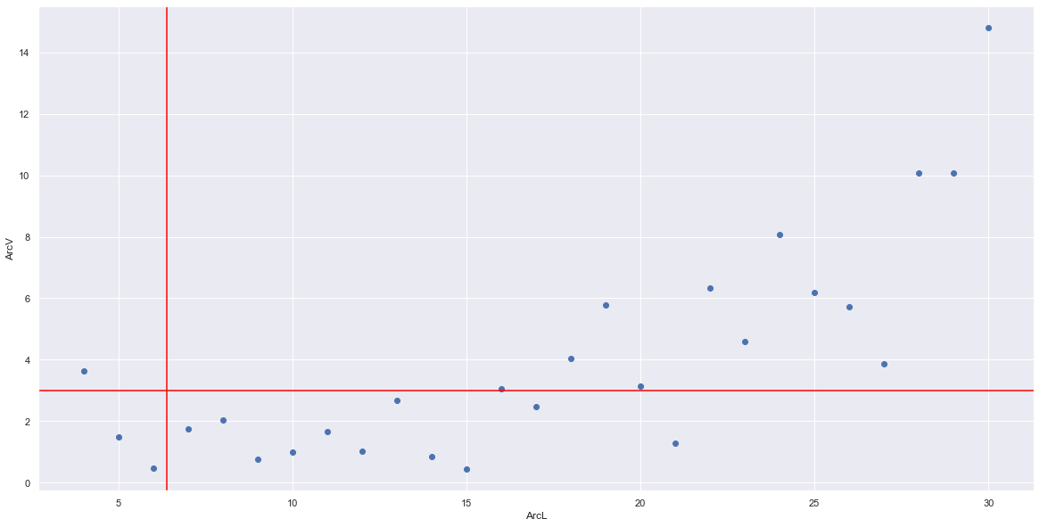

Figure 5: Graph of the Criterion over Minimum Value of Lunar Crescent Data

### Criterion Ranking based on Regression

|  |  |  |  |  |
| --- | --- | --- | --- | --- |
| Mean Absolute Error (MAE) | Mean Squared Error (MSE) | R^2 Score | Criterion | Rank |
| 2.084695652 | 22.21300329 | -0.085251825 | Alrefay_OA | 1 |
| 2.223807907 | 24.65992378 | -0.204800042 | Odeh_NE | 2 |
| 3.914207214 | 25.25453588 | -0.233850767 | Odeh_OA | 3 |
| 2.450167029 | 26.87731966 | -0.313134466 | Alrefay_NE | 4 |
| 3.590345627 | 34.8720514 | -0.70372988 | Qureshi_NE | 5 |
| 5.686520687 | 48.20263245 | -2.379832938 | Qureshi_OA | 6 |
| 6.018397651 | 52.96538573 | -2.713783795 | Yallop_Optical Aided | 7 |
| 6.211558767 | 61.3402037 | -1.99687382 | Yallop_NE | 8 |
| 6.385555556 | 77.31231111 | -1.335164835 | Istanbul | 9 |
| 6.655999814 | 76.58037215 | -0.425999706 | Bruin | 10 |
| 6.724444444 | 92.94045926 | -1.852087912 | MABIMS_2021 | 11 |
| 7.361336207 | 102.4025137 | -0.808633968 | Fatoohi_Lower_Limit | 12 |
| 7.908039804 | 116.593857 | -1.05928158 | Ilyas | 13 |
| 8.425903448 | 124.3009794 | -1.195404833 | Fatoohi_Upper_limit | 14 |
| 8.468097244 | 126.565648 | -1.235403428 | Krauss | 15 |
| 8.460689655 | 127.1567172 | -1.245842897 | Maunder | 16 |
| 8.33037037 | 136.2345333 | -3.230769231 | MABIMS_1995 | 17 |
| 9.899606343 | 155.4593905 | -1.745724924 | Fotheringham | 18 |
| 57.74421429 | 3711.136899 | -5.203120036 | Caldwell_OA | 19 |
| 123.5960167 | 15829.36749 | -6.596617689 | Caldwell_NE | 20 |
| 128.9079023 | 17576.31979 | -25.82495538 | Gautchsy | 21 |