**Project Research**

Random Processes

* Chance over large numbers can generate statistically predictable outcomes
* Gaseous particles are in constant random motion

Random Walks

* A random process consisting of a sequence of discrete steps of fixed length
  + Length varies depending on no. of dimensions and whether it is confined to a lattice
  + In nature, steps usually vary in size!
* Random walks applied to collisions of molecules in a gas = diffusion
* Mathematically described as a discrete time stochastic processes
* A *biased* random walk is biased in one direction, leading to a net drift on average of particles
  + Can either be biased if probabilities are uneven or if step sizes differ by direction
  + Could actually model this (e.g. bacteria moving towards a higher concentration)
* Random walks applied to random thermal perturbations in a liquid = Brownian motion
  + Motion of small particles suspended in a fluid due to bombardment of molecules obeying a Maxwellian velocity distribution
* In 1D: can only move in the positive or negative direction with equal probability
  + On a number line, most probable distance from the starting point after steps is 0
  + Gaussian distribution around the mean with standard deviation
  + standard deviation property applies in all numbers of dimensions, is characteristic of random walks and diffusion processes

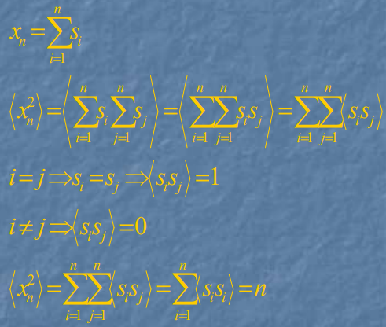

Brownian Motion

* Mathematically defined as a real-valued continuous time stochastic process. Often considered as the simplest continuous time stochastic process
* Stochastic (random) processes are a collection/family of random variables, often represented by a time series, and give a randomly determinant outcome. If a stochastic process is in continuous time it is also in continuous space, and likewise with discrete time and space
* *Hence Brownian motion is a stochastic process, whose behaviour is determined by a collection of random variables varies in time*

Diffusion

* Gaseous particles undergo diffusion because they carry kinetic energy, so diffusion occurs faster at higher temperatures since the gas has a higher KE
* Heavier gases diffuse more slowly!!
* Consider the probability that a walker is at position after steps
* To get to position , the walker must be at position or to the previous step, where the probability the walker moves to position is 0.5
* Letting the time and spatial steps become infinitesimally small leads to the diffusion eqn:

Effusion

* **Diffusion** occurs when gas molecules disperse throughout a container. **Effusion** occurs when a gas passes through an opening smaller than the mean free path of the particles (average distance travelled between collisions), into an evacuated chamber
* **Graham’s Law** experimentally found that the rate of effusion of a gas is inversely proportional to the square root of the mass of its particles (molecular mass),
* **Derivation:**
  + Assumed that all gases at the same temperature have the same average kinetic energy (based on the kinetic theory of gases)
  + Average kinetic energy of two gases with different molecular masses:
  + Re-arranging gives ⇒
  + Rate of diffusion/effusion is proportional to this

Monte Carlo Methods

* Any method that solves a problem by generating suitable random numbers and observing the fraction of numbers obeying a property
* Useful for obtaining numerical solutions to problems with complex analytical solutions

RNG in Computers

* A uniform distribution of **pseudo-**random numbers can be generated by a linear congruential generator (LCG), defined by a recurrence relation:
  + a, b, m are chosen fixed integers: multiplier, increment and modulus respectively
  + starting value is the seed
  + A random number in the interval [0,1] is given by
  + M random uniformly distributed numbers will be produced
* PRNGs generate a sequence of numbers whose properties **approximate** the properties of sequences of random numbers, so are not truly random since they are entirely determined by an initial *(seed)* value. Are very speedy and reproducible.

Diffusion-limited aggregation

* Particles undergoing a random walk due to Brownian motion cluster together to form aggregates, known as Brownian trees
* A particle freely random walks until it gets within a critical range and is pulled onto the cluster
* Brownian trees are fractals, and are mathematical models of dendritic structures (Li dendrites, electrodeposition on cells)
* Important to keep number of particles undergoing Brownian motion low, to ensure only diffusion is happening
* Resulting tree depends principally on seed position, initial particle position, and moving algorithm