**Water.org’s Global Advocacy Strategy: FY15 and Beyond**

**Prepared by Chevenee Reavis I March 25, 2015**

**Overview:**

Through several strategic planning meetings conducted over the fall months of 2014, the Water.org team has begun to more clearly articulate its global advocacy strategy than ever before. While Water.org has been an active member of several sector-led advocacy initiatives and has invested heavily in raising awareness for the global water and sanitation cause, we believe we are now poised to embark on a multi-faceted advocacy strategy that will enable the organization to advance a global “conversation” about the crisis and create an enabling environment that will support the expansion and impact of WSS Finance or WaterCredit—a solution that we believe to be a cornerstone to ending the global crisis. To inform our approach to global advocacy, Water.org made strategic investments in fiscal years 2013 and 2014 to listen and learn from practitioners in the sector and advocacy experts within and outside the field.  We pressure-tested assumptions and learned more about what the marketplace expects from Water.org.  This has helped us understand the role that we can play and clarify our objective and approach going forward.  This memo serves as an important internal communication to help clarify the global advocacy priorities, integrated strategy, and structure that Water.org seeks to activate in FY2015 and beyond.

**Context and Problem Analysis:**

In 2014, more than a third of the people on the planet lived each day without access to safe, potable drinking water and/or a basic toilet. In some respects, it’s one of the greatest failures of modern society. This provision of clean water and sanitation has been all but solved for in the “developed world”. It is a burden born almost exclusively by the world’s poor. At its very heart, it is a gross social injustice and yet there is strong, compelling evidence which demonstrates that this problem is not just one of morality but one which directly impacts nearly every basic tenant of thriving society—economic growth, gender equality, public health, education, and security.

The World Bank estimates that every $1 invested in WASH, at least $4 is returned in saved health care costs and increased economic productivity. Additional research estimates that providing sanitation alone to everyone who needs it would return $220 billion each year to the global economy. We know that every minute, a child under the age of five will die from a preventable water-borne illness. In fact, water-related diseases continue to be among the leading causes of preventable child deaths in the world. Diarrhea, and pneumonia, the two leading killers of children aged one month to five years, and under-nutrition, could be reduced by 50 percent by improving access to safe drinking water, sanitary conditions and hygienic practices. Everyday millions of hours are spent collecting water for women and girls. Addressing this challenge would fundamentally shift the paradigm for women’s empowerment and girl’s education. It is estimated that improved access to water and toilets at home and at school, would yield as much as an additional 443 million school days each year for children worldwide.

In sub-Saharan Africa and South Asia, the lack of water and sanitation services for all citizens is estimated to cost 5%-6% of the region’s Gross Domestic Product each year. There is enormous potential benefit to global financial security through the provision of water and sanitation. In 2009, this lost GDP translated to $47.7 billion in sub-Saharan Africa—more than the $46.7 billion in aid delivered to the region that year.

These statistics persist even though tremendous progress has been made. In the last two decades, millions of people climbed out of extreme poverty and secured sustainable water and sanitation access. And while the goals for water coverage outlined in the Millennium Development Goal (MDG) framework was met before the 2015 deadline, we risk falling back upon this progress as climate change impacts increase, population rates rise, urbanization places extreme pressure on already frail infrastructure, and water tables continue to drop due primarily to drain for industrial use and generating energy for the world’s growing economic needs. Achieving the MDG goal related to alleviating sanitation challenges across the globe unfortunately is sorely lagging. It is unlikely that by September 2015 the goal will be met and the challenge continues to grow in size and scope. Only 33% of the worlds waste-water is treated while nearly 35% of the world’s population live without improved sanitation.

The good news is that there are solutions that exist and Water.org believes that at its very core, the people most affected by this challenge—the world’s most vulnerable—are the key to overcoming it. Each day, billions of people are spending countless hours and monetary resources scavenging and paying for water and sanitation services at varying degrees of quality. Imagine if we could give that time back. Imagine if instead of a family spending up to 20 percent of their precious disposable income on accessing basic services through informal vendors, most often in daily increments, families could invest in securing long-term access by financing those solutions.

In 2008, the Bill and Melinda Gates Foundation estimated that more than $9 billion dollars of global demand existed for micro-level financing for water and sanitation services. In 2013, Deloitte Monitor estimated that in India alone, demand for financial services for rural sanitation could be worth up to $6-9 billion. We know that the world’s most vulnerable pay the most for what is nearly free in the most economically developed countries (MEDC). WaterCredit is an approach that puts those who are most vulnerable at the center of the solution. By facilitating affordable financing to families in need so that they may secure long-term access, we are not only ensuring coverage but also ensuring that households are viewed as customers versus beneficiaries of charity. We are also simultaneously addressing one of the greatest global obstacles to achieving universal access to water and sanitation—capital.

To date, annual investments by the international aid community in clean water and sanitation access is estimated to be $9 billion. The World Health Organization (WHO) estimates that it would cost up to $200 billion per year, for five years to achieve universal coverage. There remains a significant funding gap to achieve our goals. There are 2.5 billion people who do not currently have access to safe water and/or basic sanitation services at home. If only a fraction of the resources those families spend could be captured to capitalize long-term infrastructure, it would be a paradigm shift in terms of accelerating access and the way we think about the world’s poor—central to the solution versus a mere target of it.

**This is our global advocacy remit.** We must not only mobilize greater capital into the sector but continue to advance the global discourse around the global water and sanitation crisis, ensuring that world leaders—in government and business—understand that without solving for this challenge, we will never end extreme poverty and therefore will fall short of realizing the full potential of communities, nations, and the global economy. Specifically, we must ensure that the people who live and die this reality each day remain central to that discourse and are viewed as customers over recipients. No global solution or movement can exist without this focus. WaterCredit embodies this spirit and can galvanize new and significant flows of capital into the sector. Water.org’s approach to advocacy will focus not only on the macro issues of awareness and capital but specifically on helping to scale WaterCredit. As Water.org continuously works to identify and remove barriers to scale—political, regulatory, or otherwise—the organization will focus on building the evidence base required to share the model with others including global development agencies, governments, corporations, and international aid organizations. It is through awareness building, direct scaling of programs, and indirect scaling through partnerships and shared learning that we believe millions of people can be reached.

**Theory of Change:**

An important element of Water.org’s mission has always been to act as an educator. Since its founding in 1990, the organization has endeavored both to increase awareness about the cause and to provide opportunities to get involved.  However, over the last two decades, Water.org has evolved in terms of its programmatic approach, impact, and asset mix. The organization is now prepared to expand its programmatic offering further, embarking upon a robust and sophisticated approach to advocacy as a means to delivering impact.

In designing Water.org’s approach to advocacy, we reflected deeply on the underlying root causes of the crisis as well as where Water.org can contribute unique value.  In deconstructing the dimensions of the crisis in Water.org’s Theory of Change paper titled, “In Our Lifetime,” the organization articulated three specific chokepoints that hinder achievement of universal access: Capital, Accountability and Participation. These are certainly not the only obstacles that exist but they are three dimensions that Water.org is uniquely positioned to address. Using these dimensions as a guiding framework, we outlined the near- to long-term challenges we believe Water.org can uniquely address through direct and/or indirect advocacy.

* Immediate: In the context primarily of scaling WaterCredit, or WSS Finance as it is referred to more broadly (making access to affordable financing for water and sanitation services ubiquitous for the world’s poor), Water.org must tackle immediate hurdles that practitioners face in understanding and taking up the model. Preliminary research completed in partnership with McKinsey & Company demonstrates that an enormous market exists for such programming but lack of awareness, capacity, or tool sets among practitioners is an immediate barrier to uptake.
* Intermediate: Broadly, a supportive ecosystem—awareness, resources, and policies—are required to ensure WSS Finance can scale successfully.  In this context, Water.org seeks to increase awareness and participation among key influencing organizations that can ensure the crisis and WSS Finance solutions are firmly placed on the global development agenda. In close coordination, we will work to improve regulatory or political environments for organizations working to scale WSS finance so that capital flows into the sector, thus aptly targeting and empowering the poor so that they may be part of the worldwide solution.
* Structural: Beyond direct execution and enabling environments, long-term, structural challenges exist which underpin the very system in which we work. These include lack of political will to prioritize its citizens’ access to basic services, large-scale corruption, and/or lack of transparency around investments promised. Gender inequities or cultural apathy can also be deeply entrenched, underlying causes for persistent inequities to access. The sector will require much greater financial commitments to water and sanitation access at an international level but those governments and institutions which are making these investments must be held accountable and be transparent to those its intended to serve.

**Diagram 1. Causal hierarchy of obstacles inhibiting universal access to safe water and basic sanitation specific to chokepoints outlined in Water.org’s Theory of Change paper, “In Our Lifetime” which outlines lack of Capital, Accountability, and Participation as roots causes.**

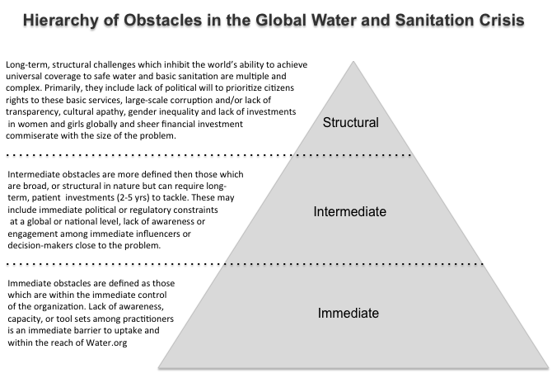

In many respects, resources are allocated first to addressing immediate causes of the crisis through near-term activities, specifically in geographies where Water.org operates, followed by Water.org’s ability to address intermediate and structural challenges that lend themselves to activities on a global level. The same is true in terms of direct correlation with measurability and tracking results. Activities that Water.org will pursue in the near-term will be inherently more measurable versus activities aimed at addressing longer-term obstacles, which will require a more nuanced and patient methodology to quantify direct impact.

**Global Advocacy Strategy:**

This section outlines the comprehensive global advocacy strategy that Water.org will focus on animating over the next several years the four strategic objectives that anchor our approach. These objectives are not mutually exclusive and we’ll employ a mix of strategies to address one or more objective, acknowledging that often activities may overlap with and reinforce one another.

|  |  |
| --- | --- |
| **Objectives** | **Core strategies** |
| Drive large-scale adoption of HH-level WSS Finance for the poor | * Learning and Knowledge Exchange: Open source data, tools and forums * Public Affairs: outreach and influencer engagement to increase awareness and mobilize resources and supporters * Institutional partnerships: influencing policies and practices of partners * Targeted policy advocacy: creating enabling environments for Water.org partners and the broader sector |
| Catalyze awareness of and investments in universal water and sanitation access |
| Create an enabling environment for WSS finance |
| Support the sector to address systemic and structure challenges |

Below outlines a visual framework for the Global Advocacy strategy being deployed in FY15.

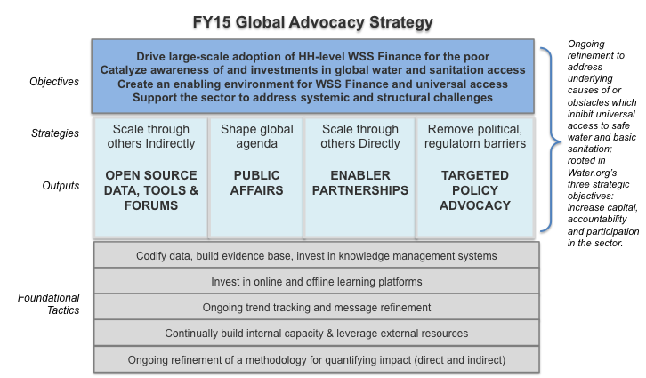

Advocacy is a broad term. While education and outreach will continue to take shape across the organization and in many forms, Water.org will also begin to formally develop a new pillar within the organization analogous to International Programs and will lead Global Advocacy efforts as defined above. Given the strong connection between Water.org's programs and the evidence base required to take on a more formal, external role, there will be close coordination and integration between International Programs and Global Advocacy in country and globally.

Structurally, we envision four functional areas that will support the attainment of these strategies: Learning and Knowledge Exchange, Public Affairs, Policy Advocacy and Institutional Partnerships. These areas and the recommended organizational structure follow.

Functional Area

Specific Position; note that dashed line indicates dot line reporting structuring

***Learning & Knowledge Exchange:*** led by the Director of International Programs, L&KE will focus primarily in FY15 on facilitating deeper connectivity between partners in WO's partner network, making components of the WaterPortal accessible to partner organizations, and partner with third party partners to develop a minimum of one piece of research or documentation of WaterCredit to help bolster Water.org's evidence base. The latter is a project currently underway with the World Bank’s Water and Sanitation Program led by International Programs with strong collaboration with the Global Advocacy team to ensure the collaboration and product can be leveraged for broader advocacy activities. The Global Advocacy and IP teams will collaborate closely to prioritize research and data needed to support external outreach and partnerships. As IP expands their team with new hires in FY15 focused on Learning and Knowledge Exchange, the mandate will expand to include audiences beyond Water.org's partner network and encompass a broader range of practitioners. Given Water.org’s experience working with microfinance institutions (MFIs) and self-identified strengths in stakeholder engagement, the organization is well placed to serve as a hub of insight and analysis to further ‘make the case’ for WSS financing to MF practitioners using data and evidence-backed analyses based on direct WaterCredit experience. The Directors of IP and GA will work closely on scoping the next phase of L&KE that will focus increasingly on external audiences.

***Public Affairs, Institutional Partnerships, and Policy Advocacy:*** led by the Director of Strategic Initiatives and Global Advocacy, the team will focus in FY15 on continuing to raise awareness for the global water and sanitation crisis, ensuring that it’s placed firmly on the global development agenda and that WSS Finance is elevated as a unique solution and best practice that should be incorporated into implementation targets.

*Public Affairs:* We will do this through a mix of strategic public relations outreach, primarily in conjunction with Water.org co-founders, public speaking, external publishing, and other thought leadership activities. Target audiences include private sector leaders, development/philanthropy/activist influencers, and often our donors. It is by design that we often prioritize advocacy initiatives that mutually reinforce not only Water.org’s thought leadership but also the team’s development efforts. An example of this is working with the United Nations community to: (1) advocate for the inclusion of universal access to safe water and ending open defecation as a standalone Post-2015 SDG and (2) to incorporate principles and practices of WSS Finance into the Implementation guidelines. These guidelines will roll out in conjunction with the new SDG framework in September 2015. Another example is the close collaboration Water.org has pursued with the Clinton Foundation to advocate for a strong focus on safe water access and sanitation. The Foundation’s recent commitment to make the issue one of three priority areas of its annual CGI meeting is a strong proof point of the value of such advocacy. We are now working with the Foundation to ensure strong “commitments to action” are announced in the 2015 Annual meeting that will measurably demonstrate that new resources have been committed to scaling WSS Finance.

*Institutional Enablers:* For the first time, Water.org will also begin to more formally identify and pursue broad partnerships with what we are calling “enabler” institutions. Enablers, as defined by Water.org, are financial institutions, WASH practitioners, and/or policy drivers best equipped, positioned and desirous to support the goal of enabling WaterCredit loans to serve hundreds of millions of people in the coming years. Enablers by definition and design are uniquely positioned relative to government, policy and resources and are motivated to lessen key barriers or directly unlock the capital flows for WASH finance—within microfinance or through other channels.

In 2014, Water.org invested in extensive stakeholder outreach, including interviews with more than 30 practitioners to gauge demand for WaterCredit expertise and identify prospective enablers with interest in potential partnership with Water.org. Through Water.org’s research, a short list of institutions was identified as prospective enabling partners, and Water.org has begun preliminary discussions with two immediate priority partners: World Bank’s Global Sanitation and Water Practice Group and Citi Microfinance.

An organizational objective in 2015 is to form a strategic partnership with no less than two "Institutional Enablers," influencing policy and practice as a means of scaling WaterCredit. This objective includes developing a methodology to quantify the number of people served with improved water or sanitation under such partnerships. It’s important to note that the International Programs team have historically had and led many touch points with organizations like the World Bank WSP and Citi Microfinance. We anticipate that these connections will continue. The rationale for establishing a more formal function to lead institutional partnerships is to (1) develop partnerships first from the perspective of advocacy that enables scaling of WC broadly beyond Water.org and (2) ensure that Water.org can optimize complex partnerships successfully by resourcing them with a central, coordinating function. This does not imply or necessitate “sole ownership” by Advocacy of the Enabler partnership or of its productivity. Rather, it assigns to Advocacy the responsibility for managing the partnership cooperation process (internal and external) over the duration of the partnership. This means that one partnership may require multiple points of intersection—a shared piece of research, a WaterCredit Advisory Services engagement, collaboration around program implementation, partnering on public affairs or policy activities, etc. The lead for institutional partnerships will serve as a lead on partnership strategy and be accountable for successful and often cross-functional execution.

*Policy Advocacy:* Also new to Water.org in FY15 is the organization’s entry into policy advocacy in a more direct manner. Given Water.org’s footprint and experience, the organization will maintain a focus on supporting USG policy advocacy as needed but also focus on supporting an enabling environment for Water.org’s work in countries where we operate. In FY15, Water.org has prioritized India, Ethiopia and Indonesia (in that order) for piloting dedicated policy advocacy activities. In FY15 Water.org will hire a full time lead for policy advocacy in India to report directly to the Director of Strategic Initiatives and Global Advocacy with a dotted line to the Country Director. In Ethiopia and Indonesia, based on current projections that the level of effort required will be less than full time, individuals which focus on policy advocacy in those countries will have a dotted line to the Director of Advocacy. This structure will enable Water.org to ensure global continuity of advocacy efforts while allowing flexibility for local adaptation and execution. Chaired by the Director of Global Advocacy, quarterly meetings across countries will enable cross team and country learning.

In FY15, global advocacy efforts are focused on achieving the following measurable goals:

* Collaborate with M&E and L&KE teams to develop partnership materials that outline the evidence base to promote WSS financing at BOP among influencers/enablers.
* Draw on Water.org’s WaterCredit experience to engage no less than two strategic institutional partners and develop a tool that can aid WO to evaluate the impact of prospective partnerships and measure the impact of those partnerships. The long-term goal is to undertake partnerships in a way that can lead to Water.org approach that can reach 50M people by 2020.
* Build plan, team, and cross-functional alignment to support and execute the formation of an institutional partnerships strategy and public affairs activities for FY15.
* Support the development of a 3-5 year India Strategy, specifically contributing an in-country advocacy strategy for India to be activated in 2HFY15.

**Strategic Roll Out**

The primary goal of this internal communication is to align organizationally around how Water.org is defining Global Advocacy, our objectives, audiences, core strategies, and structure. Critical to success is strong collaboration and alignment between International Programs and Global Advocacy teams. Strong alignment will in turn also enable the development team to increasingly package our advocacy work as a key component of Water.org’s approach going forward. Through May 2015, we’ll focus internally on ensuring the global team and Board of Directors receive this memo and have the opportunity to discuss outstanding questions and refine our thinking as appropriate. This will include a series of internal quarterly calls and a quarterly “global update” which will be circulated across the organization starting in Q3 as well as collaboration with marketing to ensure Global Advocacy messaging is included in the InterBrand messaging exercise (note that the teams have collaborated to ensure inclusion of advocacy as central to Water.org’s refined brand position).

Externally, as Water.org strengthens its approach and track record on key global initiatives and in key countries of operation (India, Ethiopia, and Indonesia), the global advocacy team will increasingly identify opportunities to position Water.org as a thought leader within the advocacy arena. Opportunities such as media, speaking, and writing will enable the organization to increase both its credibility and its fundability.