**Jenkins**

Jenkins is an open source automation tool written in java with plugins built for continuous Integration purpose. Plugins allow integration of various DevOps stages.

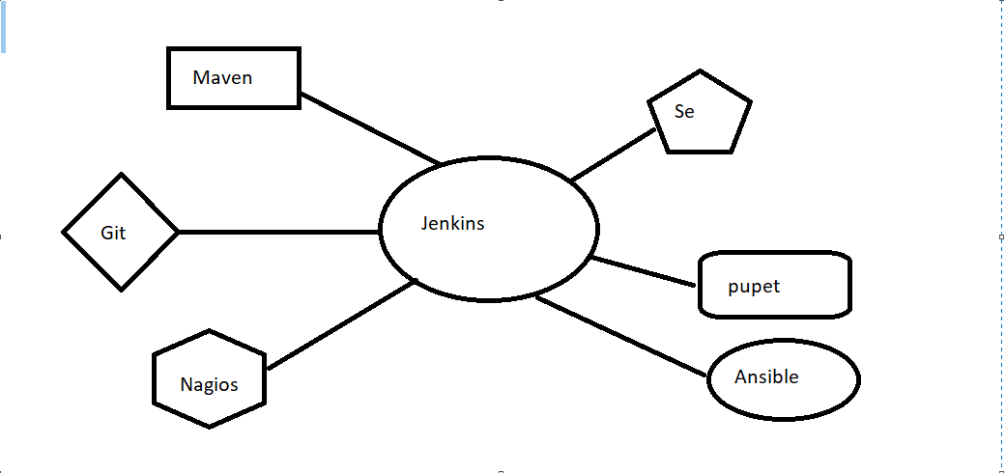

Maven ---> Build

Git ----> Version Control System

Nagios ---> Continuous Monitoring

Se ---> Continuous Testing

Puppet ---> Configuration Management

Ansible ---> Continuous Deployment

Jenkins installation steps

1. Java is pr-requisite for the jenkins
2. apt update
3. apt install openjdk-8-jdk

4.curl -fsSL https://pkg.jenkins.io/debian-stable/jenkins.io.key | sudo tee \

/usr/share/keyrings/jenkins-keyring.asc > /dev/null

5.echo deb [signed-by=/usr/share/keyrings/jenkins-keyring.asc] \

https://pkg.jenkins.io/debian-stable binary/ | sudo tee \

/etc/apt/sources.list.d/jenkins.list > /dev/null

1. apt update
2. apt install jenkins
3. systemctl enable jenkins
4. systemctl start jenkins
5. systemctl status jenkins

Take public IP address of EC2 instance.

The port num of jenkins is 8080

Ip:8080 and access the jenkins page

Or

sudo wget -O /etc/yum.repos.d/jenkins.repo \

https://pkg.jenkins.io/redhat-stable/jenkins.repo

sudo rpm --import https://pkg.jenkins.io/redhat-stable/jenkins.io.key

sudo yum upgrade

# Add required dependencies for the jenkins package

sudo yum install java-11-openjdk

sudo yum install jenkins

sudo systemctl daemon-reload

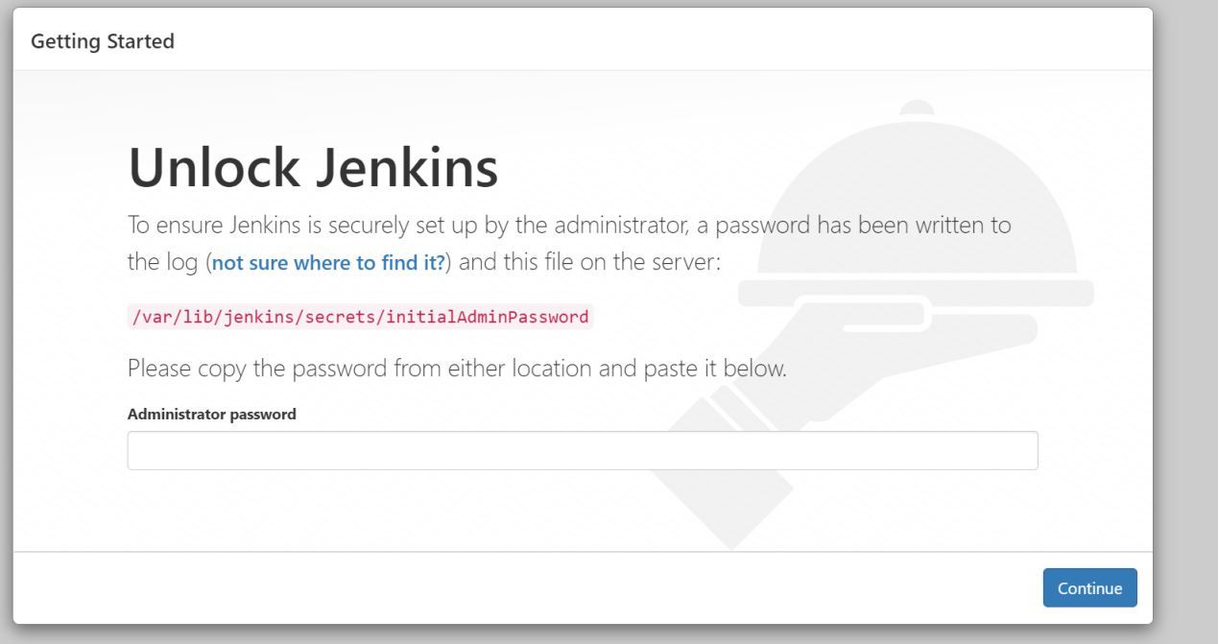

The Administrator password is stored in

**cat /var/lib/jenkins/secretes/initialAdminPassword**.

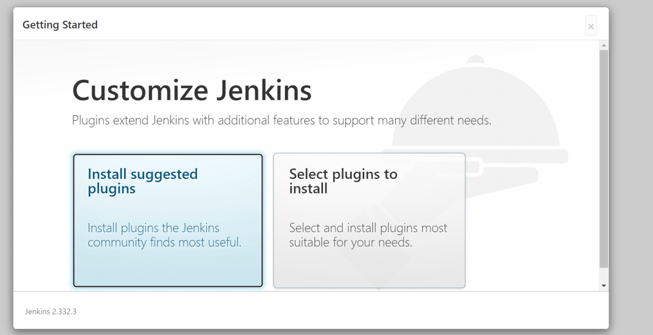

We need to install suggested plugins.

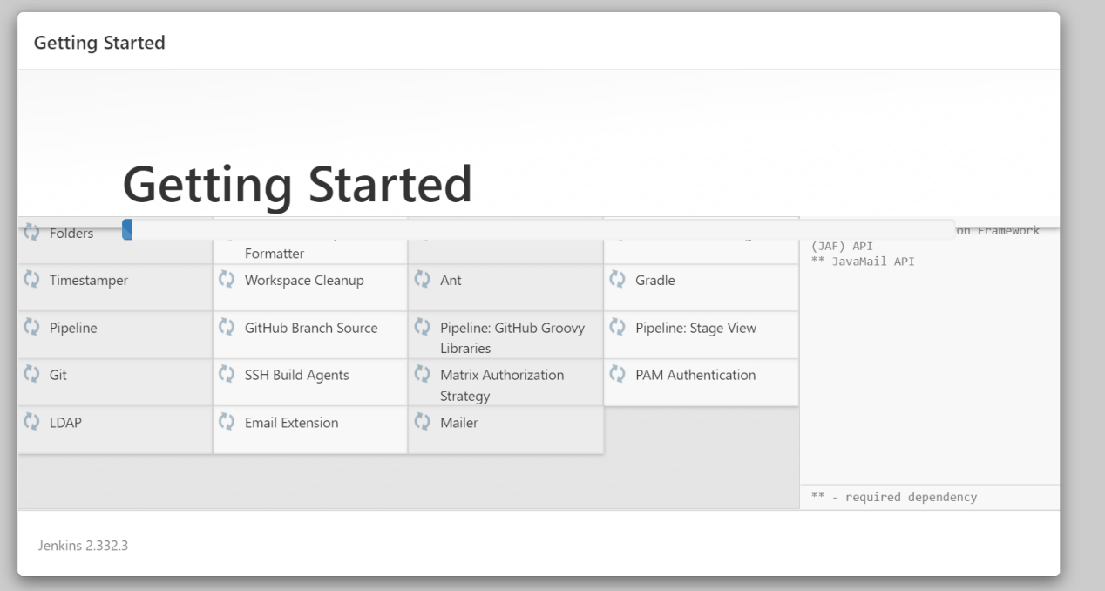

After installation of plugins to create admin user

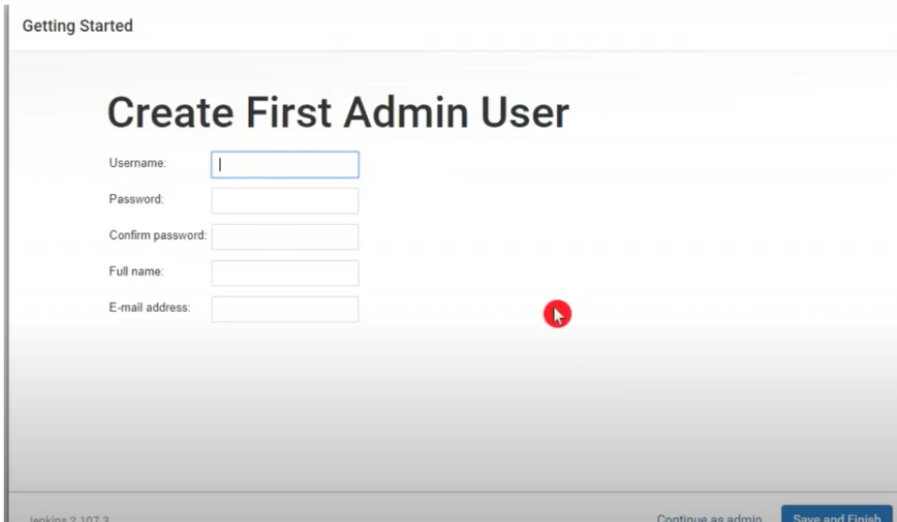

Jenkins Dashboard

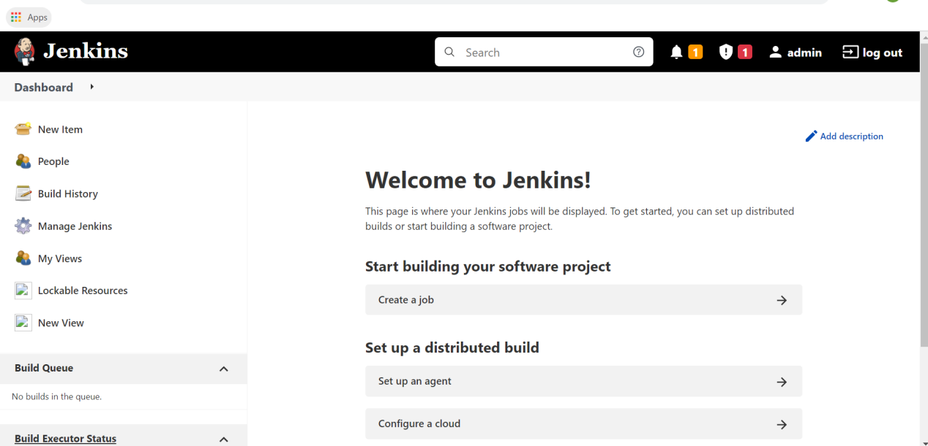

**New Item:** Every project create a new job.

**People:** How many users are created and shows the running users.

**Build History:**  Build history shows the how many builds are running and failed in hours and date wise.

**Manage Jenkins:**  Change any configuration.

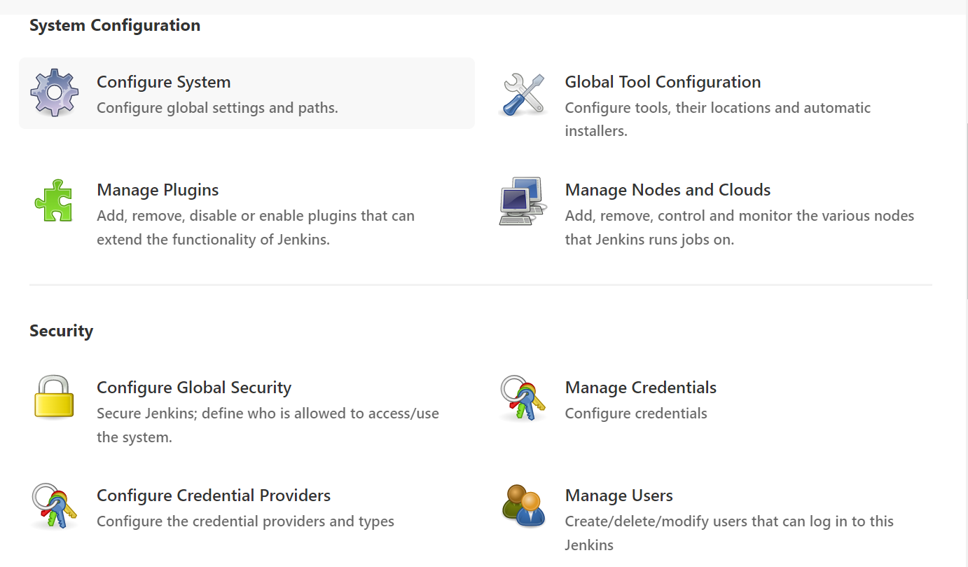

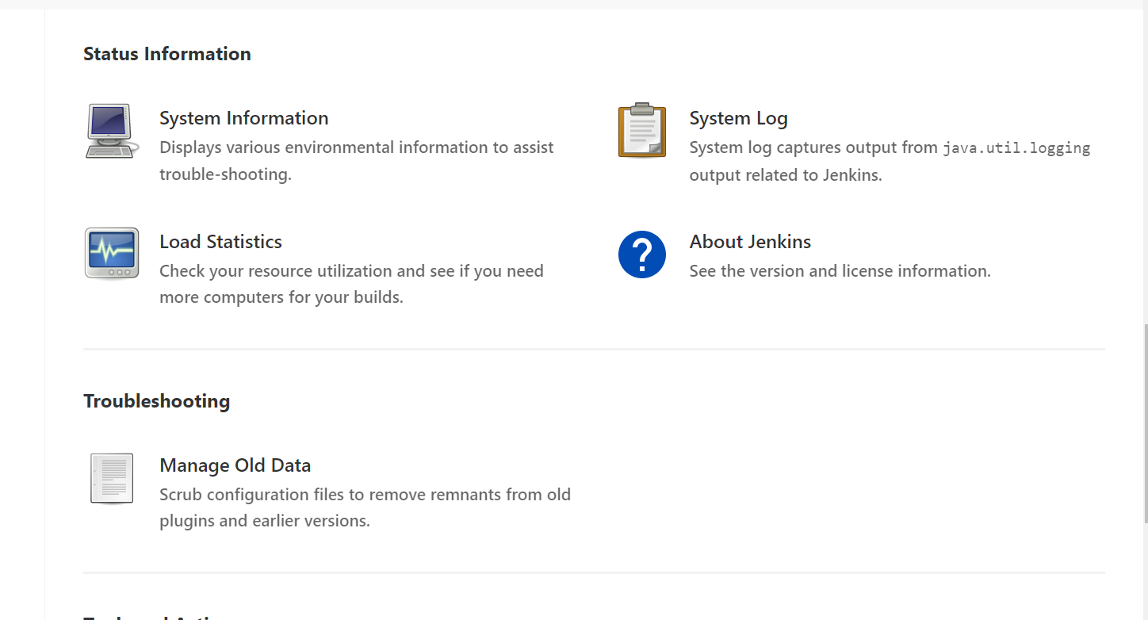

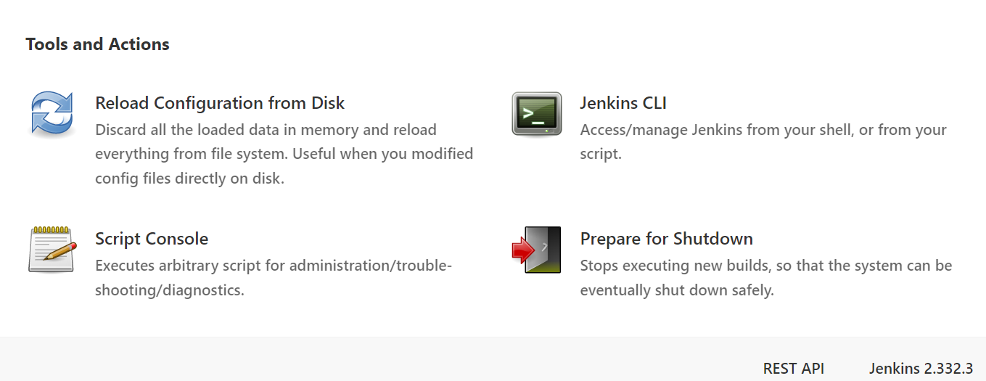

**My Views:** It shows the created jobs

**Local Resource:** Intract with the physical device.

**Configure system:** This option in this page depends on the number of plugins you have. Many plugins need some global configuration settings which can be modified from this page.

**Global Tool Configuration:** Jenkins get integrated with verity of tools. In the build job, we have seen it gets integrated with **git and maven.**

**Mange plugins:**  Plugins are the most powerful future in jenkins. You can customize jenkins as per you need by installing and setting up plugins.

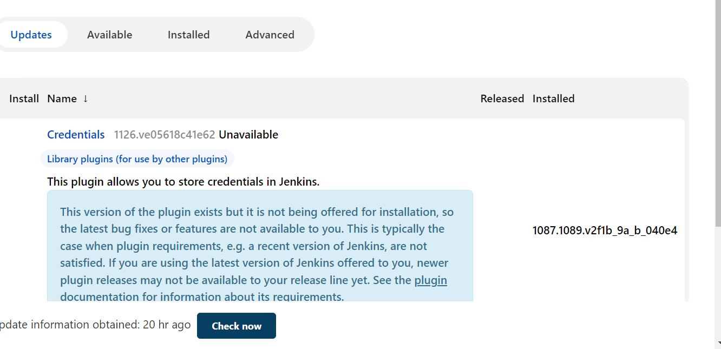

Manage plugin having 4 options.

1. Updates B. Available C. Installed D. Advanced

**Update:** If any plugin is outdated (or) new version of that plugin is available we can update the plugin from this tab.

**Available:** List of available plugin to install. Find your plugin from filter and click “install without restart” . If the settings does not take effect restart jenkins sever.

**Installed:**  List of all installed plugins, if you choose to uninstall a plugin.

**Advanced:** Some time you site behind a proxy server and don’t have a direct inter net connection. That time you won’t be able to see the list of available plugin and won’t be able to install it.

Jenkins provides the option of choosing from different types of jobs to build your project.

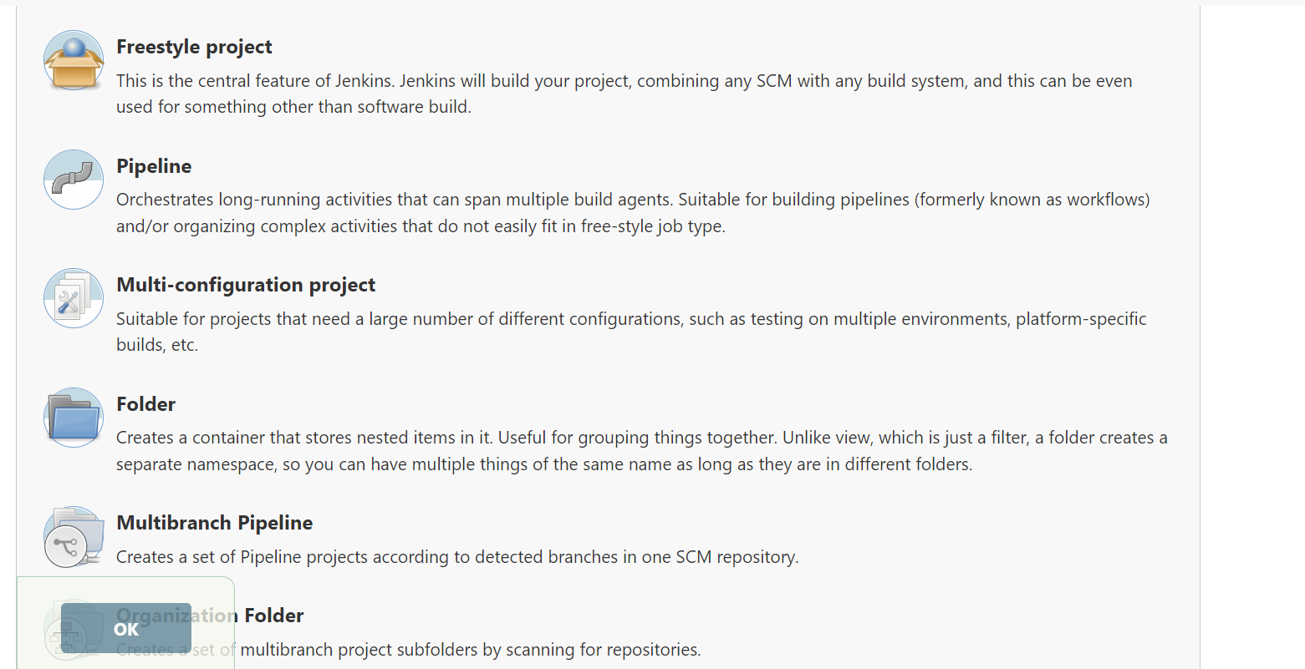

**Freestyle project:** Freestyle build jobs are general-purpose build jobs, which provides maximum flexibility. It can be used for any type of project.

**PipeLine:** This project runs the entire software development workflow as code. Instead of creating several jobs for each stage of software development, you can now run the entire workflow as one code.

**Multi-Configuration:** The multi configuration project allows you to run the same build job on different environments. It is used for testing an application in different environments.

**Folder:** This project allows users to create folders to organize and categorize similar jobs in one folder or sub folder.

**Muti branch pipeline:** This project type lets you implement different Jenkins files for different branches of the same project.

**Creation of jobs:** select new item > job/item name > select freestyle project> go to build option> select Execute shell> apply and save.

After creation of job we need select the build option.

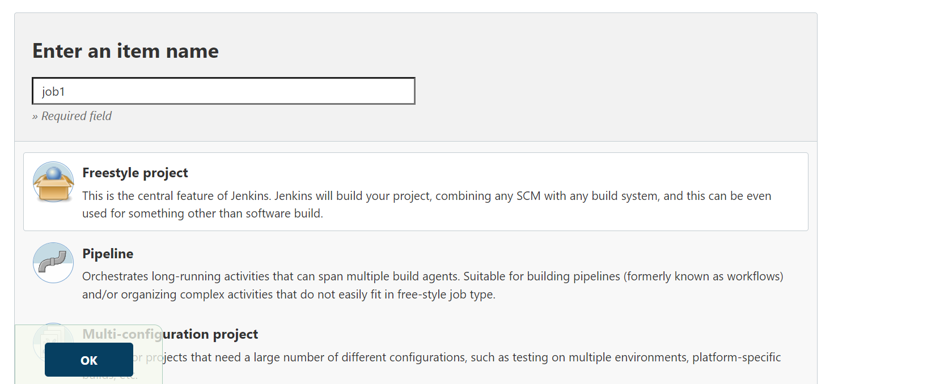

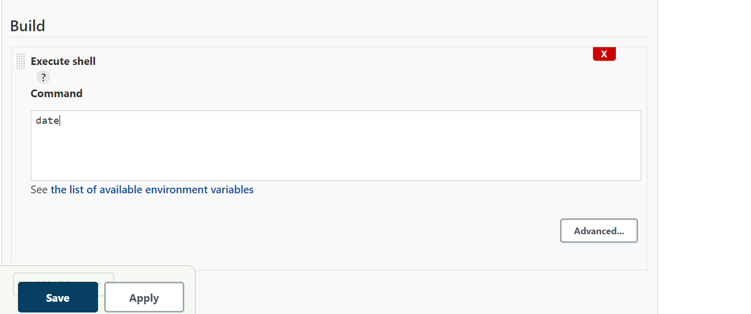

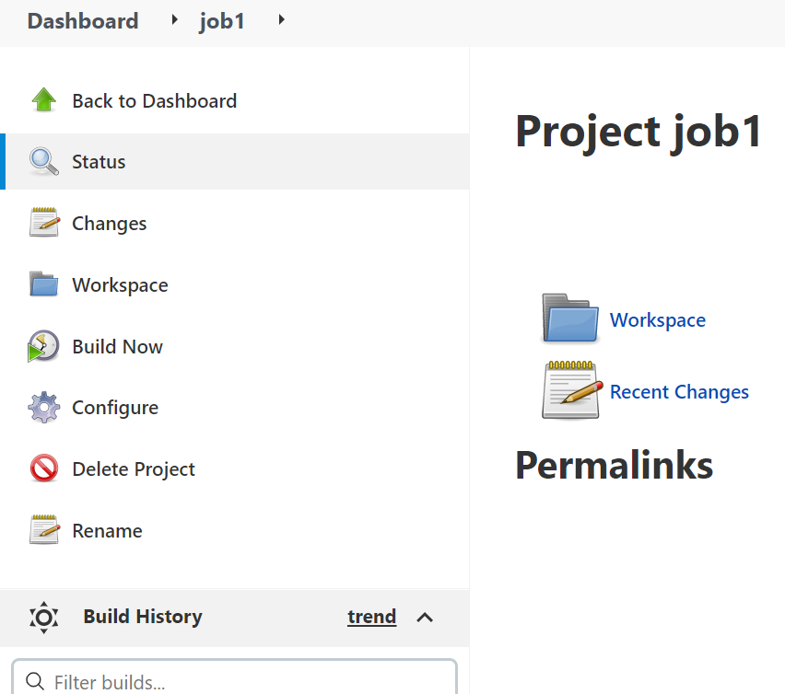

Build now is execute the created jobs.

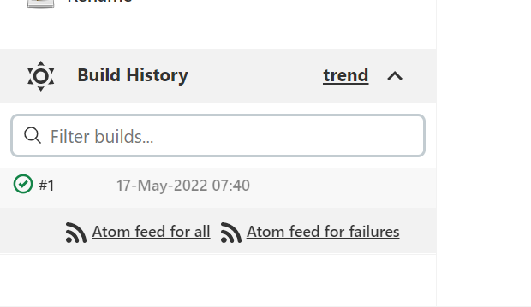

In build history show the green color the job is execution is success.

To check output of the job.

Select console output.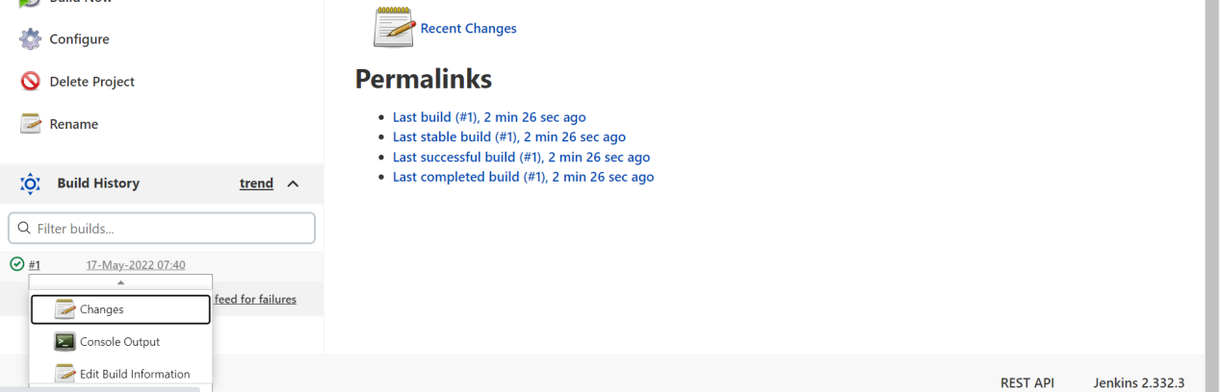

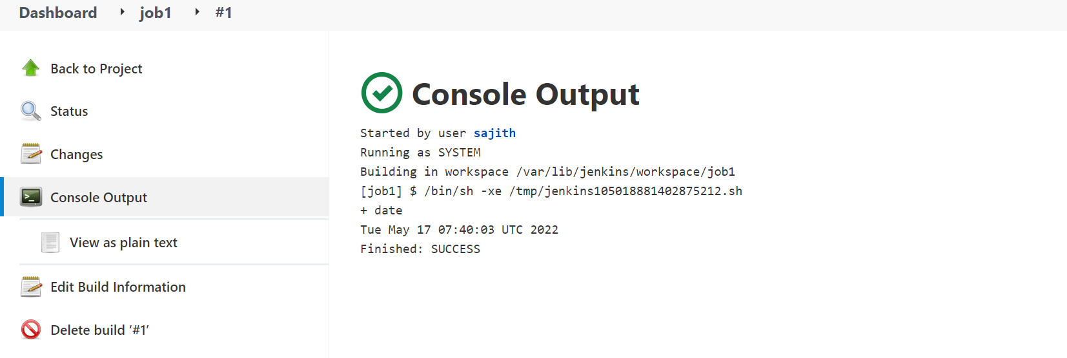

To check job history to go to build history.

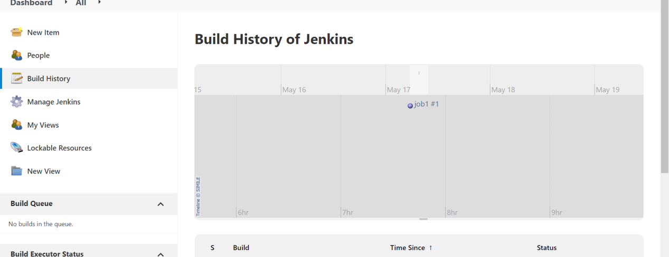

Create another two jobs.

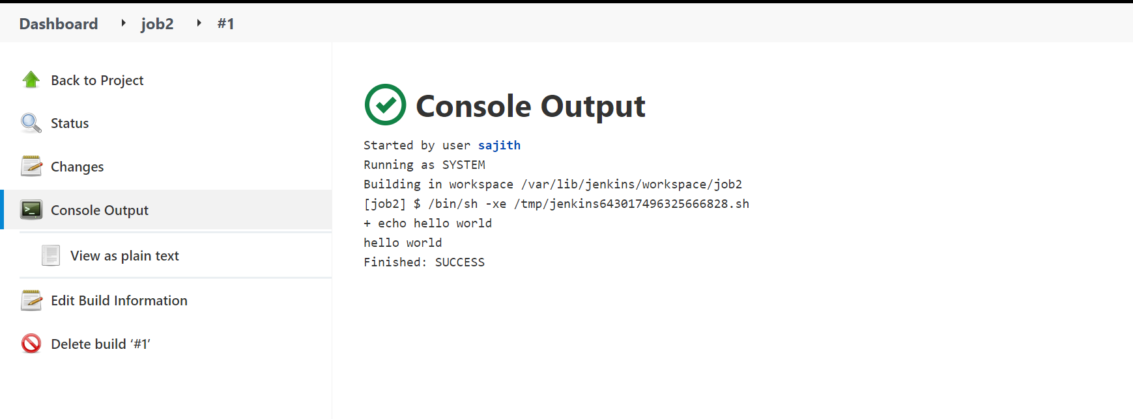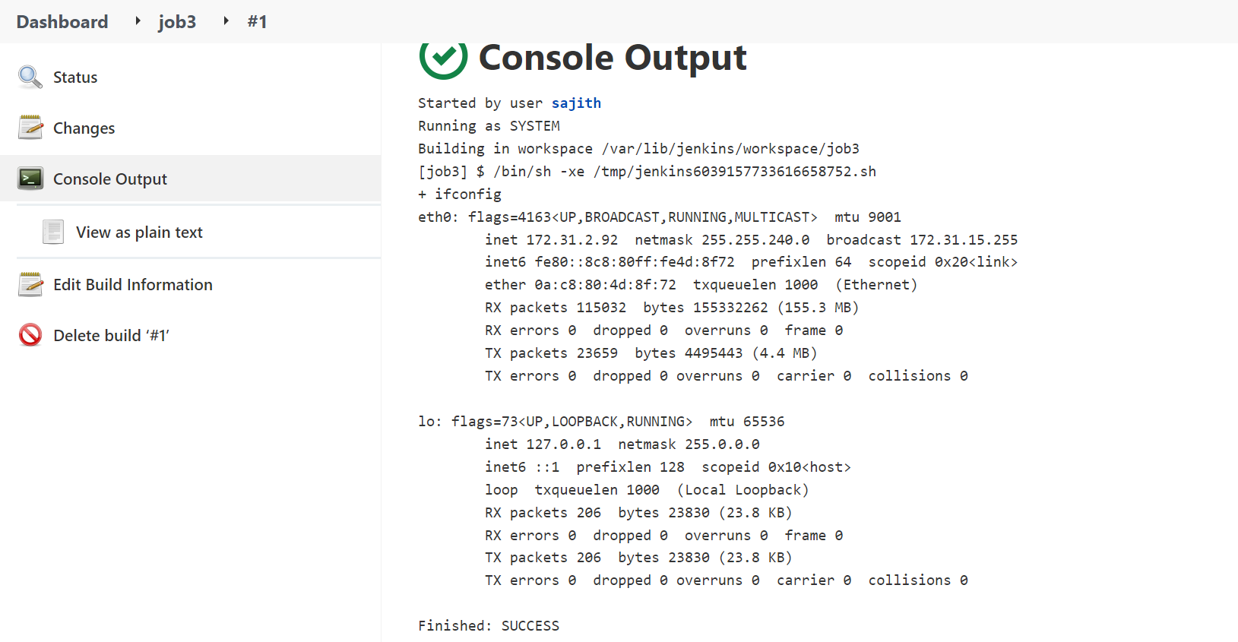

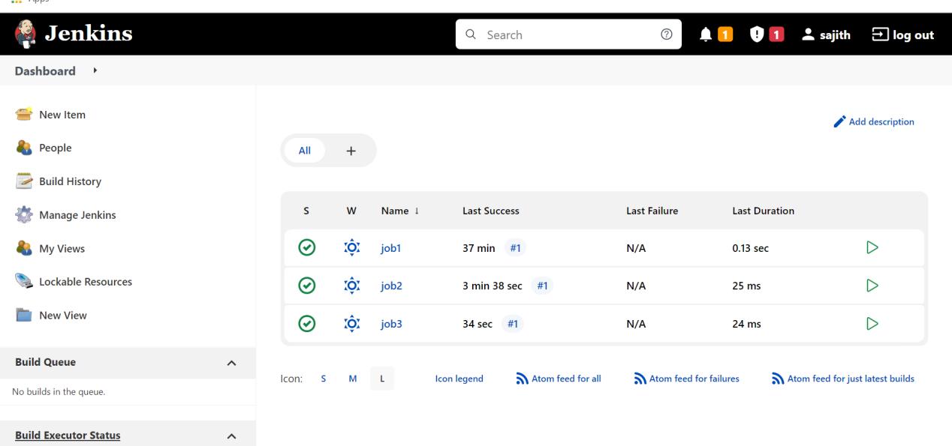

Up stream and Down stream

Up stream and down stream for the jobs

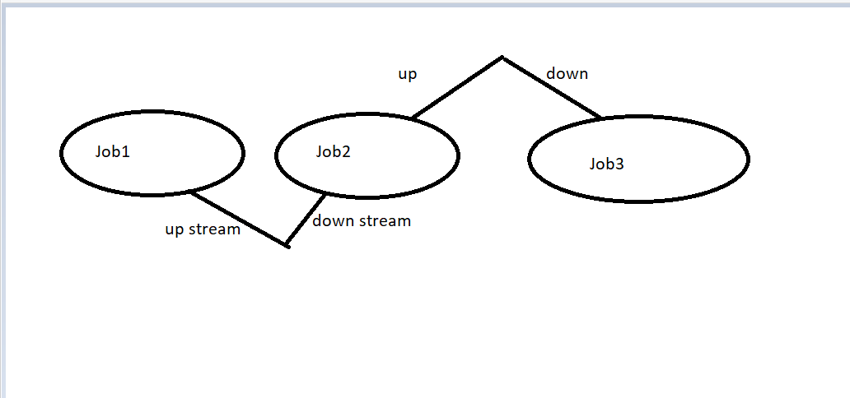

The above diagram shows the up and down stream relation

Compare job1 and job2

Job1 is the up stream for job2.

Job2 is the down stream for job1

And compare job2 and job3

Job2 is the up stream for job3

Job3 is the down stream foe job2.

In jenkins to see the graphical mode for up stream and down stream we have to install one plugin I.e **Delivery Pipeline.**

For installing Delivery pipeline

Go to manage jenkins> manage plugin> Available > search Delivery pipeline > install without restart.

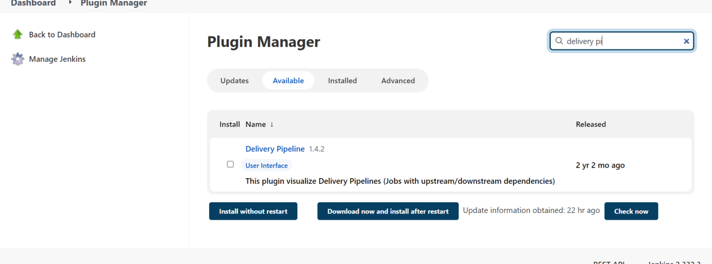

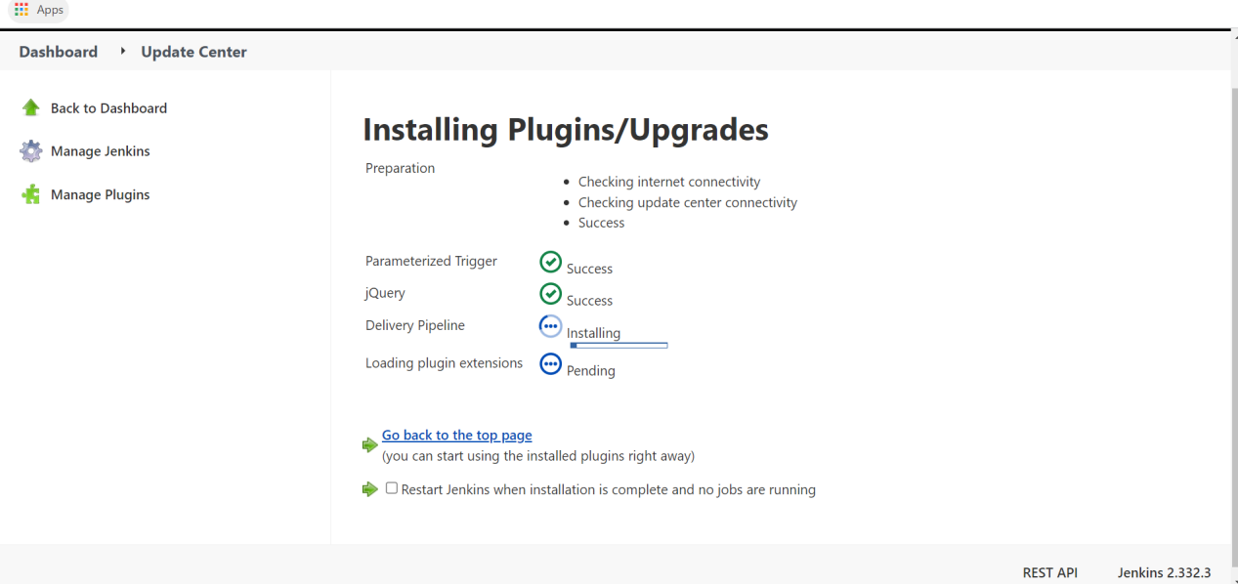

Go to job2> configure > build triggers > select build after other projects are build.

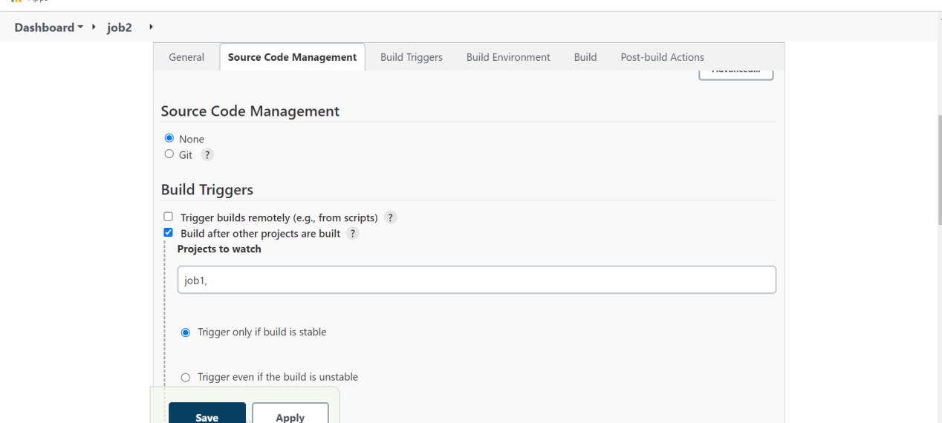

Select + symbol on dashboard

View name stream1 and select Delivery pipe line view.

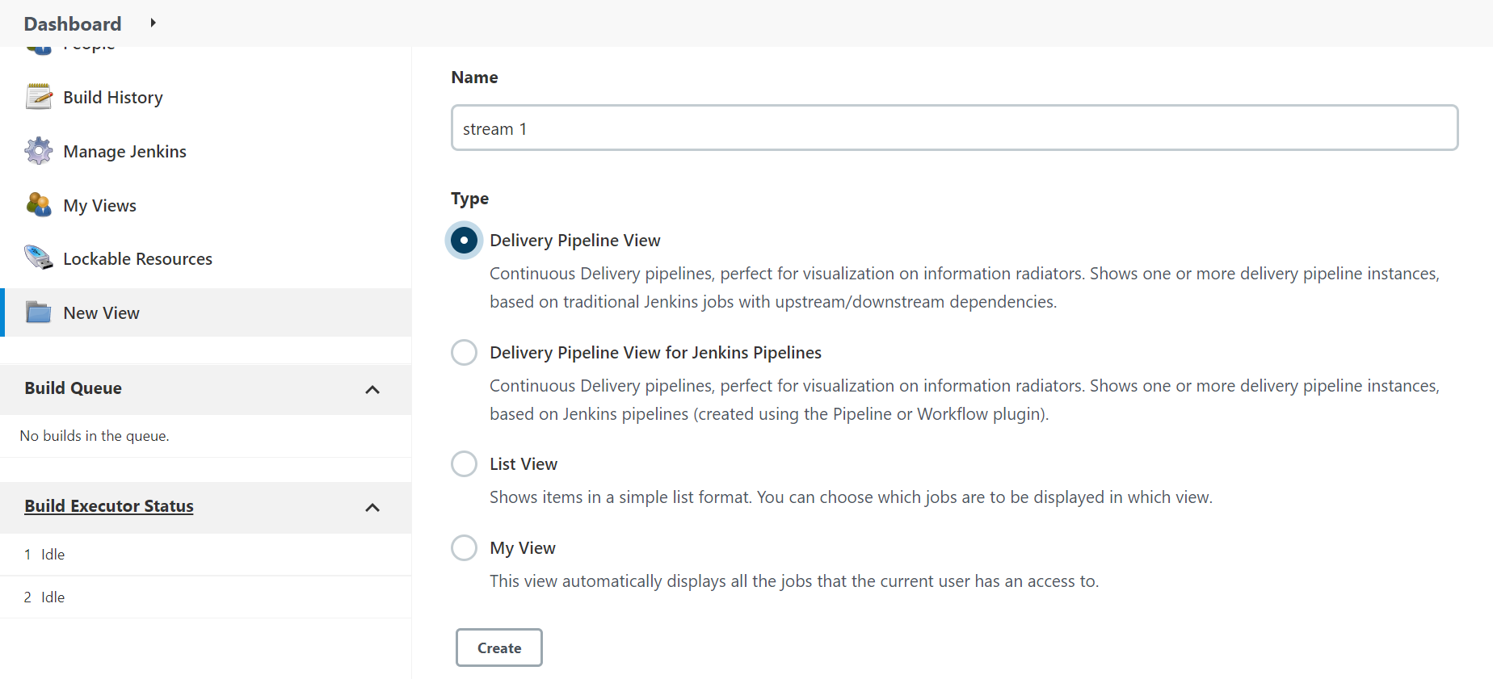

Go to edit view > pipe line > components > add

