Midterm quiz – Geospatial Data Science

For each question, exactly one answer is correct.

The general definition of a neighbor of an object i is:
1) an object next to i
2) an object closer to i than a threshold
3) an object with non-zero weight in column i of the weight matrix
4) an object with non-zero weight in row i of the weight matrix

Given a standardized spatial weight matrix, the spatial lag of an object i is:
1) the average of the values for all neighbors j of i
2) the sum of the values for all neighbors j of i
3) the sum of the reciprocal values for all neighbors j of i
4) the sum of all values minus the average distance

Assume a standardized spatial weight matrix with rook contiguity.
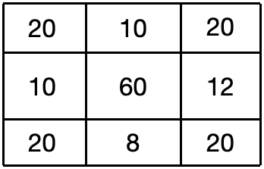
Then the spatial lag of the central cell is:
1) 180
2) 120
3) 100
4) 40
5) 15
6) 10

Assume a non-standardized spatial weight matrix with queen contiguity.

Then the spatial lag of the central cell is:
1) 180
2) 120
3) 100
4) 40
5) 15
6) 10

A spatial weight matrix W cannot be row-standardized when:
1) there is a row in W with only zeros
2) not all rows in W sum up to 1
3) there are disconnected clusters
4) W is asymmetric

When Moran's I is positive, it means:
1) there is a significant number of clusters with similar values
2) there is a significant number of clusters with dissimilar values
3) object and neighbor values are more similar than randomly reshuffled values
4) object and neighbor values are less similar than randomly reshuffled values

A low p-value for Moran's I means:
1) the observed I is likely to be measured in random reshuffling
2) the observed I is unlikely to be measured in random reshuffling
3) clusters are small
4) there is strong clustering

